|  |
| --- |
|  |
| The Owl House and Camel Yard- Nieu Bethesda |
| Nomination document for a National Heritage Site |
|  |
| **Melinda Bekker & Reinet le Roux** |
| **29 April 2015** |

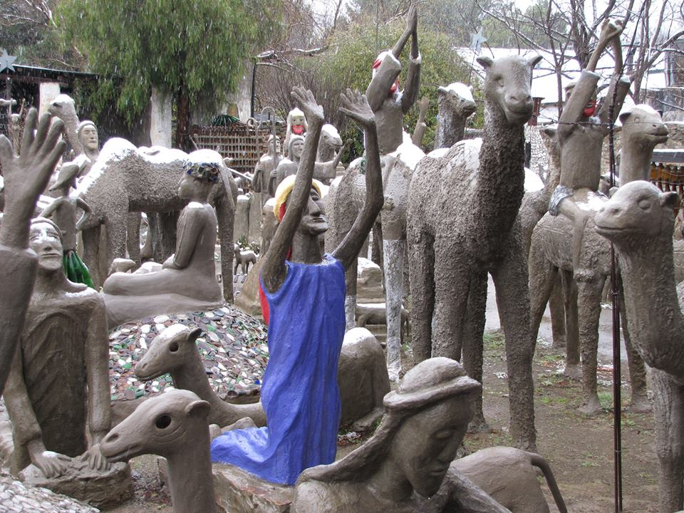

Index

1. Introduction
2. Criteria
3. Brief statement of significance
4. Expanded statement of significance
5. A Short History of the Owl House
6. Helen Martins – a short summary and the background of her life
7. Helen Martins as outsider artist
8. Koos Malgas as artist
9. The Camel Yard
10. Outsider art
    1. Examples of other local outsider artists

5.2 Examples of international outsider artists

1. A physical description of the Owl House
2. Locality Plan and Site Plan
3. List of movable objects
4. Bibliography
5. Statement of current protections
6. Heritage organisations and experts and their comments of the proposed nomination
7. Site Plan and proposed boundaries
8. Conservation or management plan
9. Heritage agreement
10. A Brief History of Nieu Bethesda
11. Socio-economic benefits
12. Criteria indicators- the intangible significance of the Owl House
13. Executive summary
14. Pictures of the Owl House and Camel Yard
15. Introduction

The Owl House and Camel Yard in Nieu Bethesda are hereby nominated to be declared as a Grade 1 National Heritage Site according to the SARHA themes in the categories: Arts and cultural expression and/or Decorative or fine art.

1. Criteria:

The Owl House and Camel Yard is nominated In terms of section 3(3)(b) of the Heritage resources act for its “possession of uncommon, rare or endangered aspects of South Africa’s natural or cultural heritage”.

The Owl House and Camel Yard are of special value because of:

1. Section 3(3)(a) – “its importance in the community”
2. Section3 (3)(b – “its possession of uncommon, rare or endangered aspects of South Africa’s natural or cultural heritage”
3. Section 3(3)(f) – “Its importance in demonstrating a high degree of creative or technical achievement at a particular period” and
4. Section 3(3)(h) – “its strong or special association with the life and work of a person, group or organisation of importance in the history of South Africa”.
5. Brief Statement of significance

The Owl House was named by Helen Martins when she was overwhelmed by a passion to transform the house into a fantasy world of glittering glass symbolizing her passion for light and her journey searching for spiritual enlightenment. By transforming her environment she sought to worship, dream and convene her message of spirituality and meaning through symbolism in the house and the camel yard. The Owl house with its strange concrete sculptures and extravagance of glass- glitter surface was the creation of reclusive artist Helen Martins. For more than a quarter of a century she worked on the transformation of her home in the isolated South African Karoo village of Nieu Bethesda, creating an intriguing world rich in personal symbolism and universal meaning. The garden became a sculpture yard populated by a throng of pilgrims and camels, owls, mermaids and other creatures, while the walls of the house were coated in colour and crushed glass to create sublime and unsettling effects.

“Like many other Outsider artists, Helen Martins had no formal training and did not regard herself as an artist. With the help of assistants, she simply continued to work on her extraordinary fantasy because it gave meaning to her life”

(Back page, A Journey through the Owl House, Anne Emslie)

The Owl House and Camel Yard created by Helen Martins and assistants, most notably Koos Malgas, represent South Africa’s foremost example of outsider art.

[Outsider Art](http://painting.about.com/od/artglossaryo/g/defoutsiderart.htm) was first recognized by the French artist Jean Dubuffet, who coined the term 'Art Brut', or Raw Art, and described it as "*fantastic, raw, visionary art created by individuals often maladjusted, with no art training, who work outside the mainstream of the art world.*"

1. Expanded statement of significance

The Owl House and Camel Yard represent South Africa’s foremost example of outsider art. The Owl House and Camel yard were created by Helen Martins and her assistants most notably Koos Malgas and became known after the internationally recognised Athol Fugard wrote a play ‘The Road to Mecca’ in 1984 that is still performed worldwide. After this visitors started looking for Nieu Bethesda and the Owl House.

Helen Martins is internationally recognised as one of the top ten female and top 13 outsider artists in the world. The Owl House and Camel Yard became a significant tourist destination for the Eastern Cape and South Africa.

1. Short history of the Owl House and Camel Yard

The Owl house is in Nieu Bethesda, a small town in the Eastern Cape between Middelburg and Graaff Reinet. The house is in New Street with an unobstructed view of the river and the mountains. Helen was born and died in this house. She later named it the Owl House and started to transform the house in a magical dream world of glittering glass particles, lamps and mirrors, stars, moons, spires and cement statues. Helen’s world, her mecca, all created and placed according to her creative ideas to bring forward a message that was beyond the understanding of most of the people of the town.

Some time after Helen Martin’s death in 1976 the property was acquired by the Municipality of Graaff Reinet and the house and yard was opened to the public. Initially a small entrance fee was charged and the local town clerk escorted visitors through the Owl House. This situation changed rapidly after Athol Fugard achieved acclaim in 1985 for The Road to Mecca, a play based on the life and work of Helen Martins. The film version of The Road to Mecca was released some years later and put Nieu Bethesda in the spotlight.

Growing concern about the deterioration of the house and yard led to the formation of The Friends of the Owl House. In 1996 the Friends of the Owl House and the local government established The Owl House Foundation (OHF). The OHF was established to manage and protect the The Owl House.

1. Helen Martins and the background of her life.

Helen Martins was born on 23 December 1897 in Nieu Bethesda, a small and isolated Karoo village in South Africa's Eastern Cape, the youngest of six children. She gained a teaching diploma after attending school in Nieu Bethesda at the Teachers College in Graaff-Reinet (the nearest town to Nieu Bethesda, (approximately 50 km away) and in 1919 moved to the Transvaal to begin working as a teacher. (P21, A journey through the Owl House, Emslie)

In 1920 Helen Martins married a fellow teacher, Willem Johannes Pienaar. Pienaar also worked as a dramatist, and the couple travelled together appearing in theatrical productions around the Transvaal, in Cape Town, and Port Elizabeth. They divorced in 1926. Around 1928 Helen Martins returned to Nieu Bethesda and spent the next 17 years looking after her ailing and elderly parents. Martins' mother died in 1941 and the father in 1945.

Martins became increasingly reclusive and isolated from the local community. Known to the residents as 'Miss Helen' and thought of as a strange and rather outlandish character, she shied away from general contact, and began transforming her house and garden.

Helen Martins' art was greeted with derision and suspicion by the villagers. Despite crippling arthritis, and the amputation of her small toes (her feet were disfigured from wearing narrow shoes) which left her unable to wear anything but slip-ons on her feet, Martins decorated her home with 'glass and light'.

Although she avoided people in general, once a year at Christmas she would open up the house and invite the locals to visit, enhancing the mirrors, [murals](http://africanhistory.about.com/od/africanarts/ig/The-Owl-House/OwlHouse-Ceiling.htm) and [crushed-glass coated walls](http://africanhistory.about.com/od/africanarts/ig/The-Owl-House/OwlHouse-InsideGlass.htm) with the light of many candles.

In 1964 Helen Martins employed Koos Malgas, an itinerant sheepshearer, to help her make the cement-and -glass statues which fill the Camel Yard outside her house. Formally a garden, the sculpture yard has over 400 figures and animals. Malgas became her foremost friend and companion, and remained by her side for the last 12 years of her life. Helen's close relationship with her Coloured assistant was viewed with great suspicion by Nieu Bethesda's Apartheid era residents.

Helen Martins’ works of art, displayed in the Camel Yard, are a bustling kaleidoscope of cement sculptures. Predominant themes are the [nativity](http://africanhistory.about.com/od/africanarts/ig/The-Owl-House/OwlHouse-Nativity.htm), a curious mélange of Christian and Eastern philosophies (particularly the Bible and the writings of Omar Khayyam), as well as a large number of owls. Helen Martins was especially fond of owls and considering them a kind of totem animal - associated with intuition and insight and wisdom. Helen Martins' eyesight began to fail and in 1976 she took her own life by swallowing a mixture of caustic soda and crushed glass in olive oil. She could not bear the thought of going blind - a great theme in her life and work is light - and she was worried that she would be taken away from her life's work. She was discovered shortly after taking the mixture and removed from Nieu Bethesda to hospital in Graaff-Reinet, where she died three days later, on 8 August 1976.

Koos Malgas remained for another two years before relocating to Worcester, but returned in 1991 to assist in the restoration of the Owl House which had been declared a national monument and was supported by the newly created Owl House Foundation. It had been Helen Martins' greatest wish that the Owl House and Camel Yard be preserved as a museum.

1. Helen Martins as outsider artist and the significance of her work as outsider artist.

After Helen’s parents died, she saw her life as grey and uninteresting and had a vision how she would brighten her life by bringing in light and transform her environment into a dream world.

Helens creation of the Owl house and Camel Yard cannot be interpreted by logical rational means, just as figures in a dream or the unfolding of a dream sequence cannot be explained or decoded through rationality. (p147. Ross)

Helen transformed the interior of the house by using various paints covering it with ground glass. Helen started systematically redecorating and transforming her entire house, inside and out, beginning with the interior. She collected bottles and glass of all colours that was crushed and fixed on the wet paint. “She painted the walls and ceilings of all the rooms in various colours in geometric designs- some, seemingly, to a rigid pre-plan, others with no apparent set rules.

Helen wanted light, and she created it in the most ingenious and novel ways. Apart from the light –reflecting, glass-encrusted surfaces everywhere, she had large mirrors specially cut to her designs in the shape of suns with rays, crescent moons, stars, hand mirrors, hearts, a cross, as well as rectangles. These were hung in every room at strategic and obviously well thought out points. They reflected room to room, light to light, image to image, moon and sunshine to other points, and when her multitude of candles and lamps were lit, must have increased to place upon and altar, have tinsel twisted around them to amplify the glitter, and her collection of varied and multi coloured paraffin lamps of all sizes fill two wall cupboards.” (p.59, Ross)

“Helen’s work encapsulates in varied and complex ways the events and experiences of her life: the light and the dark, the sun and the moon, the joy and the shadow. The Owl House and the Camel Yard are great works of imagination, both original and passionate, through which runs a cohesive and thematic thread of yearning, a quest for meaning and for wholeness, conceived with a commitment which makes her work unique and at many levels, profoundly moving.” (p258, This is my world, Ross 1997)

1. Koos Malgas as artist

In order to accomplish the transformation of her environment, Martins hired the services of local workmen. First Jonas Adams and then Piet van der Merwe were employed with structural modifications to the interior of the house - mostly replacing original windows with the vast panes of glass that bathe Martins’ home in multi-coloured light.

In 1964 she employed Koos Malgas, who quickly developed techniques for manufacturing cement and glass sculptures. Martins obviously appreciated his ability and soon he was regularly employed on the creation of the Owl House.

Every sculpture would be discussed beforehand over early morning coffee in the kitchen and, although Martins seldom did any of the physical work, together they would engineer each new inspiration into being. This process developed into a unique creative relationship that clearly defines Malgas's integral part in the creation of the Owl House.

Koos also said to Emslie: “Everything standing here represents her thoughts. Everything that was made here. She also asked me what in my opinion was right. She was beside me every day. She always watched what I did and said what was wrong”

Helen called Koos an artist and respected him as a companion and artist. Although she never saw herself as an artist. However the means to communicate her world and create her Mecca was the focus point. She was possessed by a sense of urgency- as if time would run out before she fully realized her dream of transformation. Without her assistants she could never fulfill her dream since the work was too hard for her. But what is important, it was Helen’s ideas and dream that could come true due to assistance.

Over about 12 years Martins and Malgas created from her imagination the hundreds of sculptures and relief figures that crowd the Camel Yard and cover the walls of the house. Owls and camels, her favorite animals predominate, but all kinds of real and fantastical beings are to be found. A procession of shepherds and wise men lead a vast, almost life-size camel train toward the east, integrating Christianity with Martins’ fascination for the Orient.

1. The Camel Yard

“Some of the more obvious themes and images in the Owl House and Camel Yard are owls and camels, the celestial bodies-sun, moon and stars, light and darkness, birds, domestic and wild animals, Christianity and Eastern religions and philosophies, mythical figures such as mermaids and sphinxes, structures such as churches, towers, arches, and pyramids, mirrors and water.” (p152, This is my World, Ross 1997)

Subjects that are repeated in the camel yard are owls of which there are 80 in the camel yard, house and on the stoep and approximately 49 camels. The Mona Lisa appears many times in differing forms and interpretations and also peacocks (13), lambs (18), pyramids (12), and mermaids (14). Including all the owls, there are approximately 120 birds of different types and numerous images of the sun, moon and stars. Images from Eastern philosophy and various religions, such as Islam, Christianity, Buddhism, and Hinduism, are portrayed in the form of statues, bas-reliefs, bottle edifices, structures and inscriptions formed in wire in various fences.

There are two major movements in the flow of the statues, the main one from north to south (which Helen calls east), and two others from east to west, towards the moon-gate. These, however, are not rigidly imposed. There are approximately 469 cement sculptures and other structures in the Camel Yard and in the house, and 44 bas-reliefs in the yard and on the front and back porches- a phenomenal output, and obviously the product of many years’ work. Many of them are nearly life size. (p81. Ross)

The East seems to have made a profound impression on Helen, and she reflected this in much of her work. Some of the earlier sculptures are of subjects such as pyramids, sphinxes, and Buddhas, and then there is the vast procession of camels, wise men, and shepherds marching to the east except that it was not actually true east, but Helen’s personal east-defined by her by writing, in the wire netting on the south boundary fence, “East Oos” Almost all of the sculptures face towards the east, many depicting a pilgrimage to a suitably positioned nativity scene.

The essence of Helen’s work was transformation, the transformation of things worldly, mundane or damaged through symbolism into things of beauty, spiritual perfection and worth.

Helen could not conform to the norms of society; instead she wove her own fantasy in cement, glass and light.

1. Outsider Art

The dream spaces that individuals create for themselves are intuitively produced creations. Whatever its form and wherever it is found, a common thread exists, an art produced by an inner compulsion, with no regard for commercial considerations or art conventions and fashions. It may be secretive and private, or expansive and public, but it has its roots deep within the human imagination and a manifestation that often reaches heroic proportions (Raw Vision 1 1989, 4)

Outsider Artists all over the world start to create and transform their immediate environment according to their own fantasy and dream, a yearning to live their dreams. Usually outsider artist are lonely people inspired by their unconsciousness to change their world into a better place. Symbolism plays a major role for outsider artists, to convey their message. Unusual material that is accessible is used. They are in most cases without training and the message that they want to convey is original and cannot be associated with normal art.

* 1. South African outsider artist: List of names and a short discussion

5.1.1. Dirk Cornelius van der Mescht

At the Zuney railway station in the Eastern Cape van der Mescht created a remarkable Outsider art environment of at least 60 sculptures along both sides of the railway tracks and into the garden of his adjoining home. He worked as a porter on the railway line but he got bored until he had a vision to change his environment and made sculptures of cement and wire and then painted them.

5.1.2 Sibusiso Mbhele

At Bergville Mbhele created his own extraordinary environment, which revolved almost exclusively around aeroplanes and helicopters. He created his own world in the mist of traditional villages at the foot of the Drakensberg. His Fish-Helicopter was built of scrap metal according to drawings he made.

5.1.3 Jackson Xidonkani Hlungwani

Hlungwani is a Tsonga-man born in 1923 near the village of Mbhokoto; Hlungwani combines the roles of visionary preacher, healer, woodcarver and builder in stone. Apart from the gracious flying fishes he created, there are a huge sculpture of Christ playing football and God holding a ball, altar pieces, thrones, maces, animals, bowls, birds, human figures, panels.

Acting on divine instruction he has created his New Jerusalem from rock and earth on top of a hill which overlooks the surrounding countryside. He says it is the place where everything begins and ends: the centre of the world, at the meeting point of heaven and earth, east and west. (p220, This is my world, Ross 1997)

“His world view, depicted through religious metaphor, Eve, Cain and Abel. Left and right, male and female, vertical and horizontal, interior and exterior. Hlungwani Aerial of God seems to combine elements of his vision of a crucifix.” (p221 This is my world, Ross 1997)

5.1.4 Noria Mabasa

Noria Mabasa, born in 1939 in Venda. She has worked in clay and wood and said that her sculptures are derived from dreams. Noria sold sculptures all over the world and is well known for unusual and imaginative use of the human figure.

5.1.5 Richard Netshipise

Richard Netshipise created his own garden, the Park of Redeem and the year of Redeem garden in Venda. He painted the trees and shrubs, diagonal stripes of various coloured paint, metal drums were painted and planted, tree stumps were painted to bring out figures of animals which could be found in them, items were created from household goods, such as two litre plastic bottles cut and painted to resembles sharks or voracious fishes and hung from branches in the shrubs or on pieces of wire, and other plants were clipped into a fairly sophisticated form of topiary. (p225, This is my world, Ross 1997)

5.1.6 Nukain Mabusa

Nukain Mabusa painted stone garden is situated on a farm called Esperado at Revolver Creek near Barberton in Mpumalanga. He created his own world by painting rocks, stones and boulders on the sloping hillside near his home in bright geometrical patterns of dots and stripes.

“The hillside of painted stones and boulders as created by Mabusa, did have a compelling atmosphere, which may be described as magical of spiritual” (p28 Clarke, 1992)

5.1.7 Leslie Goldman

Leslie Goldman created sculptures of scrap metal and waste and said it was an expression of his joy of living. The source of his material was already made and found objects of our environment. He used a system of construction and balance when working and put a lot of aggression into his work.

Bill Ainslie said “His work falls within that important category of activity in modern sculpture that finds its material in the waste products of our technological society and converts them or rather transforms them into objects of a different order. Although it is called junk art, this refers to the medium and not the result.”

5.2. International Outsider Artist

5.2.1 Roger Chomo

Roger Chomo was born in 1907 in a small village in the north of France. His creations started out of the urgent message for the world: to leave materialism behind before it is too late and replace it with spirituality. His first message was: ‘Halt consumerism. Chomo said to people: Be careful, it’s an easy way, it’s a trap.

He created three temples, and called it the Church of the Poor, the Refuge and the Sanctuary of Scorched Wood. Interspersed between the property’s trees and buildings are hundreds of sculptures, paintings and trees. They are decorated with tinfoil or items suspended from them as old shoes, human figures and imaginary animals. (p231, This is my world, Ross 1997)

* + 1. Nek Chand

Nek Chand’s Rock Garden in Chandigarh, India must be one of the largest, and one of the most remarkable, examples of Outsider art in the world. It is built on a scale that defies imagination, it covers approximately 60 acres. His dream vision, which started in secret, was officially opened to the public in 1976. His great interest was the forms he found in natural stones. He used to roam the foothills of the Shivalik Mountains, select stones which resembled human, animal and abstract forms, and bring them back on his bicycle. There are more than 20 000 of these rocks in his garden.

Apart from his natural rocks and cement, all his work is constructed from waste.

1. Physical description of the Owl House

The Owl House is a typical Karoo style house that was built in the late 1800 and transformed by Helen Martins over a period of almost 30 years with colour, glass and mirrors and the yard with more than 400 cement sculptures.

1. Locality plan and site plan

Attached

1. List of movable objects relating to the site that are proposed as part of the nomination

There are approximately 469 cement sculptures and other structures in the Camel Yard and in the house, and 44 bas-reliefs in the yard and on the front and back porches

Unfortunately there is no complete inventory available and it is one of the reasons for declaring this heritage resource to enforce these very important aspects.

1. Bibliography of documentation relating to the Owl House

* Ross, SI, 1997, This is my world: Helen Martins, creator of the Owl House Oxford University Press, Cape Town
* Malgas, J & Couzyn, J, Koos Malgas Sculpture of the Owl House
* Emslie, AL, A journey through the Owl House, London, Penguin
* Stias, 2014, Celebrating South African Outsider Artist: Helen Martins and Nukain Mabusa
* Nastasi, A, 2014, 10 Female Outsider Artists You Should Know (www. Flavorwire.com)
* A Fugard, 1985, The Road to Mecca, Faber and Faber.
* Du Plessis, A, 2001 Managing Miss Helen: The OHF of Nieu Bethesda, Sabinet
* Sheard, I, A Brief History of Nieu Bethesda

1. Statement of current protections and restrictions

The Owl House is the property of the Camdeboo Municipality and is leased to the Owl House Foundation. (a non-profit company). The house and surrounding walls falls within the 60 year clause of the Heritage Resources Act, 1999 (Act No. 25 of 1999) 34(1), as well as the decorations inside the house and also some of the sculptures in the Camel Yard. It is however not clear what those are. There are also household items, clothing and other apparatus.

The Owl House and garden importance was recognised already in 1991 when it was provisionally declared a national monument. (This protecting has since lapsed and was not renewed)

1. List of heritage organisations consulted and their comments on the proposed nomination

To follow in separate attachment

1. Site plan with proposed site boundaries

Not available

1. Conservation or management plans

Not available

1. Heritage Agreement

Not available

1. A brief History of Nieu Bethesda

Nieu Bethesda was founded in 1878 when the farmers of the area negotiated with the Church in Graaff-Reinet to have a Dutch Reformed Church of their own since the nearest church in Graaff-Reinet was eight hours away. The building was completed in 1905.The village came into being on the farm Uitkyk, which was originally the farm of B. J. Pienaar. Uitkyk (or Look Out) was the name since in the early years the owners had to be on the lookout for hostile Bushmen and predators. The restored Uitkyk farmhouse can still be seen on the ‘West Bank’.

In the first thirty years Nieu Bethesda grew and flourished. The school in Martin Street, where the sports complex is today, had over 200 children, among them James Kitching and Helen Martins. The Nieu Bethesda Trading Company could provide the local people with nearly everything: fresh dates, cheese, even suits from London. and there were a blacksmith, a garage, a leather shop and of course a resident minister for the N.G. Kerk. . .

In the thirties Nieu Bethesda started to decline: the depression had an effect; travelling had become easier and children were sent to boarding schools - Volkskool or Union High or the convent in Graaff Reinet or further away. This decline continued …while Helen Martins started creating her ‘Mecca’ in 1945 and carrying on for about 20 years.

Athol Fugard, had bought property in the village in 1970 He was famous as playwright already and when he wrote The Road to Mecca ( a play based on Helen Martins) in 1985, visitors from everywhere started looking for the Owl House. Visitors kept coming and Neil Sheard saw a need and bought the house where The Village Inn is today to start the first eating place in Nieu Bethesda. The Village Inn opened in November 1991 and was the first and only coffee shop and restaurant to cater to the needs of tourists for about ten years. Neil’s brother-in-law, Egbert Gerryts, was the first host and manager and became well known as the friend of many customers.

In 2005 another attraction, the James Kitching Fossil Exploration Centre opened its doors. James Kitching grew up in Nieu Bethesda and having completed grade 10 in the local school, he became a world renowned palaeontologist. The Centre provides well trained guides to give visitors a glimpse of what this part of the Karoo was like about 250 million years ago.

The Owl House and JKFEC form the nucleus of the Heritage Centre of Nieu Bethesda.

1. Socio-economic benefits

Places of cultural significance must become part of changing the image from lifeless structures or venues to a cultural tourist attraction. Chicago’s economy was changed by the fact that it became known for caring for their arts and culture. Heritage celebrations can contribute to the economic sustainability of arts and culture in society. This will give government the opportunity to ensure that the community will be able to make a living of their cultural talents. A number of SMME’s has already developed in the craft sector by selling cement sculptures in front of the Owl House. It is envisage that these activities be extended into the Pienaarsig community to form part of an arts tour and extent into other cultural activities and the hospitality sector.

1. Criteria indicators- the intangible significance of the Owl House

In 1972 only three countries was involved in the World Heritage Convention. The focus of this convention was on the seven nature wonders of the world not including the intangible criteria for the declaration of heritage sites. Only in 1998 with the plea of Africa, the intangible notion became part of the criteria for the declaration of heritage sites. It was only then that it was admitted the spiritual heritage cannot be exclude from sites that were mainly identified for their natural wonders.

The Owl House is not only a magnificent collection of art objects but the whole house and the Camel yard is one interconnected art piece and in such spirals the intangible symbolic indicators. The natural flow as intended by the creators of the Owl House as one art piece must be preserved as that forms the intangible heritage. A clear example thereof is the symbolic ‘East’ that was created and all the sculptures in the Camel yard heads towards this ‘East” of the creators.

Two applicable quotes from Lechesa Tsenoli, Parliamentary Chairperson of Arts and Culture Portfolio Committee

* “Nothing about us without us”
* “Until the lions have their own historian the history of the hunter will always clarify the hunter”

1. Executive summary

In her book ‘This is my World’ Sue Imrie Ross ask whether outsider artist exist for themselves? She answered - “I believe that they do, for there is consensus among those who have studied them that the world is a better place for what they create and for what they leave us. Outsider art and the artist that create it may be fragile, marginalized, and operate at the edges of society but through their work these artists restore and affirm a legacy of childhood, fragile in itself a sense of wonder”.

She also asks if the Owl House and the Camel yard is art. She answers with “yes: long acquaintance with Helen Martins work lead one to believe that they are. The Owl House and Camel Yard are great works of imagination, both original and passionate, through which runs a cohesive and thematic thread of yearning, a quest for meaning and for wholeness, conceived with a commitment which makes the work unique and at many levels, profoundly moving”

In the light of the significance of the Owl House and Camel yard as an international acknowledged outsider art environment we request SAHRA to declare the Owl House as a grade 1 heritage site. Whilst the process is on-going to declare the Owl House as National Heritage site we request that the Owl House will be protected as an interim arrangement.

1. Pictures of the Owl House and Camel Yard

[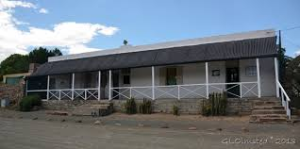](http://www.google.com/url?sa=i&rct=j&q=&esrc=s&frm=1&source=images&cd=&cad=rja&uact=8&ved=&url=http://geogypsytraveler.com/2013/07/17/the-owl-house-an-unusual-artistic-vision-of-a-personal-mecca/&ei=RnsuVdqYE9CR7AaijIDQCg&bvm=bv.90790515,d.ZGU&psig=AFQjCNE7ueePzL5uW0_1H4qvm3VQ_ZZ6pA&ust=1429195974827234)

1. [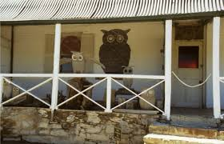](http://www.google.com/url?sa=i&rct=j&q=&esrc=s&frm=1&source=images&cd=&cad=rja&uact=8&ved=&url=http://www.abovetopsecret.com/forum/thread754567/pg1&ei=RnsuVdqYE9CR7AaijIDQCg&bvm=bv.90790515,d.ZGU&psig=AFQjCNE7ueePzL5uW0_1H4qvm3VQ_ZZ6pA&ust=1429195974827234)
2. [](http://www.google.com/url?sa=i&rct=j&q=&esrc=s&frm=1&source=images&cd=&cad=rja&uact=8&ved=&url=http://www.abovetopsecret.com/forum/thread754567/pg1&ei=RnsuVdqYE9CR7AaijIDQCg&bvm=bv.90790515,d.ZGU&psig=AFQjCNE7ueePzL5uW0_1H4qvm3VQ_ZZ6pA&ust=1429195974827234)
3. [](http://www.google.com/url?sa=i&rct=j&q=&esrc=s&frm=1&source=images&cd=&cad=rja&uact=8&ved=&url=http://www.abovetopsecret.com/forum/thread754567/pg1&ei=RnsuVdqYE9CR7AaijIDQCg&bvm=bv.90790515,d.ZGU&psig=AFQjCNE7ueePzL5uW0_1H4qvm3VQ_ZZ6pA&ust=1429195974827234)

[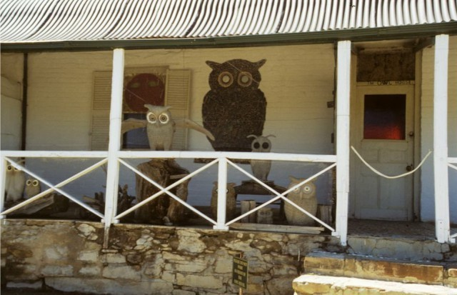](http://www.google.com/url?sa=i&rct=j&q=&esrc=s&frm=1&source=images&cd=&ved=0CAcQjRw&url=http://www.abovetopsecret.com/forum/thread754567/pg1&ei=dXsuVdDzLcHUaujOgeAF&bvm=bv.90790515,d.ZGU&psig=AFQjCNE7ueePzL5uW0_1H4qvm3VQ_ZZ6pA&ust=1429195974827234)

[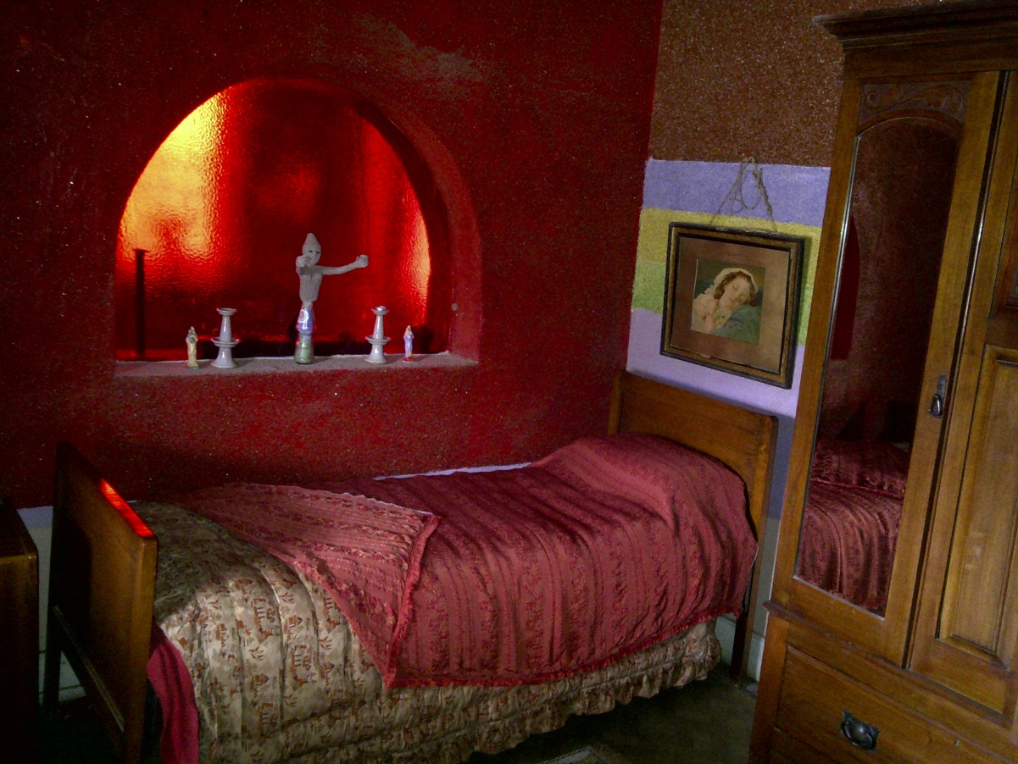](https://www.google.com/url?sa=i&rct=j&q=&esrc=s&frm=1&source=images&cd=&cad=rja&uact=8&ved=0CAcQjRw&url=https://paradysville.wordpress.com/2012/10/&ei=-nsuVdW-FIXqaNHfgYAN&bvm=bv.90790515,d.ZGU&psig=AFQjCNE7ueePzL5uW0_1H4qvm3VQ_ZZ6pA&ust=1429195974827234)

[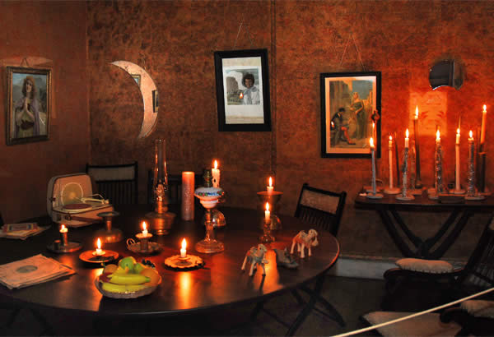](http://www.google.com/url?sa=i&rct=j&q=&esrc=s&frm=1&source=images&cd=&cad=rja&uact=8&ved=0CAcQjRw&url=http://www.ganora.co.za/listing/nieu_bethesda_helen_martins_owl_house_and_camel_yard&ei=-nsuVdW-FIXqaNHfgYAN&bvm=bv.90790515,d.ZGU&psig=AFQjCNE7ueePzL5uW0_1H4qvm3VQ_ZZ6pA&ust=1429195974827234)

1. [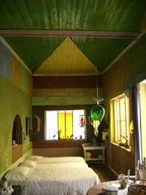](http://www.google.com/imgres?imgurl=http://onthemap.co.za/wp-content/uploads/2013/02/021713_1934_OutsiderArt2.jpg&imgrefurl=http://onthemap.co.za/outsider-art-the-owl-house-of-nieu-bethesda/&h=450&w=338&tbnid=P1FyXMT0lUkdsM:&zoom=1&docid=IZIs79OzXN2DEM&ei=4HsuVZCEK-q17gbE94HoBA&tbm=isch&ved=0CEgQMyhAMEA4yAE)[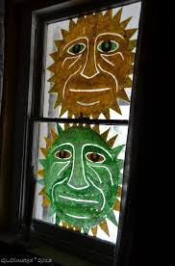](http://www.google.com/url?sa=i&rct=j&q=&esrc=s&frm=1&source=images&cd=&cad=rja&uact=8&ved=0CAcQjRw&url=http://geogypsytraveler.com/page/110/&ei=hXwuVY6sOpDxaIPsgYgK&bvm=bv.90790515,d.ZGU&psig=AFQjCNE7ueePzL5uW0_1H4qvm3VQ_ZZ6pA&ust=1429195974827234)

[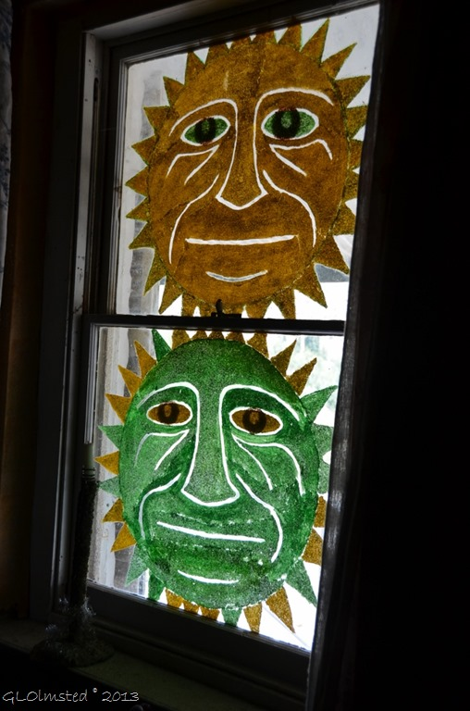](http://www.google.com/url?sa=i&rct=j&q=&esrc=s&frm=1&source=images&cd=&cad=rja&uact=8&ved=0CAcQjRw&url=http://geogypsytraveler.com/page/110/&ei=hXwuVY6sOpDxaIPsgYgK&bvm=bv.90790515,d.ZGU&psig=AFQjCNE7ueePzL5uW0_1H4qvm3VQ_ZZ6pA&ust=1429195974827234)

1. [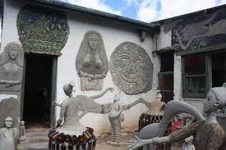](http://www.google.com/url?sa=i&rct=j&q=&esrc=s&frm=1&source=images&cd=&cad=rja&uact=8&ved=0CAcQjRw&url=http://7leagueboots.co.za/a-quick-escape-to-the-karoo/&ei=z3wuVc-gCZfhasHIgYAP&bvm=bv.90790515,d.ZGU&psig=AFQjCNE7ueePzL5uW0_1H4qvm3VQ_ZZ6pA&ust=1429195974827234)
2. [](http://www.google.com/url?sa=i&rct=j&q=&esrc=s&frm=1&source=images&cd=&cad=rja&uact=8&ved=0CAcQjRw&url=http://7leagueboots.co.za/a-quick-escape-to-the-karoo/&ei=z3wuVc-gCZfhasHIgYAP&bvm=bv.90790515,d.ZGU&psig=AFQjCNE7ueePzL5uW0_1H4qvm3VQ_ZZ6pA&ust=1429195974827234)
3. [](http://www.google.com/url?sa=i&rct=j&q=&esrc=s&frm=1&source=images&cd=&cad=rja&uact=8&ved=0CAcQjRw&url=http://geogypsytraveler.com/page/110/&ei=hXwuVY6sOpDxaIPsgYgK&bvm=bv.90790515,d.ZGU&psig=AFQjCNE7ueePzL5uW0_1H4qvm3VQ_ZZ6pA&ust=1429195974827234)

[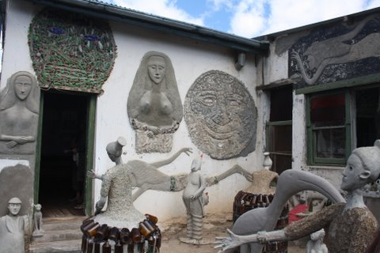](http://www.google.com/url?sa=i&rct=j&q=&esrc=s&frm=1&source=images&cd=&ved=0CAcQjRw&url=http://7leagueboots.co.za/a-quick-escape-to-the-karoo/&ei=z3wuVc-gCZfhasHIgYAP&bvm=bv.90790515,d.ZGU&psig=AFQjCNE7ueePzL5uW0_1H4qvm3VQ_ZZ6pA&ust=1429195974827234)

[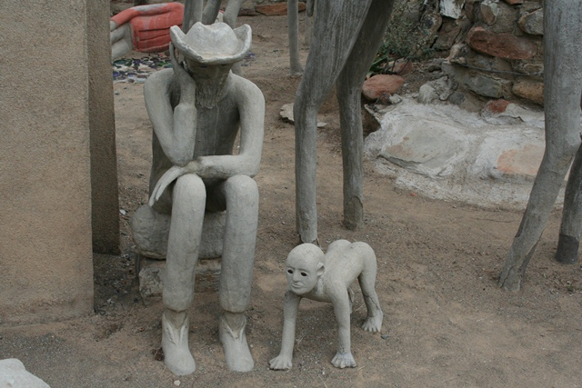](http://www.google.com/url?sa=i&rct=j&q=&esrc=s&frm=1&source=images&cd=&cad=rja&uact=8&ved=0CAcQjRw&url=http://www.karoopark.co.za/nieu-bethesda.html&ei=BH0uVcvaGM2XaqjugZgD&bvm=bv.90790515,d.ZGU&psig=AFQjCNE7ueePzL5uW0_1H4qvm3VQ_ZZ6pA&ust=1429195974827234)

[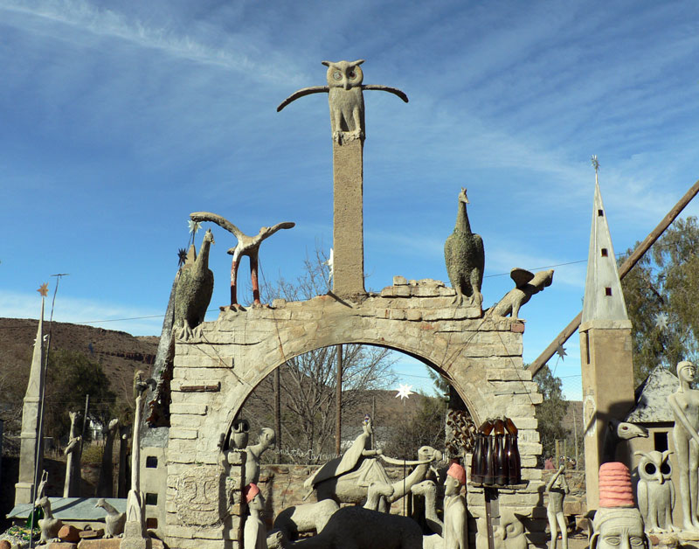](http://www.google.com/url?sa=i&rct=j&q=&esrc=s&frm=1&source=images&cd=&cad=rja&uact=8&ved=0CAcQjRw&url=http://www.safarinow.com/destinations/nieu-bethesda/galleriesandmuseums/owl-house.aspx&ei=jH0uVYeaOsP7apqNgJAK&bvm=bv.90790515,d.ZGU&psig=AFQjCNE7ueePzL5uW0_1H4qvm3VQ_ZZ6pA&ust=1429195974827234)

[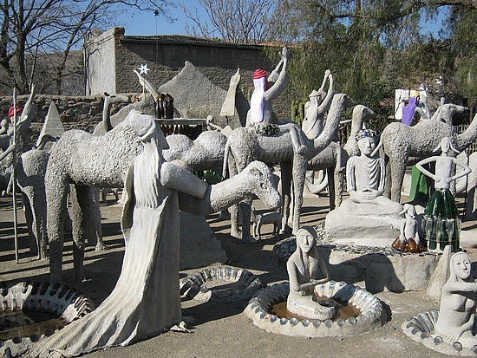](https://www.google.com/url?sa=i&rct=j&q=&esrc=s&frm=1&source=images&cd=&cad=rja&uact=8&ved=0CAcQjRw&url=https://www.pinterest.com/pin/322288917055974137/&ei=r30uVY3QBcb1ap6HgHg&bvm=bv.90790515,d.ZGU&psig=AFQjCNE7ueePzL5uW0_1H4qvm3VQ_ZZ6pA&ust=1429195974827234)

[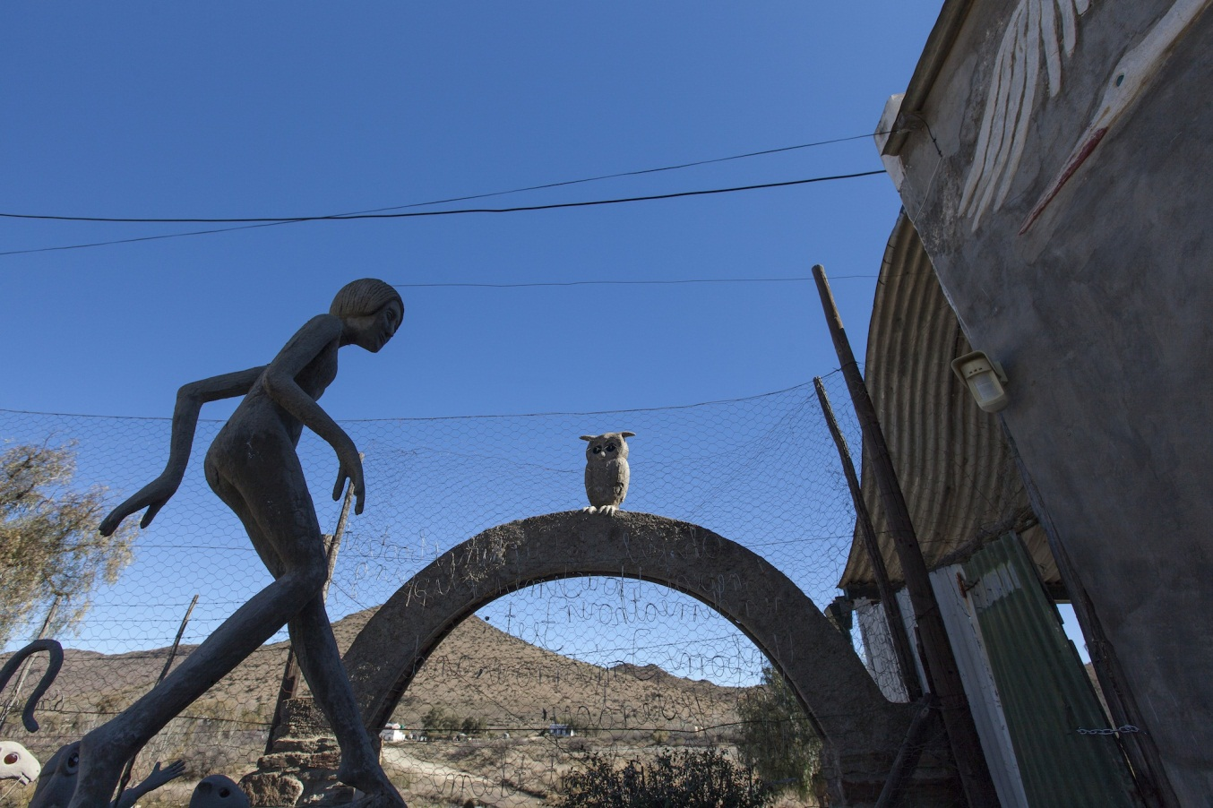](http://www.google.com/url?sa=i&rct=j&q=&esrc=s&frm=1&source=images&cd=&cad=rja&uact=8&ved=0CAcQjRw&url=http://commons.wikimedia.org/wiki/File:Sculpture_Detail,_The_Owl_House,_Nieu_Bethesda.jpg&ei=OX4uVfneA429abLMgfAE&bvm=bv.90790515,d.ZGU&psig=AFQjCNE7ueePzL5uW0_1H4qvm3VQ_ZZ6pA&ust=1429195974827234)

[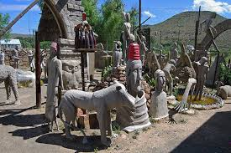](http://www.google.com/imgres?imgurl=http://www.karoo-southafrica.co.za/wp-content/uploads/2013/08/NieuBethesdaOwlHouse1.jpg&imgrefurl=http://www.karoo-southafrica.co.za/?page_id=138&h=400&w=600&tbnid=gOU-P3dSkjBauM:&zoom=1&docid=VTyfVRzyVq-BNM&ei=RnsuVdqYE9CR7AaijIDQCg&tbm=isch&ved=0CIkBEDMoYjBi)

