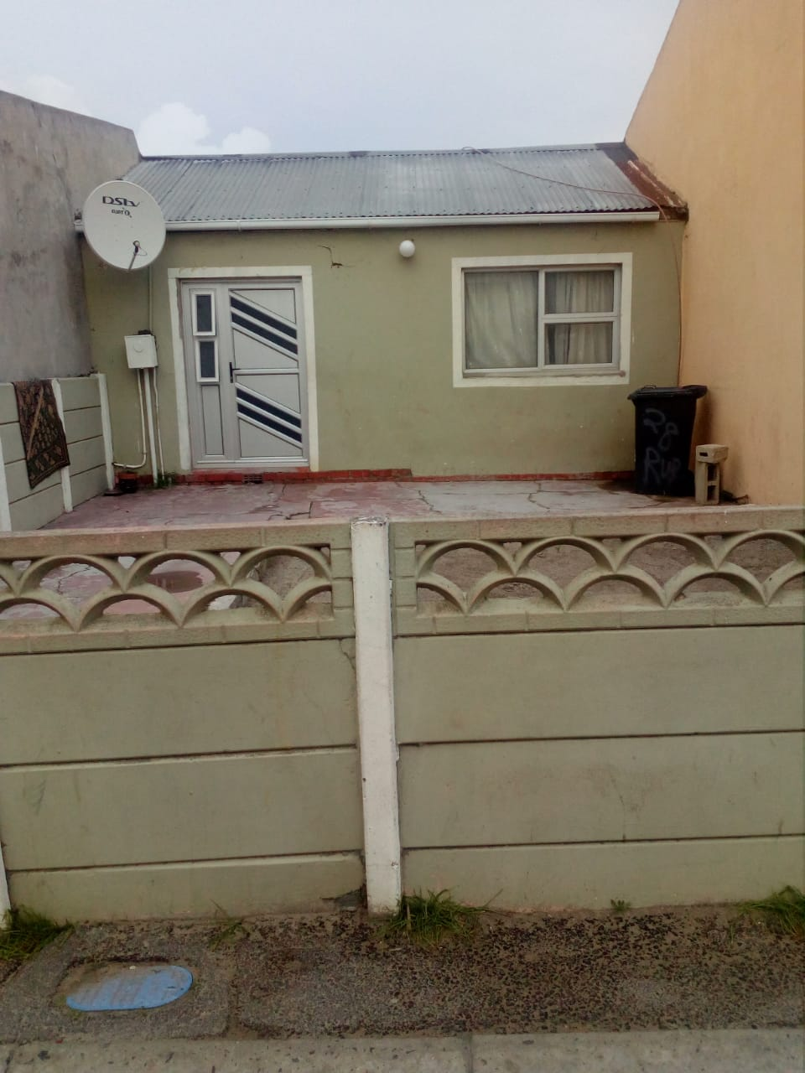
Front/ street view of the Existing Dwelling

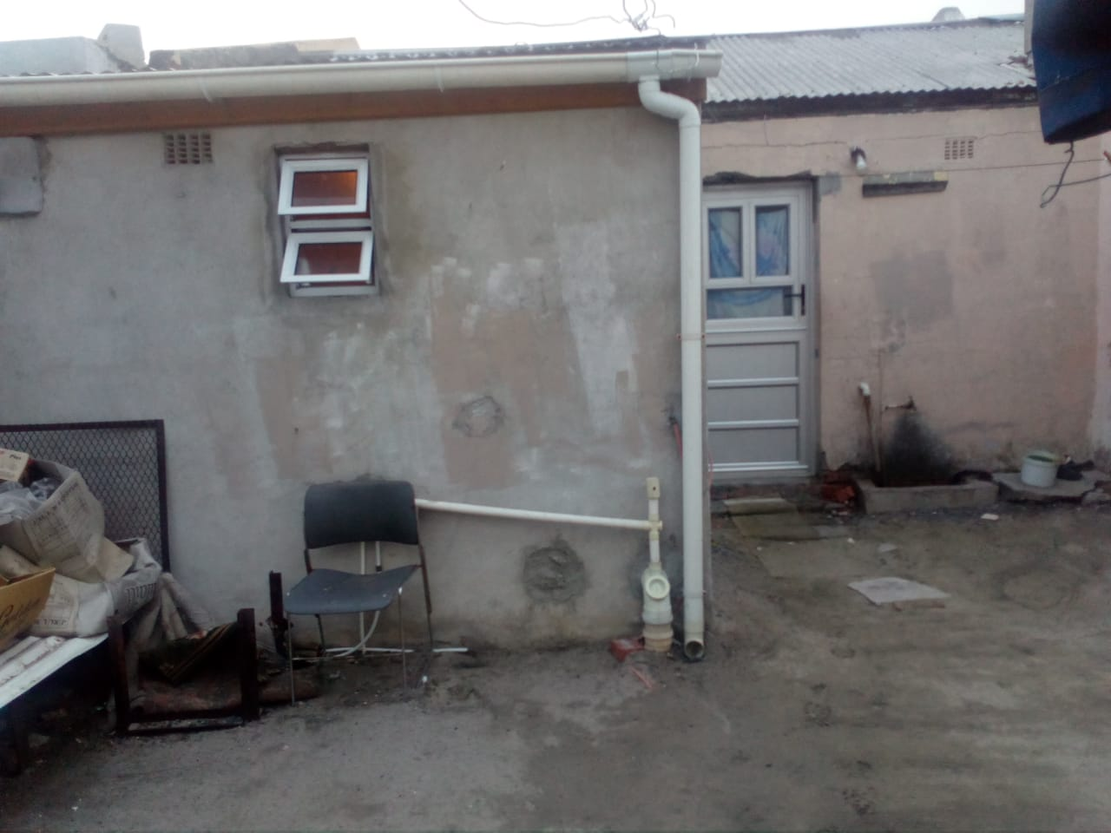 Back view of the Existing Dwelling

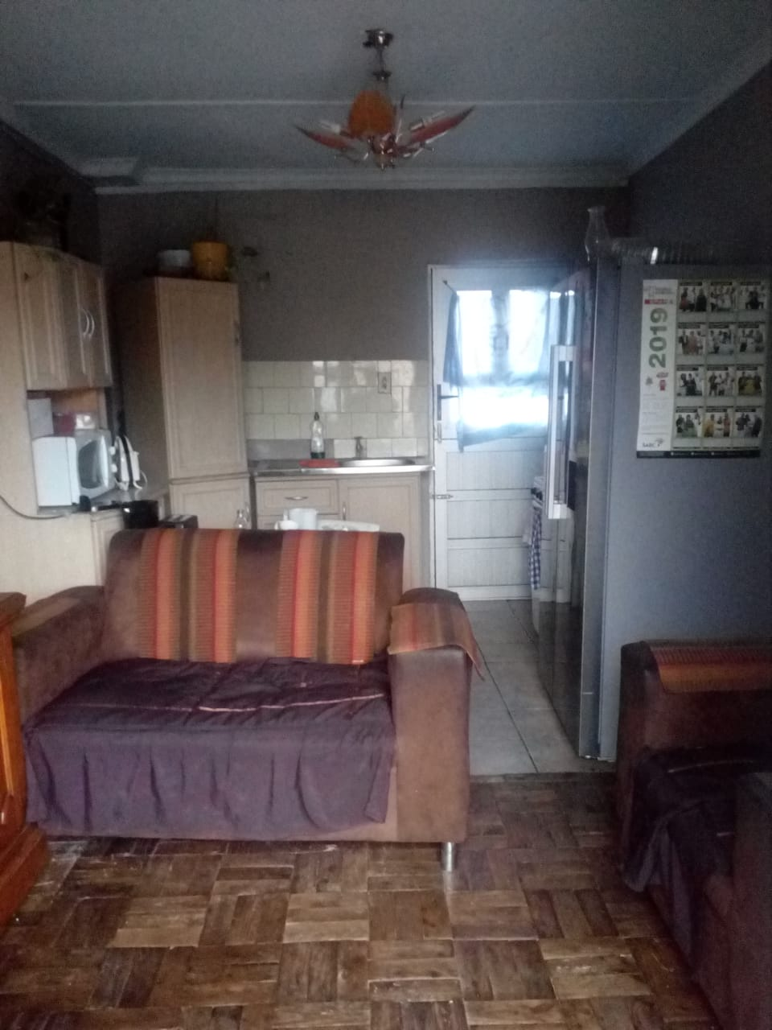
Inside View of Existing Kitchen & Dining

