Palaeontological Impact Assessment for the proposed Thabazimbi MCWAP 132 kV powerline and substation, Limpopo Province

Site Visit Report (Phase 2)

For

NCC Environmental Services (Pty) Ltd

25 March 2022

Prof Marion Bamford
Palaeobotanist
P Bag 652, WITS 2050
Johannesburg, South Africa
Marion.bamford@wits.ac.za

Expertise of Specialist

The Palaeontologist Consultant: Prof Marion Bamford
Qualifications: PhD (Wits Univ, 1990); FRSSAf, ASSAf
Experience: 33 years research; 25 years PIA studies

Declaration of Independence

This report has been compiled by Professor Marion Bamford, of the University of the Witwatersrand, sub-contracted by NCC Environmental Services (Pty) Ltd, Cape Town, South Africa. The views expressed in this report are entirely those of the author and no other interest was displayed during the decision making process for the Project.

Specialist: Prof Marion Bamford

Signature:

Executive Summary

A Palaeontological Impact Assessment was requested for the proposed construction of the Thabazimbi MCWAP 132 kV powerline and substation, Limpopo Province.

To comply with the regulations of the South African Heritage Resources Agency (SAHRA) in terms of Section 38(8) of the National Heritage Resources Act, 1999 (Act No. 25 of 1999) (NHRA), a site visit (Phase 2) Palaeontological Impact Assessment (PIA) was completed for the proposed development.

The proposed site lies mostly on non-fossiliferous rocks but a section lies on the potentially fossiliferous Malmani Subgroup (Chuniespoort Group, lower Transvaal Supergroup. These rocks might preserve trace fossils of early algal colonies such as stromatolites. The site visit walk through confirmed that there were NO FOSSILS along the powerline routes of substation footprint. Nonetheless, a Fossil Chance Find Protocol should be added to the EMPr. Based on this information it is recommended that no further palaeontological impact assessment is required unless fossils are found by the contractor, environmental officer or other designated responsible person once excavations/drilling mining activities for pole or building foundations or access roads have commenced. As far as the palaeontology is concerned, the project should be authorised.

Table of Contents

Expertise of Specialist 1
Declaration of Independence 1
1. Background 4
2. Methods and Terms of Reference 7
3. Geology and Palaeontology 7
i. Project location and geological context 7
ii. Palaeontological context 9
iii. Site visit observations …………………………………………………………………………….…….10
4. Impact assessment 12
5. Assumptions and uncertainties 13
6. Recommendation 13
7. References 14
8. Chance Find Protocol 15
9. Appendix A – Examples of fossils ………………. 16
10. Appendix B – Details of specialist 16

Figure 1: Google Earth map of the project area ……… …………….. 6
Figure 2: Google Earth Map of the project footprint ……………………..……………………………. 6
Figure 3: Geological map of the area around the project site…………. 7
Figure 4: SAHRIS palaeosensitivity map for the site for the project …………… 10
Figure 5: Site visit photographs ……………………………………………………………………..……….. 11

Background

The construction of a +/- 12km 132kV power line from Thabazimbi combined to a new MCWAP Substation, Thabazimbi, Limpopo Province requires an environmental impact assessment. Herein is the palaeontological aspect of this project.

The Scope of Work for the project is as follows (Figures 1, 2):
• Construct 100 x 100 m (1 Hectare) of 2 x 20 MVA 132kV MCWAP new substation (Study Buffer zone of 2 Hectare)
• Install 2 x 20 MVA 132/11kV fully equipped transformer bays, 132kV busbar, and 2 x 132 kV line bays (one equipped initially with the other for future use)
• Build a control room adequate to cater for all secondary plant equipment
• Construct 12km of 132 kV Kingbird Power line (Study Corridor for 1km of which will be 500m from the centre of the power line on both sites)
• Build Access road of 6m width and 200m length.

The substation will be on Farm Mooivlei 342 (Nooitgedacht) and the powerline route runs alongside a farm track to the main road. Thereafter the powerline route is adjacent to the main road.

A Palaeontological Impact Assessment was requested for the substation and powerline project. To comply with the regulations of the South African Heritage Resources Agency (SAHRA) in terms of Section 38(8) of the National Heritage Resources Act, 1999 (Act No. 25 of 1999) (NHRA), a site visit and walkthrough (Phase 2) Palaeontological Impact Assessment (PIA) was completed for the proposed development and is reported herein.

Table 1: Specialist report requirements in terms of Appendix 6 of the EIA Regulations (amended 2017)

 | A specialist report prepared in terms of the Environmental Impact Regulations of 2017 must contain: | Relevant section in report
ai | Details of the specialist who prepared the report | Appendix B
aii | The expertise of that person to compile a specialist report including a curriculum vitae | Appendix B
b | A declaration that the person is independent in a form as may be specified by the competent authority | Page 1
c | An indication of the scope of, and the purpose for which, the report was prepared | Section 1
ci | An indication of the quality and age of the base data used for the specialist report: SAHRIS palaeosensitivity map accessed – date of this report | Yes
cii | A description of existing impacts on the site, cumulative impacts of the proposed development and levels of acceptable change | Section 5
d | The date and season of the site investigation and the relevance of the season to the outcome of the assessment | N/A
e | A description of the methodology adopted in preparing the report or carrying out the specialised process | Section 2
f | The specific identified sensitivity of the site related to the activity and its associated structures and infrastructure | Section 4
g | An identification of any areas to be avoided, including buffers | N/A
h | A map superimposing the activity including the associated structures and infrastructure on the environmental sensitivities of the site including areas to be avoided, including buffers; | N/A
i | A description of any assumptions made and any uncertainties or gaps in knowledge; | Section 5
j | A description of the findings and potential implications of such findings on the impact of the proposed activity, including identified alternatives, on the environment | Section 4
k | Any mitigation measures for inclusion in the EMPr | Section 8, Appendix A
l | Any conditions for inclusion in the environmental authorisation | N/A
m | Any monitoring requirements for inclusion in the EMPr or environmental authorisation | Section 8, Appendix A
ni | A reasoned opinion as to whether the proposed activity or portions thereof should be authorised | Section 6
nii | If the opinion is that the proposed activity or portions thereof should be authorised, any avoidance, management and mitigation measures that should be included in the EMPr, and where applicable, the closure plan | Sections 6, 8
o | A description of any consultation process that was undertaken during the course of carrying out the study | N/A
p | A summary and copies if any comments that were received during any consultation process | N/A
q | Any other information requested by the competent authority. | N/A

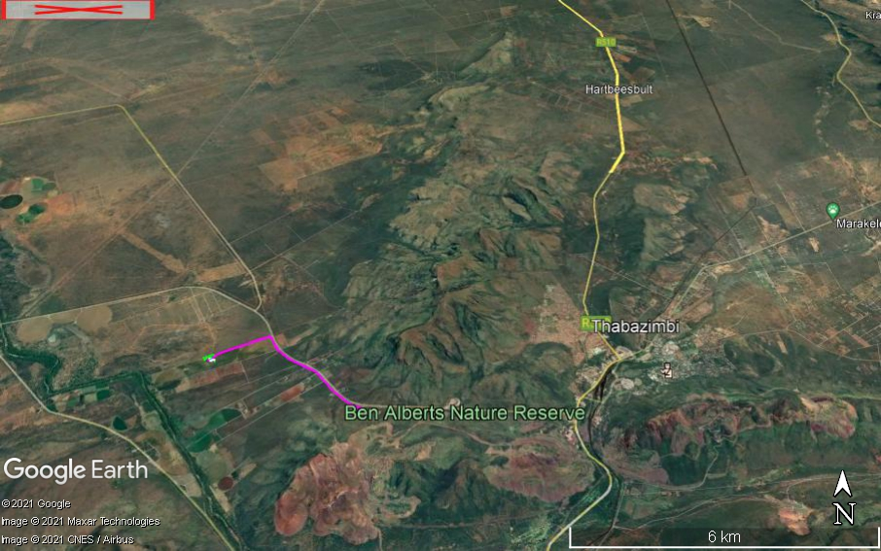
Figure 1: Google Earth map of the proposed Thabazimbi MCWAP 132 kV powerline (purple line) and Substation (green) showing the relevant land marks.

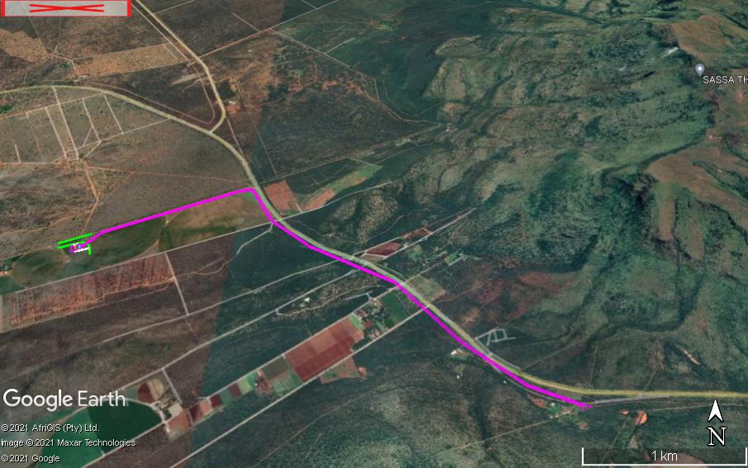
Figure 2: Google Earth map of the proposed Thabazimbi MCWAP project (colours as for Fig 1). Note that the powerline is mostly along existing roads.

Methods and Terms of Reference
The Terms of Reference (ToR) for this study were to undertake a PIA and provide feasible management measures to comply with the requirements of SAHRA.
The methods employed to address the ToR included:
- Consultation of geological maps, literature, palaeontological databases, published and unpublished records to determine the likelihood of fossils occurring in the affected areas. Sources included records housed at the Evolutionary Studies Institute at the University of the Witwatersrand and SAHRA databases;
- Where necessary, site visits by a qualified palaeontologist to locate any fossils and assess their importance, as is the case here;
- Where appropriate, collection of unique or rare fossils with the necessary permits for storage and curation at an appropriate facility (not applicable to this assessment); and
- Determination of fossils’ representivity or scientific importance to decide if the fossils can be destroyed or a representative sample collected (not applicable to this assessment).

Geology and Palaeontology

Project location and geological context

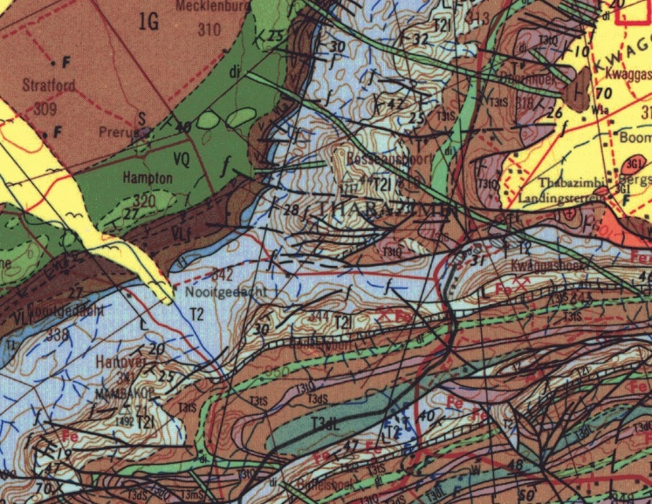
Figure 3: Geological map of the area around the Thabazimbi MCWAP project with the route indicated by the yellow line. Abbreviations of the rock types are explained in Table 2. Map enlarged from the Geological Survey 1: 250 000 map 2426 Thabazimbi.

Table 2: Explanation of symbols for the geological map and approximate ages (Eriksson et al., 2006. Johnson et al., 2006; Robb et al., 2006). SG = Supergroup; Fm = Formation; Ma = million years; grey shading = formations impacted by the project.

Symbol | Group/Formation | Lithology | Approximate Age
Q | Quaternary | Alluvium, sand | Neogene, ca 2.5 Ma to present
Jd | Jurassic dykes | Dolerite dykes, intrusive | Jurassic, approx. 180 Ma
T3dL/Vda | Daspoort Fm, Pretoria Group, Transvaal SG | Shales, sandstone, coal | Early Permian, Middle Ecca
T3tS/Vt | Timeball Hill Fm Pretoria Group, Transvaal SG | Quartzite; andesitic lava; quartzite | < 2420 Ma
T1/Vbr | Black Reef Fm, Transvaal SG | Quartzite, conglomerate, shale, basalt | Ca 2650 – 2640 Ma
T2/Vm | Malmani Subgroup, Chuniespoort Group, Transvaal SG | Dolomite, chert | Ca 2750 – 2650 Ma
1G | Western Transvaal Archaean | Granite, granite-gneiss | Ca 3100 Ma

The site lies in the northern margin of the Transvaal Basin where the basal rocks of the Transvaal Supergroup are exposed, on the contact with the much older Archaean granites.

The Transvaal Supergroup comprises one of world’s earliest carbonate platform successions (Beukes, 1987; Eriksson et al., 2006; Zeh et al., 2020). In some areas there are well preserved stromatolites that are evidence of the photosynthetic activity of blue green bacteria and green algae. These microbes formed colonies in warm, shallow seas.

In the Transvaal Basin the Transvaal Supergroup is divided into two Groups, the lower Chuniespoort Group and the upper Pretoria Group (with ten formations; Eriksson et al., 2006). The Chuniespoort Group is divided into the basal Malmani Subgroup that comprises dolomites and limestones and is divided into five formations based on chert content, stromatolitic morphology, intercalated shales and erosion surfaces. The top of the Chuniespoort Group has the Penge Formation and the Duitschland Formation.

Making up the lower Pretoria Group are the Timeball Hill Formation and the Boshoek Formation. The Hekpoort, Dwaalheuwel, Strubenkop and Daspoort Formations form a sequence as the middle part of the Pretoria Group, Transvaal Supergroup, and represent rocks that are over 2060 million years old. The Hekpoort Formation is a massive lava deposit and is overlain by the Dwaalheuwel conglomerates, siltstone and sandstone (not present here). A hiatus separates the Strubenkop Formation slates and shales from the overlying quartzites of the Daspoort Formation. Upper Pretoria Group formations are the Silverton, Magaliesberg, Vermont, Lakenvalei, Nederhorst, Steenkampsberg and Houtenbek Formations

The Transvaal sequence has been interpreted as three major cycles of basin infill and tectonic activity with the first deep basin sediments forming the Chuniespoort Group, the second cycle deposited the lower Pretoria Group, and the sediments in this area are from the interim lowstand that preceded the third cycle. These sediments were deposited in shallow lacustrine, alluvial fan and braided stream environments (Eriksson et al., 2012).

Palaeontological context
The palaeontological sensitivity of the area under consideration is presented in Figure 4. The site for the substation is in the non-fossiliferous Daspoort Formation (blue) on the map, and also on the very highly sensitive (red) Malmani Subgroup.

The Malmani Subgroup is up to 2000m thick and has been divided into five formations based on the composition of cherts, stromatolites, limestones and shales. At the base, overlying the Black Reef Formation, is the Oaktree Formation that represents a transition from siliciclastic sedimentation to platform carbonates (Eriksson et al., 2006). It is composed of carbonaceous shales, stromatolitic dolomites and locally developed quartzites. Next is the Monte Christo Formation that has an erosive breccia base and continues with stromatolitic and oolitic platformal dolomites. Above that is the Lyttleton Formation that is composed of shales, quartzites and stromatolitic dolomites. The overlying Eccles Formation includes a series of erosion breccias that locally contain gold deposits. This mineralisation has been attributed to hydrothermal remobilisation of fluids by the Bushveld complex (Eriksson et al., 2006). The topmost formation is the Frisco Formation that is composed mainly of stromatolitic dolomites but these become more shale rich towards the top of the sequence because of the deepening depositional environment.

In the Thabazimbi part of the basin the formations of the Malmani Subgroup are not distinguishable, most likely because of the lack of fossils. The Malmani Subgroup represents an extensive carbonate platform that was formed as result of the Great Oxidation Event (Palaeoproterozoic, ca 2 400 Ma). This marked the onset of a large-scale oxygen-producing photosynthesis that sequestered large quantities of ¹²C from the inorganic ocean–atmosphere reservoir into sedimentary organic matter. This, in turn, generated the atmospheric reservoir of O₂, and a complementary residual oceanic reservoir of carbon that was enriched in ¹³C. Algal colonies were the source of the oxygen and they formed stromatolites that layer upon layer of minerals precipitated by the algae. No algal cells are preserved but the stromatolites are and these are considered as trace fossils and so are protected. Rarely one can find organic matter in the stromatolites and associated algal mats but the biogenicity of the latter has been challenged (Burne and Moore, 1987; but see Noffke et al, 2001).

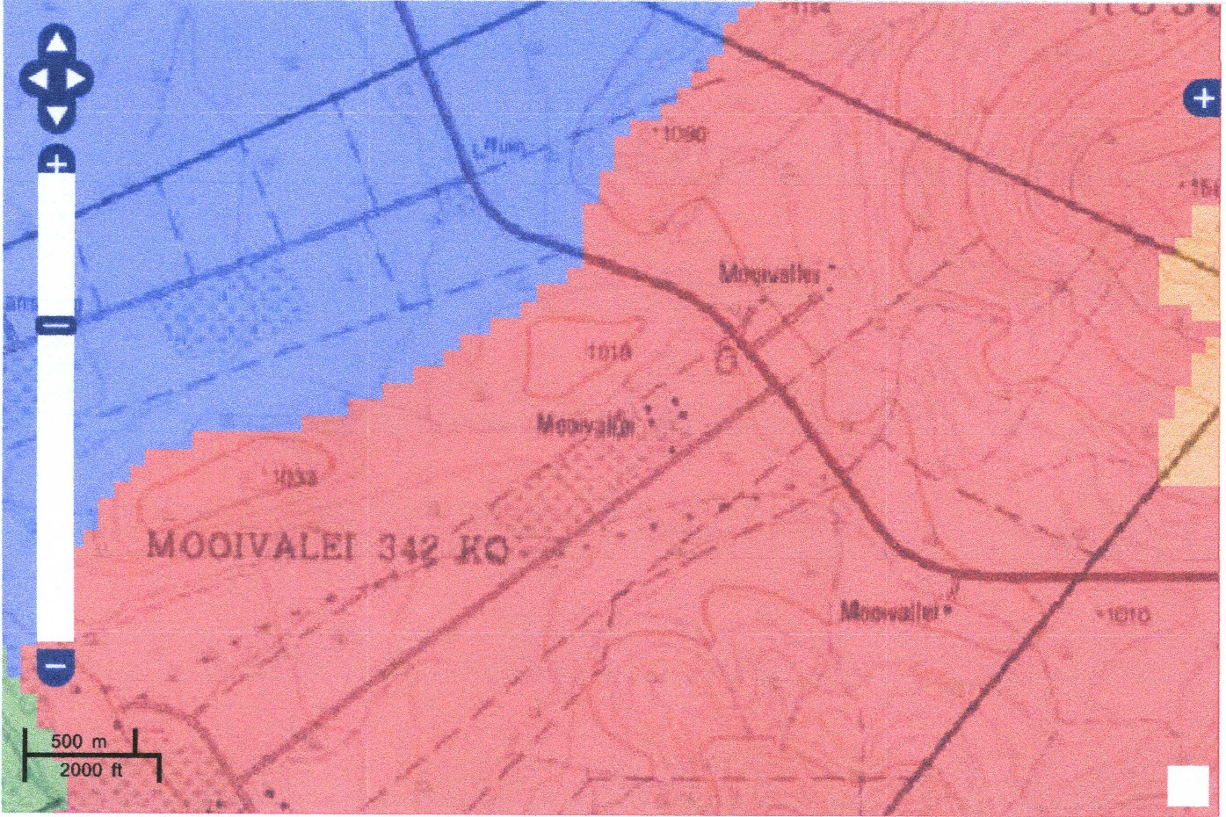
Figure 4: SAHRIS palaeosensitivity map for the site for the proposed Thabazimbi MCWAP 132 kV substation and powerline shown with the red block and yellow line respectively. Background colours indicate the following degrees of sensitivity: red = very highly sensitive; orange/yellow = high; green = moderate; blue = low; grey = insignificant/zero.

Site visit observations
The substation and powerline route plus corridor were walked through. The former is in farmlands and no rocks or fossils were visible. Along the main road the route is also disturbed and very few rocky outcrops were visible. These were quartzites only, no dolomite and no stromatolites were present (Figure 5). The loose pebbles were composed of quartzites too. It can be confirmed that there are NO FOSSILS were found along the project site and route. Note the dense vegetation that is indicative of deeper soils over much of the area.
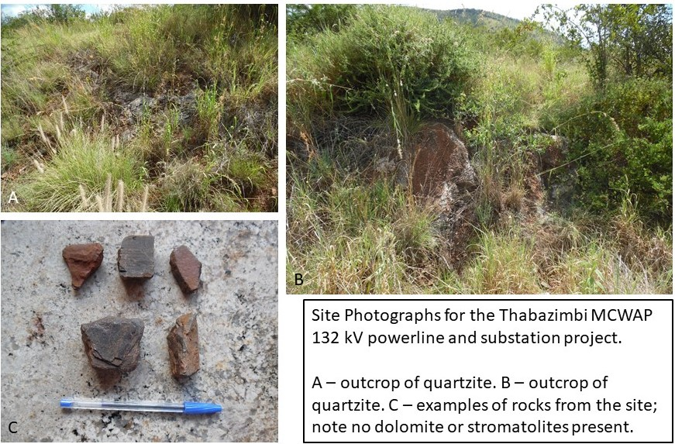Figure 5

Impact assessment
An assessment of the potential impacts to possible palaeontological resources considers the criteria encapsulated in Table 4:

Table 4a: Criteria for assessing impacts
PART A: DEFINITION AND CRITERIA
Criteria for ranking of the SEVERITY/NATURE of environmental impacts | H | Substantial deterioration (death, illness or injury). Recommended level will often be violated. Vigorous community action.
 | M | Moderate/ measurable deterioration (discomfort). Recommended level will occasionally be violated. Widespread complaints.
 | L | Minor deterioration (nuisance or minor deterioration). Change not measurable/ will remain in the current range. Recommended level will never be violated. Sporadic complaints.
 | L+ | Minor improvement. Change not measurable/ will remain in the current range. Recommended level will never be violated. Sporadic complaints.
 | M+ | Moderate improvement. Will be within or better than the recommended level. No observed reaction.
 | H+ | Substantial improvement. Will be within or better than the recommended level. Favourable publicity.
Criteria for ranking the DURATION of impacts | L | Quickly reversible. Less than the project life. Short term
 | M | Reversible over time. Life of the project. Medium term
 | H | Permanent. Beyond closure. Long term.
Criteria for ranking the SPATIAL SCALE of impacts | L | Localised - Within the site boundary.
 | M | Fairly widespread – Beyond the site boundary. Local
 | H | Widespread – Far beyond site boundary. Regional/ national
PROBABILITY  (of exposure to impacts) | H | Definite/ Continuous
 | M | Possible/ frequent
 | L | Unlikely/ seldom

Table 4b: Impact Assessment
PART B: Assessment
SEVERITY/NATURE | H | -
 | M | -
 | L | Quartzites do not preserve plant fossils; so far there are no records from the Malmani Subgroup of trace fossils such as stromatolites so it is very unlikely that fossils occur on the site. The impact would be very unlikely.
 | L+ | -
 | M+ | -
 | H+ | -
DURATION | L | -
 | M | -
 | H | Where manifest, the impact will be permanent.
SPATIAL SCALE | L | Since the only possible fossils within the area would be trace fossils such as stromatolites in the dolomites of the Malmani Subgroup, the spatial scale will be localised within the site boundary.
 | M | -
 | H | -
PROBABILITY | H | -
 | M | -
 | L | It is extremely unlikely that any fossils would be found in the soils or loose sand that will be excavated for foundations. No fossils are visible on the surface. Nonetheless, a Fossil Chance Find Protocol should be added to the eventual EMPr.

Based on the nature of the project, surface activities may impact upon the fossil heritage if preserved in the development footprint. The geological structures suggest that the rocks are the correct age and type to preserve fossils. The site visit and walk through confirmed that there were NO FOSSILS in the project footprint. Furthermore, the material to be excavated are soils and sands and they do not preserve fossils. Since there is an extremely small chance that trace fossils from Malmani Subgroup may occur below ground and may be disturbed a Fossil Chance Find Protocol has been added to this report. Taking account of the defined criteria, the potential impact to fossil heritage resources is extremely low.

Assumptions and uncertainties
Based on the geology of the area and the palaeontological record as we know it, it can be assumed that the formation and layout of the dolomites, sandstones, shales and sands are typical for the country and some might contain trace fossils, fossil plant, insect, invertebrate and vertebrate material. The site visit and walk through confirmed that there are NO FOSSILS such as stromatolites or microbial mats along the routes or the substation site. The sands of the Quaternary period would not preserve fossils. It is not known if there are fossils below the soils.

Recommendation
Based on the fossil record but confirmed by the site visit and walk through there are NO FOSSILS of stromatolites or microbial mats in the project footprint even though fossils have been recorded from rocks of a similar age and type in South Africa. It is extremely unlikely that any fossils would be preserved in the overlying soils and sands of the Quaternary. There is a very small chance that fossils may occur in below the ground surface so a Fossil Chance Find Protocol should be added to the EMPr. If fossils are found by the contractor, environmental officer, or other responsible person once excavations and drilling have commenced, then they should be rescued and a palaeontologist called to assess and collect a representative sample.

References

Beukes, N.J., 1987. Facies relations, depositional environments and diagenesis in a major early Proterozoic stromatolitic carbonate platform to basinal sequence, Campbellrand Subgroup, Transvaal Supergroup, southern Africa. Sedimentary Geology 54, 1-46.

Burne, R.V., Moore, L.S., 1987. Microbialites; organosedimentary deposits of benthic microbial communities Palaios 2(3), 241-254.

Eriksson, P.G., Altermann, W., Hartzer, F.J., 2006. The Transvaal Supergroup and its pre-cursors. In: Johnson, M.R., Anhaeusser, C.R. and Thomas, R.J., (Eds). The Geology of South Africa. Geological Society of South Africa, Johannesburg / Council for Geoscience, Pretoria. pp 237-260.

Eriksson, P.G., Bartman, R., Catuneanu, O., Mazumder, R., Lenhardt, N., 2012. A case study of microbial mats-related features in coastal epeiric sandstones from the Palaeoproterozoic Pretoria Group, Transvaal Supergroup, Kaapvaal craton, South Africa; the effect of preservation (reflecting sequence stratigraphic models) on the relationship between mat features and inferred palaeoenvironment. Sedimentary Geology 263, 67-75.

Johnson, M.R., van Vuuren, C.J., Visser, J.N.J., Cole, D.I., Wickens, H.deV., Christie, A.D.M., Roberts, D.L., Brandl, G., 2006. Sedimentary rocks of the Karoo Supergroup. In: Johnson, M.R., Anhaeusser, C.R. and Thomas, R.J., (Eds). The Geology of South Africa. Geological Society of South Africa, Johannesburg / Council for Geoscience, Pretoria. Pp 461 – 499.

Noffke, N., Gerdes, G., Klenke, T., Krumbein, W., 2001. Microbially induced sedimentary structures – a new category within the classification of primary sedimentary structures. Journal of Sedimentary Research, 71, 649–656.

Plumstead, E.P., 1969. Three thousand million years of plant life in Africa. Geological Society of southern Africa, Annexure to Volume LXXII. 72pp + 25 plates.

Robb, L.J., Brandl, G., Anhaeusser, C.R., Poujol, M., 2006. Archaean Granitoid Intrusions. In: Johnson, M.R., Anhaeusser, C.R. and Thomas, R.J., (Eds). The Geology of South Africa. Geological Society of South Africa, Johannesburg / Council for Geoscience, Pretoria. Pp 57-94.

Zeh, A., Wilson, A.H., Gerdes, A., 2020. Zircon U-Pb-Hf isotope systematics of Transvaal Supergroup – Constraints for the geodynamic evolution of the Kaapvaal Craton and its hinterland between 2.65 and 2.06 Ga. Precambrian Research 345, 105760.
https://doi.org/10.1016/j.precamres.2020.105760.

Chance Find Protocol
Monitoring Programme for Palaeontology – to commence once the excavations / drilling activities begin.

- The following procedure is only required if fossils are seen on the surface and when drilling/excavations commence.
- When excavations begin the rocks and must be given a cursory inspection by the environmental officer or designated person. Any fossiliferous material (trace fossils, fossils of plants, insects, bone or coalified material) should be put aside in a suitably protected place. This way the project activities will not be interrupted.
- Photographs of similar fossils must be provided to the developer to assist in recognizing the fossil plants, vertebrates, invertebrates or trace fossils in the shales and mudstones (for example see Figure 6). This information will be built into the EMP’s training and awareness plan and procedures.
- Photographs of the putative fossils can be sent to the palaeontologist for a preliminary assessment.
- If there is any possible fossil material found by the developer/environmental officer then the qualified palaeontologist sub-contracted for this project, should visit the site to inspect the selected material and check the dumps where feasible.
- Fossil plants or vertebrates that are considered to be of good quality or scientific interest by the palaeontologist must be removed, catalogued and housed in a suitable institution where they can be made available for further study. Before the fossils are removed from the site a SAHRA permit must be obtained. Annual reports must be submitted to SAHRA as required by the relevant permits.
- If no good fossil material is recovered then no site inspections by the palaeontologist will be necessary. A final report by the palaeontologist must be sent to SAHRA once the project has been completed and only if there are fossils.
- If no fossils are found and the excavations have finished then no further monitoring is required.

Appendix A – Examples of fossils from the Malmani Subgroup

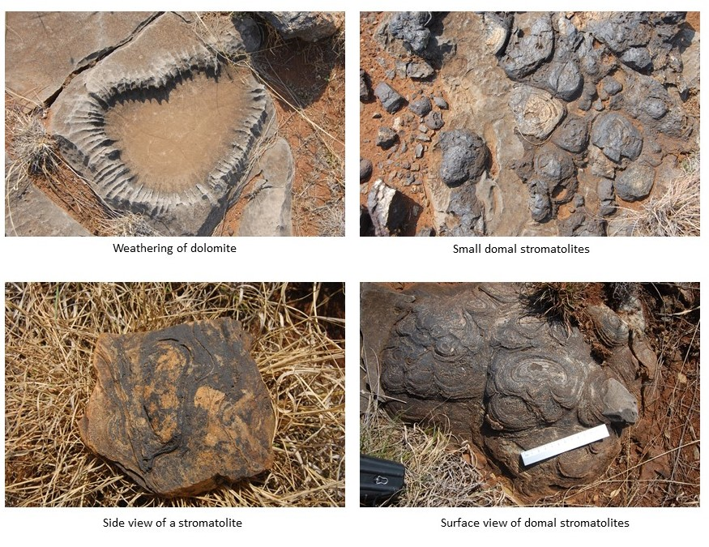
Figure 6: Photographs of stromatolites as seen in the field.

Appendix B – Details of specialists

Marion Bamford (PhD)
Short CV for PIAs – Jan 2022

I) Personal details
Present employment : Professor; Director of the Evolutionary Studies Institute.
Member Management Committee of the NRF/DST Centre of
Excellence Palaeosciences, University of the Witwatersrand,
Johannesburg, South Africa
Telephone : +27 11 717 6690
Fax : +27 11 717 6694
Cell : 082 555 6937
E-mail : marion.bamford@wits.ac.za ;
marionbamford12@gmail.com

ii) Academic qualifications
Tertiary Education: All at the University of the Witwatersrand:
1980-1982: BSc, majors in Botany and Microbiology. Graduated April 1983.
1983: BSc Honours, Botany and Palaeobotany. Graduated April 1984.
1984-1986: MSc in Palaeobotany. Graduated with Distinction, November 1986.
1986-1989: PhD in Palaeobotany. Graduated in June 1990.

iii) Professional qualifications
Wood Anatomy Training (overseas as nothing was available in South Africa):
1994 - Service d’Anatomie des Bois, Musée Royal de l’Afrique Centrale, Tervuren, Belgium, by Roger Dechamps
1997 - Université Pierre et Marie Curie, Paris, France, by Dr Jean-Claude Koeniguer
1997 - Université Claude Bernard, Lyon, France by Prof Georges Barale, Dr Jean-Pierre Gros, and Dr Marc Philippe

iv) Membership of professional bodies/associations
Palaeontological Society of Southern Africa
Royal Society of Southern Africa - Fellow: 2006 onwards
Academy of Sciences of South Africa - Member: Oct 2014 onwards
International Association of Wood Anatomists - First enrolled: January 1991
International Organization of Palaeobotany – 1993+
Botanical Society of South Africa
South African Committee on Stratigraphy – Biostratigraphy - 1997 - 2016
SASQUA (South African Society for Quaternary Research) – 1997+
PAGES - 2008 –onwards: South African representative
ROCEEH / WAVE – 2008+
INQUA – PALCOMM – 2011+onwards

vii) Supervision of Higher Degrees
All at Wits University
Degree | Graduated/completed | Current
Honours | 11 | 0
Masters | 12 | 4
PhD | 11 | 4
Postdoctoral fellows | 12 | 2

viii) Undergraduate teaching
Geology II – Palaeobotany GEOL2008 – average 65 students per year
Biology III – Palaeobotany APES3029 – average 25 students per year
Honours – Evolution of Terrestrial Ecosystems; African Plio-Pleistocene Palaeoecology; Micropalaeontology – average 12 - 20 students per year.

ix) Editing and reviewing
Editor: Palaeontologia africana: 2003 to 2013; 2014 – Assistant editor
Guest Editor: Quaternary International: 2005 volume
Member of Board of Review: Review of Palaeobotany and Palynology: 2010 –
Associate Editor: Cretaceous Research: 2018-2020
Associate Editor: Royal Society Open: 2021 -
Review of manuscripts for ISI-listed journals: 25 local and international journals

x) Palaeontological Impact Assessments
Selected from recent project only – list not complete:
• Mala Mala 2017 for Henwood
• Modimolle 2017 for Green Vision
• Klipoortjie and Finaalspan 2017 for Delta BEC
• Ledjadja borrow pits 2018 for Digby Wells
• Lungile poultry farm 2018 for CTS
• Olienhout Dam 2018 for JP Celliers
• Isondlo and Kwasobabili 2018 for GCS
• Kanakies Gypsum 2018 for Cabanga
• Nababeep Copper mine 2018
• Glencore-Mbali pipeline 2018 for Digby Wells
• Remhoogte PR 2019 for A&HAS
• Bospoort Agriculture 2019 for Kudzala
• Overlooked Quarry 2019 for Cabanga
• Richards Bay Powerline 2019 for NGT
• Eilandia dam 2019 for ACO
• Eastlands Residential 2019 for HCAC
• Fairview MR 2019 for Cabanga
• Graspan project 2019 for HCAC
• Lieliefontein N&D 2019 for Enviropro
• Skeerpoort Farm Mast 2020 for HCAC
• Vulindlela Eco village 2020 for 1World
• KwaZamakhule Township 2020 for Kudzala
• Sunset Copper 2020 for Digby Wells
• McCarthy-Salene 2020 for Prescali
• VLNR Lodge 2020 for HCAC
• Madadeni mixed use 2020 for Enviropro
• Frankfort-Windfield Eskom Powerline 2020 for 1World
• Beaufort West PV Facility 2021 for ACO Associates
• Copper Sunset MR 2021 for Digby Wells
• Sannaspos PV facility 2021 for CTS Heritage
• Smithfield-Rouxville-Zastron PL 2021 for TheroServe
• Glosam Mine 2021 for AHSA

Xi) Research Output
Publications by M K Bamford up to January 2022 peer-reviewed journals or scholarly books: over 160 articles published; 5 submitted/in press; 10 book chapters.
Scopus h-index = 30; Google Scholar h-index = 36; -i10-index = 95
Conferences: numerous presentations at local and international conferences.

