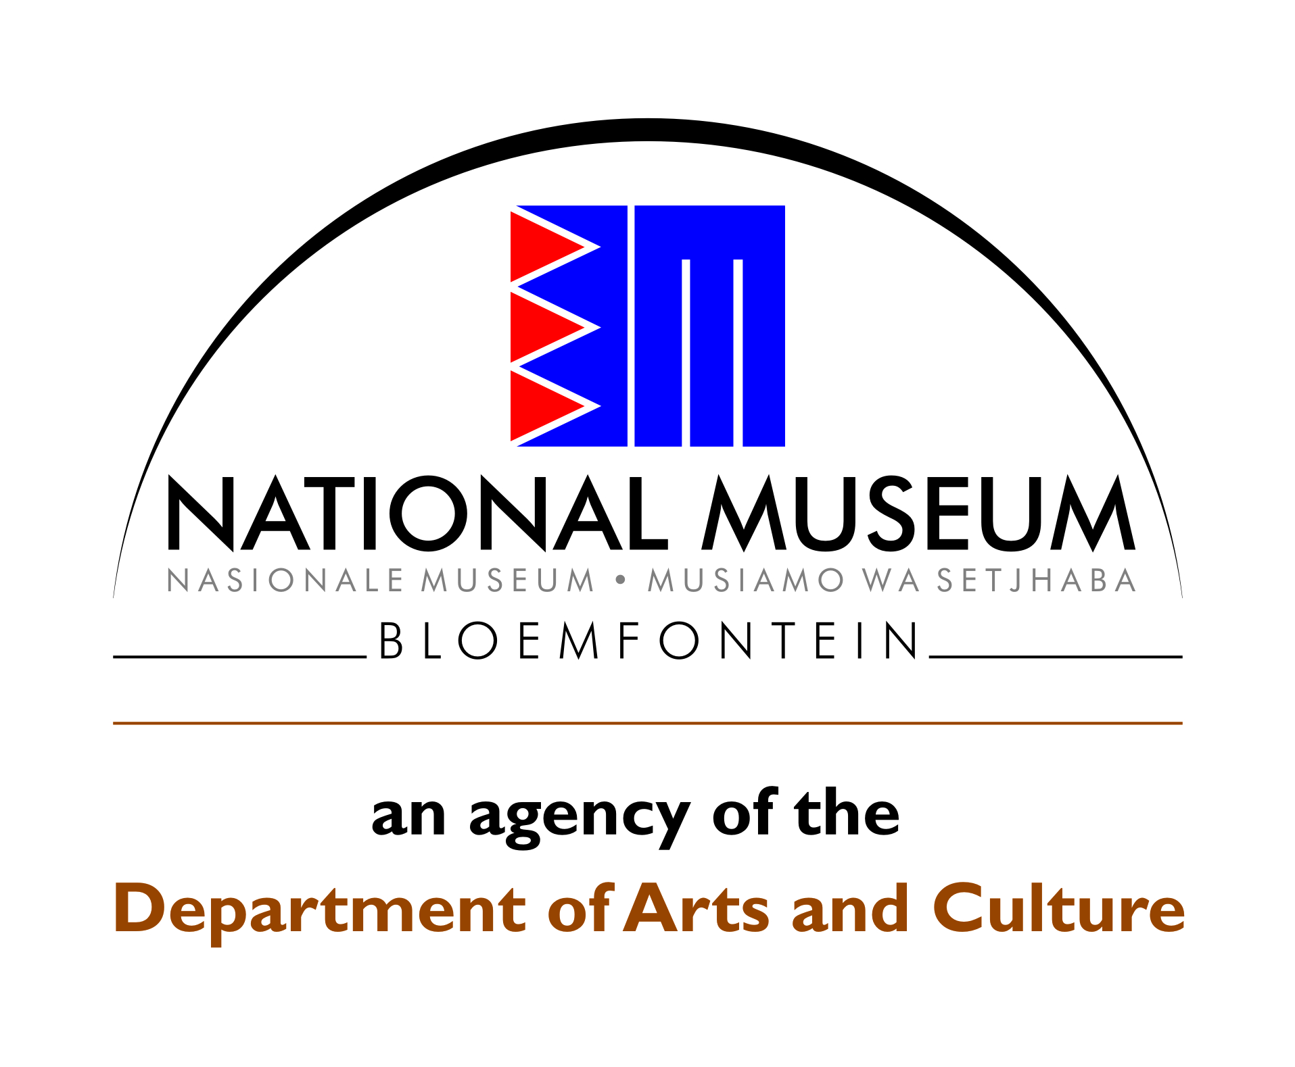
Department of Archaeology and Anthropology
P.O. Box 266 / 36 Aliwal Street
Bloemfontein
9300 / 9301

Tel.nr. 051-447 9609
Fax nr. 051-447 8043

Email: gerda.coetzee@nasmus.co.za

19 April 2018
Phillip Hine
SAHRA
P.O. Box 4637
CAPE TOWN
8000

Dear Phillip,

APPLICATION FOR AMENDMENT TO CASE ID 11272 / PERMIT ID 2581
TREKBOER RESEARCH PROJECT: ARCHAEOLOGICAL FIELDWORK ON THE FARM MOOIFONTEIN, PORTION 9 OF THE FARM MORGENWACHT 109, COLESBERG DISTRICT, NORTHERN CAPE

Your letter dated 24 August 2017 refers:

The permit that was issued by your office only allows for excavations at three middens. I would like to apply for an amendment to this restriction based on the following:

- Surveying of the site during September 2017 revealed a much larger site than initially anticipated.
- There are a large number of middens scattered across the site, some flowing into each other making it difficult to determine strict lines or boundaries for these middens.
- The site is very old, containing foundations from the early 1800s onwards, which are mostly undisturbed by human activities. Archival records indicate that there were already trekboers on the farm in 1809. This means that the site provides the unique opportunity to gain more information about these early inhabitants by excavating some of the foundations and determining the functions of various structures.
- The site also contains artefacts of three different groups, namely the Khoi-San, the Boers and the British during the Anglo-Boer (South African) War. The presence of slaves is also a strong possibility but this will require more data for analysis and verification.

I would therefore like to request permission to amend the permit to allow for excavations of a representative sample of the identified middens as well as for the excavation of foundations or walls that could provide deeper insight into their purpose as well as activities conducted by the farmstead’s inhabitants.

Kind regards

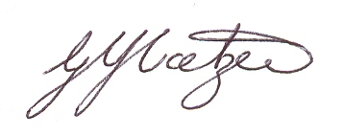

Gerda Coetzee

