RoRo Terminal (Car Terminal) Durban
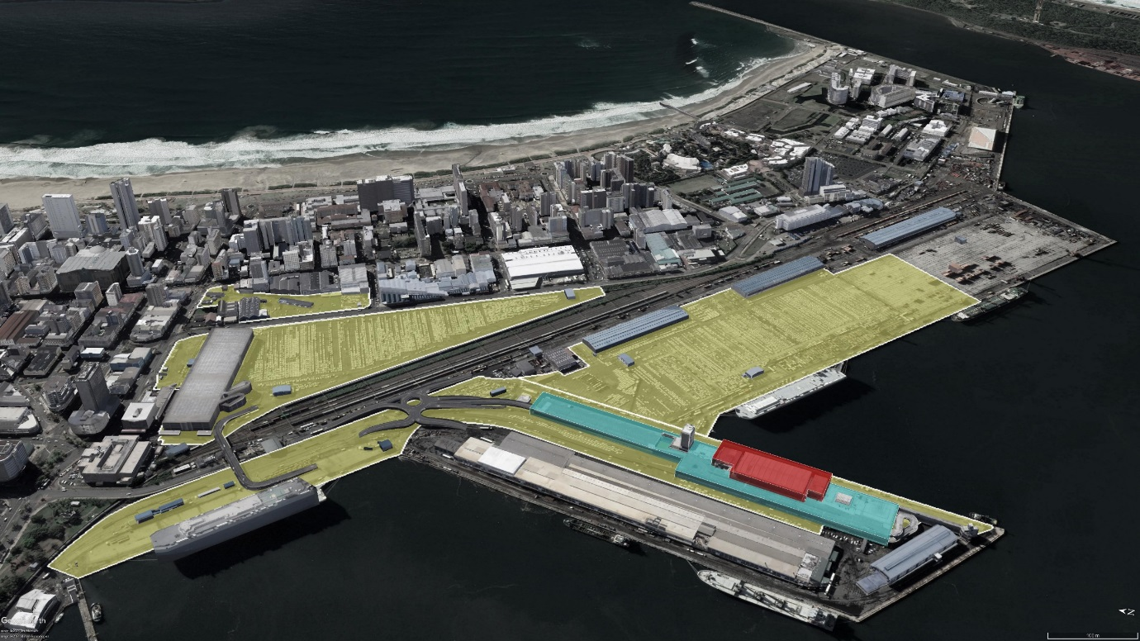
Current – Port of Durban – Point Area showing Car Terminal (13000 bays)
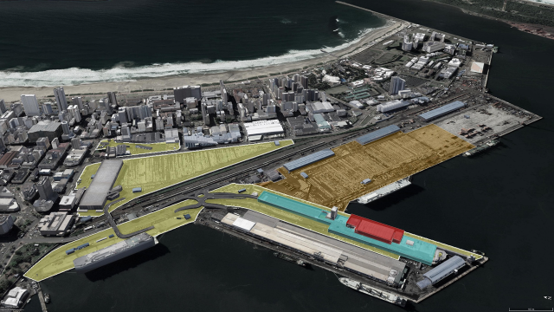
Impact of Durban Hub – Loss of Car Terminal to Container Terminal

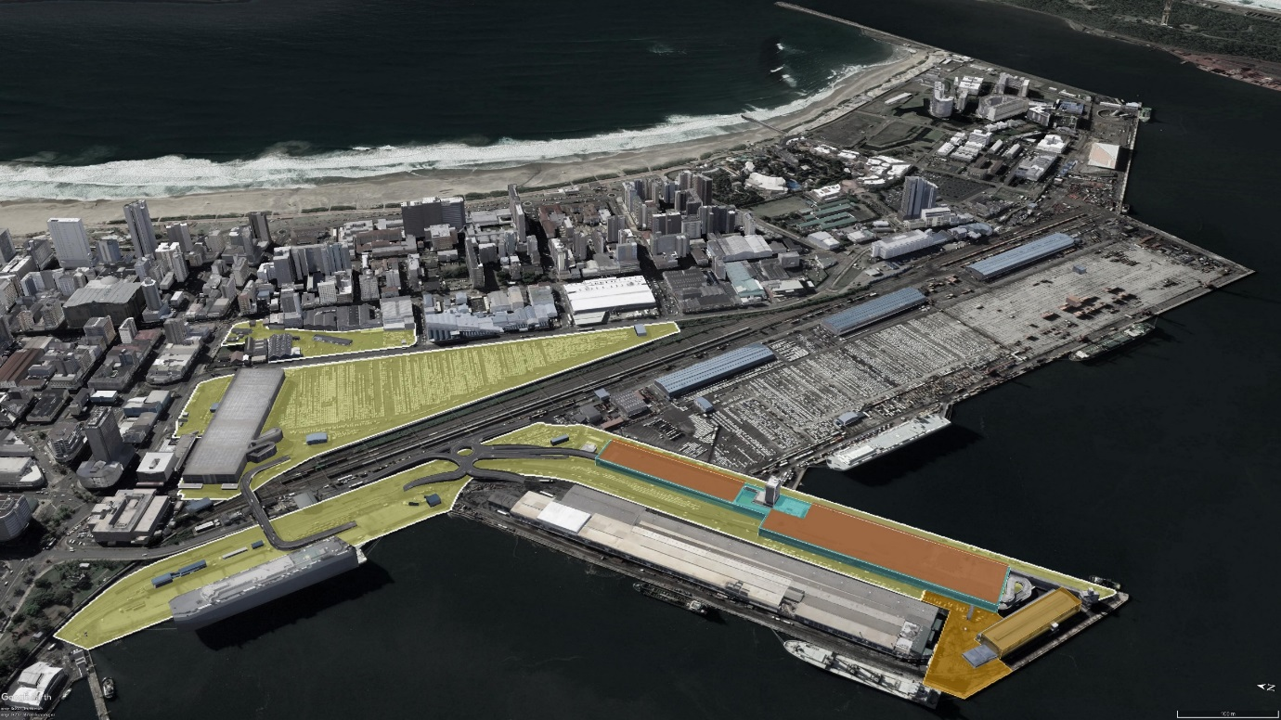
Consolidating Car Terminal at Point: Cato Creek and T-jetty Area

