 | Mariagrazia Galimberti,  The South African Heritage Ressources Agency,  111 Harrington Street,  Cape Town 800,  South Africa.  Paris, the 3rd of March 2014.
UPR 2147 CNRS
Dynamique de l’Evolution Humaine
44 rue Amiral Mouchez, 75014 Paris, France.

Dominique GOMMERY
dominique.gommery@evolhum.cnrs.fr
 33 (0)1 43 13 56 19
 33 (0)1 43 13 56 30
http://www.evolhum.cnrs.fr/gommery/index.htm

TO WHOM IT MAY CONCERN

Proposal for a temporary export
of primates specimens
from Brad Pit B (Bolt's Farm Area-Klinkert's)

I, Dr. Dominique Gommery (UPR 2147 CNRS, 44 rue de l'Amiral Mouchez, 75014 Paris, France), request from SAHRA a temporary export permit for 18 specimens of fossil primates from Brad Pit B (BPB 1, BPB 2, BPB 3, BPB 4, BPB 5, BPB 6 BPB 7, BPB 8, BPB 13, BPB 14, BPB 15, BPB 16, BPB 18, BPB 19, BPB 21, BPB 26, BPB 27, BPB 30). These 18 specimens will be hand carried by myself and stored only in my office (in the UPR 2147 CNRS building) during the study in France.

This temporary export is necessary for proper and in-depth identification, thorough description and analysis in order to publish the results in a peer-reviewed journal. The high quality pictures of the specimens will be taken in our facility, at the UPR 2147 of CNRS, with the photographic material we just acquired. These fossils from BPB have probably an age very close to the limit Early Pliocene/Late Pliocene (probably ca. 3.6 Ma) which means that they are the second oldest primate remains from the Cradle of Humankind. An extensive discussion has to be done in order to compare these remains with the different primates of the same age from East Africa. The aim is to identify the specificity of the South African material but also to specify, if possible, the tempo and the path of migration of these animals as well as the ecological context.

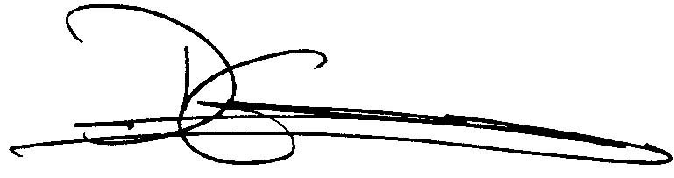

Dominique GOMMERY (Ph.D & HDR)
Director of Research of the CNRS
Research Fellow in the Department of Anthropology and Archaeology,
UNISA (University of South Africa), Pretoria, South Africa.
Associate Researcher to the Plio-Pleistocene Section, Ditsong National Museum of Natural History, Pretoria, South Africa.

