|  |
| --- |
| **Professional Consultancy Services for Coastal Engineering Infrastructure Proclaimed Fishing Harbours Western Cape** |

|  |
| --- |
| **Harbour Maintenance**  **Checklist for submission to DEA**  **Arniston Harbour** |

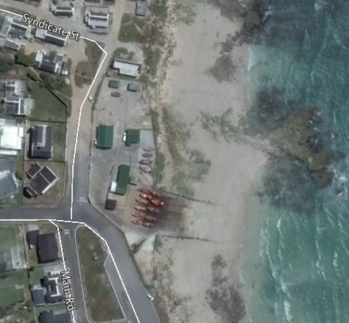

**Arniston Harbour**

**Prepared by:**

Pieter Badenhorst Professional Services CC

**On behalf of**

Mott MacDonald

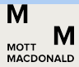5 St Georges Building

St Georges Mall

Cape Town 8001



**For:**

Coega Development Corporation

**Date:** **12 February 2017**

**CONTENTS**

1 Project description & proposed works 1

1.1 Background information 1

1.1.1 Project Background 1

1.1.2 Hydrographic and Geophysical Characteristics 2

1.1.3 Tides 3

1.1.4 Offshore Wind and Wave characteristics 3

1.1.5 Nearshore currents and circulation 5

1.1.6 Sediment transport 5

1.2 Project General Scope of Work and Maintenance 5

1.2.1 Slipway 6

1.2.2 Embankment 8

1.2.3 Harbour fencing 10

1.2.4 Slipway management 11

2 Arniston checklist - DEA 12

2.1.1 BACKGROUND INFORMATION 13

2.1.2 GEOGRAPHICAL INFORMATION 13

2.1.3 DETAILS OF THE PROPOSED ACTIVITY AND ENVIRONMENTAL CONTEXT 13

2.1.4 PROVIDE A DETAILED DESCRIPTION OF POTENTIALLY LISTED ACTIVITIES THAT MAY BE APPLICABLE TO THE PROJECT 17

List of Figures

Figure 1.1.2: High Risk area 2

Figure 1.2.1: Geophysical survey 2

Figure 1.4.1: Deep water wave height (WWIII) 4

Figure 1.4.2 Deep water wave period (WWIII) 4

Figure 1.4.3: Annual wind rose (NCEP) 5

Figure 1.2.1: Harbour layout with slipway 6

Figure 1.2.1.1: Slipway 6

Figure 1.2.1.2: Failure of concrete surface 7

Figure 1.2.1.2.1: Slipway cross section 8

Figure 1.2.2.1: Arniston embankment 8

Figure 1.2.2.2: Typical rock revetment design 9

Figure 1.2.3.1: External harbour fence 10

Figure 1.2.3.2: Fence at slipway 10

------------------------------------------------------------------------------------------------------------------------

# Project description & proposed works

*Please note that the overall project has been divided into four consultancy contracts. Since the project is for the same client information generated by other consultants have been used as applicable to compile this document. Further extracts have been made from technical reports compiled by Mott MacDonald Consulting Engineers (MM).*

## Background information

### Project Background

The National Department of Public Works (NDPW) has appointed the Coega Development Corporation (CDC) as implementing agents for the repair, maintenance and upgrade of the 13 proclaimed Western Cape fishing harbours. The 13 fishing harbours have been split into four separate work packages. MM have been appointed by CDC for the professional consulting services required to repair, maintain and upgrade the marine infrastructure for Work Package 4, which includes Stilbaai, Arniston, Gansbaai and Struisbaai.

The coastline at Arniston Harbour is orientated South to North (facing East) (see Arniston in Figure 1.1.1 for locality) and is exposed to south westerly swell. The site is characterised by sandy beaches and rocky outcrops. The shoreline is exposed and subject to dynamic coastal conditions. From satellite images the breaker zone was measured > 400 m during a storm event. Furthermore, the sediment are clear on satellite images which indicate high concentrations of sediment in suspension. This is also an indication of high wave energy.

A coastal setback study for the Overberg District was conducted by SSI during 2012. Apart from the coastal setback line, the study also estimated high risk areas with regards to coastal erosion based on wave run-up, topography, sea level rise, wave conditions, etc. The area highlighted red in the Figure 1.1.2 below was identified as a high risk urban area during the study, which include the harbour area and slipway.

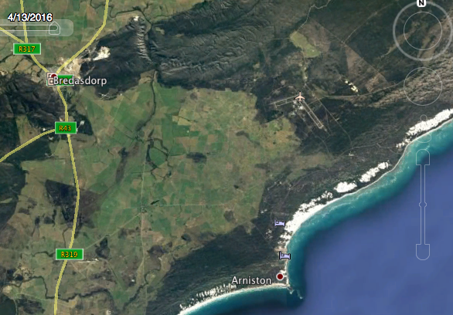

***Figure 1.1.1: Location map***

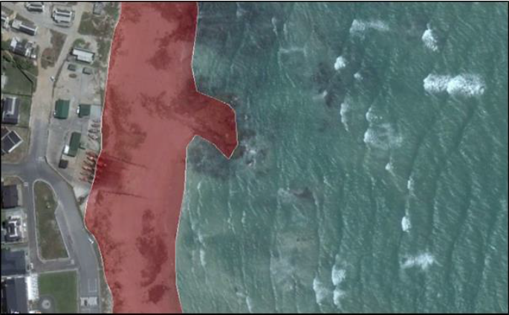

Figure 1.1.2: High Risk area

### Hydrographic and Geophysical Characteristics

During November 2016 Tritan Survey conducted a hydrographic geophysical survey of Arniston Harbour. The extent of the survey area is illustrated in the Figure 1.2.1 below. The dark blue/green area represents 2 m CD and the red/yellow areas between represent 0 m and +2 m CD.

The entire area is very shallow, as illustrated by the green areas shown in the Figure 1.2.1 which represents seabed levels between -0.5 and -1 m CD.

The site comprises of mainly Sandstones from the Table-mountain Group, overlain by calcarenites of the Bredasdorp Group. The results from the seismic survey suggested that the whole area is covered with a layer of sediment with average sediment thickness of approximately 0.33 m, and maximum sediment thickness of approximately 0.62 m.

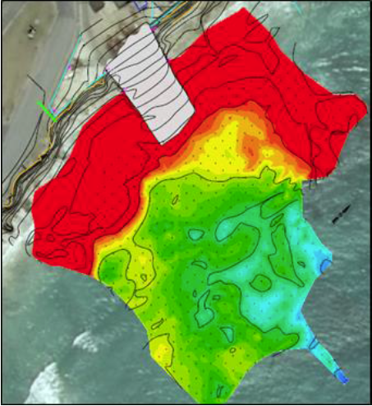

Figure 1.2.1: Geophysical survey

### Tides

South Africa tides are semi-diurnal (two tides per day). Table 1 lists the predicted tidal levels for Mossel Bay, which are assumed to be applicable to the Stilbaai, Arniston and Struisbaai sites. The above Table indicates that the maximum tidal variation is approximately 2.44 m, with the mean tidal variation being about 1.2 m.

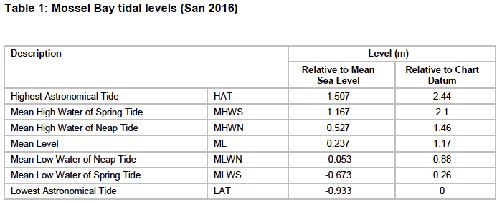

### Offshore Wind and Wave characteristics

The wave height and wave period roses in the Figures below were created from historical wave conditions sourced from the NOAA WAVEWATCH III Model (WWIII). The historical wind conditions was sourced from the National Centres for Environmental Prediction (NCEP) Global Forecast System (GFS) Atmospheric Model.

The location of the representative wind and wave offshore extraction points are listed in the Table 3 below:

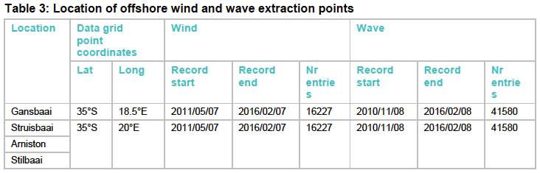

Representative offshore wind and wave conditions at Stilbaai, Arniston and Struisbaai are illustrated in the Figures 1.4.1 to 1.4.3 below.

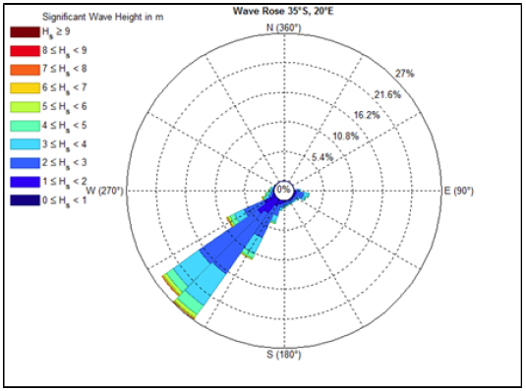

Figure 1.4.1: Deep water wave height (WWIII)

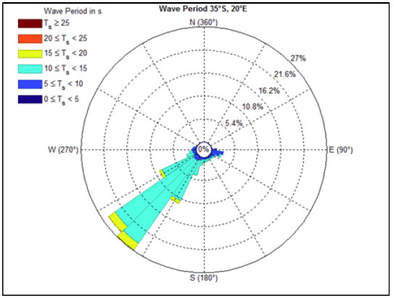

Figure 1.4.2 Deep water wave period (WWIII)

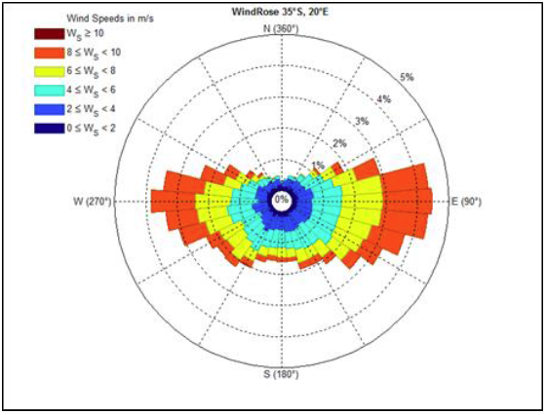

Figure 1.4.3: Annual wind rose (NCEP)

### Nearshore currents and circulation

Nearshore waves, wind and tides predominantly govern the nearshore circulation pattern (nearshore currents). The nearshore hydrodynamics are generally complex and expensive to simulate in a numerical model. For the design of the repair/upgrade of the various harbour structures, the modelling of the detailed nearshore hydrodynamics is not considered feasible. This shall be confirmed during detail design phase.

### Sediment transport

Since the site is located on an exposed coastline, longshore transport rates are assumed to be medium to high. The dominant wave direction is south westerly and therefore the net longshore transport at the site is eastbound.

Although the availability of dry, loose sand and strong winds will result in a potential high rate of aeolian sand transport, the magnitude of the longshore and cross shore sediment transport rate is generally significantly greater than the wind-blown sediment.

## Project General Scope of Work and Maintenance

The marine infrastructure for this harbour is limited to a 24m wide, 70m long slipway (see Figure 1.2.1). All fishing vessels are launched and retrieved from this slipway by means of a retrieval winch located in a winch house at the top of the slipway. The harbour offers little protection from wave conditions.

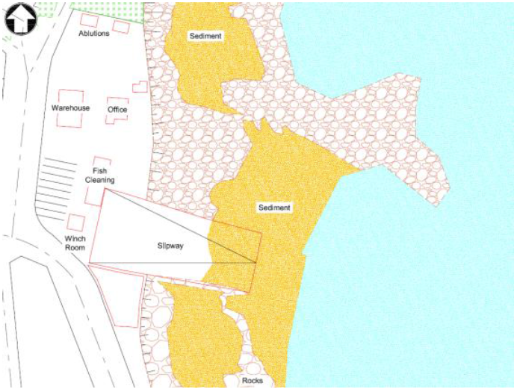

Figure 1.2.1: Harbour layout with slipway

### Slipway

#### Investigation and findings

The overall dimensions of the concrete slipway are 70m long, 24m wide with a 1:16 slope. The leading walls (side walls) of the slipway divert outwards from the lower (24m) to top (34m) section of the slipway.

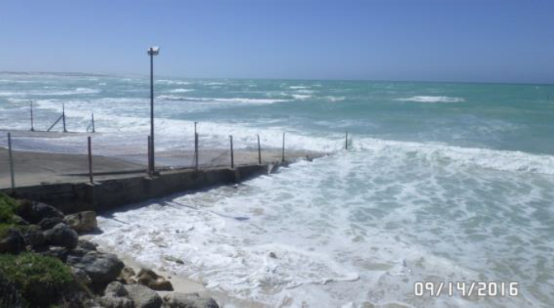

Figure 1.2.1.1: Slipway

**Observed condition of existing structure**

The lower section of slipway in the intertidal zone is in poor condition. Plunging waves breaking onto the slipway have caused slab instability and breakup of concrete panels. Previous attempts of concrete repairs to these panels have been unsuccessful as a concrete repair section has failed and had to be removed. This has left a hole behind and become a hazard to both fisherman and their boats. Further cracks, patches “potholes” are observed throughout the structure. Loss of backfill material at the southern leading wall of slipway and subsidence in the slipway leading wall/pavement is evident. There is a misalignment of joints throughout.

#### Construction methodology and concept drawings

Ongoing localised remedial works have failed resulting in the slipway not being fit for purpose and creating a hazard to current harbour operations. It is evident that localised patching is a short term solution, (see failure of concrete remedial patch below in Figure 1.2.1.2), and a long term solution is required.

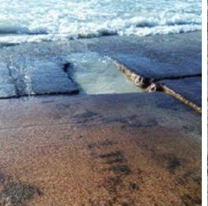

Figure 1.2.1.2: Failure of concrete surface

To provide a long term solution it is recommended that the lower portion of the slipway is to be replaced with new concrete precast panels as shown in Figure 1.2.1.2.1.

It has been noted that the construction of the new slipway will affect the stakeholders and the slipway design must take cognisance of this. Communication of the design development phases should be communicated to the stakeholders.

The concept design for the slipway showing the original design and proposed additions on same footprint is shown below in Figure 1.2.1.2.1.

Construction methodology:

* Lower half of the slipway deck to be removed and replaced
* As far as possible the existing lead walls will incorporated into new design
* New insitu beams constructed to support precast concrete panels
* New precast deck to be placed (temporary wave break will need to be constructed to achieve this (contractors call)
* New fencing to sides of slipway
* Localised concrete repair and maintenance to rest of slipway as required

Outcome: replace lower half of slipway “like for like” and therefore no change in footprint.

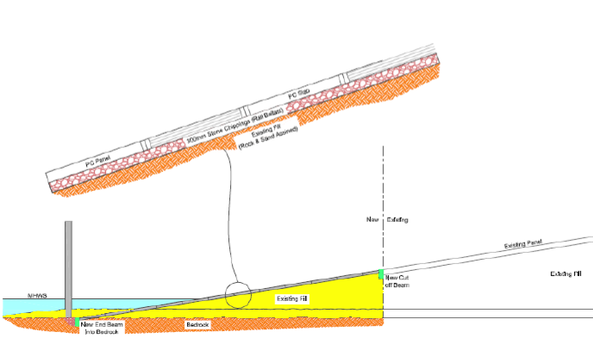

Figure 1.2.1.2.1: Slipway cross section

### Embankment

#### Investigation and findings

The embankment protects the harbour infrastructure above the slipway and is located along the entire length of the seaward facing boundary of the harbour facility (about 95m in total).

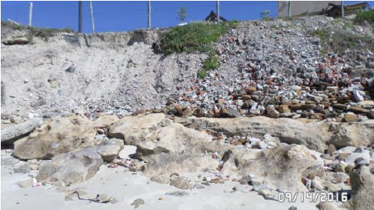

Figure 1.2.2.1: Arniston embankment

Significant erosion of embankment by wave action and wave run-up, has resulted in severe slippage/failure of large portions of the embankment, thereby undermining the fence perimeter and parking area above (see Figure 1.2.2.1). The continuing undermining of the embankment is putting harbour infrastructure (buildings) at risk. There is limited vegetative cover providing stability. Some sections of the embankment appear to be builders’ fill used to reclaim land. Presence of heavy foreign objects used in fill material, to reclaim land for the parking area, is evident.

#### Construction methodology and concept drawings

The embankment requires protection through the appropriate coastal sea defence and the following options are deemed feasible and shall be investigated in more detail during preliminary design:

* Option 1 – Rock revetment
* Option 2 – Geotextile sandbag containers (GSC)
* Option 3 – Vertical concrete structure or combination (i.e concrete structure and rock revetment)
* Option 4 – Do nothing or retreat

The typical concept detail of one of the different options is shown in the following figure 1.2.2.3. The final configuration of the preferred option will be optimised during final design

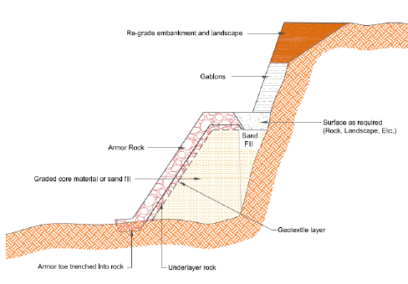

Figure 1.2.2.2: Typical rock revetment design

The construction methodology will be as follows:

* New coastal defence required (likely rock revetment)
* Excavation for a toe into beach and shaping of embankment to take revetment
* Geotextile layer placed against insitu
* Underlayer rock to be placed and shaped by excavator
* Armour rock to be positioned by crane

Outcome: The structure is new and footprint will be increased therefore a basic assessment will be required.

### Harbour fencing

#### Investigation and findings

The external harbour fence (275m) consists of wooden posts with a 50x50mm PVC diamond mesh. The fence provides no anti-climb over protection and has no overhang as shown in Figure 1.2.3.1.

Fence perimeters around the slipway leading walls are non-existent as shown in Figure 1.2.3.2. The Dock Master mentioned that the swash running across the slipway results in material being trapped in the fence and leading to its failure. The fence perimeter adjacent to the embankment is in poor condition with some sections missing. Wooden posts are completely undermined and “hanging in the air”. The perimeter fencing adjacent to the road is generally in good condition with minor sections having had work done to close gaps.

Although the external fence perimeter is not continuous around the harbour, the fencing is in fair condition.

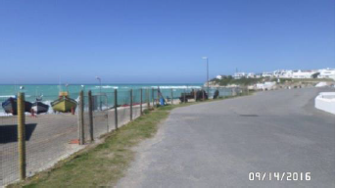

Fence

Figure 1.2.3.1: External harbour fence

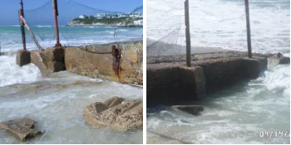

Figure 1.2.3.2: Fence at slipway

Maintenance of the fencing will not change the footprint of the harbour.

#### Construction methodology and concept drawings

**Construction methodology:**

The fences will be replaced and detail to be provided at design phase.

Outcome: no increase of footprint.

### Slipway management

#### Investigation and findings

A winch house is located at the top of the slipway where one winch is used to retrieve boats and stack them in parallel lines on the slipway deck above the high water mark.

There has been a recent fire in the winch room, (2015), but no structural concerns are immediately evident from the fire. The Dock Master noted that the line of site of the winch operator in operating the winch to retrieve boats is satisfactory. It was his opinion that this would be impeded if the winch room was recessed below ground as per Delta BEC’s SEDF report.

The winch and other equipment required for retrieving the boats appears to be in good condition. This includes pulleys, wire ropes, hooks, chains, shackles and bollards that set the line for retrieving boats in different locations along the slipway. The Dock Master also made mention of improving the safety to winch personnel by adding an emergency exit to the back of the winch room.

From the initial assessment the plant and equipment used for winching appears to be adequate, however it is recommended that a specialist service provider undertake a detailed assessment to confirm this. The Dock Master is satisfied with the winch room at its current position for line of site during operation and therefore the winch room should not be recessed underground.

#### Construction methodology and concept drawings

No concept drawing is available because repair work will be undertaking as identified on site.

**Construction Methodology**

* Refurbishment and maintenance as required to the entire operation

Outcome: Maintenance work only

# Arniston checklist - DEA



|  |
| --- |
| **Chief Directorate: Integrated Environmental Authorisations** |
|  |
| **Minimum requirements for the determination of Environmental Impact Assessment (EIA) applicability** |

The information requested in this form consists of the minimum requirements that this Department requires to address your query. The information below is required to assist the assessing officer in responding to your query. All fields are compulsory. Please note that if the requested information is deemed insufficient, this Department may request additional information to be submitted.

Any queries related to this form may be addressed to 012 399 9371.

Please submit the completed form in one of the following ways:

1. **Post:**

The Director: Integrated Environmental Authorisations

Department of Environmental Affairs

Private Bag X447

Pretoria

0001

1. **Hand Deliver:**

**Department of Environmental Affairs**

Environment House

473 Steve Biko Road

Arcadia

Pretoria

1. **E-mail :**

[EIAAdmin@environment.gov.za](mailto:EIAAdmin@environment.gov.za)

### BACKGROUND INFORMATION

|  |  |  |
| --- | --- | --- |
| Name of Contact person | Pieter Badenhorst | |
| Postal Address | PO Box 1058, Wellington 7654 | |
| Telephone Number | W: 021 8737228 | C: 0827763422 |
| Fax Number | 0866721916 | Email: pbps@iafrica.com |

### GEOGRAPHICAL INFORMATION

|  |  |  |
| --- | --- | --- |
| Property Description | Arniston Fishing Harbour | |
| Physical Address where the development will take place | Off Syndicate Street, Arniston  (opposite Protea Hotel) | |
| Farm name(s)/ Erf No | The harbour is on Erven 172 & 173, Arniston. Part of the slipway is on the beach outside Erf 173. | |
| Local Municipality | Bredasdorp | |
| District Municipality | Overberg | |
| SG21 Digit code(s) for the proposed site | C01100020000017200000  C01100020000077300000 | |
| Co-ordinates of the proposed site/s (DDMMSS) | Latitude (S) | Longitude (E) |
| 34° 39' 57,26” | 20° 13' 55,34” |

### DETAILS OF THE PROPOSED ACTIVITY AND ENVIRONMENTAL CONTEXT

|  |  |
| --- | --- |
| Does the proposed development involve the construction of a new facility or the expansion of a new facility? | No |
| Have any activities physically commenced? If so, provide the date of commencement of these activities. | No |
| What is the current zoning and current land use of the site(s)? | Zoning not available.  The property is used as a small fishing harbour, a few fishing vessels and a ski boat launch. |
| State the extent of proposed development (ha/m2) | The exact footprint of the works within the harbour has not yet been finalised, but all activities are proposed inside the cadastral boundaries of the Harbour as indicated on Figure 1 below with blue line.  Proposed works inside the harbour (upgrades and repairs to harbour infrastructure) will remain within the existing footprint of the relevant infrastructure.    Figure 1  The building of a protection section along the embankment, both sides of the slipway, is new work and will require environmental authorisation (see Figure 2 below for embankment that will be protected).    Embankment  About 65m  Embankment  About 30m  Figure 2 |
| Describe the proposed development in detail (include capacities, output, etc.) and provide a concise description of all associated infrastructure with respect to the proposed development (e.g. the diameter and lengths of pipelines that may be required) | The description of work is shown in section 1 (starting page 1) of the report.  The proposed works all constitute repairs and maintenance to existing infrastructure in the harbour, except for the new embankment protection works.  The proposed works will not increase the harbour footprint but the embankment protection is new work and will require environmental authorisation. |
| Will the proposed development result in waste generation, effluent discharges, air emissions or impacts on the natural or cultural environment - briefly explain? | The project largely involves repairs and maintenance to existing infrastructure in the harbour, which are not expected to result in any waste effluent or emissions, other than those normally associated with construction activities and which will be managed on site.  The embankment protection works will also generate normal building waste and will be further described in the EIA.  At this stage it is not clear whether the Breakwater, Seawalls and slipways are older than 60 years but should it be the case the necessary permit application will be made to the South African Heritage Resources Agency (SAHRA) in terms of the National Heritage Act 25 of 1999. |
| Does the site(s)/route(s) form part of the Critical Biodiversity Area - If so, provide details | No |
| Are there any watercourses on the site(s)/route (includes rivers, wetlands, drainage lines, streams etc.) or does the site fall within 32 m from the edge of a watercourse. If so, provide details. | No |
| Does the site fall within 100 m of the high-water mark of the sea or an estuary? | Yes. The majority of the works will take place below the high-water mark of the sea. |
| Does the proposed development fall inside an urban area? | This is likely since the harbour is on the edge of town as shown below.    Harbour  Town |
| Describe what investigation or assessment have already been undertaken (if any) to inform this request. Provide attachment herewith. | Engineering assessments and studies were undertaken to assess the requirements for maintenance. These are described in section 1 of this report. |

### PROVIDE A DETAILED DESCRIPTION OF POTENTIALLY LISTED ACTIVITIES THAT MAY BE APPLICABLE TO THE PROJECT

|  |  |
| --- | --- |
| Listed activity as described in GN R. 983, GN R. 984 and GN R.985 | Description of project activity that may trigger the listed activity |
| ***e.g. GN R.983 Item XX(x): The development of bridge exceeding 100 square metres in size within a watercourse*** | ***e.g. A bridge measuring 110 square metres will be constructed within the watercourse*** |
| GN R.983 Activity 19: The infilling or depositing of any material of more than 5 cubic metres into, or the dredging, excavation, removal or moving of soil, sand, shells, shell grit, pebbles or rock of more than 5 cubic metres from –  (i) a watercourse;  (ii) the seashore; or  (iii) the littoral active zone, or a distance of 100 m inland of the high water mark of the sea, whichever distance is the greater –  But excluding where such infilling, depositing, dredging, excavation, removal or moving –  (b) is for maintenance purposes undertaken in accordance with a maintenance management plan. | Protection works for the embankment will deposit more than 5m3 within 100m of the HWM and this activity will thus be activated. |
| GN R.983 Activity 52: The expansion of structures in the coastal public property where the development footprint will be increased by more than 50 square metres, excluding such expansions within existing ports or harbours where there will be no increase in the development footprint of the port or harbour. | Strenghtening/repair of the breakwater and seawalls as well as repair of the slipways will be required. Section 1 describes how this work will be undertaken within the existing footprint and thus no increase in development footprint will take place.  The embankment will increase the footprint by more than 50m2.  The activity will therefore be activated. |
| GN R.983 Activity 55: Expansion  (i) in the sea;  (iii) within the littoral active zone; and  (v) within a distance of 100 m inland of the high water mark  In respect of:  (d) breakwater structures;  (f) coastal harbours or ports  But excluding the expansion of infrastructure or structures within existing ports or harbours that will not increase the development footprint of the port or harbour. | Strenghtening/repair of the breakwater and seawalls as well as repair of the slipways will be required. Section 1 describes how this work will be undertaken within the existing footprint and thus no increase in development footprint will take place.  The activity is therefore not activated. |
| GN R.983 Activity 65: The expansion and related operation of an island, anchored platform or any other permanent structure on or along the sea bed, where the expansion will constitute an increased development footprint, excluding expansion of facilities, infrastructure or structures for aquaculture purposes. | As described above maintenance and repair work is required on permanent structures in the harbours and on the sea bed, however, none of these are considered to increase the footprint of the actual structures, except for construction work to protect the embankment and thus this activity will be activated – that is if DEA consider the existing embankment a permanent structure. |

|  |  |
| --- | --- |
| Identified Competent Authority to consider the application: | Department of Environmental Affairs |
| Reason(s) in terms of Sec 24C of NEMA 1998, as amended | The activity is proposed by a National Department: The National Department of Public Works |

**DECLARATION BY THE PROPONENT / ENVIRONMENTAL PRACTITIONER**

I…**Pieter Badenhorst**…in my personal capacity or duly authorised thereto by hereby declare that I:

* regard the information contained in this checklist to be true and correct;
* am fully aware of my responsibilities in terms of the National Environmental Management Act (NEMA) Act No. 107 of 1998), the Environmental Impact Assessment Regulations (EIA Regulations), 2014 in terms of NEMA (Government Notice No. 982 refers) and the relevant specific environmental management Acts, and that failure to comply with these requirements may constitute an offence in terms of the environmental legislation;
* am fully aware that the Department’s determination of the applicability of the EIA Regulations,2014 is based on information at my disposal that is relevant to this request;
* aware that the response from the competent authority, to this request, is specific to the EIA Regulations, 2014 and does not exempt me from my legal obligations in terms of any other applicable legislation; and
* am aware that a false declaration is an offence in terms of regulation 48 GN R No. 982

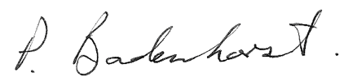 20 February 2017

|  |
| --- |
| Signature of the proponent / environmental practitioner: Date: |
|  |

PBPS for Mott MacDonald

|  |
| --- |
| Name of company (if applicable): |