|  |
| --- |
| **Professional Consultancy Services for Coastal Engineering Infrastructure Proclaimed Fishing Harbours Western Cape** |

|  |
| --- |
| **Harbour Maintenance**  **Checklist for submission to DEA**  **Struisbaai Harbour** |

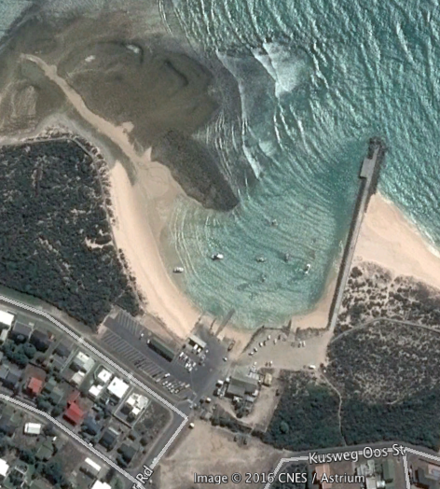

**Struisbaai Harbour**

**Prepared by:**

Pieter Badenhorst Professional Services CC

**On behalf of**

Mott MacDonald

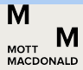5 St Georges Building

St Georges Mall

Cape Town 8001



**For:**

Coega Development Corporation

**Date:** **20 February 2017**

**CONTENTS**

1 Project description & proposed works 1

1.1 Background information 1

1.1.1 Project Background 1

1.1.2 Hydrographic and Geophysical Characteristics 2

1.1.3 Tides 2

1.1.4 Offshore Wind and Wave characteristics 3

1.1.5 Nearshore currents and circulation 5

1.1.6 Sediment transport 5

1.1.7 Sediment sampling 5

1.2 Project General Scope of Work and Maintenance 6

1.2.1 Breakwater 6

1.2.2 Quay 1 and 2: 7

1.2.3 Slipways 1, 2 and 3 9

1.2.4 Jetty 10

1.2.5 Rehabilitation of rock revetment 11

1.2.6 Dredging 13

2 Struisbaai checklist - DEA 15

2.1.1 BACKGROUND INFORMATION 16

2.1.2 GEOGRAPHICAL INFORMATION 16

2.1.3 DETAILS OF THE PROPOSED ACTIVITY AND ENVIRONMENTAL CONTEXT 16

2.1.4 PROVIDE A DETAILED DESCRIPTION OF POTENTIALLY LISTED ACTIVITIES THAT MAY BE APPLICABLE TO THE PROJECT 19

3 Appendices 22

3.1 : Sediment sampling report 22

List of Figures

Figure 1.2.1: Geophysical survey 2

Figure 1.4.1: Deep water wave height (WWIII) 4

Figure 1.4.2 Deep water wave period (WWIII) 4

Figure 1.4.3: Annual wind rose (NCEP) 5

Figure 1.2.1: Harbour layout 6

Figure 1.2.1.1: Struisbaai Breakwater 6

Figure 1.2.2.1: Quay 1 (left) and Quay 2 (right) 7

Figure 1.2.2.2: Proposed maintenance of quays 8

Figure 1.2.3.1a: Slipway 1 9

Figure 1.2.3.1b: Slipways 2 and 3 9

Figure 1.2.4.1: Jetty 10

Figure 1.2.4.2: Bollards and timber 11

Figure 1.2.4.2a: Subsiding of rock revetment 12

Figure 1.2.4.2b: Rock revetment detail 12

Figure 1.2.5.1: Proposed area for dredging Struisbaai harbour 14

Figure 1.2.5.2: Proposed spoil area for dredge material 14

------------------------------------------------------------------------------------------------------------------------

# Project description & proposed works

*Please note that the overall project has been divided into four consultancy contracts. Since the project is for the same client information generated by other consultants have been used as applicable to compile this document. Further extracts have been made from technical reports compiled by Mott MacDonald Consulting Engineers (MM).*

## Background information

### Project Background

The National Department of Public Works (NDPW) has appointed the Coega Development Corporation (CDC) as implementing agents for the repair, maintenance and upgrade of the 13 proclaimed Western Cape fishing harbours. The 13 fishing harbours have been split into four separate work packages. MM have been appointed by CDC for the professional consulting services required to repair, maintain and upgrade the marine infrastructure for Work Package 4, which includes Stilbaai, Arniston, Gansbaai and Struisbaai.

Stilbaai is located about 300 km east of Cape Town. The mouth of the Goukou Estuary is located approximately 850 m north from the harbour and is permanently open. The coastline can be characterised as sandy beached with rocky outcrops and is in pristine condition. Figure 1.1.1 below illustrates the harbour location with regards to the Goukou Estuary as well as the general coastline characteristics.

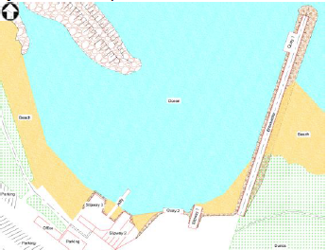

Quay 2

Quay 1

Slipway 3

Slipway 2

Slipway 1

***Figure 1.1.1: Location map***

### Hydrographic and Geophysical Characteristics

During November 2016 Tritan Survey conducted a hydrographic geophysical survey of Struisbaai Harbour. The extent of the survey area is illustrated in Figure 1.2.1 below. The dark blue area represents 2.5 m CD and the red areas represent 0 m CD. The entire basin is very shallow and the bathymetry along the quay at the breakwater is only about -1 m CD

The lighter green represents seabed levels between -0.5 and -1 m CD and the dark green areas seabed levels between -1 m and -1.5 m CD.

The site comprises of mainly Sandstones from the Table-mountain Group, overlain by calcarenites of the Bredarsdorp Group. The results from the seismic survey suggested that the whole area is covered with a layer of sediment, with a maximum thickness of approximately 3.75m and an average thickness of 1.1m (Tritan, 2016).

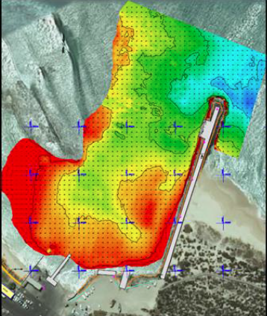

Figure 1.2.1: Geophysical survey

### Tides

South Africa tides are semi-diurnal (two tides per day). Table 1 lists the predicted tidal levels for Mossel Bay, which are assumed to be applicable to the Stilbaai, Arniston and Struisbaai sites. The above Table indicates that the maximum tidal variation is approximately 2.44 m, with the mean tidal variation being about 1.2 m.

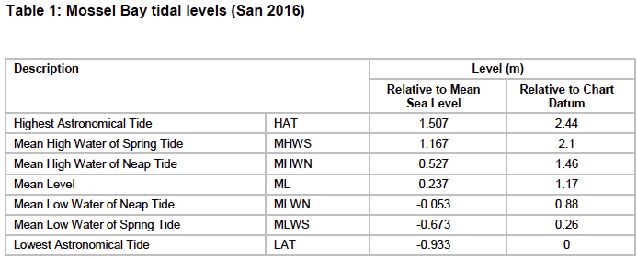

### Offshore Wind and Wave characteristics

The wave height and wave period roses in the Figures below were created from historical wave conditions sourced from the NOAA WAVEWATCH III Model (WWIII). The historical wind conditions was sourced from the National Centres for Environmental Prediction (NCEP) Global Forecast System (GFS) Atmospheric Model.

The location of the representative wind and wave offshore extraction points are listed in the Table 3 below:

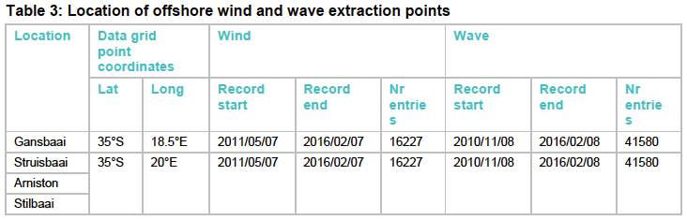

Representative offshore wind and wave conditions at Stilbaai, Arniston and Struisbaai are illustrated in the Figures 1.4.1 to 1.4.3 below.

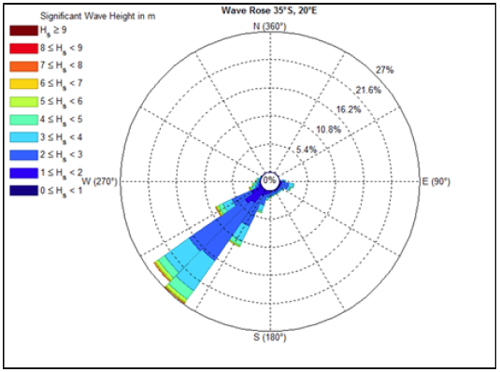

Figure 1.4.1: Deep water wave height (WWIII)

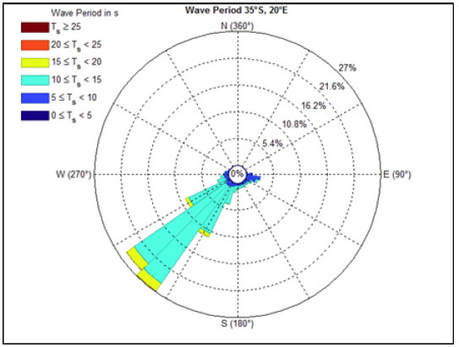

Figure 1.4.2 Deep water wave period (WWIII)

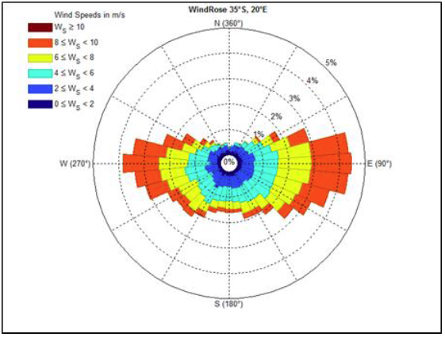

Figure 1.4.3: Annual wind rose (NCEP)

### Nearshore currents and circulation

Nearshore waves, wind and tides predominantly govern the nearshore circulation pattern (nearshore currents). The nearshore hydrodynamics are generally complex and expensive to simulate in a numerical model. For the design of the repair/upgrade of the various harbour structures, the modelling of the detailed nearshore hydrodynamics is not considered feasible. This shall be confirmed during detail design phase.

### Sediment transport

Since the site is located on an exposed coastline, longshore transport rates are assumed to be medium to high. The dominant wave direction is south westerly and therefore the net longshore transport at the site is eastbound. Due to the general absence of rock on the beach and in the nearshore zone, it is assumed that the net longshore transport rate is not limited by the availability of sand to be transported.

Due to the long-term accretion and erosion trends as determined by Theron (Theron, 2010), it can be assumed that the cross-shore sediment transport also causes changes in the location of the shoreline and most likely the beaches adjacent the harbour are not dynamically stable.

Although the availability of dry, loose sand and strong winds will result in a potential high rate of aeolian sand transport, the magnitude of the longshore and cross shore sediment transport rate is generally significantly greater than the wind-blown sediment.

### Sediment sampling

Sediment sampling was undertaken by Lwandle Marine Environmental Services (see full report in Appendix 3.1). The report concluded as follows:

*The comparisons show that Arniston, Gansbaai, Stilbaai and Struisbaai sediments are uncontaminated by heavy metals or the measured organic compounds and would qualify for unconfined open ocean disposal. Nevertheless, should harbour dredging be required, the dredge spoil disposal site(s) will need to be carefully selected.*

## Project General Scope of Work and Maintenance

Struisbaai harbour consists of a 185m long main breakwater, two small offloading quays, a jetty and three slipways. A trot mooring system inside the harbour basin is used. The trot mooring system consists of a network of long and heavy ground chains anchored, with risers at intervals and offers 56 trot moorings.

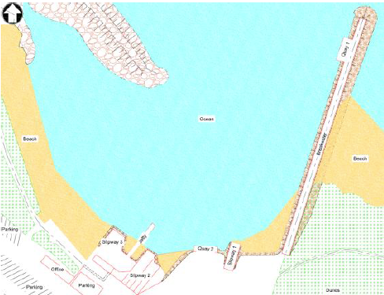

Figure 1.2.1: Harbour layout

### Breakwater

#### Investigation and findings

The breakwater is a conventional 185m long rubble mound breakwater with concrete crown wall (see Figure 1.2.1.1). The crown wall/crest element serves as an access road to Quay 1 and the head of the breakwater.

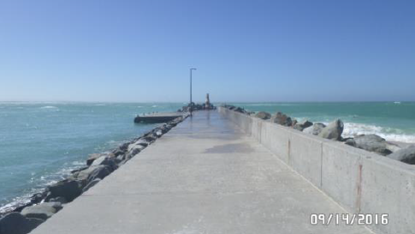

Figure 1.2.1.1: Struisbaai Breakwater

**Observed condition of existing structure**

The overall condition of the breakwater is good with minor areas showing abrasion, corrosion and cracking. Although wave overtopping was noted, the rock revetment on the leeside slope of the breakwater is satisfactory to Quay 1. Localised areas of loosely packed rock are showing signs of failure which could lead to potential collapse of the access road. This is due to undermining (±2m) of the rock revetment and a loss of core material between Quay 1 and the head of the breakwater.

**Conceptual design**

Minor concrete remedial works to the crown wall is required.. Replacement and stabilisation of core material under access road is required and it is envisaged that pressurised cement grouting will do this. The grouting technique will be verified during detail design, subject to a detailed analysis of the extent of the void and the ability of the rock protection to restrain the grouting. At the head of the breakwater the rock revetment will require rehabilitation to return it to its initial design slope.

**Construction methodology:**

* Localised concrete repair to crown wall and capping slab
* Grouting to voids under the capping slab at the head of the breakwater
* Rehabilitation of the rock revetment at the head of the breakwater where the voids have formed. The section of rehabilitation is at quay 1 on the inside of the breakwater.
* Likely use an excavator to shape with divers assessing the positioning in the water.

Outcome: rehabilitation to initial design, no widening footprint

### Quay 1 and 2:

Precast concrete quay deck supported on concrete portal frames (see Figure 1.2.2.1). The quay is termed open as the seawater can pass underneath.

#### Investigation and findings

**Quay 1:** Precast concrete panels adjacent to the breakwater have moved, opening up gaps in the deck. The movement of panels is caused from a combination of the support concrete portal frames moving and uplift forces on the underside of the panels from breaking waves underneath the structure. Currently two panels show signs of distress. The horizontal concrete beams are showing signs of abrasion and movement away from their original position.

**Quay 2**: Dock authorities have condemned this structure as unsafe for use. Precast concrete panels have failed, been unseated and collapsed onto the revetment below. The concrete portal frames that the precast concrete panels are placed upon, show signs of subsidence and movement out of the vertical. This movement has opened up the joints between the concrete beams and concrete panels resulting in the failure of the quay deck.

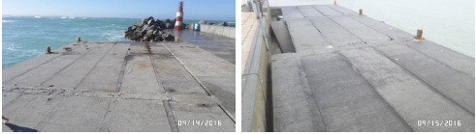

Figure 1.2.2.1: Quay 1 (left) and Quay 2 (right)

#### Construction methodology and concept drawings

The initial visual assessment showed that the concrete portal frames are intact even though there appears to be movement of some of the frames in the horizontal/vertical direction. A more detailed visual conditional assessment is required to assess the substructure and assessment of the nature of the subsidence. This will determine whether there is a need for a replacement of the quay substructure.

The current envisaged repair methodology is to stabilise the substructure and replace the damaged precast concrete panels with a new fixing down detail, (to absorb wave energy), and allow holes through the units to alleviate the upwards forces under the panels. At this time, it is not deemed to be feasible to alleviate the upward forces from wave energy by investigating different quay options or adapting the rock protection underneath.

It is noted that holes in the will vent uplifting seawater and may not be desired by the public and stakeholders and will require communication between all parties

**Construction methodology:**

Concept design shown in Figure 1.2.2.2.

* Shore up existing concrete portal frame structure through post fixing details and bracing
* Replace damaged precast concrete slabs with new recast slabs as required
* Provide new fixing detail to ensure new concrete slabs remain secure
* Localised concrete repair and patching as required.

Outcome: design to improve longevity of quay walls. No additional work to be carried out on substructure other than localised patching. No increase in footprint.

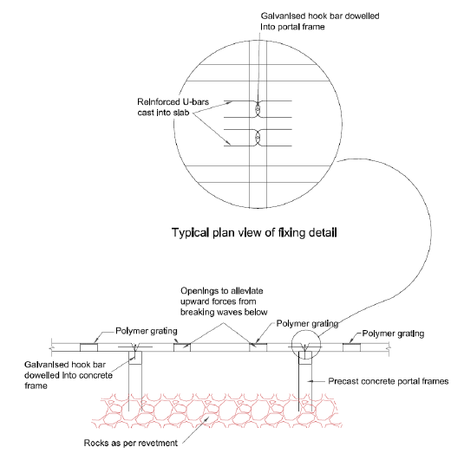

Figure 1.2.2.2: Proposed maintenance of quays

### Slipways 1, 2 and 3

#### Investigation and findings

**Slipway 1:** 21m long concrete slipway consisting of 14 (3x3m) in situ concrete panels on a bed on screeded stone. The slipway “cuts” through the rock revetment providing access to the back of the harbour basin (Figure 1.2.3.1a).

**Slipway 2:** 30m long, 15m wide slipway consisting of in situ concrete panels (Figure 1.2.3.1b)

**Slipway 3:** 21m long, 11m wide slipway consist of in situ concrete panels (Figure 1.2.3.1b)

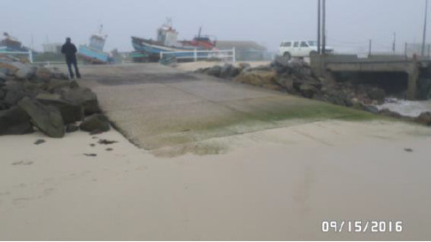

Figure 1.2.3.1a: Slipway 1

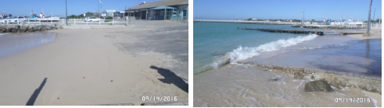

Slipway 3

Slipway 2

Figure 1.2.3.1b: Slipways 2 and 3

**Slipway 1:** The bottom section of the slipway was covered with sediment build-up and minor undermining/ scour along the sides of the slipway was observed. Joint alignments of panels are good. Abrasion of concrete on the lower portions was observed, but this is not a major concern. Minor undermining at side edges of slipway is visible and marine/algae growth on the lower section of slipway was noted. The Dock Master mentioned that they would like the slipway to be extended.

**Slipway 2**: The slipway is currently not in use, due to heavy sediment build-up on the lower section of the entire slipway. The visible concrete panels of the slipway show signs of abrasion and minor cracking.

**Slipway 3:** As with slipway 2 there is sediment build up on the slipway. The joints in the concrete panels are misaligned and there is vertical movement in the concrete panels. There is no side protection to the slipway and minor scouring is occurring. Marine/algae growth on the lower section of slipway was visible. The Dock Master requested that this slipway be extended due to difficulty in launching boats at low tides. This slipway is currently in use.

#### Concept design

**Slipway 1 and 3:** Minor repair works at sides of slipway and investigation into the request to extend the slipway. Further detailed analysis of the bathymetric survey will assist in establishing the as-built details of the slipway and thereby determine if the slipways meet the current industry standards.

**Slipway 2:** Further detailed analysis of bathymetric survey is required to establish a dredging maintenance plan to alleviate sediment build up. Minor remedial work to the concrete panels as required.

Should Slipway 1 and 3 be extended, the same detail will be used as per the Arniston slipway. i.e precast concrete panels. An extension of the slipway is likely to trigger an Environmental Basic Assessment as the footprint of the slipway would increase. **[This now NOT included as part of this report and checklist]**

#### Construction methodology and concept drawings

**Construction methodology:**

* ~~Slipway 1 and 3 to be extended using precast concrete panels (same concept as Arniston Slipway)~~
* Slipway 1 and 3 to have localised concrete repair and patching
* Slipway 2 to have localised concrete repair and patching

Outcome: no increase of footprint.

### Jetty

#### Investigation and findings

The 30m long jetty (see Figure 1.2.4.1) consists of concrete deck panels supported on concrete portal frames. Three concrete deck panels span between beam supports with a total of seven spans. Timber horizontal beams are fixed to the concrete portal structure with tyre fenders attached.

The jetty subsides going seawards, but no immediate reason for this was observed. The joints between precast concrete panels are deteriorating from horizontal movement causing the joints to open and become vulnerable to attack. Timber members used for tyre mooring have deteriorated and this is seen by a loss of cross sectional area of the timbers (see Figure 1.2.4.2).

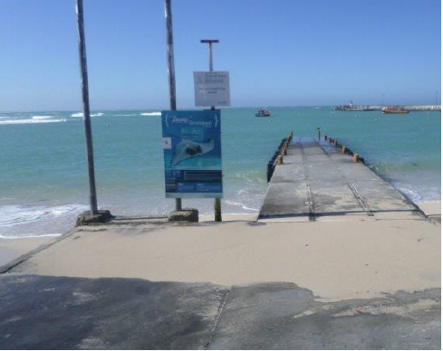

Figure 1.2.4.1: Jetty

Minor maintenance and repair works are required to arrest the movement. Timber members require replacing. The Bollards require rehabilitation through sand-gritting and recoating with corrosion protection paint.

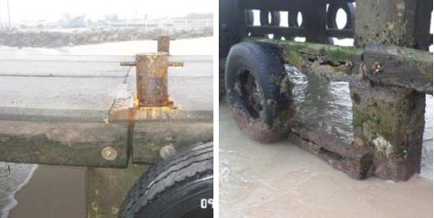

Figure 1.2.4.2: Bollards and timber

#### Construction methodology and concept drawings

No concept drawing is available because repair work will be undertaking as identified on site.

**Construction Methodology**

* Minor maintenance and repair to timber sections. Replace like for like.
* Minor maintenance and repair to bollards through gritt blasting and recoating with corrosion paint.

Outcome: repair and maintenance, no listed activity activated.

### Rehabilitation of rock revetment

#### Investigation and findings

The rock revetment between Slipway 2 and the breakwater is in poor condition due to settlement of the crest and washout of fines/backfill material from behind the revetment. Bulging at the toe was evident due to sliding and displacement of the rocks.

#### Concept design

The subsidence of the crest (see Figure 1.2.4.2a) of wall and overtopping of the rock revetment has resulted in the backfill behind the revetment being leached out causing subsidence. It was noted by the Dock Master that the parking behind the wall has recently been backfilled to fill the subsidence. This is likely a short term solution and therefore requires further analysis to verify if the crest of the seawall is high enough to achieve minimum overtopping design limits.

Detailed analysis of wave conditions, bathymetric and topographical survey is required to confirm if the revetment achieves its design function. Should the study results indicate a high risk with regards to erosion, it may be necessary to increase the crest height.

Typically, the following detail as in Figure 1.2.4.2b is envisaged for the rehabilitation of the rock revetment to its current levels.

[picture will be improved]

Work however on existing footprint.

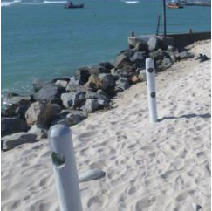

Subsiding rocks

Figure 1.2.4.2a: Subsiding of rock revetment

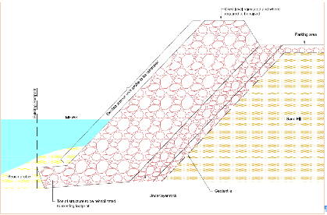

Figure 1.2.4.2b: Rock revetment detail

**Construction methodology**

* Assess the position of the toe through trial pits to establishing the footprint (Note DPW have no as-built or drawings for position)
* Remove rock in sections to insert geotextile layer
* Rehabilitate toe to original footprint position
* Reinstate the rock armour
* If required raise the crest level to reduce overtopping.
* Backfill and reinstate parking area behind

Outcome: footprint to remain as is and rock revetment rehabilitated and improved as required on existing footprint

### Dredging

#### Investigation and findings

Sediment is driven by wave and wind forces with the wave driven transport being the main contributor to sediment build-up in the harbour basin. Sediment driven by wave action travels in a north to south direction. Floating mooring buoys (trot system) are fixed to the harbour basin floor.

There is sediment build-up alongside the breakwater on the up-drift side, (south side), due to longshore sediment transport travelling south to north. This beach has reached its storage capacity and sediment is rounding the breakwater and being deposited in the harbour basin through wave action.

Sediment is also being blown directly over the breakwater into the harbour basin. This sediment rounding the breakwaters is being deposited in front of the slipways creating problems with launching and recovery of boats. It was noted by the Dock Master that the sediment build-up has greatly reduced the capacity of the harbour to moor boats using the trot system and currently only 25 of the 56 trot moorings can be used.

To alleviate the sand accretion in the harbour basin, work has been done in the past in constructing an artificial rock reef to refract waves into a channel that runs north away from the basin. The channel, through creating a current away from the basin, would then transport the sediment. This system appears to have had little success and the Doc Master mentioned that loaders would be opening the channel in the near future.

#### Concept design

The Struisbaai harbour is quite exposed to the wave conditions and is located in a small formed bay protected by a breakwater on the Eastern side. The facility is extremely shallow with the seabed comprising predominantly medium slightly silty sand material with isolated grit and gravel fragments.

The Struisbaai facility requires dredging of material over a relatively large area to depths ranging from 1 to 2m. From the Multibeam data it is apparent that the facility’s entrance channel and basin extent is still visible, but covered by this layer of sediment. The facility’s initial channel and basin arrangement was probably driven by the presence of shallow rock outside of this area, which would require consideration of the dredging risk in this area.

The littoral drift process seems to move the sediment material into the basin and deposits it on a very subtle slope of about 1 in 30.

The disposal of the dredged material would require special attention as this greatly affects production, risk and overall dredging costs dramatically. The possibility of a beach nourishing exercise should be considered as the preferred option (see Figure 1.2.5.2).

When the material type, dredging volumes and dredge material distribution is considered, it is anticipated that the dredging campaign will be conducted utilising a Suction Hopper Dredger or alternatively a Barge mounted DOP dredger. Caution would need to be applied with the procurement of these services, as the exposure to wave action and very limited draft in this area would need to be considered. This could lead to some increased downtime and the use of smaller equipment with slower productions, all factors leading to an increase in cost per unit volume of material dredged. The basin also seems to be somewhat more calm during Winter periods and it could be advantageous to conduct the dredging campaign during this season.

The proposed area for dredging is shown in Figure 1.2.5.1. It is estimated that about 34000m3 would need to be dredged out in order to reinstate the facility to acceptable conditions. Further analysis of the bathymetric surveys is required to calculate accurate dredged volumes amounts.

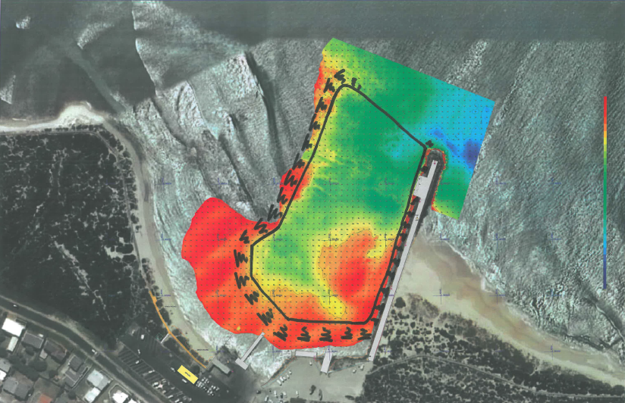

Figure 1.2.5.1: Proposed area for dredging Struisbaai harbour

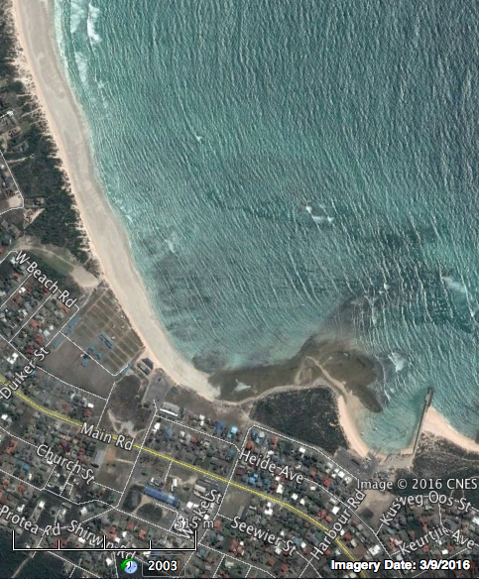

Possible replenishment of beach

Harbour

Figure 1.2.5.2: Proposed spoil area for dredge material

# Struisbaai checklist - DEA



|  |
| --- |
| **Chief Directorate: Integrated Environmental Authorisations** |
|  |
| **Minimum requirements for the determination of Environmental Impact Assessment (EIA) applicability** |

The information requested in this form consists of the minimum requirements that this Department requires to address your query. The information below is required to assist the assessing officer in responding to your query. All fields are compulsory. Please note that if the requested information is deemed insufficient, this Department may request additional information to be submitted.

Any queries related to this form may be addressed to 012 399 9371.

Please submit the completed form in one of the following ways:

1. **Post:**

The Director: Integrated Environmental Authorisations

Department of Environmental Affairs

Private Bag X447

Pretoria

0001

1. **Hand Deliver:**

**Department of Environmental Affairs**

Environment House

473 Steve Biko Road

Arcadia

Pretoria

1. **E-mail :**

[EIAAdmin@environment.gov.za](mailto:EIAAdmin@environment.gov.za)

### BACKGROUND INFORMATION

|  |  |  |
| --- | --- | --- |
| Name of Contact person | Pieter Badenhorst | |
| Postal Address | PO Box 1058, Wellington 7654 | |
| Telephone Number | W: 021 8737228 | C: 0827763422 |
| Fax Number | 0866721916 | Email: pbps@iafrica.com |

### GEOGRAPHICAL INFORMATION

|  |  |  |
| --- | --- | --- |
| Property Description | Struisbaai Fishing Harbour | |
| Physical Address where the development will take place | Off Harbour Road, Struisbaai | |
| Farm name(s)/ Erf No | The locality of harbour is shown below with surrounding property boundaries. The harbour buildings are on erven 848 and 1394 (possibly also Re 654). No erf indicated for the harbour itself. | |
| Local Municipality | Cape Agulhas | |
| District Municipality | Overberg | |
| SG21 Digit code(s) for the proposed site | C01100080000139400000  C01100080000084800000 | |
| Co-ordinates of the proposed site/s (DDMMSS) | Latitude (S) | Longitude (E) |
| 34° 48' 01,92” | 20° 03' 28,06” |

### DETAILS OF THE PROPOSED ACTIVITY AND ENVIRONMENTAL CONTEXT

|  |  |
| --- | --- |
| Does the proposed development involve the construction of a new facility or the expansion of a new facility? | No |
| Have any activities physically commenced? If so, provide the date of commencement of these activities. | No |
| What is the current zoning and current land use of the site(s)? | According to available information Stilbaai Harbour itself is not on an erf and has no zoning. Zoning for erven unknown.  The property is used as a small fishing harbour, a few fishing vessels and a ski boat launch. |
| State the extent of proposed development (ha/m2) | The exact footprint of the works within the harbour has not yet been finalised, but all activities are proposed inside the cadastral boundaries of the Harbour as indicated on Figures 1 and 3 below. Dredged sand (about 34 000m3) will be deposited on the beach as show below (see Figure 2 below).  Proposed works inside the harbour (upgrades and repairs to harbour infrastructure) will remain within the existing footprint of the relevant infrastructure.    Figure 1    Possible replenishment of beach  Harbour  Figure 2    Figure 3 |
| Describe the proposed development in detail (include capacities, output, etc.) and provide a concise description of all associated infrastructure with respect to the proposed development (e.g. the diameter and lengths of pipelines that may be required) | The description of work is shown in section 1 (starting page 1) of the report.  The proposed works all constitute repairs and maintenance to existing infrastructure in the harbour and maintenance dredging.  Although only the dredging exercise (activity 19 of Listing Notice 1) could activate a listed activity the listed activity indicates that it is excluded should the work by for maintenance purposes under a Maintenance Management Plan (MMP). It is therefore the intention, should DEA agree, to submit a (MMP) addressing relevant activities for DEA’s approval (this MMP will be compiled as per the requirements of DEA&DP but will be submitted to DEA for approval). |
| Will the proposed development result in waste generation, effluent discharges, air emissions or impacts on the natural or cultural environment - briefly explain? | The project largely involves repairs and maintenance to existing infrastructure in the harbour, which are not expected to result in any waste effluent or emissions, other than those normally associated with construction activities and which will be managed on site.  The project includes maintenance dredging within the harbour, for which the it is proposed to submit a MMP. Sampling of sediments to be dredged (see report by Lwandle as Appendix 3.1 (page 22) indicates that sediments are not contaminated (contaminants are well within guideline levels) and as such are suitable for offshore disposal (i.e. onshore disposal at a hazardous waste facility is not required). As indicated above the intention is to temporally “store” the relatively small volume of sand on land to be used as fill material or to replenish the beach to the south as shown in Figure 2 above. Correspondence between other consultants for this project with DEA: Oceans and Coasts regarding the proposed project confirms that no Coastal Waters Discharge Permit (or any other application) will be required in terms of the NEM:Integrated Coastal Management Act 36 of 2014.  At this stage it is not clear whether any of the stuctures are older than 60 years but should it be the case the necessary permit application will be made to the South African Heritage Resources Agency (SAHRA) in terms of the National Heritage Act 25 of 1999. |
| Does the site(s)/route(s) form part of the Critical Biodiversity Area - If so, provide details | No |
| Are there any watercourses on the site(s)/route (includes rivers, wetlands, drainage lines, streams etc.) or does the site fall within 32 m from the edge of a watercourse. If so, provide details. | No |
| Does the site fall within 100 m of the high-water mark of the sea or an estuary? | Yes. |
| Does the proposed development fall inside an urban area? | This is likely since the harbour is on the edge of town as shown below.    Harbour  Town |
| Describe what investigation or assessment have already been undertaken (if any) to inform this request. Provide attachment herewith. | Engineering assessments and studies were undertaken to assess the requirements for maintenance. These are described in section 1 of this report.  A sediment specialist study has been undertaken by Lwandle (Appendix 3.1, page 22) to determine the level of contaminants in the sediment to be dredged. |

### PROVIDE A DETAILED DESCRIPTION OF POTENTIALLY LISTED ACTIVITIES THAT MAY BE APPLICABLE TO THE PROJECT

|  |  |
| --- | --- |
| Listed activity as described in GN R. 983, GN R. 984 and GN R.985 | Description of project activity that may trigger the listed activity |
| ***e.g. GN R.983 Item XX(x): The development of bridge exceeding 100 square metres in size within a watercourse*** | ***e.g. A bridge measuring 110 square metres will be constructed within the watercourse*** |
| GN R.983 Activity 19: The infilling or depositing of any material of more than 5 cubic metres into, or the dredging, excavation, removal or moving of soil, sand, shells, shell grit, pebbles or rock of more than 5 cubic metres from –  (i) a watercourse;  (ii) the seashore; or  (iii) the littoral active zone, or a distance of 100 m inland of the high water mark of the sea, whichever distance is the greater –  But excluding where such infilling, depositing, dredging, excavation, removal or moving –  (b) is for maintenance purposes undertaken in accordance with a maintenance management plan. | Maintenance dredging is required in the harbour basin and entrance channel, as indicated in Figure 3 above. The intention is to replenish the beach as shown in Figure 2 above.  A MMP will be compiled for ongoing maintenance dredging in the harbour basin and at the entrance channel and the deposition/disposal thereof and submitted to DEA for approval prior to the start of dredging activities.  Should DEA agree that the activity can be undertaken under a MMP then it is not activated. |
| GN R.983 Activity 52: The expansion of structures in the coastal public property where the development footprint will be increased by more than 50 square metres, excluding such expansions within existing ports or harbours where there will be no increase in the development footprint of the port or harbour. | Strenghtening/repair of the various structures as described will be required. Section 1 describes how this work will be undertaken within the existing footprint and thus no increase in development footprint will take place.  The activity is therefore not activated. |
| GN R.983 Activity 55: Expansion  (i) in the sea;  (iii) within the littoral active zone; and  (v) within a distance of 100 m inland of the high water mark  In respect of:  (d) breakwater structures;  (f) coastal harbours or ports  But excluding the expansion of infrastructure or structures within existing ports or harbours that will not increase the development footprint of the port or harbour. | Strenghtening/repair of structures will be required. Section 1 describes how this work will be undertaken within the existing footprint and thus no increase in development footprint will take place.  The activity is therefore not activated. |
| GN R.983 Activity 65: The expansion and related operation of an island, anchored platform or any other permanent structure on or along the sea bed, where the expansion will constitute an increased development footprint, excluding expansion of facilities, infrastructure or structures for aquaculture purposes. | As described above maintenance and repair work is required on permanent structures in the harbours and on the sea bed, however, none of these are considered to increase the footprint of the actual structures and this activity is thus not applicable. |

|  |  |
| --- | --- |
| Identified Competent Authority to consider the application: | Department of Environmental Affairs |
| Reason(s) in terms of Sec 24C of NEMA 1998, as amended | The activity is proposed by a national department: The National Department of Public Works |

**DECLARATION BY THE PROPONENT / ENVIRONMENTAL PRACTITIONER**

I…**Pieter Badenhorst**…in my personal capacity or duly authorised thereto by hereby declare that I:

* regard the information contained in this checklist to be true and correct;
* am fully aware of my responsibilities in terms of the National Environmental Management Act (NEMA) Act No. 107 of 1998), the Environmental Impact Assessment Regulations (EIA Regulations), 2014 in terms of NEMA (Government Notice No. 982 refers) and the relevant specific environmental management Acts, and that failure to comply with these requirements may constitute an offence in terms of the environmental legislation;
* am fully aware that the Department’s determination of the applicability of the EIA Regulations,2014 is based on information at my disposal that is relevant to this request;
* aware that the response from the competent authority, to this request, is specific to the EIA Regulations, 2014 and does not exempt me from my legal obligations in terms of any other applicable legislation; and
* am aware that a false declaration is an offence in terms of regulation 48 GN R No. 982

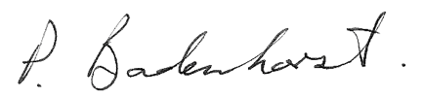 21 February 2017

|  |
| --- |
| Signature of the proponent / environmental practitioner: Date: |
|  |

PBPS for Mott MacDonald

|  |
| --- |
| Name of company (if applicable): |

# Appendices

## : Sediment sampling report

