PHASE 2 ARCHAEOLOGICAL IMPACT ASSESSMENT MITIGATION FOR BOIKARABELO COAL MINE (SAHRA PERMIT NO. 80/11/07/015/51)

Resgen south africa (Pty) ltd

february 2012

This document has been prepared by Digby Wells Environmental.
Report Title: Phase 2 Archaeological Impact Assessment Mitigation for Boikarabelo Coal Mine (SAHRA Permit No. 80/11/07/015/51)
Project Number: RES973
Name | Responsibility | Signature | Date
Johan Nel  Archaeologist | Specialist:  Permit holder  Report integration
Dr Maria van der Ryst  Archaeologist | Specialist:  Principle Investigator
Natasha Higgitt  Archaeologist | Specialist:  Field assistant
Guy Thomas  Archaeologist | Specialist:  Field assistant
Louise Nicolai  Environmental Manager | 1st Review |  | 23/02/2012
This report is provided solely for the purposes set out in it and may not, in whole or in part, be used for any other purpose without Digby Wells Environmental prior written consent.

EXECUTIVE SUMMARY
This report summarises the results of archaeological fieldwork undertaken on sites located within the proposed Boikarabelo Coal Mine project area during the period 3-11 October 2011. These sites were identified during an Archaeological Impact Assessment (AIA) which was undertaken in September 2009 and February 2010 as part of an Environmental Impact Assessment (EIA) for the proposed Boikarabelo Coal Mine.
A total of 12 sites were recommended for Site Test Pit’s (STP’s) and three sites for mapping and test excavations as indicated in Table 3-2. In consultation with the project Principal Investigator and other specialists on site, only two sites were excavated. There were several factors that influenced the decision.
Due to the large extent and low archaeological visibility of the majority of the sites only limited archaeological remains could be recovered. In most cases the sampling in the form of STPs auguring and selective excavations produced a very low incidence of cultural material. At the permitted sites very little archaeological remains were present that allowed dating or contextualising the Boikarabelo sites.
As a direct result of the low archaeological visibility of deposits the Phase 2 fieldwork concentrated on the recording of spatial layout rather than sampling cultural material. In terms of research and archaeological significance sites that were deemed to have more visible structural features and dense archaeological artefactual remains, and therefore research potential, were selected for further archaeological investigations.
A number of sites where mitigation had been recommended were found to be of such low archaeological visibility and density that the mitigation of those sites could not be justified in terms of the current project. However, all the sites for which mitigation had been requested were surveyed, the archaeological data recorded, the deposit was tested using soil augers and the spatial layout of each settlement was mapped.
Sites 009/010 were sampled using STP’s and mapped. Sites 011 and 021/022 were sampled by means of STP and test excavations and mapped. Sites that were surveyed and mapped included: 008, 012, 013, 017, 018, 019, 020, 021, and 027. Viable deposits that could be excavated were not present at any of the remaining sites.
Site surveys were done by initial transect sweeps of the site to identify the relative extent of the site and all evident features and artefacts clusters were flagged. A Trimble GIS-enabled GPS was used to record features and large concentrations of artefacts. Retrieval of representative material culture samples was achieved through structured sampling. These included surface collection, auger test points in a grid, shovel test pits and excavation through selective test trenches.
In general, as stated earlier, our initial investigations and sampling of deposits established that the archaeological deposit at some of the sites was superficial and shallow. Apart from surface features comprising stones of grain bin foundations, and low-density scatters of ceramics that signalled settlements, there were only few viable deposits that could be tested (either through auger samples, STPs or test excavations). Furthermore, if was found that several sites identified as single sites in the Phase 1 AIA were in fact part of larger sites. The table below provides an integrated site list where site numbers have been combined based on the larger or more central parts of sites. The mitigation measures that were proposed in the Phase 1 AIA, as well as those included in the SAHRA permit, were therefore reviewed.
Actual mitigated sites compared to sites identified in the Phase 1 AIA
Mitigated sites | Phase 1 AIA equivalent | Significance rating
Site 009 (STP, mapping) | Site 009  Site 010 | General Protection: Grade IV B
Site 011 (Test excavations, STP, mapping) | Site 011 | General Protection: Grade IV B
Site 021 (Test excavations, mapping) | Site 020  Site 021  Site 022 | General Protection: Grade IV B
Site 013 (monitoring and mapping) | Site 012  Site 013 | General Protection: Grade IV C
Site 018 (STP) | Site 018  Site 019 | General Protection: Grade IV C
Site 015 | Site 015  Site 016 | General Protection: Grade IV C

Material culture from the mitigation project included ceramics, lithics and faunal remains, as well as special finds such a single copper bead and a carved soapstone pipe bowl. The excavated pottery were analysed based on stylistic attributes, but were inconclusive in terms of providing contextual and temporal information. Surface collections of pottery however indicated a probable early Moloko (probably Icon) facies and at least one site had been identified to the Letsibogo facies. The relative age of the sites were therefore inferred to range from the late 17th to late 18th centuries CE.
All excavated and collected material was described, catalogued and packaged on site for further collections management at the University of Pretoria, with the University of South Africa as the final storage location.
Recommendations have also been provided for additional sites that were subsequently found during the Phase 2 project. However, these sites have not been sampled as the permit specifically excluded ‘any associated development activities to the mine which were not assessed’ previously.
Recommendations made include:
During the construction phase an archaeologist must be present when the surface layers at any of the identified archaeological sites are removed. The purpose of this will be to ensure due diligence in the management of the heritage component. It is also likely that human remains will be unearthed at this stage of the construction process and the presence of an archaeologist can substantially mitigate the delays associated with the recovery of human remains. In addition to this the archaeologist must record any cultural material of spatial features that become evident during the stripping to augment the current Phase 2 report and provide more detail data on each of the sites. This is further detailed in the methodology for the site archaeologist.
The following heritage management and monitoring actions must be observed:
  - In line with the Burra Charter (2003) in situ conservation must be pursued as far as feasible.
  - All sites that will be directly impacted on or destroyed during the construction process must be further recorded and mapped (Phase 3).
  - Site records must be sufficiently detailed to create an archive of sites that will be destroyed. Documentation will be reviewed and assessed by the appointed archaeological practioner to ensure that highest standards are maintained.
  - It is recommended that the site be monitored on a regular basis (6 months to a year) by a professional archaeologist to report on the general upkeep and status of heritage sites within the boundaries of the mine.

GLOSSARY
AIA | Archaeological Impact Assessment
ATP | Auger Test Pit
BCE | Before Common Era, synonymous with BC
BP | Before Present, i.e. 1950, used to describe calibrated radiocarbon dates
CE | Common Era (synonymous to AD)
CRM | Cultural Resources Management
Daga | Mud/clay mixture used to plaster wattle and daub walls. Sometimes mixed with cattle dung to smooth floors or walls. Usually only visible in archaeological record after burning that turns the mixture into a brick-like consistency and texture.
Digby Wells | Digby Wells Environmental
EDM | Electronic Distance Measurement instrument
EMP | Environmental Management Plan
EIA | Environmental Impact Assessment
Ha | Hectare
Historical | Alludes to European contact and subsequent settlement; includes colonial eras.
HSMP | Heritage Site Management Plan
Iron Age | Metals and metal working – including copper, gold, and iron – appears in archaeological record associated with more complex, stratified society, usually agropastoral economies; overlaps historical period in areas; ceases at various times during 19th century with colonial expansion.
Kya | Thousand years ago
Monitoring | Periodic monitoring of sites during the Life of Mine, typically applied to significant sites that won't be impacted on directly, but with a risk of secondary impacts.
Mya | Million years ago
Project area | The boundaries of the Boikarabelo Coal Mine
Radiocarbon dating | Absolute radiometric dating technique for carbon-bearing material
Site | Used to refer to locality where archaeological record is visible or present. Can include single occurrences or scatters of artefacts, stonewalls, daga, dung or midden deposit.
STP | Shovel Test Pit
Study area | The wider archaeological and historical socio-cultural environment and landscape, including south-eastern Botswana, north-west Limpopo and the Waterberg.
Watching brief | The process where a qualified archaeologist is present on-site during any activity in, near or at a heritage resource site that may be impacted on, or where there is potential for exposing heritage resources during construction or other activities. Note that in context of this report it is distinct from monitoring

TABLE OF CONTENTS
1 Introduction 1
2 TERMS OF REFERENCE 1
2.1 Permission granted (Permit No. 80/11/07/015/51) 1
2.2 Summary of Permit conditions 1
3 STUDY AREA 2
4 AIM AND OBJECTIVES 9
5 METHODOLOGY 9
5.1 Literature review 9
5.2 Survey and mapping 10
5.3 Sampling 10
5.4 Collections management 11
5.5 Analyses 12
6 Literature review 12
6.1 Stone Age 12
6.1.1 Earlier Stone Age (ESA) 12
6.1.2 Middle Stone Age (MSA) 12
6.1.3 Late Stone Age (LSA) 13
6.2 Iron Age 14
7 mitigation results 17
7.1 Site 009/010 17
7.1.1 SAHRA Permit Requirements: Mapping and Test Excavations 17
7.1.2 Pottery analysis 18
7.2 Site 011 23
7.2.1 SAHRA Permit Requirements: Shovel Test Pits 23
7.2.2 Locality A 23
7.2.3 Locality B 25
7.2.4 Pottery analysis 26
7.3 Site 021 29
7.3.1 SAHRA Permit Requirements: Shovel Test Pits 29
7.3.2 Pottery analysis 33
7.3.3 Lithic material 37
7.3.4 Faunal analysis 37
7.4 Surface material 39
8 Site significance ratings 43
9 Site Mapping 44
10 DISCUSSION OF RESULTS 53
10.1 Relative dating of sites 54
10.2 Site types identified 54
10.2.1 Site type 1 55
10.2.2 Site type 2 56
10.2.3 Site type 3 56
10.3 Relative cultural identity of archaeological societies 56
11 LIMITATIONS and KNOWLEDGE GAPS 58
12 potential risks 58
13 recommendations 59
14 CONCluSION 61
15 REFERENCES 62
LIST OF FIGURES
Figure 5-1: Schematic representation of test excavation reference system 11
Figure 7-1: Identified vessels from site 9 Locality A. Numbers 1, 4 and 5 were identified as jars and numbers 2 and 3 as constricted jars (Biemond 2012) 18
Figure 7-2: Identified vessels from site 9 Locality B. Numbers 1 and 4 were identified as jars and numbers 2, 3 and 5 as constricted jars (Biemond 2012) 19
Figure 7-3: Illustrated profiles and sketches of identified vessels from site 9 Locality A (1-6), Site 9 Locality B (7-11 and Site 011 Locality B (12-13). Jars are represented by numbers 1-4, 7, 8 and 12. Constricted jars are represented by numbers 5, 6, 9-11 and 13-15 (Biemond 2012) 22
Figure 7-4: Sketch map of test excavation of Locality A, Site 011, spit 2 (100 mm level) indicating shape and size of grain bin platform 24
Figure 7-5: Site 011, Locality A indicating the remains of the stone grain bin platform. The nine squares from the lower left hand corner are illustrated in Figure 7-4 above. Note the relative homogeneity of the soil from the surface to lower levels of the excavation (200 mm) 25
Figure 7-6: Site 011, Locality B, spit 2 (100 mm level): Note the occurrence of broken lower grindstones and pottery scatters 26
Figure 7-7: Site 011, Locality B after removal of the southern half of the feature. Note again the relative homogeneity of the soil from the surface to lower levels of the excavation (200 mm). Also note the absence of any visible archaeological deposit or other remains 26
Figure 7-8: Vessels identified from site 11 including jars (numbers 1-4) constricted jars (numbers 5-7) (Biemond 2012) 27
Figure 7-9: RES 021 Locality A section plan 30
Figure 7-10: RES 021 Locality B section plan 30
Figure 7-11: RES 021 Locality B Spit 1 31
Figure 7-12: Wire-drawn metal bead recovered from Site 021 Locality B. Note the clamped closure ends 32
Figure 7-13: Side profile of soapstone pipe bowl from Site 021 Locality B. Note raised decorative motif 32
Figure 7-14: Cross section of pipe from Site 021. 33
Figure 7-15: Vessels identified vessels from site 21. Numbers 1 and 2 constitute jars, 3-5 and 7 constricted jars and number 8 was considered to be bowl fragment with red ochre on the exterior. Sherd 6 had an abraded edge and may have been used as a moulding tool (Biemond 2012) 34
Figure 7-16: Illustrated profiles and sketches of identified vessels from Sites021. Numbers 6-10 represent vessels from Site 021. The remainder are from Site 021 and include jars (numbers 6 and 10) and constricted jars (numbers 7-9) (Biemond 2012). 36
Figure 7-17: Stylistic representation of Early Moloko vessel shapes (Biemond 2012). 39
Figure 7-18: Early Moloko facies pottery collected from the surface of Site 027 (Biemond 2012) 40
Figure 7-19: Examples of Letsibogo facies pottery collected from surface 40
Figure 7-20: Stylistic representation of Letsibogo vessel shapes (Biemond 2012) 41
Figure 7-21: Early Moloko facies (numbers 1-3) and Letsibogo facies (numbers 4, 5, 7,8-12) pottery collected from the surface of Site 027 (Moloko) and Sites 012, 013, 018, 019 (Letsibogo). Sherds 6, 9 and 13 have no provenance. 42
Figure 10-1: Aerial view of the Molokwane Iron Age site. Note the large open space in the centre (red line) indicating central cattle kraal. The different wards are represented by the scalloped stonewalls radiating from centre (photo courtesy Neels Kruger © 2012) 55
Figure 10-2: Daniell’s 1801 depiction of a Tlhaping settlement at Dithakong. Note the granary to the left on a raised stone platform. Also note the reed walls. These would leave little to no trace post-site abandonment 57
Figure 10-3: Example of a grain bin platform identified at Basinghall, Botswana, with lower grindstones (Biemond 2006) 57

LIST OF TABLES
Table 3-1: Geographical details of farms where mitigated sites are located in the Boikarabelo Project Area 3
Table 3-2: Relative centre coordinates of sites and SAHRA permission compared to actual mitigation undertaken 4
Table 6-1: Approximate date ranges for the three South African Stone Age periods 14
Table 7-1: Summary catalogue of the excavated ceramic Sherds from Site 09 Localities A and B (Biemond 2012) 20
Table 7-2: Analysis of the identifiable vessel types from Site 09 Localities A and B (Biemond 2012) 21
Table 7-3: Summary catalogue of the excavated ceramic sherds from Site 011 Localities A and B (Biemond 2012) 28
Table 7-4: Analysis of the identifiable vessel types from Site 09 Localities A and B (Biemond 2012). 29
Table 7-5: Summary catalogue of the excavated ceramic sherds from Site 021 Localities A, B and C (Biemond 2012) 34
Table 7-6: Analysis of the identifiable vessel types from Site 21 35
Table 7-7: Description of mammal size in terms of bovine classes. 37
Table 8-1: Review of recommended site significance ratings post mitigation 43

LIST OF PLANS
Plan 1: Regional location of Boikarabelo Coal Mine 6
Plan 2: Project boundary of the Boikarabelo Coal Mine Project Area, 1: 50 000 topographical map sheet 2327 CA Hardekraaltjie 7
Plan 3: Detail of mitigated sites in the Boikarabelo Coal Mine Project Area 8
Plan 4: Site 004 indicating approximate site boundary, grain bin platforms and potential extent of household units, and central space that may have included a cattle enclosure 45
Plan 5: Site 009 indicating positions of STPs, grain bin platforms and approximate site boundary 46
Plan 6: Site 011 indicating positions of STPs, test excavations, grain bin platforms and approximate site boundary 47
Plan 7: Site 013 (including site 012) showing location of visible grain bin platforms and relative site extent 48
Plan 8: Site 014 indicating approximate site boundary, grain bin platforms and potential extent of household units and central space that may have included a cattle enclosure 49
Plan 9: Sites 018 and 019 with location of cattle deposit and approximate site boundary 50
Plan 10: Sites 021 indicating approximate site boundary and test excavations 51
Plan 11: Location of sites on 1: 50 000 topographical map sheet indicating sites in relation to each other. Note that mitigated and/or mapped sites are differentiated from site points with buffers 52
Plan 12: Location of mitigated sites in relation to proposed mine infrastructure and footprints 60
LIST OF APPENDICES
Appendix A: Statement of Significance and Impact Assessment Methodology
Appendix B: Specialist Pottery Analysis Report
Appendix C: Specialist Faunal Analysis Report
Appendix D: Accession Register and Catalogue of Material Culture
Appendix E: Curriculum Vitae of Specialists
Appendix F: Initial Recommendations
Appendix G: Sites Considered for Destruction and in situ Preservation

Introduction
Digby Wells Environmental (Digby Wells) was appointed as an independent environmental consultant by Resgen South Africa (Pty) Ltd (Resgen), to undertake an Environmental Impact Assessment (EIA) for the proposed Boikarabelo Coal Mine. This assessment was concluded in 2010. The EIA included a Phase 1 Archaeological Impact Assessment (AIA). Digby Wells appointed Professional Grave Solutions (Pty) Ltd Heritage Unit (PGS-HU) to undertake this AIA in 2009 and 2010. The AIA findings showed that certain sites would be impacted on by the development of the Boikarabelo Coal Mine, and relevant mitigation measures were subsequently recommended.
In 2010 Digby Wells was reappointed by Resgen to undertake the necessary mitigation of the sites that would be impacted on as per the South African Heritage Resources Agency (SAHRA) permit requirements. The mitigation took place over a two week period in October 2012. Field assistance was supplied by students from the Department of Anthropology and Archaeology of the University of Pretoria under supervision of Dr Ceri Ashley (senior lecturer: Archaeology). Dr Maria van der Ryst of the Department of Anthropology and Archaeology, University of South Africa, undertook the role of Principle Investigator. Mr Wim Biemond provided input and assistance with the ceramic analysis.

TERMS OF REFERENCE
The Terms of Reference (TOR) are based on the recommendations provided in the Phase 1 AIA report, the SAHRA Archaeological Review Comment (ARC) on that report. However, the permit requirements supplied in the SAHRA Phase 2 permit informed the primary TOR.

Permission granted (Permit No. 80/11/07/015/51)
The permit was issued under Section 35(4) of the National Heritage Resources Act, Act 25 of 1999 (NHRA). Permission was granted in terms of this permit to conduct:
Shovel Test Pits (STP) for sites: 002, 003, 006, 011, 017, 018, 019, 020, 022, 026, and 027;
Mapping and test excavations for sites: 009, 010, 012; and
Monitoring for sites: 001, 013 (to be mapped with site 012), 015 and 016.

Summary of Permit conditions
The permit was granted in terms of certain conditions being met. The most pertinent of these are summarised below:
All sites affected by the Phase 2 project must be mapped, including sites for which only monitoring were required;
Where STPs and test excavations yielded significant information SAHRA and the developer had to be notified to establish a way forward;
Where STPs and test excavations yielded less significant results, application for site destruction need to applied for from SAHRA before destruction can take place;
Human remains are ethically sensitive and when found accidentally, all necessary consultations as may be required by the NHRA must be undertaken; and
The permit does not apply to any development activities that were not assessed as part of the Phase 1 AIA of this project.

STUDY AREA
The project area lies within the Western Sandy Bushveld vegetation region within the Savanna Biome. This is characterised by the occurrence of tall open woodland to low woodland, with trees such as the Acacia erubescens on flat areas, Combretum apiculatum on shallow soils and Terminalia sericea on deep soils. Sandstone, mudstone, sandstone, conglomerate, siltstone and shale of the Mokolian Waterberg group are found in the north of this region. The rainfall occurs in summer with very dry winters. The average rainfall is 450 mm in the north. The temperature fluctuates between 36ºC in summer and -3.7ºC in winter (Mucina & Rutherford 2006).
The project area is located approximately 60 km north of Lephalale, Limpopo, near the small hamlet of Steenbokpan as illustrated in Plan 1 and Plan 2.
The relevant farm names and numbers and corner coordinates where mitigated archaeological sites are located are provided in Table 3-1 below. The position of mitigated sites are summarised in Table 3-2 and illustrated in Plan 3.
Table 3-1: Geographical details of farms where mitigated sites are located in the Boikarabelo Project Area
Province | Map Sheet | Town/City | Farm name | Co-ordinates
Limpopo | 2327CA Hardekraaltjie | Lephalale | Zeekoevley 421 LQ | Top left corner: S23.6335 E27.09975 | Top right corner: S23.606694 E27.135038
 |  |  |  | Bottom left corner: S23.655138 E27.1114 | Bottom right corner: S23.630083 E27.147694
Limpopo | 2327CA Hardekraaltjie | Lephalale | Kalkpan 243 LQ | Top left corner: S23.606694 E27.135038 | Top right corner: S23.5953 E27.178861
 |  |  |  | Bottom left corner: S23.630083 E27.147694 | Bottom right corner: S23.618038 E27.189583
Limpopo | 2327CA Hardekraaltjie | Lephalale | Witkopie 238 LQ | Top left corner: S23.566675 E27.1193694 | Top right corner: S23.564638 E27.15327
 |  |  |  | Bottom left corner: S23.606694 E27.135038 | Bottom right corner: S23.5953 E27.178861

Table 3-2: Relative centre coordinates of sites and SAHRA permission compared to actual mitigation undertaken
Site No. | Relative centre coordinates | SAHRA Permission | Actual Mitigation Completed
Site 001 | 23.58986S  27.115788E | Monitoring | Auger samples, mapping
Site 002 | 23.59086S  27.15922E | STP | Auger samples, mapping
Site 003 | 23.60233S 27.14765E | STP | Auger samples, mapping
Site 006 | 23.57060S  27.16174E | STP | Auger samples, mapping
Site 009 | 23.63169 S 27.13259 E | Test excavation and mapping | STP, mapping
Site 010 | 23.63040 S 27.13388 E | Test excavation and mapping | STP, mapping
Site 011 | 23.62635 S 27.14091 E | STP | STP, test excavation, mapping
Site 012 | 23.63640 S 27.12973 E | Test excavation and mapping | Auger samples, mapping
Site 013 | 23.63745 S 27.12823 E | Monitoring | Auger samples, mapping
Site 014 | 23.61938 S 27.12991E | None | Auger samples, mapping
Site 015 | 23.63492 S 27.11224 E | Monitoring | Auger samples, mapping
Site 016 | 23.63341 S 27.10998 E | Monitoring | Auger samples, mapping
Site 017 | 23.61427 S 27.14582 E | STP | Auger samples, mapping
Site 018 | 23.61578 S 27.15096 E | STP | Auger samples, mapping
Site 019 | 23.61565 S 27.15288 E | STP | Auger samples, mapping
Site 020 | 23.60606 S 27.14661E | STP | STP, test excavation, mapping
Site 021 | 23.60612 S 27.15590 E | STP | STP, test excavation, mapping
Site 022 | 23.60573 S 27.15650 E | STP | STP, test excavation, mapping
Site 026 | 23.56817S  27.16016E | STP | Auger samples, mapping
Site 027 | 23.59810 S 27.15373 E | STP | Auger samples, mapping

Plan 1: Regional location of Boikarabelo Coal Mine
Plan 2: Project boundary of the Boikarabelo Coal Mine Project Area, 1: 50 000 topographical map sheet 2327 CA Hardekraaltjie
Plan 3: Detail of mitigated sites in the Boikarabelo Coal Mine Project Area

AIM AND OBJECTIVES
The aim and objectives of this archaeological mitigation project were:
To establish the site extent, integrity, approximate age and significance of sites identified during the Phase 1 AIA through various sampling techniques;
To identify the spatial features and settlement layout of each site;
To place the site within the broader chronological and cultural context;
To analyse collected and excavated material culture, where relevant;
To provide a report to Resgen that will explain the methodology, findings and results of the study; and
Create an archive of the sites for future use, both in terms of academic interest and cultural resource management in the region.

METHODOLOGY
Internationally accepted archaeological field methods, techniques, standards and best practice were employed and adapted to suit site-specific conditions during this project. The methodology was primarily informed by the aim and objectives of the study: establishing site extent, integrity, approximate age, settlement layout and spatial features of a site. As a result, the methodology employed comprised of the following:
Literature review to contextualise the study results;
Site survey and mapping;
Detailed test excavations and sampling;
Cultural material analyses and documentation; and
Collection management.
The four phases of research methodology followed during this study are outlined below in more detail.

Literature review
Published and unpublished literature was reviewed to provide a historical context within which the various sites could be described and interpreted. In general a lacuna was found in terms of existing material that could facilitate interpretation and comparison of sites. A broad overview was thus done in terms of the potential archaeological record that may be found in the region, focussing mainly on the three Stone Age periods and the Late Iron Age. Overall the interpretation of the Boikarabelo sites was thus partly inferred from sites within the area and further afield. Mr Wim Biemond must here be acknowledged for his contribution and providing access to his unpublished MA research on similar sites in Botswana approximately 50 km north of Boikarabelo.

Survey and mapping
Site survey was done by flagging all evident archaeological features and artefacts to determine the approximate extent of the sites and settlements. Where visible, features such as cattle kraals and middens were included. The predominant features were however limited to concentrations of stones (grain bin platforms) and upper and lower grindstones. Occurrences of pottery were not mapped, unless these could be determined to be in situ.
The larger sites were surveyed in transects by a team of students and lecturers from the Department of Anthropology and Archaeology, University of Pretoria. Subsequently, the approximate perimeters of sites were determined. The perimeters and visible features were mapped using a Geographical Information System (GIS) enabled GPS (Trimble™ Juno). Initially, a Nikon™ total station was used, but due to the size of many of the sites and difficulty with line of site, was abandoned.

Sampling
Retrieval of representative material culture samples was achieved through random and structured sampling. Random sampling was achieved by collecting diagnostic artefacts from the surface of sites. Samples were more or less randomly taken in areas where deposit or other subsurface features such as burnt house remains kraal or midden deposit could be expected. Soil augers (Ø 150 mm, bucket depth 200 mm) were used to obtain these samples.
Structured sampling included shovel test pits (STPs) and stratified test excavations. STPs were excavated at various intervals in grids laid out over parts of sites where higher information potential such as deposits or features were expected. The test excavations incorporated visible features or deposits. This was done to obtain material for analyses and to determine feature size, probable use and spatial layout. All test excavations were completed as square grids, where a 1 m x 1 m square was the base unit.
For consistency, sites were named based on sites recorded in the Phase 1 AIA. Individual areas where test excavations were done were termed Locality A, B, etc. Squares were referenced using a coordinate system based on an arbitrary datum taken at each test excavation locality. This system allows for a theoretical infinite extension of the grid along the four cardinal directions to include as much or little of a site as required. Figure 5-1 provides an illustrated example of the grid system and referencing. The datum (red dot) at the locality represents a zero coordinate from where north-south and east-west baselines extends (represented by dashed lines). Each square is referenced to the south-western coordinate, for example square 0/0 will thus be immediately north-east of the datum, N1/0 will be the second square north of the datum along the north-south baseline, etc.
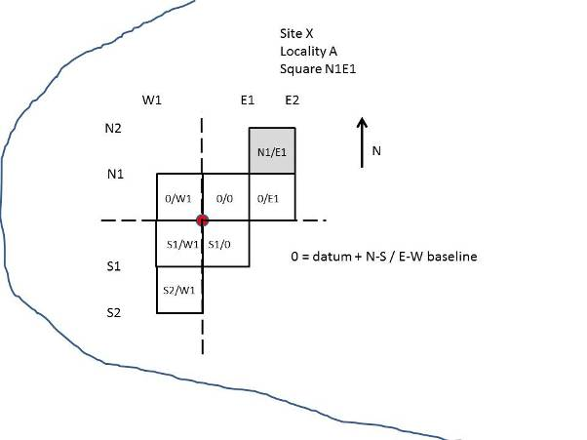
Figure 5-1: Schematic representation of test excavation reference system

Collections management
Collections management was done both on and off site. This included documentation, cataloguing, packaging, storage and cleaning of excavated material. Collections management complied with guidelines and minimum requirements provided by the Department of Anthropology and Archaeology of the University of South Africa (Unisa) – the legal repository as per permit requirements.
On site management included cleaning, sorting and packaging of excavated material according to material type. A site catalogue was compiled where provenance, material type, mass and quantity were described. Accession numbers were also allocated. Acid-free geological sample bags were used as containers in the field. Where charcoal was collected the samples were enclosed in tinfoil and placed in sample bags.
All excavated material was cleaned and repackaged by the Department of Anthropology and Archaeology, University of Pretoria (UP) in preparation for analyses and storage by Unisa. Cleaning of material only consisted of removing excess soil and dust. Diagnostic potsherds were cleaned by brief rinsing of sherds. No interventive or preventive conservation took place, other than ensuring that packing material was acid free and no destructive cleaning or sampling was done.

Analyses
Due to the relative small material culture sample that was collected, only two forms of analyses were done. A faunal analysis was undertaken by a postgraduate at the Department of Anthropology and Archaeology, UP specialising in archaeozoology, Mr Munyadziwa Magoma. The pottery was analysed by Mr Wim Biemond, a Botswana archaeologist familiar with the regional archaeology. Mr Biemond is also a postgraduate student at the Department of Anthropology and Archaeology, Unisa specialising in sites similar to those identified at Boikarabelo.

Literature review
The review that was undertaken mainly focused on providing a temporal and regional context of the Iron Age sites identified in the Phase 1 AIA (Fourie 2009). Subsequent to the Phase 2 mitigation, it was however expanded to include a brief review of the Stone Age.

Stone Age

Earlier Stone Age (ESA)
The ESA in southern Africa is defined by the Oldowan complex, first identified in the East African Rift Valley. In South African the primary Oldowan examples are found in the Cradle of Humankind World Heritage Site (Klein 2000; Kuman 1998). The predominant tool type is a more casual and expediently made form that consisted of rough cobbles and simple flakes. The flakes were used for activities such as skinning and cutting meat. The second complex found in the ESA is the more common Acheulean. Tools that were produced were large handaxes and cleavers produced by Homo species roughly 1.4 million years ago (Deacon & Deacon 1999). Acheulean artefacts are usually found near the raw materials from which they were quarried, butchery sites, or as isolated finds. Significant hominid evolutionary changes occurred during the later stages of the ESA, such as the appearance of Homo erectus/ergaster around 300 000 years ago with larger brain capacities.

Middle Stone Age (MSA)
The origins of culture and language are associated with the emergence of anatomical modern humans, Homo sapiens, during the MSA. The exponential increase in human cognitive abilities also manifested in the complexity of the stone tools created. Much larger tool diversity appears and relative homogeneity of tools is also found. The MSA is furthermore associated with the earliest symbolic actions such as personal ornamentation and art. What these concepts ultimately attest to is the development of abstract thinking (Henshilwood et al 2001). By the beginning of the MSA, tool kits included prepared cores, parallel-sided blades and triangular points that are hafted to make spears (Volman 1984). By 100 000 years ago the Homo species show clear evidence for cultural and anatomical modern behaviour. The more extensive use of caves as shelter and the controlled use of fire are also common during this period.

Late Stone Age (LSA)
The LSA is characterised by specialised tools and toolkits. In a southern African context, the LSA is closely associated with hunter-gatherer groups, such as the San and also their rock art. Rock art is considered to have inherent spiritual meaning and significant symbolic complexity (Lewis-Williams, 1981). LSA sites contain diagnostic artefacts, such as microlithic scrapers and segments. Due to the nomadic nature of LSA people, open sites are difficult to identify and usually poorly preserved. It is also within this period that the autochthonous groups came into contact with groups migrating into southern Africa. Initial contact was between hunter-gatherer groups and expanding Bantu-speaking farming societies and, secondly, with the arrival of European colonists along the coast.
The Stone Age archaeology around the project area has not been extensively researched. The best example of a Stone Age site is Olieboomspoort Shelter, approximately 60 km south-east of the project area. From this site, the ESA occupation is short, while the MSA occupation is extensive. It is followed by a long break in occupation until the early Holocene about 8000 years ago. Dates for the MSA occupation layers at Olieboomspoort have been calibrated to 20 187 CE. Felsite, quartz and other cryptocrystalline silicates were exploited as raw material throughout the MSA and LSA sequences identified in the Waterberg. ESA bifacial lithics were uncovered at Olieboomspoort, including a handaxe (Van der Ryst 2006).
The Later Stone Age of the area is characterised as part of the Wilton Industry. This industry is characterised by the use of small end scrapers and segments (Sampson 1974). The LSA of Olieboomspoort has a Wilton character (van der Ryst 2006). With the influx of herders and famers, the hunter-gatherer way of life had to adapt to a shared landscape. This resulted in a change in technology and forcing the hunter-gatherers to safe havens such as shelter localities (Van der Ryst 2006).
Table 6-1: Approximate date ranges for the three South African Stone Age periods
Industry | Period | Industries
ESA | c. 2.5 mya to 250 kya | Oldowan and Acheulean stone tools;  Associated with Homo habilis, H. erectus/ergaster
MSA | c. 250 kya to 22 kya | Various lithic industries that included bifacial handaxes, blades, prepared cores;  Associated with archaic Homo spp. and anatomical modern H. sapiens
ESA | c. 22 kya to recent  (contact with either Bantu-speaking communities or Europeans, but still practiced in certain places) | Specialised lithic industries that included microlithic tools, bladelets, arrowheads, composite tools;  Associated with modern H. sapiens (hunter-gatherers such as San)

Iron Age
The Iron Age as a whole represents the spread of Bantu-speaking people and includes both the pre-historic and historic periods. It can be divided into three distinct periods:
The Early Iron Age (EIA): Most of the first millennium CE.
The Middle Iron Age (MIA): 10th to 13th centuries CE
The Late Iron Age (LIA): 14th century to colonial period.
The Iron Age is characterised by the ability of these early people to manipulate and work metal ores into implements. In a southern African context the Iron Age immediately follows on the LSA, without intermediary stages found in North Africa, Europe and Asia (e.g. Neolithic, Copper Age and Bronze Age). As competition for resources intensified the territories of the hunter-gatherers were gradually encroached upon forcing them to move into more marginal areas. Metallurgy first appeared in a rather advanced state that permitted the smelting of copper and iron, emphasising current theory that metallurgy was introduced from elsewhere and did not develop locally. Movement of Iron Age communities are based on a process of ceramic seriation. Huffman (1970) and Phillipson (1977), for example, demonstrated via ceramic seriation that Iron Age groups moved southwards from a possible central homeland in three streams over different periods. Their hypotheses have since undergone significant reviews, as well receiving opposition. There remains however a general consensus regarding the movement of Bantu-speakers that can be reconstructed through ceramic seriation. These streams are associated with different Eastern Bantu groups as well as the different Iron Age periods.

Early Iron Age
The first certain appearance of Iron Age communities appear in southern Africa during the first half of the 1stmillennium CE. Important EIA ceramic facies relevant to this study are the Bambata (c. 150-650 CE), Diamant (c. 750-1000 CE) and Happy Rest (c. 500-750 CE) facies of the Kalundu tradition (Huffman 2007). These EIA people practiced a mixed farming economy. Knowledge research on the EIA has been hampered by uneven distribution of research and general poor preservation of these early sites.

Middle Iron Age
The archaeological sequence during the Middle Iron Age (MIA) is well known. Briefly, the Zhizo ceramic facies spread over south-west Zimbabwe, Botswana, and the Limpopo Valley (Huffman 1974). Thus far, the largest Zhizo site is Schroda, located on the southern bank of the Limpopo River. Schroda was also probably the first site in the interior directly connected to the East Coast ivory trade. Recent research (Smith 2005) indicates that the climate was similar to current climatic conditions. These data suggest that subsistence agriculture would have been difficult, and that Zhizo people probably moved into the basin specifically to hunt elephant. Thus, hunting for ivory facilitated the link with the East Coast trade (Hanisch 1980, 1981; Voigt 1983; Wood 2000, 2005). Some researchers believe that complex society could not have developed without the emergence of external trade. Trade allowed for the accumulation and control of wealth, which eventually lead to class distinction (Huffman 1982).
After approximately 100 years of political control, the Zhizo people abandoned Schroda. The Zhizo chiefdom relocated to Botswana where archaeologically it becomes known as Toutswe (Denbow 1982; Huffman 1982). New research shows that other Zhizo people remained in the valley and became the Leokwe group (Calabrese 2000a, 2005).
At the same time, K2 ceramics appear over a wide area (Fouche 1937). The K2 facies forms part of the Leopards Kopje cluster, made by the Western Shona (Huffman 1974, 1978, 1984). The Leopard’s Kopje cluster derives from the Doornkop facies to the south (Huffman 2007). The appearance of K2 coincided with favourable climatic conditions. Identified as a warmer and wetter period, known as the Medieval Warm Epoch (Smith 2005; Tyson & Lindsay 1992), cultivation of the Limpopo floodplain now became a viable option. In addition, K2 also took over control of the coastal trade, thus allowing for accumulation of wealth, increased population and craft specialisation (Huffman & Schoeman 2005).
Ultimately, K2 dominated the landscape and incorporated Leokwe. According to ceramic data, Leokwe consciously remained ethnically distinct (Calabrese 2005). During this time, K2 society began to change. Up to now, all sites, including K2, followed the Central Cattle Pattern (CCP) (Huffman 1982, 2000). With the accumulation of excess wealth and increased population, K2 society changed from one based on ranking to class distinction. Initially, the removal of cattle from the centre of K2 marks this change spatially. Later, the elite residence on top of Mapungubwe Hill (Gardener 1963) marks the manifestation of social classes and the beginnings of sacred leadership (Huffman 1982). Somewhat later, the first palace signifies the full development of scared leadership. By this time, Mapungubwe had become the first town and capital of the first state in southern Africa.

Late Iron Age
The LIA in the Shashe-Limpopo basin is considered to date from the 13th century CE after the abandonment of Mapungubwe. Climatic data suggests that this abandonment was related to climatic change marking the beginning of the ‘Little Ice Age’ (Tyson & Lindsay 1992, Huffman 1996).
Around 1500 CE two different facies derived from Icon (Moloko Branch) become visible in the archaeological record. The Letsibogo facies has been recorded in the Motloutswe drainage in Botswana and in the Blouberg in the Limpopo Province. The Madikwe facies has been recorded from the Makapansgat area west into Botswana. Stylistically these facies differ in terms of the decoration technique employed. Letsibogo emphasises punctates as opposed to stabs and fingernail impressions in Madikwe. Both these facies predate stonewalling ascribed to Sotho-Tswana speakers (Huffman 2007). These two facies form part of the Moloko Sequence, and are intermediate phases between the parent facies, Icon, and the later historical ceramic types, such as Buispoort, which later became associated with the western Sotho Tswana identity (Huffman 2007).
Within the study area, two significant migrations have taken place through the Iron Age. The two migrations represent different branches of the general southerly Bantu migration. The first migration forms part of the initial stages of the EIA Happy Rest sub- branch, while the second later migration through the area is from the Moloko sub-branch.
The first migration is considered the very first stages of what would eventually lead into the formation of centralised states such as Mapungubwe and, later, Great Zimbabwe. The Happy Rest facies is the first occurrence of the Kalundu Branch of the Iron Age in South Africa, and is the parent facies of both the Diamant and later Eiland ceramic traditions. Happy Rest is first found in the archaeological record around 500 CE, continuing until 750 CE (Huffman 2007). A subsequent shift into Diamant ceramics took place around 750 CE and it was accompanied by a westward shift in ceramic distribution. Diamant continues until the end of the first millennium CE (1000 CE), with the area of influence of the subsequent Eiland ceramics being broader, and stretching into Botswana to the west. Diamant eventually splits off into the Baratani and Eiland facies, with the Baratani facies far to the west and the Eiland facies slightly further to the north. The Eiland facies eventually stems into the Broadhurst facies at around 1300 CE (Huffman 2007). The Broadhurst facies indicates the end of the Happy Rest sub-branch in the region.

mitigation results
Only three sites were considered to have sufficient deposit and/or features present to conduct viable excavations. The remainder of the sites were mapped and each site tested randomly in areas where deposit could be expected by taking soil samples using a 150 mm auger.

Site 009/010

SAHRA Permit Requirements: Mapping and Test Excavations

Mitigation completed: Shovel Test Pits and Mapping
Site 009 was found to be part of Site 010. The extent of the site was determined by feature mapping as well as random and stratified sampling. Plan 5 illustrates the site extent and the localities where STPs were excavated. The site extent was determined to be approximately 7 ha.
At Locality A STPs (100 cm x 50 cm) were excavated at 10 m intervals and oriented north-south, incorporating features presumed to be grain bin foundations. In total, nine STPs were dug at Locality A. STPs were excavated at Locality B (Site 010 in the Phase 1 AIA) arranged in 5 m intervals north-south and east-west around a very large (>30 m²) disturbed area. In the Phase 1 report this area was described as consisting of ash lenses and possible midden deposit. However, no such evidence was found during the mitigation. This may be due to the fact that the area was still actively used by burrowing animals such as aardvark. Random auger samples were also taken in parts of the site where deposit could be expected, such as the relative centre of the site, around the stone features and in relative undisturbed areas adjacent to burrows where artefactual material was exposed. None of these auger test points (ATP) found evidence of any significant deposit.
The stratified STP sampling at Locality A did not yield any significant results. Small fragments of pottery were found in some of the STPs. These fragments were found at a relatively shallow depth within the first 150 mm of soil. The STPs were excavated until a visible change in soil type, texture and colour was observed. This layer was determined to be archaeological sterile, consisting of the Ah land type that contained red well-drained high base status soils. The Hutton soil form is the dominant soil in this land type. According the Smith (2010) the soils are non-structured with a clay content of 6% to 12%. The depth of this sterile layer was approximately 300 mm throughout the STPs at Locality A.
At Locality B, the stratified STPs sampling around the burrows exposed a fairly large sample of fragmented pottery. Comparative to Locality A, the average depth where these artefacts were found ranged from 50 mm to 200 mm below surface. However, this difference in depth can be attributed to soil being periodically deposited on the surface due to burrowing activities. A sterile layer similar to that found at Locality A was noted at an average depth of 300 mm to 400 mm below surface. Taking into account the slight gradient between Locality A and B, as well as the soil deposited at Locality B by animal burrowing activities, the depth of this sterile layer corresponded to the same layer at Locality A.
The presence of several relatively large pottery clusters found in the STPs at Locality B may indicate that some type of midden deposit does indeed exist. In spite of this, negligible faunal remains and no other material culture were recovered – probably due to the extensive nature of the burrows. The proposed test excavations were thus not undertaken, as no deposit was found where viable and meaningful excavations could be undertaken.
The predominant artefacts collected from Site 009 were pottery fragments described in more detail below. As stated above, Sites 009 and 010 were found to be a single large site. Site 009 is therefore referred to as Locality A and Site 010 as Locality B of Site 009.
A negligible sample of faunal remains was recovered from Site 009. No diagnostic remains were identified. Teeth fragments were excavated but these were too small to be diagnostic.
Charcoal was found in some of the STPs from Site 009 Locality B. However insufficient context could be established and the sample was too small for radiocarbon analysis.

Pottery analysis

Locality A
The specialist report (Biemond 2012) examined 17 (14%) rim sherds and 122 (100%) undecorated sherds recovered from the STPs and summarised in Table 7-1. All sherds were blackened from soot and therefore are interpreted to be part of cooking vessels. Only two vessel types could be identified from the sherds as described in Table 7-2 and illustrated in Figure 7-1 (five jars and two constricted jars).
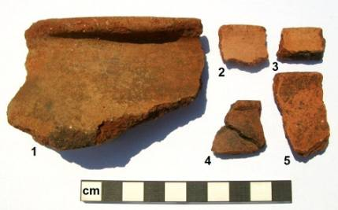
Figure 7-1: Identified vessels from site 9 Locality A. Numbers 1, 4 and 5 were identified as jars and numbers 2 and 3 as constricted jars (Biemond 2012)

Locality B
The specialist report (Biemond 2012) identified 27 (11%) rim sherds and 239 (100%) undecorated sherds recovered from the STPs. A total of 18 (8%) highly burnished sherds, 203 (84%) burnished sherds and 18 (8%) unburnished sherds were found, summarised in Table 7-1 below. Fourteen sherds were blackened from use on a fire and are therefore interpreted to be part of cooking vessels. Only two vessel types (two jars and seven constricted jars) could be identified from the sherds as described in Table 7-2 and illustrated in Figure 7-2. Three sherds had evidence of red ochre applied to the vessel exteriors.
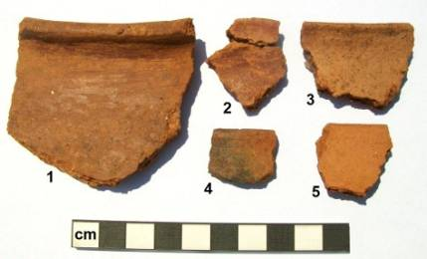
Figure 7-2: Identified vessels from site 9 Locality B. Numbers 1 and 4 were identified as jars and numbers 2, 3 and 5 as constricted jars (Biemond 2012)
Table 7-1: Summary catalogue of the excavated ceramic Sherds from Site 09 Localities A and B (Biemond 2012)
_{Trench} | _{Rim Sherds} | _{Decorated Sherds} | _{Undecorated Sherds} | _{Soot Blackened} | _{HB} | _{B} | _{UB} | _{Total Sherds} |  | _{Sherds < 1cm}
_{Locality A}
_{L2/1} | ₁₀ |  | ₈₂ | ₃ |  | ₈₂ |  | ₈₂ |  | ₄₆
_{L2/3} | ₁ |  | ₂ |  |  | ₂ |  | ₂
_{STP 4} | ₁ |  | ₁₂ |  |  | ₁₂ |  | ₁₂
_{STP 5} | ₁ |  | ₄ |  |  | ₄ |  | ₄ |  | ₃
_{STP 6} | ₃ |  | ₂₁ |  |  | ₂₁ |  | ₂₁
_{STP 7} | ₁ |  | ₁ |  |  | ₁ |  | ₁
_{Total-n} | ₁₇ |  | ₁₂₂ | ₃ |  | ₁₂₂ |  | ₁₂₂ |  | ₄₉
_{Total%} | ₁₄ |  | ₁₀₀ |  |  | ₁₀₀ |  | ₁₀₀
_{Locality B}
_{10#2} | ₁₅ |  | ₁₇₀ | ₃ | ₁₁ | ₃ | ₁₅₉ | ₈ | ₁₇₀ |  | ₈₅
_{10#3} | ₁₂ |  | ₆₉ |  | ₃ | ₁₅ | ₄₄ | ₁₀ | ₆₉
_{Total-n} | ₂₇ |  | ₂₃₉ | ₃ | ₁₄ | ₁₈ | ₂₀₃ | ₁₈ | ₂₃₉ |  | ₈₅
_{Total%} | ₁₁ |  | ₁₀₀ | ₁ | ₆ | ₈ | ₈₄ | ₈ | ₁₀₀

HB – Highly Burnished B – Burnished UB – Unburnished
Table 7-2: Analysis of the identifiable vessel types from Site 09 Localities A and B (Biemond 2012)
Trench | Vessel type | Undecorated | Decorated | Total n
Locality A
L2 | Jars | 5 |  | 5
L2 | Constricted jars | 2 |  | 2
 | Total n | 7 |  | 7
Locality B
10#2 | Jars | 1 |  | 1
10#2 | Constricted jars | 2 |  | 2
10#3 | Jars | 1 |  | 1
10#3 | Constricted jars | 5 |  | 5
 | Total n | 9 |  | 9
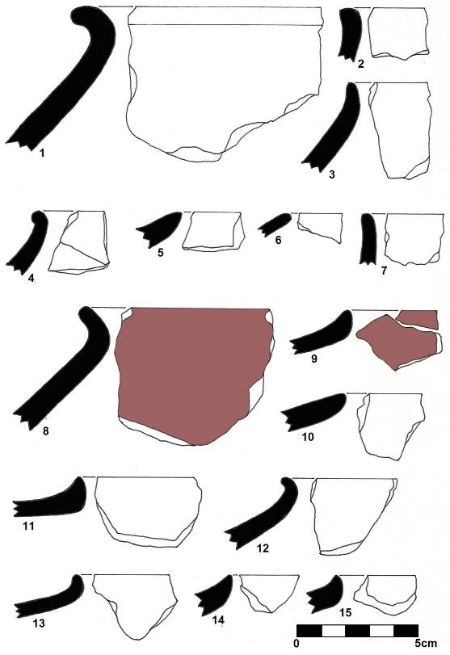
Figure 7-3: Illustrated profiles and sketches of identified vessels from site 9 Locality A (1-6), Site 9 Locality B (7-11 and Site 011 Locality B (12-13). Jars are represented by numbers 1-4, 7, 8 and 12. Constricted jars are represented by numbers 5, 6, 9-11 and 13-15 (Biemond 2012)

Site 011

SAHRA Permit Requirements: Shovel Test Pits

Mitigation completed: Shovel Test Pits, Test Excavations and Mapping
Site 011 was initially indicated as a small site with only limited surface features present. However, we subsequently established that the site was much more extensive and that the part identified merely represented a single grain bin of the much larger site. The approximate site boundary was established to be at least 13 ha, as indicated in Plan 6. It was therefore decided to extend the proposed mitigation measures (see Fourie 2009) to include test excavations and mapping.
A datum was established in the relative centre of the site from which STPs were excavated. These were done at 20 m intervals over 200 m from the approximate centre of the site along north-south and east-west baselines. Two localities were also excavated.
In total 20 STPs were excavated across the site. The average depth of the pits was 300 mm where soil changes became apparent, similar to those noted at Site 009 (cf. Smith 2010). Only small pottery fragments were found within the initial 100 mm of soil. These were too small for any diagnostic analysis. Neither cattle dung nor any midden deposits were found. In order to determine whether any possible deposit was excluded, auger samples were taken at 10 m intervals along the two baselines as well as randomly at various other presumed grain bin platforms. These samples also did not expose any deposit.
The two localities that were excavated both included concentrations of stones presumed to be grain bin platforms. The features were chosen due to the perceived primary context of each (stones platforms arranged in regular patterns, mostly in situ and the presence of broken lower grindstones). The relationship relative to the distance between each also provided a measure of control in interpretation, which will be explained in more detail below. The two features were furthermore selected in terms of potential analytic cultural and organic material, such as floors and house rubble, possible carbonized grains, charcoal, beads and other artefacts in lieu of any visible midden or other deposit.

Locality A
Initially a square grid of 25 m² was set out over the grain bin platform as illustrated in Figure 7-7. The exposed feature was recorded and mapped before all surface material was collected by sieving using a compartmented screen. The sieve comprised an upper 10 mm x 10 mm diamond mesh and a lower 2 mm x 2 mm galvanised mesh. After surface cleaning, the feature was excavated in arbitrary 50 mm spits as no stratigraphy was observed. In total, five spits (250 mm) were removed from various squares. Squares were abandoned when no artefacts, organic or faunal material, features, structures or deposit were found.
The stone platform seemed to be in situ throughout the first two to three spits as shown in Figure 7-4 and . Below this, changes in soil became evident. The soil character changed to a homogenous red sandy loamy textured soil with practically no inclusions larger than 2 mm², indicating floodplain soil overlain with Kalahari windblown sand. This was found to be consistent with the specialist soil report undertaken as part of the environmental impact assessment (Smith 2010). This hard compact layer was excavated as a unit to a depth of over 300 mm at the conclusion of the test excavation. It was determined to be culturally sterile consistent with the soil layers identified in the STPs.
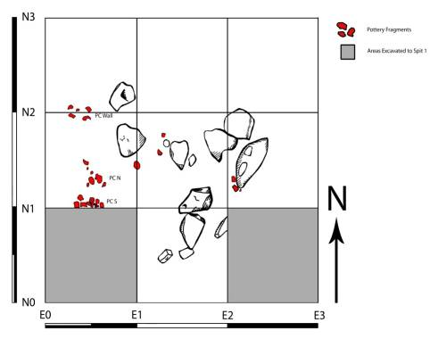
Figure 7-4: Sketch map of test excavation of Locality A, Site 011, spit 2 (100 mm level) indicating shape and size of grain bin platform
The predominant material culture was pottery, although a small sample of faunal material was also collected. The fauna however was too fragmented to analyse other than a very tentative result that to mammal remains. The species and size range could not be determined.
The pottery sample from Site 011 was too small to determine any relative age or site identity. However, based on surface samples collected throughout the Boikarabelo project area it can tentatively be inferred that the site may fall within a Sotho-Tswana Kwena and/or Ngwato ceramic tradition from the late 17th to late 18th centuries CE (Biemond 2012).
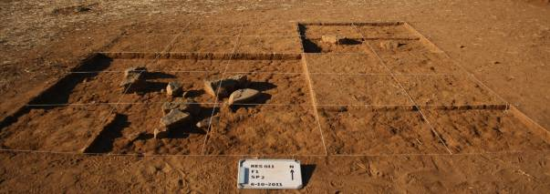
Figure 7-5: Site 011, Locality A indicating the remains of the stone grain bin platform. The nine squares from the lower left hand corner are illustrated in Figure 7-4 above. Note the relative homogeneity of the soil from the surface to lower levels of the excavation (200 mm)

Locality B
The excavation method at Locality B was the same as at Locality A. A square grid of 9 m² was set out over the feature as illustrated in Figure 7-6. The exposed feature was also recorded and mapped after which all surface material was collected by sieving. Arbitrary 50 mm spits were used as this feature also displayed no stratigraphy. Three spits (150 mm) were excavated for all nine squares. The three southern squares were deepened by another spit to a depth of 200 mm.
Feature 2 consisted of roughly equal-sized stones arranged in a circular pattern about 100 cm in diameter. Again, artefacts collected were mainly pottery fragments and fauna remains too fragmented for analyses. A small concentration of charcoal was found in spit 2 (100 mm). This was collected but it was too small and out of context to consider submitting it for radiocarbon dating.
Below 150 mm soil changes occurred as at Locality A. This hard compact layer was also excavated as a unit in one square to a depth of over 300 mm. This was also a culturally sterile consistent with the soil layers identified in the STPs.
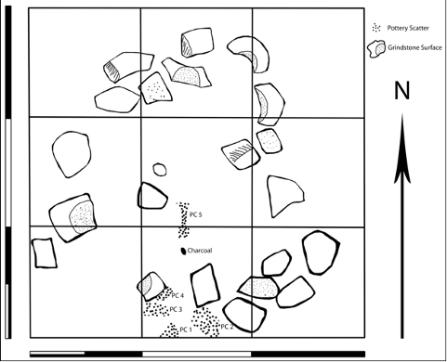
Figure 7-6: Site 011, Locality B, spit 2 (100 mm level): Note the occurrence of broken lower grindstones and pottery scatters
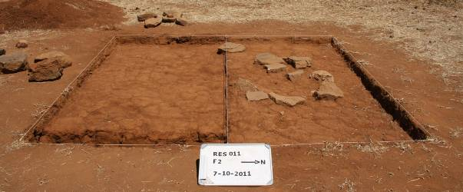
Figure 7-7: Site 011, Locality B after removal of the southern half of the feature. Note again the relative homogeneity of the soil from the surface to lower levels of the excavation (200 mm). Also note the absence of any visible archaeological deposit or other remains

Pottery analysis
The majority of the projects ceramic assemblage was recovered from Site 011. According to the specialists report (Biemond 2012), 41 (10%) rim sherds, 3 (1%) decorated sherds and 400 (99%) undecorated sherds were recovered from the excavation. A total of 360 (89%) burnished sherds and 43 (11%) un-burnished sherds were recovered. Table 7-3 provides a summary of the total number of sherds. Nineteen sherds were blackened by fire and are therefore interpreted to be part of cooking vessels.
Table 7-4 summarises the two vessel types that were identified from the assemblage: nine jars and one constricted jar shown in Figure 7-3 above.
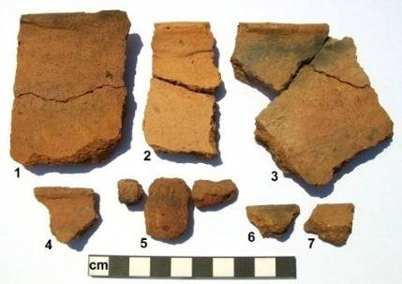
Figure 7-8: Vessels identified from site 11 including jars (numbers 1-4) constricted jars (numbers 5-7) (Biemond 2012)
A range of artefacts and other material was found at Site 011 that included possible ochre, faunal remains, shell, metal fragments, charcoal, and lithics. The ochre was excavated from around the possible grain bin platforms. The metal fragments were of a very small and could not be identified visually as any specific artefact. The shell was identified as fresh water mussel. The remainder of the faunal sample was too fragmented for feasible analysis.
Although charcoal was found at Locality B the context and sample size were too little for radiocarbon analysis. The lithics uncovered include a fine-grained sandstone broken medial bladelet, a fine-grained quartzite broken medial flake, a weathered fine-grained quartzite MSA flake and quartz flake.
Table 7-3: Summary catalogue of the excavated ceramic sherds from Site 011 Localities A and B (Biemond 2012)
Trench | Rim Shards | Decorated Shards | Undecorated Shards | Soot Blackened | HB | B | UB | Total Shards | Shards < 1cm
F1N2/1 | 1 | 2 | 7 |  |  | 7 | 2 | 9
F1N2/2 | 4 | 1 | 25 | 1 |  | 23 | 3 | 26 | 2
F1N2/3 | 1 |  | 23 | 2 |  | 13 | 10 | 23 | 7
F1N3/1 | 4 |  | 69 |  |  | 59 | 10 | 69 | 21
F1N3/2 | 10 |  | 43 |  |  | 37 | 6 | 43 | 13
F1N3/3 | 4 |  | 42 |  |  | 35 | 7 | 42 | 4
F1N4/2 | 9 |  | 20 |  |  | 20 |  | 20
F2P2 | 2 |  | 54 | 3 |  | 50 | 4 | 54
F2P4 | 3 |  | 16 |  |  | 16 |  | 16 | 2
F2/2 | 2 |  | 31 | 1 |  | 31 |  | 31 | 6
F2/2 | 1 |  | 70 | 12 |  | 69 | 1 | 70 | 16
Total-n | 41 | 3 | 400 | 19 |  | 360 | 43 | 403 | 71
Total% | 10 | 1 | 99 | 5 |  | 89 | 11 | 100
HB – Highly Burnished B – Burnished UB – Unburnished
Table 7-4: Analysis of the identifiable vessel types from Site 09 Localities A and B (Biemond 2012).
Trench | Vessel type | Undecorated | Decorated | Total n
F1 | Jars | 5 |  | 5
F1 | Constricted jars | 1 | 1 | 2
F2 | Jars | 4 |  | 4
 | Total n | 10 | 1 | 11

Site 021

SAHRA Permit Requirements: Shovel Test Pits

Mitigation completed: Test Excavations and Mapping
Site 021 and 022 was found to be a single site, and represented the only site recommended for mitigation that had clear evidence of a viable deposit. Three localities were therefore excavated in lieu of the recommended STPs as indicted in Plan 10. All three localities consisted of ash deposits. The aim was to obtain material that could be used for dating and to determine some cultural affinity. This was also the only site where faunal remains were found.
The excavations at site 021 were undertaken in the relative centre of Site 021 where an ash deposit occurred. The test excavations were described as Locality A/Feature 1, Locality B/Feature 2 and Locality C/Feature 3.
Localities A and C were excavated in single 1 m x 1 m square grids each. Locality A was excavated in three 50 mm spits to a depth of 150 mm and then abandoned as the deposit yielded negligible results. Locality C was excavated in six 50 mm spits to a depth of 300 mm. This deposit here also presented little to no viable material and the excavation was abandoned.
The grid at Locality B was extended 1 m x 2 m to include a seemingly good deposit as indicated by animal burrowing activities. The excavation was however completed in two spits (100 mm). The three localities indicated that the average deposit depth at Site 021 was less than 300 mm, when sterile soil was reached. The sterile layer was consistent with that identified at Sites 009 and 011, although Site 021 was located above the calcrete ridge to the north of the former sites.
Localities A and B consisted of two stratigraphic layers as indicated in Figure 7-9 and Figure 7-10. Only a single stratigraphic layer was identified at Locality C.
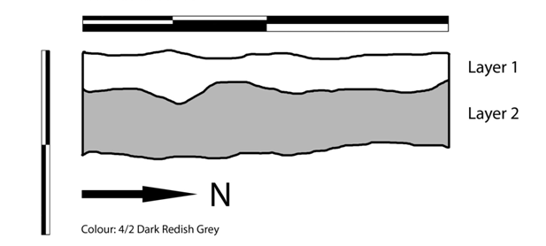
Figure 7-9: RES 021 Locality A section plan
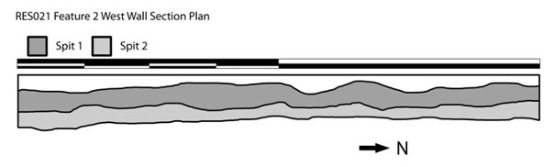
Figure 7-10: RES 021 Locality B section plan
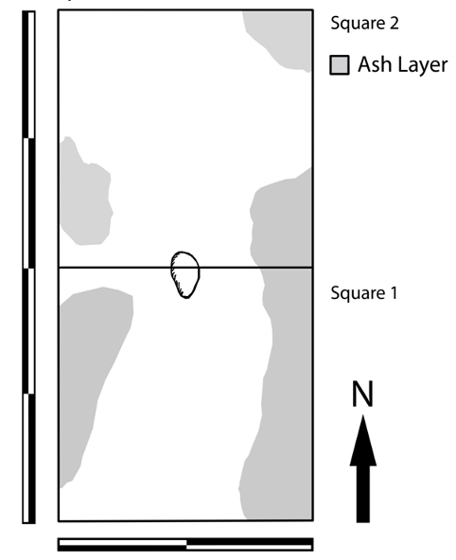
Figure 7-11: RES 021 Locality B Spit 1
This site produced the only viable faunal sample for analysis as well as a relative good pottery sample. Two special finds were also recovered – a copper wire bead (Figure 7-12) and a carved soapstone pipe bowl (Figure 7-13 and Figure 7-14). The cultural material was mainly found in Locality B.
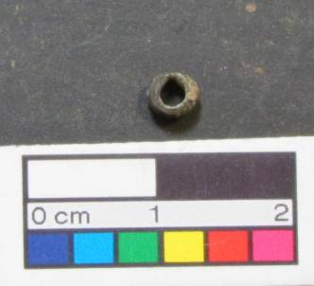
Figure 7-12: Wire-drawn metal bead recovered from Site 021 Locality B. Note the clamped closure ends
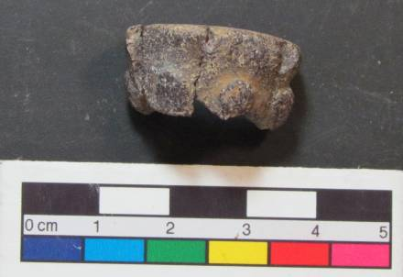
Figure 7-13: Side profile of soapstone pipe bowl from Site 021 Locality B. Note raised decorative motif
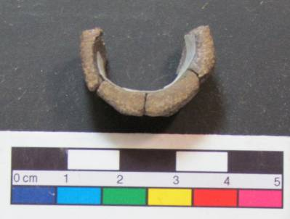
Figure 7-14: Cross section of pipe from Site 021.

Pottery analysis
Table 7-5provides a summary of the pottery analysed (Biemond 2012). In total 9 (3%) rim sherds and 336 (100%) undecorated sherds were recovered from the excavation. A total of 54 (16%) highly burnished sherds, 228 (68%) burnished sherds and 54 (16%) unburnished sherds were also identified. Twenty sherds were blackened by fire and are interpreted to be part of cooking vessels.
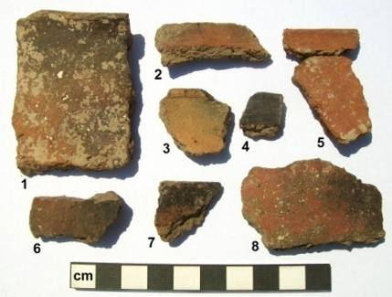
Figure 7-15: Vessels identified vessels from site 21. Numbers 1 and 2 constitute jars, 3-5 and 7 constricted jars and number 8 was considered to be bowl fragment with red ochre on the exterior. Sherd 6 had an abraded edge and may have been used as a moulding tool (Biemond 2012)
Four sherds were coloured with red ochre on the outside. Potsherd 6 in Figure 6 has an abraded edge and was probably used as a pot moulding tool.
Three vessel types were identified from the assemblage: seven jars, one constricted jar, and one bowl (cf. Figure 7-15 and Figure 7-16).
Table 7-5: Summary catalogue of the excavated ceramic sherds from Site 021 Localities A, B and C (Biemond 2012)
Trench | Rim Shards | Decorated Shards | Undecorated Shards | Red Ochre | Soot Blackened | HB | B | UB | Total Shards | Shards < 1cm
F2/1/1 | 7 |  | 132 | 3 | 4 | 16 | 93 | 23 | 132 | 12
F2/2/1 | 2 |  | 53 | 1 | 6 | 6 | 35 | 12 | 53 | 8
F2/2/2 |  |  | 65 |  | 8 | 3 | 50 | 12 | 65 | 2
F3 |  |  | 86 |  | 2 | 29 | 50 | 7 | 86 | 10
Total-n | 9 |  | 336 | 4 | 20 | 54 | 228 | 54 | 336 | 32
Total% | 3 |  | 100 | 1 | 6 | 16 | 68 | 16 | 100
HB – Highly Burnished B – Burnished UB – Unburnished

Table 7-6: Analysis of the identifiable vessel types from Site 21
Trench | Vessel type | Undecorated | Decorated | Total n
F2 | Jars | 5 |  | 5
F2 | Constricted jars | 1 |  | 1
F2 | Bowl | 1 |  | 1
F3 | Jars | 2 |  | 2
 | Total n | 9 |  | 9

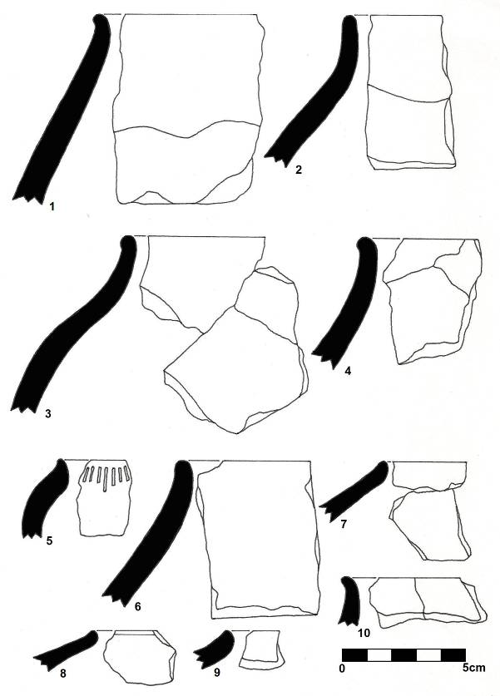
Figure 7-16: Illustrated profiles and sketches of identified vessels from Sites021. Numbers 6-10 represent vessels from Site 021. The remainder are from Site 021 and include jars (numbers 6 and 10) and constricted jars (numbers 7-9) (Biemond 2012).

Lithic material
Lithics collected were fine-grained quartzite products: a flake, two broken flakes and a rejuvenated flake core. Lithics produced from cryptocrystalline silicates (CCS) included a broken flake, two battered pieces and one rejuvenated flakes core. A single notched flake of hornfels was also found.

Faunal analysis
The faunal analysis was adapted from Driver’s (1999) method. Faunal remains from each excavated site were counted, weighed and then divided into identifiable and non-identifiable samples. Remains in the identifiable group were further grouped in terms of taxonomy, animal size and age. Taxonomic analysis attempted to classify specimens into possible species range, for example sheep/goat, cattle or antelope. Where taxonomic classification was not possible, specimens were analysed according to size range. The accepted standard for mammal faunal remains refers to bovine size that is Bov I to Bov IV. This classification refers to relative size of the animal compared to a baseline or type species as described in Table 7-7 below. Alternatively, animal size was described in simple small, medium or large categories.
Table 7-7: Description of mammal size in terms of bovine classes.
Bovine class | Type mammal | Other examples
Bov I | Oribi (Ourebia ourebi) | Duiker
Bov II | Sheep/goat (Ovis/Capra) | Impala
Bov III | Cattle (Bos taurus) | Kudu
Bov IV | Buffalo (Syncerus caffer) | Eland
Age determination of individuals was also attempted. Very general age groups were used: mature, immature and unknown. Age was determined based on epiphyseal fusion, i.e. whether or not and to what extent the epiphyses (generally the extremities of long bones such as legs or arms) have fused with the shafts.
The unidentifiable sample was surveyed for taphonomic attributes. Taphonomy refers to mode and effects of deposition on the faunal remains. Use wear and modification were also considered during analysis. Faunal remains were investigated for cut or chop marks, evidence of burning, and modification (for example bone needles or awls). Actual body size was not considered as no complete skeletal remains were present.
The total sample available for analysis was 1752. Less than 2% of this was identifiable. Although this low number was considered unusual, it was probably due to relatively short periods of occupation and taphonomic processes including poor preservation. In general, archaeological deposits were superficial. Midden deposit was only found at one site (Site 20) that was subsequently excavated. No faunal remains were found in any of the other excavated locations. Furthermore, evidence suggested that occupation of the various sites were all single-event occupations with no discernible stratigraphy.
Identifiable specimens were limited to 29 individual pieces in total. Only seven pieces were identified at species level, whilst the remainder (22) were described either in terms of bovid or mammal. The nominal number of identifiable bones in the sample necessitated a descriptive approach to the analysis. Furthermore, calculation of Minimum Number of Individuals (MNI) and (Number of Identified Specimens) NISP were not possible.
Taxonomically, two mammal and one reptile species were identified. The mammals were deemed to be cattle (probably Bos taurus) and an undetermined rodent species. The reptile was considered to be a type of tortoise, but could not be identified to species level. The majority of the identifiable sample indicated the presence of Bov II and Bov III types of mammal. This could indicate the presence of domestic sheep/goats and cattle. This result is expected given the general spatial, temporal and cultural context of the site. The absence of game species in the identifiable sample may suggest that animals were hunted and butchered at the kill site, and only parts brought back to the settlement.
Animals known to have existed in the region, but that were not identified at species level, included domestic sheep and/or goat, as well as antelope species, elephant, buffalo and most plains game species currently found naturally in similar habitats. Again, taphonomic processes probably explain the lack of representative species under circumstances not conducive to preservation.
The tortoise remains are not unexpected. It is an easily collected and important food source. In addition, tortoises may be associated with various activities including rituals such as rainmaking, the carapace scales were used as decoration and the empty shell served as a container. The rodent remains are insignificant.
Notably the bovid sample (Bov II and Bov III) consisted of few specimens that could be identified as mature animals. This may comment on class or social stratification, as young animals may have been the preferred choice for consumption by a particular part of the society. Due the fragmented nature of the sample, sex determination could not be done.
Little evidence of cut or chop marks were visible on the entire sample, probably also on account of the fragmented nature of most of the remains. However, 70% of the faunal sample showed localised burning. As a rule, localised burning on bone suggests meat being cooked on open coals or fire. Bones that were burnt to black or grey may in turn suggest that refuse was intentionally burnt. However, middens may also be accidentally set alight when burning embers are discarded. The evidence is therefore not conclusive for any intentional burning of midden deposits. In fact, the relative lack of ash deposits at any the sites would rather suggest accidental burning.
Analysis of the faunal remains indicated the predominant presence of Bov III-size animals – cattle – that seem to have been the preferred meat source. This in turn suggests a pastoral element to the site, where domesticated cattle were readily kept and available for slaughter. Protein was likely supplemented by hunting game and collecting smaller animals such as tortoises.

Surface material
A small surface collection was made during the PI visit and included diagnostic potsherds and lithics. The diagnostic pottery is described in more detail in the ceramic analysis report appended as Appendix B. A brief summary is provided as a very tentative and relative social and temporal context for the Boikarabelo cultural landscape. Some of the surface pottery can be attributed to early Moloko and Letsibogo facies based on stylistic and decorative analysis (Biemond 2012).
Two jars and a single bowl were identified from sherds collected from Site 27 (Figure 7-18). The vessels can be placed into vessel types 2, 3 and 4 illustrated in Figure 7-18 (Bremond 2012).
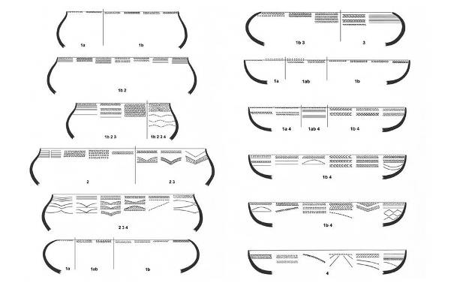
Figure 7-17: Stylistic representation of Early Moloko vessel shapes (Biemond 2012).
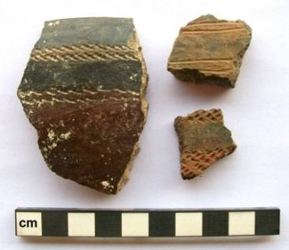
Figure 7-18: Early Moloko facies pottery collected from the surface of Site 027 (Biemond 2012)
Seven vessels (six jars and one bowl) were identified to the Letsibogo facies from four sites namely Sites 012, 013, 018, 019 (see Figure 7-19 and Figure 7-21). Three additional sherds were collected that also fit the Letsibogo facies. The vessels were considered to represent four decoration types as described in Figure 7-20 below.
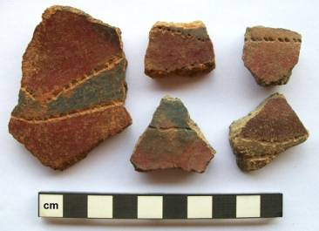
Figure 7-19: Examples of Letsibogo facies pottery collected from surface
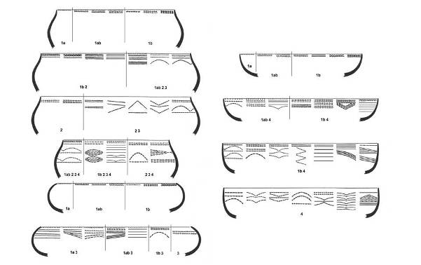
Figure 7-20: Stylistic representation of Letsibogo vessel shapes (Biemond 2012)
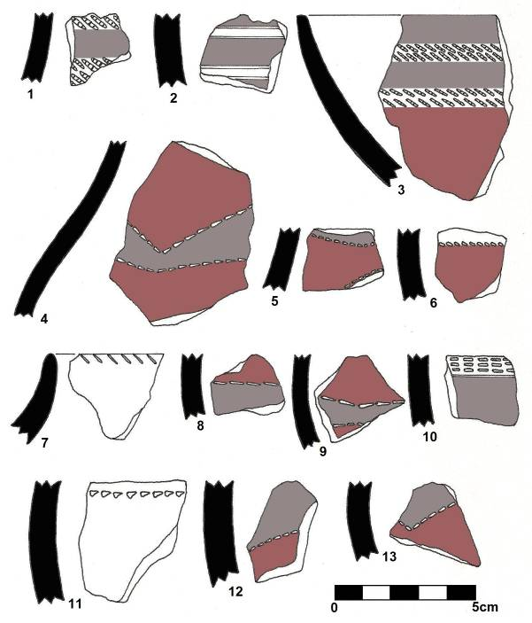
Figure 7-21: Early Moloko facies (numbers 1-3) and Letsibogo facies (numbers 4, 5, 7,8-12) pottery collected from the surface of Site 027 (Moloko) and Sites 012, 013, 018, 019 (Letsibogo). Sherds 6, 9 and 13 have no provenance.
Some lithics were identified from random surveys conducted by the specialist within the project area. These lithics include three flakes (two produced from hornfels, one from fine-grained quartzite), two MSA points (one produced from hornfels and one from sandstone), one hornfels side scraper, one ESA handaxe, and one awl produced from banded ironstone.

Site significance ratings
The significance ratings provided in the Phase 1 AIA were reviewed and reassessed following the mitigation of the sites. Thirteen sites were reviewed with their field ratings and statements of significance subsequently falling in the General Protected category as Grade IV A, B and C sites.
In total, eight sites were rated as General Protected: Field Rating IV C. Three sites were rated as General Protected: Field Rating IV B where additional further recording may be necessary. Only two sites were rated as General Protected: Field Rating IV A requiring further mitigation before destruction. Of these, Site 004 won’t be impacted on by current proposed activities. This site is recommended for preservation and monitoring.
Table 8-1: Review of recommended site significance ratings post mitigation
Site number | (A) Importance to community or pattern in country's history | (B) Possession of uncommon, rare or endangered natural or cultural heritage aspects | (C) Information potential | (D) Importance in demonstrating principle characteristics | (E) Importance in aestheitc characteristics | (F) Degree of techinical / creative skill at a particular period | (G)Association to community or cultural group for social, cultural or spiritual reasons | (H)Association with life or work of a person, group or organisation of importance in the history of the country | (I) Site of significance relating to history of slavery | Site significance rating | Statement of Significance
Site 002 | 1 | 1 | 2 | 1 | 1 | 1 | 3 | 1 | 1 | 12 | GP IV C
Site 003 | 1 | 1 | 2 | 1 | 1 | 1 | 1 | 1 | 1 | 10 | GP IV C
Site 004 | 3 | 1 | 5 | 3 | 3 | 1 | 3 | 1 | 1 | 21 | GP IV B
Site 009 | 2 | 1 | 3 | 2 | 1 | 1 | 3 | 1 | 1 | 15 | GP IV C
Site 011 | 2 | 1 | 5 | 2 | 1 | 1 | 3 | 1 | 1 | 17 | GP IV B
Site 014 | 2 | 1 | 3 | 2 | 1 | 1 | 3 | 1 | 1 | 15 | GP IV C
Site 017 | 2 | 1 | 5 | 2 | 1 | 1 | 3 | 1 | 1 | 17 | GP IV B
Site 018 | 1 | 1 | 1 | 1 | 1 | 1 | 1 | 1 | 1 | 9 | GP IV C
Site 019 | 1 | 1 | 1 | 1 | 1 | 1 | 1 | 1 | 1 | 9 | GP IV C
Site 020 | 1 | 1 | 1 | 1 | 1 | 1 | 1 | 1 | 1 | 9 | GP IV C
Site 021 | 2 | 1 | 7 | 3 | 3 | 1 | 3 | 1 | 1 | 22 | GP IV B
Site 024 | 1 | 1 | 1 | 1 | 1 | 1 | 1 | 1 | 1 | 9 | GP IV C
Site 027 | 1 | 1 | 1 | 1 | 1 | 1 | 1 | 1 | 1 | 9 | GP IV C
Site N028 | 4 | 3 | 7 | 3 | 1 | 1 | 3 | 1 | 1 | 24 | GP IV A
Site N029 | 3 | 2 | 7 | 5 | 1 | 4 | 1 | 1 | 1 | 25 | GP IV A

Site Mapping
Sites were mapped to include all visible features in order to determine approximate site boundaries. Coordinates were taken where surface material was visible. Based on results from the mitigated sites, a buffer of 50 m was created for management purposes.
Site 004 was not initially recommended for mitigation. However this site was found to be much larger in extent and was subsequently mapped. The site is located outside the current proposed mining operations as illustrated in Plan 12.
Plan 4: Site 004 indicating approximate site boundary, grain bin platforms and potential extent of household units, and central space that may have included a cattle enclosure
Plan 5: Site 009 indicating positions of STPs, grain bin platforms and approximate site boundary
Plan 6: Site 011 indicating positions of STPs, test excavations, grain bin platforms and approximate site boundary
Plan 7: Site 013 (including site 012) showing location of visible grain bin platforms and relative site extent
Plan 8: Site 014 indicating approximate site boundary, grain bin platforms and potential extent of household units and central space that may have included a cattle enclosure
Plan 9: Sites 018 and 019 with location of cattle deposit and approximate site boundary
Plan 10: Sites 021 indicating approximate site boundary and test excavations
Plan 11: Location of sites on 1: 50 000 topographical map sheet indicating sites in relation to each other. Note that mitigated and/or mapped sites are differentiated from site points with buffers

DISCUSSION OF RESULTS
The archaeological record at Boikarabelo has an exceedingly deep time depth. Evidence of ESA occupation was found, and a continuation into the Later Stone Age can be argued for based on the widespread occurrence of MSA to LSA lithic artefacts. Although not unique in terms of southern Africa, the Stone Age sequence in the wider project area remains relatively unknown as seen in the general lack of available research describing the area. Furthermore, the presence of ESA and MSA material in potentially dateable calcrete deposits is an important factor that must be considered in terms of future research potential. These sites however fell outside the ambit of this study and will not be discussed in more detail, but recommendations have been made for at least one dedicated Stone Age mitigation project as part of the management plan.
No evidence for Early Iron Age occupation has been found, although the potential remains that sites from this period similar to ones occurring north of the Limpopo River may be present. In general, the Iron Age record indicated a relatively recent occupation that may be associated with Sotho-Tswana speaking communities. Probable dates may be between the late 1600s to late 1800s, and possibly even extending into the early 20th century CE. Much of the interpretation and discussion of the identified and mitigated sites are inferred from similar sites identified by Biemond in Botswana in similar landscapes, although some significant differences have been recognised.
Overall, occupation seemed to be brief at all sites. Noticeable stratification in terms of deposit was limited or absent. Grain bin foundations were generally found on the surface and up to very shallow (<200 mm) subsurface depths. Very few were grain bin foundations were intact and foundation stones were scattered in an average radius of 2 m to 5 m.
Except at Site 027, no evidence of household structures or features such as floors, daga, hearths or middens were found. Apart from structural features in the form of grain bin remains positioned around a central open space, no deposit indicating the presence of central cattle kraals was evident at any sites other than at the additional identified Site N028 and the assumed cattle outpost at Site 018/019. A relative scarcity of diagnostic pottery found in context of sites (i.e. not surface finds) limited positive assignment in terms of relative age and the occupational history of the sites. The low levels of artefactual material also reflect the ephemeral nature of the sites.
Based on current knowledge of Late Iron Age socio-political organisation – excluding Great Zimbabwe and associated traditions – the sites do seem to conform to horizontal stratified societies, typical of prehistoric Sotho-Tswana societies in general. Notwithstanding the ephemeral nature of the sites at Boikarabelo, the general site layout consist of central open areas (probably cattle enclosures) surrounded with family units (households) that are characteristic features of the Sotho-Tswana settlement pattern. The only visible remains of such features were the grain bin platforms and lower grinding stones. With increasing population growth, wards would be added to the central settlement in a similar pattern but on a smaller scale. This type of spatial organisation and social stratification is known as the Central Cattle Pattern (CCP), developed by Kuper (1980) and refined by Huffman (1982, 1986, 2007).
An important point that must be taken into account in terms of the proposed Boikarabelo Coal Mine is the location of graves. Although no human remains or graves were found, the likelihood is high that human remains may be exposed during construction activities. By referencing the CCP and based on data from archaeological sites with a similar spatial organisation and from the same time period, various individuals would be buried in different parts of a site. Young children – infants to around two years old – were buried inside houses under floors or in veranda walls. Women and children older than two were buried in the courtyard next to houses. Men and other high status individuals were buried in cattle kraals. Based on this, an average of at least one burial per household and two or more per cattle kraal can be present at any one site, depending on the extent of a settlement.
The low visibility and ephemerality of the sites do not however suggest a lower significance for the sites. Indeed, the relative invisibility of the sites is an important factor that must be considered both during the construction phases at Boikarabelo and academically. In view of the low visibility of this settlement type, particular care will have to be taken during the construction phase to identify possible sub-surface features and archaeological materials. The remains of stone grain bin foundations and lower grindstones are often the only cultural remains that signal the presence of a site. It is only when the spatial distribution of the grain bin structures are mapped that a pattern becomes evident that comprises a central open space that signifies a cattle kraal surrounded by houses and grain bins.

Relative dating of sites
Relative dates for the four mitigated grain bin sites were inferred from the ceramic analyses. Biemond (2012) identified vessels described as short-necked jars and constricted jars. One vessel (described as a ‘jar made by an apprentice’) exhibits rim notching – a key feature in Kwena (Tswana) pottery decoration. The vessel profiles were also considered to be similar to Kwena pottery from large 18th and 19th century CE Tswana sites such as Molokwane (Pistorius 1992).
The temporal range for occupation was therefore estimated from the late 17th to early 18th centuries CE onwards. Sites 009, 011 and 021 represented an occupation phase between the 18th and 19th centuries CE. The Moloko and Letsibogo sites may date from the 17th century to late 18th century.

Site types identified
At least three different site types were identified based on settlement pattern and visible features/space within sites.

Site type 1
Sites 004, 009, 011, 014 and 021
This site type was similar to the so-called ‘grain bin sites’. These sites were found mainly in the lower lying plains, although some were also identified on or near the calcrete ridge and river plateau. The sites are characterised by concentrations of stones, often associated with lower grindstones, surrounding a central open space. The stone features represented the – often disturbed – bases or platforms of grain bins that would have stood within the domestic space of households. In Botswana some such complex sites exceeded 20 ha, with more than four wards attached to the central settlement (Biemond). Ongoing research at Basinghall farm in Botswana and data generated through archaeological impact assessments for the Mmamabula Energy Project confirmed relative cultural affinities between the Boikarabelo sites and those in Botswana (Biemond 2011a and 2011b).
The settlement layout can therefore be compared to some of the early Tswana towns, such as Kaditswene (Boeyens1998) and Molokwane (Pistorius1992), albeit on a smaller scale and without the very visible stonewalling of these sites. An aerial view of the Molokwane megasite is shown in Figure 10-1. Sites that conform to this pattern included Sites 009, 011, 014 and 021, as well as the additional recorded Site N028. These sites can be associated with both Letsibogo and Early Moloko ceramics (Biemond pers. comm.), placing them within a Tswana-speaking cultural identity. This aspect will be discussed in more detail under 10.3 below.
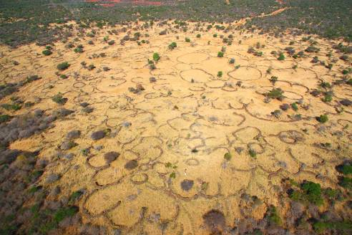
Figure 10-1: Aerial view of the Molokwane Iron Age site. Note the large open space in the centre (red line) indicating central cattle kraal. The different wards are represented by the scalloped stonewalls radiating from centre (photo courtesy Neels Kruger © 2012)

Site type 2
Site 018/019
Type 2 is represented by a single site (Site 018/019). The only visible feature was a shallow dung deposit with small scatters of pottery on the periphery. This site was interpreted as a cattle outpost, and as such may only have been occupied during certain seasons.

Site type 3
Sites 002, 003, 012/013, 016, 017, 020, 024, 027
The only evidence for these sites (also the majority of sites) was pottery exposed at animal burrows. In the Phase 1 AIA some of these sites were identified to also contain ash and/or dung deposits. However, such deposits could not be located during subsequent site visits, including during the mitigation process. The identified ‘deposits’ may have been small ash lenses that were subsequently destroyed by burrowing activities. It is therefore assumed that these sites represent scattered households or shelters at agricultural fields – this assumption may be supported by the fact that most of these sites are located in relative good agricultural soils. Only one site (Site 027) presented evidence of house remains (daga) on the surface, but no in situ remains could be found.

Relative cultural identity of archaeological societies
The Iron Age sites under review have been tentatively identified as being occupied by Tswana speakers with pottery traditions belonging to two Moloko facies. Ethnographic evidence (Schapera 1953) and archaeological data (Boeyens 1998) concur that these groups entered the region from the 13th to 15th centuries CE. The typical settlement pattern associated with Moloko pottery (and by inference Tswana-speaking groups) is a form of the CCP discussed in 10 above. Evidence from other Moloko sites indicated that refuse was discarded (ash middens) around the central kraal and behind household areas. Mortuary rituals and practices were very specific (cf. Biemond 2012).
Of importance is the possible presence of Letsibogo facies pottery at Boikarabelo. Letsibogo is a sub-branch of Moloko that developed in central and eastern Bostwana during the 16th century CE (Huffman & Kinahan 2002, 2003; Huffman 2007; Biemond 2011b, 2012). Ethnographic and historical research identified Letsibogo pottery as an expression of an early Tswana-speaking group. The BaKaa occupied the landscape at Shoshong from the 16th century to 1849 CE (Kirby 1940; Biemond 2012). According to both ethnographic and archaeological evidence, the BaKaa seem to have been replaced (conquered or displaced) by the incoming Ngwato. Thus far, well-documented Letsibogo sites have only been identified in Botswana (Huffman 2007; Biemond 2011b).
Ethnographic evidence for the grain bin platforms identified at Boikarabelo (and Botswana) has been collated by Biemond (2011a, 2011b, 2012). In 1801 the Somerville and Truter expedition from the Cape encountered the Tlhaping at Dithakong. The Tlhaping at that time was the southernmost Tswana-speaking group known or encountered (Somerville 1979). Among the expedition was an artist, Samuel Daniell, who recorded the Thlaping settlement and sketched a household depicted in Figure 10-2, replete with a granary and reed walls.
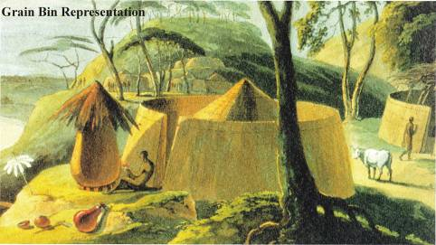
Figure 10-2: Daniell’s 1801 depiction of a Tlhaping settlement at Dithakong. Note the granary to the left on a raised stone platform. Also note the reed walls. These would leave little to no trace post-site abandonment
Biemond’s (2006) research at Basinghall in Botswana identified sites ranging from <1 ha to more than 10 ha in extent. The grain bin platforms illustrated in Figure 10-3 located at Basinghall are arguably very similar to those depicted in Daniell’s recording and the same as those at Boikarabelo.
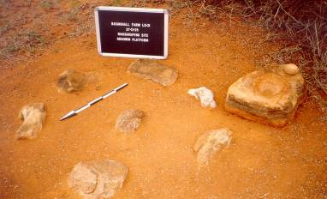
Figure 10-3: Example of a grain bin platform identified at Basinghall, Botswana, with lower grindstones (Biemond 2006)

LIMITATIONS and KNOWLEDGE GAPS
The Phase 2 project was based on the information provided in the Phase 1 AIA report and the subsequent SAHRA comments. A lack of comparative published information for the archaeological record in the region led to misidentification of sites in the Phase 1 AIA. Sites were in general identified as low density sites with low-medium significance ratings. However, some sites were shown to be much larger than originally anticipated.
The resulting limitations on fieldwork, as well as the authorization in terms of the SAHRA permit for mitigation of the specified sites only did not allow for the mitigation of additional sites identified during the Phase 2 mitigation process. These sites were only recorded and will be included as an Addendum to this report.
The lack of published information is perhaps the single largest knowledge gap in terms of interpretation of sites and artefacts. In addition, the relative paucity of material culture and deposit found during excavations, STPs and site mapping are limiting factors in reconstructing the cultural affinities and chronology of the Boikarabelo settlements. The ceramic analyses are, based on mainly undecorated vessel fragments, cannot provide firm dates for the sites at Boikarabelo Coal Mine, other than indicating a very broad and relative period of possible occupation. The lacuna of research in the area did not allow positive contextual identity of the sites to be determined, other than placing the sites within a broad and generic Sotho-Tswana context dated to between the mid-17th century CE and early 18th century CE.

potential risks
Potential risks that were identified during the Phase 2 mitigation are as follows.
The single largest risk is the accidental discovery of human remains during site clearing and construction. Given the type and estimated age of the sites found at Boikarabelo Coal Mine, a high likelihood exists that human remains can be present in the open pit areas where all the archaeological sites will be destroyed. At similar sites mitigated north of the Limpopo River archaeological burials were consistently found in the central cattle kraals and living spaces. Such remains are protected by legislation including the Human Tissues Act (Act No. 65 of 1983) and the National Heritage Resources Act (Act No. 25 of 1999). If any human remains are uncovered during construction and mining activities, the archaeologist or SAHRA must be informed immediately. The appointed archaeologist will apply for the removal of the human remains under an emergency permit. Note that this process will incur some expense as removal of human remains is at the cost of the developer. Time delays may result while application is made to the authorities and an archaeologist is appointed to do the work.
In terms of continuing development yet unidentified sites could be discovered during the course of development. According to the SAHRA minimum standards this must be reported to the archaeologist or to the heritage resources authority and the developer may need to give the archaeologist sufficient time to assess and document the finds and, if necessary, rescue a sample (SAHRA 2007:4).

recommendations
Although Digby Wells was satisfied that the archaeological sites under review have been adequately recorded and sampled, Resgen requested that Digby Wells undertake more extensive mitigation of sites after reviewing this report. The original recommendations made based on the mitigation results are attached as Appendix F. Resgen’s request may have influenced was in part informed in light of the recent adverse situation involving mining activities at the Mapungubwe National Park and World Heritage Site. Resgen furthermore insisted that the proper and responsible management of archaeological and other heritage resources should be of high priority.
Resgen requested, in consultation with Digby Wells, that three sites that will be destroyed by mining infrastructure be completely mitigated to determine exact site, extent and possible locations of graves. The occurrence of graves can thus be predicted with greater accuracy at the remaining sites.
The three recommended sites for further extensive mitigation include:
Site 011;
Site 014; and
Site 021.
These sites were chosen based on their integrity, position in the landscape and information potential.
Remaining sites will be tested more extensively, mainly to determine the presence of human remains as far as possible. The Forensic Anthropology Research Centre based at the University of Pretoria will facilitate Digby Wells where human remains are concerned.
A second request by Resgen was to provide a site management plan for sites that will not be directly affected by mining activities. This was specifically requested for the additional site identified during the mitigation project – Site N0028. Resgen will conserve and preserve this site in situ.
As a result this report is submitted as an interim report detailing progress to date and in support of destruction permit application for sites listed in Appendix G.
Plan 12: Location of mitigated sites in relation to proposed mine infrastructure and footprints

CONCluSION
Based on the excavations and materials that were sampled during this mitigation project, the Boikarabelo archaeological sequence is assigned to Sotho-Tswana settlements, each of which comprised several wards. The settlement layout pattern with a central cattle kraal surrounded by houses and grain bins, in situ structural features such as numerous grain bin foundations that occur in association with lower grind stones that were used to process grains such as millet, sorghum and maize, and the African farmer ceramic sequence are characteristic of settlements with an economy based on cattle, small stock and subsistence farming. In view of the low percentage of decorated ceramics it is merely possibly to assign a relative age to most of the sites. A provisional reconstruction of the cultural chronology based on the small decorated ceramic sample suggests that the occupation can be attributed to the Letsibogo facies of the early Moloko tradition dating to around the 15th to 16th centuries. It is also feasible that some of the settlements date to the later Moloko up to the historic period. As very little academic research has been done on this phase of the Iron Age in the immediate area to the Mine, no further in-depth interpretations of the sites can be made, as there is limited data to inform the archaeological sequence.
Although current impacts on the sites have been mitigated, there is a high probability that archaeological material – including burials – will be found during stripping and soil movement excavations in the development of infrastructure. Archaeological sites are often buried and there is always the possibility that sub-surface archaeological occurrences may be revealed through the proposed mining activities. As a result, Resgen requested that more intensive examination of selected sites take place to determine possible spatial layout of sites and predict potential locations of graves.
The site significance ratings were reviewed. Post-mitigation ratings were ranked as General Protected sites, Grades IV B and C

REFERENCES
Baard, E. 1967. Dagga stone pipes in the collection of the National Museum. Researchers of the National Museum 2(7): 216-233.
Biemond, WM. 2006. The Iron Age sequence around a Limpopo river floodplain on Basinghall Farm, Tuli Block, Botswana during the second millennium A.D. Paper presented at the Society of Africanist Archaeologists (SAFA) Biennial Conference, Calgary, Canada.
Biemond, WM. 2010. Stylistic ceramic analysis.Unpublished report.
Biemond, WM. 2010a. The Iron Age sequence around a Limpopo River floodplain on Basinghall Farm, Tuli Block, Botswana, during the second millennium AD. MA in progress: Chapter 2 and 6.
Biemond, WM. 2010b. Stylistic ceramic analysis.Unpublished report.
Biemond, WM. 2011a. Final Report of the Phase 2 Archaeological Mitigation for the mining and power station development Mmamabula Energy Project (MEP) Central District Botswana. Botswana National Museum and Monuments Excavation Permit No: NMMAG 12/9 XXIII(67). Prepared by Lentswe Archaeological Consultants.
Biemond, WM. 2011b. The Iron Age sequence around a Limpopo River floodplain on Basinghall Farm, Tuli Block, Botswana, during the second millennium AD. MA in progress.University of South Africa.
Boeyens, JCA. 1998. Die LatereYstertydperk in suidoos- en sentraal-Marico. D.Phil. thesis, University of Pretoria.
Burra Charter. 2003. The Australia ICOMOS charter for the conservation of places of cultural significance. International Council on Monuments and Sites.
Burret, RS. 2007. The Garonga ceramic assemblage. Southern African Humanities 19:153-166.
Calabrese, J. A. 2000a. Interregional Interaction in Southern Africa: Zhizo and Leopard’s Kopje Relations in Northern South Africa, Southwestern Zimbabwe, and Eastern Botswana, AD 1000 to 1200. African Archaeological Review, 17(4): 183-210
Campbell, AC, Kinahan, J, & van Waarden, C. 1996. Archaeological sites at Letsibogo Dam. Botswana Notes and Records 28: 47-53
Deacon, H. J & Deacon, J. 1999.Human Beginnings in South Africa. David Phillip: Cape Town.
Fouch´e, L. 1937. Mapungubwe: Ancient Bantu Civilization on the Limpopo, Cambridge University Press, Cambridge.
Fourie, W. 2010. Archaeological Impact Assessment: Res Gen SA Boikarabelo Coal Mine Project on portions of the farms Orsono 700 LQ, Zeekoevley 421 LQ, Vischpan 274 LQ, Kruishout 271 LQ, Kalkpan 243 LQ, Witkopje 237 LQ and Diepspruit 386 LQ, District Lephalale, Limpopo. Unpublished report for Digby Wells Environmental. Matakomo Heritage Consultants: Pretoria
Gardner, G. 1963. Mapungubwe. Volume II, J. L. van Schaik, Ltd., Pretoria
Hanisch, E. (1980). An Archaeological Interpretation of Certain Iron Age Sites in the Limpopo/Shashi Valley, M. A. Thesis, University of Pretoria, Pretoria.
Hanisch, E. (1981). Schroda: A Zhizo site in the Northern Transvaal. In Voigt, E. (ed.), Guide to Archaeological Sites in the Northern and Eastern Transvaal, Southern African Association of Archaecologists, Pretoria, pp. 37–53.
Henshilwood, C. S; d‟Errico, F; Marean, C. W; Milo, R.G & Yates, R. 2001. An early bone tool industry from the Middle Stone Age at Blombos Cave, South Africa: implications for the origins of modern human behaviour, symbolism and language. Journal of Human Evolution 41: 631- 678.
Huffman, TN. 1986. Archaeological evidence and conventional explanations of southern Bantu settlement patterns.Africa 56: 280-290.
Huffman, TN. 1989. Ceramics, settlements and Late Iron Age migrations. The African Archaeological Review 7:155-182.
Huffman, TN. 1990. Obituary: The Waterberg Research of Jan Aukema. The South African Archaeological Bulletin 45(152): 17-19
Huffman, T. 2004. The archaeology of the Nguni past. Southern African Humanities 16:79-111.
Huffman, TN. 2007. Handbook to the Iron Age: the archaeology of pre-colonial farming societies in southern Africa. Scottsville: University of KwaZulu-Natal Press.
Huffman, TN & Kinahan, J. 2002/2003. Archaeological mitigation of the Letsibogo Dam: agropastoralism in southeastern Botswana. Southern African Field Archaeology 11 & 12: 4-63.
Human Tissues Act (Act No. 65 of 1983).
Klein, R. G. 2000. The Earlier Stone Age of Southern Africa. The South African Archaeological Bulletin 55 (172): 107-122.
Kirby, PC. 1940. The diary of Dr Andrew Smith, 1834-1836, Vol. 2. Cape Town: Van Riebeeck Society.
Kuman, K., 1998. The earliest South African industries. In: Petraglia, M., Korisettar, R. (Eds.), Early Human Behavior in Global Context: The Rise and Diversity of the Lower Palaeolithic Record. Routledge, London, pp. 151–186.
Kuper, A. 1980. Symbolic divisions of the southern Bantu Homestead. Africa 50(1): 8-23.
Tyson, P.D., & Lindsey, J.A. (1992). The climate of the last 2000 years in southern Africa. The Holocene, 2, 271–278.
Miller, D, Killick, D & van der Merwe, NJ. 2001. Metal working in the northern Lowveld, South Africa, A.D. 1000-1890. Journal of Field Archaeology 28: 401-417.
Mönnig, HO. 1967. The Pedi. Pretoria: Van Schaik.
Mucina, L & Rutherford, MC. 2006. The vegetation of South Africa, Lesotho and Swaziland. Strelitzia 19. South African National Biodiversity Institute: Pretoria.
Parsons, QN. 1973. On the origins of the bamaNgwato. Botswana notes and records 5: 82-103.
Phillips, JE. 1983. African smoking and pipes. The Journal of African History 24(3): 303-319).
Pistorius, JCC. 1992. Molokwane, an Iron Age Bakwena village: early Tswana settlement in the Western Transvaal. Johannesburg: Perskor.
SAHRA. 1999. Government Gazette 1999. National Heritage Resources Act No. 25 of 1999.
SAHRA. 2007. APM Guidelines: Minimum standards: Archaeological and Palaeontological components of Impact Assessment Reports.
Sampson, GC. 1974. The Stone Age archaeology of southern Africa. New York: Academic Press.
Schapera, I. 1953. The Tswana. London: International African Institute Press.
Schapera, I & Goodwin, AJH. 1962. Chapter 7: Work and Wealth. In: Schapera, I (Ed). The Bantu-Speaking Tribes of South Africa.Maskew Miller Limited: Cape Town.
Shaw, M. 1974. Material Culture. In: Hammond-Tooke, W. D. The Bantu-speaking people of southern Africa. Routledge & Kegan Paul Ltd: London.
Smith, H. 2011. Soil Assessment for the Resource Generation Power Station, Ash Dump and Camp. Unpublished Specialist Report for the Boikarabelo EIA. Randburg: Digby Wells Environmental.
Somerville, W. 1979. William Somerville’s Narrative of his journeys to the eastern cape Frontier and to Lattakoe 1799-1802. With a bibliographical introduction and map and a historical introduction and notes by Edna and Frank Bradlow. Cape Town: Van Riebeeck Society.
Stayt, HA. 1968. The BaVenda. Frank Cass and Company Limited: London.
Thondhlana, TP & Martinón-Torres, M. 2009. Small size, high value: Composition and manufacture of Second Millennium AD copper-based beads from northern Zimbabwe. Journal of African Archaeology 7 (1):79-97.
Van der Ryst, MM. 2006.Seeking shelter: Later Stone Age hunters, gatherers and fishers of Olieboomspoort in the western Waterberg, south of the Limpopo. PhD University of the Witwatersrand: Johannesburg.
Voigt, E. (1983). Mapungubwe: An Archaeozoological Interpretation of an Iron Age Community, Museum Monograph No. 1, Transvaal Museum, Pretoria.
Wood, M. 2000. Making Connections: Relationships between International Trade and Glass Beads from the Shashe-Limpopo. Goodwin Series 8 African Naissance: The Limpopo Valley 1000 Years Ago : 78-90.
Wood, M. 2005. Glass beads and pre-European trade in the Shashe-Limpopo region. Unpublished M.A. Thesis. University of the Witwatersrand, South Africa.

Appendix A: Statement of Significance and Impact Assessment Methodology
Appendix B: Specialist Pottery Analysis Report
Appendix C: Specialist Faunal Analysis Report
Appendix D: Principal Investigator’s Report
Appendix E: Accession Register and Catalogue of Material Culture

Appendix F: Initial Recommendations

Appendix G: Sites Considered for Destruction and in situ Preservation

