PERMIT APPLICATION FOR THE EXHUMATION AND RELOCATION OF THE GRAVE ON ROAD D2969 BETWEEN MANZINI AND SWALILI IN THE EHLANZENI DISTRICT, MPUMALANGA PROVINCE

SUPPLEMENTARY INFORMATION

CONTENTS
1. THE ROAD REHABILITATION AND HERITAGE IMPACT ASSESSMENT REQUIREMENT IN TERMS OF SECTION 38 OF THE NATIONAL HERITAGE RESOURCES ACT 2
2. DETAILS OF THE ACTION/S FOR WHICH APPLICATION IS MADE 3
3. DETAILS OF EFFORTS MADE TO CONTACT AND CONSULT COMMUNITIES AND INDIVIDUALS WHO BY TRADITION HAVE AN INTEREST IN SUCH GRAVE OR BURIAL GROUND 3
4. THE NAME, CONTACT DETAILS, QUALIFICATIONS AND EXPERIENCE OF THE ARCHAEOLOGIST WHO WILL SUPERVISE THE WORK 4
4.1. CONTRIBUTION TO JOURNALS 4
4.2. BOOKS 6

- THE ROAD REHABILITATION AND HERITAGE IMPACT ASSESSMENT REQUIREMENT IN TERMS OF SECTION 38 OF THE NATIONAL HERITAGE RESOURCES ACT

The above road is under rehabilitation. The project owners are the Department of Public Works Road and Transport, Mpumalanga Province. The road was surfaced with asphalt. By “rehabilitation” it is implied that the surface has developed potholes and other structural problems which require physical repair. Rehabilitation includes patching up or complete overlay of a new asphalt surface, rehabilitation of the edges and any other interventions deemed necessary within the servitude area. In essence rehabilitation of this nature is not considered a new development project. Section 38 of the National Heritage Resources Acts (25/1999) prescribing a Heritage Impact Assessment therefore is not applicable.

However in the case in point, members of the local community have indicated the location of a burial of a deceased relative within the limits of the road’s servitude (Lat: 25˚ 10′ 44.69″, Long: 31˚ 08′ 11.09″). While the name of the deceased has been supplied as MAKILE LEGANENKO, the age of the burial is not certain. However an age bracket of within the last 100 years can reasonably be assigned.

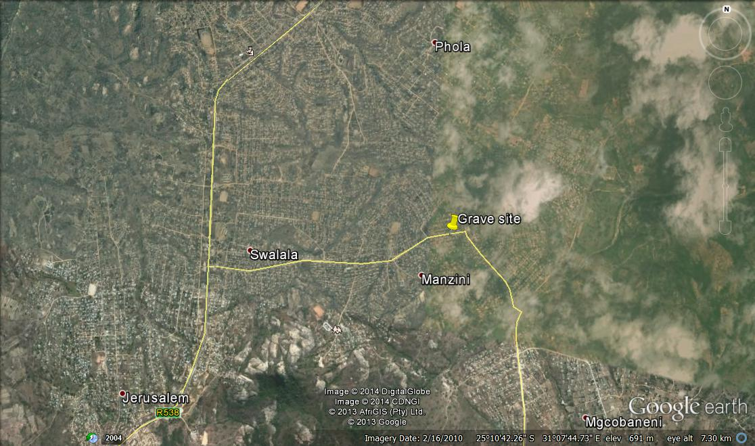
Fig. 1. Map of the area showing the location of the grave site

- DETAILS OF THE ACTION/S FOR WHICH APPLICATION IS MADE
The excavation will be preceded by rites in accordance with funerary tradition in the area. The exhumation will be conducted with strict adherence to archaeological salvage methods. This project is therefore treated as an archaeological excavation in which the following things will be noted
- Grave marker (if any)
- Stratigraphy
- Nature of grave fill and burial chamber
- Burial posture and orientation
- Grave goods (if any)
- State of conservation/completeness of the skeletal remains

A decision has been made by the community in consultation with local authorities that the remains will be moved to a formal cemetery, Phola Cemetery. The re-interment will be done in accordance with local funerary rites.

The Department of Public Works, Road and Transport has hired a funeral home for the logistics to move the remains to the formal cemetery

- DETAILS OF EFFORTS MADE TO CONTACT AND CONSULT COMMUNITIES AND INDIVIDUALS WHO BY TRADITION HAVE AN INTEREST IN SUCH GRAVE OR BURIAL GROUND

This application is in response to the wishes of relatives of the deceased as expressed in an affidavit prepared and signed by Ms Alleta Khoza (grandchild of the deceased) before a Commissioner of Oaths (see attachment). Further to that and in addition the Traditional Authority represented by Chief T. F. Mashego has granted consent for the exhumation to be done in accordance with the wishes of the deceased’s next of kin.

- NAME, CONTACT DETAILS, QUALIFICATIONS AND EXPERIENCE OF THE ARCHAEOLOGIST WHO WILL SUPERVISE THE WORK

Edward Matenga (PhD in Archaeology & Heritage, MPhil in Archaeology – Uppsala University, Sweden).
8843, Odessa Cres, Cosmo City, Ext 7, Northrising, 2188, Johannesburg
Mobile: 084 073 7774. Email: e.matenga598@gmail.com

I have more than 20 years of field experience in archaeology and museum practice. I have excavated archaeological burials and published the findings. I am a practised heritage research consultant with management skills having worked as a Senior Curator in a Museum and Director of an archaeological World Heritage Site. The following is a select list of publications which demonstrate familiarity of with research cycles:

  - CONTRIBUTION TO JOURNALS

1990. “Iron Age burials in and around Harare” Prehistory Society of Zimbabwe Newsletter 80: pp11-14
1993a. “The Budiriro burial excavations, Harare, May-June 1990”. Nyame Akuma, 39, Society of African Archaeologists: pp60-8.

1994. “Nyakambiri Burial Excavations, Marondera, Zimbabwe”. Zimbabwean Prehistory 21: pp38-42.

1996b "Conservation History of the Great Enclosure, Great Zimbabwe, with reference to the proposed restoration of a lintel entrance." In Pwiti, Gilbert and Robert Soper (eds). Aspects of African Archaeology: Papers from the 10th Pan-African Association for Prehistory and Related Studies: pp825-826.

1997. “Restoration of the Western Entrance to the Great Enclosure, Great Zimbabwe”. Zimbabwean Prehistory, 22: pp6-13.

2000a. (With G. Chikwanda). Illegal mining Activities at Chumnungwa Ruins Mberengwa District, Zimbabwe 1995-1997: Some Aspects of Community Attitudes towards Heritage Protection. Conservation and Management of Archaeological Sites, 4(3): pp167-175. London: James &James

2001 “Architectural conservation and environmental management of Great Zimbabwe” in Authenticity and Integrity in an African context. Saouma-Forero, G. (ed.): pp114-119, Paris: UNESCO.
2003. An Evaluation of the Critical Economic Resources of Great Zimbabwe, In Chami, F & G. Pwiti (eds), Climate, Trade and Modes of Production in Sub-Saharan Africa (Studies in the African Past), Dar es Salaam: University of Dar es Salaam Press: pp118-127.

2006. With G. Mahachi. “Chinengundu Mashayamombe and shrines of the First Chimurenga war 1896-7, Mondoro District, Zimbabwe”. Zimbabwea

  - BOOKS

1993b. Archaeological Figurines from Zimbabwe. Studies in African Archaeology 5. Uppsala: Societas Archaeologica Upsaliensis.

1995. With Lindahl, Anders "Ceramics and Homesteads: an Ethno-archaeological Study in the Buhera District south-eastern Zimbabwe." Studies in African Archaeology 11.

1998. The Soapstone Birds of Great Zimbabwe: Symbols of a Nation. Harare: African Publishing Group.

1998. Iron Age Figurines from Zimbabwe. In Zimbabwe: Past and Present. Tervuren: Royal Museum of Central Africa. (Publication accompanying exhibition at the Royal Museum of Central Africa)

2000. Anthropomorphic figure from Zimbabwe. In Mack, J. Africa: Arts and Culture. London: Trustees of the British Museum.

2011: The Soapstone Birds of Great Zimbabwe: Archaeological Heritage, Religion and Politics In Postcolonial Zimbabwe and the Return of Cultural Property. Studies in African Archaeology 16. Uppsala: Uppsala University. (Published PhD Thesis)

