Inander Projects (Pty) Limited

Revised Basic Assessment Report (BAR) and Environmental Management Programme (EMPr)
For
Witkranz Colliery
Compiled in terms of Appendix 1 and Appendix 4 of the amended Environmental Impact Assessment Regulations, 2014 (Government Notice No. 326) (EIA Regulations, 2014) and submitted as contemplated in Regulation 19 of Chapter 4 of the EIA Regulations, 2014
For
The application for an Environmental Authorization and a Waste Management Licence in terms of the National Environmental Management Act, 1998 (Act No. 107 of 1998), National Environmental Management: Waste Act, 2008 (Act No. 59 of 2008), Amended Environmental Impact Assessment Regulations 2014, Government Notice R327 - Listing Notice 1 of 2014 For Mining Permit

DMRE Reference No.: MP 30/5/1/1/3/12368 MP

December 2021
File Referencing No: 3814/2021
Contents Page

Executive Summary 1
1. Introduction 4
1.1. Who is Developing the BAR and EMPR? 4
1.1.1. Name and contact details of the Environmental Assessment Practitioner (EAP) who prepared the BAR and EMPR 4
1.1.2. Expertise of the EAP who prepared the BAR and EMPR 4
1.2. Who will Evaluate and Approve the BAR and EMPR? 5
1.3. DETAILS OF THE APPLICANT 6
1.3.1. Name of the Applicant 6
1.3.2. Name of the Project 6
1.3.3. Postal Address of Applicant 6
1.3.4. Responsible Person 6
1.3.5. Contact Person 6
1.4. DESCRIPTION OF THE PROPERTY (LOCATION OF THE PROJECT) 6
1.4.1. Regional Setting 6
1.4.2. Physical Address and Farm Name of the Mining Area 6
1.4.3. Magisterial District & Regional Services Council 6
1.4.4. Direction and Distance to Nearest Towns 7
1.4.5. Locality Plan 7
1.4.6. Land Tenure and Use of Immediate and Adjacent Land 10
2. Description of the scope of the proposed PROJECT 13
2.1. Listed Activities and Specified Activities 13
2.2. Description of the proposed Project 13
2.2.1. Target Mineral 17
2.2.2. Mining Method Used at the Witkranz Colliery Area 17
2.2.3. Planned Life of Project 17
2.3. Witkranz Colliery Surface Infrastructure Description 17
2.3.1. Access 17
2.3.2. Power line Infrastructure 17
2.3.3. Water Supply Infrastructure 17
2.3.4. Stockpiling facilities 17
2.3.5. Workshops and Buildings 17
2.3.6. Waste Management 20
2.4. Witkranz colliery Method Statement 21
2.4.1. Construction Phase 21
2.4.2. Operational Phase 21
2.4.3. Decommissioning phase 22
2.4.4. Final Rehabilitation 22
2.4.5. After Closure Phase 22
3. Policy and legislative context 24
3.1. Constitution of the Republic of South Africa (Act No. 108 of 1996) 24
3.2. National Environmental Management Act 24
3.3. National Environmental Management Air Quality Act 25
3.4. The National Heritage Resources Act 25
3.5. National Environmental Management Biodiversity Act (Act 10 of 2004) (NEMBA) 25
3.6. Mpumalanga Nature Conservation Act (Act 10 of 1998) 26
3.7. Mineral and Petroleum Resources Development Act (MPRDA): Act 28 of 2002 26
3.8. National Water Act (NWA): Act No. 36 of 1998 27
3.9. National Environmental Management: Waste Act (Act No. 59 of 2008) 27
3.10. EIA Guidelines 27
4. need and desirability of the proposed activities 29
4.1. Motivation for the Need and desirability of the Project 29
5. motivation for the preferred development footprint 31
5.1. Consideration of Alternatives 31
5.1.1. Location Alternatives 31
5.1.2. Design/ Layout Alternatives 31
5.1.3. Transport Alternatives 32
5.1.4. No Go Option 32
5.2. Concluding Statement 32
5.3. Details Of The Public Participation Process Followed and Results Thereof 32
5.3.1. Registration and BAR Phase 33
5.3.2. Draft Basic Assessment Report 34
5.2. Environmental Attributes (Baseline Information) 36
5.2.1. Geology 36
5.2.2. Climate 39
5.2.3. Extreme weather conditions 43
5.2.4. Topography 43
5.2.5. Soil 44
5.2.6. Land-Use 44
5.2.7. Archaeological and Cultural importance 45
5.2.8. Agricultural aspect 45
5.2.9. Natural Vegetation/Plant Life 45
5.2.10. Animal life 48
5.2.11. Surface Water 49
5.2.12. Groundwater 52
5.2.13. Sensitive Landscapes 54
5.2.14. Air Quality 73
5.2.15. Noise 74
5.2.16. Socio-Economic Status 74
6. environmental impact assessment 77
6.1. Environmental Impact Assessment Process Followed 77
6.1.1. Approach to Environmental Impact Assessment 77
6.1.2. Environmental Impact Assessment Process Followed 77
6.2. Environmental Impact Assessment Methodology 78
6.3. Results of the Environmental Impact Assessment 80
6.3.1. Assessment of the Witkranz Colliery impacts/risks 80
6.4. Summary of Specialist Reports 108
6.5. Environmental Impact Statement 108
6.5.1. Description of affected environment 108
6.5.2. Summary of key findings of the environmental impact assessment 108
6.6. Aspects for Inclusion as conditions of the Environmental Authorisation 108
6.7. Description of Assumptions, Uncertainties and Gaps in Knowledge 109
6.8. Reasoned Opinion as to Whether the Proposed Project should or should not Continue 109
6.8.1. Reason why the activity should be authorised or not 109
6.8.2. Conditions that must be included in the authorisation 109
6.9. Period for which the Environmental Authorisation 109
6.10. Undertaking 109
6.11. Financial Provision 110
6.12. Other Information Required by the Competent Authority 110
6.13. Other Matters Required in Terms of Section 24 (4) (a) and (b) of the Act 110
1. DETAILS OF THE EAP 112
2. description of the aspects of the activity 112
3. COMPOSITE MAP 112
4. DESCRIPTION OF THE MANAGEMENT OBJECTIVES INCLUDING MANAGEMENT STATEMENTS 112
4.1 General Closure Principles and Objectives 112
4.2 Management of Environmental Damage, Environmental Pollution and Ecological degradation caused by THE Witkranz Colliery Activities 112
4.2.1 Infrastructure Areas 113
4.3 Potential Risk of Acid Mine Drainage 113
4.4 Steps taken to Investigate, Assess and Evaluate the Impacts of the Acid Mine Drainage 114
4.5 Engineering and designs Solutions to be Implemented to Avoid or Remedy Acid Mine Drainage 114
4.6 Measures to Remedy Residual or Cumulative Impacts from Acid Mine Drainage 114
4.7 Volumes and Rates of Water Use Required for the Proposed Project 115
4.8 Water Use Licence Application 115
5. ENVIRONMENTAL MANAGEMENT PROGRAMME 116
6. FINANCIAL PROVISION 125
6.1 Description of Closure Objectives and Extent to which they have been aligned to the described Baseline Environment 125
6.2 Confirmation that the Environmental Objectives in relation to Closure have been Consulted with Landowners and Interested and Affected Parties 125
6.3 Rehabilitation Plan for the Proposed Project 125
6.4 Compatibility of the Rehabilitation Plan with the Closure Objectives 125
6.5 Determination of the Quantum of the Financial Provision Required to Manage and Rehabilitate the Environment 125
6.6 Method of Providing for the Financial Provision 126
7. mechanism for monitoring compliance with and perfomamce assessMent against the environMental management programme and reporting thereoF 128
7.1 Inspections and Monitoring 128
7.2 Monitoring compliance with and performance assessment against the environmental management programme and reporting thereof 128
7.3 PROCEDURE FOR ENVIRONMENTAL RELATED EMERGENCIES AND REMEDIATION 128
7.3.1 Introduction 129
7.3.2 What is an Environmental Emergency? 129
7.3.3 Purpose of the procedure 129
7.3.4 Who should use these procedures? 129
7.3.5 Responsibilities 129
7.3.6 Notification process 130
7.3.7 Emergency equipment and supplies 130
7.3.8 Communication systems 130
7.3.9 Training 130
7.3.10 Review of procedure 130
7.3.11 Emergency Response flowchart for Inander Projects (Pty) Limited 130
7.4 ENVIRONMENTAL AWARENESS PLAN 131
7.4.1 Objectives and Legal Requirements 131
7.4.2 Manner of informing employees of risks to avoid pollution and degradation of the environment 132
7.4.3 Induction for all employees, including contractors 135
7.4.4 General environmental awareness training 135
7.4.5 Provision for job specific environmental awareness training 135
7.4.6 Competency training 136
7.4.7 Review of awareness and training material 136
7.4.8 Roles and responsibilities 136
7.5 Undertaking to Comply 137
Tables
Table # | Table Description | Page
Table 1: Direction and Distance to Nearest Towns. 7
Table 2: Schedule of properties listing surface ownership surrounding Witkranz Colliery. 10
Table 3: Proposed Witkranz Colliery Listed Activities. 14
Table 4: Comments from the I&APs 35
Table 5: Mean monthly rainfall, rain days and evaporation data for the site. 39
Table 6: Wettest years between November and April 40
Table 7: Maximum monthly rainfall data (mm). 40
Table 8: Peak 24-hr rainfall depths for the site. 40
Table 9: Mean monthly temperature data for 0515320 (Carolina). 41
Table 10: Average Wind Speed and Direction. 42
Table 11: GM12 Eastern Highveld Grassland biome vegetation 45
Table 12: List of Mammals at the GM 12 Eastern Highveld Grassland biome. 47
Table 13: List of Bird Species at the GM 12 Eastern Highveld Grassland biome. 48
Table 14: List of Invertebrates at the GM 12 Eastern Highveld Grassland biome. 48
Table 15: List of the dominant taxa in the Eastern Highveld Grassland vegetation unit / ecosystem 56
Table 16: Information regarding the above-mentioned quaternary catchment areas. 63
Table 17: The above criteria are expressed for each impact in tabular form according to the following definitions: 77
Table 18: Results of the Environmental Impact Assessment for Witkranz Colliery. 80
Table 19: Environmental Management Programme for the proposed Witkranz Colliery. 116
Table 20: Financial provision for Witkranz Colliery 128
Table 21: Responsibilities 130
Table 22: Environmental Awareness Matrix. 134

FIGURES
Figure # | Figure Description | Page
Figure 1: Regional Setting for Witkranz Colliery. 9
Figure 2: Locality Plan. 10
Figure 3: Land Tenure Plan for the Witkranz Colliery area. 12
Figure 4: Surface layout plan 20
Figure 5: Layout plan for the boxcut 21
Figure 6: Generalised stratigraphic section of the area. 41
Figure 7: Elevation figure. 46
Figure 8: Position of four streams that originate near the permit area. 53
Figure 9: National Vegetation Types in the vicinity of the proposed Witkranz Colliery (SANBI: 2018) 58
Figure 10:Climate diagram for the Eastern Highveld Grassland subdivision. 59
Figure 11: Threatened Ecosystems in the vicinity of the proposed Witkranz Colliery Area (SANBI: 2018) 63
Figure 12: DWS quaternary drainage regions in the vicinity of the Witkranz Colliery area. 65
Figure 13: River Freshwater Ecosystem Priority Areas in the vicinity of the proposed Witkranz Colliery. 67
Figure 14: National Wetland Map 5 for the proposed Witkranz Colliery. 69
Figure 15: National Wetland Vegetation Types in the vicinity of Witkranz Colliery Area. 70
Figure 16: Mpumalanga Biodiversity Sector Plan Terrestrial Assessment for the proposed Witkranz Colliery 72
Figure 17: Mpumalanga Biodiversity Sector Plan Freshwater Assessment for the proposed Witkranz Colliery. 74
Figure 18: emergency response. 133

Appendices
Appendix A Regulation 2 (2) plan
Appendix B Windeed list
Appendix C Layout plan
Appendix D Public participation process
Appendix E Groundwater specialist report
Appendix F Screening tool

Executive Summary
Inander Projects (Pty) Limited proposes to mine coal on a portion of portion 16 of the farm Witkranz 53 IT, situated within the Carolina Magisterial District. Witkranz Colliery is situated approximately 12.5 kilometres southwest of Carolina town and 15 kilometres northeast of Breyten town.
The proposed mining permit area is most probably underlain by the E and D seam. The coal is mainly seam E which is 15 to 17 metres deep. Seam E may have an average thickness of 1.5 m and the coal quality is probably high. In some parts of the area Seam D may occur. The monthly production rates will be in the order of 40 000 tons of ROM per month. The opencast mining will be undertaken using the conventional truck and shovel mining technique with concurrent rehabilitation.
The life of this resource at the planned mining rate is 24 months, which includes a pre-production build up phase aimed mostly at establishing the box-cut and other related mining infrastructures. All R.O.M coal from the proposed mining area will be stockpiled on site. No coal processing (washing) will be undertaken; hence no coal discards will be generated from the proposed mining area. However, crushing and screening will be conducted.
Due to space limitation (5 ha mining permit area) mining related infrastructures such as the mobile offices, hard-park, storm-water management facility and stockpiling facilities will be placed outside the 5-ha mining permit area. Furthermore, an in-pit water storage and in-pit coal storage was decided upon. A surface pollution control dam and ROM (outside the mining permit area due to space limitation) will; however, be considered and constructed should the in-pit storage facilities not be sufficient during mining.
In view of the above, Inander Projects (Pty) Limited has lodged a mining permit (Reg. No.: 2017/472381/07) with the Department of Mineral Resources and Energy (Mpumalanga Regional Office) in accordance with the relevant guidelines and regulations under the Mineral and Petroleum Resources Development Act, 2002 as amended.

In addition to the above, the National Environmental Management Act, 1998 (Act 107 of 1998), (NEMA), and the National Environmental Management: Waste Act, 2008 (Act 59 of 2008), (NEMWA), requires that any person or entity that intends to undertake activities listed in the NEMA listing notice regulations (Government Notices No. 327, 325 and 324) as amended in 2017 and waste management activities listed under GN 921 must obtain an environmental authorisation in terms of section 24D of the NEMA and a waste management licence in terms of part 4 of chapter 4 of the NEMWA before undertaking such activities. Activities that will require an environmental authorisation and a waste management licence in terms of the above-mentioned acts were identified and are listed in a table contained in this report.

According to the NEMA EIA Regulations 2014, an application for an environmental authorisation together with an application for a waste management licence for the above triggered listed activities and waste management activities, (integrated environmental authorisation) must be submitted to a competent authority in line with the requirements of the above-mentioned regulations. The Department of Mineral Resources and Energy (eMalahleni Office) is the competent authority for the above-mentioned applications.

Regulation 19 of the amended NEMA Regulations requires that if a BAR process must be applied to an application, the applicant must submit a basic assessment report and an EIR/EMPr to the competent authority which has been subjected to a public participation process and which reflects the incorporation of comments received, including any comments of the competent authority. In view of the above, a draft BAR and EMPr report which concerns assessment of environmental impacts and a programme for management of the impacts for the proposed activities at the Witkranz Colliery, was compiled and submitted in terms of the NEMA EIA Regulations, 2014 for review and commenting by the public including the competent authority. The environmental impact assessment, which results are thereof detailed in this report (Final BAR and EMPr), was undertaken in compliance with the accepted plan of study described in the above-mentioned basic assessment report as well as studies requested by the interested and affected parties during the public and participation process.

PART A

_________________________________________________________________________________

BASIC ASSESSMENT REPORT

SECTION ONE
_________________________________________________________________________________

Introduction

Introduction

Who is Developing the BAR and EMPR?

Name and contact details of the Environmental Assessment Practitioner (EAP) who prepared the BAR and EMPR
EAP: Mr. Ornassis Tshepo Shakwane
Professional registration:
SACNASP: 117080
EAPASA: 2019/1763
IAIA Membership No.: 3847
Company: Geovicon Environmental (Pty) Limited
Postal Address:
P.O. Box 4050
MIDDELBURG, 1050
Tel: (013) 243 5842
Fax: (086) 632 4936
Cell No.: 082 498 1847
Email: tshepo@geovicon.com

Expertise of the EAP who prepared the BAR and EMPR
Geovicon Environmental (Pty) Limited is a geological and environmental consulting company. The company was formed during 1996, and currently has more than 20 years’ experience in the geological and environmental consulting field. Geovicon Environmental (Pty) Limited has successfully completed consulting areas in the Mining sector (coal, gold, base metal and diamond), Quarrying sector (sand, aggregate and dimension stone), industrial sector and housing sector. Geovicon Environmental (Pty) Limited has undertaken contracts within all the provinces of South Africa, Swaziland, Botswana and Zambia. During 2001 Geovicon Environmental (Pty) Limited entered the field of mine environmental management and water monitoring.
Geovicon Environmental (Pty) Limited is a Black Economically Empowered Company with the BEE component owning 60% of the company. Geovicon Environmental (Pty) Limited has three directors i.e. O.T Shakwane, J.M. Bate and T.G Tefu.
Mr. O.T Shakwane obtained his BSc (Microbiology and Biochemistry) from the University of Durban Westville in 1994, and completed his honours degree in Microbiology in 1995. Mr O.T Shakwane has also completed short courses on environmental law and environmental impact assessment with the University of North West’s Centre for Environmental Management. He has worked with the three state departments tasked with mining and environmental management i.e. Department of Water and Sanitation (Gauteng and Mpumalanga Region), Department of Mineral Resources (Mpumalanga Region) and Department of Agriculture, Conservation and Environment (Gauteng Region). Mr. Shakwane has been in the consulting field since 2004 and has completed various areas similar to the proposed Witkranz Mining area as an environmental assessment practitioner. Mr Shakwane is the environmental assessment practitioner for the environmental impact assessment for the proposed Witkranz Mining area.
Over the past years Geovicon Environmental (Pty) Limited has formalised working relationships with companies that offer expertise in the following fields i.e. Geohydrology, Civil and Geotechnical Engineering, Geotechnical Consultancy, Survey and Mine Planning and Soil & Land Use Consultancy. Geovicon Environmental (Pty) Limited is an independent consulting company, which has no interest in the outcome of the decision regarding the Witkranz Mining Area’s basic assessment process

Who will Evaluate and Approve the BAR and EMPR?
Before the proposed project can proceed, an EAP must compile an application for an environmental authorisation for the proposed project. An impact assessment (basic assessment process) must be undertaken in support of the application for an environmental authorisation. The basic assessment process will determine the potential environmental impacts that may result from the proposed project and an environmental management programme will be compiled to provide measures for mitigation against the identified impacts. The above-mentioned application must be made to the competent authority and in terms of section 24D (1) of NEMA, the Minister responsible for mineral resources is the responsible competent authority for this application. In view of the above, the application for the environmental authorisation for the proposed project was submitted to the Department of Mineral Resources and Energy (DMRE), Mpumalanga Regional Office for their consideration and decision making.
In the spirit of co-operative governance and in compliance with the requirements of NEMA and the MPRDA, the competent authority may, during the processing for the environmental authorisation application, consult with other organs of state that administers laws that relate to matters affecting the environment relevant to this application. Note that during the public participation process for the proposed project, the EAP will also consult with the below listed state authorities.
The organs of state that are to be consulted may include the following:
Mpumalanga Tourism and Parks Agency (MTPA) and Department of Water and Sanitation (DWS).
Note; however, that this list is not exhaustive as more organs of state may be identified by the competent authority and EAP during the public participation process.

DETAILS OF THE APPLICANT

Name of the Applicant
Inander Projects (Pty) Limited

Name of the Project
Witkranz Colliery

Postal Address of Applicant
Inander Projects (Pty) Limited
38A Hexrivier street
Aerorand
Middelburg
1050

Responsible Person
Mr Mashudu Gangazhe

Contact Person
Mr Mashudu Gangazhe
Tel: (082) 432 1006
Fax: (086) 240 4987

DESCRIPTION OF THE PROPERTY (LOCATION OF THE PROJECT)

Regional Setting
The Witkranz Colliery is situated within the Carolina Magisterial District approximately 17.5 kilometres southwest of Carolina town and 19 kilometres northeast of Breyten town. Access to the mine is via the R36 Provincial Road or R33 Provincial Road. See Figure 1, for the regional setting of Witkranz Colliery and Table 1 for the distance and directions of towns around the Witkranz Colliery.

Physical Address and Farm Name of the Mining Area
Witkranz Colliery is situated on a portion of portion 16 of the farm Witkranz 53 IT, southwest of Carolina, Mpumalanga.

Magisterial District & Regional Services Council
- Magisterial District: Carolina Magisterial District, Mpumalanga
- District Municipality: Gert Sibande District Municipality
- Local Municipality: Chief Albert Luthuli Local Municipality

Direction and Distance to Nearest Towns
Table 1: Direction and Distance to Nearest Towns.
TOWN | DIRECTION | DISTANCE (KM)
Carolina | South West | 12.5 km
Breyten | North East | 15 km
Chrissiesmeer | South East | 28 km

Locality Plan
Refer to Figure 2 for the locality plan of the Witkranz Colliery area.

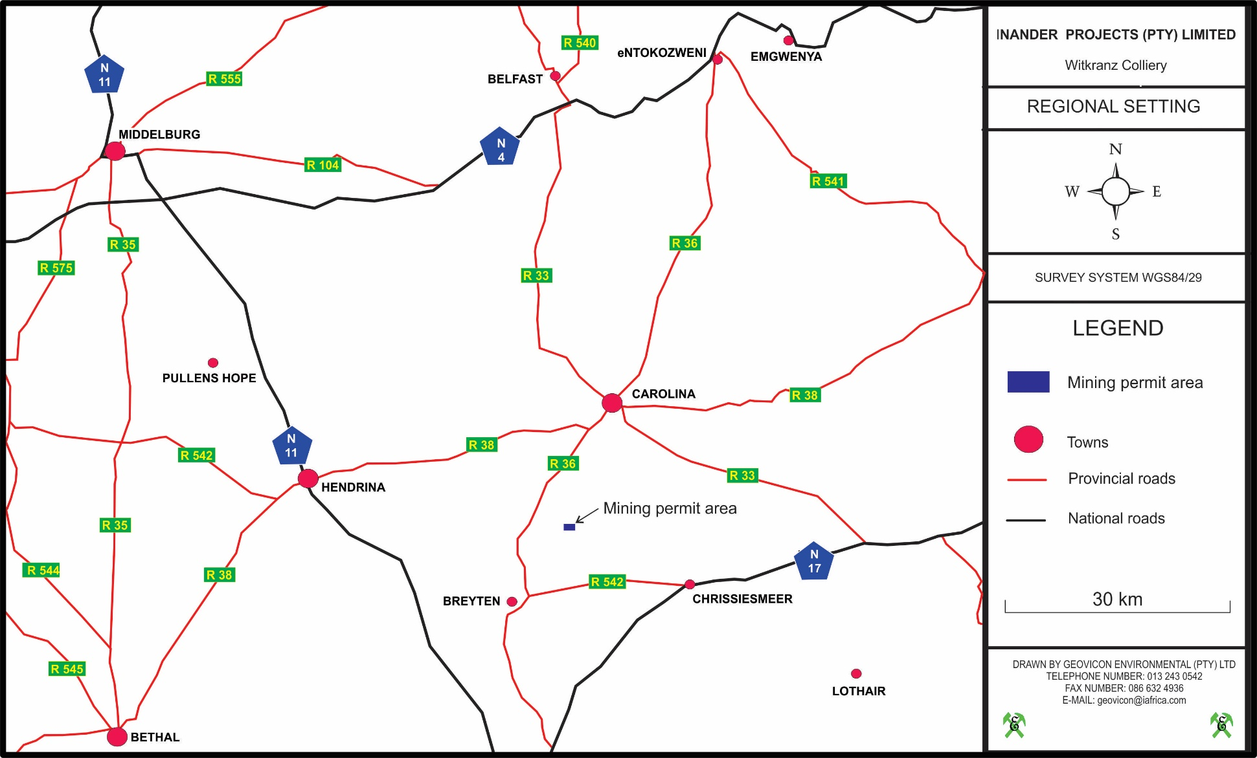
Figure 1: Regional Setting for Witkranz Colliery.

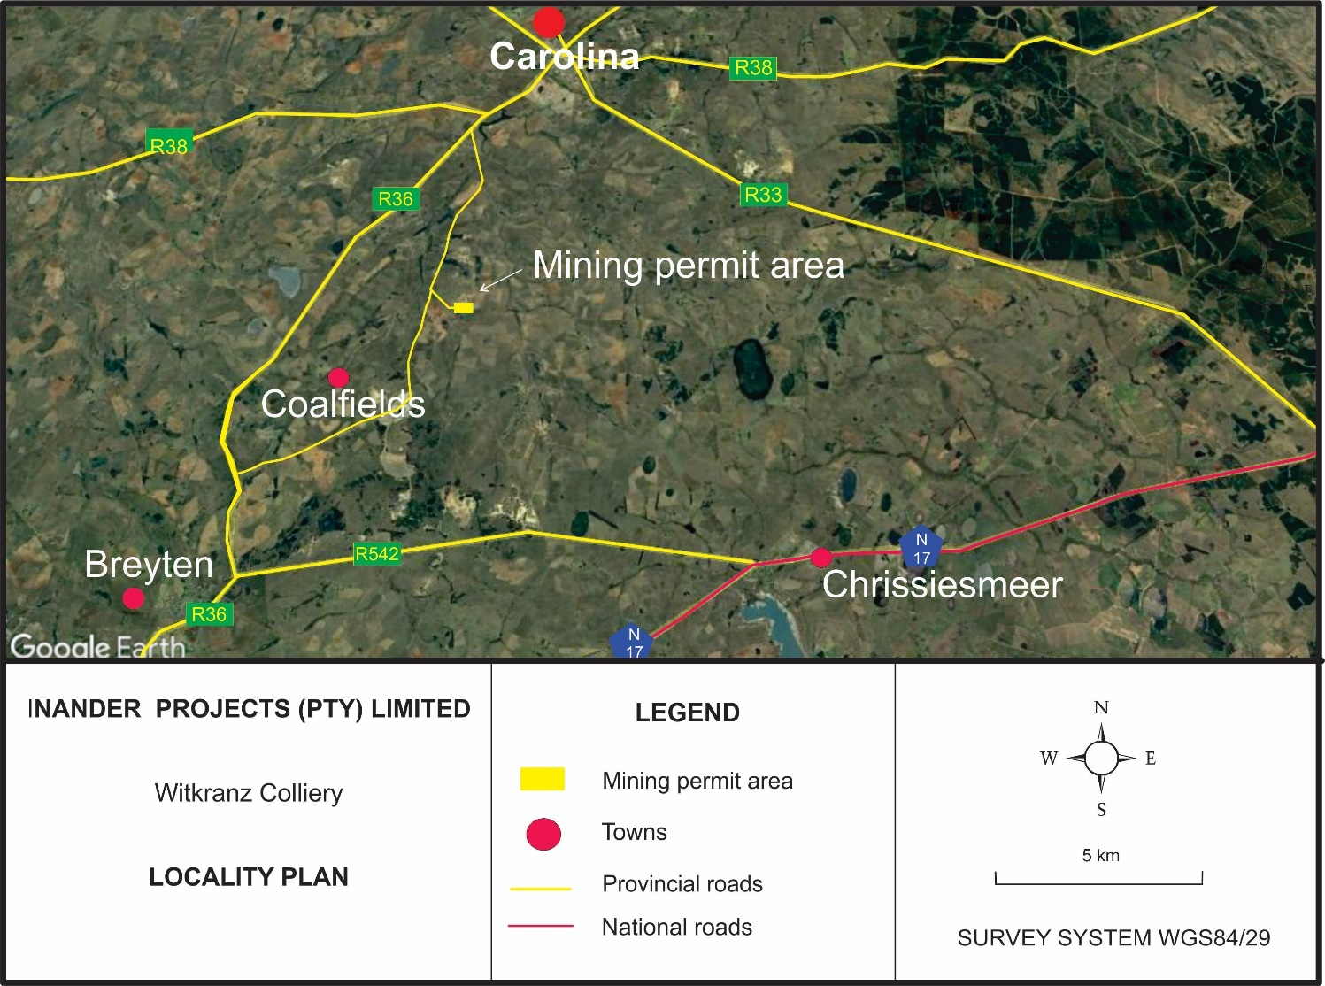
Figure 2: Locality Plan.

Land Tenure and Use of Immediate and Adjacent Land
Land tenure for the properties within and immediately around the proposed Witkranz Colliery area is indicated on Figure 3 and described in Table 2 the land where Witkranz Colliery is situated was used mainly for grazing purposes. Adjacent land is used for mining, residential, agriculture and wilderness purposes.
Table 2: Schedule of properties listing surface ownership surrounding Witkranz Colliery.
FARM NAME AND NUMBER | 21 DIGIT SURVEYOR  GENERAL CODE | DESCRIPTION OF SUB-DIVISION | SURFACE OWNER
Witkranz 53 IT | T0IT00000000005300001 | Portion 1 | Northern Coal (Pty) Limited
Witkranz 53 IT | T0IT00000000005300015 | Portion 15 | Baadtjiesbult Boerdery (Pty) Limited
Witkranz 53 IT | T0IT00000000005300016 | Portion 16* | Nel Stephanus Jacobus
The asterisk (*) indicate the portion on which the mining permit is applied for, also refer to Appendix A Regulation 2 (2) Plan and Appendix B windeed list of the farm.

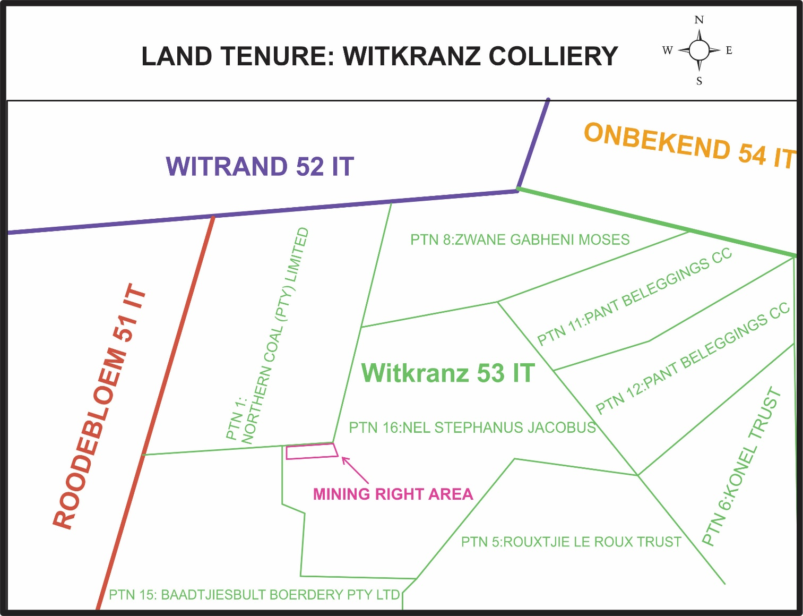
Figure 3: Land Tenure Plan for the Witkranz Colliery area.

SECTION TWO
_________________________________________________________________________________

Description of the Scope of the proposed Project

Description of the scope of the proposed PROJECT

Listed Activities and Specified Activities
In terms of the NEMA and NEMWA, the proposed Witkranz Colliery will result in the conducting of activities that are considered as listed activities and waste management activities. In terms of the above-mentioned legislations, none of the above-mentioned listed activities can be conducted without an environmental authorisation and/or a waste management licence. In view of the above, Inander Projects (Pty) Limited has submitted an application for an environmental authorisation and an application for a waste management licence for all listed activities and waste management activities to be conducted at the proposed Witkranz Colliery to the competent authority (DMRE). This section will give a description of the listed activities and waste management activities that will be included in the application for an environmental authorisation and waste management licence. Table 3 is compiled as prescribed by the DMRE, EIR and EMPr template and reflects all project activities applied for.

Description of the proposed Project
Mining will be conducted by opencast methods, using truck and shovel lateral rollover mining technique. A competent mining contractor will be contracted to conduct the opencast mining at the proposed Witkranz Colliery opencast mining area.

Access to the opencast will be via a ramp to the initial box cut. The ROM coal will be transported by truck via roads.

The soft overburden will be removed by mechanical methods. The hard overburden will be drilled and blasted and then removed by mechanical methods. The coal will be drilled and blasted prior to removal. Replacement of overburden material into the mining pit will be according to the following sequence:
- Placement of hard overburden at base of pit.
- Placement of soft overburden.
- Final cover of available topsoil
Surface infrastructure that will be constructed includes, box-cut for the opencast mining activities, overburden material stockpiles. Coal from the Colliery will be transported directly to clients for further processing. Water from the pit will captured in an in-pit sump and water from the sump will be used for dust suppression. Where the in-pit sump is not sufficient enough to temporary store water; as an alternative, a PCD will be constructed on surface to store water from the opencast pit.
These activities will be undertaken on a portion of portion 16 of the farm Witkranz 53 IT. Approximately 240 000 in situ tons of coal is available on the property.

Table 3: Proposed Witkranz Colliery Listed Activities.

NAME OF ACTIVITY  (E.g. For prospecting - drill site, site camp, ablution facility, accommodation, equipment storage, sample storage, site office, access route etc…etc…etc E.g. for mining,- excavations, blasting, stockpiles, discard dumps or dams, Loading, hauling and transport, Water supply dams and boreholes, accommodation, offices, ablution, stores, workshops, processing plant, storm water control, berms, roads, pipelines, power lines, conveyors,etc…etc…etc.) | Aerial extent of the Activity Ha or m² | LISTED ACTIVITY  (Mark with an X where applicable or affected). | APPLICABLE LISTING NOTICE (GNR 327, GNR 325 or GNR 324) | WASTE MANAGEMENT  AUTHORISATION Indicate whether an authorisation is required in terms of the Waste Management Act). (Mark with an X )
Listing notices 1: Activity 21  Any activity including the operation of that activity which requires a prospecting right in terms  of section 16 of the Mineral and Petroleum Resources Development Act, 2002 (Act No. 28 of  2002), including associated infrastructure, structures and earthworks, directly related to  prospecting of a mineral resource, including activities for which an exemption has been  issued in terms of section 106 of the Mineral and Petroleum Resources Development Act,  2002 (Act No. 28 of 2002). | 5,00 ha | X | NO. 327 | N/A
Listing Notices 1: Activity 9  The development of infrastructure exceeding 1000 metres in length for the bulk transportation of water or storm water- (i) with an internal diameter of 0,36 metres or more; or (ii) with a peak throughput of 120 litres per second or more; excluding where- (a) such infrastructure is for bulk transportation of water or storm water or storm water drainage inside a road reserve; or (b) where such development will occur within an urban area.  The construction of storm water channels and water pipelines exceeding 1 km for the conveyance of mine affected water at the proposed project. | 0.3 ha | X | NO. 327 | N/A
Listing Notices 1: Activity 24  The development of-  (i) a road for which an environmental authorisation was obtained for the route  determination in terms of activity 5 in Government Notice 387 of 2006 or activity 18 in  Government Notice 545 of 2010; or  (ii) a road with a reserve wider than 13,5 meters, or where no reserve exists where the road is wider than 8 metres; but excluding-  (a) roads which are identified and included in activity 27 in Listing Notice 2 of 2014; or  (b) roads where the entire road falls within an urban area.  The development of a road where the road 8 meters wide. | 0.25 ha | X | NO. 327 | N/A
Listing Notices 1: Activity 27  The clearance of an area of 1 hectare or more, but less than 20 hectares of indigenous vegetation, except where such clearance of indigenous vegetation is required for the undertaking of a linear activity or maintenance purposes undertaken in accordance with a maintenance management plan. | 5,00 ha | X | NO. 327 | N/A
Listing Notices 3 Activity 4  The development of a road wider than 4 metres with a reserve less than 13,5 metres. | 2.5 Ha | X | GNR 324 | N/A
Listing notices 3: Activity 19  The widening of a road by more than 4 metres, or the lengthening of a road by more than 1 kilometre. | 2.5 Ha | X | GNR 324 | N/A
Category A: Activity 15  The establishment or reclamation of a residue stockpile or residue deposit resulting from activities which require a prospecting right or mining permit in terms of the Mineral and Petroleum Resources Development Act, 2002 (Act No. 28 of 2002) (Overburden stockpiles, which will include topsoil, subsoil and hards overburden material). | 2.5 ha | X | NO. 921 | X

Target Mineral
Coal.

Mining Method Used at the Witkranz Colliery Area
Mining will be conducted by opencast methods, using truck and shovel lateral rollover mining technique. A competent mining contractor will be contracted to conduct the opencast mining at the proposed Witkranz Colliery opencast mining area.
Access to the opencast will be via a ramp to the initial box cut. The ROM coal will be transported by truck via roads.
The soft overburden will be removed by mechanical methods. The hard overburden will be drilled and blasted and then removed by mechanical methods. The coal will be drilled and blasted prior to removal. Replacement of overburden material into the mining pit will be according to the following sequence:
- Placement of hard overburden at base of pit.
- Placement of soft overburden.
- Final cover of topsoil (minimum 300 mm).

Planned Life of Project
The current estimated life of the proposed Witkranz Colliery is 2 years.

Witkranz Colliery Surface Infrastructure Description

Access
There is a good network of tarred roads connecting to unnamed gravel roads from the mine with surrounding towns. The R38 from Hendrina which intersects with the R36 from Carolina.

Power line Infrastructure
Diesel powered vehicles and machinery will be used for the proposed project.

Water Supply Infrastructure
Water will be required at the proposed mining area for the purpose of supplying potable water and for dust suppression. Water will be sourced from the borehole or via a water supplier for portable water whereas dust suppression water will be obtained from the pit. Alternatively, water may be sourced from the Local Municipality.

Stockpiling facilities
Stockpiling facilities includes overburden stockpiles (Hards and Softs), topsoil stockpile and an R.O.M facility.

Workshops and Buildings
Mobile office containers will be utilised. All machinery will be maintained at an offsite workshop. Should emergency repairs be required the repairs will be conducted on site on areas covered with tarpaulins

Refer to Figure 4 for the infrastructure layout plan and Figure 5 for box-cuts’ layout plan.
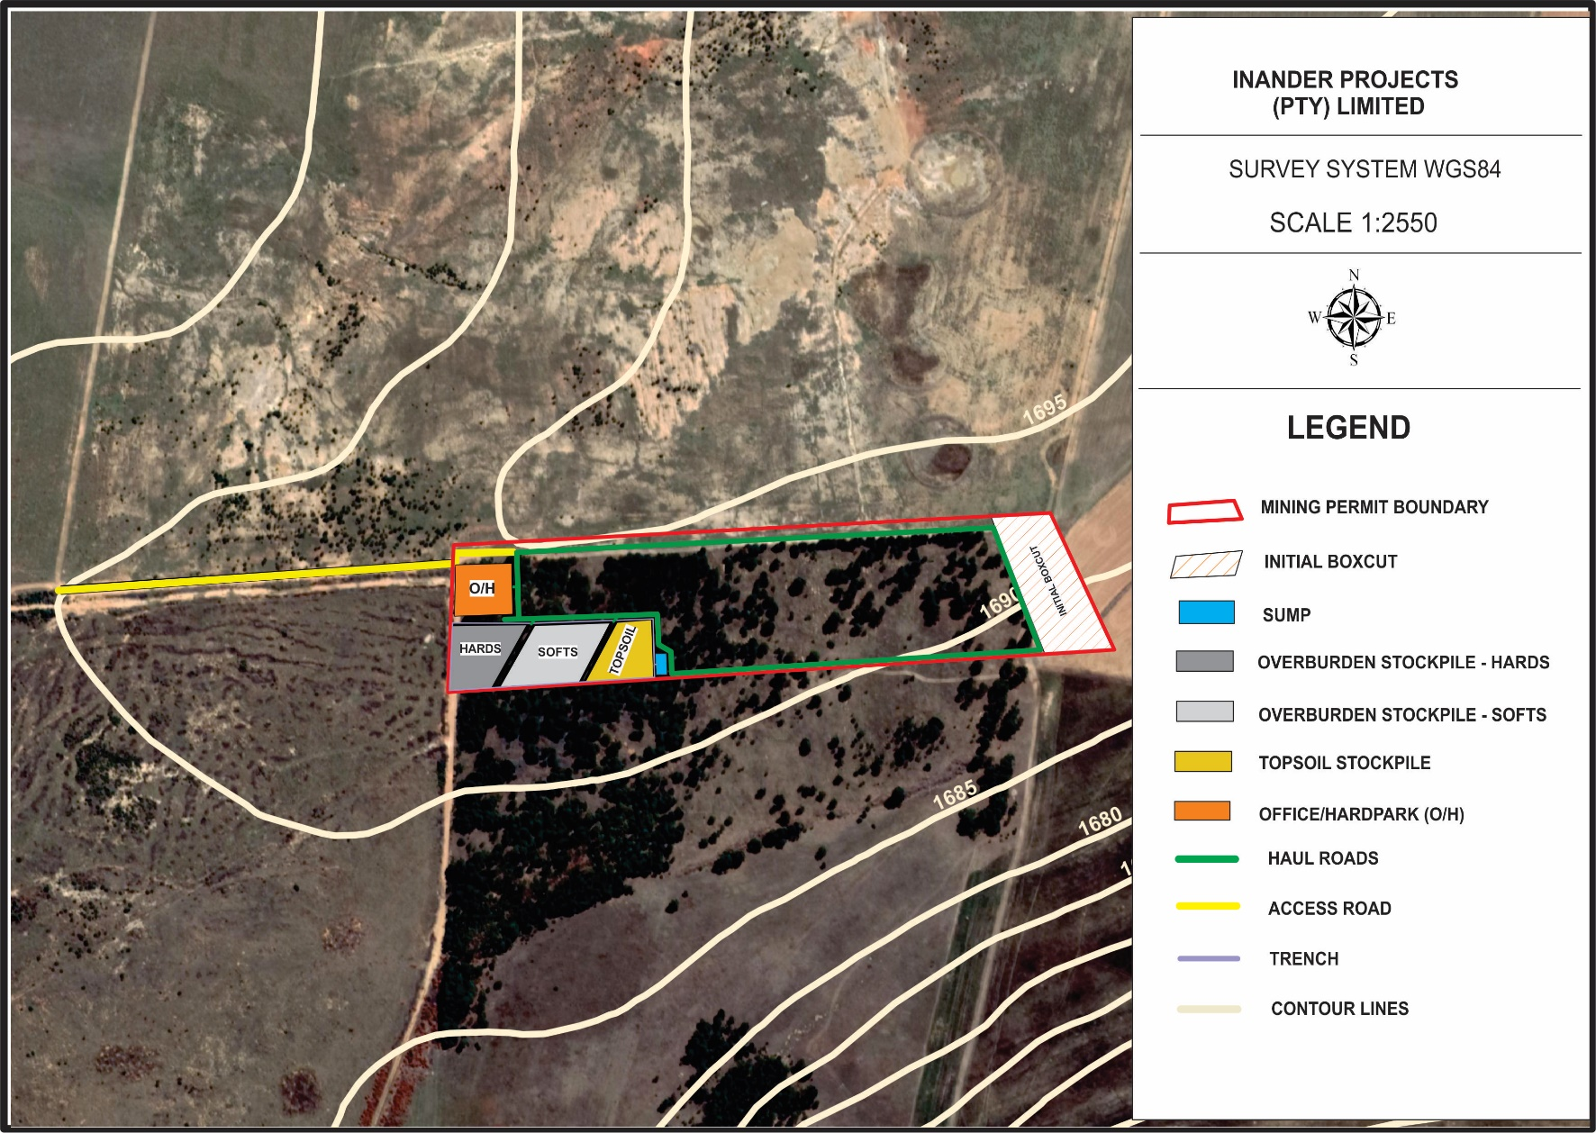
Figure 4: Surface layout plan, also attached as Appendix C.
Due to space limitations (5 ha), the proponent proposes to use an in-pit sump and an in-pit coal storage facility. During operation, the in-pit sump and coal storage facility will be placed on one boxcut and it will progress with mining thus allowing a maximum of 4 voids at a time during mining. Figure 5 below shows the layout plan for the boxcut that will be used for the in-pits infrastructures mentioned above.

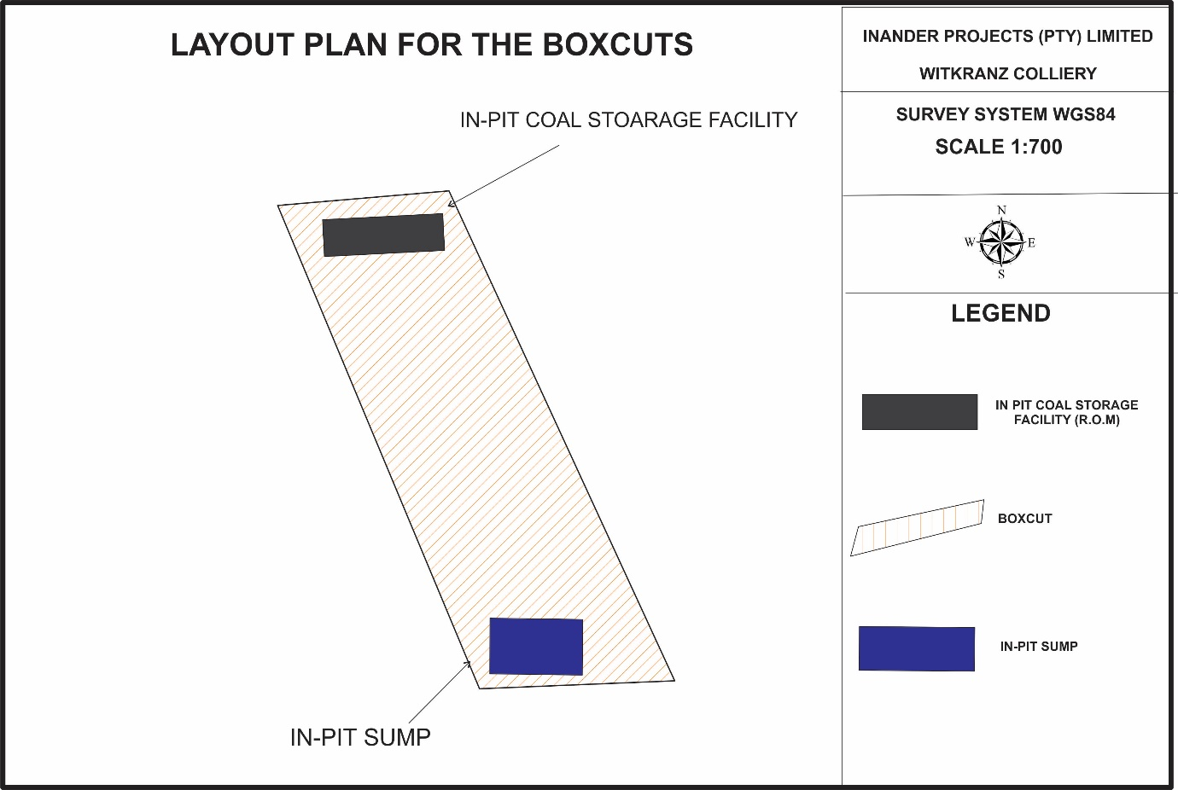
Figure 5: Layout plan for the boxcut.

Waste Management

Waste Identification and Management
The proposed mining operation will generate the following waste types i.e.: electronic waste, hazardous waste, general waste, recyclable waste and sewage waste. A waste management procedure will be compiled and implemented by the mine, which will ensure that a waste inventory that may contain all waste including waste not indicated in section of the report is compiled and filed.
Hazardous Waste
Hazardous waste any waste that contains elements or compounds that may have a detrimental impact on health and the environment is not disposed or handled correctly. This waste generally consists of oil, grease, chemicals, paints, their containers and any materials/substances contaminated by these.
General Waste
This is waste that does not contain any hazardous materials. Note that domestic waste, which will be generated from the proposed project, is considered as general waste. Domestic waste includes plastics, discarded food waste, cans, cardboard and packaging, polystyrene, building rubble, etc.
Electronic Waste
This waste includes products nearing the end of their "useful life" and may include computers, televisions, VCR’s radio’s, copiers and fax machines and telephones.
Recyclable Waste
This waste include material that is collected on the mine for reselling, re-use or recycling purposes. Recyclable materials are divided into the following:
• Scrap metals;
• Paper;
• Used printer cartridges etc.

Waste Management Facilities
Hazardous Waste
Hydrocarbon waste will be collected in 210 litre drums for storage. The removal of the drums or any other appropriate receptacle will be undertaken by a waste disposal company, for disposal at a registered licensed waste disposal site. The drums will be placed on protected concreted ground. Chemical toilets will be used for the management of sewage waste generated on site and will be maintained by a suitable contractor. Skips will be used to temporary store scrap materials and a reputable scrap collector will deployed to collect scrap.
General Waste
The general waste that will be generated is domestic waste will be collected in 210 litre drums and disposed of at a registered domestic waste disposal site.

Witkranz colliery Method Statement
In terms of the DMRE BAR and EMPR template, Inander Projects (Pty) Limited must describe the methods and technology to be employed for the proposed project. In view of the above, a method statement for each phase of the proposed project has been provided. This identifies all actions, activities or processes associated with the proposed mining operation.

Construction Phase
The following mine surface infrastructure will be established, namely:
- Access and haul roads
- Office containers
- In-pit Sump
- Material stockpiles (topsoil, softs, hards and ROM)
- Box-cut

Operational Phase
During the operational phase, coal will be mined in a systematic manner to remove the available coal seams. All overburden material removed will be stockpiled in such a manner that concurrent rehabilitation can be undertaken by replacing the said material in the correct sequence into the mined-out cuts.
Water Pollution Management Facilities
Witkranz Colliery will operate on the strategy of maximising the utilisation of “dirty water” in the mining area and will have a policy of zero discharge of contaminated water. The water accumulated in the pit will be pumped into the sump. The water from the in-pit sump and the pit will be utilised to suppress dust in areas where dust may emanate. Where the in-pit sump is not sufficient enough to store water, as an alternative, a PCD will be constructed on surface to store water from the opencast pit. Furthermore, a sump collecting water around the stockpiling area will be developed, this sump will be operated empty and will be kept dry, water from this sump will be utilized for dust suppression.
Potable water Plant
There will be no potable water treatment plant at Witkranz Colliery. Drinking water will be obtained from the nearby water supplier or borehole.
Transport
Mine officials and senior skilled employees will use their own vehicles for all transport requirements. Where necessary a bus services will be made available to transport other employees from their residences to their working place. Normal light delivery vehicles will be utilised to transport employees to the opencast mining areas.
A number of haul roads will be constructed around the mine for the transportation of coal from the opencast areas and coal from the pit will be transported by trucks.

Housing
No houses or hostels will be established on the mining areas.
Storm water management
Overburden material will be used as berms to divert storm water away from the mining areas. Witkranz Colliery will practice a policy of clean and dirty water separation where dirty water is contained and stored in the in-pit sump and the sump in the stockpiling area and this water will be re-used for dust suppression.

Decommissioning phase
Infrastructure areas
The retention or demolition of mine infrastructure presents a significant cost and should be considered at the purchasing and planning stages. The market value of infrastructure will change over the life of the operation and the degree to which the infrastructure is maintained during the operational period should reflect the intended post-closure use. The decommissioning phase should be considered during upgrades of mine infrastructure, with the aim to remove upon closure. The following should be available during decommissioning of infrastructure:
- A list of the areas and mine infrastructure that require decommissioning;
- A description of strategy, timing, and the techniques preferred to remove and dispose of mine’s infrastructure;
- Consultation with Interested and Affected Parties in regards to retention of mine’s infrastructure.
Monitoring and reporting
The water quality monitoring program will be continued, until it can be shown that water quality (surface and groundwater) is both stable and within acceptable guidelines and limits, as determined by the relevant State Departments. Frequency of monitoring will remain monthly for the surface water monitoring points and three monthly for groundwater monitoring points for the first three years after closure. Thereafter, the frequency for surface water monitoring points will decrease to 3-monthly and the groundwater monitoring points to 6-monthly. This will again be reviewed after a further 2 years.
Long term stability
Rehabilitation will be ongoing during the operational phase. The shaping of the pits will allow for the re-establishment of natural runoff patterns.

Final Rehabilitation
No roads will remain in place after the decommissioning phase. Note that the access and haul roads will be graded during this phase, in order to remove any fine carbonaceous material build-up on the roads during mining activities. The said roads will then be ripped to the depth of 300 mm, at 90° to the inherent slope, and seeded with a recommended seed mix. Any carbonaceous material removed from the said roads will be dumped in the final void before the said voids are leveled. After leveling the said voids, the areas will be seeded and conform to the rest of the rehabilitated areas.

After Closure Phase
The rehabilitated area will be monitored until closure of the site. After the decommissioning of the site and if it can be determined that the site is stable, an environmental authorisation for the decommissioning of the site and a closure certificate will be applied for in terms of the relevant laws.

SECTION THREE
_________________________________________________________________________________

Policy and legislative context

Policy and legislative context

Constitution of the Republic of South Africa (Act No. 108 of 1996)
Section 24 of the Constitution of the Republic of South Africa (Act No.108 of 1996) states that everyone has the right:
a) to an environment that is not harmful to their health or well-being; and
b) to have the environment protected, for the benefit of present and future generations, through reasonable legislative and other measures that;
(i) prevent pollution and ecological degradation;
(ii) promote conservation; and
(iii) secure ecologically sustainable development and use of natural resources while promoting justifiable economic and social development.
In terms of Section 24 of the Constitution of the Republic of South Africa (Act No.108 of 1996), everyone has the right to an environment that is not harmful to their health or well-being. In addition, people have the right to have the environment protected, for the benefit of present and future generations, through applicable legislations and other measures that prevent pollution, ecological degradation and promote conservation and secure ecological sustainable development through the use of natural resources while prompting justifiable economic and social development. The needs of the environment, as well as affected parties, should thus be integrated into the overall project in order to fulfil the requirements of Section 24 of the Constitution. In view of the above, a number of laws pertaining to environmental management were promulgated to give guidance on how the principles set out in section 24 of the Constitution of the Republic of South Africa (Act No.108 of 1996) would be met. Below are laws applicable to the proposed project that were promulgated to ensure that section 24 of the Constitution of the Republic of South Africa (Act No.108 of 1996) is complied with.

National Environmental Management Act
Section 24(1) of the NEMA states:
“In order to give effect to the general objectives of integrated environmental management laid down in this Chapter [Chapter 5], the potential consequences for or impacts on the environment of listed activities or specified activities must be considered, investigated, assessed and reported on to the competent authority or the Minister of the Department of Mineral Resources, as the case may be, except in respect of those activities that may commence without having to obtain an environmental authorisation in terms of this Act.”
In order to regulate the procedure and criteria as contemplated in Chapter 5 of NEMA relating to the preparation, evaluation, submission, processing and consideration of, and decision on, applications for environmental authorisations for the commencement of activities, subjected to environmental impact assessment, in order to avoid or mitigate detrimental impacts on the environment, and to optimise positive environmental impacts, and for matters pertaining thereto, Regulations (EIA Regulations, 2014) were promulgated. These Regulations took effect from the 4th of December 2014.
In addition to the above, Section 28 of the NEMA includes a general “Duty of Care” whereby care must be taken to prevent, control and remedy the effect of significant pollution and environmental degradation. This section stipulates the importance to protect the environment from degradation and pollution irrespective of the operations taking places or activities triggered / not triggered under No. 326, No. 325 and No. 324.
In view of the above, an environmental impact assessment is being undertaken to comply with the requirements of the NEMA and the NEMA EIA Regulations, 2014. The NEMA EIA Regulations of December 2014 determines requirements to be met in order to obtain an environmental authorisation. This report has therefore been compiled in compliance with the above regulations.

National Environmental Management Air Quality Act
The National Environmental Management: Air Quality Act (Act No.39 of 2004) (NEM: AQA) focuses on reforming the law regulating air quality in South Africa in order to protect the environment through the provision of reasonable measures protecting the environment against air pollution and ecological degradation and securing ecological sustainable development while promoting justifiable economic and social developments. This Act provides national norms and standards regulating air quality management and control by all spheres of government. These include the National Ambient Air Quality Standards (NAAQS) and the National Dust Control Regulations (NDCR). The standards are defined for different air pollutants with different limits based on the toxicity of the pollutants to the environment and humans, number of allowable exceedances and the date of compliance of the specific standard.
On 22 November 2013 the list of activities which result in atmospheric emissions which have or may have a significant detrimental effect on the environment, including health, social conditions, economic conditions, ecological conditions or cultural heritage was published under GN R893 in Governmental Gazette No 37054, in terms of Section 21(1)(b) of the NEM: AQA.
The proposed will not trigger any of the activities listed under the above-mentioned Regulations, however Inander Projects (Pty) Limited must ensure that emissions from their activities complies with the standards as set in the above-mentioned regulations.

The National Heritage Resources Act
The National Heritage Resources Act (Act No. 25 of 1999) (NHRA) focuses on the protection and management of South Africa’s heritage resources. The governing authority for this act is the South African Heritage Resources Agency (SAHRA). In terms of the NHRA, historically important features such as graves, trees, archaeology and fossil beds are protected as well as culturally significant symbols, spaces and landscapes. Section 38 of the NHRA stipulates the requirements a developer must undertake prior to development. In terms of Section 38 of the NHRA, SAHRA can call for a Heritage Impact Assessment (HIA) where certain categories of development are proposed.
A HIA is the process to be followed in order to determine whether any heritage resources are located within the area to be developed as well as the possible impact of the proposed development thereon.
The Act also makes provision for the assessment of heritage impacts as part of an EIA process and indicates that if such an assessment is deemed adequate, a separate HIA is not required. An assessment of the proposed area will be done during the drilling programme to determine if there are any sites that require protection. Any sites identified will be marked and no drilling will be undertaken in close proximity of such a site.

National Environmental Management Biodiversity Act (Act 10 of 2004) (NEMBA)
The National Environmental Management: Biodiversity Act (Act No. 10 of 2004) (NEMBA) provides for the management and protection of South Africa’s biodiversity within the framework established by NEMA. The Act aims to legally provide for biodiversity conservation, sustainable, equitable access and benefit sharing and provides for the management and control of alien and invasive species to prevent or minimize harm to the environment and indigenous biodiversity. The Act imposes obligations on landowners (state or private) governing alien invasive species as well as regulates the introduction of genetically modified organisms. The Act encourages the eradication of alien species that may harm indigenous ecosystems or habitats. The NEMBA ensures that provision is made by the site developer to remove any aliens which have been introduced to the site or are present on the site.
The NEMBA also provides for listing of threatened or protected ecosystems, in one of four categories: critically endangered, endangered, vulnerable or protected. The purpose of listing protected ecosystems is primarily to conserve sites of exceptionally high conservation value.
The Act supports South Africa’s obligations under sanctioned international agreements regulating international trade in specimens of endangered species, and ensures that the utilization of biodiversity is managed in an ecological sustainable way.
The BAR and EMPR has been complied to ensure that all applicable requirements prescribed in the NEMBA are complied with.

Mpumalanga Nature Conservation Act (Act 10 of 1998)
The Mpumalanga Nature Conservation Act, No. 10 of 1998, aims to consolidate and amend the laws relating to nature conservation within the province and to provide for matters connected therewith. Provincial legislation relevant to biodiversity conservation comprises of two Provincial Acts, the Mpumalanga Nature Conservation Act (Act 10 of 1998) and the Mpumalanga Tourism and Parks Agency Act (Act 5 of 2005). In relation to nature conservation, the province has developed the Mpumalanga Biodiversity Sector Plan (MBSP). This plan has been jointly developed by the Mpumalanga Tourism and Parks Agency (MTPA) and the Department of Agriculture, Rural Development, Land and Environmental Affairs (DARDLEA). The MBSP takes its mandate from the South African Constitution, the National Biodiversity Act (10 of 2004) and the Mpumalanga Nature Conservation Act 10 of 1998. Areas identified under the MBSP as sensitive were identified and where applicable measures will be proposed for ensuring that the areas are not degrade by the proposed project activities.

Mineral and Petroleum Resources Development Act (MPRDA): Act 28 of 2002
The Department of Mineral Resources and Energy (DMRE) is responsible for regulating the mining and minerals industry to achieve equitable access to the country’s resources and contribute to sustainable development. The Mineral and Petroleum Resources Development Act, 2002 (Act 28 of 2002) (MPRDA) requires that an EIA be conducted and that the EMP be drafted for the mitigation of impacts identified during the environmental impact assessment for a mining project. During December 2014, the “One Environmental System” was implemented by Government which initiated the streamlining of the licensing processes for mining, environmental authorisations and water use. Under the One Environmental System, The Minister of Mineral Resources, will issue environmental authorisations and waste management licences in terms of the National Environmental Management Act, 1998 (Act No. 107 of 1998) (NEMA), and the National Environmental Management: Waste Act, 2008 (Act No. 59 of 2008) (NEMWA), respectively, for mining and related activities. The Minister of Environmental Affairs will be the appeal authority for these authorisations. In view of the above the application for the environmental authorisation for the proposed project was submitted to the Department of Mineral Resources as the competent authority.

National Water Act (NWA): Act No. 36 of 1998
The National Water Act (Act No. 36 of 1998) (NWA) is the primary regulatory legislation, controlling and managing the use of water resources as well as the pollution thereof in South Africa. The NWA recognises that the ultimate aim of water resource management is to achieve sustainable use of water for the benefit of all users and that the protection of the quality of water resources is necessary to ensure sustainability of the nation’s water resources in the interests of all water users. The NWA presents strategies to facilitate sound management of water resources, provides for the protection of water resources, and regulates use of water by means of Catchment Management Agencies, Water User Associations, Advisory Committees and International Water Management. The National Government has overall responsibility for and authority over water resource management, including the equitable allocation and beneficial use of water in the public interest. Further, an industry can only be entitled to use water if the use is permissible under the NWA. The enforcing authority on water users is the Department of Water and Sanitation (DWS).
Further, Regulation 704 of the NWA deals with the control and use of water for mining and related activities aimed at the protection of water resources.
No water use licence application will be submitted to the Department of Water and Sanitation for their consideration. However, measures will be undertaken to ensure that requirements in terms of the NWA and the GN 704 are complied with where necessary.

National Environmental Management: Waste Act (Act No. 59 of 2008)
The National Environmental Management: Waste Act (NEMWA) requires that all waste management activities must be licensed. According to Section 44 of the NEMWA, the licensing procedure must be integrated with an EIA process in terms of the NEMA.
The objectives of NEMWA involve the protection of health, wellbeing and the environment. The NEMWA provides measures for the minimisation of natural resource consumption, avoiding and minimising the generation of waste, reducing, recycling and recovering waste, and treating and safely disposing of waste.
Waste management activities are triggered by the proposed project, hence application in terms of the NEMWA was submitted to the Department of Mineral Resources and Energy.

EIA Guidelines
A number of national and provincial EIA guidelines were published by different departments. These guidelines are mainly aimed at assisting relevant stakeholders by providing information and guidance and giving recommendations on a number of aspects relating to the environmental impact assessment process. The guidelines can be used by the competent authority, applicant and the EAP during the EIA process. It is therefore important that the EAP and the person compiling a specialist report must have relevant expertise when conducting the environmental impact assessments.
A number of guidelines were consulted during the compilation of this report and these include amongst them the following i.e., Guidelines on the Need and Desirability, Department of Environmental Affairs and Tourism Integrated Environmental Management Guidelines, Department of Water and Sanitation’s Best Practice Guidelines and the Western Cape Provincial Department of Environmental Affairs and Development Planning Guidelines on Public Participation.

SECTION FOUR
_________________________________________________________________________________

Need and desirability of the proposed activities

need and desirability of the proposed activities

Motivation for the Need and desirability of the Project
In terms of the EIA Regulations the need and desirability of any development must be considered by the relevant competent authority when reviewing an application. The need and desirability must be included in the reports to be submitted during the environmental authorisation application processes.
The section of the BAR and EMPr will indicate the need and desirability for the approval of the BAR and EMPr for Witkranz Colliery.
This project is crucial in ensuring that Inander Projects (Pty) Limited maintains job employment and coal production rates at Witkranz Colliery to supply the local and the export markets.
Inander Projects (Pty) Limited expects that substantial benefits from the project will accrue to the immediate project area, the sub-region and the province of Mpumalanga. These benefits must be offset against the costs of the project.
The potential benefits of the proposed project are:
- Highly significant benefits to the province of Mpumalanga in terms of the long-term coal supply. Long-term coal supply contracts bring about needed job creation and other local, provincial and national socio-economic benefits.
- Potential reduction in crime as a result of job creation.
- Local growth in the economy of the towns of Carolina, Hendrina, Middelburg and surrounding areas, and for local businesses.
- Economic benefits for contractors and other suppliers of goods and services.
- Economic opportunities and other potential benefits for land owners from compensation for impacts.
Through the implementation of the Social and Labour Plan (SLP) the mine employees will be developed in terms of skills development and career progression; small businesses will be established and sustained and the mine will support community infrastructure development and poverty eradication.
This BAR recommends that Inander Projects (Pty) Limited, and also its contractors, follow the approach of maximising and enhancing benefits rather than merely focussing on reducing or avoiding negative impacts, and that all opportunities for additional benefits to local land owners be actively pursued.
Based on the environmental assessment conducted as described in this Report, there are no environmental impacts associated with the proposed project that cannot be mitigated.

SECTION FIVE
_________________________________________________________________________________

Motivation for the preferred development footprint

motivation for the preferred development footprint

Consideration of Alternatives
The National Environmental Management Act 107 of 1998, Environmental Impact Assessment Regulations, 2014 requires environmental reports (Scoping Report and Environmental Impact Assessment Report) to identify alternatives for projects applied for. In terms of the above-mentioned regulations an alternative in relation to a proposed activity, refers to different means of meeting the general purpose and requirements of the activity, which may include alternatives to the (a) the property on which or location where it is proposed to undertake the activity; (b) the type of activity to be undertaken; (c) the design or layout of the activity; (d) the technology to be used in the activity; (e) the operational aspects of the activity; and (f) the option of not implementing the activity.
Inander Projects (Pty) Limited intends on undertaking an opencast mining operation namely Witkranz Colliery. A number of alternatives were considered for the proposed mining operation. This section of the report will highlight the alternatives considered for the mining operation activities at Witkranz Colliery.

Location Alternatives
The location of the proposed development is the most suitable due to its ideal location in terms of the requirements for coal mining. Therefore, no alternatives in relation to the location of the mine were considered.

Design/ Layout Alternatives
Site layout alternatives considered include the following i.e.:
Dirty water dams:
Two alternatives were considered i.e., in-pit water storage and surface pollution control dam. Due to space limitation (5 ha mining permit area) the in-pit water storage was decided upon. A pollution control dam (outside the mining permit area due to space limitation) will; however, be considered and constructed should the in-pit storage facility not be sufficient for the water generated during mining.
Access:
Two alternatives were considered i.e., expansion of the existing road and constructing a new road. Since the proponent would like to limit their pollution footprint the existing access road was decided upon. Should permission for using the existing road not be obtained, a new road will be designed and constructed for access to the mining permit area.
Coal stockpiling facility:
Two alternatives were considered i.e., in pit coal storage and surface coal storage. Due to space limitation (5 ha mining permit area) the in-pit coal storage was decided upon. A surface coal storage facility will however be considered and constructed should the in-pit storage facility not be sufficient for the coal generated during mining.
Topsoil and overburden stockpiling facility:
Two alternatives were considered i.e., placing the stockpiling facilities outside the mining permit area and placing the stockpiling facilities inside the mining permit area. Due to space limitation (5 ha mining areas), placing the stockpiling facilities outside the mining permit area was decided upon. Placing stockpiling facilities within the permit area will be considered if the first alternatives is rejected by the competent authority.

Transport Alternatives
In terms of the proposed Witkranz Colliery the most viable option to accessing the site will be via the R36 Hendrina – Carolina Road.

No Go Option
Should the project not commence, the following will result i.e.:
The mine will not commence, which will result in the potential labour force losing their employment opportunity and all support that the mine would have provided to the local businesses will also cease.
Witkranz Colliery has supply contracts for the type of coal that is available in these reserves, hence should the mine not commence, and the mine will not be able to honour their supply contracts. This will have serious impacts on the ability of the mine continue with their business.
Accordingly, the consequences of not proceeding with the proposed project will have a detrimental impact on the current and future labour force, the surrounding previously disadvantaged communities, the owners of the mine, and the coal export market. This may ultimately have an impact on the region as a whole, due to a loss of revenue and due to a loss in taxes.

Concluding Statement
Based on the above, the proposed coal mining operation, situated on a portion of portion 16 of the farm Witkranz 53 IT with the surface infrastructure placed outside of the 5-ha mining permit boundary and an in-pit water and coal storage facility accessed via the R36 road, is preferred for the proposed mining project.

Details Of The Public Participation Process Followed and Results Thereof
Public participation is the cornerstone of any EIA process. The principles of the NEMA govern many aspects of EIA’s, including public participation. The general objectives of integrated environmental management laid down in the NEMA include to “ensure adequate and appropriate opportunity for public participation in decisions that may affect the environment”. The National Environmental Management Principles include the principle that “The participation of all interested and affected parties in environmental governance must be promoted, and all people must have the opportunity to develop the understanding, skills and capacity necessary to achieve equitable and effective participation, and participation by vulnerable and disadvantaged persons must be ensured”, which basically means that the person responsible for the application (EAP) must ensure that provision of sufficient and transparent information on an ongoing basis to stakeholders are made to allow them to comment, and to ensure that the participation of previously disadvantaged people like women and the youth are undertaken.
In terms of the EIA Regulations, 2014, when applying for environmental authorisation, the Environmental Assessment Practitioner managing the application must conduct at least a public participation process where all potential or registered interested and affected parties, including the competent authority, are given a period of at least 30 days to submit comments on each of the basic assessment reports, EMPR, scoping report and environmental impact assessment report, and where applicable the closure plan. In this case a Basic Assessment Report (BAR) is considered.
This section of the BAR and EMPR will give an explanation of the public participation process taken in order to comply with the above-mentioned requirements. A number of public participation guidelines were published in a bid to assist persons responsible for the environmental authorisation applications. As much of the available guidelines were used in determining the public participation process, in guiding the public participation process of the proposed project.
Geovicon Environmental (Pty) Ltd on behalf of Inander Projects (Pty) Limited is applying for an environmental authorisation for the proposed Witkranz Colliery. The application for the environmental authorisation is undertaken in terms of the process as laid out in part 2 of Chapter 4 under the NEMA EIA Regulations, 2014. The above-mentioned regulations requires that an applicant for an environmental authorisation submit a BAR and EMPR to the competent authority after having subjected the reports to a public participation process.
In view of the above, a public participation process was initiated for the proposed Witkranz Colliery. The public participation process for the proposed project was designed to provide sufficient and accessible information to interested and affected parties (I&APs) in an objective manner to assist them to:
- raise issues of concern and make suggestions for enhanced benefits;
- contribute local knowledge and experience;
- verify that their issues have been captured;
- verify that their issues have been considered in the technical investigations; and
- comment on the findings of the EIA.
The following were conducted in undertaking of the public participation process for the proposed project.

Registration and BAR Phase
The public participation process commenced with the provision of potential Interested and affected parties (I&AP’s) 30 days to register as interested and affected parties and to comment on the draft BAR and EMPR. The registration and commenting process starts on the 25th of June 2021 and ends on the 26th of July 2021. Note that all parties are provided enough time (at least 30 days) to comment on the report.

Notification of potential interested and affected parties
The following methods of notification were used to notify the potential interested and affected parties of the opportunity to register during the public participation process for the proposed project:
- On the 25th of June 2021, notices were posted in the Highveld News which is distributed in Carolina, informing the public that the BAR is in the Carolina public library. The notices were compiled in compliance with the requirements of Regulation 41(3) of the EIA Regulations, 2014.
- Written notices were sent to all surface owners and lawful occupiers of the land on which the proposed mining will be undertaken.
- Site notices inviting the public to register as interested and affected parties were also used to invite comments on the BAR and EMPR from the public.
- The draft BAR and EMPR was also submitted to all the commenting authorities for their comments.
- A copy of the draft BAR and EMPR was placed in the local library (Carolina).

Registered Interested and Affected Parties
The following are currently registered as interested and affected parties for the Witkranz Colliery:
- Department of Mineral Resources, Mpumalanga Regional Office (Competent Authority),
- Department of Water and Sanitation, Mpumalanga Regional Office (Commenting Authority)
- National Department of Agriculture, Forestry and Fisheries, Mpumalanga Regional Office (Commenting Authority)
- Mpumalanga Tourism and Parks Agency (Commenting Authority)
- South African Heritage Resources Agency (Commenting Authority)
- Witkranz Colliery, immediate land owners and lawful occupiers
- Ward 21 Councillor (Carolina Local Municipality)

Proof of Consultation
Proof of the above-mentioned consultation and results are attached as Appendix D.

Finalisation of Interested and Affected Party Database
On expiry of registration period, the database of interested and affected parties was finalised. All parties who indicated the interest of being registered as interested and affected parties were added to the list of interested and affected parties.
Note: All organs of state, which have jurisdiction in respect of any aspect of the proposed project and the competent authority are automatically registered as interested and affected parties.

Draft Basic Assessment Report
The draft BAR and EMPR was made available for comment to all relevant stakeholders during the above-mentioned registration phase of the proposed project public participation process.

Comments, Issues and Responses on the Draft Basic Assessment Report
The comments and issues that were raised by the interested and affected parties were addressed and are included in this final BAR and EMPR, see Table 4 below.

Table 4: Comments from the I&APs
Interested & Affected Party | Date Comments Received | Issues Raised | EAP’s Responses to Issues Raised | Consultation  Status  (Consensus dispute, not finalised, etc.)
Direct & Adjacent Surface owners
*Koos Jordaan | - | - | - | Completed
Msobo coal, Awande Nojekwa | - | - | - | Completed
Babheni Moses Zwane | - | - | - | Completed
Mr Jacobus Petrus Le Roux | - | - | - | Completed
State Departments and others
Komilla Narasoo - MTPA | - | - | - | Completed
Mthembi Golden - IUCMA | - | - | - | Completed
Shabane Loves – DAFF (DFFE) | - | - | - | Completed
Molepe Emmy - Eskom | - | - | - | Completed
*The asterisk indicates the direct farm/surface owner. No comments were received; however, proof of consultation is attached as Appendix D.

Environmental Attributes (Baseline Information)

Geology

Regional Geology
Witkranz Colliery falls within the Ermelo Coalfield of the well-known Middle Ecca stage Coal Province. The mining area is situated within the eastern portion of the Ermelo Coalfield. Several coalmines have been, or are operating within this coalfield.
The coal seams present within the Carolina – Breyten sector are alphabetically numbered from the top as follows; A, B, C, D and E seams. The A and D seams are generally too thin (< 0,6 meters) to be of economic importance. The B seam generally attains a thickness of between 2 – 3.7 m and consists of alternating layers of poor and good quality coal with generally high ash content. The C seam can attain a thickness of between 0.6 and 2 m and is generally the target seam within the Ermelo area. The E seam is generally well developed in the Carolina – Breyten sector of the Coal Province and may attain a thickness of 3 m.
There are two major factors that control the aerial distribution of the coal seams within the Carolina – Breyten sector of the Ermelo Coalfield. The first is the topography of the pre-Karoo basement, which affects the distribution of the lower seams, whilst the present-day erosional surface has affected the distribution of the upper seams, and occasionally the entire coal measure package.
The influence of pre-Karoo ridges may also propagate their effects upwards due to differential compaction of the sediments within the valleys and ridge areas resulting in a thinning or non-deposition of the coal seams.
On a local scale, fluvial channels have given rise to erosion (during sediment formation), non-deposition, and thinning of the coal seam.
The host rocks of the coal seams vary from fine-grained laminated and micaceous to coarse and gritty sandstones with alternating zones of shale and shaly sandstone. The total thickness of the Middle Ecca is up to 170 m and the main coal zone within it, up to 85 m. The thickness of the partings between seams A and B, B and C, and C and D are 30 – 60 m, 6 – 9 m and approximately 12 m respectively.
The A seam occurs in isolated outliers in the sector. Although of moderate quality, it has no reported economic importance. It occurs usually as an interbanded shaley coal seam with a thickness of 1 m.
The B seam may be split into in seam bands and occurs as three discrete leaves. These are designated as the BX, B and B1 seams (also locally known as the B upper, B and B1 seams). The BX seam (B upper) attains a thickness of approximately 1 m and is separated from the B seam by a thin shale or sandstone (~ 0.4 m) parting. This seam consists of dull coal with occasional bright bands. The B seam varies in thickness from 1 – 2.7 m. This seam consists of a bright banded coal of good quality and low ash content within the Carolina area.
The C seam is a complex seam, consisting of several plies separated by partings of variable thickness. Traditionally the C seam group is subdivided into the C upper and C lower seams. The C upper seam may be split into two seams. The C upper seam is well developed over the sector. However, it is usually a complex seam of two or three plies, split by in seam sandstones, siltstones or mudstones of variable extent and thickness. In the Carolina – Breyten sector, the seam is more complex, due to the proximity of large channel fill sandstones. A further complication is the occurrence of a thin, although laterally persistent seam (locally known as the B1). This thin seam may either be separated from the C upper by a thin parting or may gradually migrate up the sequence to the base of the B seam. The upper portion of the C upper seam is typically of poor quality and may be torbanitic over large areas. The lower portion of the seam is of good quality coal and consists of vitrain and durain bands. The C lower seam is usually thin and seldom greater than 0.6 m in thickness. The floor of the seam is usually sandstone or interbedded sandstone and shale, whilst the roof is generally interbedded carbonaceous shale. The upper portion of the seam is generally of good quality, with interbanded vitrain and durain bands. The lower portion of the seam normally becomes more torbanitic towards the base.
The D seam seldom attains a thickness greater than 0.6 m and thus is usually too thin to be of economic importance. The overlying and underlying sediments are predominantly sandstones with minor siltstone intercalations. The coal is vitrainitic with occasional durain bands.
The E seam is well developed and is of economic significance. It attains a thickness of over three meters (although thinning to a maximum thickness of 1.2 m within the Carolina area). The roof and floor of the seam are generally composed of competent sandstone. The seam consists of predominantly bright banded (vitrainitic) coal.
In terms of geological structures, near vertical dolerite dykes are generally associated with the Karoo Supergroup rocks and are known to occur widespread throughout the Ermelo Coalfield. These dykes are very important from a geohydrological perspective, because:
- The crystalline nature of an igneous dyke makes it impervious to groundwater flow, thus creating a very effective no-flow groundwater boundary.
- Dykes therefore have the ability to divide the aquifer system into smaller sub compartments, often displaying distinct groundwater quality and water level conditions.
- What seems like a contradiction, dykes are targeted when exploring for groundwater. During the initial intrusion of the magma into a fault or discontinuity, rapid cooling causes fractures to form all along the contact. These fractures have the potential to take into or release significant volumes of groundwater from storage.
- Dolerite dykes (although not allowing groundwater to flow at right angles through it) therefore also have the potential to create parallel flow paths for both groundwater and contamination (if present).
- Groundwater impacts, both in term of quality and quantity, consequently tend to extend along the strike of a dyke.

Local Geology
The local geology is summarized in Figure 6 below.

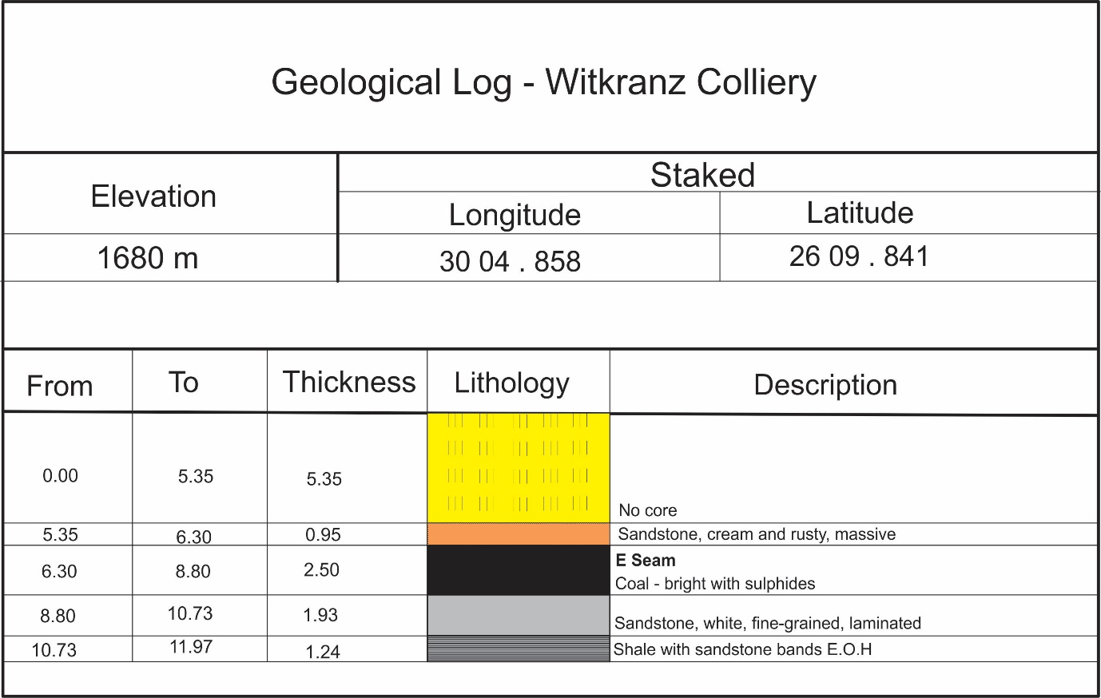
Figure 6: Generalised stratigraphic section of the area.

Climate

Regional Climate
Witkranz Colliery falls within the summer rainfall region of South Africa, in which more than 80% of the annual rainfall occurs from October to March. Eighty five percent of the rain falls during summer thunderstorms occurring every 3 - 4 days in summer. They occur in the form of conventional thunderstorms, are usually of short duration and high intensity and accompanied by lightning, strong winds, and sometimes hail. 68.5

Mean Monthly Rainfall and Evaporation
The mean annual precipitation of the mining permit area is 607 mm. This is appreciably lower than the MAP for the area (Quaternary mean annual precipitation = 688 mm). The mean annual evaporation of the mining permit area is 1 446 mm (S-Pan). The monthly average rainfall, rainfall days, and evaporation rates are presented in Table 5. The Mpumalanga Highveld has distinct wet and dry seasons. 92% of the mining permit area’s mean annual rainfall falls between October and April inclusively. 67% of the area’s mean annual evaporation occurs in this period (Midgley et al., 1990).
Table 5: Mean monthly rainfall, rain days and evaporation data for the site.
Month | Ave Rainfall (mm) | Ave rain days | Ave Evaporation (mm S-Pan)
October | 72.0 | 8.2 | 137.4
November | 105.6 | 11.2 | 137.1
December | 105.7 | 11.2 | 155.7
January | 101.5 | 10.6 | 163.1
February | 75.9 | 7.6 | 139.8
March | 67.7 | 7.9 | 137.2
April | 31.8 | 4.2 | 104.1
May | 9.5 | 2.2 | 90.8
June | 5.4 | 0.8 | 74.6
July | 4.4 | 0.8 | 80.5
August | 8.0 | 1.2 | 101.9
September | 21.1 | 2.8 | 123.6
Mean Annual | 607* | 68.5 | 1 446

Climatic Water Balance
The Department of Water and Sanitation require a climatic water balance that incorporates a list of years which have the wettest six months of the year, either November to April or May to October. In this case November to April is wetter than May to October. The wettest six months between November and April are listed in Table 6.
Table 6: Wettest years between November and April
Rating | Year | Total rainfall between November and April (mm)
Wettest year | 1984 | 937.5
2nd wettest year | 1961 | 857
3rd wettest year | 1918 | 832.3
4th wettest year | 1991 | 811
5th wettest year | 1990 | 794.5
6th wettest year | 1967 | 799
7th wettest year | 1975 | 773
8th wettest year | 1987 | 762.5
9th wettest year | 1923 | 760.2
10th wettest year | 1915 | 756.2

Peak Rainfall Data

Maximum Monthly Rainfall Data
The maximum monthly rainfall data was distilled from the daily rainfall record and is presented in Table 7.
Table 7: Maximum monthly rainfall data (mm).
Oct | Nov | Dec | Jan | Feb | Mar | Apr | May | Jun | Jul | Aug | Sep
209 | 295.5 | 238.7 | 242 | 196 | 202.5 | 97.5 | 69 | 71.5 | 44 | 66.7 | 147

Peak 24-hr Rainfall Data
The peak 24-hr rainfall depths are presented in Table 8.
Table 8: Peak 24-hr rainfall depths for the site.
Recurrence Interval (year) | 24-hour rainfall depth (mm)
2 | 41
10 | 77
20 | 93
50 | 113
100 | 130
200 | 148

Mean monthly temperature
The mean maximum and minimum temperatures, extrapolated from the Pretoria, Middelburg, Belfast and Carolina weather stations are presented in Table 9.
Table 9: Mean monthly temperature data for 0515320 (Carolina).
Month | Temperature (°C)
 | Mean | mean max | Mean min
January | 18,9 | 24,5 | 13,4
February | 18,4 | 23,8 | 12,9
March | 17,6 | 23,2 | 12,0
April | 15,0 | 21,0 | 9,0
May | 12,1 | 19,0 | 5,2
June | 9,0 | 16,2 | 1,8
July | 9,7 | 17,1 | 2,4
August | 11,9 | 19,4 | 4,5
September | 14,8 | 22,2 | 7,5
October | 16,3 | 22,8 | 9,6
November | 17,3 | 23,1 | 11,4
December | 18,4 | 24,1 | 12,8
Total | 179,4 | 256,4 | 102,5
Average | 27,6 | 39,4 | 15,8

Wind Direction and Speed at the Mine
Wind direction and speed for the Carolina area is provide in Table 10 below.
Table 10: Average Wind Speed and Direction.
 | N |  | NE |  | E |  | SE |  | S |  | SW |  | W |  | NW
 | N | V | N | V | N | V | N | V | N | V | N | V | N | V | N | V
Jan | 110 | 2,7 | 214 | 3,0 | 139 | 3,1 | 82 | 4,3 | 32 | 3,0 | 65 | 2,9 | 90 | 3,4 | 115 | 2,9
Feb | 78 | 2,7 | 213 | 3,3 | 169 | 3,2 | 143 | 4,1 | 41 | 3,0 | 50 | 3,3 | 74 | 3,0 | 91 | 2,9
Mar | 93 | 2,5 | 217 | 3,1 | 179 | 2,9 | 103 | 3,3 | 40 | 2,6 | 48 | 2,8 | 73 | 3,2 | 90 | 2,7
Apr | 89 | 2,4 | 174 | 2,8 | 124 | 2,8 | 75 | 3,1 | 40 | 2,5 | 84 | 3,2 | 111 | 3,3 | 128 | 2,9
May | 105 | 2,4 | 127 | 2,8 | 107 | 2,9 | 83 | 3,2 | 48 | 3,0 | 67 | 3,5 | 111 | 3,5 | 124 | 3,0
Jun | 78 | 2,3 | 121 | 2,6 | 102 | 2,6 | 55 | 3,2 | 45 | 3,1 | 106 | 4,0 | 113 | 3,6 | 137 | 2,9
Jul | 95 | 2,3 | 139 | 2,6 | 97 | 2,9 | 64 | 3,7 | 38 | 3,1 | 89 | 3,7 | 111 | 3,5 | 128 | 3,0
Aug | 108 | 2,7 | 161 | 3,5 | 102 | 3,2 | 41 | 4,2 | 34 | 3,2 | 81 | 4,5 | 123 | 4,5 | 187 | 3,3
Sep | 116 | 2,9 | 207 | 3,5 | 120 | 3,6 | 59 | 4,1 | 31 | 3,0 | 73 | 3,9 | 109 | 3,9 | 162 | 3,7
Oct | 106 | 2,9 | 212 | 3,4 | 123 | 3,9 | 52 | 3,3 | 24 | 3,4 | 59 | 3,5 | 112 | 3,7 | 172 | 3,6
Nov | 102 | 3,0 | 186 | 3,4 | 133 | 3,4 | 45 | 3,9 | 30 | 3,1 | 69 | 3,1 | 153 | 3,9 | 164 | 3,4
Dec | 108 | 2,9 | 208 | 3,2 | 138 | 3,1 | 55 | 3,8 | 33 | 3,2 | 61 | 3,1 | 125 | 3,0 | 141 | 3,3
Year | 99 | 2,6 | 182 | 3,1 | 128 | 3,1 | 71 | 3,7 | 36 | 3,0 | 71 | 3,5 | 109 | 3,6 | 137 | 3,2

Extreme weather conditions
The area is prone to host extreme events on a regular basis. These events include the following:
- The area is prone to drought conditions.
- Regular frost occurs during the winter months.
- Rainfall occurs as scattered thunderstorms.
- Strong gusty winds prior to and during thunderstorms.

Topography
The elevation of the surrounding area ranges from 1695 m above sea level to 1703 m above sea level (Figure 7). The surrounding area is considered undulating and consists of hills and valleys, often with streams in the valleys and pans in the hills.
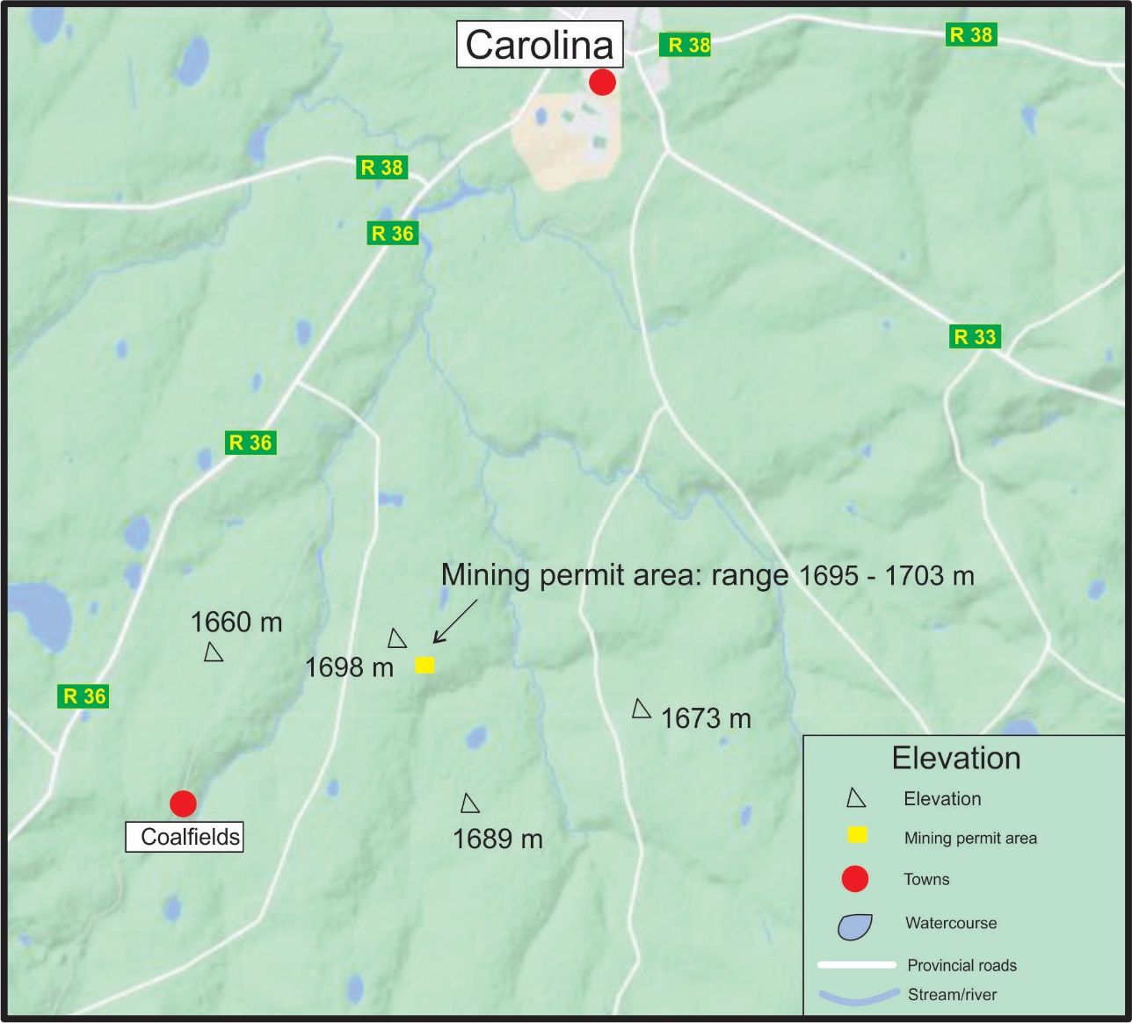
Figure 7: Elevation figure.
.

Soil
The Witkranz Colliery falls within the GM 12 Eastern Highveld Grassland biome which is dominated by red to yellow sandy soils of the Ba and Bb land types found on shales and sandstones of the Madzaringwe Formation (Karoo Supergroup). Land types Bp (65%) and Ba (30%).
Land capability
The land capability classification adopted by the Chamber of Mines (2007) recognises four classes, viz. Class I (wetland), Class II (arable land) Class III (grazing land), and Class IV (wilderness land). The land capability in the Witkranz Colliery area falls within the Class III and Class IV.

Land-Use
The land in the area is mainly used for wilderness purposes and limited grazing. Adjacent land is used for mining, limited crop production & grazing and wilderness purposes.

Archaeological and Cultural importance
According to the screening tool from the Department of fisheries, forestry and environmental, the Witkrans mining permit area falls within the medium to low archaeological and cultural importance.

Agricultural aspect
Some of the adjacent farms are used for crop production; however, the mining project is too insignificant to have detrimental impact on agricultural activities around the area. The mining permit holder must nonetheless implement the mitigation measures recommended in the EMP to avoid impact on surrounding areas.

Natural Vegetation/Plant Life
The vegetation is short dense grassland dominated by the usual highveld grass composition (Aristida, Digitaria, Eragrostis, Themeda, Tristachya etc) with small, scattered rocky outcrops with wiry, sour grasses and some woody species (Acacia caffra, Celtis Africana, Diospyros lyciodes subsp lycioides, Parinari capensis, Protea caffra, P.welwitschii and Rhus magalismontanum). Table 11 shows a list of all the vegetation found in the GM12 Eastern Highveld Grassland biome.
Table 11: GM12 Eastern Highveld Grassland biome vegetation
Graminoids (Grass like plants)
Aristida aequiglumis | Three-awn
Aristida congesta | Tassel three-awn
Aristida junciformis | Gongoni three-awn
Brachiaria serrata | Velvet signal grass
Cynodon dactylon | Couch grass
Digitaria monodactyla | One finger grass
Digitaria tricholaenoides | Purple finger grass
Elionurus muticus | Wire grass
Eragrostis chloromelas | Narrow curly leaf
Eragrostis curvula | Weeping love grass
Eragrostis plana | Tough love grass
Eragrostis racemosa | Narrow heart love grass
Eragrostis sclerantha | Love grass
Heteropogon contortus | Spear grass
Loudetia simplex | Common russet grass
Microchloa caffra | Pincushion grass
Monocymbium ceresiiforme | Boat grass
Setaria sphacelata | Bristle grass
Sporobolus africanus | Ratstail dropseed
Sporobolus pectinatus | Dropseed
Themeda triandra | Red grass
Trachypogon spicatus | Giant spear grass
Tristachya leucothrix | Trident grass
Tristachya rehmannii | Trident grass
Herbs (Forbs, plants)
Berkheya setifera | Rasperdissedoring
Haplocarpa scaposa | Tonteldoosbossie
Justicia anagalloides | --
Pelargonium luridum | --
Acalypha angustata | Copper leaf
Chamaecrista mimosoides | Fishbone cassia
Dicoma anomala | Maagbitterwortel
Euryops gilfillanii | --
Euryops transvaalensis | --
Helichrysum aureonitens | --
Helichrysum caespititium | Speelwonderboom
Helichrysum calicomum | --
Helichrysum oreophilum | --
Helichrysum rugulosum | --
Ipomoea crassipes | --
Geophytic herbs
Gladiolus crassifolius | --
Haemanthus humilis | --
Hypoxis rigidula | Kaffertulp
Ledebouria ovatifolia | --
Succulent herbs
Aloe ecklonis | Ecklone’s aloe
Low shrubs
Anthospermum rigidum | --
Stoebe plumose | --

Animal life
Table 12: List of Mammals at the GM 12 Eastern Highveld Grassland biome.
Species | Common Name | Conservation Status
 |  | Regional (SANBI, 2016) | IUCN (2017)
Aonyx capensis | Cape Clawless Otter | NT | NT
Atilax paludinosus | Water Mongoose | LC | LC
Canis mesomelas | Black-backed Jackal | LC | LC
Crocidura mariquensis | Swamp Musk Shrew | NT | LC
Cynictis penicillata | Yellow Mongoose | LC | LC
Damaliscus pygargus | Blesbok | LC | LC
Dasymys incomtus | African Marsh rat | NT | LC
Gerbilliscus brantsii | Highveld Gerbil | LC | LC
Hystrix africaeaustralis | Cape Porcupine | LC | LC
Leptailurus serval | Serval | NT | LC
Lepus saxatilis | Scrub Hare | LC | LC
Orycteropus afer | Aardvark | LC | LC
Otomys auratus | Vlei Rat (Grassland type) | NT | NT
Pedetes capensis | Springhare | LC | LC
Rhabdomys pumilio | Four-striped Grass Mouse | LC | LC
Suricata suricatta | Suricate | LC | LC
Sylvicapra grimmia | Common Duiker | LC | LC

Table 13: List of Bird Species at the GM 12 Eastern Highveld Grassland biome.
Species | Common Name | Status
Acridotheres tristis | Indian myna | Common resident
Bubulcus ibis | Cattle egret | Common resident
Colius striatus | Mouse bird | Common resident
Streptopelia capicola | Cape Turtle-Dove | Common resident
Vanellus armatus | Blacksmith Plover | Common resident

Table 14: List of Invertebrates at the GM 12 Eastern Highveld Grassland biome.
Species | Common Name | Conservation Status
 |  | Regional (SANBI, 2016) | IUCN (2017)
Amphibians
Amietia delalandii | Common River Frog | LC | Unlisted
Strongylopus fasciatus | Striped Stream Frog | LC | LC

Surface Water
The Witkranz Colliery falls within the Inkomati Water Management Area. The site is located in the quaternary catchment X11B near the Boesmanspruit Stream. Refer to Figure 8.

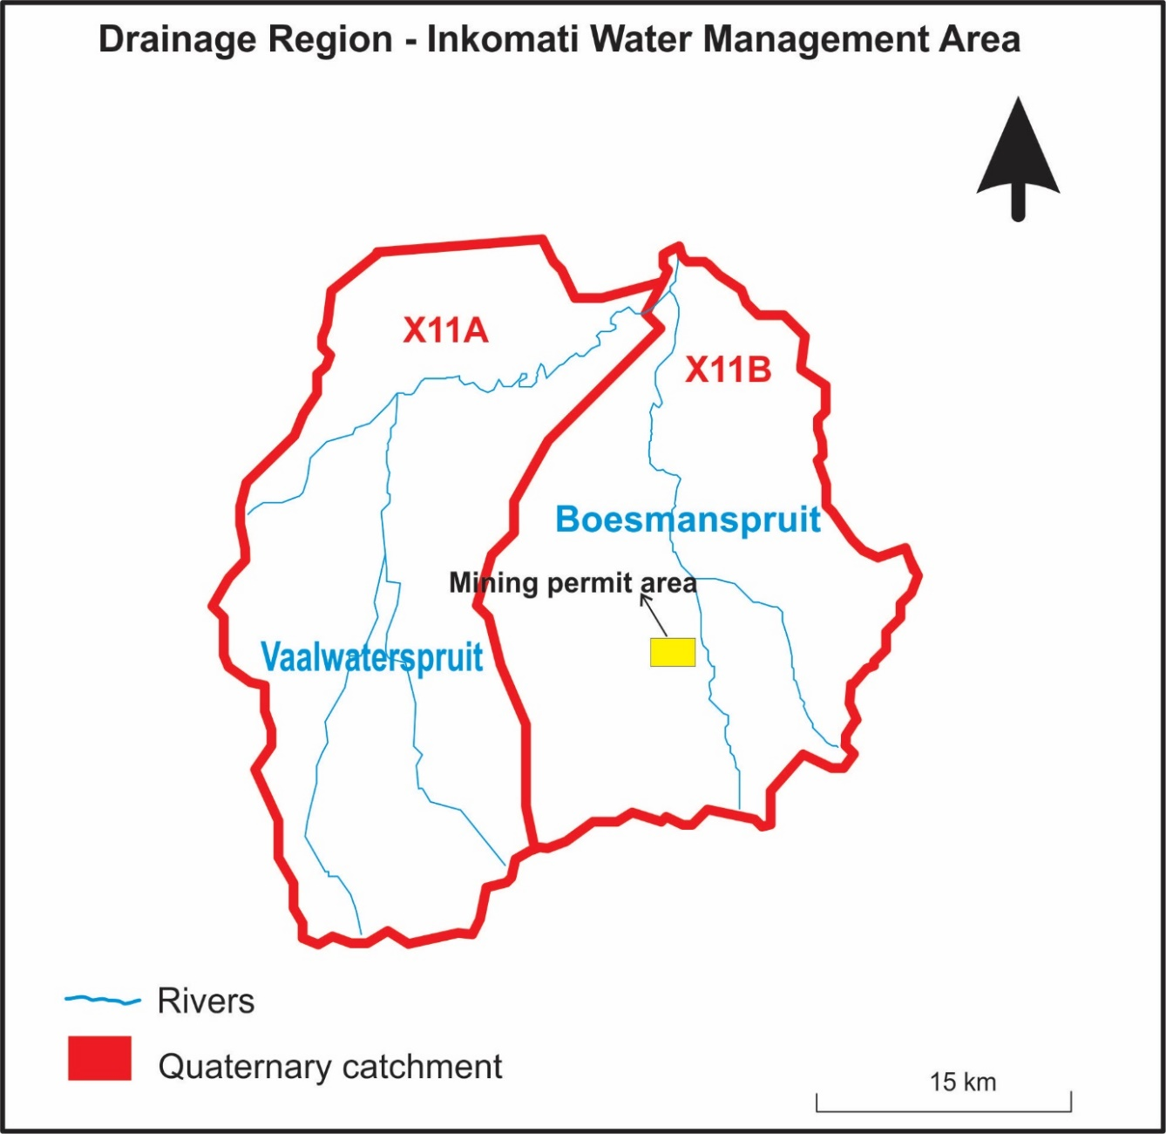
Figure 8: Position of four streams that originate near the permit area.

River diversions
No river diversions are planned for the mining activities covered by this report.

Water Use

The likely downstream users were determined by examining aerial photography and literature surveys.

The downstream users were therefore considered in the stream. The downstream usage classes are evaluated below:
- Domestic users –local inhabitants may consume this river water and will likely also use the water for laundry.
- Recreational users – it is likely that local inhabitants will swim in the streams.
- Industrial users – there are mining and industrial activities downstream of the proposed operations. However, these operations are not sensitive to poor quality water.
- Aquatic users – the catchments are heavily impacted by agriculture and mining, and sensitive aquatic users are unlikely to be present.
- Irrigation users – the river water is might to be used for small-scale or informal irrigation.
- Livestock – the river water is likely to be used for drinking by livestock.

Water Authority
The catchment area is government water-controlled catchment. The authority in charge is the Department of Water and Sanitation (Mpumalanga Regional Office).

Groundwater
A groundwater study was conducted by Groundwater complete, attached as Appendix E for the proposed mining permit area.
      - Aquifer classification.
According to literature the Karoo Supergroup sediments typically act as secondary aquifers (intergranular and fractured rock aquifers). However, the multi-layered weathering system present on these rocks could prove to have up to two aquifer systems present in the form of a shallow, regolith aquifer with a weathered, intergranular soft rock base associated with the contact of fresh bedrock and the weathering zone; and a fractured bedrock aquifer. These aquifer systems are discussed below.
Saturated Zone
In the saturated zone, at least four aquifer types may be inferred from knowledge of the geology of the area:
- A shallow aquifer formed in the weathered zone, perched on the fresh bedrock.
- An intermediate aquifer formed by fracturing of the Karoo sediments.
- Aquifers formed within the more permeable coal seams and sandstone layers.
- Aquifers associated with the contact zones of the dolerite intrusives.
Although these aquifers vary considerably regarding geohydrological characteristics, they are seldom observed as isolated units. Usually, they would be highly interconnected by means of fractures and intrusions. Groundwater will thus flow through the system by means of the path of least resistance in a complicated manner that might include any of these components.
Shallow perched aquifer
A near surface weathered zone is comprised of transported colluvium and in-situ weathered sediments and is underlain by consolidated sedimentary rocks (sandstone, shale and coal). Groundwater flow patterns usually follow the topography, often coming very close to surface in topographic lows, sometimes even forming natural springs. Experience of Karoo geohydrology indicates that recharge to the perched groundwater aquifer is relatively high, up to 3% of the Mean Annual Precipitation (MAP).
Fractured Karoo rock aquifers
The host geology of the area consists of consolidated sediments of the Karoo Supergroup and consists mainly of sandstone, shale and coal beds of the Vryheid Formation of the Ecca Group. Most of the groundwater flow will be along the fracture zones that occur in the relatively competent host rock. The geology map does not indicate any major fractures zones in this area, but from experience it can be assumed that numerous major and minor fractures do exist in the host rock. These conductive zones effectively interconnect the strata of the Karoo sediments, both vertically and horizontally into a single, but highly heterogeneous and anisotropic unit.
Aquifers associated with coal seams
The coal seam forms a layered sequence within the hard rock sedimentary units. The margins of coal seams or plastic partings within coal seams are often associated with groundwater. The coal itself tends to act as an aquitard allowing the flow of groundwater at the margins.
Aquifers associated with dolerite intrusives
Dolerite intrusions in the form of dykes and sills are common in the Karoo Supergroup, and are often encountered in this area. These intrusions can serve both as aquifers and aquifuges. Thick, unbroken dykes inhibit the flow of water, while the baked and cracked contact zones can be highly conductive. These conductive zones effectively interconnect the strata of the Ecca sediments both vertically and horizontally into a single, but highly heterogeneous and anisotropic unit on the scale of mining. These structures thus tend to dominate the flow of groundwater. Unfortunately, their location and properties are rather unpredictable. Their influence on the flow of groundwater is incorporated by using higher than usual flow parameters for the sedimentary rocks of the aquifer.
Unsaturated zone
Although a detailed characterization of the unsaturated zone is beyond the scope of this study, a brief description thereof is supplied.
The unsaturated zone in the proposed mining area is in the order of between 1 and 20 meters thick and consists of colluvial sediments at the top, underlain by residual sandstone/siltstone/mudstone of the Ecca Group that becomes less weathered with depth.
According to the Parsons Classification system, the aquifer could be regarded as a minor aquifer system, but also a sole aquifer system in some cases where groundwater is the only source of domestic water.

      - Groundwater quality.
Groundwater within the immediate vicinity of the application area (where water quality information is available) is of good quality if compared with the SANS 241:2015 standards. Furthermore, groundwater quality conditions are considered to be representative of the ambient or unaffected environment. Groundwater TDS concentrations, as measured in May 2021, vary between 53 mg/l and 172 mg/l, which are low and perfectly suitable for human consumption. The groundwater sulphate content is also very low and representative of ambient or unaffected conditions.

      - Contaminant transport model results
The main aim of the contaminant transport model was to simulate or predict the groundwater quality related impacts resulting from the planned mining and related activities. The proposed open pit and related mine infrastructure were included in the model simulations as source areas. Note that only the open pit was, however, included in the post closure simulations. In order to better indicate the impact that these sources may potentially have on the surrounding groundwater quality conditions, contamination contours were exported from the contaminant transport model at 25- and 50-years post closure.
The contamination was simulated by applying contaminated recharge to the entire surface areas of the potential sources. The source areas were assigned a theoretical concentration of 100%, therefore the results of the model simulations are regarded as being qualitative rather than quantitative.
A groundwater depression cone resulting from pit dewatering will alter the hydraulic gradients and force groundwater and any potential contamination, within the affected area, to migrate towards its center. Groundwater levels would therefore firstly need to recover from the impacts of pit/aquifer dewatering before contamination can leave the pit area and migrate in the natural downgradient direction/s.
At 25 years post closure, groundwater levels were simulated to have recovered sufficiently from the impacts of pit dewatering to allow for the migration of contamination away from the source areas and in the natural downgradient groundwater flow direction/s. The contamination plume was simulated to migrate towards the east/south-east and north (to a lesser extent) and affected an area of nearly 19 ha (including the pit footprint area). The maximum plume concentration was approximately 55% of the source concentration, or 1 100 mg/l if the source had a theoretical TDS concentration of 2 000 mg/l.
After 50 years, the total affected area increased by approximately 63% to ±31 ha. Plume concentrations increased over time, however, natural occurring processes such as dilution and dispersion caused concentrations to only reach approximately 80%, or 1 600 mg/l if the source had a theoretical TDS concentration of 2 000 mg/l.
Particle tracking was also simulated for the application area. During the simulation, all particles migrate in the downgradient groundwater flow direction until encountering a groundwater sink. The aim with the particle tracking was therefore not to simulate/predict the distance that particles/contaminants are able to migrate over a certain time period, but rather to understand the direction of migration. As with the contamination plumes, particles were simulated to migrate towards the east, south-east and north-east in the direction of the perennial Boesmanspruit and one of its non-perennial tributaries.

      - Recommendations
Groundwater monitoring (i.e. sampling and water level measurements) should be conducted at quarterly intervals, and the schedule re-assessed by a qualified geohydrologist at a later stage in terms of stability of water levels and quality. If the sampling program requires changes, it should be done so in consultation with the appropriate authorities.
Monitoring of all boreholes should commence prior to any construction or mining. This background information will play an invaluable role in future impact assessments. The following variables must be considered for monitoring; EC, pH, TDS, total hardness, total alkalinity, calcium, magnesium, sodium, potassium, chloride, sulphate, fluoride, nitrate, iron, manganese, aluminium and turbidity.
The following is recommended:

- A survey of the immediate application area for additional monitoring boreholes should be conducted.
- If none are available, at least two boreholes should be drilled for source monitoring purposes.
- Monitoring boreholes should preferably be sited with the aid of a geophysical line/grid survey.
- Monitoring of all boreholes should commence prior to any construction or mining.
- Groundwater monitoring (i.e. sampling and water level measurements) should be conducted at quarterly intervals.
- Groundwater samples should be analysed at a SANAS accredited laboratory for chemical and physical constituents generally affected by coal mining and related activities.
- Monitoring results should be entered into an electronic database as soon as results are available.
- Monitoring results should regularly be assessed and reported on by a suitably qualified specialist.

Sensitive Landscapes
Inander Projects (Pty) Limited recognises that all streams and wetlands should be treated as sensitive landscapes. To this extent, Geovicon Environmental (Pty) Ltd an independent consultant, undertook a desktop study over the Witkranz Colliery area to determine the presence of any sensitive areas. A screening tool report was also generated for the mining permit are in question and is attached as Appendix F According to the study there are sites that resembles sensitive landscapes which were identified in close proximity to the site.
The proposed Witkranz Colliery is situated in the Eastern Highveld Grassland Vegetation Unit (Gm 12) within the Mesic Highveld Grassland Bioregion of the Grassland Biome. Figure 9 South African National Biodiversity Institute (SANBI, VEGMAP 2018) provides a visual indication of the proposed Witkranz Colliery and the ecosystem or vegetation unit in which it occurs.

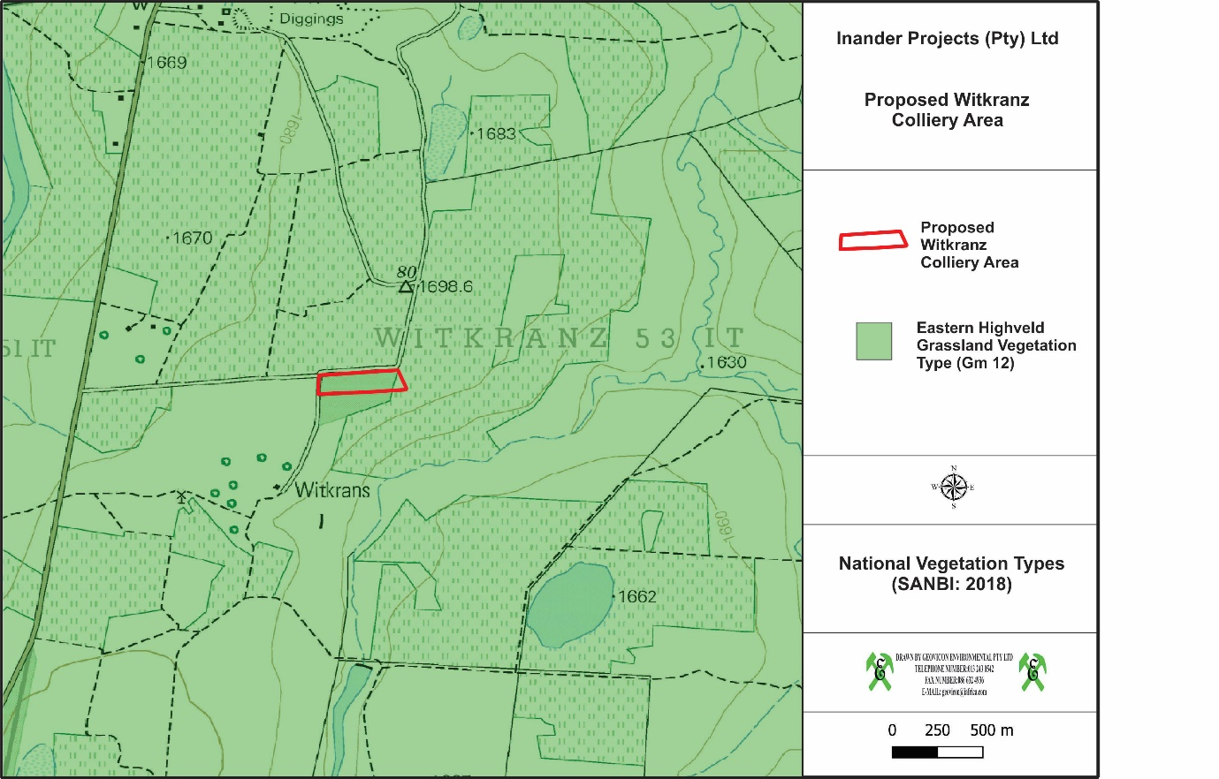
Figure 9: National Vegetation Types in the vicinity of the proposed Witkranz Colliery (SANBI: 2018)

The Eastern Highveld Grassland Vegetation Type is situated in both Mpumalanga and Gauteng Provinces, on the plains between the town Belfast and the eastern side of Johannesburg in the west and extending southwards to Bethal, Ermelo and west of Piet Retief. The altitude ranges from 1 520 to 1 780 metres above sea level l but may only be 1300 metres above sea level at some places which is the lowest altitude recorded in this vegetation unit.
The vegetation and landscape features comprise of slightly too moderately undulating plains, including some low hills and pan depressions. The vegetation is short dense grassland dominated by the usual highveld grass composition (Aristida, Digitaria, Eragrostis,Themeda, Tristachya etc.) with small, scattered rocky outcrops with wiry, sour grasses and some woody species (Acacia caffra, Celtis africana, Diospyros lycioides subsp lycioides, Parinari capensis, Protea caffra, Protea welwitschii and Rhus magalismontanum).
The climate is strongly seasonal summer rainfall, with very dry winters. Figure 10 shows a climate diagram for the Eastern Highveld Grassland vegetation unit.
Figure 10:Climate diagram for the Eastern Highveld Grassland subdivision.
MAP – Mean Annual Precipitation APCV – Annual Precipitation Coefficient of variation
MAT – Mean Annual Temperature MFD – Mean Frost Days
MAPE – Mean Annual Potential Evaporation
MASMS – Mean Annual Soil Moisture Stress

Table 15: List of the dominant taxa in the Eastern Highveld Grassland vegetation unit / ecosystem
Scientific name | Common name
Graminoids (Grass like plants)
Aristida aequiglumis | Three-awn
Aristida congesta | Tassel three-awn
Aristida junciformis | Gongoni three-awn
Brachiaria serrata | Velvet signal grass
Cynodon dactylon | Couch grass
Digitaria monodactyla | One finger grass
Digitaria tricholaenoides | Purple finger grass
Elionurus muticus | Wire grass
Eragrostis chloromelas | Narrow curly leaf
Eragrostis curvula | Weeping love grass
Eragrostis plana | Tough love grass
Eragrostis racemosa | Narrow heart love grass
Eragrostis sclerantha | Love grass
Heteropogon contortus | Spear grass
Loudetia simplex | Common russet grass
Microchloa caffra | Pincushion grass
Monocymbium ceresiiforme | Boat grass
Setaria sphacelata | Bristle grass
Sporobolus africanus | Ratstail dropseed
Sporobolus pectinatus | Dropseed
Themeda triandra | Red grass
Trachypogon spicatus | Giant spear grass
Tristachya leucothrix | Trident grass
Tristachya rehmannii | Trident grass
Herbs (Forbs, plants)
Berkheya setifera | Rasperdissedoring
Haplocarpa scaposa | Tonteldoosbossie
Justicia anagalloides | --
Pelargonium luridum | --
Acalypha angustata | Copper leaf
Chamaecrista mimosoides | Fishbone cassia
Dicoma anomala | Maagbitterwortel
Euryops gilfillanii | --
Euryops transvaalensis | --
Helichrysum aureonitens | --
Helichrysum caespititium | Speelwonderboom
Helichrysum calicomum | --
Helichrysum oreophilum | --
Helichrysum rugulosum | --
Ipomoea crassipes | --
Geophytic herbs
Gladiolus crassifolius | --
Haemanthus humilis | --
Hypoxis rigidula | Kaffertulp
Ledebouria ovatifolia | --
Succulent herbs
Aloe ecklonis | Ecklone’s aloe
Low shrubs
Anthospermum rigidum | --
Stoebe plumose | --

Eastern Highveld Grassland vegetation unit
National information regarding this vegetation unit:
Conservation target: 24 %
Transformed: 44 % (cultivation, plantations, mines, urbanisation, dams)
Conservation status: Endangered
It is poorly protected
Provincial information regarding this vegetaion unit according to the Mpumalanga Biodiversity Sector Plan Handbook (Lötter et. al. 2014).
Original extent in Mpumalanga: 1 232 256.67 ha
Still natural in Mpumalanga: 432 728.50 ha
Percentage natural in Mpumalanga (including old lands as modified): 35.12 %
Percentage natural in Mpumalanga (excluding old lands): 47.98 %
Conservation target: 24 %
Proportion of target protected in Mpumalanga: 12.99 %
Poorly protected within Mpumalanga
Threat status for Mpumalanga: Vulnerable
Near endemic in Mpumalanga
According to the Mpumalanga Biodiversity Sector Handbook (Lötter et. al. 2014) the most important ecological drivers in Mpumalanga are built infrastructure, cultivation, mining, prospecting and residential areas. The proposed Witkranz Colliery area is situated in the Nkangala District Municipality with the percentages for the different ecological drivers as a percentage of the surface area of Mpumalanga as:
Built infrastructure – 14.3 %
Cultivation – 1.8 %
Mining – 39.9 %
Prospecting – 75.6 %
Residential – 8 %

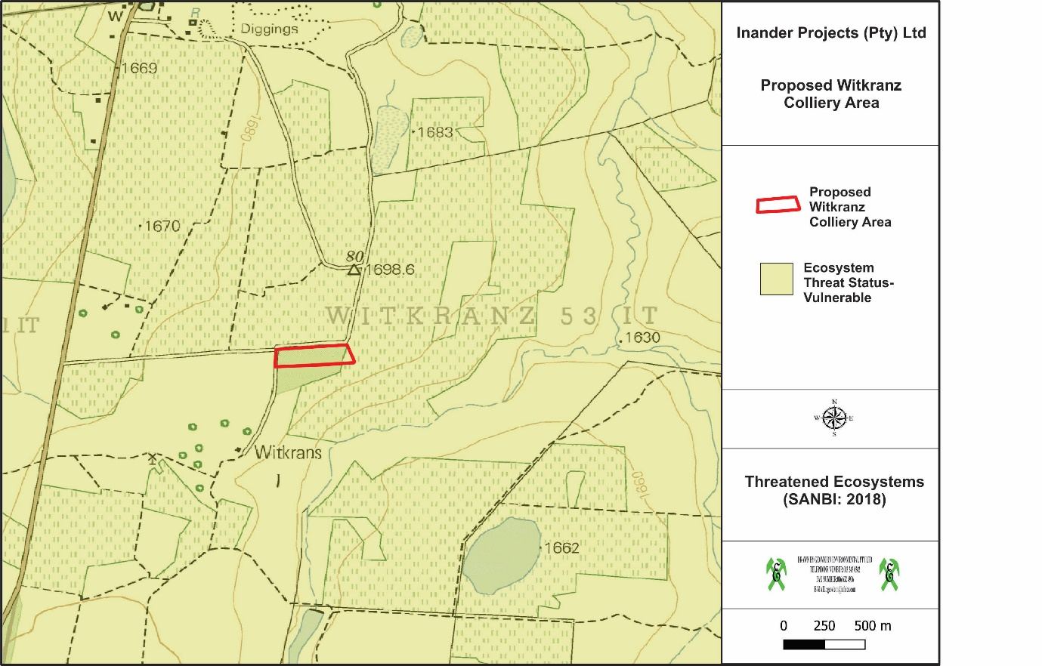
Figure 11: Threatened Ecosystems in the vicinity of the proposed Witkranz Colliery Area (SANBI: 2018)

This ecosystem’s threat status is vulnerable. According to Government Notice 1002, Government Gazette No. 34809 9 December 2011), vulnerable ecosystems are considered threatened ecosystems since it is ecosystems that have a high risk of undergoing significant degradation of ecological structure, function or composition as a result of human intervention, although they are not critically endangered ecosystems or endangered ecosystems.
The proposed Witkranz Colliery is situated within Quaternary Catchment X11B (Figure 12).

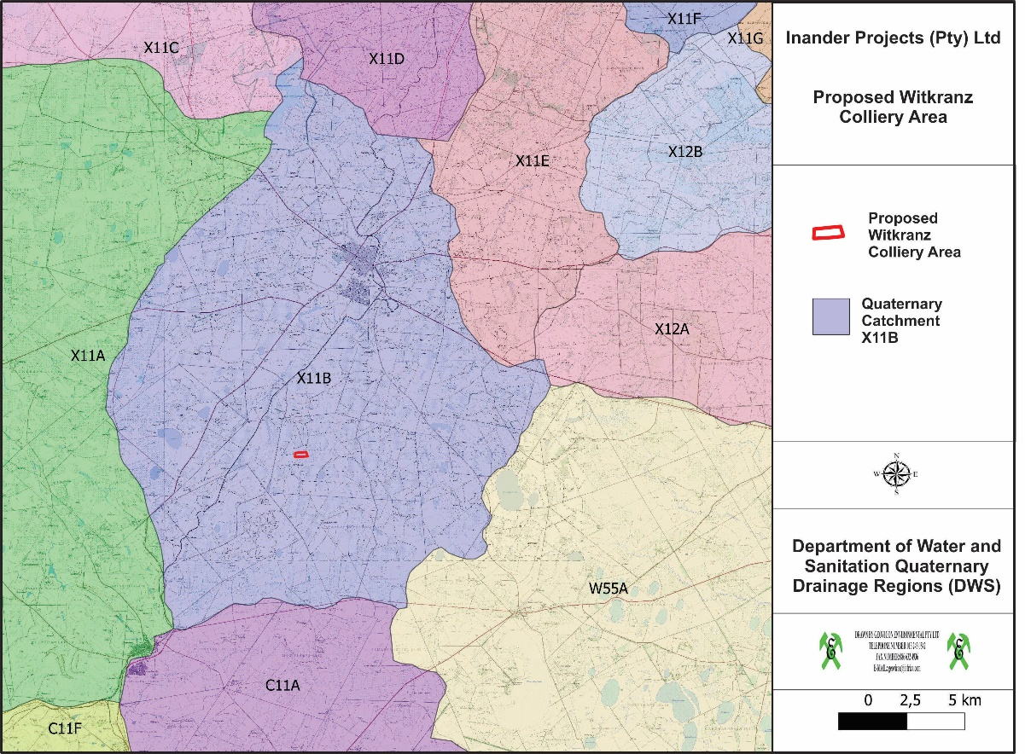
Figure 12: DWS quaternary drainage regions in the vicinity of the Witkranz Colliery area.

Table 16: Information regarding the above-mentioned quaternary catchment areas.
X11B
Drains into | Komati River
Size in km² | 602
Mean annual precipitation (mm) | 716,4
Evaporation (mm) | 1816,10
Mean annual surface runoff (mm) | 72,70

The proposed Witkranz Colliery is situated within a River Freshwater Ecosystem Priority Area (Figure 13) which provides strategic spatial priorities for conserving South Africa’s freshwater ecosystems and supports sustainable use of water resources.

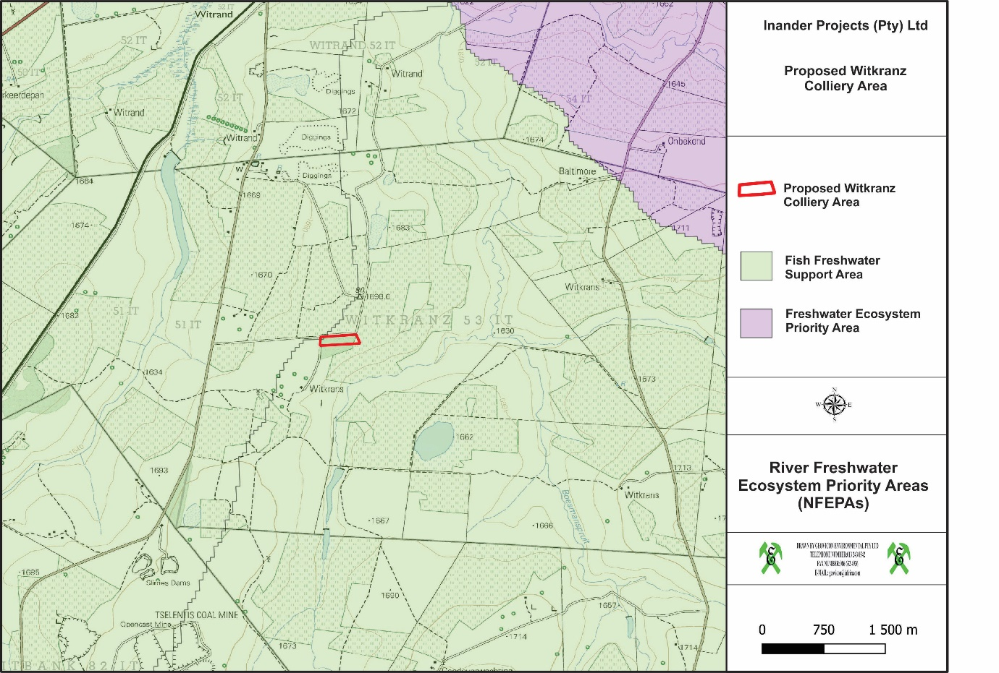
Figure 13: River Freshwater Ecosystem Priority Areas in the vicinity of the proposed Witkranz Colliery.

The proposed Witkranz Colliery area is situated in the vicinity of some National Wetland areas (Figure 14) (SANBI, NBA National Wetland Map 5), falling into the Mesic Highveld Grassland Group 4 wetland ecosystem type (SANBI) (Figure 15).

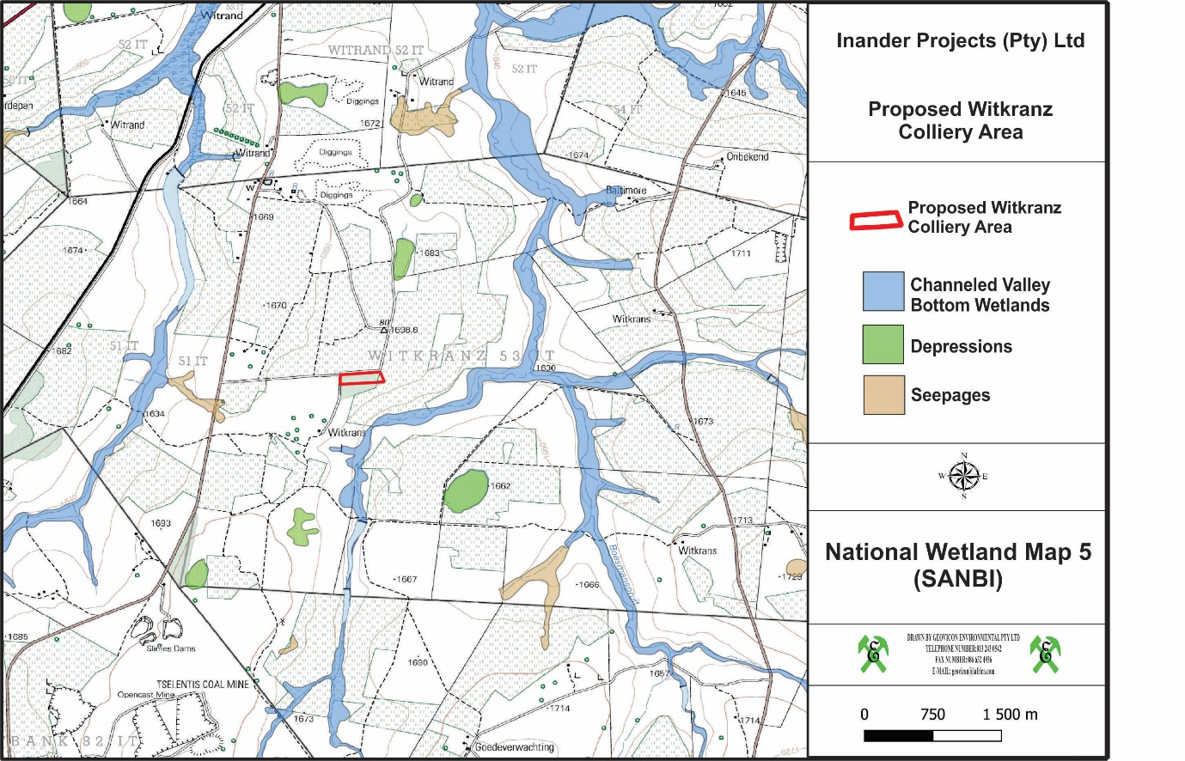
Figure 14: National Wetland Map 5 for the proposed Witkranz Colliery.

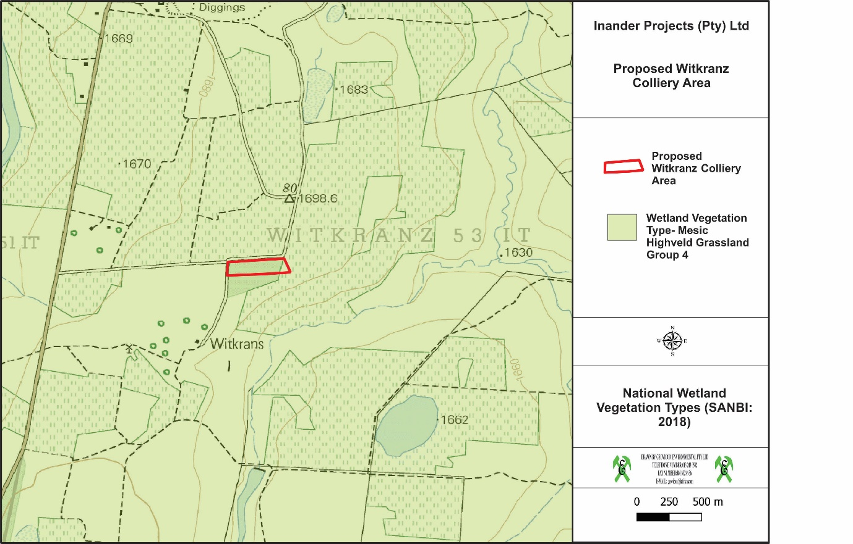
Figure 15: National Wetland Vegetation Types in the vicinity of Witkranz Colliery Area.

According to the Mpumalanga Biodiversity Sector Plan GIS-based electronic application (Mpumalanga Tourism and Parks Agency (MTPA), 2013), the proposed Witkranz Colliery is primarily situated in terrestrial assessment categories of “Heavily Modified”, meaning areas that are currently transformed and where biodiversity and ecological function has been lost to the point that it is not worth considering for conservation at all; “Moderately modified – old lands” meaning areas which were modified within the last 80 years but were at some point abandoned, including old mines and old cultivated lands, collectively termed “old lands”; and “Other Natural Areas (ONAs)”, meaning areas that are not identified to meet biodiversity pattern or process targets (Figure 16).

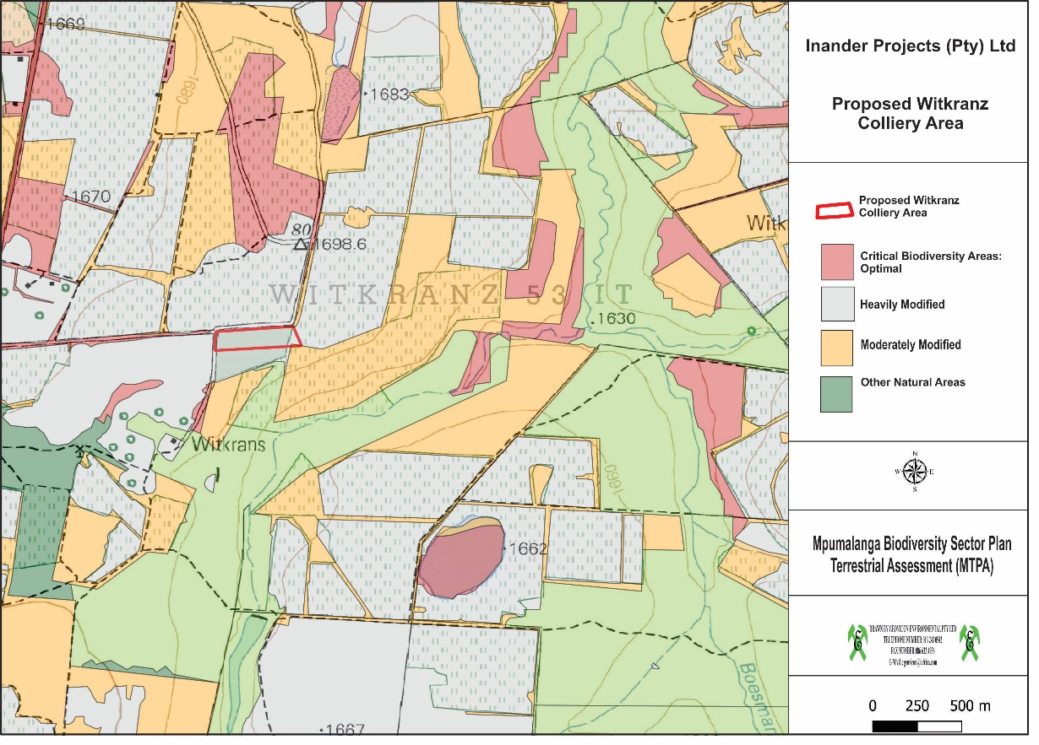
Figure 16: Mpumalanga Biodiversity Sector Plan Terrestrial Assessment for the proposed Witkranz Colliery

According to the Mpumalanga Biodiversity Sector Plan GIS-based electronic application (Mpumalanga Tourism and Parks Agency (MTPA), 2013), the proposed Witkranz Colliery is primarily situated in freshwater assessment categories of “Heavily Modified” meaning areas that have experienced a form of land use that has resulted in the near complete loss of biodiversity and a degree of loss of ecological function; “Other Natural Areas” meaning areas that have not been identified as a priority in the current systematic biodiversity plan but retain most of their natural character and perform a range of biodiversity and ecological infrastructural functions; “Ecological Support Areas (ESA) – Wetlands” meaning areas that support the hydrological functioning of rivers, water tables, freshwater biodiversity as well as providing a host of ecosystem services through their ecological infrastructure. They need to be maintained in a healthy condition; and “Dams” meaning artificial water bodies which may have impacted on wetlands or river systems. These areas may, however, still have a recharge effect on wetlands, groundwater, and river systems (Figure 17).

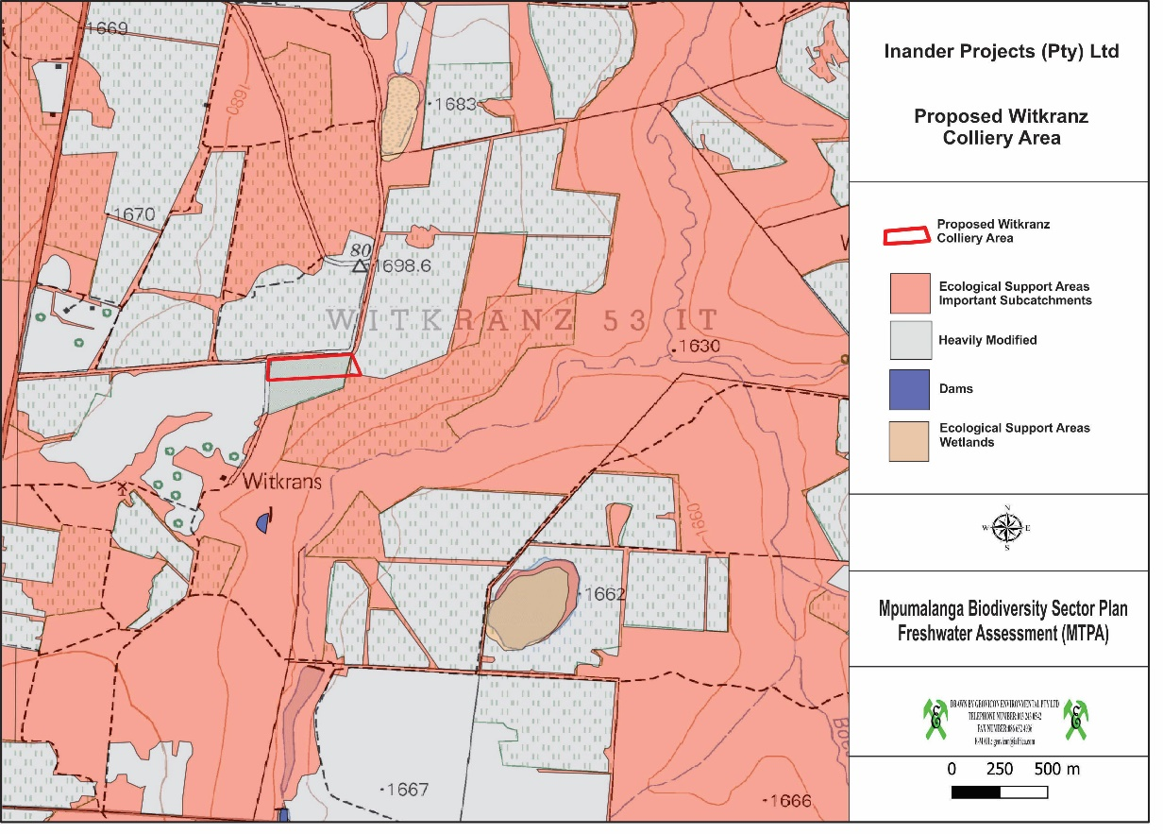
Figure 17: Mpumalanga Biodiversity Sector Plan Freshwater Assessment for the proposed Witkranz Colliery.

      - Impacts on sensitive landscapes
There are no wetlands identified within the mining permit areas thus no mitigation measures provided on the EMP. However, it is advised that the mining permit holder must apply for a GA if they will conduct activities within 500m of a stream, wetland or any watercourse, if any.

Air Quality
Emissions inventory: Construction
Heavy construction is a source of dust emissions that may have substantial temporary impact on local air quality. Building and road construction are two examples of construction activities with high emissions potential. Emissions during the construction of a building or road can be associated with land clearing, drilling and blasting, ground excavation, cut and fill operations (i.e., earth moving), and construction of a particular facility itself. Dust emissions often vary substantially from day to day, depending on the level of activity, the specific operations, and the prevailing meteorological conditions. A large portion of the emissions results from equipment traffic over temporary roads at the construction site.
The temporary nature of construction differentiates it from other fugitive dust sources as to estimation and control of emissions. Construction consists of a series of different operations, each with its own duration and potential for dust generation. In other words, emissions from any single construction site can be expected (1) to have a definable beginning and an end and (2) to vary substantially over different phases of the construction process. This is in contrast to most other fugitive dust sources, where emissions are either relatively steady or follow a discernible annual cycle. Furthermore, there is often a need to estimate area-wide construction emissions, without regard to the actual plans of any individual construction project.
The quantity of dust emissions from construction operations is proportional to the area of land being worked and to the level of construction activity. By analogy to the parameter dependence observed for other similar fugitive dust sources, one can expect emissions from heavy construction operations to be positively correlated with the silt content of the soil (that is, particles smaller than 75 micrometres [μm] in diameter), as well as with the speed and weight of the average vehicle, and to be negatively correlated with the soil moisture content.
Emissions inventory: Mining
Initial operations involve the removal of top- and subsoil with front-end loaders and bull dozers. The exposed overburden, the earth between the topsoil and the coal seam will be levelled and if required, drilled and blasted. The overburden material will be removed down to the coal seam by shovel and truck operation. The topsoil and overburden material will be stockpiled in designated areas on-site for later use in the reclamation processes.
The uncovered coal seam will be drilled and blasted if required. A shovel or front-end loader will load the broken coal onto haul trucks for transport to a temporary storage pile.
During mine reclamation, which proceeds continuously throughout the life of the mine, material from the overburden spoils piles will be used to fill mined-out areas. Topsoil will be placed on the graded spoils, and the land will be prepared for re-vegetation by furrowing, mulching, etc.

Noise
The proposed project area is surrounded by predominantly mining and agricultural activities. Potential noise sources from the area may therefore be emanating from these various sources. The proposed project may contribute towards noise levels through the mining activities with the use of associated infrastructure.

Socio-Economic Status
Chief Albert Luthuli Local Municipality is located within the Gert Sibande district, Mpumalanga. The municipality boasts both mining and agricultural sectors that contribute significantly to the local, provincial and national GDP.

Population density, growth and location
The mid-year population estimates for 2015 for Mpumalanga Province is estimated at 4 283 900 (7.8% of the total national population) and has remained steady in the period between 2002 and 2015 (Stats SA, Statistics release P0 302, 2016). The population figure for Gert Sibande District was 1 308 129 (Census 2011) and new statistics released by Statistics SA (www.localgovernment.co.za) for 2016 estimate the district’s population at 1 445 624.
The Chief Albert Luthuli Local Municipality population was 395 466 in 2011 and increased to 455 228 in 2016 (Stats SA, www.localgovernment.co.za), thus comprising 30.5% of the district. The number of households also increased from 119 874 to 150 420 during this same period. However, the average household size decreased from 3.2% to 3%.

Major economic activities and sources of employment
Mining in the Chief Albert Luthuli Local Municipality is the highest contributor to both economic growth and job creation. Given the abundance of coal reserves in Mpumalanga (and being the key mineral within Chief Albert Luthuli Local Municipality); the local space is likely to benefit from the resources abundantly found within the locality; at the expense of agriculture.
The Economy of the municipality is driven by the Mining sector which contributed 50% in 2009 followed by electricity at 12.1% and Finance at 10.8%. Agriculture and manufacturing don’t seem to be performing well within the local space.

SECTION SIX
_________________________________________________________________________________

Environmental impact assessment

environmental impact assessment

Environmental Impact Assessment Process Followed

Approach to Environmental Impact Assessment
The term ‘environment’ is used in the broadest sense in an EIA. It covers the physical, biological, social, economic, cultural, historical, institutional and political environments.
An Environmental Impact Assessment is a good planning tool. It identifies the environmental consequences of a proposed project from the beginning and helps to ensure that the project, over its life cycle, will be environmentally acceptable and integrated into the surrounding environment in a sustainable way.

Environmental Impact Assessment Process Followed
Under Section 24 of the National Environmental Management Act (NEMA), the Minister promulgated the regulations pertaining to environmental impact assessments (EIA Regulations, 2014) under Government Notice No. 326 in Government Gazette 38282 of 4 December 2014. These EIA regulations repealed the 2010 EIA regulations and therefore any process relating to environmental authorisations must be undertaken under the EIA Regulations, 2014.
Chapter 4 of the EIA Regulations, 2014 deals with the provisions for application for environmental authorisation. In view of the above, Inander Projects (Pty) Limited is obliged to comply with provisions of Chapter 4 for the intended environmental authorisation application for the activities (listed activities) within the proposed project.
Part 2 of chapter 4 of the EIA Regulations, 2014 contemplate process to be undertaken for the application for environmental authorisation for the proposed project, which is the BAR process. The process to be followed is describe below.

Pre-application consultation with the Competent Authority
In terms of section 24D (1) of the National Environmental Management Act, 1998 (Act 107 of 1998), the Minister responsible for mineral resources is the competent authority for environmental matters relating to mining and associated activities. In view of the above, the application for the environmental authorisation for the proposed project was submitted to the Department of Mineral Resources (DMRE), Carolina Regional Office for their consideration and decision making.

BAR Phase
In compliance with Regulation 19 of the EIA Regulations, 2014, the BAR and EMPR will be submitted to the competent authority within 90 days after the acknowledgement of the environmental authorisation application.
As part of the public participation, the draft BAR and EMPR was made available to the commenting authority, potential and registered interested and affected parties for their comment for a period of 30 days during the EIA phase.

Information Gathering
Environmental baseline data has been obtained via desktop studies, pertaining to surface water, geohydrological data, topographical analyses, soil surveys, vegetation surveys, wetland surveys and geological conditions. Weather data was acquired from the South African Weather Service. The data accumulated and analysed is sufficient to gain a baseline indication of the present state of the environment. The use of this baseline study for impact assessments is thus justified and reliable conclusions could be made.

Decision on the BAR application
In compliance with Regulation 20 of the EIA Regulations, 2014, the competent authority will within 107 days of receipt of the BAR and EMPR grant or refuse the environmental authorisation.

Environmental Impact Assessment Methodology
The following prediction and evaluation of impacts is based on the proposed Witkranz Colliery and associated activities.
The evaluation distinguishes between significantly adverse and beneficial impacts and allocates significance against national regulations, standards and quality objectives governing:
- Health & Safety;
- Protection of Environmentally Sensitive Areas;
- Land use; and
- Pollution levels.
Irreversible impacts are also identified. See Table 17 for the definitions of the criteria and Table 18 for the results of the environmental impact assessment for the proposed Witkranz project
The significance of the impacts is determined through the consideration of the following criteria:
Probability | : | likelihood of the impact occurring
Area (Extent) | : | the extent over which the impact will be experienced.
Duration | : | the period over which the impact will be experienced.
Intensity | : | the degree to which the impact affects the health and welfare of humans and the environment (includes the consideration of unknown risks, reversibility of the impact, violation of laws, precedents for future actions and cumulative effects).
Table 17: The above criteria are expressed for each impact in tabular form according to the following definitions:
Probability | Definition
Low | There is a slight possibility (0 – 30%) that the impact will occur.
Medium | There is a 30 –70% possibility that the impact will occur.
High | The impact is definitely expected to occur (70% +) or is already occurring.
Area (Extent) | Definition
Small | 0 – 40 ha
Medium | 40 – 200 ha
Large | 200 + ha
Duration | Definition
Short | 0 – 5 years
Medium | 5 – 50 years
Long | 51 – 200 years
Permanent | 200 + years
Intensity | Definition
Low | Does not contravene any laws.  Is within environmental standards or objectives.  Will not constitute a precedent for future actions.  Is reversible.  Will have a slight impact on the health and welfare of humans or the environment.
Medium | Does not contravene any laws.  Will not constitute a precedent for future actions.  Is not within environmental standards or objectives.  Is not irreversible.  Will have a moderate impact on the health and welfare of humans or the environment.
High | Contravene laws.  May constitute a precedent for future actions.  Is not within environmental standards or objectives.  Is irreversible.  Will have a significant impact on the health and welfare of humans or the environment.

Significance and Risk Category | Definition
Negligible | The impact/risk is insubstantial and does not require management
Low | The impact/risk is of little importance, but requires management
Medium | The impact/risk is important; management is required to reduce negative impacts to acceptable levels
High | The impact/risk is of great importance, negative impacts could render options or the entire project unacceptable if they cannot be reduced or counteracted by significantly positive impacts, and management of these impacts is essential
Positive (No risk identified) | The impact, although having no significant negative impacts, may in fact contribute to environmental or economical health

Results of the Environmental Impact Assessment

Assessment of the Witkranz Colliery impacts/risks
Table 18: Results of the Environmental Impact Assessment for Witkranz Colliery.

Construction Phase
ACTIVITY | NATURE OF THE IMPACT | ENVIRONMENTAL ASPECT | IMPACT ASSESSMENT |  |  |  |  | MITIGATION MEASURES
 |  |  | E | P | D | I | S
CONSTRUCTION PHASES
Activity 21 of listing notice 1: Any activity including the operation of that activity which requires a mining permit in terms of section 27 of the Mineral and Petroleum Resources Development Act, 2002 (Act No. 28 of 2002), including association infrastructures, earthworks, directly related to the extraction of the mineral resource.
Activity 24 of listing notice 1: The development of a road where the road is wider than 8 meters.
Activity 27 of listing notice 1: The clearance of an area of 1 hectare or more, but less than 20 hectares of indigenous vegetation, except where such clearance of indigenous vegetation is required for the undertaking of a linear activity or maintenance purposes undertaken in accordance with a maintenance management plan.
Construction of haul and access roads, overburden stockpiles and in pit sump. | All activities will result in the stripping and removal of the topsoil layer, which will disrupt the soil profile. | Soil/Land capability | Without mitigation |  |  |  |  | Stockpile the removed topsoil on a topsoil stockpile area which is separate from other overburden materials.
 |  |  | S | L | S | M | M
 |  |  | With mitigation
 |  |  | S | L | S | L | L
 | The stripping of topsoil will result in the reduction of the land capability of the area. | Land capability | Without mitigation |  |  |  |  | Strip soils with intact vegetation to retain the soil characteristics and reuse soil during rehabilitation.
 |  |  | S | M | S | M | M
 |  |  | With mitigation
 |  |  | S | L | S | L | L
 | All activities will result in the removal of the topsoil layer, which will result in the loss of natural vegetation cover. | Natural vegetation | Without mitigation |  |  |  |  | The topsoil removed from successive cuts must be used to cover the disturbed areas and these areas must then be seeded with a recommended seed mix to ensure natural vegetation remaining in the soil (seed bank) is re-established.
 |  |  | S | M | S | M | M
 |  |  | With mitigation
 |  |  | S | L | S | L | L
 | The formation of overburden stockpiles will result in topographical highpoints, which will alter the local topographical patterns of the immediate area. | Topography | Without mitigation |  |  |  |  | Ensure that as little space as possible is used for the construction of stockpiling facilities for the overburden material.
 |  |  | S | M | S | M | M
 |  |  | With mitigation
 |  |  | S | L | S | L | L
 | The constructed workshop, mine infrastructure and overburden stockpiles may be visible from the nearby roads | Topography | Without mitigation |  |  |  |  | Visual berms will be constructed around the visible parts of the mining area to shield the said mine infrastructure.
 |  |  | S | M | S | M | M
 |  |  | With mitigation
 |  |  | S | L | S | L | L
 | All activities will result in the removal of the topsoil layer, which will result in the loss of natural vegetation cover | Vegetation | Without mitigation |  |  |  |  | All topsoil material to be stockpiled separately at appropriate height. Note that the topsoil will retain its seed bank if stripped with intact vegetation and stockpiled properly.
 |  |  | S | M | S | M | M
 |  |  | With mitigation
 |  |  | S | L | S | L | L
 | Surface water emanating from the construction site will contain increased amount of silt, which will contaminate the surface water environment | Surface Water Quality | Without mitigation |  |  |  |  | Ensure that the dam is designed by a suitably qualified person who will ensure that the dam covers as little space as possible whilst complying with the relevant legal requirements. The mine will be designed and constructed such that all dirty water is drained or pumped to the dam.
 |  |  | S | M | S | M | M
 |  |  | With mitigation
 |  |  | S | L | S | L | L
 | Surface water emanating from the construction site will contain increased amount of silt, which will contaminate the surface water environment | Surface Water Quality | Without mitigation |  |  |  |  | Construct berms along the stockpiles and disturbed area to reduce the levels of silt that may report to the nearby stream.
 |  |  | S | M | S | M | M
 |  |  | With mitigation
 |  |  | S | L | S | L | L
 | Movement of vehicles over exposed areas will result in the generation of dust. Generated dust will migrate towards the predominant wind direction. | Air Quality | Without mitigation |  |  |  |  | Conduct dust suppression on haul and access roads on a regular basis. Monitor the dust fall out concentration
 |  |  | S | M | S | M | M
 |  |  | With mitigation
 |  |  | S | L | S | L | L
 | Machinery used will generate fumes and noise that may have detrimental effects on the surrounding air quality environment and health of the employees and residents of nearby houses. | Air Quality | Without mitigation |  |  |  |  | Ensure that the used mine vehicles’ exhaust systems are in good repair order.  Limit speed of mine vehicles.  Conduct dust suppression
 |  |  | S | M | S | M | M
 |  |  | With mitigation
 |  |  | S | L | S | L | L
 | Noise generated from construction activities may add to the current noise levels. This may have impacts on local residents. | Noise | Without mitigation |  |  |  |  | Limit mining activities during day time
 |  |  | S | M | S | M | M
 |  |  | With mitigation
 |  |  | S | L | S | L | L
 | Adjacent landowners may be impacted on by dust, noise, vibration, visual impacts and nuisance generated during the construction phase of the proposed opencast areas. | Social | Without mitigation |  |  |  |  | See mitigation under environmental management section, i.e. air, noise, etc  Implementation of the Environmental Awareness Plan for the employees.
 |  |  | S | M | S | M | M
 |  |  | With mitigation
 |  |  | S | L | S | L | L
 | Potential increase in crime and petty theft. | Social | Without mitigation |  |  |  |  | Discourage squatting & recruitment on the opencast areas
 |  |  | S | M | S | M | M
 |  |  | With mitigation
 |  |  | S | L | S | L | L
 | The mining operation will create employment opportunities. | Social | Positive |  |  |  |  | No mitigation measures
Excavation of an initial box-cut | The excavation of the initial box-cut (including the in pit water and coal storage facilities) will result in the disturbance of the geological profile | Geology | S | L | S | L | L | No mitigation can be undertaken for the predicted impact.
 |  |  | With mitigation
 |  |  | S | L | S | L | L
 | The excavation of the initial box cut (including the in-pit water and coal storage facilities) will result in the formation of topographical voids, which will impact on the local topographical patterns | Topography | Without mitigation |  |  |  |  | Use material from the following cuts to backfill the voids created by the construction of the initial box-cut and the in-pit water and coal storage facilities
 |  |  | S | M | S | M | M
 |  |  | With mitigation
 |  |  | S | L | S | L | L
 | The stripping of soil layers during the excavation of the initial box-cut (including the in-pit water and coal storage facilities) will result in the loss of topsoil. This will further impact on the land use and land capability | Soil/Land Capability | Without mitigation |  |  |  |  | Stockpile topsoil to appropriate height hence reducing loss of fertility. Use stockpiled topsoil for rehabilitation of the backfilled opencast pit, hence rehabilitated areas can be used for other purposes.
 |  |  | S | M | S | M | M
 |  |  | With mitigation
 |  |  | S | L | S | L | L
 | The excavation of the initial box-cut (including the in-pit water and coal storage facilities) will result in the removal of natural vegetation due to the stripping of topsoil | Vegetation | Without mitigation |  |  |  |  | The topsoil removed from successive cuts must be used to cover the disturbed areas and these areas must then be seeded with a recommended seed mix to ensure natural vegetation remaining in the soil (seed bank) is re-established.
 |  |  | S | M | S | M | M
 |  |  | With mitigation
 |  |  | S | L | S | L | L
 | Animal burrows and habitats will be destroyed by the activities. This will further result in the migration of animals away from the areas of disturbance. | Animal life | Without mitigation |  |  |  |  | Rehabilitation of the disturbed areas will encourage the migration of animals back into the destroyed areas.
 |  |  | S | L | S | L | L
 |  |  | With mitigation
 |  |  | S | L | S | L | N
 | Rain and runoff water may enter the initial box-cut and the in pit water and coal storage facility). This will result in the loss of clean runoff water that could report to the nearby water body | Surface Water Quality | Without mitigation |  |  |  |  | Divert runoff water away from the initial box-cut to the in-pit water storage facility and.
 |  |  | S | M | S | M | M
 |  |  | With mitigation
 |  |  | S | L | S | L | L
 | Contamination of the clean water by the remaining coal and carbonaceous material may result if clean runoff water is allowed to enter the mining pit, which could impact negatively on the surrounding surface water environment if released. | Surface Water Quality | Without mitigation |  |  |  |  | Contain all dirty water from the opencast pit into a polluted water containment facility.
 |  |  | S | M | S | M | M
 |  |  | With mitigation
 |  |  | S | L | S | L | L
 | The stripping of soils from the initial box-cut will result in the exposure of soils causing the generation of dust during windy periods. Movement of mine vehicles will also result in the generation of dust. This may ultimately affect the occupants of structures within the impact zone. | Air Quality/Social | Without mitigation |  |  |  |  | Conduct dust suppression daily on dust generating areas. Enforce appropriate speed limits for the mine vehicles.
 |  |  | S | M | S | M | M
 |  |  | With mitigation
 |  |  | S | L | S | L | L
 | Ground vibration and air blast levels from blasting may affect surrounding structures. A distance of 500 meters from the blast is generally accepted as the area of possible negative impact from blasting. | Social/Land Capability | Without mitigation |  |  |  |  | No structures occur within the distance of 500 m from the mining area, hence blasting is not expected to impact on any structures.
 |  |  | S | M | S | M | M
 |  |  | With mitigation
 |  |  | S | L | S | L | L
 | This does however not allow Inander Projects (Pty) Limited to blast irresponsibly. Irresponsible blasting may still affect the structures within the surrounds of the mine e.g., fly rock may be problematic if blasting is not done properly | Social/Land Capability | Without mitigation |  |  |  |  | Conduct blasting according to a blast design designed by a basting expert. This will ensure that the vibration and air blast are within the acceptable limits.
 |  |  | S | M | S | M | M
 |  |  | With mitigation
 |  |  | S | L | S | L | L
 | Dust and noxious fumes may be generated during blasting that can affect the neighbouring residents and road users. | Social/Land Capability | Without mitigation |  |  |  |  | Proper stemming, and delay blasts when prevailing wind is blowing towards the area of concern.  Conduct blasting according to a blast design by a blasting expert. A blaster with appropriate qualifications must be used for blasting. This will ensure that the generation of excessive dust and fumes are prevented.
 |  |  | S | M | S | M | M
 |  |  | With mitigation
 |  |  | S | L | S | L | L
 | Machine operators in close proximity to machinery and employees in the opencast pit will be exposed to high noise during blasting and operation of mine machinery. These noise levels will attenuate to acceptable levels within a short distance (500 m). Note that no significant noise increases are expected within a 500 m radius of the activities. | Noise | Without mitigation |  |  |  |  | Ensure that the mine employees are issued with earplugs and that they are instructed to use them. Educate employees on the dangers of hearing loss due to mine machinery.
 |  |  | S | M | S | M | M
 |  |  | With mitigation
 |  |  | S | L | S | L | L
 | The initial box-cut will be visible from the surrounding area. | Social | Without mitigation |  |  |  |  | Use the topsoil from the initial box-cut to construct a visual berm around visible areas of the mine.
 |  |  | S | M | S | M | M
 |  |  | With mitigation
 |  |  | S | L | S | L | L
 | During individual consultations with the adjacent landowners, raised issues with regard to the blasting, which they envisage will affect structural integrity of their houses. | Social | Without mitigation |  |  |  |  | A structural survey will be done on their houses to identify any cracks or faults present before commencement of the mine
 |  |  | S | M | S | M | M
 |  |  | With mitigation
 |  |  | S | L | S | L | L
 | During individual consultations with the adjacent landowners, raised issues with regard to the blasting, which they envisage will affect structural integrity of their houses. | Social | Without mitigation |  |  |  |  | A seismograph will be placed at the strategic places to record ground vibration and air blast levels at those places during blasting.
 |  |  | S | M | S | M | M
 |  |  | With mitigation
 |  |  | S | L | S | L | L
 | During individual consultations with the adjacent landowners, raised issues with regard to the blasting, which they envisage will affect structural integrity of their houses. | Social | Without mitigation |  |  |  |  | If it can be proven that the blasting has damaged their houses, Inander Projects (Pty) Limited must compensate for their damages.
 |  |  | S | M | S | M | M
 |  |  | With mitigation
 |  |  | S | L | S | L | L

Operational Phase
ACTIVITY | NATURE OF THE IMPACT | ENVIRONMENTAL ASPECT | IMPACT ASSESSMENT |  |  |  |  | MITIGATION MEASURES
 |  |  | E | P | D | I | S
OPERATIONAL PHASE
Activity 21 listing notice 1: Any activity including the operation of that activity which requires a mining permit in terms of section 27 of the Mineral and Petroleum Resources Development Act, 2002 (Act No. 28 of 2002), including association infrastructures, earthworks, directly related to the extraction of the mineral resource.
Activity 27 of listing notice 1: The clearance of an area of 1 hectare or more, but less than 20 hectares of indigenous vegetation, except where such clearance of indigenous vegetation is required for the undertaking of a linear activity or maintenance purposes undertaken in accordance with a maintenance management plan.
 | Removal and subsequent replacement of topsoil and subsoil material for access to the target coal will result in the disturbance of the geological profile. | Geology | With Mitigation |  |  |  |  | No mitigation can be undertaken for this impact. The Coal will however be replaced by the overburden material in the mined out opencast pits.
 |  |  | S | H | P | M | M
 |  |  | Without Mitigation
 |  |  | S | H | P | M | M
 | Opening of the coal during mining will result in the formation of a void, which will alter the local topographical patterns within the immediate mining area. | Topography | With Mitigation |  |  |  |  | Ensure that the rehabilitated areas maintain natural slopes and these areas are free draining.
 |  |  | S | H | P | M | M
 |  |  | Without Mitigation
 |  |  | S | H | P | M | M
 | Stripping of top- and subsoil layers during mining will result in the disruption of the soil profile. The soils’ physical, chemical and biological properties may be altered due to loss of topsoil through erosion, stockpiling of soils and mixing of deep and surface soils during handling, stockpiling and subsequent placement. | Land Capability | With Mitigation |  |  |  |  | Systematic removal of coal from the opencast pit.
 |  |  | S | M | S | M | L
 |  |  | Without Mitigation
 |  |  | S | M | M | M | M
 | The impact on soils may lead to reduction in the land capability and use. | Land Capability | Without mitigation |  |  |  |  | Chemical analyses must be conducted to check the properties of soils and a soil specialist must be appointed who will recommend remediation measures that must be undertaken to restore soil properties. This must be done du
 |  |  | S | M | S | M | M
 |  |  | With mitigation
 |  |  | S | L | S | L | L
 | Opencast mining will result in the removal of the topsoil layer, which will result in the loss of vegetation cover. Mining operation may result in the ingress of alien invasive species. | Vegetation | Without mitigation |  |  |  |  | Create an alien and invasive eradication plan. Stockpile topsoil with its intact vegetation to retain soil properties.
 |  |  | S | M | S | M | M
 |  |  | With mitigation
 |  |  | S | L | S | L | L
 | Disturbance to and/or exclusion of animals currently occupying/utilising the site. | Animal Life | Without mitigation |  |  |  |  | No unnecessary disturbance of land must be undertaken. Where possible, avoid the distraction of animal habitat. Moreover, rehabilitate the area in such that it will allow animals to migrate back to the land.
 |  |  | S | M | S | M | M
 |  |  | With mitigation
 |  |  | S | L | S | L | L
 | There is a risk that mining employees will resort to trapping of wild animals that may still be present on site and surrounding areas. | Animal Life | Without mitigation |  |  |  |  | No poaching will be allowed on site. Create an environmental awareness plan on biodiversity and educate employees on preserving animals on site.
 |  |  | S | M | S | M | M
 |  |  | With mitigation
 |  |  | S | L | S | L | L
 | Formation of a void during mining will result in loss of MAR within the catchments. Surface run-off may result in soil erosion over rehabilitated areas. | Surface Water Quality | Without Mitigation |  |  |  |  | Ensure that the operational coal covers as little space as possible during mining; hence rehabilitation must be conducted concurrently with mining to ensure that the mined areas are returned to free draining surfaces. Establish vegetation as soon as possible after completion of the soil placement and profiling.
 |  |  | S | M | S | L | L
 |  |  | With Mitigation
 |  |  | S | M | S | L | L
 | Water captured within the pit may contain elevated ion concentrations, which may impact detrimentally on the environment if allowed to enter the natural environment. | Groundwater Quantity | Without Mitigation |  |  |  |  | All dirty water from the mine will be diverted and captured within the opencast pit.  All mining activities will be undertaken outside the 1:100-year flood line.
 |  |  | S | M | S | L | L
 |  |  | With Mitigation
 |  |  | S | M | S | L | L
 | Since no mining will be undertaken within the 1:100-year flood line, no wetland is expected to be physically affected by the proposed mine | Groundwater Quality | Without Mitigation |  |  |  |  | Surrounding boreholes used by residents must be monitored on a quarterly basis. This will determine the extent of the dewatering cone from the opencast pit and any user affected must be compensated by the mine
 |  |  | S | M | S | L | L
 |  |  | With Mitigation
 |  |  | S | M | S | L | L
 | During the operational phase, it is expected that the main impact on the groundwater quantity will be dewatering of the surrounding aquifer and loss of groundwater contribution to catchment base flow. Water entering the mining pit will have to be pumped out to enable mining activities to continue. This may cause a lowering of the groundwater table in and around the mine and hence loss of groundwater to catchment base flow. No privately owned boreholes were identified within the area. | Groundwater Quality | Without Mitigation |  |  |  |  | Mining must be undertaken concurrently with rehabilitation. Only three cuts must be operational at any time during mining, hence reducing the extent of the cone of depression.
 |  |  | S | M | S | L | L
 |  |  | With Mitigation
 |  |  | S | M | S | L | L
 | Carbonaceous material remaining from the removal of run of mine coal may cause acid mine drainage after rehabilitation of the opencast pit. This may cause more harm on the already damaged groundwater regime. | Groundwater Quality | Without Mitigation |  |  |  |  | Reduce the exposure of the carbonaceous material to free oxygen. This will be achieved by placing the carbonaceous material at the bottom of the opencast pit and backfill as fast as possible.
 |  |  | S | M | S | L | L
 |  |  | With Mitigation
 |  |  | S | M | S | L | L
 | During mining, fine coal, coal and soil dust may accumulate in the workings. This may have health impacts on the employees. | Human Health | Without Mitigation |  |  |  |  | Employees must be issued with dust masks and instructed to use them.  Dust suppression must be undertaken at the opencast pit and all areas where dust may emanate.
 |  |  | S | M | S | M | M
 |  |  | With Mitigation
 |  |  | S | M | S | L | L
 | Machine operators in close proximity to machinery will be exposed to noise levels in excess of 85 dB. | Noise | With Mitigation |  |  |  |  | Issue earplugs to employees and educate on their use and on the effect of noise on their health
 |  |  | S | L | S | L | L
 |  |  | With Mitigation
 |  |  | S | L | S | L | N
 | Some of the social impacts on neighbouring parties relate to noise, visual, air quality deterioration etc. and have been addressed earlier in this section of the impact assessment. | Social | Without Mitigation |  |  |  |  | No additional mitigation, refer to applicable sections of the impact assessment
 |  |  | S | L | S | M | L
 |  |  | With Mitigation
 |  |  | S | L | S | L | L
 | The proposed project will create much needed employment opportunities, which can be enhanced by employing members of the local communities. Capital and operating expenditure on the proposed Coal will benefit the local economy both directly through local buying and indirectly through salaries earned by employees in the area | Social | Positive |  |  |  |  | No Mitigation Measures
 | Potential socio-economic impacts of the mining operation include threat of increase in crime and petty theft | Socio economic aspects | Without Mitigation |  |  |  |  | Through the environmental awareness plan the employees will be made aware of the impact crime will have on the surrounding farmers and the environment.
 |  |  | S | L | S | L | L
 |  |  | With Mitigation
 |  |  | S | L | S | L | L
 | Blasting of the overburden and coal seams will result in the generation of dust, which may contain fine coal. The dust will migrate towards the wind direction, The dust will also settle on the surrounding vegetation cover. This dust cloud may impact negatively on the nearby residents and wetland areas. | Air Quality | Without Mitigation |  |  |  |  | During blasting, minimum explosives will be used and the blasting holes will be stemmed.  Despite the above, blasting must be done according to a blast design by a basting expert.
 |  |  | S | M | S | M | M
 |  |  | With Mitigation
 |  |  | S | S | S | L | L
 | During blasting, noise levels may reach in excess of 130 dBA. Noise, ground vibration and air blast levels from blasting may affected surrounding structures. A distance of 500 meters from the blast is generally accepted as the area of possible negative impact from blasting. | Noise | Without Mitigation |  |  |  |  | Monitor noise levels to ensure that the required noise levels are maintained within the surrounding areas.
 |  |  | S | M | S | M | M
 |  |  | With Mitigation
 |  |  | S | S | S | L | L
 | Visual impacts may result from the proposed Witkranz Colliery opencast operation | Visual | Without Mitigation |  |  |  |  | Ensure that a visual berm is constructed on any visible parts of the proposed mining operation.
 |  |  | S | M | S | M | M
 |  |  | With Mitigation
 |  |  | S | S | S | L | L
Category A: Activity 15: The establishment or reclamation of a residue stockpile or residue deposit resulting from activities which require a prospecting right or mining permit in terms of the Mineral and Petroleum Resources Development Act, 2002 (Act No. 28 of 2002) (Overburden stockpiles, which will include topsoil, subsoil and hards overburden material).
Activity 21 listing notice 1: Any activity including the operation of that activity which requires a mining permit in terms of section 27 of the Mineral and Petroleum Resources Development Act, 2002 (Act No. 28 of 2002), including association infrastructures, earthworks, directly related to the extraction of the mineral resource.
Operation of the coal stockpile area | The stockpiling of the coal will result in the formation of a topographical highpoint. | Topography | Without Mitigation |  |  |  |  | The coal at the coal stockpiles will be removed as soon as possible and the area rehabilitated during the decommissioning phase. Rehabilitate the opencast pit concurrently with mining.
 |  |  | S | M | S | L | L
 |  |  | With Mitigation
 |  |  | S | M | S | L | L
 | Runoff from the coal stockpiles may contain elevated chemical concentrations, which will impact negatively on the environment if released. | Surface Water Quality | Without Mitigation |  |  |  |  | Divert all runoff water from the coal stockpiles area to the in-pit sump.
 |  |  | S | M | S | L | L
 |  |  | With Mitigation
 |  |  | S | M | S | L | L
 | Rain water entering the coal stockpiling areas will come into contact with coal resulting in the contamination of the water. Allowing the water to seep into the groundwater regime will result in the pollution of groundwater. | Ground Water Quantity | Without Mitigation |  |  |  |  | Use compacted material for the construction of the foundation of the coal stockpile areas and allowing the drainage from the area to report to the in-pit sump
 |  |  | S | M | S | L | L
 |  |  | With Mitigation
 |  |  | S | M | S | L | L
Operation of other mine infrastructure | During transportation and stockpiling of coal, machinery movement and wind blowing over exposed surfaces will generate diesel fumes, soil and coal dust. | Air Quality | Without Mitigation |  |  |  |  | Place coal stockpiles such that impacts are limited. Limit the size of the coal stockpiles to the recommended size. Keep mine vehicles in good repair order.
 |  |  | S | M | S | L | L
 |  |  | With Mitigation
 |  |  | S | M | S | L | L
 | The dust will during windy days form dust clouds and migrate towards the wind direction, which will eventually settle on vegetation cover and surrounding property. This dust cloud may impact negatively on the nearby residents and on the natural vegetation cover. | Vegetation | Without Mitigation |  |  |  |  | Conduct dust suppression on the roads within the stockpiling area and limit the vehicle activity as much as possible on these roads
 |  |  | S | M | S | L | L
 |  |  | With Mitigation
 |  |  | S | M | S | L | L
 | The coal stockpiles may be visible from a certain distance resulting in a visual impact. | Visual | Without Mitigation |  |  |  |  | Use visual berms to shield visible parts of the mine.
 |  |  | S | M | S | L | L
 |  |  | With Mitigation
 |  |  | S | M | S | L | L
 | The presence of the coal stockpiles will have an impact on the neighbouring landowners due to the dust and noise generated from the operation of the coal stockpiling areas. Note however, that the coal from the mine will be wet resulting in limited generation of dust if removed soon enough. | Social | Without Mitigation |  |  |  |  | Conduct dust suppression. Maintain the mine vehicles in good order. Limit the activity within the coal stockpiling area. Conduct dust and noise monitoring and undertake recommendations from the results of such monitoring. Remove coal from the stockpile as soon as possible (if possible, within one to two days of stockpiling).
 |  |  | S | M | S | M | M
 |  |  | With Mitigation
 |  |  | S | M | S | L | L
 | The transportation of coal and overburden material (top soils, sub soils and hards) along the haul roads may result in the contamination of virgin land (soil and vegetation) due to spillages along the roads. | Land Capability/ Soil | Without Mitigation |  |  |  |  | Trucks to obey maximum speed limit to be set by the mine. Construct spillage control measures such as berms along the roads.  All roads to be inspected regularly for any spillages. Any spillages will be removed as soon as it is practically possible.
 |  |  | S | M | S | M | M
 |  |  | With Mitigation
 |  |  | S | M | S | L | L
 | The transportation of coal and overburden material (top soils, sub soils and hards) along the haul roads may result in the contamination of virgin land (soil and vegetation) due to spillages along the roads. | Land Capability/ Soil | Without Mitigation |  |  |  |  | Trucks transporting coal to the destined clients must cover the coal with tarpaulins to prevent spillages along the roads.
 |  |  | S | M | S | L | L
 |  |  | With Mitigation
 |  |  | S | M | S | L | L
 | Leaking oils and fluids from trucks will result in the contamination of soils along the haul and access roads. | Land Capability/ Soil | Without Mitigation |  |  |  |  | Maintain mine vehicles in good repair order. Emergency repairs to be conducted on protected ground e.g., areas covered with tarpaulins. All roads to be inspected regularly for any spillages. Any spillages will be removed as soon as it is practically possible.
 |  |  | S | M | S | L | L
 |  |  | With Mitigation
 |  |  | S | M | S | L | L
 | Spillage from the hydrocarbon fluids storage areas (diesel tanks and oil storage areas) in the mining area may result in the contamination of the soils and nearby streams. | Soil/Surface Water Quality | Without Mitigation |  |  |  |  | Any accidental spillages to be collected and remedied as soon as possible. Mine must always have oil spill remediation kits at the mine.  All new hydrocarbons must be stored on demarcated areas and use thereof must be recorded. All old hydrocarbons must be recycled or disposed of properly.
 |  |  | S | M | S | M | M
 |  |  | With Mitigation
 |  |  | S | M | S | L | L
 | Spillage of hydrocarbon fluids outside the mining area may result in the contamination of the soils, surface and groundwater. | Soil/Ground Water Quality | Without Mitigation |  |  |  |  | Emergency repairs must be conducted on protected ground e.g., tarpaulins.
 |  |  | S | M | S | M | M
 |  |  | With Mitigation
 |  |  | S | M | S | L | L
 | Runoff water from the haul/access roads will contain elevated levels of hydrocarbons and coal contaminated silt loads respectively, which will impact negatively on the environment if released. | Surface Water | Without Mitigation |  |  |  |  | Hydrocarbons must be separated from the water and silt before their disposal.
 |  |  | S | M | S | L | L
 |  |  | With Mitigation
 |  |  | S | M | S | L | L
 | Use of haul and access roads will result in the generation of dust, which may impact negatively on neighbouring landowners, employees and the nearby roads. | Air quality | Without Mitigation |  |  |  |  | Haul roads must be graded regularly to remove any layer of coal material from the vehicles. Conduct dust suppression on the roads Maintain the roads on a regular basis
 |  |  | S | M | S | L | L
 |  |  | With Mitigation
 |  |  | S | M | S | L | L
 | Employees working in close proximity to mine machinery will be exposed to high levels of noise, which may in the long term be detrimental to their health. | Noise | Without Mitigation |  |  |  |  | Issue employees with earplugs and instruct them how to use the earplugs.
 |  |  | S | M | S | L | L
 |  |  | With Mitigation
 |  |  | S | M | S | L | L
 | Employees working in close proximity to mine machinery will be exposed to high levels of noise, which may in the long term be detrimental to their health. | Noise | Without Mitigation |  |  |  |  | The mine must through the implementation of the environmental, awareness plan encourage the employees to use these earplugs.
 |  |  | S | L | S | L | L
 |  |  | With Mitigation
 |  |  | S | L | S | L | N

Decommissioning and Closure Phases
NATURE OF THE IMPACT | ENVIRONMENTAL ASPECT | IMPACT ASSESSMENT |  |  |  |  | MITIGATION MEASURES
 |  | E | P | D | I | S
DECOMMISSIONING AND CLOSURE PHASES
Decommissioning of mining (Site Rehabilitation)
Activity 21 listing notice 1: Any activity including the operation of that activity which requires a mining permit in terms of section 27 of the Mineral and Petroleum Resources Development Act, 2002 (Act No. 28 of 2002), including association infrastructures, earthworks, directly related to the extraction of the mineral resource.
Contamination of surface water with silt during rehabilitation. | Surface Water Quality | Without mitigation |  |  |  |  | Construct and maintain contours/berms around the affected areas.
 |  | S | M | S | M | M
 |  | With mitigation
 |  | S | L | S | L | L
Generation of noise | Noise | Without mitigation |  |  |  |  | Provide earplugs to employees.  Ensure that mine machinery used are in good repair.
 |  | S | L | S | L | L
 |  | With mitigation
 |  | S | L | S | L | N
Generation of dust. | Air Quality | Without mitigation |  |  |  |  | Dust suppression
 |  | S | L | S | L | L
 |  | With mitigation
 |  | S | L | S | L | N
Hydrocarbon spillages may render the infrastructure areas to be of no agricultural value after mining. | Land Capability | Without mitigation |  |  |  |  | Remove and dispose of all oil, diesel and grease contaminated surfaces and cover with clean topsoil. Work on protected ground (tarpaulins).
 |  | S | L | S | L | L
 |  | With mitigation
 |  | S | L | S | L | N
Generation of noise. | Noise | Without mitigation |  |  |  |  | Issue earplugs to employees.  Ensure that machinery, equipment and vehicles are regularly serviced. Monitor noise levels in the surrounding communities.
 |  | S | L | S | L | L
 |  | With mitigation
 |  | S | L | S | L | N
Generation of dust | Air Quality | Without mitigation |  |  |  |  | Conduct dust suppression
 |  | S | L | S | L | L
 |  | With mitigation
 |  | S | L | S | L | N
Contamination of surface water with silt generated from the rehabilitated areas. | Surface Water Quality | Without mitigation |  |  |  |  | Remove carbonaceous build up on the stockpile area and place at the bottom of the opencast pit. Construct contours on rehabilitated areas.
 |  | S | M | S | M | M
 |  | With mitigation
 |  | S | L | S | L | L
Hardened bare areas may cause increased runoff and erosion gullies. | Soil | Without mitigation |  |  |  |  | All hardened areas must be ripped, areas with topsoil scarified and areas without topsoil covered with a layer of topsoil before being seeded
 |  | S | M | S | M | M
 |  | With mitigation
 |  | S | L | S | L | L
Due to prolonged storage of topsoil, the fertility of the topsoil may have been lost, hence resulting poor re-establishment of vegetation on final rehabilitated area. | Land Capability | Without mitigation |  |  |  |  | Undertake chemical tests to determine the ability of the topsoil to support vegetation, if it found that the fertility is reduced fertilisers must be used (under the recommendation of a specialist) to improve the fertility of the topsoil.
 |  | S | M | S | M | M
 |  | With mitigation
 |  | S | L | S | L | L
Machine operators in close proximity to machinery will be exposed to noise levels in excess of 85 dB. | Noise | Without mitigation |  |  |  |  | Issue employees with earplugs and instruct them how to use the earplugs.
 |  | S | M | S | M | M
 |  | With mitigation
 |  | S | L | S | L | L
The movement of mine machinery within the mine surface areas will also create noise, which may be a nuisance to the residents of the neighbouring property. | Noise | Without mitigation |  |  |  |  | The mine must keep their machinery in good repair.
 |  | S | L | S | L | L
 |  | With mitigation
 |  | S | L | S | L | N
Ponding and erosion gullies will result in the failure to revert the mined area to recommended land use after mining. | Land Capability | Without mitigation |  |  |  |  | Monitor rehabilitated areas. Any signs of ponding must be addressed
 |  | S | M | S | M | M
 |  | With mitigation |  |  |  |  | by levelling as soon as possible.
 |  | S | L | S | L | L
Invader species and noxious weeds may colonise the areas prior to the establishment of natural vegetation. | Vegetation | Without mitigation |  |  |  |  | Progress of establishment of re-vegetation must be monitored regularly. Identified declared invader species or exotic plant species must be removed
 |  | S | M | S | M | M
 |  | With mitigation
 |  | S | L | S | L | L
Rehabilitated areas may show areas of soil erosion, which may remove replaced topsoil. | Soil | Without mitigation |  |  |  |  | Monitor rehabilitated areas. Any signs of soil erosion must be addressed by levelling as soon as possible.
 |  | S | L | S | L | L
 |  | With mitigation
 |  | S | L | S | L | N

Summary of Specialist Reports
For this basic assessment draft report, only the desktop study was conducted hence no specialist reports are summarized.

Environmental Impact Statement
Inander Projects (Pty) Limited has applied for a mining permit over the Witkranz Colliery. The mining operation will involve the systematic removal of coal within the Witkranz Colliery. A conventional opencast mining will be used for the mining of coal. During the life of mine a minimum of 40 000 tons of coal will be mined per month. After mining has ceased the mined-out area will be backfilled, shaped and seeded.

Description of affected environment
The proposed project is situated within the Carolina region. The proposed project is situated in area characterised by elevated over undulating plateau with rivers such as the Boesmanspruit River. A variety of soil types were identified within the project area, which include recharge, interflow and responsive soils. The land uses over the project area correspond to the soils found in the area and include mainly agriculture (grazing) and wilderness with limited industrial and residential stands. Due to the above land uses significant change has occurred on the natural vegetation within the proposed Witkranz Colliery, with most of the area being grazing conforming to modified land.

Summary of key findings of the environmental impact assessment
During the proposed mining operation impacts may only occur on soils, natural vegetation, surface water, groundwater, sensitive landscapes, air quality, noise, and visual aspects should the mining method statement not be adhered to, Inander Projects (Pty) Limited will undertake measures to ensure that the identified impacts are minimised. Assessment of the impacts with the proposed mitigation measures has shown the significance of the impacts on all affected environmental aspects to be reduced from to low and negligible significance.

Aspects for Inclusion as conditions of the Environmental Authorisation
In authorising the proposed Witkranz Colliery, the following conditions should form part of the environmental authorisation:
- Inander Projects (Pty) Limited may not alter the location of any of the project activities included in this environmental impact assessment without obtaining the required environmental authorisation to do so under NEMA.
- Inander Projects (Pty) Limited will not undertake any new activity that was not part of this environmental impact assessment and that will trigger a need for an environmental authorisation without proper authorisation.
- The EMPR must be implemented fully at all stages of the proposed project
- Inander Projects (Pty) Limited must limit night-time operations. This would be relevant for all work taking place at night within 150 m from the closest receptors in this community. If night work is conducted, such must be conducted in agreement with the land owners and affected parties (lawful land occupier and labours).

Description of Assumptions, Uncertainties and Gaps in Knowledge
The EIA Regulations, 2014 outline specific requirements that a description of any assumptions, uncertainties and gaps in knowledge which relate to the assessment and mitigation measures must be provided in the BAR.
The assessments undertaken are based on conservative methodologies and these methods attempts to determine potential negative impacts that could occur on the affected environmental aspects. These impacts may however be of smaller magnitude than predicted, while benefits could be of a larger extent than predicted.
This section outlines various limitations to the specialist studies that have been undertaken and indicates, where appropriate, the adequacy of predictive methods used for the assessment. This has been done to provide the authorities and interested and affected parties with an understanding of how much confidence can be placed in this impact assessment.
The impact assessment has investigated the potential impact on key environmental media relating to the specific environmental setting for the site. A number of desktop assessment were undertaken and result thereof and are presented in this report.
The information provided in this BAR and EMPR is therefore considered sufficient for decision-making purposes.

Reasoned Opinion as to Whether the Proposed Project should or should not Continue

Reason why the activity should be authorised or not
According to the impact assessment undertaken for the proposed project, the key impacts of the project are on water, dust, noise and informal settlement.
The project will also have positive impacts due to the employment to be created although for a short term.
The public will also be requested for their comments. These comments will be addressed the as far as possible to the satisfaction of the interested and affected parties.
The management of the impacts identified in the impact assessment for all phases of the proposed project will be undertaken through a range of programmes and plans contained in the EMPR. In consideration of the programmes and plans contained within the EMPR, layouts and method statements compiled for the project, which is assumed will be effectively implemented, there will be significant reduction in the significance of potential impacts.
Based on the above, it is therefore the opinion of the EAP that the activity should be authorised.

Conditions that must be included in the authorisation
See section 6.6 above.

Period for which the Environmental Authorisation
Based on the mining method statement, the environmental authorisation should be given for two years.

Undertaking
The signed undertaking will be presented to the DMRE on execution of the Witkranz Colliery.

Financial Provision
According to the EIA Regulations, 2014, where applicable, details of any financial provisions for the rehabilitation, closure, and ongoing post decommissioning management of negative environmental impacts must be provided in the BAR and EMPR. The financial provision will be provided in the final BAR.

Other Information Required by the Competent Authority
Aside from the BAR and EMPR no other information has been requested by the competent authority

Other Matters Required in Terms of Section 24 (4) (a) and (b) of the Act
Any matter required in terms of the above section of the Act will be complied together with Inander Projects (Pty) Limited

PART B

_________________________________________________________________________________

Environmental Management Programme

DETAILS OF THE EAP
The details of the EAP are provided in section 1.1 of Part A of this document

description of the aspects of the activity
The requirements to describe the aspects of the activity are covered by the environmental management programme and are included in PART A of the document under section 1. The reader is; therefore, referred to section 1 of PART A of this document.

COMPOSITE MAP
The map superimposing the proposed project, its associated structures and infrastructure on the environmental sensitivities of the preferred site will be provided on approval of the EMPR. Note that all areas that must be avoided due to their environmental sensitivity will be indicated in the Layout Plan.

DESCRIPTION OF THE MANAGEMENT OBJECTIVES INCLUDING MANAGEMENT STATEMENTS

4.1 General Closure Principles and Objectives
The following are the closure objectives, general principles and objectives guiding closure of the Witkranz Colliery area closure planning:
- Rehabilitation of areas disturbed as a consequence of mining to a land capability that will support and sustain a predetermined post-closure land use;
- Removal of all infrastructure/equipment that cannot be beneficially re-used, as per agreements established, and returning the associated disturbed land to the planned final land use;
- Removal of existing contaminated material from affected areas;
- Establishment of final landforms that are stable and safe in the long run;
- Establishment and implementation of measures that meet specific closure related performance objectives;
- Monitoring and maintenance of rehabilitated areas forming part of site closure to ensure the long-term effectiveness and sustainability of measures implemented.

4.2 Management of Environmental Damage, Environmental Pollution and Ecological degradation caused by THE Witkranz Colliery Activities
The following actions will be undertaken by Inander Projects (Pty) Limited to ensure that the closure objectives are attained.

4.2.1 Infrastructure Areas
- All infrastructure and equipment used during the mining operation will be removed from the site.
- All haul roads that were used for access during mining will be allowed to re-establish to its pre-mining condition. Should unsatisfactory results be noted, the area will be physically rehabilitated.
- All rehabilitated areas will be maintained for a period of 2 years, where after the frequency will be reassessed. Where necessary, vegetation cover will be maintained by annual application of fertiliser.
- Maintenance with respect to erosion will be conducted on a minimum three-monthly basis if and where required.

4.2.2.1 Buildings (Offices, Workshops and Stores)
Mobile structures will be used and such structures will be removed from the sites during decommissioning of the site.

4.3 Potential Risk of Acid Mine Drainage
Sulphate is probably the most reliable indicator of pollution emanating from coal mining. Sulphate concentrations can however increase due to mobilisation during the mining process. The chemistry analyses supplied within this report should henceforth serve as baseline water quality throughout of acid mine drainage (AMD) formation.
The reactions of acid and sulphate generation from sulphide minerals are discussed according to the three-stage stoichiometric example of pyrite oxidation after James, (1997) and (Ferguson & Erickson, 1988) in which one mole of pyrite oxidized forms two moles of sulphate:
Reaction (2.1) represents the oxidation of pyrite to form dissolved ferrous iron, sulphate and hydrogen. This reaction can occur abiotically or can be bacterially catalysed by Thiobacillus ferrooxidans.
FeS₂ +7/2 O₂ + H₂O = Fe²⁺ + 2SO₄²⁻ + 2H⁺ (2.1)
The ferrous iron, (Fe²⁺) may be oxidised to ferric iron, (Fe³⁺) if the conditions are sufficiently oxidising, as illustrated by reaction (2.2). Hydrolysis and precipitation of Fe³⁺ may also occur, shown by reaction (2.3). Reactions (2.1), (2.2) and (2.3) predominate at pH > 4.5.
Fe²⁺ + 1/4O₂ + H⁺= Fe³⁺ + 1/2H₂O (2.2)
Fe³⁺ + 3H₂O = Fe(OH)₃ (s) +3H⁺ (2.3)
Reactions (2.1) to (2.3) are relatively slow and represent the initial stage in the three-stage AMD formation process.
Stage the life of the proposed mining operations. The following few paragraphs contains a brief overview 1 will persist as long as the pH surrounding the waste particles is only moderately acidic (pH > 4.5). A transitional stage 2 occurs as the pH decreases and the rate of Fe hydrolyses (reaction 2.3) slows, providing ferric iron oxidant. Stage 3 consists of rapid acid production by the ferric iron oxidant pathway and becomes dominant at low pH, where the Fe²⁺ (ferric iron) are more soluble (reaction 4):
FeS₂ + 14 Fe³⁺ + 8H₂O = 15Fe²⁺ + 2SO₄²⁻ + 16H⁺ (2.4)
Without the catalytic influence of the bacteria, the rate of ferrous iron oxidation in an acid medium would be too slow to provide significant AMD generation. As such the final stage in the AMD generation process occurs when the catalytic bacteria Thiobacillus ferrooxidans have become established. Reactions (2.2) and (2.4) then combine to form the cyclic, rapid oxidation pathway mainly responsible for the high contamination loads observed in mining environments.

4.4 Steps taken to Investigate, Assess and Evaluate the Impacts of the Acid Mine Drainage
The identification of the monitoring parameters is crucial and depends on the chemistry of possible pollution sources. They comprise a set of physical and/or chemical parameters (e.g., groundwater levels and predetermined organic and inorganic chemical constituents). Once a pollution indicator has been identified it can be used as a substitute to full analysis and therefore save costs. The use of pollution indicators should be validated on a regular basis in the different sample position. The parameters should be revised after each sampling event; some metals may be added to the analyses during the operational phase, especially if the pH drops.

4.5 Engineering and designs Solutions to be Implemented to Avoid or Remedy Acid Mine Drainage
Mining should aim to remove as much of the coal seam (acid generating material) as possible.
Separate acid generating material and non-acid generating material, as characterised by geochemical sampling and analyses, should be separated during mining
Manage in-pit seepage and rainfall through a collection and storage system. Water stored in pit should be utilised locally for dust suppression, as far as possible. Excess pit water should be pumped to surface to be incorporated into the mine water balance.
The size of un-rehabilitated areas (pit, spoils, and un-vegetated areas) that produce contaminated runoff should be minimised.
Rehabilitation should be planned to promote free drainage and to minimise or eliminate ponding of storm water. On-going rehabilitation as mining operations progress is required.
The clean and dirty water flow areas on a mine site should be identified.
Engineer the final backfilled opencast topography such that runoff is directed away from the opencast areas.
The final layer (just below the topsoil cover) should be as clayey as possible and compacted if feasible, to reduce recharge to the opencasts.

4.6 Measures to Remedy Residual or Cumulative Impacts from Acid Mine Drainage
Remove as much coal from the opencasts as possible, as pyritic material that is the main cause of acid mine drainage, is associated with the coal.
Place remaining acid producing material as low as possible in the pit to ensure fast flooding of the material. All mined areas should be flooded as soon as possible to bar oxygen from reacting with remaining pyrite.

4.7 Volumes and Rates of Water Use Required for the Proposed Project
The volumes and rates of water use required for the mining operation will be assessed during the mining activities.

4.8 Water Use Licence Application
No Integrated water use licence application will be submitted to the Department of Water and Sanitation for the proposed mining operation.

ENVIRONMENTAL MANAGEMENT PROGRAMME
Table 19: Environmental Management Programme for the proposed Witkranz Colliery.

Impact Activity Reference | Environmental Attribute | Impact Management Objectives | Targets (Impact Management Outcomes) | Management Actions and Interventions | Responsibility For Actions/Intervention | Monitoring Action | Responsibility and Frequency for Monitoring | Time period for Management Action
CONSTRUCTION PHASE
Construction of mine infrastructure, haul and access roads, box-cut, and diversion trenches.
Activity 9 of listing notice 1: The construction of storm water channels and water pipelines exceeding 1 km for the conveyance of mine affected water at the proposed project.
Activity 21 of listing notice 1: Any activity including the operation of that activity which requires a mining permit in terms of section 27 of the Mineral and Petroleum Resources Development Act, 2002 (Act No. 28 of 2002), including association infrastructures, earthworks, directly related to the extraction of the mineral resource.
Activity 24 of listing notice 1: The development of a road where the road is wider than 8 meters.
Activity 27 of listing notice 1: The clearance of an area of 1 hectare or more, but less than 20 hectares of indigenous vegetation, except where such clearance of indigenous vegetation is required for the undertaking of a linear activity or maintenance purposes undertaken in accordance with a maintenance management plan.
Loss of soils, erosion of the soils and impacts on land owner’s livelihood. | Soils, Topography Land Use and Land Capability. | To ensure that the activities in the development of the mining area and associated infrastructure do not have detrimental impacts on the soils, land use and land capability. | Ensure that stockpile construction have minimum impact on topography. | Stockpile soils in designated areas. Ensure that there is no unnecessary disturbance of the area. Keep the stockpile height at 15 m maximum. Ensure that no erosion of the stockpiles occurs and that soils are stripped with its vegetation. | Appointed contractor and site manager. | Visual monitoring through inspections. | Environmental Control Officer (ECO) during construction. | During construction phase.
 |  |  | Ensure that excavation of the initial box-cuts has minimum impact on topography. Ensure that movement and stockpiling of soils do not detrimentally reduce the fertility of the topsoil | Remove on average a layer of 300 mm of topsoil from the infrastructure areas and stockpile areas (subsoil overburden, hards material and run of mine coal stockpiling areas) and all soil forms (topsoil) from the initial box-cut area before removing the remaining soil profile (subsoil) and hard overburden material. Stockpile topsoil separately from subsoil and hards overburden. | Appointed contractor and the applicant site manager. | Visual monitoring and inspections. | ECO monthly. | During construction phase.
 |  |  | Ensure that soil movement is conducted to have minimum impact on the viability of the soils. | All topsoil will be removed only in necessary areas. No unnecessary disturbance of natural habitat must be allowed. | Appointed contractor. | Visual monitoring and inspections | ECO monthly. | During construction phase.
Loss of natural vegetation in the affected areas. | Flora. | To ensure that the establishment of the mining area and associated infrastructure/equipment do not have detrimental impact on the area’s flora. | Ensure that the removal of topsoil is conducted such that the impacts on the area’s ability to maintain a natural vegetation cover is minimised | Minimum depth of topsoil removal will be 300 mm form the stockpiling and the initial box-cut area. This will ensure that the seed bank of the topsoil is as far as possible preserved. The soil must be stripped with its intact vegetation. | Appointed contractor and site manager. | Visual monitoring and inspections. | ECO monthly. | During construction phase.
 |  |  | Ensure that stockpiling of topsoil is conducted in a manner that will not impact on the ability of the area to maintain vegetation cover | All topsoil removed will be stockpiled separately on the designated topsoil stockpile area. | Appointed contractor and site manager. | Visual monitoring and inspections. | ECO monthly. | During construction phase.
Migration of animal life due to disturbance caused proposed project | Animal Life | Ensure that the animal life within in the project is not affected by the proposed project | Maintenance of the current status on animal life within the project area | Establishment of the site will be undertaken according to the mining method statement. | Appointed contractor and site manager. | Visual monitoring and inspections. | ECO monthly. | During construction phase.
 |  |  |  | Poaching and hunting will be prohibited at the mining site. The mine must create biodiversity awareness/education to ensure that the employees and any person rendering a service at the mine including visitors are aware of the importance of preserving biodiversity. | Appointed contractor and site manager. | Visual monitoring and inspections. | ECO monthly. | During construction phase.
Deterioration of water quality in in the nearby steams and within the groundwater regime. | Surface and Ground Water. | Ensure that the establishment of the project and its associated infrastructure does not have detrimental impact on nearby stream and the groundwater regime. | Ensure that construction of mine infrastructure has the least possible impact on the surface water runoff patterns, and thus loss of MAR within all catchments. | Construct infrastructure according to design specifications. Implement surface water management strategies. | Appointed contractor and site manager. | Regular inspections. | ECO monthly. | During construction phase.
 |  |  | Ensure that impacts from diesel spills on surface water quality are minimised. | Remove diesel spills as soon as possible. Keep spill kits on site at all times and educate employees and any other person rendering service at the mine on how to use spill kits and/or report spills to the relevant department or responsible person. Any emergency repairs within the mining area must be conducted on protected ground either a concreted floor or on top of tarpaulin. | Appointed contractor and site manager | Regular inspections. | ECO monthly | During the construction phase
 |  |  | Ensure that impacts from dirty water captured within the mine, on surface water quality is minimised. | Any dirty water captured within the mine must be diverted to the sump and the mine must construct dirty water and clean water separation structures. Implement a surface water monitoring programme. | Appointed contractor and site manager | Regular inspections | ECO monthly. | During construction phase.
 |  |  | Ensure that diversion trenches/berms, and initial box-cut are designed and constructed to minimise impacts on ground water. | Any dirty water captured within the mine must be diverted to the sump and the mine must construct dirty water and clean water separation structures. Implement a ground water monitoring programme.  Monitoring of all boreholes should commence prior to any construction or mining.  Groundwater monitoring (i.e. sampling and water level measurements) should be conducted at quarterly intervals.  Groundwater samples should be analysed at a SANAS accredited laboratory for chemical and physical constituents generally affected by coal mining and related activities. | Appointed contractor and site manager | Regular inspections | ECO monthly | During construction phase.
Air pollution through air pollutants’ emissions, from the construction site. | Air quality. | Ensure that all operations during the construction phase do not result in detrimental air quality impacts. | Ensure that impacts from dust and diesel fumes generated by machinery on local air quality is minimised | All machinery will be fitted with the correct exhaust systems, which will be maintained and the mine must keep maintenance records. | Appointed contractor and site manager. | Visual inspections of areas with possible dust emissions. | ECO monthly. | During construction phase.
 |  |  | Ensure that impacts from dust generated by blowing wind on local air quality is minimised. | Water for dust suppression purposes will be obtained from the sump. If dust suppression is not effective, the mine must resort to other dust suppression methods.  Speed on access and haul roads will be limited to 40 km/hour. | Appointed contractor and site manager | Regular inspections | ECO monthly | During construction phase
 |  |  | Ensure that impacts from dust generated by blasting on local air quality is minimised. | Blasting will as far as possible be conducted when wind direction is away from the houses. | Appointed contractor and site manager | Regular inspections. | ECO monthly | During construction phase
Increased noise levels. | Noise aspects. | Ensure that the noise levels emanating from the construction sites will not have detrimental effects on the mine employees and surrounding communities/land owners. | Ensure that noise impacts on machine operators and/or residences are minimised. | Machine operators will be issued with earplugs, and instructed how to use them. Ensure that machines, vehicles and equipment are well services and maintained so that they do not produce loud noise when being used. | Appointed contractor and site manager. | Use of earplugs will be checked and reported. | Site manager will check the use of the earplugs as regularly as possible. | During construction phase.
 |  |  | Ensure impacts from noise and vibration generated during blasting are minimised | All residences and structures within a 500-meter radius of the proposed mining operation will be surveyed and a photographic record of these taken to determine a pre-mining condition. An open-door policy will be implemented and the mine will keep a complaint’s register which will keep records of all complaints, timeframes and solutions implemented regarding issues raised. | Site manager | Regular Inspection. | Site manager checking as regularly as possible. | During construction phase.
Impacts on the Visual Aspects | Visual Aspects. | Ensure that the impacts on the overall visual aesthetic to the residences and landowners in the vicinity of the permit mining area. | Ensure that visual impacts from the generation of dust are minimized. | Blasting holes will be stemmed and a blasting specialist/technician must be appointed to conduct blasting using appropriate explosives. | Appointed contractor and site manager. | Visual monitoring and Inspection. | ECO monthly | During construction phase.
 |  |  | Ensure that dust generated by wind and movement of machinery is minimised to have minimum visual impacts. | Water for dust suppression purposes will be obtained from the sump. If dust suppression is not effective, the mine must resort to other dust suppression methods.  Speed on access and haul roads will be limited to 40 km/hour. | Appointed contractor and site manager. | Visual monitoring and Inspection | ECO monthly | During construction phase.
 |  |  | Ensure that visual impacts from the mining activities are minimized | Berms will be constructed around visible parts of the mine to act as visual berms. | Appointed contractor and site manager | Visual monitoring and Inspection. | ECO monthly | During construction phase
Damage or destruction of sites with archaeological and cultural significance. | Sites of archaeological and cultural importance. | Ensure that the discovery of any archaeological and cultural is reported and that operational activities does not have detrimental impacts on the heritage sites if any. | The mining operations will be undertaken in compliance with the requirements of the National Heritage Resources Act, 1999 (Act 25 of 1999). | Report any archaeological or cultural discovery and ensure that operation doesn’t have detrimental impact on the heritage sites if any. | Appointed contractor. | The site will be monitored for any mining related damages on a regular basis. | ECO monthly. | During construction phase.
Impact from the influx of job seekers and employment of farm labourers. | Socio-economic aspects. | Ensure that measures are taken to discourage influx of job seekers. | Measures taken will be in line with the company’s recruitment policies. | Recruitment will not be undertaken on site and the mine will ensure to create awareness that preference will be given to local people first thus discouraging an influx of job seekers to the area. | Appointed contractor and site manager. | Visual monitoring. | Site manager | During the pre-construction and construction phase.
Impact on the livelihood of the land owners. | Socio-economic aspects. | Ensure that measures are taken to reduce the impact on the livelihood of the land owners. | Measures taken will be in line with the company’s social policy. | All personnel entering the properties will be vetted.  Employees will not wonder around the properties without supervision.  Fire-fighting measures will be implemented and employees will be educated on how to manage fire-outbreaks on site. | Appointed contractor and site manager. | Site inspections and meetings with the land owners | Site manager | During the construction.
OPERATIONAL PHASE
Operation of other mine infrastructure (pollution control facilities/ mine workshop complex and use of haul and access roads).
Activity 9 of listing notice 1: The construction of storm water channels and water pipelines exceeding 1 km for the conveyance of mine affected water at the proposed project.
Activity 21 of listing notice 1: Any activity including the operation of that activity which requires a mining permit in terms of section 27 of the Mineral and Petroleum Resources Development Act, 2002 (Act No. 28 of 2002), including association infrastructures, earthworks, directly related to the extraction of the mineral resource.
Soil profile disruption, contamination of soils, destruction of natural vegetation and loss of land use. | Soils, Natural Vegetation, Land Use and Land Capability. | Ensure that the operation of the systematic removal of coal, stockpiling and transportation do not have detrimental impacts on the soils, natural vegetation and current land use. | Ensure that the operation of the mine infrastructure has minimum impact on the soil. | Any emergency repairs within the mining area must be conducted on protected ground either a concreted floor or on top of tarpaulin.  Any accidental spillage of hydrocarbon fluids must be cleaned as soon as possible. Keep spill kits on site. | Appointed contractor and site manager. | Regular inspections | ECO monthly. | During the operational phase of the project.
 |  |  | Ensure that measures are taken to prevent the severe reduction of land capability due to mining. Ensure that movement and stockpiling of soils do not detrimentally reduce the fertility of the topsoil | Stockpile soils in designated areas. Ensure that there is no unnecessary disturbance of the area. Keep the stockpile height at 15 m maximum. Ensure that no erosion of the stockpiles occurs and that soils are stripped with its vegetation. | Appointed contractor | Regular inspections | ECO monthly | During the operational phase of the project
 |  |  | Manage the unmined and rehabilitated land within the mining area. | Rehabilitated areas must be maintained to ensure that as far as possible the rehabilitated areas are reverted to grazing land, ensure that there is no unnecessary disturbance of land and that movement and grazing is restricted within rehabilitated areas until the vegetation is fully established. | Appointed contractor | Regular inspections | ECO monthly. | During the operational phase of the project
 |  |  | Ensure that vegetation on mined out areas and rehabilitated areas becomes self-sustaining | Maintain the vegetation cover by reseeding or applying fertilizers or conducting any other measures recommended by suitably qualified persons on areas showing sparse or unsatisfactory vegetation cover. | Appointed contractor | Regular inspections. | ECO monthly | During the operational phase of the project.
Loss of natural vegetation in the affected areas. | Flora. | To ensure that the establishment of the mining area and associated infrastructure/equipment do not have detrimental impact on the area’s flora. | Ensure that the removal of topsoil is conducted such that the impacts on the area’s ability to maintain a natural vegetation cover is minimised | Minimum depth of topsoil removal will be 300 mm form the stockpiling and the initial box-cut area. This will ensure that the seed bank of the topsoil is as far as possible preserved. The soil must be stripped with its intact vegetation. | Appointed contractor and site manager. | Visual monitoring and inspections. | ECO monthly. | During construction phase.
 |  |  | Ensure that stockpiling of topsoil is conducted in a manner that will not impact on the ability of the area to maintain vegetation cover | All topsoil removed will be stockpiled separately on the designated topsoil stockpile area. | Appointed contractor and site manager | Visual monitoring and inspections. | ECO monthly | During construction phase
Migration of animal life due to disturbance caused proposed project | Animal Life | Ensure that the animal life within in the project is not affected by the proposed project | Ensure that loss of indigenous fauna is minimised. | Ensure that environmental education of mine staff takes place at all levels to limit unnecessary damage to habitats and/or disturbance of fauna. Poaching and hunting will be prohibited at the mining site. The mine must create biodiversity awareness/education to ensure that the employees and any person rendering a service at the mine including visitors are aware of the importance of preserving biodiversity. | Appointed contractor and site manager. | Visual monitoring and inspections. | ECO monthly. | During operational phase.
Exposure of soils may lead to increased silt loads in surface water runoff. | Surface and Ground Water. | Ensure that the systematic removal of coal, stockpiling and transportation does not have detrimental impacts on the surface and ground water environment. | Ensure that diesel spillages do not occur. | Remove diesel spills as soon as possible. Keep spill kits on site at all times and educate employees and any other person rendering service at the mine on how to use spill kits and/or report spills to the relevant department or responsible person. Any emergency repairs within the mining area must be conducted on protected ground either a concreted floor or on top of tarpaulin. | Appointed contractor and site manager. | Visual monitoring and inspections. | ECO monthly. | During operational phase.
 |  |  | Ensure that runoff reporting into the opencast pit is minimized  Ensure that impacts of seepage from the rehabilitated workings on groundwater is minimised | Any dirty water captured within the mine must be diverted to the sump and the mine must construct dirty water and clean water separation structures. Implement a ground and surface water monitoring programme. Construct a pollution control dam designed by a qualified person according to the relevant standards and legislation if the in-pit sumps are not adequate | Appointed contractor and site manager. | Visual monitoring and inspections. | ECO monthly | During operational phase.
 | Groundwater and surface water | Ensure that the systematic removal of coal, stockpiling and transportation does not have detrimental impacts on the surface and ground water environment. | Ensure that mining activities don’t have detrimental impact on water sources | Implement a ground water monitoring programme.  Groundwater monitoring (i.e. sampling and water level measurements) should be conducted at quarterly intervals.  Groundwater samples should be analysed at a SANAS accredited laboratory for chemical and physical constituents generally affected by coal mining and related activities. | Appointed contractor and site manager. | Monitoring and inspections. | ECO/Service provider quarterly | During operational phase.
Generation of dust and fuel fumes by vehicular movement. | Air quality. | Ensure that the air quality in the vicinity of the mining sites and sites’ access routes are not detrimentally altered. | Ensure that impacts from dust and diesel fumes generated by machinery on local air quality is minimised. | All machinery will be fitted with the correct exhaust systems, which will be maintained and in good repair. Enforce a 40km/hour speed limits on site and ensure that dust suppression is undertaken on access and/or haul roads. | Appointed contractor and site manager. | Visual inspections of areas with possible dust emissions. | ECO monthly. | During the operational phase.
 |  |  | Ensure that impacts from dust generated by blowing wind on local air quality is minimised | Water for dust suppression purposes must be obtained from the sump and used to suppress dust. If dust suppression is not effective, the mine must resort to other dust suppression methods.  Speed on access and haul roads will be limited to 40 km/hour. | Appointed contractor and site manager | Regular inspections | ECO monthly. | During operational phase.
Increased noise levels. | Noise aspects. | Ensure that the noise levels emanating from the operational site will not have detrimental effects on the mine employees and surrounding communities/land owners. | Ensure that noise impacts on machine operators and/or residences are minimised. | Machine operators will be issued with earplugs, and instructed how to use them. Ensure that machines, vehicles and equipment are well services and maintained so that they do not produce loud noise when being used. | Appointed contractor and site manager. | Site checks regularly. | Site manager. | During operational phase.
 |  |  | Ensure impacts from noise generated during blasting are minimised | All residences and structures within a 500-meter radius of the proposed mining operation will be surveyed. An open-door policy will be implemented and the mine will keep a complaint’s register which will keep records of all complaints, timeframes and solutions implemented regarding issues raised. | Site manager | Use of earplugs will be checked and reported. | Site manager | During operational phase.
Damage or destruction of sites with archaeological and cultural significance. | Sites of archaeological and cultural importance. | Ensure that the discovery of any archaeological and cultural is reported and that operational activities does not have detrimental impacts on the heritage sites if any. | The mining operations will be undertaken in compliance with the requirements of the National Heritage Resources Act, 1999 (Act 25 of 1999). | Report any archaeological or cultural discovery and ensure that operation doesn’t have detrimental impact on the heritage sites if any. | Appointed contractor. | The site will be monitored for any mining related damages on a regular basis. | ECO monthly. | During the operational phase.
Safety, intrusion and livelihood impacts on the landowners and occupiers. | Socio-economic aspects. | Ensure that the mining operation does not significantly disrupt the daily living and movements of the land owners and occupiers. | The mine will ensure that all safety standards are met and that access to landowners and occupiers are not detrimentally affected. | Announce any road closures and other disruptions and maintain roads used for the operation in good order. | Appointed contractor and site manager. | Liaison with affected parties. | Site manager as and when necessary. | Throughout the operational phase.
 |  |  |  | Keep communication with land owners and land occupiers open during the operational phase of the project. Ensure that negotiations on compensation are undertaken before the mining can commence. This will include any other conditions that the landowner may deem necessary for the mining operation. | Applicant and site manager. | Meetings with the landowners.  Minutes of any meeting held with landowners and agreements will be recorded and filed. | Site manager as and when meetings are held. | Throughout the operational phase.
 |  |  |  | Ensure that safety measures are implemented to prevent impacts on land owners and occupiers. | Site manager. | Regular checks and inspections. | Site manager | Throughout the operational phase
Impact on the livelihood of the land owners. | Socio-economic aspects. | Ensure that measures are taken to reduce the impact on the livelihood of the land owners. | Measures taken will be in line with the company’s social policy. | All personnel entering the properties will be vetted.  Employees will not wander around the properties without supervision.  Fire-fighting measures will be implemented and employees will be educated on how to manage fire-outbreaks on site. | Appointed contractor and site manager. | Site inspections and meetings with the land owners | Site manager | During the operational phase.
DECOMMISSIONING AND CLOSURE PHASE
Removal of infrastructure and final rehabilitation of disturbed areas
Activity 21 of listing notice 1: Any activity including the operation of that activity which requires a mining permit in terms of section 27 of the Mineral and Petroleum Resources Development Act, 2002 (Act No. 28 of 2002), including association infrastructures, earthworks, directly related to the extraction of the mineral resource.
Compaction and contamination of soils within the rehabilitation site. | Soils. | Ensure that the soils in the vicinity of the rehabilitation site is not detrimentally impacted. | Ensure that all areas are kept free of erosion | Ripping will be conducted at right angles to the natural slope. | Appointed contractor. | Regular site check. | Site manager will conduct the inspections monthly. | Throughout the decommissioning and closure phases.
 |  |  |  | All stockpiled soil will be chemically analysed prior to use. Dependent on the analysis obtained, fertiliser will be added as per analysis recommendation report prior to use for rehabilitation | Appointed contractor | Regular site check. | ECO will conduct the inspections monthly | Throughout the decommissioning and closure phases
Re-instatement of, land capability, land use and topographical patterns. | Land Capability, Land Use and Topography. | Ensure that the rehabilitation of the site re-instate the soil productivity, land capability, land use and topographical patterns | Ensure that all areas are kept free of erosion. | Erosion maintenance will be undertaken by surface ripping of compacted and eroded areas at right angles to the inherent slope. Ensure that area is free draining and there’s no ponding on site. | Appointed contractor. | Regular site check. | Site manager will conduct the inspections. | During decommissioning phase and closure phases.
 |  |  | Ensure that the vegetation has sufficient time to colonise the area. | After this initial period, the rehabilitated areas will be assessed to determine the colonisation of the area and recommendations obtained as to when cultivation/grazing can commence. | Appointed contractor | Regular site check. | Site manager will conduct the inspections. | During decommissioning phase and closure phases.
 |  |  | Ensure that the vegetation has sufficient time to colonise the area | Rehabilitated areas will be seeded after the first rain. This will ensure that the desired vegetation cover will be achieved. | Appointed contractor. | Regular site check. | Site manager will conduct the inspections. | During decommissioning phase and closure phases.
Pollution of surface water environment. | Surface Water. | Ensure that the rehabilitation of the site does not have detrimental impacts on the surface water environment. | Ensure that the vegetation has sufficient time to colonise the area. | Dirty water diversion trenches will be kept in place until all dirty areas are rehabilitated. | Appointed contractor. | Regular site check. | Site manager will conduct the inspections. | Throughout the decommissioning and closure phases.
 |  |  |  | All haul roads and stockpiling areas will be graded and ripped.  Ripping to be at right angles to the natural slope. | Appointed contractor | Regular site check. | Site manager will conduct the inspections | Throughout the decommissioning phase.
 |  |  |  | The storm water diversion trenches will be kept intact and maintained until such time that it can be proven that the rehabilitated area is maintenance free and self-sustaining. | Appointed contractor | Site inspections will be conducted. | Site manager will conduct the inspections | Throughout the decommissioning phase and closure phases.
 | Groundwater and surface water. | Ensure that the systematic removal of coal, stockpiling and transportation does not have detrimental impacts on the surface and ground water environment. | Ensure that mining activities don’t have detrimental impact on water sources | Implement a ground water monitoring programme.  Groundwater monitoring (i.e. sampling and water level measurements) should be conducted at quarterly intervals.  Groundwater samples should be analysed at a SANAS accredited laboratory for chemical and physical constituents generally affected by coal mining and related activities. | Appointed contractor and site manager. | Monitoring and inspections. | ECO/Service provider quarterly | During operational phase.
Air pollution from rehabilitation site. | Air quality. | Ensure that rehabilitation do not have detrimental impacts on air quality. | Ensure that the vegetation has sufficient time to colonise the area | Dust suppression will be on going during working day. Water will be obtained from the sump in the pit. | Appointed contractor. | Visual inspections of areas with possible dust emissions will be conducted | ECO will conduct inspections monthly. | Throughout the decommissioning phase.
 |  |  |  | All machines will be fitted with the correct exhaust systems | Site manager and appointed contractor | Site inspections will be conducted | Site manager will conduct inspections monthly | Throughout the decommissioning phase
Generated noise from the rehabilitation site. | Noise. | Ensure that the rehabilitation activities does not have detrimental impacts on people. | To ensure that the rehabilitation personnel’s health is not adversely affected by noise generation. | All rehabilitation activities will cease at 18h00 to ensure that no third party is impacted on during the night-time hours. | Appointed contractor and site manager. | Regular site check. | Site manager. | Throughout the decommissioning phase.
 |  |  |  | Vehicles, machinery and equipments will be serviced regularly. Broken exhaust systems will be replaced. | Site manager and appointed contractor | Regular site check | Site manager | Throughout the decommissioning phase
Damage or destruction of sites with archaeological and cultural significance. | Sites of archaeological and cultural importance. | Ensure that the rehabilitation does not have detrimental impacts on heritage sites if any. | Should heritage sites be identified, they should not be damaged or destroyed by the rehabilitation activities. | Report any archaeological and/or cultural significance discoveries. A hundred-meter buffer will be maintained between any archaeological and cultural important site and the rehabilitation site. | Appointed contractor and the site manager. | The sites will be monitored for any rehabilitation related damages. | ECO will monitor the site monthly. | Throughout the decommissioning phase.
Impact on the livelihood of the land owners. | Socio-economic aspects. | Ensure that measures are taken to reduce the impact on the livelihood of the land owners. | Measures taken will be in line with the company’s social policy. | All personnel entering the properties will be vetted. Fire-fighting measures must be implemented and the workforce must be educated on fire management. | Appointed contractor and site manager. | Site inspections and meetings with the land owners | Site manager | Throughout decommissioning phase.

FINANCIAL PROVISION
Section 24 P of NEMA requires an applicant applying for an environmental authorisation related to mining to comply with the prescribed financial provision for the rehabilitation, closure and ongoing post decommissioning management of negative environmental impacts before the Minister responsible for mineral resources issues the environmental authorisation. The above-mentioned financial provision may be in the form of a bank guarantee, trust fund or cash.

6.1 Description of Closure Objectives and Extent to which they have been aligned to the described Baseline Environment
The closure objectives for the proposed project as detailed under section 4.1 of the EMPR, were determined in consideration of physical (infrastructure), biophysical (environmental) and socio-economic measures as well as alignment to the closure components provided by the Department of Mineral Resources and Energy (DMRE). See section 4.1 for the closure objectives.

6.2 Confirmation that the Environmental Objectives in relation to Closure have been Consulted with Landowners and Interested and Affected Parties
The draft BAR and EMPR is made available to the interested and affected parties during the public participation process for the proposed project. Note that the consultation of interested and affected parties included the owners of the properties directly affected by the proposed project and owners of land immediately adjacent the proposed project area.
The above confirms that the land owners and interested and affected parties will be consulted regarding the environmental objectives in relation to the closure of the proposed project.

6.3 Rehabilitation Plan for the Proposed Project
In terms of Regulation 23 of NEMA EIA Regulations, 2014, an EMPR must address the requirements as determined in the regulations, pertaining to the financial provision for the rehabilitation, closure and post closure of the proposed operations. In view of the above, a rehabilitation plan must be provided to the DMRE in support of the financial provision determined for the proposed operations. Since no disturbance has results on site due to the proposed project no annual rehabilitation plan was compiled.

6.4 Compatibility of the Rehabilitation Plan with the Closure Objectives
The rehabilitation plan will be drafted to be compatible with the closure objectives.

6.5 Determination of the Quantum of the Financial Provision Required to Manage and Rehabilitate the Environment
The financial pecuniary provision for Witkranz Colliery will be determined based on the requirements of Chapter 2.4.1 of the Guideline document for the evaluation of the quantum of closure-related financial provision provided by a Mine, revision 1.6, September 2004, DMRE. The financial provision for the first year will be determined and will, with its associated reports be included in the final BAR.

6.6 Method of Providing for the Financial Provision
According to Regulation 8 of the Regulations pertaining to the pertaining to the financial provision for mining, exploration, mining or production operations (GNR 1147), an applicant or holder of a right or permit must make financial provision by one or a combination of the following:
- financial guarantee from a bank registered in terms of the Banks Act, 1990 (Act No. 94 of 1990) or from a financial institution registered by the Financial Services Board as an insurer or underwriter;
- deposit into an account administered by the Minister responsible for mineral resources; or;
- contribution to a trust fund established in terms of applicable legislation.
Inander Projects (Pty) Limited has opted to use a financial guarantee to provide for the determined quantum for financial provision. See Table 20 below.

Table 20: Financial provision for Witkranz Colliery
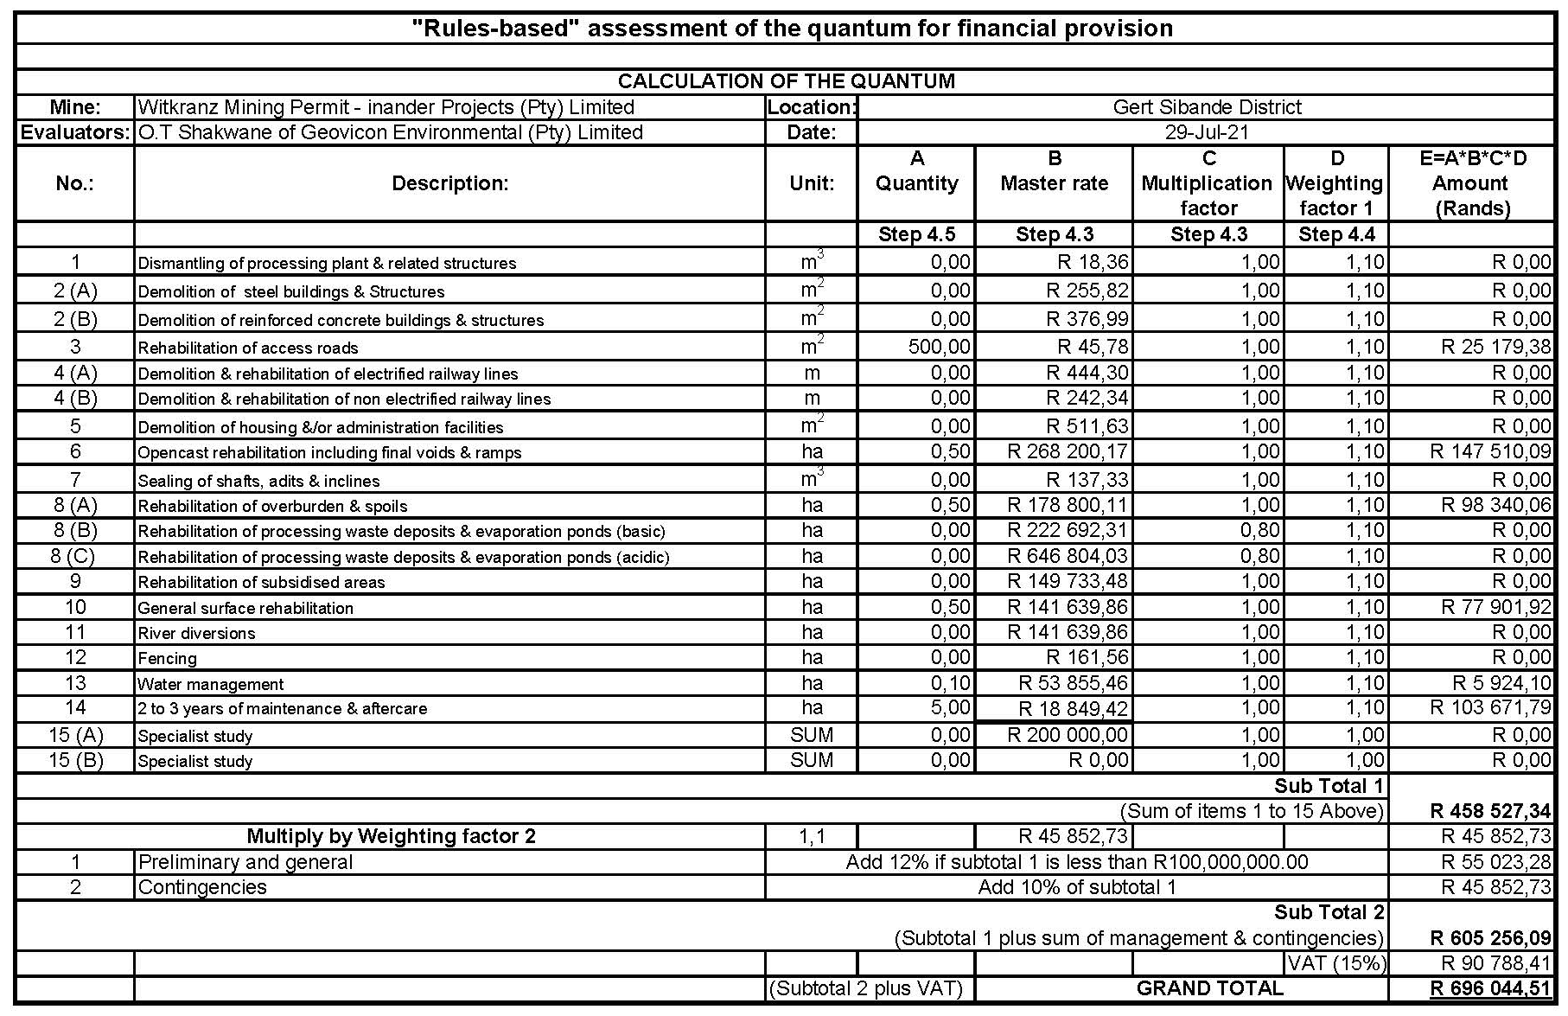

mechanism for monitoring compliance with and perfomamce assessMent against the environMental management programme and reporting thereoF

7.1 Inspections and Monitoring
During the impact assessment, potential impacts on the environment were identified. Mitigation measures were also specified for prevention and management of the impact so as to minimise their effect on the environment. This section will describe how the mine intends to ensure that the mitigation measures are being undertaken and that their effectiveness is proven.
A monitoring programme has been developed for the identified impacts and their mitigation measures. This monitoring programme will be undertaken and results thereof used to determine the effectiveness of the mitigation measures. The ECO will have an overall responsibility for ensuring that all monitoring is conducted according to the approved EMPR.

7.2 Monitoring compliance with and performance assessment against the environmental management programme and reporting thereof
As part of the general terms and conditions for a mining permit, and in order to ensure compliance with the environmental management programme and to assess the continued appropriateness and adequacy of the environmental management programme Inander Projects (Pty) Limited will:
- Conduct monitoring on a continuous basis
- Conduct performance assessments of the environmental management programme annually
- Compile and submit a performance assessment report to the minister in which compliance with the approved environmental management programme is demonstrated
The performance assessment report will as a minimum contain the following:
- Information regarding the period applicable to the performance assessment
- The scope of the assessment
- The procedure used for the assessment
- The interpreted information gained from monitoring the approved environmental management programme
- The evaluation criteria used during the assessment
- The results of the assessment
Recommendations on how and when non-compliance and deficiencies will be rectified

7.3 PROCEDURE FOR ENVIRONMENTAL RELATED EMERGENCIES AND REMEDIATION
Inander Projects (Pty) Limited has developed procedures for environmental related emergencies for Witkranz Colliery which is explained in more detail below. Note that these procedures will be revised by the responsible person. The date of commencement of the revised procedures will always be indicated to prevent confusion

7.3.1 Introduction
An effective, comprehensive, well considered and tested environmental emergency preparedness and response plan has the potential to save lives, prevent unnecessary damage to the company and other property and to manage environmental risk. The aim is to identify potential for and respond to accidents and emergency situations, and for preventing and mitigating the environmental impacts that may be associated with them. However, the emergency preparedness and response should be reviewed and revised where necessary.

7.3.2 What is an Environmental Emergency?

An environmental emergency is an unplanned event, which has the potential to result in a significant adverse environmental impact and/or could result in legal liability to Inander Projects (Pty) Limited in terms of environmental legislation requirements. The following define most likely potential environmental emergencies:
- Hydrocarbon spills or leaks
- Surface fires, including veld fires
- A chemical spill
- Transportation accidents
- Other environmental emergencies requiring special services

7.3.3 Purpose of the procedure
To provide guidance to all mine employees and contractors in the event of an environmental emergency at Witkranz Colliery and related to its activities.
This procedure is developed so as to provide guidance to ensure that:
Danger to the environment, personnel, contractors and the non-employee is minimised.
- Legal liability is managed and minimised.
- Public relations are effectively managed during and following emergencies.
- Reporting is effective and corrective/follow-up actions are implemented.

7.3.4 Who should use these procedures?
This procedure contains information relevant to all employees and contractors of the mine. It is the responsibility of all employees to familiarise themselves with the contents of this procedure. Furthermore, mine management should ensure that all contractors have access to this procedure and the requirements contained herein (See Table 21).

7.3.5 Responsibilities
Table 21: Responsibilities
Mine Management | Inander Projects (Pty) Limited is responsible for the safety and well-being of employees working at Witkranz Colliery as well as the protection of the environment from unnecessary negative impacts. The management of the Colliery has a responsibility to initiate a warning process should an emergency occur or should something at the Colliery deteriorate in an uncontrolled manner presenting a risk to employees, the public or the environment.
Local Government(s) | Local governments have the responsibility to warn residents of a hazardous situation, these warnings must be based on information provided by the Colliery.
All employees, contractors and other relevant parties | All employees, contractors and other relevant parties should ensure that they are familiar with this procedure.

7.3.6 Notification process
There are six main steps in managing an emergency, from the identification of the situation to final close off. They are as follows:
- Find and identify
- Ensure human safety
- Reporting
- Containment and clean-up
- Corrective action
- Monitoring

7.3.7 Emergency equipment and supplies
There is a directory of emergency equipment and other supplies on site as well as person/s responsible for the equipment.

7.3.8 Communication systems
Communication is critical during an emergency on site so that efforts to manage the situation are coordinated to produce the desired results. The communication channels that are available on site include:
- Internal phone line system
- Hand held radios
- Cellular phones

7.3.9 Training
The mine management ensures that employees are trained regarding potential emergencies that may occur at Witkranz Colliery

7.3.10 Review of procedure
To ensure that the procedure is adequate, management will review the procedure at any time deemed necessary and change the emergency procedures at Witkranz Colliery.

7.3.11 Emergency Response flowchart for Inander Projects (Pty) Limited

The emergency response at Witkranz Colliery is undertaken, as shown in Figure 18 below.

Report as required
Investigate
Initiate corrective action
Monitor as required
Environmental issue identified
Determine if there is a risk of environmental pollution, associated legal risk or risk to human health or community well-being in the short term
No
Yes
Take appropriate action to ensure human safety
Establish if identifier can contain the problem without further risk to him/her, other people or the environment
Notify appropriate person(s) e.g., Environmental Control Officer etc.
Take appropriate action
Yes
No
Remedy the problem
Not an environmental emergency: report the incident through the incident reporting system

Figure 18: emergency response.

7.4 ENVIRONMENTAL AWARENESS PLAN
In terms of section 39(3)(c) of the Mineral and Petroleum Resources Development Act, 2002 (Act 28 of 2002), Witkranz Colliery must compile and implement an environmental awareness plan. The above-mentioned environmental awareness plan must describe the manner in which the site manager (in this case Witkranz Colliery) will inform their employees of any environmental risk which may result from their work and the manner in which the environmental risks will be addressed to avoid pollution or/and degradation of the environment. This document, therefore concerns the details of the environmental awareness plan for Witkranz Colliery as required by the Mineral and Petroleum Resources Development Act, 2002 (Act 28 of 2002).

7.4.1 Objectives and Legal Requirements
The following are the objectives of the environmental awareness plan
- To identify the necessary training needs for different categories of employees in the mine
- To train all employees on environmental issues on the mine
The following legislation apply to this environmental awareness plan
- Employment Equity Act, 1998 (Act 55 of 1998)
- National Environmental Management Act, 198 (Act 77 of 1998)
- Mineral and Petroleum Resources Development Act, 2002 (Act 28 of 2002).

7.4.2 Manner of informing employees of risks to avoid pollution and degradation of the environment
The identification of environmental training and environmental awareness needs are derived from an analysis of the type of role different categories of employees play at Witkranz Colliery. The following categories are considered, viz:

- Senior Management
- Middle management (Environmental Officers)
- Supervisors
- Operators
- Visitors and contractors

Each of these categories have different responsibilities and therefore have different knowledge requirements and environmental awareness training needs, to obtain that knowledge.
The different categories and environmental awareness and training needs are summarised below in Table 22:

Table 22: Environmental Awareness Matrix.
Occupation Category | EMP Responsibility | Required knowledge and output | Training required | Interval
Senior management | Managing | Understand the EMP objectives | Induction and post-leave awareness/training | Annually
 |  | Knowledge of the Colliery's significant impacts and risks. | EMP Workshops | Once off
 |  | Review the EMP actions | EMP objectives and actions /Management reviews | Annually
 |  | Knowledge of EMP Procedures (awareness and emergency) | Specific training program on EMP | Once off, refresh annually
Middle and Junior management | Implementing and daily management | Knowledge of Colliery's significant environmental impacts | EMP Review workshops | Annually
 |  | Setting of EMP objectives for environmental improvement | EMP Review workshops | Annually
 |  | Knowledge of EMP procedures (awareness and emergencies) | Specific training programmes on EMP | Once off, refresh annually
 | Adhering to procedures to control impacts | Understand EMP objectives | Induction and post-leave training | Annually
 |  | Knowledge of significant impacts | Induction and post-leave training | Annually
 |  | Knowledge of procedures (awareness and emergency) | EMP Review workshop | Annually
Plant and machine operators, assemblers and elementary occupations | Executing assigned EMP actions  Controlling work activities to prevent impacts. | General awareness of EMP impacts and objectives. | Induction and post-leave training | Continuously
 |  | Understand environmental requirements relating to work | Induction and post-leave training | Annually
 |  | activities and consequences of not following requirements
 |  | Knowledge of procedures | Training and information sharing | Continuously
Visitors and contractor | Managing and controlling daily actions to prevent or control impacts | Basic awareness of EMP | Induction or specific modules/ awareness programme | Once off, annual review if applicable
 |  | Environmental requirements of work activities | Induction or specific awareness programme | Once off, annual review if applicable
 |  | Knowledge of procedures | Training and information sharing | Continuously
 |  | Understanding environmental consequences of personal actions and performance. | Induction or specific modules/ awareness programme | Once off, annual review if applicable
 |  | Compliance to procedures | Induction or specific awareness programmes.
Personnel requiring specific training and awareness identified on site by management, Environmental Officer, training department, etc. | Managing and controlling daily actions to prevent impacts | Examples include but are not limited to:  Waste management  Hazardous chemical handling | Specific training programme on EMP procedures. | As required

7.4.3 Induction for all employees, including contractors
All employees (including contractor employees) undergo induction. Witkranz Colliery's induction includes training and awareness on environmental issues on the Colliery and is compulsory for all new employees. The induction programme as mentioned above, have an environmental management component. On an annual basis the environmental section of the induction gets updated. Consideration is given to the following:

- Significant environmental impacts as identified in the EMP
- Procedures: environmental awareness and emergency procedures
- Trends in incidents
- Trends in audit findings

7.4.4 General environmental awareness training
General awareness training is offered to operators, processors and the other various sections of the mine during the safety toolbox talks. This is conducted on rotational basis. New environmental awareness topics are determined and new topics are introduced after all the shifts have received training/awareness on the current topic. The following is undertaken to ensure that the above awareness training is conducted.

- A monthly environmental awareness topic for discussion is distributed to all mine sections. These topics are discussed at the safety toolbox talks, by SHE (Safety, Health and Environmental) representative and environmental officers if available.
- The topics are displayed on the notice boards of all mine sections.
- Ad hoc environmental awareness sessions to various departments/sections are conducted on request. The presentations focus on the environmental issues relevant to individual tasks.

7.4.5 Provision for job specific environmental awareness training
Job specific training is developed to address urgent training needs as identified /required. The training material focus on the following:

- Waste prevention and control (implementation of the waste management procedure).
- Water management (Leaking pipes and taps)
- Hydrocarbon and chemical spill reporting and clean-up
- Storing and handling of chemicals
- Rehabilitation
- Dust management on the mine

Supervisory staff within specific mine sections are equipped with the necessary knowledge and information to guide their employees on environmental aspects applicable in performing a specific task.

7.4.6 Competency training
Management (training official/environmental officer) is responsible for the environmental awareness training of middle management and supervisors. This training is conducted through workshops. If required, external organisations may be requested to provide training to selected employees (e.g. EMP auditing).

Competence and the effectiveness of training and development initiatives as described in the matrix, are determined through the following:

- Trend analysis and reporting
- Analysis of work areas during visits and audits
- Trend analysis of monthly incidents (or zero tolerance if available) as recorded per mine section.

7.4.7 Review of awareness and training material
The content of all awareness and training material will be updated at least once a year.

7.4.8 Roles and responsibilities
In the case where there is no training department on site, a responsible person should be identified (Mine manager, Environmental Officer or Consultant) to ensure that the objective of this procedure is met.

7.5 Undertaking to Comply

I, ..............................................., the undersigned and duly authorised thereto by Inander Projects (Pty) Limited have studied and understand the contents of this document in it’s entirety and hereby duly undertake to adhere to the conditions as set out therein including the amendment(s) agreed to by the Regional Manager.
Signed at ..............………......... this.................................day of…………...................20........

....................................... .......................................
Signature of applicant Designation

APPROVAL

Approved in terms of Section 39(4) of the Mineral and Petroleum Resources Development Act, 2002 (Act 28 of 2002)

Signed at……………………………….this.........................................day of……………..............20......

.......................................…………………………………..
REGIONAL MANAGER

REGION:………………………………

