eThembeni
Cultural
Heritage

Amafa aKwazulu-Natali 01 May 2015
195 Jabu Ndlovu Street Pietermaritzburg 3200
Telephone 033 3946 543
bernadetp@amafapmb.co.za

Attention Bernadet Pawandiwa

Dear Ms Pawandiwa

Heritage Impact Assessment Reporting and Request for a Record of Decision
Richards Bay Port Expansion, KwaZulu-Natal

eThembeni Cultural Heritage was appointed by AECOM in February 2013 to undertake a Baseline Heritage Study as a prelude to a full Phase 1 Heritage Impact Assessment (HIA) of the proposed Richards Bay Port expansion, as required by the National Environmental Management Act 107 of 1998 as amended (NEMA), in compliance with Section 38 of the National Heritage Resources Act 25 of 1999 (NHRA).
The baseline report (attached on SAHRIS file) recommended a full Phase 1 Heritage Impact Assessment be conducted, for which eThembeni Cultural Heritage was subsequently appointed in 2014. It was subsequently determined, after the inception of SAHRIS, that such a study had been undertaken by Umlando for MSA Environmental, Legal & Mining Services in 2009 (attached on SAHRIS file).
On behalf of our client, AECOM, we request that a Record of Decision please be issued on the basis of the Mlando Report.

Yours sincerely
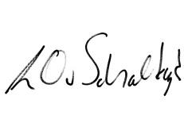

Len van Schalkwyk .

