

**FOR OFFICIAL USE ONLY:**

File No.:

Date received:

Date approved:

Applicant:

Site / Object:   
Permit No.:

**SOUTH AFRICAN HERITAGE RESOURCES AGENCY**

111 HARRINGTON STREET, CAPE TOWN, 8001

PO BOX 4637, CAPE TOWN, 8000

TEL: 021 462 4502 FAX: 021 462 4509

**APPLICATION FOR PERMIT:**

**ARCHAEOLOGICAL AND PALAEONTOLOGICAL SITES AND METEORITES**

Please note: Permit Applications expire one year after the date of receipt.

*In terms of Section 35 (4) of the National Heritage Resources Act, 1999 (Act No. 25 of 1999) no person may, without a permit issued by the relevant heritage resources authority, destroy, damage, excavate, alter, deface or otherwise disturb any archaeological or palaeontological site or material or any meteorite; or bring onto, or use at an archaeological or palaeontological site any excavation equipment or any equipment that assists in the detection or recovery of metals or archaeological and palaeontological material or objects, or use such equipment for the recovery of meteorites.*

Other application forms are available for shipwrecks (303), heritage objects , export of archaeological and palaeontological material (304);  
burials (305), the built environment and landscape (307) or the registration of private collections (402).

**Applicants are advised that without full details no permit may be issued*.***

**A. APPLICANT’S DETAILS**

1. Name and address of applicant: **Mary Patrick, for Cape Archaeological Survey cc**

**Unit 2, Greenwich Grove, Duke Road, Rondebosch, 7700**

Phone: (H) **021 761 4744** . . . (W) **.021 685 158** . . . . . . . . . . (Cell) **083 208 0648**

Fax: . . . .**N/A.** . . . . . . . . . E-mail: **maryp@method1.co.za**

Identity number of applicant (or passport): **Company Registration No CK 90/31205/23**

2. Academic qualifications of applicant: **MA Archaeology (UCT) 22 years experience as a contract archaeologist**

3. Previous relevant experience of applicant: **see attached appendix 1:project sheet for work successfully completed**

4. Name and address of a person who can serve as a reference, i.e. a qualified **archaeologist**, palaeontologist or geologist, as relevant: **Mr Dave Halkett, ACO Contracts Office,** **University of Cape Town**

5. Name and address of the South African scientific institution with which the applicant collaborates:

**Department of Human Biology, University of Cape Town**

6. Name and address of the South African scientific institution that will curate the material recovered:

**Robben Island Museum**

**B. DETAILS OF SITE(S) OR OBJECT(S)**

7. Name(s) of site:

**Old Power Station Cooling Ponds associated with a WW 11 Building**

8. Nature of site or object(s) *e.g. archaeological, palaeontological, meteorite****\*:* Built Environment Feature**

*\* Please supply a short description of the site, including, type and approximate date on a separate sheet of paper*

9. Period, era, age or date of site or object(s) * **World War 11** **Building –Historical Period (1945- 1949).**

10. Geographical situation of site / object  *MARK POSITION OF SITE ON A PHOTOSTAT OF A 1:10 000 or 1:50 000 MAP*:

Province**: Western Cape**

Magisterial district: : 1: 50 000 Map number : . . . . . . . . . . . . . . . . . . . . . . (or SAN chart)

Latitude & Longitude: **33.806734 S 18.366222E** . Recording method (GPS, Trig., Other) :

Farm Name and No.: . . . . . . . . . . . . . . . . . . . . . . / Town **: Robben Isalnd**

Nearest Town: **Cape Town** . . . . . . . . . . . . . . . . . . . . . . . . . . / Street address & Erf # :

11. If it is a national or provincial heritage site / object, the number and date of the notice in the *Government Gazette* **UNESCO World Heritage Site**

**C. PURPOSE OF APPLICATION**

12. Purpose of and reasons for application*

**Please see appendix 2, a report by Ron Viney that fully outlines the rationale for the excavation. Below is an extract from this report**

.

**“The excavation and reuse of the WW11 site is consistent with current thinking on the adaptive reuse of historical structures. The National Heritage Resources Act, 25 of 1999, The 1969 ICOMOS [Venice] Charter and its amendments, as well as the Australia ICOMOS [Burra] Charter all provide for adaptive reuse strategies to be implemented within historical contexts.**

**The aim is not an absolute return to the past but to reintegrate the WWII landscapes in their current setting. The number and size of the artefacts, as well as the requirements for environment control in housing the artefacts, cannot be adequately housed within the Old Power Station building itself.**

**The small outbuilding initially allocated to house both the fumigation and plant is inadequate bearing the requirements for storage of artefacts in mind.**

**It is recommended that:**

**1. The cooling pond is excavated as per SAHRA requirements to assess the merits of reuse of the pond.**

**2. The cooling pond be suitably reinstated as per the project architects specifications to house the plant.”**

***\* PLEASE SUPPLY FULL MOTIVATION OR RESEARCH PROPOSAL***

13 Nature of activity. *Please circle the appropriate activities below*

**Destruction or Damage**\* **for:** **Analysis** / Dating / **Restoration** / Security / Other*

**Excavation or disturbance**\* **x**

**Alteration**\*

**Removal from original site**\*

**Exhumation and re-interment**\*

**Explore with a metal detector or other equipment\***\*

**Other (e.g. removal of graffiti at rock art site)\***

*Please supply extra details on a separate sheet of paper*:*

14. Period for which permit is required. *Permits are not normally issued for periods longer than three years:*

**From** . .**February 2012 .** . . . . . . . . . . . . . . . . . . . . . . . . . . . **To** . **February 2013**. . . . . . . . . . . . . . . . . . . . . . . . .

1. Have you consulted the landowner about this project? Please supply documentation.

**See attached documentation – appendix 3**

16. Institutional support (as relevant):

**I,**  N/A  **Head of**

**(South African Institution) where the applicant will be based while undertaking this project, hereby state that I support the application.**

Signature: Date:

**I,** ???  **Head of Robben Island Museum** **(Institution) hereby undertake to store in our institution the material and records from this project once completed.**

Signature: Date:

**----------------------------------------------------------------------------------------------------------------------------------------------**

**I, Mary Kennedy Patrick**

**undertake strictly to observe the terms, conditions, restrictions, regulations and guidelines under which the Council may issue the permit to me.**

**Signature:**  **Place: Rondebosch**

**(APPLICANT)**

**Date: 22 February 2012**

**Accompanying Documentation**

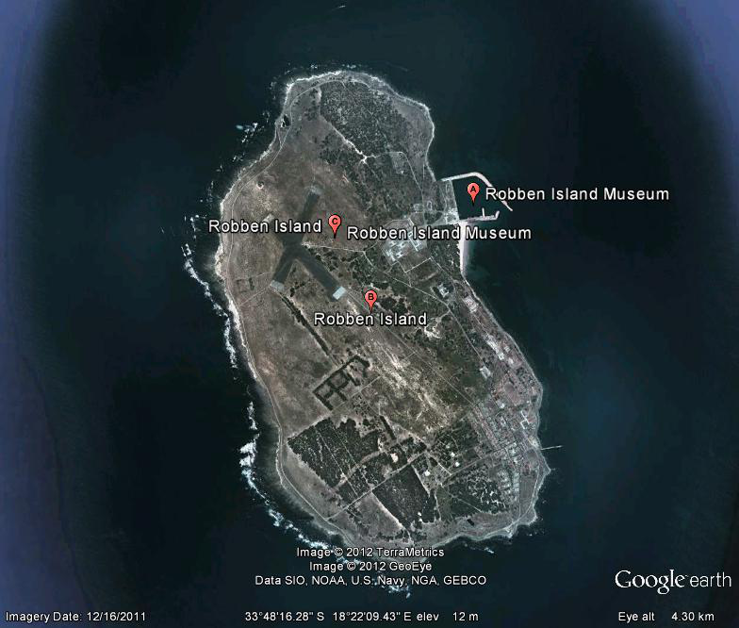

Figure 1: Goggle Map showing the layout of the island and GPS coordinates

From May 2006, certain permit applications submitted to the South African Heritage Resources Authority, SAHRA, in terms of the National Heritage Resources Act (Act No 25 of 1999) must be accompanied by payment of the appropriate fee.

Permit Applications made on **SAHRA APM Permit Form No 302** will carry the following fees:

|  |  |  |
| --- | --- | --- |
| 1. Permits issued by the **SAHRA Archaeology, Palaeon­tology and Meteorite Unit** (APM) Unit for Grade I archaeological or palaeontological heritage resources or meteorites; and for Grade II & III and generally protected heritage resources, on an agency basis, for Provincial Heritage Resources Authorities | **Fee** | **\*Permit Code** |
| 1. Application fee for destruction, damage, excavation, alteration or disturbance in terms of s.35(4) for research and conservation; | CEO to deter­­mine | **\*AP302REC** |
| 1. Application fee for destruction, damage, excavation, alteration or disturbance in terms of s.35 (4) for mitigation or development; | R150 | **\*AP302DES** |
| 1. Application fee for filming by commercial film by commercial film crews in terms of s.35 (4); | CEO to determine | **\*AP302FIL** |

**Kindly ensure that you supply the Application Code (see table above*) followed by the surname of the permit applicant, in the reference section of the bank deposit slip.**

For example

Charges may be waived, at the discretion of SAHRA Chief Executive Officer, for certain permit applications.

It should be NOTED that SAHRA may, in terms of section 3 of the SAHRA permitting regulations, require that a financial deposit be lodged with SAHRA to safeguard a heritage resource until satisfactory completion of the action for which the permit is required.

**PAYMENT may be made** by depositing the relevant amount into the SAHRA bank account and faxing or producing the proof of payment (i.e., stamped deposit slip, internet banking confirmation, etc.), OR through Internet Banking and emailing or faxing proof of payment, OR by cheque, on application.

PLEASE TAKE NOTE THAT APPLICATIONS NOT ACCOMPANIED BY A PAYMENT OR PROOF OF PAYMENT MAY NOT BE PROCESSED UNLESS EXEMPTED ABOVE OR BY SAHRA.

**SAHRA banking details:**   
South African Heritage Resources Agency   
ABSA Bank, Adderley Street; Cape Town   
Bank Code: 63 2005; Account Number: 40-6416-0070.

Should you have any queries please contact the appropriate unit via: SAHRA, PO Box 4637, Cape Town 8000; or by email at info@sahra.org.za; or Tel:  021 462 4502; Fax: 462 4509.