Mr Jamie Pote, Botanical Specialist Consultant
Postnet Suite 177, Private bag X0002, Fig Tree, Port Elizabeth, 6033
Email: jamiepote@aerosat.co.za, Cell: (+27) 083 743 9353, Fax: (+27) 086 690 3704
22 March 2009
Att: Robyn Thompson
SRK Consulting

Mapping of Species of Special Concern for proposed Seaview Bulk water pipeline servitudes
A. Protected Plants
A list of Species of Special Concern is provided which provides details of Flora identified as being present within the proposed pipeline servitude, including conservation Status, estimated distribution and recommended action regarding permits and relocation. Since the impact of the pipeline will be predominantly restricted to the pipeline servitude, which occurs predominantly within already transformed road reserves it would be advisable that once the exact footprint has been identified and demarcated, any relocation activities are commenced.
In terms of the National Forests Act, 1998 (Act No 84 of 1998) and Government Notice 1339 of 6 August 1976 (promulgated under the Forest Act, 1984 (Act No 122 of 1984) for protected tree species), the removal, relocation or pruning of any protected plants will require a license (Refer relevant Appendix).
Protected indigenous plants in general are controlled under the relevant provincial Ordinances or Acts dealing with nature conservation. In the Eastern Cape the relevant statute is the 1974 Provincial Nature Conservation Ordinance no 19 (PNCO). In terms of this Ordinance, a permit must be obtained from the Department of Economic Affairs Environment and Tourism (DEAET) to remove or destroy any plants listed in the Ordinance. At the time of compilation of this report the provincial Environmental Conservation Act (2003) had not yet been promulgated hence the protected plant species contained therein have not been included in this report.
Explanation of Conservation Status:
PNCO: Protected by the Provincial Nature Conservation Ordinance of 1974;
NFA: Protected by the National Forests Act 84 of 1998;
CARA: Conservation of Agricultural Resources Act 43 of 1983 (Category 1, 2 or 3)
IUCN: Red Data listed species of the Threatened Species Programme (Interim Assessment 2007)
- CR - CRITICALLY ENDANGERED (CR): A taxon is Critically Endangered when the best available evidence indicates that it meets any of the criteria A to E for Critically Endangered (see Section V), and it is therefore considered to be facing an extremely high risk of extinction in the wild.
- EN - ENDANGERED (EN): A taxon is Endangered when the best available evidence indicates that it meets any of the criteria A to E for Endangered (see Section V), and it is therefore considered to be facing a very high risk of extinction in the wild.
- VU - VULNERABLE (VU): A taxon is Vulnerable when the best available evidence indicates that it meets any of the criteria A to E for Vulnerable (see Section V), and it is therefore considered to be facing a high risk of extinction in the wild.
- NT - NEAR THREATENED (NT) : A taxon is Near Threatened when it has been evaluated against the criteria but does not qualify for Critically Endangered, Endangered or Vulnerable now, but is close to qualifying for or is likely to qualify for a threatened category in the near future.
- LC - LEAST CONCERN (LC): A taxon is Least Concern when it has been evaluated against the criteria and does not qualify for Critically Endangered, Endangered, Vulnerable or Near Threatened. Widespread and abundant taxa are included in this category.

Obtaining permission for the destruction or removal of protected species
It is recommended that before the clearing of the proposed site is authorized, the appropriate permission be obtained from the Department of Economic Affairs, Environment and Tourism (DEAET) for the destruction of species. In order to obtain permission to remove or destroy species a letter needs to be drafted and sent to DEAET together with an application form. This letter must list the species (including localities) that will be removed or destroyed and the reason for their removal or destruction.
These permits may be subject to certain conditions, for example allowing various nurseries to collect plants before vegetation clearance commences; the removal of certain species for rehabilitation purposes etc. These conditions will be drafted after the application has been received by DEAET and a site visit has been undertaken.
All individuals of the protected indigenous species should firstly be avoided if possible, if not then secondly translocated or utilized during rehabilitation and landscaping. If this is not possible permits will be required to either trim or remove individuals.
B. Alien Invasive Plant species
Alien Invasive Plants require removal according to the Conservation of Agricultural Resources Act 43 of 1983 (CARA).

Eradication protocol
Specific eradication and management procedures should be stipulated in the EMP as to the methods to be implemented to remove and control the various alien invasive species as they tend to require species specific techniques. It is further recommended that the weeds indicated also be controlled within the powerline servitude as they may become problematic under disturbed conditions.

C. Applicable Legislation
Conservation of Agricultural Resources Act 43 of 1983 and Conservation of Agricultural Resources Regulations.
In terms of section 6 of the Act, the Minister may prescribe control measures with which all land users have to comply. The control measure may relate to the following:
- the control of weeds and invader plants;
- the restoration or reclamation of eroded land or land which is otherwise disturbed or denuded;
Forest Act 122 of 1984
Protected trees
The Forest Act provided for the protection of trees on private land by providing that ‘no person may cut, damage, destroy, disturb or remove any protected tree from the land in question, or collect, remove, transport, export, purchase, sell, donate or in any other manner acquire or dispose of any part or produce thereof’. The Minister was authorised, in respect of any land not forming part of a State forest, to declare a particular tree, a particular group of trees, or trees belonging to a particular species occurring on that land, to be a protected tree or trees (Appendix 6) Regulations published under the Act list 58 species of protected trees to which these prohibitions apply. Although the NFA has repealed the old Forest Act, the majority or regulations promulgated under the Act still remain in force until such time they are replaced by new regulations under the NFA.
National Forests Act 84 of 1998 (NFA)
Protected trees
The Minister may declare a tree, group of trees, woodland or a species of trees as protected. The Minister is required to publish a list of all species protected under this Act, an appropriate warning of the prohibitions set out and the consequences of its infringements, annually in the Government Gazette. The prohibitions provide that ‘ no person may cut, damage, disturb, destroy or remove any protected tree, or collect, remove, transport, export, purchase, sell, donate or in any other manner acquire or dispose of any protected tree, except under a licence granted by the Minister’. A permit must be obtained from the Department of Water Affairs and Forestry (DWAF) to remove or destroy any plants listed in the NFA
Provincial Nature Conservation Ordinance of 1974 (PNCO)
Protected indigenous plants in general are controlled under the relevant provincial Ordinances or Acts dealing with nature conservation. In the Eastern Cape the relevant statute is the 1974 Provincial Nature Conservation Ordinance. In terms of this Ordinance, a permit must be obtained from the Department of Economic Development and Environmental Affairs (DEDEA) to remove or destroy any plants listed in the Ordinance.

D. Recommended Protocol for Search and Rescue of SSC
- A suitable timeframe must be allowed before construction commences to undertake the plant rescue and relocation operation;
- Permits must be obtained from the respective departments before removal of protected species, depending upon applicable legislation.
- Plants that can be used during rehabilitation/landscaping should be identified and stored appropriately in the on-site nursery or storage facility for use after construction and alien vegetation clearing;
- Plants identified as being suitable for relocation as listed can either be stored temporarily or replanted within the areas demarcated for rehabilitation.
E. Conclusions
- The majority of species present within or adjacent to the proposed servitude tend to have widespread distributions and would thus not be under any significant threat as a result of water pipeline construction. Species (such as trees and cosmopolitan species that are however protected by the legislation) are not necessarily suited to relocation and permits must be obtained before destruction from the relevant departments (Department of Water Affairs and Forestry for NFA listed species and Department of Economic Development and Environmental Affairs for PNCO listed species).
- No IUCN Red Listed species were found to occur within the proposed servitude.
- Dormant species including bulbs and species belonging to the Iridaceae were not observed but may be present within the proposed servitude. These should be relocated during the construction phase if necessary.
- The species noted will require permits from the respective departments where appropriate. Certain species (such as trees and cosmopolitan species that are however protected by the legislation) are not necessarily suited to relocation and permits must be obtained before destruction.
- CARA listed species require removal as per Conservation of Agricultural Resources Act and a management plan should be incorporated into the EMP to retain the servitude invasive free.

Yours Sincerely

Jamie Pote

Table 1: List of species of special concern, with Vegetation community, Conservation Status and Recommended Action indicated.
Botanical Name | Family | Status | Fynbos | Thicket | Transformed | Common Name | Distribution | Recommended Action
Acacia cyclops | Fabaceae (Mimosoideae) | CARA | X |  | X | Rooikranz | Widespread, introduced | Weed, remove
Acacia longifolia | Fabaceae (Mimosoideae) | CARA |  |  | X | Long-leaved Wattle | Widespread, introduced | Weed, remove
Acacia mearnsii | Fabaceae (Mimosoideae) | CARA |  |  | X | Black Wattle | Widespread, introduced | Weed, remove
Acacia saligna | Fabaceae (Mimosoideae) | CARA |  |  | X | Port Jackson willow | Widespread, introduced | Weed, remove
Acrolophia capensis | Orchidaceae | PNCO | X |  |  |  | Widespread | Relocate/Permit
Astephanus marginatus | Apocynaceae | PNCO | X |  |  |  | Widespread | Permit
Carpobrotus edulis | Mesembryanthemaceae | PNCO | X |  | X | Sour Fig | Widespread | Permit
Carpobrotus sp. | Mesembryanthemaceae | PNCO | X |  |  | Sour Fig | Widespread | Permit
Cynanchum sp. | Apocynaceae | PNCO | X | X |  |  | Widespread | Permit
Erica chloroloma | Ericaceae | PNCO | X |  |  |  | Widespread | Permit
Eucalyptus spp. | Myrtaceae | CARA |  | X | X | Gum tree | Widespread, introduced | Remove
Indet. | Scrophulariaceae | PNCO | X | X |  |  |  | Permit
Indet. | Rutaceae | PNCO | X |  |  |  |  | Permit
Indet. | Restionaceae | PNCO | X |  |  |  |  | Permit
Pinus spp. | Pinaceae | CARA |  |  | X | Pine | Widespread, introduced | Weed, remove
Scadoxus puniceus | Amaryllidaceae | PNCO |  | X |  | Blood Lily | Widespread | Relocate
Secamone alpinii | Apocynaceae | PNCO |  | X |  |  | Widespread | Permit
Sideroxylon inerme | Sapotaceae | NFA |  | X |  | White Milkwood | Widespread | Permit, Avoid
Solanum americanum | Solanaceae | exotic weed |  | X | X | American nightshade | Widespread, introduced | Weed, remove
Urtica sp. | Urticaceae | exotic weed |  | X | X |  | Widespread, introduced | Weed, remove

Table 2: Location of Species of Special Concern.
Botanical Name | Family | Status | 1 | 2 | 3 | 4 | 5 | 6 | 7 | 8 | 9 | 10 | 11 | 12 | 13 | 14 | 15 | 16 | 17 | 18 | 19 | 20 | 21 | 22 | 23 | 24 | 25
Acacia cyclops | Fabaceae (Mimosoideae) | CARA | X |  | X | X | X | X |  | X | X |  |  |  | X
Acacia longifolia | Fabaceae (Mimosoideae) | CARA |  |  |  |  |  |  |  |  |  |  |  |  |  | X |  |  | X | X |  |  |  | X
Acacia mearnsii | Fabaceae (Mimosoideae) | CARA |  |  |  |  |  |  |  |  |  |  |  |  | X | X |  |  | X | X |  |  |  | X | X | X | X
Acacia saligna | Fabaceae (Mimosoideae) | CARA |  |  |  |  |  |  |  |  |  |  |  |  |  | X |  |  | X | X |  |  |  | X
Acrolophia capensis | Orchidaceae | PNCO | X |  |  | X
Astephanus marginatus | Apocynaceae | PNCO | X |  |  | X
Carpobrotus edulis | Mesembryanthemaceae | PNCO | X |  | X | X | X | X |  |  |  |  |  |  |  | X
Carpobrotus sp. | Mesembryanthemaceae | PNCO | X |  |  | X
Cynanchum sp. | Apocynaceae | PNCO | X | X |  | X
Erica chloroloma | Ericaceae | PNCO | X |  |  |  |  | X |  |  |  |  |  |  |  |  |  |  |  | X
Eucalyptus spp. | Myrtaceae | CARA |  |  |  |  | X |  |  | X |  | X | X | X | X |  | X | X | X | X | X |  |  |  | X | X | X
Indet. | Scrophulariaceae | PNCO | X | X |  | X |  | X
Indet. | Rutaceae | PNCO |  |  |  |  |  | X
Indet. | Restionaceae | PNCO | X | X |  | X |  | X
Pinus spp. | Pinaceae | CARA |  |  |  |  |  |  |  |  |  |  |  |  |  | X |  | X | X | X |  | X | X | X
Scadoxus puniceus | Amaryllidaceae | PNCO
Secamone alpinii | Apocynaceae | PNCO |  | X
Sideroxylon inerme | Sapotaceae | NFA |  | X |  |  |  |  | X | X |  | X |  | X
Solanum americanum | Solanaceae | exotic weed |  | X |  |  |  |  |  |  |  |  |  |  |  | X
Urtica sp. | Urticaceae | exotic weed |  | X

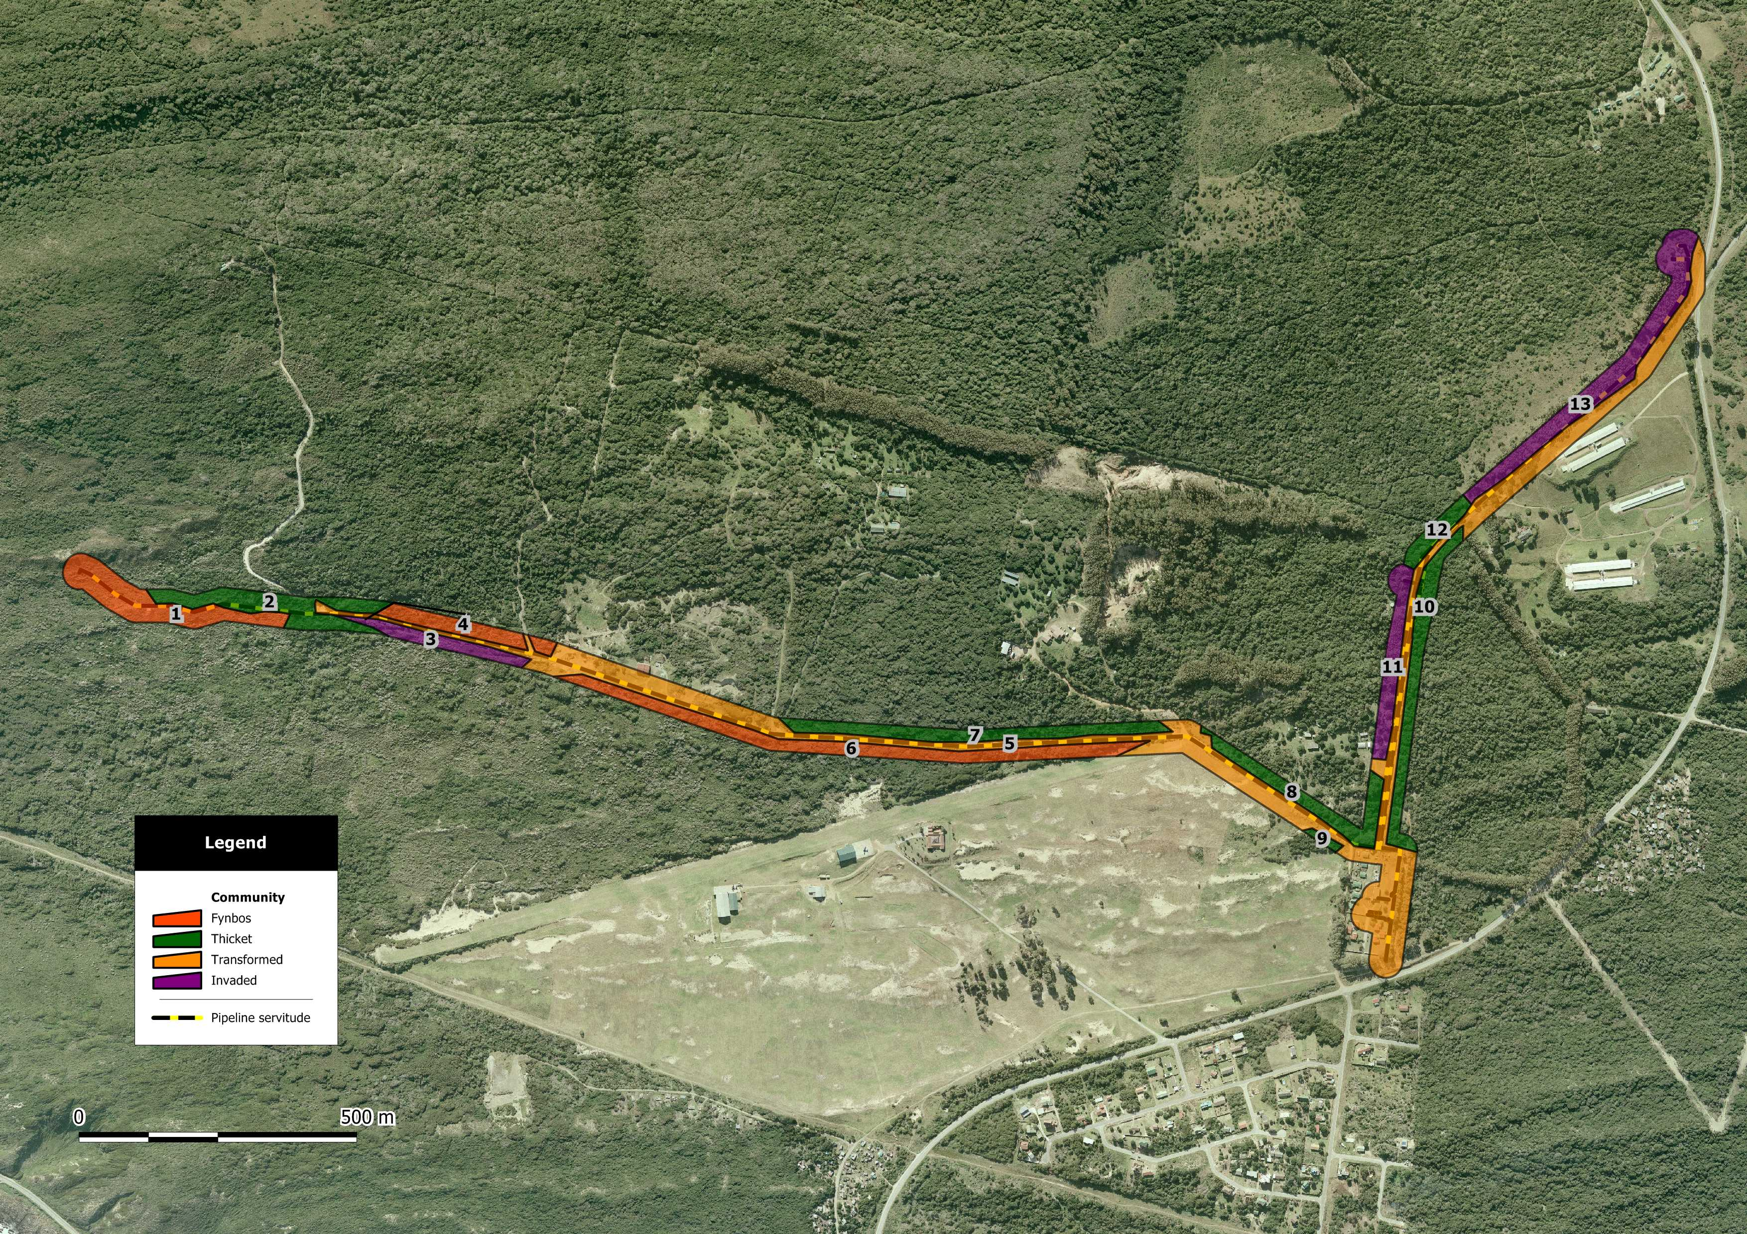
Map 1: Map indicating SSC habitat for Seaview Bulk water Pipeline Servitude.
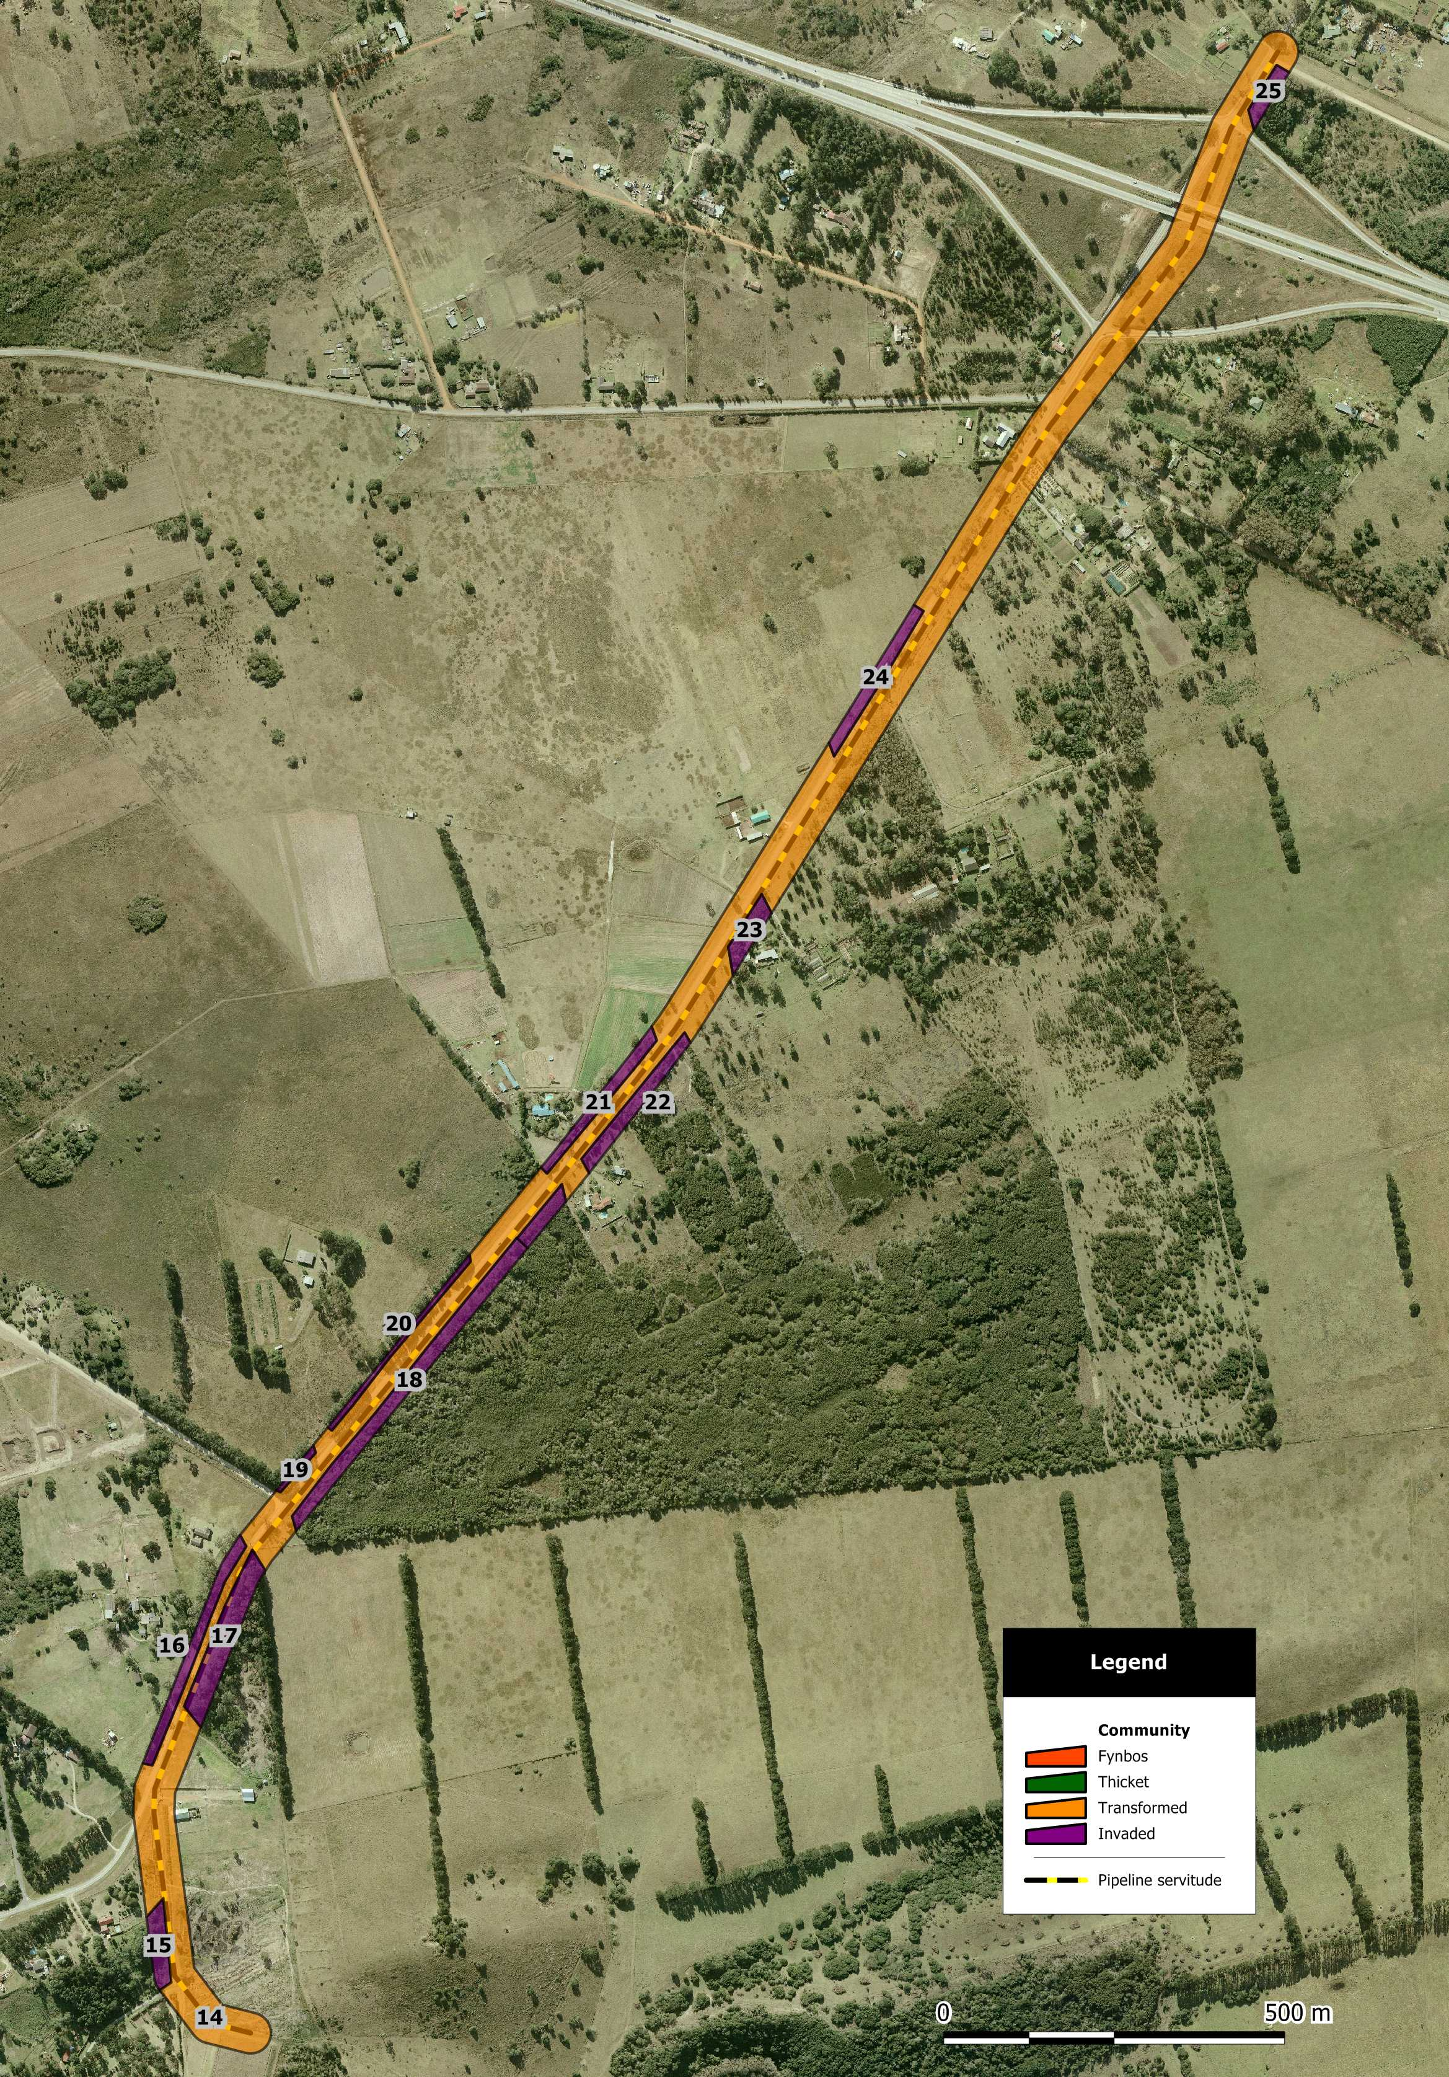
Map 2: Map indicating SSC habitat for Greenbushes - Chelsea Bulk water Pipeline Servitude.

