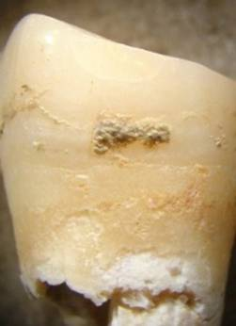
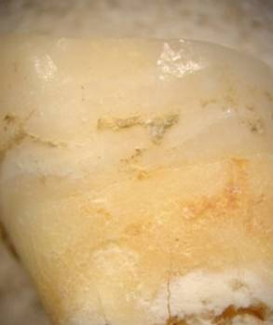

Figure 1 (left): Calculus on Neolithic tooth RH1 before removal. Note several smaller areas of calculus to right and left of main accumulation.

Figure 2 (right): Tooth after calculus removal. Portions of the calculus are still remaining on the tooth for future work. No damage has been inflicted on the tooth.
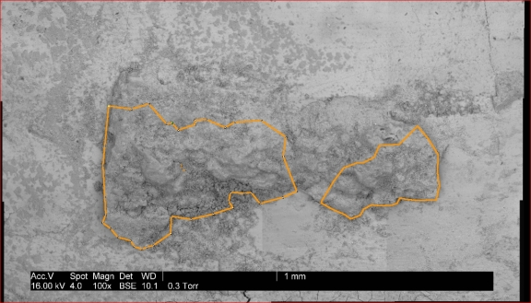
Figure 3: ESEM image of the calculus on RH1 prior to removal, with areas that were removed outlined.

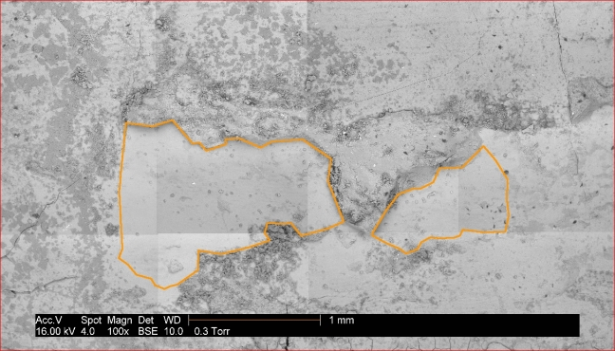
Figure 4: ESEM image of the calculus after removal, with the areas that were removed outlined. The size of these two areas was calculated using MIPAV (a program designed for processing medical images) to be 1.8681 mm². Note the lack of fresh scratches on the exposed enamel surface.

