Specimen list for thin-sectioning
Iziko South African Museum
Karoo Palaeontology

Please see the list below of specimens we would like to section for histological analyses. The red lines indicate the proposed areas to be cut. Please note that all the specimens below will certainly be CT-scanned before the sections are made.

SAM-PK-K11221: Lower jaw fragment of Endothiodon.

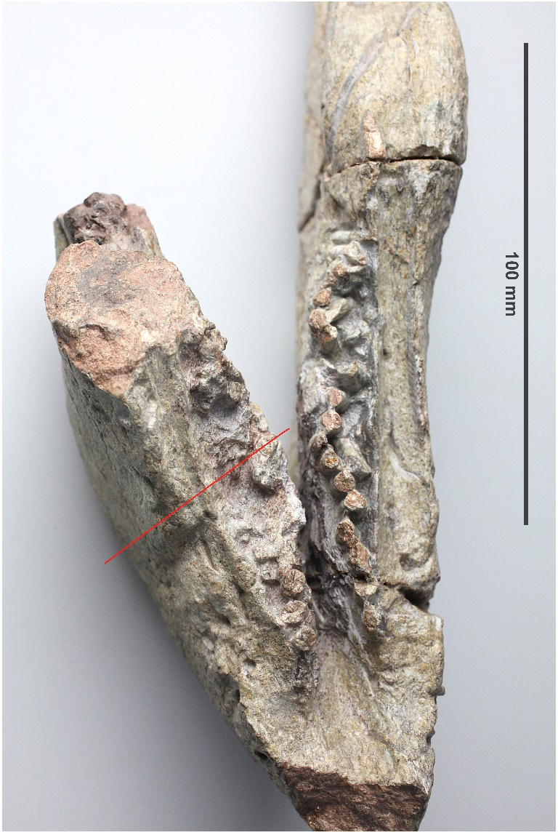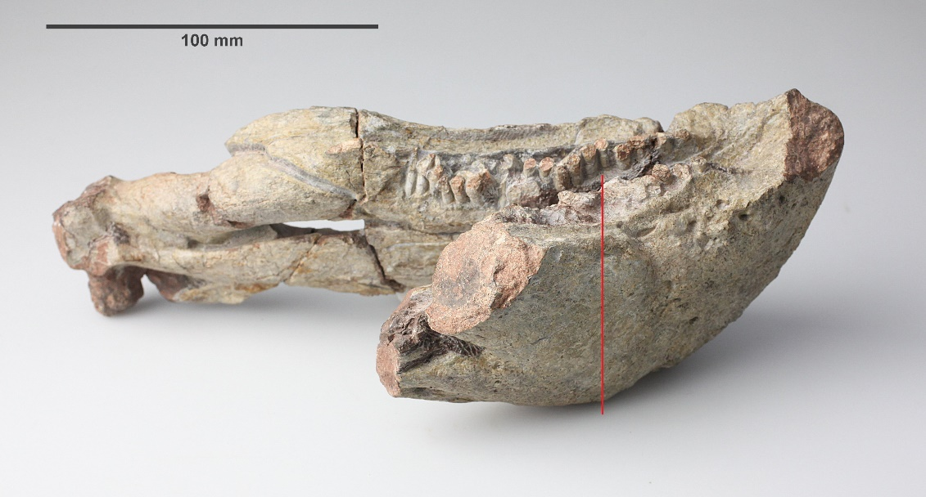

SAM-PK-K11134: Lower jaw of Endothiodon in lateral view (top) and ventral view (bottom). Please note that the right side of the dentary has very well preserved lower jaw teeth in distinct tooth rows, but only the end fragment of the left dentary will be sectioned, so that the teeth on the right side will not be damaged.

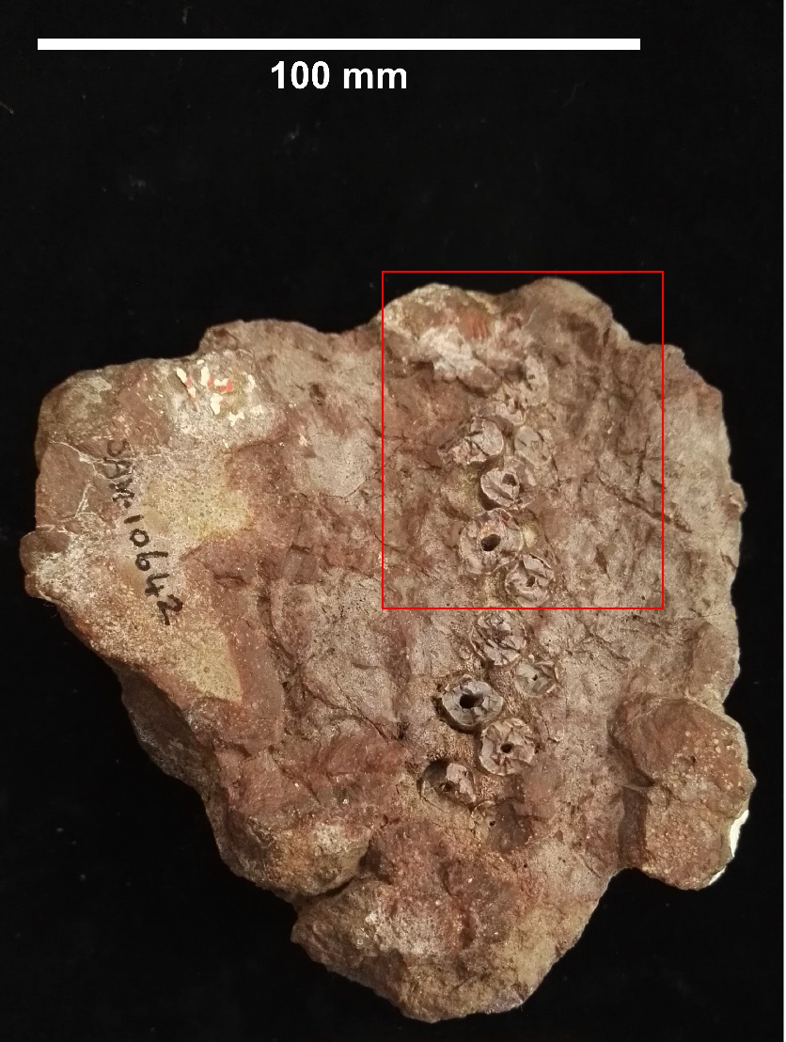
SAM-PK-10642: Maxilla fragment of Endothiodon – please note this specimen is still listed as Pachytegos stockleyi in the collections but has been synonymised with Endothiodon bathystoma by Cox and Angielczyk (2015). This applies to any other Pachytegos specimens.

