APPENDIX 2: STROMATOLITE MATERIAL COLLECTED

N.B. Scale bars in cm and mm. Locality details given in Appendix 1.

STROMATOLITE SAMPLE | SPEC. NO. | LOC. NO. | NOTES
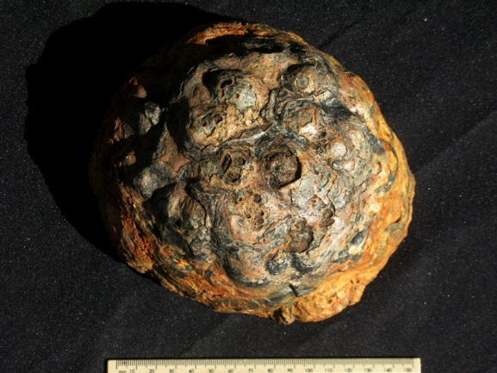 | CGS  VNA1 | 117 | Domical core of large stromatolitic dome showing button-like microdomes (laterally-linked hemispheres) on outer surface (See report Figs. 22-23).
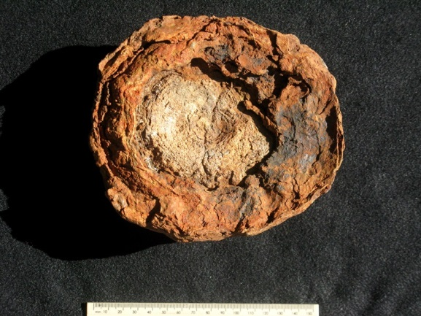 | CGS  VNA1 | 117 | Lower side of the same specimen. Over parts of the circumference the laminae are recurved inwards.
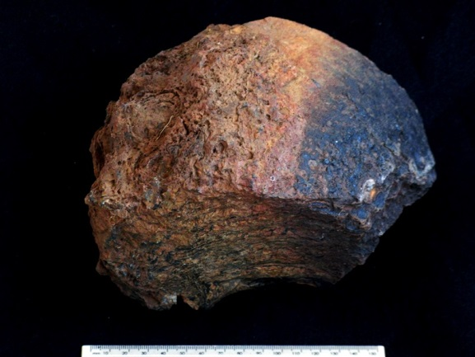 | CGS  VNA2 | 117 | Sector of proximal part of large stromatolitic dome surrounding the core (CGS VNA1). Outer laminae recurved round the base to give cushion-like geometry. Outer surface crinkly to sparsely pustular (See report Figs. 22-23).
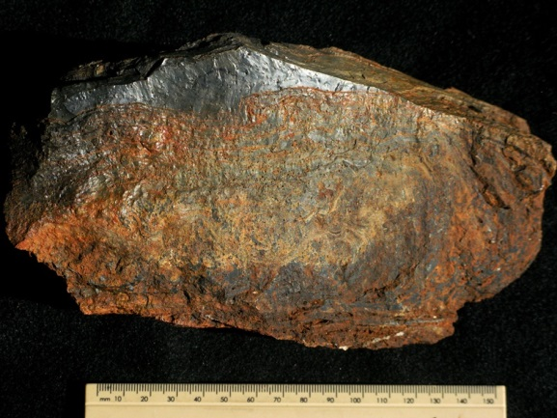 | CGS  VNA3 | 117 | Block from periphery of large stromatolitic dome (same dome as VNA1-VNA7. Lamination undulating but laterally-linked hemisphaeroids not clearly developed in outer part of dome.
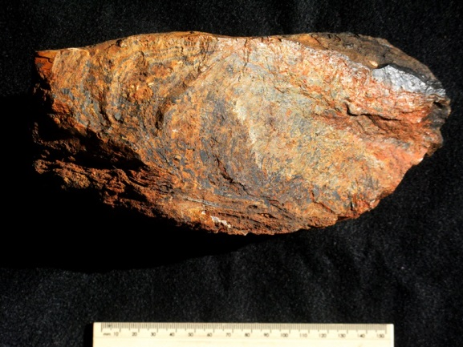 | CGS  VNA4 | 117 | Block from periphery of large stromatolitic dome (same dome as VNA1-VNA7. Lamination undulating but laterally-linked hemisphaeroids not clearly developed in outer part of dome.
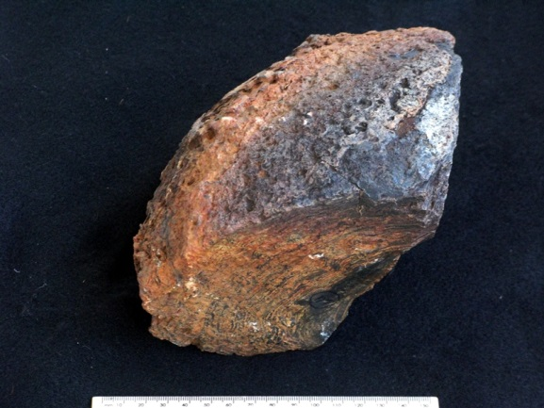 | CGS  VNA5 | 117 | Sector of proximal part of large stromatolitic dome surrounding the core (CGS VNA1). Outer laminae recurved round the base to give cushion-like geometry. Outer surface crinkly to sparsely pustular.
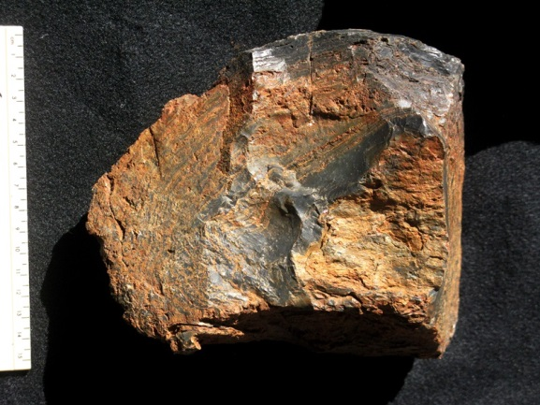 | CGS  VNA6 | 117 | Sector of proximal part of large stromatolitic dome surrounding the core (CGS VNA1). Outer laminae recurved round the base to give cushion-like geometry.
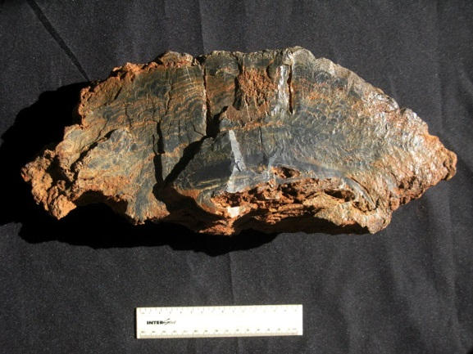 | CGS  VNA7 | 117 | Cross-section through moderately large stromatolitic dome showing smooth to undulose basal laminae with development of laterally-linked hemisphaeroids towards the periphery.
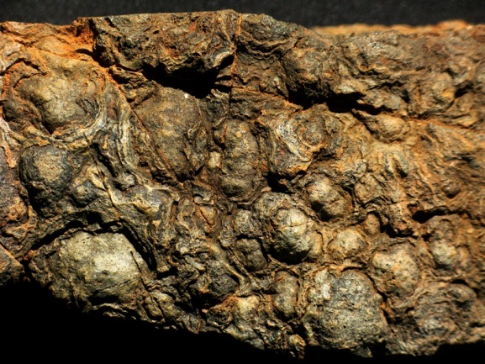 | CGS  VNA7 | 117 | Outer surface of same specimen showing small hemispheroids of various sizes in plan view (up to 3 cm in diameter).
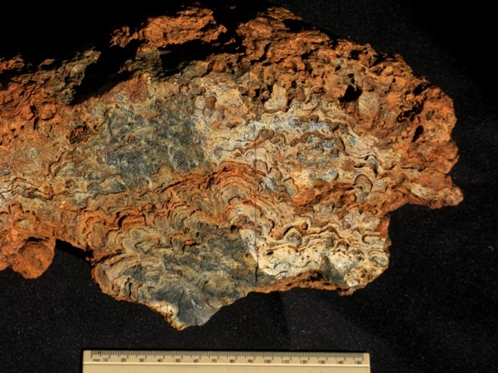 | CGS  VNA8 | 132 | Medium-sized stromatolitic dome composed entirely of laterally-linked hemisphaeroids.
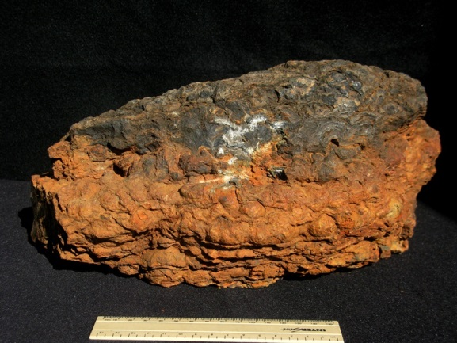 | CGS  VNA9 | 132 | Portion of extensive, irregular stromatolitic sheet composed of laterally-linked hemisphaeroids.
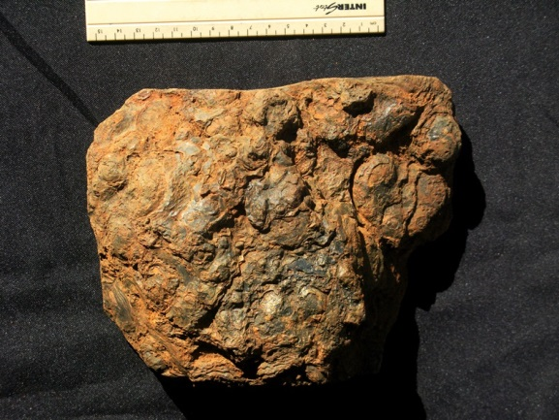 | CGS  VNA10 | 128 | Portion of extensive, irregular stromatolitic sheet composed of laterally-linked hemisphaeroids, seen from above.
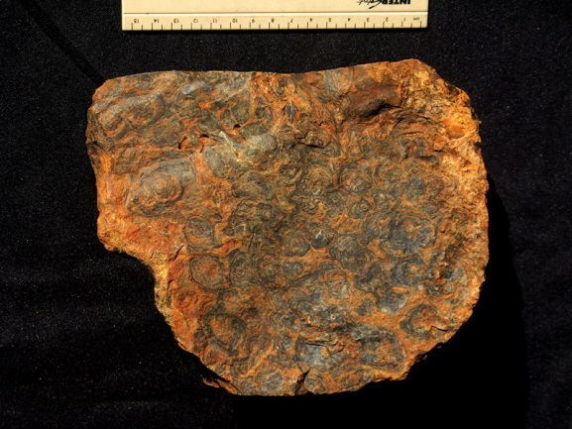 | CGS  VNA10 | 128 | Transverse section through the specimen above showing internal lamination within discrete, small-scale hemisphaeroids (up to c. 2 cm diameter).
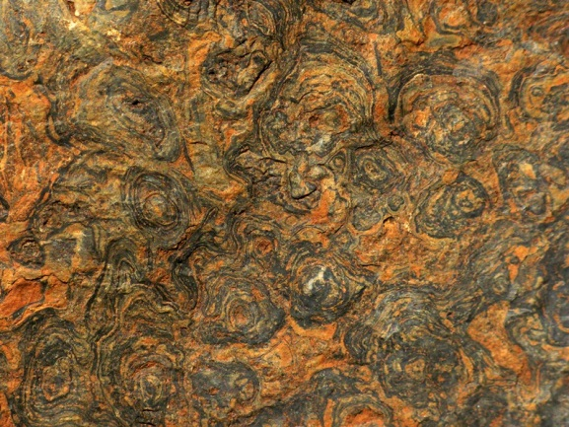 | CGS  VNA10 | 128 | Detail of specimen shown above.
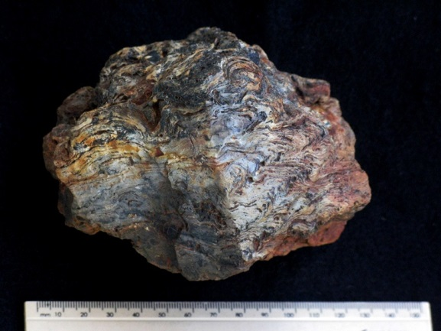 | CGS  VNA11 | 116 | Float block of silicified stromatolitic carbonate.
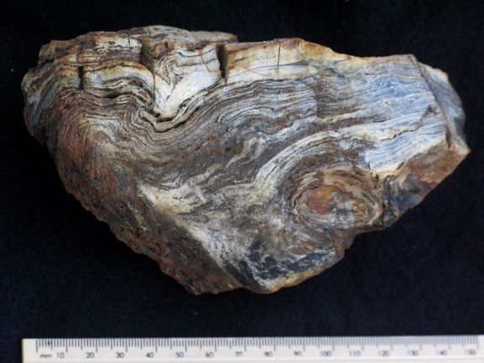 | CGS  VNA12 | 116 | Float block of silicified stromatolitic carbonate.
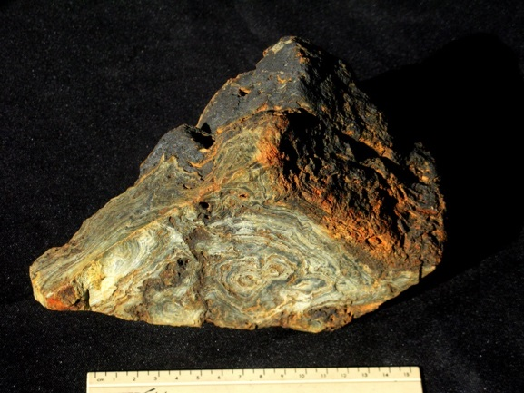 | CGS  VNA13 | 117 | Block of stromatolitic rock, dense and silicified showing good stromatolitic lamination at base, with porous, leached, manganese-stained periphery (towards top of image)
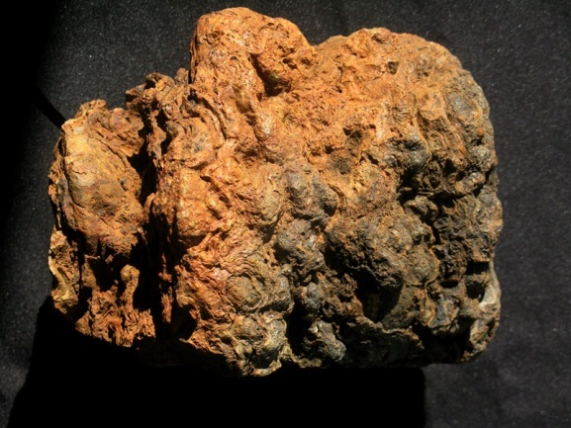 | CGS  VNA14 | 217 | Portion of medium-sized stromatolitic head (seen on its side, top towards the right; c. 17 cm tall). Narrower base (LHS) composed of undulose laminae expanding upwards to form a cauliflower-shaped head built of small laterally-linked hemisphaeroids.
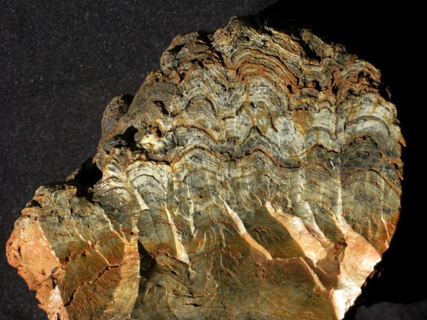 | CGS  VNA14 | 217 | Vertical section through stromatolitic head seen above showing clear development of hemisphaeroids towards the periphery (top). Block as seen here is c. 17 cm wide.
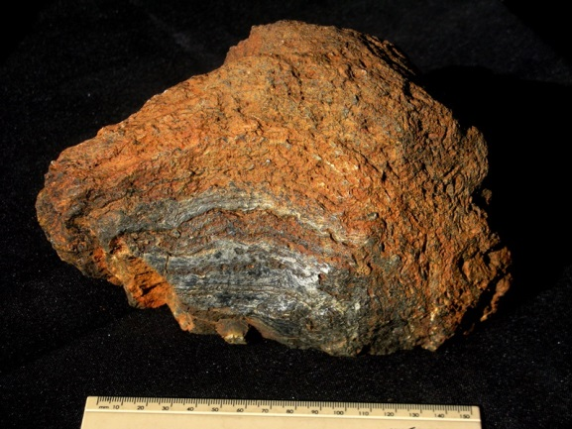 | CGS  VNA15 | 118 | Stromatolitic blocks showing even to undulose internal lamination, clearer and better silicified towards the base. Poor preservation of lamination in periphery might reflect decomposition prior to silicification.
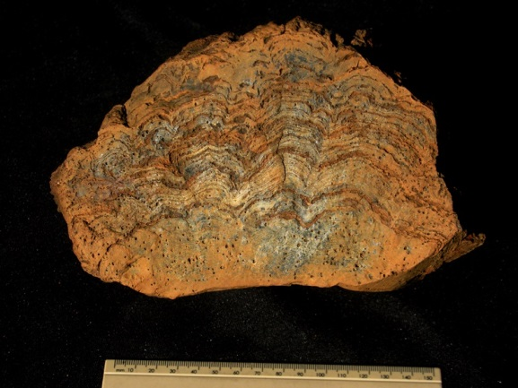 | CGS  VNA16 | 118 | Vertical section through well-silicified, medium-sized stromatolitic dome composed of small, laterally-linked hemispheroids.
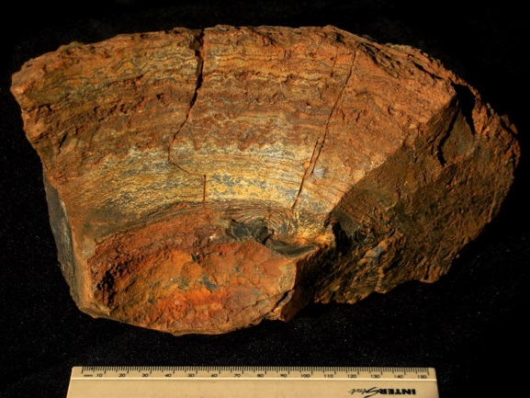 | CGS  VNA17 | 117 | Float block from periphery of large stromatolitic dome showing even to crinkly lamination with development of shallow, button-like hemisphaeroids only at certain intervals.
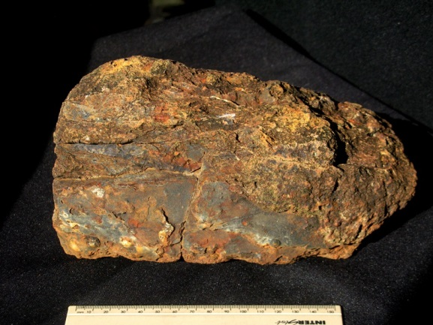 | CGS  VNA17 | 117 | Upper surface of block illustrated above showing smooth to sparsely pustular lamina surface.
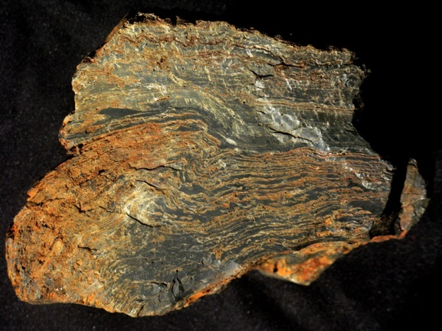 | CGS  VNA18 | 117 | Vertical section through internal portion of large stromatolitic dome, just peripheral to hemispherical core. The lamination is predominantly wavy to crinkly. Specimen is c. 18 cm across.
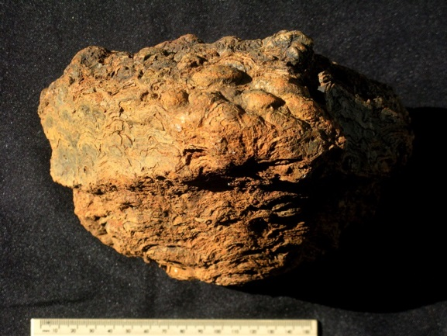 | CGS  VNA19 | 120 | Lateral view of upwardly-expanding cauliflower-headed stromatolite composed of laterally-linked hemispheroids forming pronounced buttons on the upper surface.
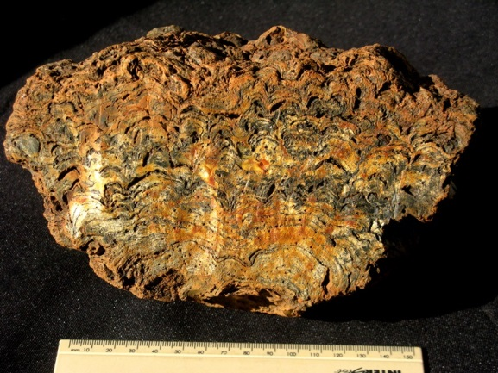 | CGS  VNA19 | 120 | Vertical section through specimen seen above showing larger hemispheroids towards the base.
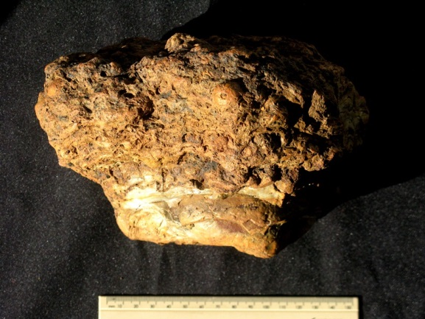 | CGS  VNA20 | 967  (Almond 2013 report) | Lateral view of upwardly-expanding, cauliflower-headed stromatolite with undulating laminae building narrower base and wider head made up of small hemisphaeroids.  Collected 2013 (S27 02 00.6 E24 47 08.4)
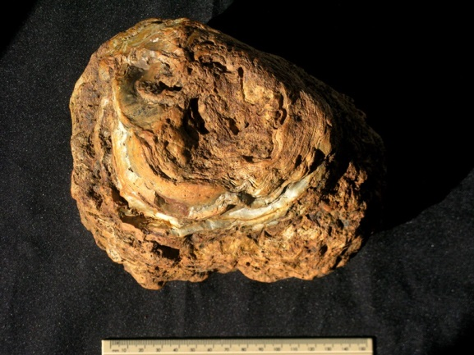 | CGS  VNA20 | 967 | Ventral view of specimen illustrated above.
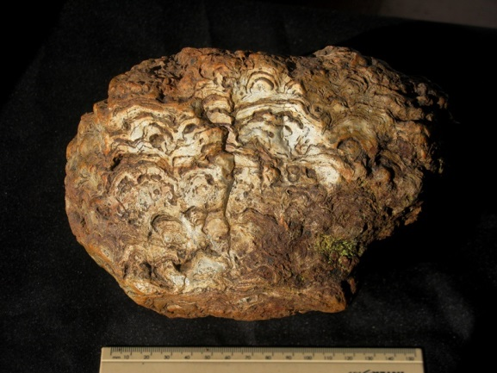 | CGS  VNA20 | 967 | Vertical section through specimen illustrated above.
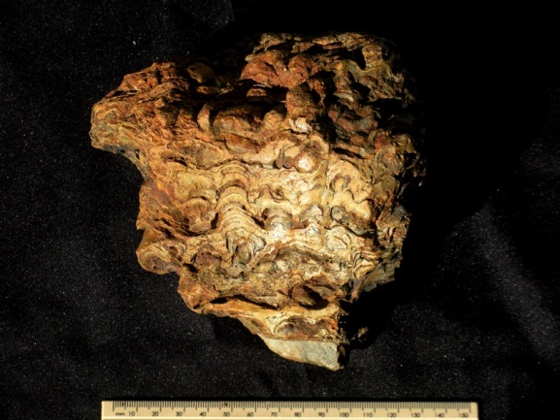 | CGS  VNA21 | 120 | Vertical section through stromatolitic cauliflower head.
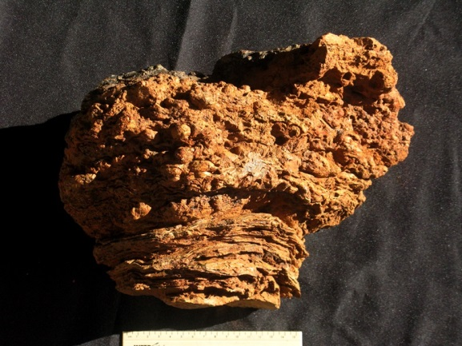 | CGS  VNA22 | 120 | Lateral view of upward-expanding stromatolite with undulating lamination at base and laterally-linked hemisphaeroids building the cauliflower-like head.
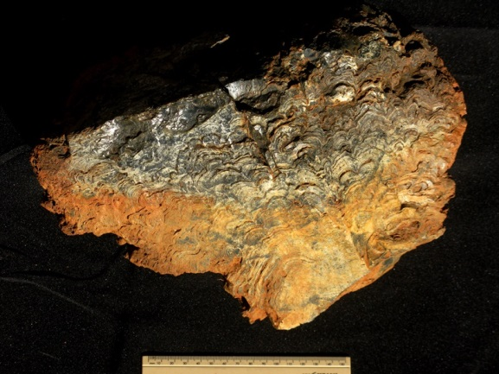 | CGS  VNA22 | 120 | Vertical section through the specimen illustrated above.
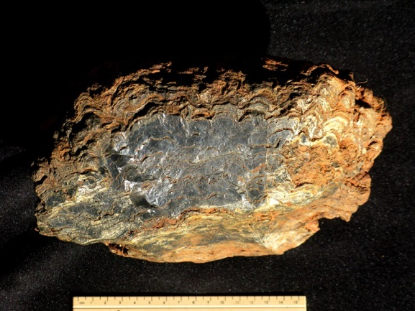 | CGS  VNA23 | 117 | Highly-silicified medium-sized stromatolitic dome composed of laterally-linked hemisphaeroids towards the periphery.
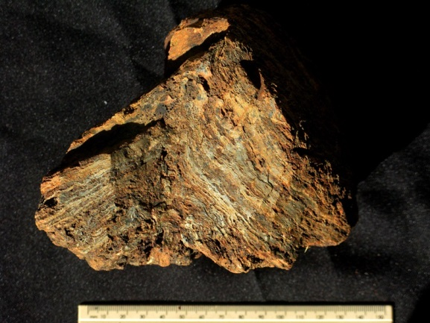 | CGS  VNA24 | 117 | Float block from large stromatolitic dome showing sharp flexure within even internal lamination (cf Wright & Altermann 2000, Fig. 3).
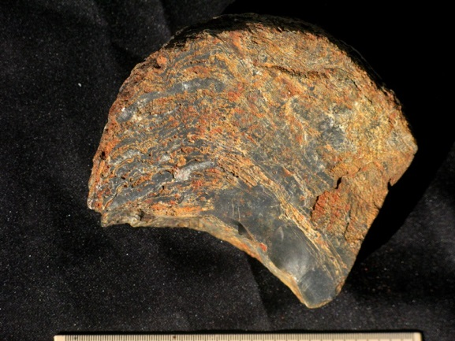 | CGS  VNA25 | 116 | Block through well-silicified inner region of a large stromatolitic dome. Laminae are curved inwards round the cushion-shaped base (top of stromatolite towards the RHS). Belongs to same large dome as specimens VNA26-28 (See report fig. 21).
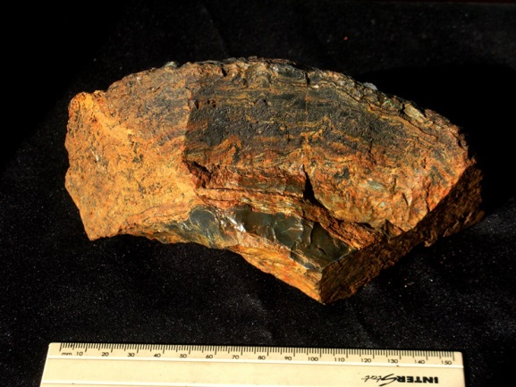 | CGS  VNA26 | 116 | Another block from the same internal sector as the specimen above.
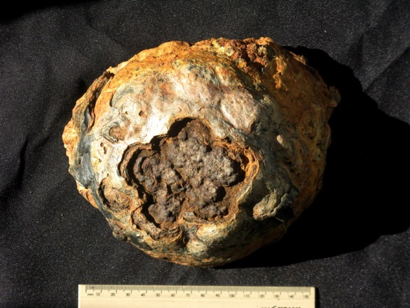 | CGS  VNA27 | 116 | Domical core of large stromatolitic dome showing button-like microdomes (laterally-linked hemispheres) on outer surface (See report fig. 21).
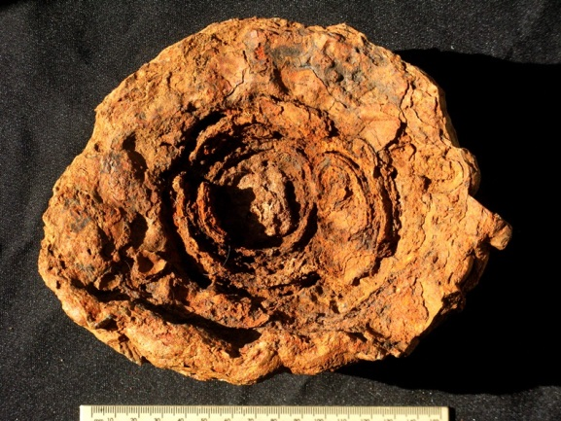 | CGS  VNA27 | 116 | Ventral surface of specimen seen above showing origin of large dome from coalescence of a few small initial microdomes.
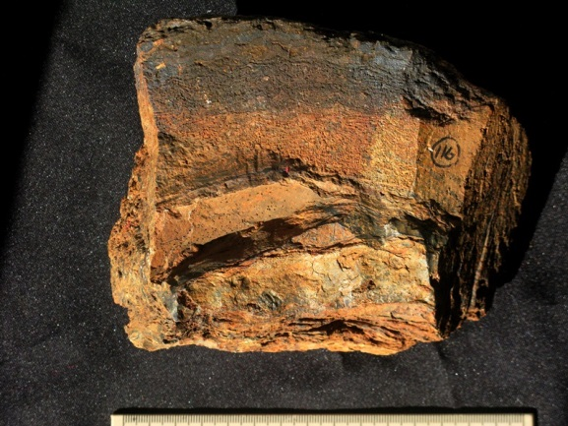 | CGS  VNA28 | 116 | Sector of inner part of large stromatolitic dome just peripheral to the core with smooth to crinkly lamination.
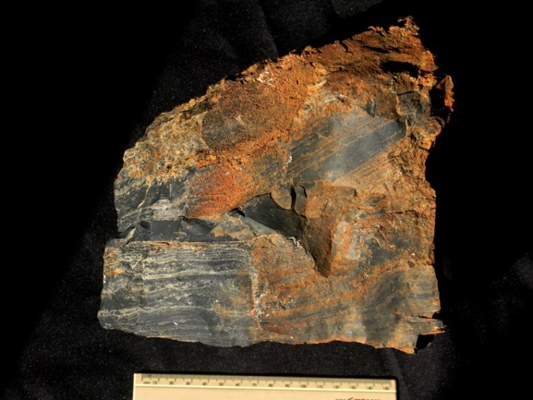 | CGS  VNA29 | 168 | Sizeable block of dark grey silicified carbonate showing lamination at various scales. Potential sample for microfossil analysis.
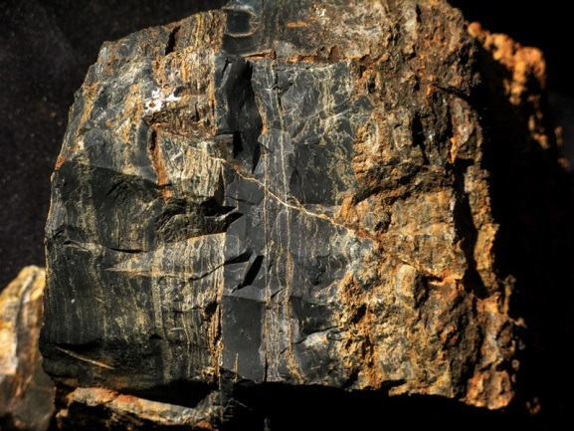 | CGS  VNA29 | 168 | Different view of same block as seen above showing close-up of lamination.

