NATURA VIVA cc

Palaeontological Impact Assessments & Heritage Management,

Natural History Education, Tourism, Research

Attn: Ms Monique Jordaan
SunEdison Energy Southern Africa (Pty) Ltd
Unit HG005, Block H,
Ground Floor, Oxford Gate,
Hyde Park Lane Office Park,
Hyde Lane, Hyde Park,
Johannesburg 2196

Date: 20 October 2017

PALAEONTOLOGICAL HERITAGE COMMENT:

WATERLOO PV SOLAR POWER PLANT NEAR VRYBURG, NORTHWEST PROVINCE
–REVISED POWER LINE ROUTE

Dear Ms Jordaan,

I have studied the revised power line connection route from the authorized Waterloo PV Solar Power Plant on the farm Waterloo 922 near Vryburg to the existing Mookodi Substation (Fig. 1) from a point of view of potential impacts on palaeontological heritage resources.

The palaeontological sensitivity of the rock units concerned has already been assessed in previous desktop and field-based impact assessments by the author (Almond 2013a, 2013b, 2016, 2017). The power line route traverses the outcrop area of the potentially stromatolitic Boomplaas Formation (Vb in Fig. 2 below) as well as those of the comparatively insensitive Vryburg Formation (Vv) and Dwyka Group (C-Pd). The Solar Plant itself overlies the Boomplaas Formation that is known to contain important Precambrian stromatolites (fossil microbial mounds) in this area. A short sector of the revised powerline route also traverses the Boomplaas Formation (middle blue area in Fig. 2), but here the potentially fossiliferous bedrocks are indicated in the subsurface where they are unlikely to be directly impacted by the small-scale, shallow excavations (pylon footings, access road) entailed in construction of the proposed powerline.

The proposed changes in the routing of the proposed new transmission line do not materially affect the conclusions of my original palaeontological report for the Waterloo Solar Power Plant project (Almond 2013a), as updated by the Phase 2 report for this project (Almond 2017) viz:

The overall impact of the proposed solar plant development on the southern portion of Waterloo 992 is provisionally rated as of NEGATIVE MEDIUM SIGNIFICANCE in palaeontological heritage terms {N.B. this applies before mitigation].

Following the recent Phase 2 recording and collection of stromatolites on Farm Waterloo 992 covered by this report [Almond 2017], it is considered that a representative, scientifically-useful sample of the various stromatolite types known to be present in the Boomplaas Formation in the Vryburg region would be conserved within the following areas once the solar facility is constructed: (a) the area just outside and to the east of the main solar facility project area on Waterloo 992 and (b) protected areas proposed on neighbouring farms Champions Kloof 731 and Hartsboom 734 (See Almond 2016a, 2016b, Groenewald 2016 and Fig. 2 herein). This would apply with the proviso that all the palaeontological mitigation measures outlined in these specialist reports as well as the present report are followed through.

In the case of Farm Waterloo 992, these mitigation measures include:

- protection of that portion of the area encircled in red in Fig. 39 that lies outside the defined solar facility project area by security tape or a fence during construction, and

- exclusion of the sensitive stromatolite-rich area from the route of the access road or selection of an alternative road option.

These specialist palaeontological recommendations should be included within the Environmental Management Programme (EMPr) for the proposed solar energy facility on Farm Waterloo 992. Provided that these recommendations are followed through, the authorised solar facility development is unlikely to compromise a significant fraction of the in situ fossil stromatolite occurrences within the northern outcrop area of the Boomplaas Formation and there are no objections to its construction.

It should be emphasised that once the recommended palaeontological heritage mitigation has been fully followed through (over and above the fossil sampling which has already been completed), the proposed solar park development will actually have a positive impact on our understanding of local palaeontological heritage.

Yours sincerely,

Dr John E. Almond (Palaeontologist)
Natura Viva cc
Cape Town

REFERENCES

ALMOND, J.E. 2013a. Proposed PV Solar Facility on a portion of the farm Waterloo 992 near Vryburg, Naledi Local Municipality, North-West Province.Palaeontological heritage assessment: combined desktop & field-based study, 29 pp. Natura Viva cc, Cape Town.

ALMOND, J.E. 2013b. Proposed PV Solar Facility on a portion of the farm Rosendal 673 near Vryburg, Naledi Local Municipality, North-West Province. Palaeontological heritage assessment: desktop study, 15 pp. Natura Viva cc, Cape Town.

ALMOND, J.E. 2016. Waterloo PV solar power plant near Vryburg, Northwest Province – expansion of facility footprint and new power line route. Palaeontological heritage comment, 3 PP. Natura Viva cc, Cape Town.

ALMOND, J.E. 2017. Recording & surface sampling of Precambrian stromatolites from the Boomplaas Formation (Ghaap Group) on a portion of the farm Waterloo 992 near Vryburg, Naledi Local Municipality, North-West Province. Palaeontological heritage: phase 2 mitigation report, 42 pp. Natura Viva cc, Cape Town.

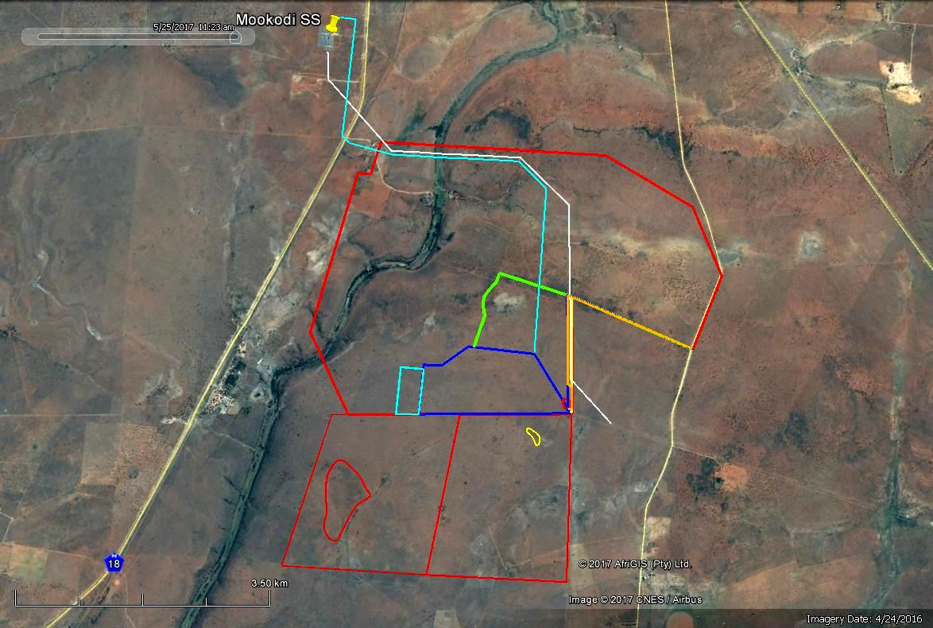

Fig. 1. Google earth© satellite image of the broader study region to the south of Vryburg, Northwest Province. Note N is towards the top right in this view (Compare Fig. 2).

KEY:

Red polygons: outline of Farm Waterloo 992 (north) and Champions Kloof 731 (2 southern polygons)
Dark blue plus pale blue polygons: expanded development area for the authorised 75 MW Waterloo Solar Power Park
Pale blue line: revised grid connection to Mookodi Substation on Rosendal 673
White line: existing Eskom transmission line
Small red and yellow shapes on Champion’s Kloof 731: areas with well-preserved stromatolites (Almond 2016a, 2016b, 2017)
Green, orange & yellow lines: access road options (Please see Fig. 40 for more detail)

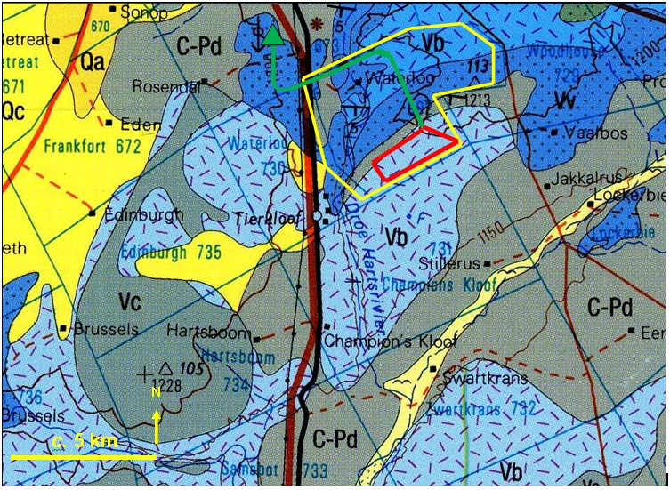

Fig. 2. Extract from the 1: 250 000 geological map 2724 Christiana (Council for Geoscience, Pretoria) showing the outline of the Waterloo Solar Power Park study area on the farm Waterloo 992, located some 10 km southeast of Vryburg (yellow polygon). The red polygon shows the expanded development area and the green line indicated the approximate power line route to Mookodi Substation (green triangle).
The main geological units represented mapped the broader study region include:

GHAAP GROUP (SCHMIDTSDRIF SUBGROUP)

Vryburg Formation (Vv, dark blue with stipple) – late Archaean fluvial and shallow marine quartzites, mudrocks, conglomerates with two intervals of andesitic volcanics

Boomplaas Formation (Vb, pale & middle blue with dashes) – late Archaean dolomites (locally stromatolitic or oolitic) interbedded with siliciclastics (quartzite, shale, flagstone). N.B. The middle blue areas indicate where this formation is inferred to occur in the subsurface where it is unlikely to be directly impacted by the small-scale, shallow excavations entailed in construction of the proposed powerline.

KAROO SUPERGROUP

Dwyka Group (C-Pd, middle grey) – Permocarboniferous glacial sediments

