Sea Shadow Survey Team
20th September 2020
- Introduction
Sea Shadow survey and dive team were contacted by Mr R Scott-Rodger August 2020 to conduct a ROV search in the Xora river mouth area for the wreckage of the Waratah which has been missing since 1909. The field of work was conducted over a period of 5 days. The results of the field of work analysed and conclusions drawn. The report highlights the procedures that were followed and observations made after analysing the film footage

Site Location: Xora river mouth

- Survey Area Dive targets

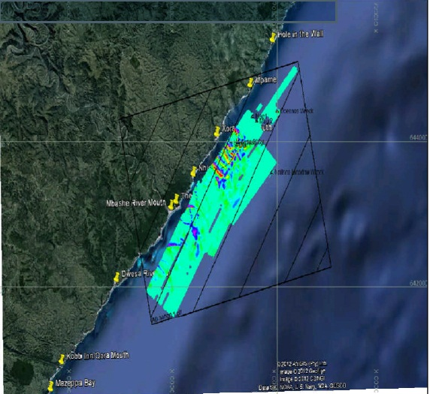

- Hardware
ROV Geneinno T1 with 150mtr control cable

4.1 Vessels
m.v Sodwana Diver
Sodwana Diver is a semi rigid with 2 x 100hp Yamaha outboards chartered by the client for the purpose of this survey. The vessel has a SAMSA Category C license which is valid up to 15nm offshore and was recently certified with IMCA.
4.2 Equipment
Satellite positioning systems
- Lowrance HDS-05 GPS receiver

4.3 System Calibrations and Accuracy Checks

- Horizontal GNSS Position Check

System | Manufacturer Specifications
Lowrance HDS-05 GNSS | - Internal, high-sensitivity GPS+WAAS (Americas) or GPS+EGNOS+MSAS (non-Americas)
Table 1- Manufacturers’ quoted system specifications
- Mobilization
The mobilisation was undertaken on the 4th September 2020. The Sea Shadow Team met at Margate with Sodwana diver team. The Sea Shadow team then left for Xora arriving the following afternoon. ROV operation started early on the morning of the 6th September 2020.
Demobilization occurred on Monday 11th September 2020, with all gear returned .

5.1 m.v. Sodwana Diver

Sodwana Diver is a semi rigid with 2 x 100hp Yamaha outboards chartered by the client for the purpose of this survey. The vessel has a SAMSA Category C license which is valid up to 15nm offshore and was recently certified with IMCA.

- Personnel

Name | Position |  | Qualifications & Experience
Field Survey Team
Richard Scott-Roger |  | Client
Nathan Scott-Roger |  | ROV OPERATOR
Greg DeValle |  | Skipper
Grant |  | ROV assistant
Table 2 – Personnel involved in the field acquisition.

- Survey Operations and Acquisition
7.1 Planned Dive positions

Planned ROV points were acquired from the master survey map from previous survey
 | ROV SITES | AVERAGE DEPTH
Area XORA | 15 | 50 MTRS
Table 3 – Dive sites

- Results & Interpretation
8.1.1 DAY1 & Day 2
The ROV operation started in the 6th Sep where 3 ROV targets were identified per day
Day one
Dive targets 1-3 were checked on day one and all 3 of the targets were sand .The operation was complete by 14.30 and the prep work started for day Two.

Day Two
ROV targets 4-6 were checked on day two and all 3 targets were sand but visibility was poor. The operation was completed at 16.00 and the prep work started for day Three.
Day Three
ROV targets 7-9 were checked on day three . Targets were rock and the operation for the day was completed by 15.00. Prep work for day Four was started.
Day Four
ROV targets 10-12 were checked on day Four and all targets were sand only. The operation was complete at 17.15 and prep work for day Five was started.
Day Five
ROV Targets 13-15 were checked on day Five and all targets were rock. The operation was complete at 15.20 and prep for demobilizing was started.

11th September 2020 The crew left Xora and returned to Durban.

