3.1.5. Harbour Precinct

Location of the Site

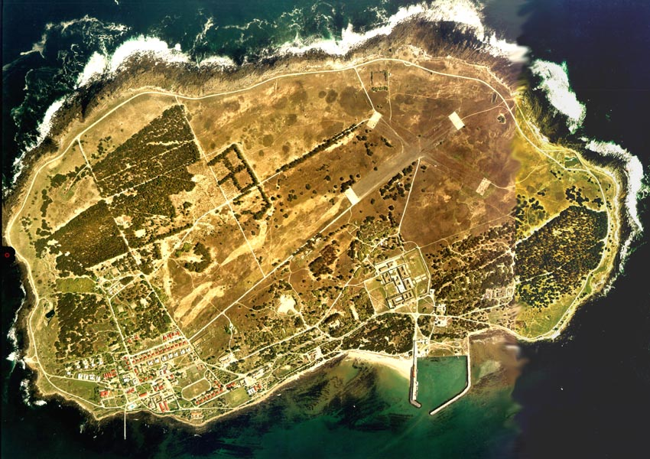
Fig.: 3.1.5.1 Aerial Picture: Precinct Location

Site Description:

The Murray’s Harbour is situated on the East coast of the Island. It is a relatively small harbour that consists of one breakwater and the quay where all the staff and visitors boats from the main land arrive.

The island visitors arrive at the main quay, pass a Diesel store, the Harbour office, an Ablution block and the X-ray building and get picked up by busses in front of the “Welcome Gate” to start the tour on the island.

Significance

The Harbour is the destination after the journey from the mainland- it’s the point of arrival and departure between the Island and the mainland. As the gateway to the Island, it symbolised the threshold between freedom and incarceration.

The Visitors’ Centre on the edge of the harbour was the place of contact for political prisoners with their families and outside world.

Linkages and Access Routes:

- General visual linkages with the sea in a North and Northeastern direction. Visual connection with Bloubergstrand to the East and Table Mountain to the South.
- Important visual and physical link with Maximum Security Prison through the arched portal/ gateway
- Towards the Northwest, access is gained to the Power Station, ‘’Ou Tronk’ and WW2 structures
- Point of entry and link to the ‘Penguin Walk

Number: 335- 336
Name: Visitors’ Rooms
Description
T-shaped structure of plastered and painted brickwork in parts and slate clad walls in some sections. Upper levels of wall made of plastered imitation slate, fibre cement roof sheets, steel windows. Approximately 9m x 41m. Structure incorporates the main Gateway to the Island, made of 4-metre high pediment walls.
The room to the immediate right of the archway, going towards the prison, was initially a dentist’s room but in the early 1980s it was used to house the sound equipment that monitored and recorded prison visits.
Of historical and symbolic significance as meeting place between political prisoners and visiting families.
(Baumann and Le Grange, 2001)

Status of the Built Structures:  The Visitors’ Rooms building is presently not in use and an appropriate use needs to be considered. It is in fair condition. Paint work deteriorating. (Baumann and Le Grange, 2001) | Fig. 3.1.5.2  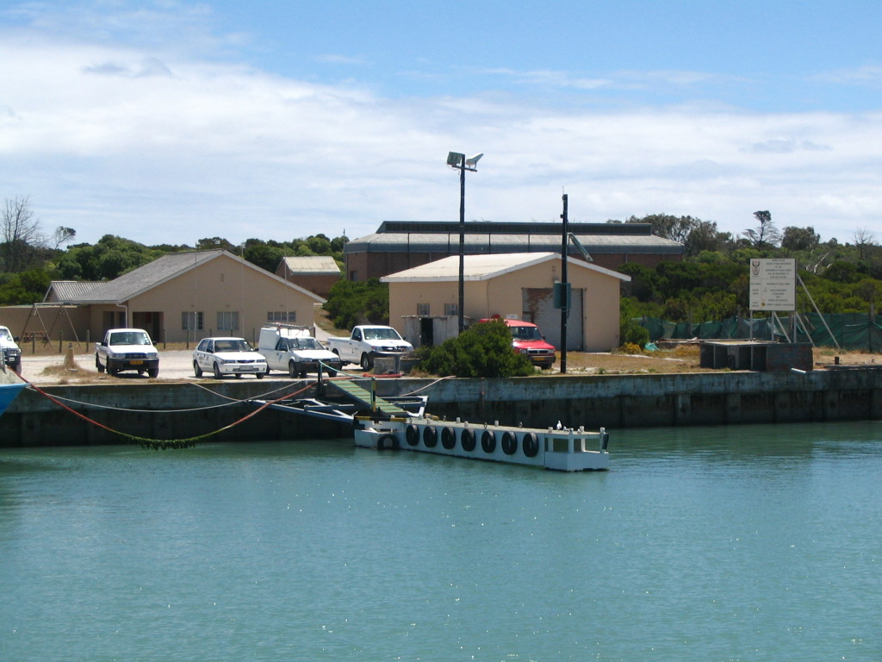

Number: 338
Name: Storeroom
Description
Plastered block work walls with corrugated iron roof sheets. (Baumann and Le Grange, 2001)

Status of the Built Structures:  The Storeroom is in fair condition. (Baumann and Le Grange, 2001) | Fig. 3.1.5.3

Number: 340
Name: Floating Jetty / Patrol Boat Harbour
Description
Timber and steel structure on floating pontoons.
Of historic significance in terms of its association with the patrolling along the coast of the Island and with the incarceration of prisoners in general. (Baumann and Le Grange, 2001)

Status of the Built Structures:  The Floating Jetty/Patrol Boat Harbour is in poor condition. (Baumann and Le Grange, 2001) | Fig. 3.1.5.4

Number: 342
Name: X-Ray Building
Description
The building is approximately 12m x 6m. Plastered cement brick walls, fibre cement (big-six profile) roof sheets, steel windows and timber doors. (Baumann and Le Grange, 2001)

Status of the Built Structures:  The X-ray Building is in fair condition. Steel windows are rusting in places. (Baumann and Le Grange, 2001) | Fig. 3.1.5.5  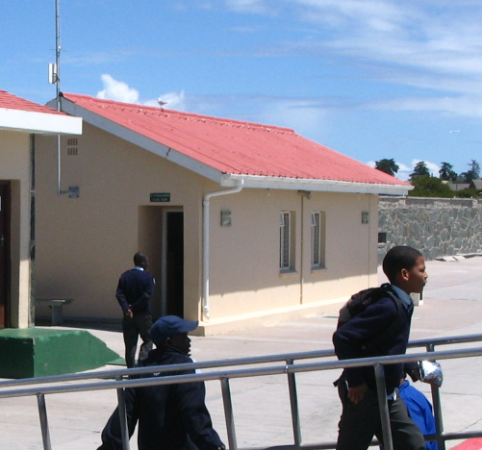

Number: 343
Name: Ablution Block
Description
Approximately 15m x 9m. Slate clad cement block walls, Fibre cement roof tiles, fibre cement fascia boards, timber casement windows with concrete surrounds, and timber doors.
As part of the Harbour the building is of historic significance. (Baumann and Le Grange, 2001)

Status of the Built Structures:  The Ablution Block is in general good condition. Reinforced concrete window surrounds are deteriorating with exposed reinforcing steel rusting badly. (Baumann and Le Grange, 2001) | Fig. 3.1.5.6  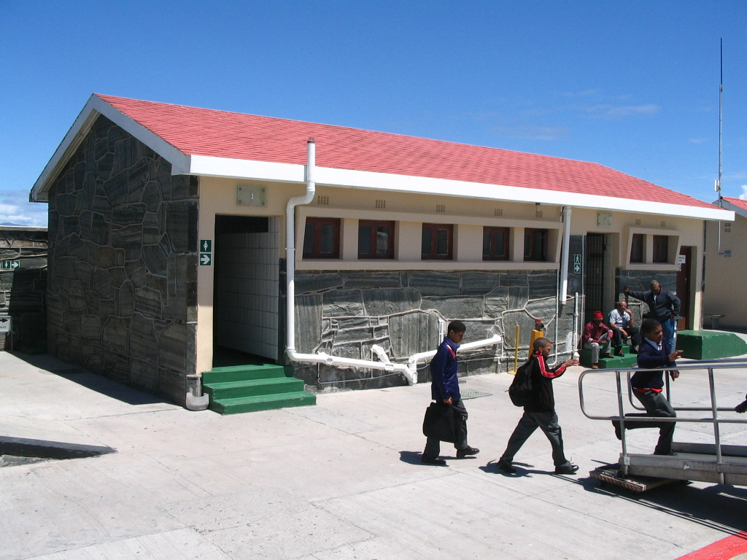

Number: 344
Name: Harbour Office
Description
Approximately 34m x 9m. Slate clad cement block walls, Fibre cement roof tiles, fibre cement fascia boards, timber casement windows with concrete surrounds and timber doors. (Baumann and Le Grange, 2001)

Status of the Built Structures:  The Harbour Office is in good condition. Cement pointing between stone is deteriorating. (Baumann and Le Grange, 2001) | Fig. 3.1.5.7  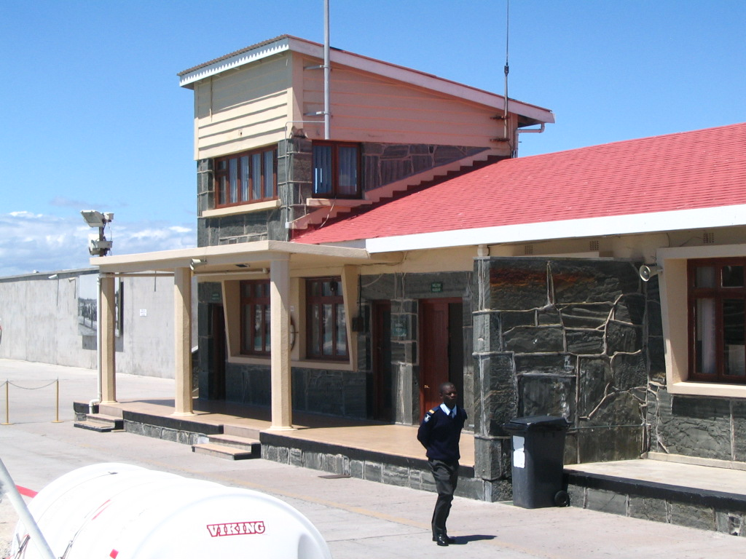

Number: 345
Name: Main Quay

Description
Approximately 230m in length by 18m wide. Concrete floor surface incorporating bollards and searchlights along the northern edge.
Founded within the area of the earliest landings on the Island, the quay was built in historical phases with the first major works being done during WW2. (Baumann and Le Grange, 2001)
As the main element of Murray’s Bay Harbour, the main quay is of both historic and symbolic value.
(Baumann and Le Grange, 2001
Status of the Built Structures:  The Main Quay is in good condition. The limited control of the use of the quay by vehicles of various kinds needs to be evaluated. Greater control of access and of the parking of tour busses needs to be monitored. Alternative parking areas should be investigated. (Baumann and Le Grange, 2001) | Fig. 3.1.5.8  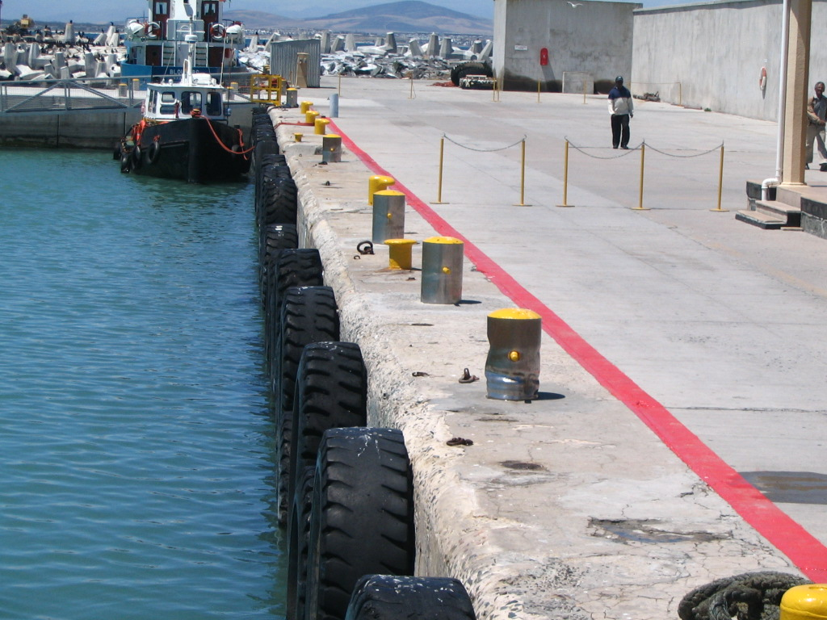

Number: 346
Name: Diesel Store
Description
Approximately 10m x 6m. Plastered cement block work walls, unpainted. (Baumann and Le Grange, 2001)

Status of the Built Structures:

The Diesel Store is in fair condition. (Baumann and Le Grange, 2001)

Number: 347
Name: West Quay Wall
Description
Originally built by the SA Engineering Corp. during WW2 by Christiani & Nielsen (Pty) Ltd, 1956-57 as part of a SA Naval station.
Located to the south of the main quay, this part of the quay wall is approximately 80m in length by 4m high.
It is partly covered by Slate cladding, Higher sections of the wall are plastered in a pattern that imitates the slate cladding and its raised jointing/pointing. (Baumann and Le Grange, 2001)
As part of the improved Murray’s Bay Harbour the West Quay is of historic significance. (Baumann and Le Grange, 2001)

Status of the Built Structures:  The West Quay Wall is in good condition generally. Pointing between slate cladding breaking in selected places. (Baumann and Le Grange, 2001) | Fig. 3.1.5.9  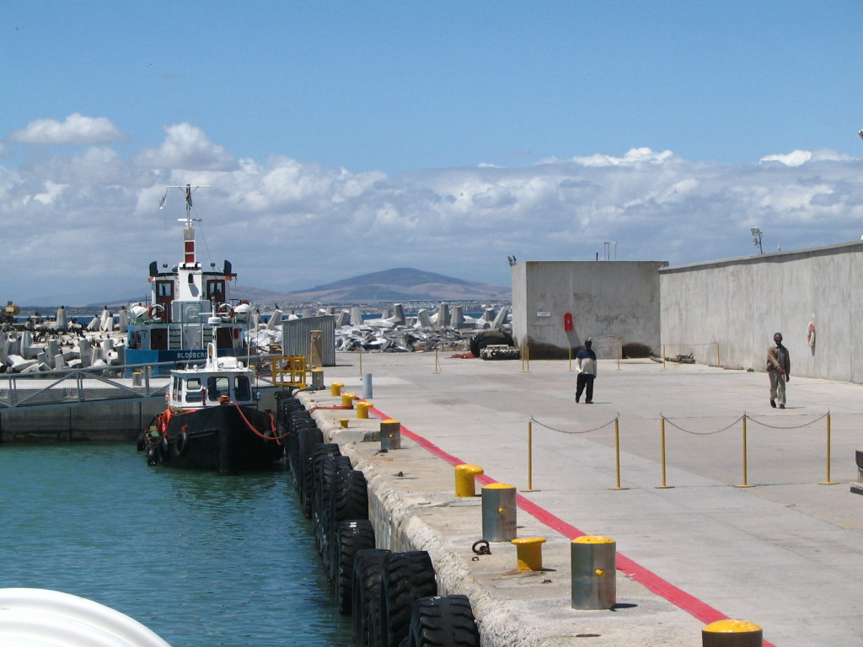

Number: 349
Name: East Quay Wall
Description
Reinforced concrete ‘dollose’. (Baumann and Le Grange, 2001)

Status of the Built Structures:  The East Quay Wall is in fair condition. (Baumann and Le Grange, 2001) | Fig. 3.1.5.10  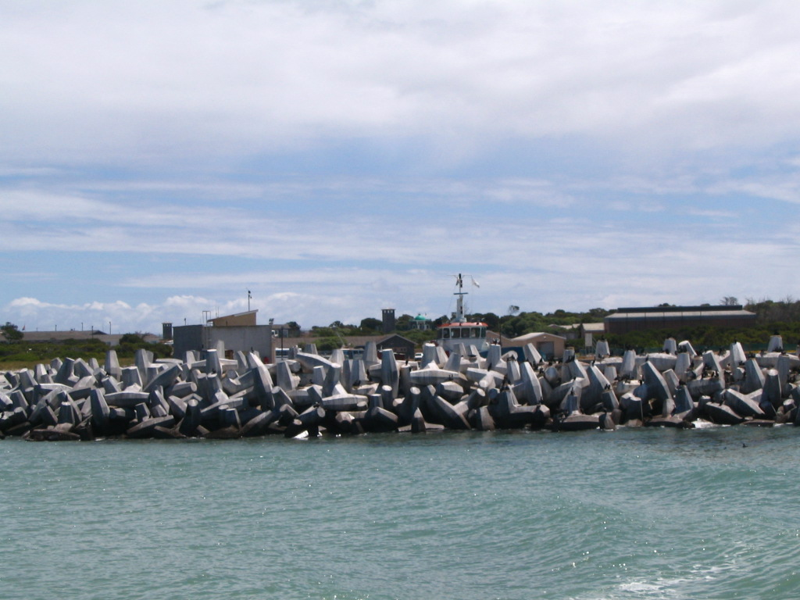

Number: 350
Name: South Breakwater
Description
Reinforced concrete 'dolosse'. (Baumann and Le Grange, 2001)

Status of the Built Structures:  The South Breakwater is in fair condition. (Baumann and Le Grange, 2001) | Fig. 3.1.5.11

Number: 353
Name: Murray’s Harbour

Description
Built in 1940 as part of extensive reclamation works. Enlarged first in 1956/57 and again later in 1987-1989.
At its deepest the harbour is 6 metres deep.
Approximately 270m x 290m in area, bounded to the north and north-east by man-made breakwater.
Murray’s Harbour is situated in a bay that was always a safe, natural landing place for boats. Boats often used to shelter here when stormy weather, especially during winter, prevented them landing at Cape Town.
The stone and slate on the walls of the prison, harbour and kramat, are vertically laid with raised joints in a ‘crazy paving’ style that became common on the Island in the last fifty years. Unfortunately, this building style allows for the deterioration of the stone and water can seep into the underlying building structure. (Riley, P.,Conservation Study of Robben Island, Unpublished Report, National Monuments Council, 1993)
Built within the area first used by Murray for whale fishing, the harbour is of historic significance.
The Murray’s Bay Harbour basin is of historic and symbolic significance in that it has historically been one of the main points of arrival on the Island. (Baumann and Le Grange, 2001)
Status of the Built Structures:  Murray’s Harbour has a problem of pollution of water (through fuel/diesel discharges and debris) caused by the daily use of the Ferries and Building Contractor’s boats needs to be regularly monitored. Generally in good condition. (Baumann and Le Grange, 2001) | Fig. 3.1.5.12  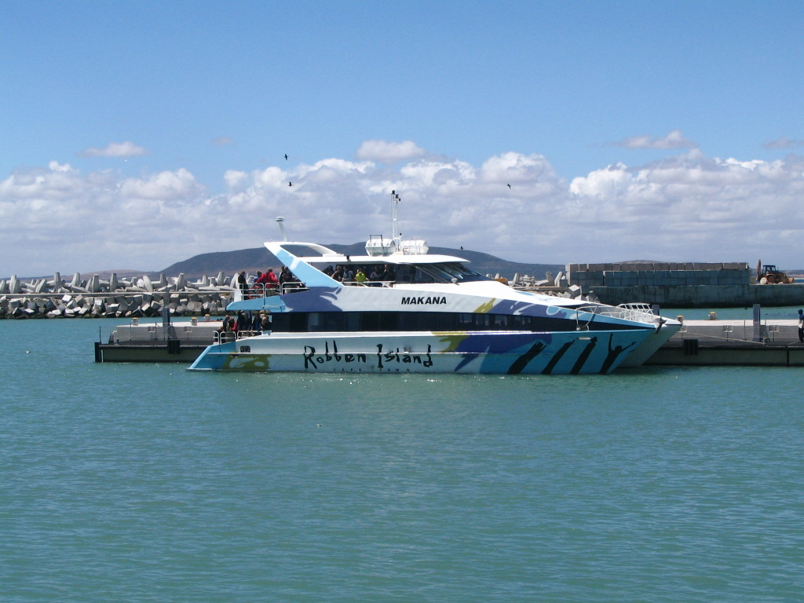

Number: 354
Name: North Breakwater
Description
Breakwater constructed of pre-cast reinforced concrete dolosse. (Baumann and Le Grange, 2001)
Some have inscriptions (political slogans) from ex-prisoners.

Status of the Built Structures:  The North Breakwater is currently under reconstruction. | Fig. 3.1.5.13  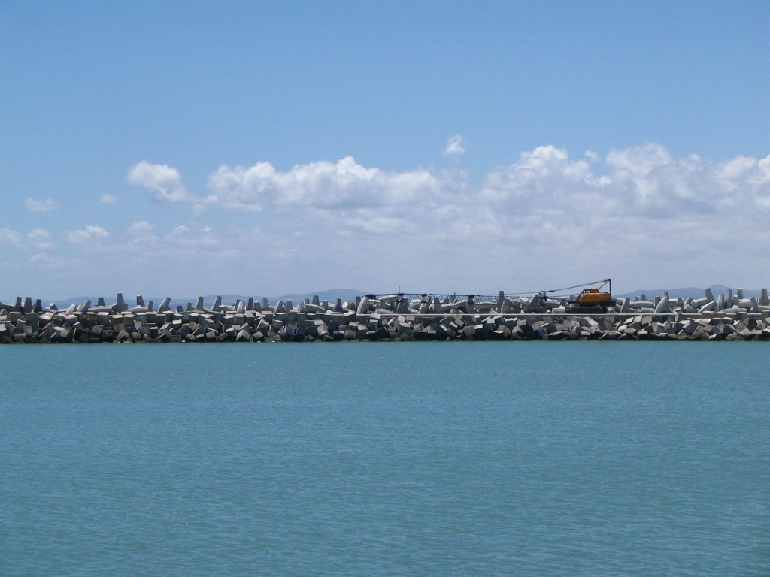

Number: 355
Name: Floating Jetty
Description
Timber structure. (Baumann and Le Grange, 2001)

Status of the Built Structures:  The Floating Jetty is in poor condition. (Baumann and Le Grange, 2001) | Fig. 3.1.5.14

Number: 356
Name: Yacht Club Camping Area

Description
1,8 meter high ‘vibra-crete’ pre-cast concrete walled area, including paved areas. (Baumann and Le Grange,
2001)

Status of the Built Structures:  The Yacht Club Camping Area is in neglected condition. (Baumann and Le Grange, 2001) | Fig. 3.1.5.15  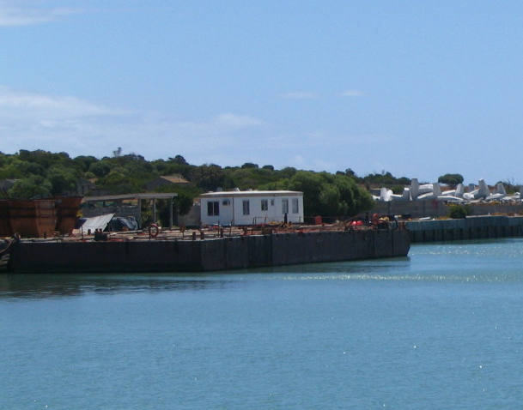

Number: 357
Name: Yacht Club Ablution Block

Description
Face brick walls, timber windows with plastered surrounds. (Baumann and Le Grange, 2001)

Status of the Built Structures:
The Yacht Club Ablution Block is in fair condition. (Baumann and Le Grange, 2001)

Number: 359
Name: Penguin Walk
Description
Wooden boardwalk, 1,4meters wide, with timber handrail. (Baumann and Le Grange, 2001)
In terms of serving the purpose of viewing penguins the Penguin Walk is of environmental significance.
(Baumann and Le Grange, 2001)

Status of the Built Structures:
The Penguin Walk is in good condition. Invasion of alien vegetation needs to be monitored. (Baumann and Le Grange, 2001)

Annexures
Drawings

- Robben Island Maximum Security Prison: Repairs, Renovations and Minor Works
Visitors Centre: Ground Floor & Roof Plans

- Robben Island Maximum Security Prison: Repairs, Renovations and Minor Works
Visitors Centre: Elevations

References

- Baumann, N. and Le Grange, L, Robben Island Conservation and Use Plan, 2001
Lucien Le Grange Architects and Urban Planners
Nicolas Baumann Urban Conservation and Planners
Tim Hart, Archeaological Contracts office, UCT

- Riley, P.,Conservation Study of Robben Island, Unpublished Report, National Monuments Council, 1993

