Export permits

Please note an export permit must be linked to an object or site that has to be created on SAHRIS! If the object/site you want to work on has not been created yet, you would need to do so. Thanks!

The proposal should include (you can fill these in below):
- a list of participants (name, affiliation, phone no, email addresses) and how they are involved;
- the name and address of the facility, including address, it is being scanned at;
- name and address of the museum/university department that currently hosts the object;
- names of the responsible person(s) during transport and while the fossil is at the facility;
- the period/time frame during which the fossil(s) will be outside the country;
- detailed information on the fossil(s), especially as it is a "unique" specimen;
- detailed information on the research project behind it & methodology including expected outcomes (i.e., the reason for export);
- the written confirmation of the institution that currently hosts the object that the object may be used as proposed and be returned in good condition;
- should there be any damage/destructive analysis (e.g., coating for higher resolution) undertaken, this needs to be stated in detail;
- Statement why this study cannot be done in South Africa.

Applicant (name and affiliation): this is usually the museum curator!
Bernhard Zipfel; University Curator of Collections, University of the Witwatersrand; bernhard.zipfel@wits.ac.za; +27 8 3779 3394

Applied for (principal researcher):
Renaud Joannes-Boyau; Faculty of Science, Southern Cross University; renaud.joannes-boyau@scu.edu.au; +61 2 6620 3271

Participants with affiliations, email addresses, phone numbers (& their role):
Andy Herries; Palaeosciences Lab, Department of Archaeology and History, La Trobe University; A.Herries@latrobe.edu.au; +61 420 741 692

Angeline Leece; Palaeosciences Lab, Department of Archaeology and History, La Trobe University; A.Leece@latrobe.edu.au; +61 473 737 500

Stephanie Baker; Palaeo-Research Institute, University of Johannesburg, South Africa
stephanieb@uj.ac.za; 083 252 776

Institution incl. address that currently hosts the object:
The Fossil Primate and Hominid Vault
Evolutionary Studies Institute
University of the Witwatersrand
1 Jan Smuts Ave
Braamfontein, Johannesburg, 2000
South Africa

Facility incl. address at which the experiment will be done:
Geoarchaeology and Archaeometry Research Group (GARG)
Southern Cross University
Lismore Campus
1 Military Rd
East Lismore, NSW, 2480
Australia

Table of objects or upload file:

Specimen  number | Taxon | Locality | Tooth | Status | Picture
15b | Paranthropus | Drimolen | M3 | Well preserved; Moderately worn.
57 | Paranthropus | Drimolen | dm2 | Fragmentary; Minor cracking through multiple cusps and some enamel missing
75 | Paranthropus | Drimolen | M3 | Fragmentary; Large fragment of enamel missing from mesial face
101 | Paranthropus | Drimolen | M2/3 | Fragmentary; Most of the disto-lingual portion of the tooth missing
108 | Paranthropus | Drimolen | C, P3, P4, M1 | Fragmentary; Central crack through C crown, multiple small crack running through P3, P4 and M1 well preserved | 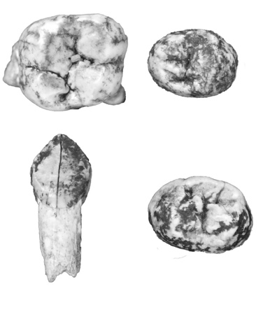
136 | Paranthropus | Drimolen | dm1 | Fragmentary; Small cracks running through multiple cusps
146 | Paranthropus | Drimolen | dm2 | Well preserved
148 | Paranthropus | Drimolen | M1 | Fragmentary; Inferior margin of crown damaged | 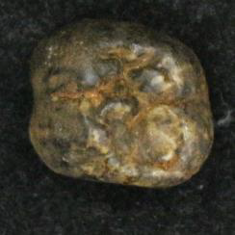
152 | Paranthropus | Drimolen | M1, M2 | Fragmentary; Both teeth in multiple pieces (rearticulated with paraloid)
35 | Homo | Drimolen | Dm2, M1 | Well preserved though disarticulated
39 | Homo | Drimolen | M1 | Fragmentary; Crown split in half (rearticulated with paraloid)
100 | Homo | Drimolen | M1 | Fragmentary; Enamel flack missing on lingual face | 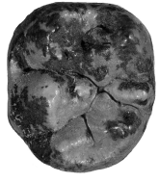
102 | Homo | Drimolen | C | Well preserved
132 | Homo | Drimolen | dm2, M1 | Fragmentary; Distal portion of tooth and most of central portion absent
153 | Homo | Drimolen | P3 | Fragmentary; Buccal portion of tooth absent | 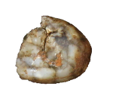

Time frame:

Pick up April 18-20th 2022 and return November 1st 2023.

Aim/rationale:

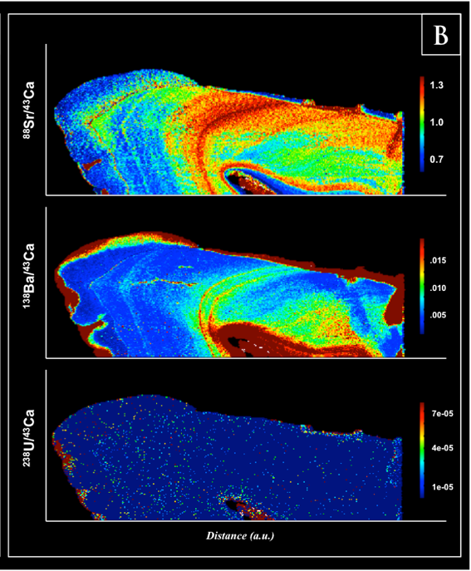
This prior work was carried out as part of SAHRA temporary export permits 9890 and 2539 and shows proof of concept for the work and a significant publishable outcome. All these hominin teeth have been returned to their respective repositories. The aim of this export permit application is to sample two other genera, Paranthropus robustus and early Homo, to compare the breastfeeding and dietary histories of the main early hominin genera in South Africa. The aim is to temporarily export 16 hominin teeth (10 Paranthropus robustus and 6 early Homo) from the Drimolen Main Quarry for stable isotope and trace element analyses. These teeth have all been studied and described as part of a comprehensive analysis of the Drimolen dentition by Dr Angeline Leece who completed her PHD on the teeth in 2020 (Leece, 2020). Some have been published in Moggi Cecchi et al 2010 and others in Martin et al (2021). The remainder are currently being published in the American Journal of Biological Anthropology (Leece et al., in press) and a follow up paper in PEERJ by Leece et al.
Figure 1: Example of trace elemental mapping of hominin tooth with LA-ICPMS

Dr Leece will aid Dr Joannes-Boyau in undertaking the analysis as part of a post-doc jointly between Prof Herries at La Trobe University and Dr Joannes-Boyau at southern Cross University; both funded by Australian Research Council grants. As with our previous study the work will be minimally invasive. All teeth will be hand carried to Australia by Dr Joannes-Boyau and returned by either Dr Joannes-Boyau or Prof Herries.

Factors influencing the hominoid (great apes, humans, and fossil ancestors) early life histories are poorly understood, and little is known about how ecology modulates the pace of their development (Macho & Lee-Thorp, 2014). Traditionally, studies of early life history evolution are based on dental eruption and growth disturbances in teeth (Smith, 2013). There is, however, a general discrepancy between the chronological ages and growth patterns of early African hominins (Smith et al., 2015). In particular, these methods appear to be a poor predictor for the timing of weaning (gradual replacement of breast milk by other foods) or other life history traits. In fact, because first molar eruption is not correlated with weaning age in living great apes, the timing of dental development probably will not be a good indicator of hominin weaning behaviours. Weaning is an important life history trait critical to developmental and reproductive rates (Joannes-Boyau et al., 2019; Austin et al., 2013). Information regarding weaning time also has implications for behavioural patterns of these species (i.e appearance of extended childhood in the genus Homo). This project will reconstruct the weaning age and breastfeeding patterns in early hominin infants (A. africanus, P. robustus, Homo) by looking at tooth chemistry and deciduous molar macrowear. Studies on tooth chemistry hold the strongest potential for assessing the timing of diet transitions during weaning (Smith, 2013). Our recent studies into distributions of strontium (Sr) and barium (Br) in the deciduous teeth accurately recorded the breastfeeding patterns of Australopithecus africanus (Joannnes-Boyau et al., 2019; Figure 1) and Neanderthal children (Austin et al., 2013; Smith et al., 2019). The same methodology will be applied to the early Pleistocene hominins from Drimolen. The results from this will be compared to other hominin specimens and fossil and modern faunal remains already analysed as well as captive great apes from zoos with recorded dietary and breastfeeding histories.

Nursing is an important life history trait critical to developmental and reproductive rates, not accessible by any other means than geochemical analyses of the enamel. Our recent work was the first to accurately describe breastfeeding patterns of Australopithecus africanus (Joannes-Boyau et al., 2019) as well as Neanderthal children (Austin et al., 2013; Smith et al., 2019), giving important information of the different species development pattern and social interaction. To access the hidden information, we have demonstrated that by mapping the distributions of strontium (Sr) and barium (Br) in teeth, we were able to highlight important features of the early life history such as birth line, breastfeeding patterns, weaning period, and diet as well as stress-related bands (either social or medical stresses), migration and territory mobility range. The same methodology will be applied to other key Plio-Pleistocene hominins from South Africa, giving an incredible insight into the discrepancy or similarities of the different species.

Methodology (short):

The use of trace elemental and isotopic mapping corresponds to a paradigm shift in the investigation of past populations’ dietary habits. Laser Ablation Inductively Coupled Plasma Mass Spectrometer (LA-ICP-MS) provided a breakthrough in micro-scale analyses, and has subsequently been used to measure trace elements and isotopes continuously along tooth profiles (Grün et al., 2008; Austin et al., 2013; Joannes-Boyau et al., 2019). The system comprises a New Wave laser unit from ESI® firing at 213nm and coupled to an Agilent 7700x ICP-MS quadrupole for trace element analyses. Isotopic mapping is conducted on a similar laser from ESI® (higher wave length 193nm) coupled to a Thermo Neptune Plus Multicollector ICPMS, allowing to separate elements with similar mass. In order to successful map the tooth for trace element and isotopic distribution, we need to obtain a flat surface of the enamel and dentine. The analyses itself is virtually non destructive (Figure 2). The laser ablation tracks are shallow lines not deeper than 10microns (i.e. 15 times smaller than the width of a human hair). Maps are created by parallel shallow ablation tracks of 100microns wide and 10 microns deep that once put together represent the distribution of each trace element. Each tooth will be embedded in low temperature wax to maintain maximum firmness of the specimen. Then each sample will be vertically cut in half (see picture below) using a high precision diamond saw to minimise the loss of material, leaving a smooth flat surface ready for analysis. After, mapping is completed, teeth will be reassembled together and the wax is then removed with warm water, leaving no visible damages to the specimens (Figure 2). Our Project will first map each tooth for trace element analyses. Elemental maps will provide insights into diffusion and adsorption patterns of each element, and help us account for diagenetic processes using rare earth elements (e.g. Ce or Eu). We will use barium (Ba) and strontium (Sr) to describe hominins’ dietary pattern, the trophic level of the species and to reconstruct the nursing sequence of each specimen (Joannes-Boyau et al., 2019). Finally, maps of calcium and strontium isotope ratios will be obtained on the Multicollector ICPMS, allowing us to better understand the migration pattern, and vector of mobility of each individual.

Confirmation/permit by museum: Curator letter

Damage/destructive analysis? (if yes, explain in detail)
The analyses on itself is virtually non-destructive but does require cutting of the tooth. In order to successful map the tooth for trace element and isotopic distribution, we need to obtain a flat surface of the enamel and dentine and so the tooth is cut in half using a 150micron (0.15mm) blade. The laser ablation tracks are then run on the interior surface of the tooth so there is nothing visible on the exterior of the tooth. The laser ablation tracks are shallow lines not deeper than 10microns (i.e. 15 times smaller than the width of a human hair). Following analysis, any cut teeth will be restored together using Paraloid. With such a small cut 0.15mm there is no visible alteration to the tooth as seen in an example from our previous study in Figure 2.

Figure 2: Example of trace elemental mapping of hominin tooth with LA-ICPMS mapping, with virtually no visible damages

Statement why this study cannot be done in South Africa:
The facilities required for this analysis do not exist in South Africa. The facilities at Southern Cross University (GARG) are state of the art, have been used in this way in the past on South African hominin teeth of Australopithecus africanus (SAHRA temporary export permit 2538, 9890) have been published in Nature (Joannes-Boyau et al. 2019) and are best suited to this analysis.

References

Leece, A.B., Martin, J., Herries, A.I.R., Riga, A., Menter, C., Moggi-Cecchi, J. In Press. New hominin dental remains from the Main Quarry excavation (1999-2008) at Drimolen, South Africa. American J. Biological Anthropology.

Martin, J.M., Leece, A.B., Neubauer, S., Baker, S.E., Mongle, C.S., Boschian, G., Schwartz, G.T., Smith, A.L., Ledogar, J.A., Strait, D.S., Herries, A.I.R. (2021). Drimolen cranium DNH 155 documents microevolution in an early hominin species. Nature Ecology and Evolution. https://doi.org/10.1038/s41559-020-01319-6 .5, 38–45

Moggi-Cecchi, J., Menter, C., Boccone, C., Keyser, A. (2010). Early hominin dental remains from the Plio-Pleistocene site of Drimolen, South Africa. Journal of Human Evolution, 58: 374-405.

Smith, T.M.*, Austin, C.*, Green, D.R.* Joannes-Boyau, R.* Bailey, S., Dumitriu, D., Fallon, S., Grün, R., James,H.F., Moncel, M-H., Williams, I.S., Wood, R., Arora, M. (2018) Wintertime stress, nursing, and lead exposure in Neanderthal children. Science Advances 4: eaau9483

Austin, C., Smith, T., Bradman, A., Hinde, K., Joannes-Boyau, R., Bishop, D., Hare, D., Doble, P., Eskenazi, B., Arora, M. (2013) Barium distributions in teeth reveal early life dietary transitions in primates. Nature 498, 216-219.

Grün, R., Aubert, M., Joannes-Boyau, R., Moncel, M.H. (2008). High-resolution analysis of uranium and
thorium concentration as well as U-series isotope distributions in a Neanderthal tooth from Payre using laser ablation ICP-MS. Geochimica et Cosmochimica Acta 72, 5278-5290.

Joannes-Boyau, R., Adams, J.W., Austin, C., Arora, M., Moffat, I., Herries, A.I.R., Tonge, M.P., Benazzi, S., Evans, A.R., Kullmer, O., Wroe, S., Dosseto, A., Fiorenza, L. (2019). Elemental signatures of Australopithecus africanus teeth reveal seasonal dietary stress. Nature. 572, 112-115

