Public Notice
A Stolen Object: Chinese Diagnostic Figure

On the 19 December 2014, the Adler Museum of Medicine at Wits University noticed that the Chinese Diagnostic Figure in the Chinese display cabinet was missing. The object description is as follows: Recumbent Ivory Female Figure on black cough. A Chinese woman patient took such a figure with her when visiting her doctor. On it she point to the area where there is pain thus avoiding the necessity of underdressing.
Accession number 1977/696
Measurement: 22 cm (estimations)
Colour: Cream-White
Hereunder is a postcard showing a missing object:-
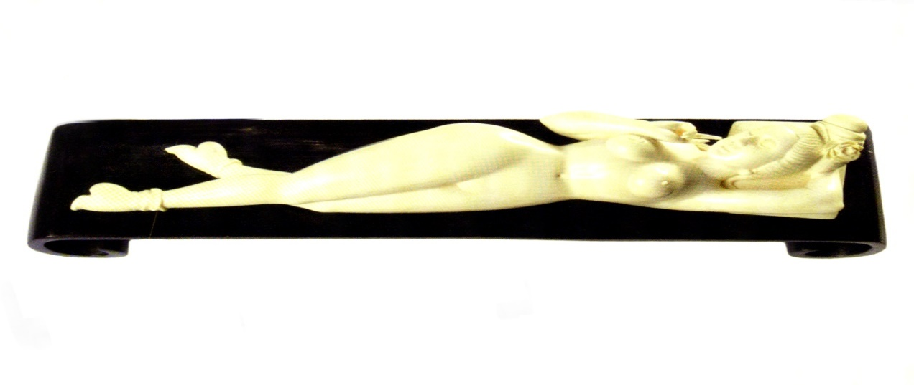
The museum is hereby informing the public, museums, art collectors, museum association and different authorities about this and requesting their assistance in this regard.

Should you come across it, please contact Serg. T. Ngobeni at + 27 488 6511 and Mr. Luvuyo Dondolo of the Adler Museum of Medicine at +27 717 2067 or via email at Luvuyo.Dondolo@wits.ac.za .

Luvuyo Dondolo
Senior Curator
Adler Museum of Medicine
Wits University
Johannesburg

