PALAEONTOLOGICAL SPECIALIST STUDY: FIELD ASSESSMENT & RECOMMENDATION FOR EXEMPTION FROM FURTHER STUDIES & MITIGATION

EXISTING BORROW PIT ALONG THE DR1662 NEAR DYSSELDORP, EDEN DISTRICT MUNICIPALITY, WESTERN CAPE

John E. Almond PhD (Cantab.)
Natura Viva cc,
PO Box 12410 Mill Street,

Cape Town 8010, RSA
naturaviva@universe.co.za

March 2013

1. EXECUTIVE SUMMARY

It is proposed to re-excavate and extend the existing borrow pit DR01662/22.15/0.44L along the DR01662 for road material, situated on the Farm Leeuwen Blad 3 some 14 km southeast of Dysseldorp in the Little Karoo region of the Western Cape. The pit is excavated into mudrocks of the Gydo Formation (Lower Bokkeveld Group), a rock unit that is well known for its rich fossil heritage – especially shelly invertebrates – from the Early Devonian Period.

The Lower Bokkeveld sediments in the study area are highly cleaved and their palaeontological sensitivity is correspondingly very low. No further palaeontological heritage studies or mitigation are recommended for this project.

2. INTRODUCTION

The Department of Transport, Western Cape, is applying to the Department of Mineral Resources for approval to exploit road material from an existing borrow pit along the unsealed road DR01662 to the southeast of Dysseldorp, Little Karoo Region, as well as to extend the pit. The pit in question (DR01662/22.15/0.44L, located at 33° 39' 40.2"S, 22° 32' 30.4" E) is situated on Farm Leeuwen Blad 3 on the west side of the DR01662 in the foothills of the Kammanassieberge Range, some 14 km SE of Dysselsdorp, Eden District Municipality (Fig. 1).

A previous desktop basic assessment of the pit site by the author assessed its palaeontological heritage sensitivity as high due to the presence here of potentially fossiliferous mudrocks of the Gydo Formation (Lower Bokkeveld Group). A palaeontological field assessment of the pit as part of an HIA was requested by Heritage Western Cape (HWC case 1913 - 2003 ref 120726TS38, Interim comment 8 August 2012) in accordance with the requirements of the National Heritage Resources Act, 1999 (Section 38).

The present palaeontological heritage field assessment and short report were accordingly commissioned by Vidamemoria Heritage Consultants, Cape Town (Address: 3rd Floor, Guarantee House, 37 Burg Street, Greenmarket Square, Cape Town; tel: 021-424 8432; e-mail: Quahnita@vidamemoria.co.za). This is Vidamemoria pit no. 194 and NID ref. no. 131. Fieldwork for this project was carried out on 10 December 2012.

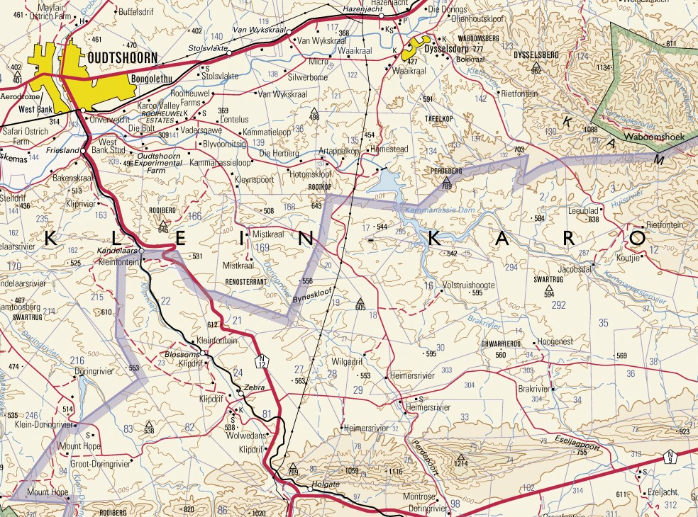
5 km
N
DR01662/22.15/0.44L

Fig. 1. Extract from topographical sheet 3322 Oudtshoorn (Courtesy of the Chief Directorate: National Geo-spatial Information, Mowbray) showing the location of the borrow pit DR01662/22.15/0.44L some 14 km southeast of Dysseldorp, Eden DM, Western Cape (blue dot).

3. GEOLOGICAL CONTEXT

The geology of the borrow pit study area is shown on 1: 250 000 sheet 3322 Oudtshoorn (Council for Geoscience, Pretoria; Toerien 1979) (Fig. 2). The pit (Fig. 3) is situated at c. 530 m amsl in a small stream valley in the foothills of the Kammanassieberge Range and about 200m north of the Huisrivier, a tributary of the Kammanassierivier. The substantial existing pit is partially occupied by a farm dam and a ridge of prominent-weathering sandstone runs west-east along its northern edge (Fig. 3).

The study area is underlain by mudrocks of the Gydo Formation (Dg) (Lower Bokkeveld Group, Cape Supergroup) of Emsian or Early Devonian age, some 400 million years old (Theron 1999, Theron & Johnson 1991, Thamm & Johnson 2006). This formation consists of an upward-coarsening, shallowing succession of dark grey to black mudrocks, fine-grained sandstones and medium-grained wackes (dark, impure sandstones). These sedimentary rocks were deposited in a cool shallow seaway, the Agulhas Sea, on the south-western margins of Gondwana some 400 million years ago. Offshore mudrocks were deposited in quiet, deeper waters and may be massive or well-laminated. Pyrite-rich horizons indicate episodes of anoxia at or shortly below the sea floor. Near-shore sandstones were laid down in more turbulent settings and often show the influence of major storms (e.g. well-developed wave ripples, hummocky cross-stratification). The Gydo Formation is consistently the most fossil-rich formation within the Bokkeveld Group (Section 4). Steeply-dipping sandstones of the upper Table Mountain Group (Baviaanskloof Formation) build both flanks of the valley.

Recessive-weathering, grey-green siltstones of the Gydo Formation are intermittently exposed within the proposed pit extension area to the south of the dam. They are highly cleaved and mantled with thin gravelly soil and downwasted gravels. The best bedrock exposures are seen in the cut face along the northern edge of the dam which is incised into interbedded grey-green micaceous wackes (impure sandstones) and siltstones of the uppermost Gydo Formation. The Gydo is a coarsening-upwards, shoaling succession and these thin to medium beds form the transition zone towards the base of the Gamka Formation that builds the sandstone ridge to the north. As indicated on the geological map (Fig. 2) the Lower Bokkeveld succession on the western side of the Kammassieberg is affected by narrow, west-east trending fold axes. Both the wackes and siltstones of the Lower Bokkeveld succession in the study area are pervasively cleaved with occasional thin quartz veins (Figs. 4 & 5).

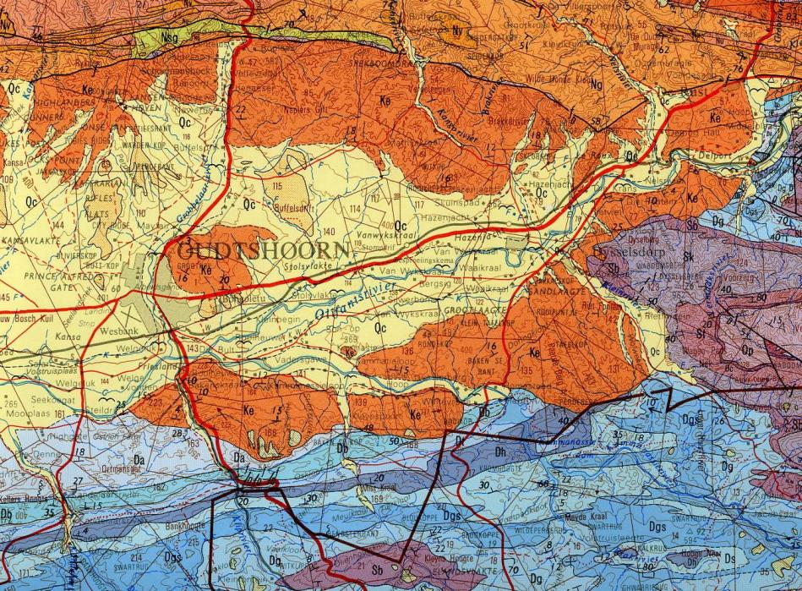
DR01662/22.15/0.44L
N
5 km

Fig. 2. Extract from 1: 250 000 geology sheet 3322 Oudtshoorn (Council for Geoscience, Pretoria) showing location of the existing borrow pit DR01662/22.15/0.44L on the south-western margin of the Kammanassieberge. The pit is excavated into offshore marine mudrocks of the Early Devonian Gydo Formation (Dg, pale blue) at the base of the Bokkeveld Group. Sandstones of the Gamka Formation (Dg, middle blue) crop out along the northern edge of the pit study area.

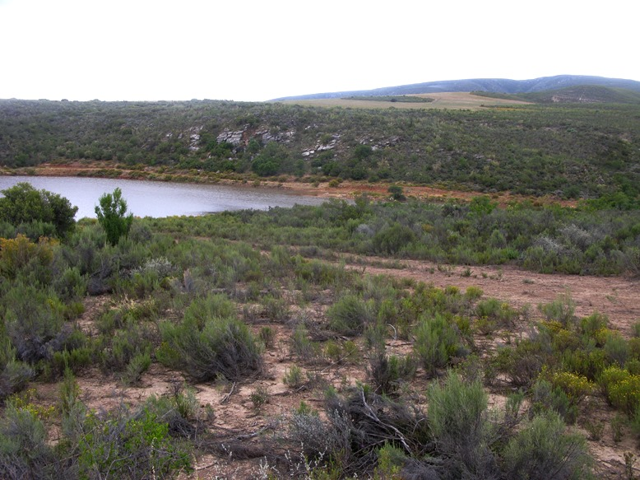

Fig. 3. View towards the NNE across the DR01662/22.15/0.44L pit study area showing the dam within the existing pit and ridge of Gamka Formation sandstones behind it. The proposed pit extension overlies Gydo Formation mudrocks in the foreground.

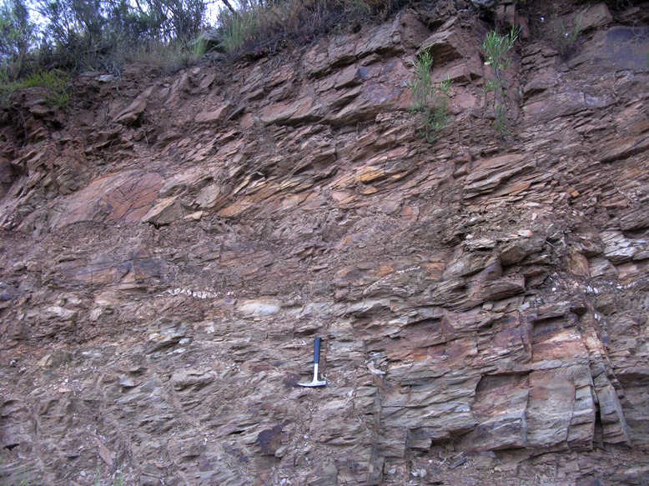

Fig. 4. Interbedded wackes and siltstones with quartz veins within the Gydo / Gamka transition zone exposed in cut face along the northern side of the pit (Hammer = 27 cm).

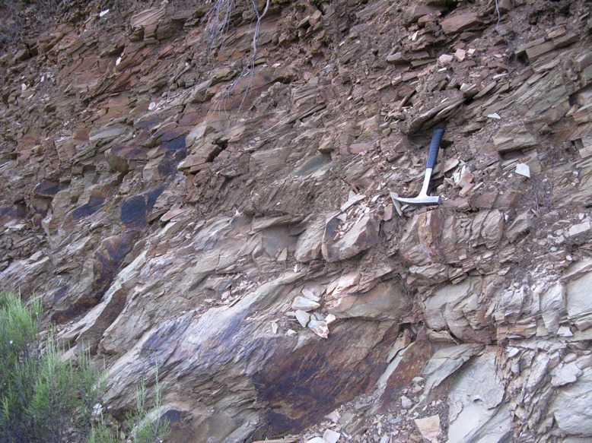

Fig. 5. Detail of cut face shown in previous figure showing pervasive tectonic cleavage penetrating both wacke and siltstone facies (Hammer = 27 cm).

4. PALAEONTOLOGICAL HERITAGE

The lower part of the Bokkeveld Group in the Western Cape (Ceres Subgroup plus lowermost Bidouw Subgroup) – and in particular the Gydo Formation - is known for its rich fossil assemblages of shallow marine invertebrates of the Malvinokaffric Faunal Province of Gondwana (Cooper 1982, Oosthuizen 1984, Hiller & Theron 1988, Theron & Johnson 1991, MacRae 1999, Almond in De Beer et. al. 2002, Thamm & Johnson 2006, Almond 2008). Key fossil groups here include trilobites, brachiopods, various subgroups of molluscs (bivalves, gastropods, nautiloids etc), and echinoderms (starfish, brittle stars, crinoids, carpoids, sea cucumbers etc), with several minor taxa including corals, conulariids, tentaculitids and rare fish remains, among others (Almond 1997, Anderson et al. 1999). These shelly fossil assemblages – generally preserved as impressions or moulds, but occasionally in the Gydo Formation also embedded within phosphatic or siliceous nodules – are especially abundant within the mudrock-dominated units such as the Gydo, Voorstehoek and Waboomberg Formations in their more distal (offshore) outcrop areas. Thin lenticles of shelly debris, known as coquinas, have been concentrated by storm activity and mainly consist of disarticulated specimens.

Fossils from various localities in the Gydo Formation within the broader Swartberg – Little Karoo study region have been treated by Oosthuizen (1984), Theron et al. (1991) and Almond (2005), among others.

No shelly or other fossils were observed within the Gydo siltstones in the proposed pit extension area nor in the heterolithic siltstone / wacke succession exposed in the cut face along the northern edge of the existing pit. It is likely that most or all the fossils originally present within these rocks have been completely destroyed by tectonic cleavage and weathering. Those that have survived will be highly distorted and poorly preserved, with high levels of disruptive secondary mineralisation (e.g. iron and manganese compounds). The Late Caenozoic gravels and soils mantling the Bokkeveld bedrocks are of low palaeontological sensitivity.

The palaeontological sensitivity of this site is therefore rated as VERY LOW.
5. CONCLUSIONS & RECOMMENDATIONS

The existing DR01662/22.15/0.44L borrow pit on Farm Leeuwen Blad 3 near Dysseldorp is excavated into mudrocks and wackes (impure sandstones) of the Gydo Formation that elsewhere is well known for its rich fossil heritage – especially shelly invertebrates – from the Devonian Period.

The Lower Bokkeveld sediments in the study area are highly cleaved and their palaeontological sensitivity is correspondingly very low. No further palaeontological heritage studies or mitigation are recommended for this project.

6. ACKNOWLEDGEMENTS

Ms Quahnita Samie of Vidamemoria Heritage Consultants, Cape Town, is thanked for commissioning this specialist study and for kindly providing the necessary background information. I am very grateful to Madelon Tusenius for companionship and logistical support in the field.

7. REFERENCES

ALMOND, J.E. 1997. Fish fossils from the Devonian Bokkeveld Group of South Africa. Stratigraphy. African Anthropology, Archaeology, Geology and Palaeontology 1(2): 15-28.

ALMOND, J.E. 2005. Geology of the Gamkaberg-Rooiberg Conservation Area, Little Karoo, 255pp. Unpublished report for Cape Nature, Natura Viva cc., Cape Town.

ALMOND, J.E. 2008. Palaeozoic fossil record of the Clanwilliam Sheet area (1: 250 000 geological sheet 3218), 42 pp. Report produced for the Council for Geoscience, Pretoria.

ANDERSON, M.E., ALMOND, J.E., EVANS, F.J. & LONG, J.A. 1999. Devonian (Emsian-Eifelian) fish from the Lower Bokkeveld Group (Ceres Subgroup), South Africa. Journal of African Earth Sciences 29: 179-194.

COOPER, M.R. 1982. A revision of the Devonian (Emsian – Eifelian) Trilobita from the Bokkeveld Group of South Africa. Annals of the South African Museum 89: 1-174.

DE BEER, C.H., GRESSE, P.G., THERON, J.N. & ALMOND, J.E. 2002. The geology of the Calvinia area. Explanation to 1: 250 000 geology Sheet 3118 Calvinia. 92 pp. Council for Geoscience, Pretoria.

HILLER, N. & THERON, J.N. 1988. Benthic communities in the South African Devonian. In: McMillan, N.J., Embry, A.F., & Glass, D.J. (Eds.) Devonian of the World, Volume III: Paleontology, Paleoecology and Biostratigraphy. Canadian Society of Petroleum Geologists, Memoir No. 14, pp 229-242.

JELL, P.A. & THERON, J.N. 1999. Early Devonian echinoderms from South Africa. Memoirs of the Queensland Museum 43: 115-199.

MACRAE, C. 1999. Life etched in stone. Fossils of South Africa. 305pp. The Geological Society of South Africa, Johannesburg.

OOSTHUIZEN, R.D.F. 1984. Preliminary catalogue and report on the biostratigraphy and palaeogeographic distribution of the Bokkeveld Fauna. Transactions of the Geological Society of South Africa 87: 125-140.

THAMM, A.G. & JOHNSON, M.R. 2006. The Cape Supergroup. In: Johnson, M.R., Anhaeusser, C.R. & Thomas, R.J. (Eds.) The geology of South Africa, pp. 443-459. Geological Society of South Africa, Marshalltown.

THERON, J.N. 1972. The stratigraphy and sedimentation of the Bokkeveld Group. Unpublished DSc thesis, University of Stellenbosch, 175pp, 17pls.

THERON, J.N. 1999. Lithostratigraphy of the Gydo Formation (Bokkeveld Group). SACS Lithostratigraphic Series No. 33, 1-11. Council for Geoscience, Pretoria.

THERON, J.N. & JOHNSON, M.R. 1991. Bokkeveld Group (including the Ceres, Bidouw and Traka Subgroups). Catalogue of South African Lithostratigraphic Units 3: 3-5.

THERON, J.N., WICKENS, H. DE V. & GRESSE, P.G. 1991. Die geologie van die gebied Ladismith. Explanation to 1: 250 000 geology sheet 3320, 99 pp. Council for Geoscience, Pretoria.

TOERIEN, D.K. 1979. The geology of the Oudtshoorn area. Explanation to Sheet 3322. 13 pp. Geological Survey / Council for Geoscience, Pretoria.

8. QUALIFICATIONS & EXPERIENCE OF THE AUTHOR

Dr John Almond has an Honours Degree in Natural Sciences (Zoology) as well as a PhD in Palaeontology from the University of Cambridge, UK. He has been awarded post-doctoral research fellowships at Cambridge University and in Germany, and has carried out palaeontological research in Europe, North America, the Middle East as well as North and South Africa. For eight years he was a scientific officer (palaeontologist) for the Geological Survey / Council for Geoscience in the RSA. His current palaeontological research focuses on fossil record of the Precambrian - Cambrian boundary and the Cape Supergroup of South Africa. He has recently written palaeontological reviews for several 1: 250 000 geological maps published by the Council for Geoscience and has contributed educational material on fossils and evolution for new school textbooks in the RSA.

Since 2002 Dr Almond has also carried out palaeontological impact assessments for developments and conservation areas in the Western, Eastern and Northern Cape under the aegis of his Cape Town-based company Natura Viva cc. He is a long-standing member of the Archaeology, Palaeontology and Meteorites Committee for Heritage Western Cape (HWC) and an advisor on palaeontological conservation and management issues for the Palaeontological Society of South Africa (PSSA), HWC and SAHRA. He is currently compiling technical reports on the provincial palaeontological heritage of Western, Northern and Eastern Cape, Gauteng, Limpopo and Free State for SAHRA and HWC. Dr Almond is an accredited member of PSSA and APHP (Association of Professional Heritage Assessment Practitioners – Western Cape).

Declaration of Independence

I, John E. Almond, declare that I am an independent consultant and have no business, financial, personal or other interest in the proposed borrow pit project, application or appeal in respect of which I was appointed other than fair remuneration for work performed in connection with the activity, application or appeal. There are no circumstances that compromise the objectivity of my performing such work.
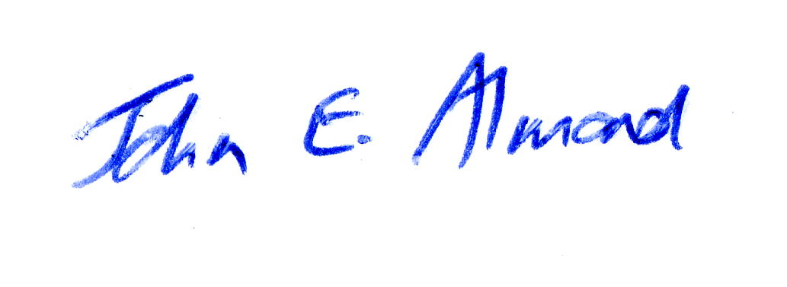
Dr John E. Almond
Palaeontologist
Natura Viva cc

