**VEGETATION ASSESSMENT:**

**PROPOSED DEVELOPMENT OF ‘LINGFIELD EQUESTRIAN ESTATE’,**

**SUMMERVELD, KWAZULU-NATAL**

## 9 September 2016

**Prepared for: Prepared by:**

**Guy Nicolson Consulting CC Peter le Roux**

**6 Indwa Place, 5 Spearman Rd**

**Kloof, 3610 Hayfields, Pietermaritzburg 3201**

**South Africa Cell: 082 3315950**

**Tel: [+27] (31) 764 2515 Email:** [**mwpler@mweb.co.za**](mailto:mwpler@mweb.co.za)

**Fax: [+27] (31) 764 2515**

**Mobile: [+27] 82 772 9941**

**Email:** [guyn@saol.com](mailto:guyn@saol.com)

# CONTENTS

## Page

1. Project brief 2
2. Declaration 2
3. Study site 2
4. Methods 3
5. Findings 3
6. Analysis of findings 6
   1. D’MOSS and KZN Sandstone Sourveld classification 6
   2. Comments on the revised development layout in relation to D’MOSS or other areas with development constraints 6
7. Summary, comments and conclusion 8
8. References 9

### Project brief

1. Examine the vegetation on the study site, describe and rank the vegetation types according to environmental sensitivity and/or plants of conservation concern and comment on plant-related implications for developing the site.
2. Highlight vegetation constraints that may affect the proposed development, in order to facilitate the preparation of an environmentally acceptable layout.
3. Examine a revised layout and produce a final report on the extent to which previously identified constraints have been taken into account.
4. A specific requirement was to inspect the overall development area and confirm whether any areas qualified as “indigenous vegetation” and therefore would trigger an EIA if more than 1 hectare of them was transformed (in terms of EIA 2014 GNR 983 Activity 27).
5. Inspect the areas at the interface between the development area and the D’MOSS/KZN Sandstone Sourveld boundary to determine whether there would be cumulatively more than 300 square metres transformed by the development.

### Declaration

I declare that I have no business, personal or financial interest in the project, other than fair remuneration for work completed, and that there are no circumstances that would compromise my objectivity.

### Study site

The 62 ha property comprises portions of the Farm Moller No. 14243, Summerveld, Outer West, Ethekwini. Boundaries and GPS co-ordinates of the approximate centre point are shown in Figure 1 below.

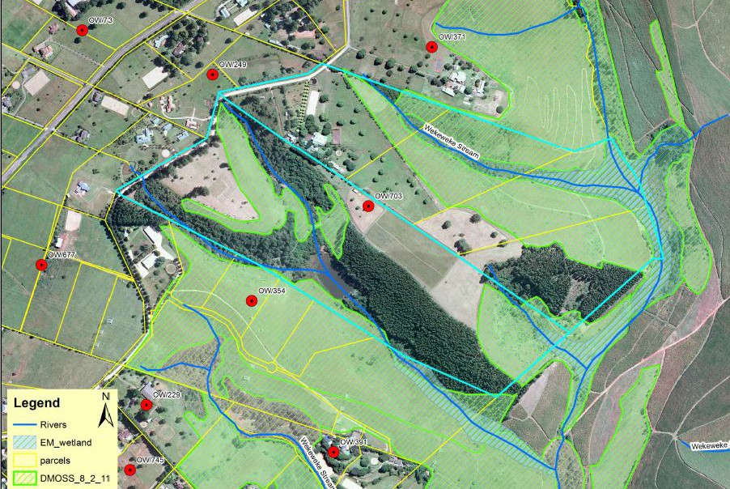

29°48'29.14"S

30°43'10.25"E

### Figure 1. Farm boundary (red line) and D’MOSS areas (green hatching).

### Methods

A site visit was undertaken on 16th September 2015 to examine the property, identify and broadly classify the habitats, search for plants of conservation significance and map habitat types. The main references for examining the status of species and vegetation types were:

* The website <http://redlist.sanbi.org/species> for the Redlist of Threatened South African Plants.
* Legislation and maps covering the listing of threatened habitats and ecosystems (December 2011).
* The classification by Mucina and Rutherford (2006) of vegetation types and their conservation importance.
* The report on the property by J.E. Granger (2008).

Past land use was initially detected from using the time function on Google© dating back to 2002 images while the most recent images were 2015. Habitats, features and infrastructure were plotted and size of each polygon measured using Google Earth Pro©. Key indicator species of plants were listed for each habitat type.

The preliminary report (le Roux September 2015) was used for revising the original development layout; the final layout is depicted as Figure 4 (page 7) of this report.

### Findings

Vegetation types varied significantly and included riparian woodland/forest with dams and wetlands, primary grassland, secondary grassland and paddocks with pastures. A brief description of each habitat is provided in Table 1 below, with the vegetation map presented in Figure 2 and the description of the vegetation types in Table 2.

### Table 1. Vegetation and other features on the property, illustrated in Figure 2.

|  |  |  |  |  |
| --- | --- | --- | --- | --- |
| **Area** | **Size**  **(ha)** | **Description** | **Comment** | **Vegetation**  **Constraints** |
| **A** | 15.78 | Buildings, paddocks, roads & other  infrastructure. | Transformed environment | Nil |
| **B** | 19.56 | Secondary grassland, low to moderate species diversity. | Cultivated (mostly timber) <10 years ago. | Low |
| **C** | 11.65 | Primary grassland, high to moderate species diversity. | Comprises 3 small patches & 3  larger patches; all representative of KZN Sandstone Sourveld. | High |
| **C1** | 1.14 | Primary grassland, moderate species  diversity (mowed veld). | Contiguous with larger primary  grassland. | High |
| **C2** | 0.95 | Secondary grassland (old cropland). Low species diversity. | Cultivated >10 years ago – thus defined as “indigenous vegetation”. | High per Dec. 2014  legislation**\*** |
| **D** | 13.22 | Water courses & wetlands with riparian vegetation. | Highly variable habitats, dominated by riparian woody species. | High |
| **Total** | **62.3** |  |  |  |

**\*** Definition of “indigenous vegetation” per text box below, with reference box on next page.

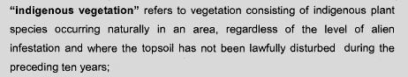

NOTE: The above does not represent an environmental trigger if the site To be developed is less than 1 ha in extent.

Government Gazette reference for the above definition:

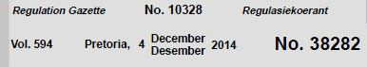

|  |  |  |
| --- | --- | --- |
|  | | |
|  | |  |
| **A** (15.78 ha) | Buildings, paddocks, roads, infrastructure |
| **B** (19.56 ha) | Secondary grassland |
| **C** (11.65 ha) | Primary grassland |
| **C1** (1.14 ha) | Primary grassland (mowed) |
| **C2** (0.95 ha) | Secondary grassland >10y since last cultivation |
| **D** (13.22 ha) | Water course & wetlands with riparian vegetation |

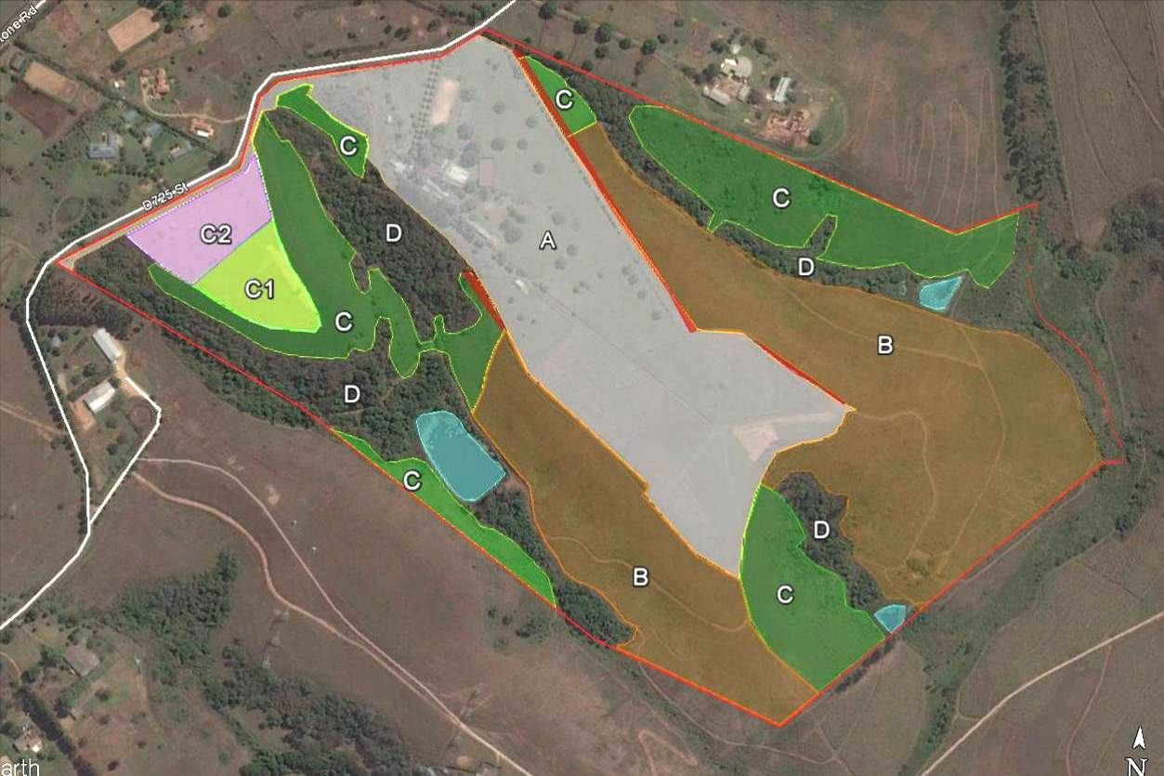**Figure 2. Vegetation and other features of the study site (Google Earth Pro 23/10/2014 image). Also see Table 2 below.**

**Table 2. Key species and habitat types (Alien plants shaded grey).**

|  |  |
| --- | --- |
| **A. Buildings, paddocks, roads, infrastructure (15.78 ha)** | **Key species**  *Centella asiatica Digitaria eriantha Eragrostis curvula Paspalum dilatatum*  *Pennisetum clandestinum Stenotaphrum secundatum Trifolium repens* |
|  |

|  |  |
| --- | --- |
| **B. Secondary grassland, previously *Eucalyptus***  **plantations, with low species diversity (19.56 ha).** | **Key species**  *Cymbopogon validus Digitaria eriantha Eucalyptus grandis Helichrysum panduratum Imperata cylindica Lantana camara*  *Maesa lanceolata Melia azedarach Pteridium aquilinum Pseudarthria hookeri Setaria megaphylla Smilax anceps Tagetes minuta Trema orientalis* |
|  |

|  |  |
| --- | --- |
| **C. Primary grassland – diverse, but some patches moribund (11.65 ha).** | **Key species**  *Brachiaria serrata Crotalaria dura Diheteropogon amplectens Helichrysum pilosellum Hypoxis hemerocallidea Indigofera hilaris Kauhautia amatymbica Polygala virgata*  *Pteridium aquilinum Pseudarthria hookeri Senecio glaberrimus Themeda triandra Vernonia natalensis Vernonia oligocephala* |
|  |

|  |  |
| --- | --- |
| **D. Water course & wetlands with associated riparian vegetation (13.22 ha).** | **Key species**  *Bridelia micrantha Caesalpinia decapetala Ficus sur*  *Halleria lucida Lantana camara*  *Persicaria senegalensis Rauvolfia caffra*  *Rubus sp. Scadoxus puniceus Setaria megaphylla*  *Solanum mauritianum Strelitzia nicolai Syzigium cordatum Trema orientalis Trimeria grandifolia* |
|  |

### Analysis of findings

### D’MOSS and KZN Sandstone Sourveld classification

The D’MOSS areas illustrated in Figure 1 below correlated with my areas mapped as KZN Sandstone Sourveld, apart from one D’MOSS area that was not representative of KZN Sandstone Sourveld (Figure 3). This area was cultivated in the past, most of it being planted to *Eucalyptus* that has since been felled and cleared.

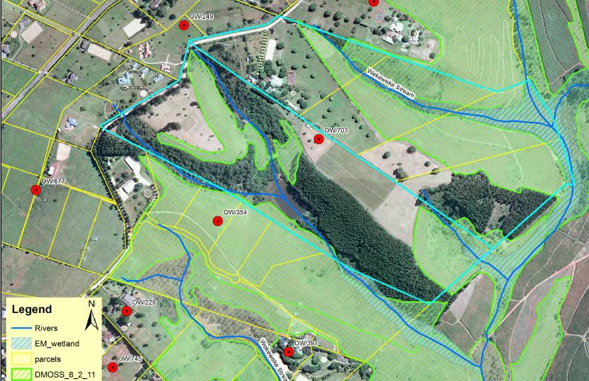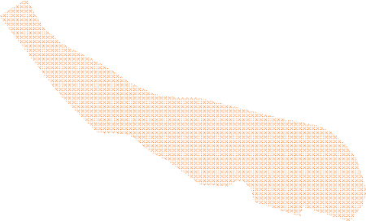

|  |  |
| --- | --- |
|  | |
|  | **D’MOSS area not representative of KZN Sandstone Sourveld** |
|  |

### Figure 3. D’MOSS area previously under timber and recently cleared.

* 1. **Comments on the revised development layout in relation to D’MOSS or other areas with development constraints (see Figure 4).**
     1. The initial findings indicated proposed development sites that cumulatively exceeded 300 m2 and overlapped the D’MOSS/KZN Sandstone Sourveld.

The revised layout (Figure 4) has been examined and all sites that overlapped D’MOSS or KZN Sandstone Sourveld have been excluded or reduced to the extent that they do not cumulatively exceed 300 m2.

* + 1. One development area not mapped as part of D’MOSS (site 3 in Figure 4) was identified as primary grassland.

In my initial report this area was identified as being a high biodiversity constraint area. It has subsequently been excluded from the proposed development and incorporated in the conservation servitude.

* + 1. One development area not mapped as part of D’MOSS (site 1 in Figure 4) was identified as secondary grassland cultivated more than 10 years ago.

Site 1 in Figure 4 (0.95 ha) is classified as indigenous vegetation (per page 3) and would have required authorisation for development if it had been >1 ha in extent (Note: Development Site 2 was a gum plantation until felled in 2012 and does not meet the definition of indigenous vegetation).

* + 1. Two substantial areas of secondary grassland totalling 9.24 ha (sites 4 & 5 in Figure 4) have been added to the conservation servitude.

**D’MOSS**

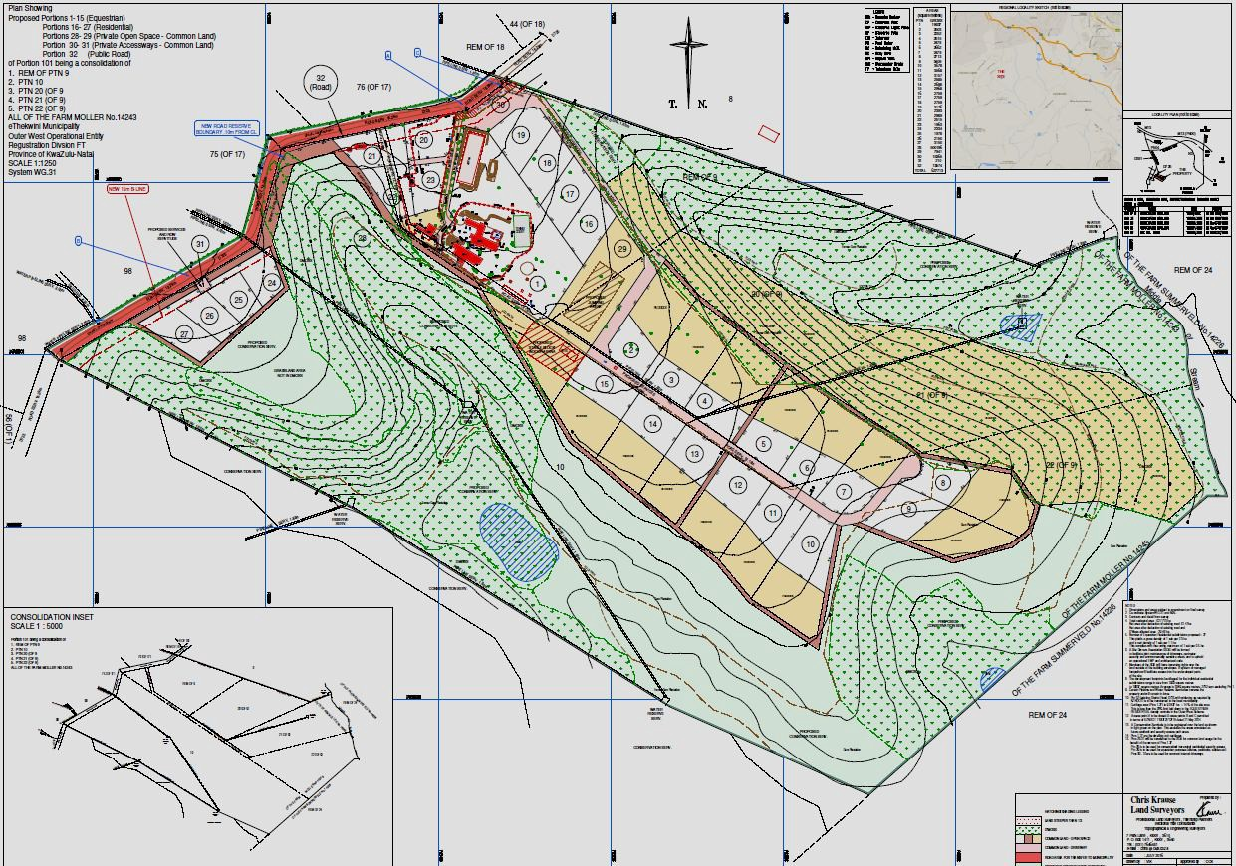

# 1 6

**3**

**D’MOSS**

# 2

**Proposed development sites outside the existing development footprint:**

**1: 0.95 ha Cultivated >10 years ago**

**2: 2.2 ha Cultivated <10 years ago (gum trees)**

**5**

# 4

**D’MOSS**

**Primary & secondary grassland added to conservation servitude:**

**3: 1.14 ha KZN Sandstone Sourveld**

**4: 7.02 ha Secondary Grassland**

**5: 2.22 ha Secondary Grassland**

**Figure 4. Revised (final) development layout showing proposed development sites outside the existing development footprint, plus primary and secondary grasslands added to the conservation servitude. Site 6 is mapped as D’MOSS but falls within existing paddocks**

Vegetation assessment ‘Lingfield Equestrian Estate’. September 2016 7

### Summary, comments and conclusion

1. My recommendations for excluding land with high biodiversity constraints have been satisfactorily addressed in the revised layout.
2. Areas that cumulatively exceeded 300 m2 and fell within D’MOSS sites have been excluded from development. Site 6 (Figure 4) is an anomaly as it appears in some maps as D’MOSS although it falls within grazing paddocks. The D’MOSS map in Figure 3 above indicates this portion as falling outside D’MOSS.
3. One area of secondary grasslands disturbed more than 10 years ago (site 1 Figure 4) has been included in the development layout. Being less than 1 hectare the development footprint on this site would not require an environmental authorization to be developed.
4. A 1.14 ha patch of primary grassland (site 3 Figure 4) not mapped as D’MOSS has been excluded from development. Being contiguous with a viable portion of diverse KZN Sandstone Sourveld, this represents a significant addition to the conservation servitude.
5. The addition of non-D’MOSS areas 4 and 5 to the conservation servitude (Figure 4) is also significant because it provides ecological links with the three previously separated D’MOSS portions.
6. The EMP must include a specific requirement that any construction activities on development sites 1 and 2 (Figure 4) must be confined to these sites, i.e. no parking, driving, storage or temporary dumping may be permitted to encroach on the adjacent conservation servitude, whether D’MOSS or secondary grassland.
7. A management plan is required for all the areas designated D’MOSS and Conservation Servitude in Figure 4, in order to provide a framework for maintaining species diversity and ecological processes. Some of these requirements were recommended by Granger (2008), but the following are considered essential:
   * A detailed plan for ongoing control of invasive alien plants (work in progress was evident).
   * A structured plan for burning primary and secondary grasslands at appropriate intervals and under conditions favourable for ensuring species diversity. There is currently too much moribund grass with the associated risks of high-intensity fires, woody encroachment and loss of plant diversity.
   * A rehabilitation plan for secondary grasslands, these being mostly areas previously planted to *Eucalyptus* (designated B: Secondary grassland in Figure 2). These sites mostly occur on steep slopes and still have a component of ruderal weeds, but rehabilitation to moderately diverse grassland is feasible.
   * Details on methods, resources required and timing are essential.

In conclusion, the iterative process of preliminary investigations and refinements of the development layout have been dealt with very successfully. The addition of important portions of land to the conservation servitude to ensure effective ecological links has significantly enhanced the conservation potential of the property.

The development as described and assessed in this report would not trigger any requirements for environmental authorization based on vegetation transformation that would occur in the development process.

### References

Boon, R. 2010. *Trees of Eastern South Africa*. Fauna and Flora Publications Trust.

Gibbs Russell *et al.* 1990. Grasses of Southern Africa. Memoirs of the Botanical Survey of South Africa No. 58. Botanical Research Institute, Pretoria.

Granger, J.E. 2008. An assessment of the vegetation and associated features on Lingfield Farm (Described as Sub 9 of the Farm Moller No. 14243 and Sub 10 of the Farm Moller), Summerveld, KwaZulu-natal.

Henderson L. 2001. Alien Weeds and Invasive Plants. Agricultural Research Council. Pretoria. Mentis M.T. 2010. Environmental Risk Management in South Africa. Private Bag X7005 Hillcrest.

Mucina, L. and Rutherford C. (ed.) 2006. The Vegetation of South Africa, Lesotho and Swaziland. SANBI Pretoria.

Pooley E. 1998. A Field Guide to Wild Flowers KwaZulu-Natal and the Eastern Region. The Flora Publications Trust. Natal Herbaruim. Durban.

Scott-Shaw R. 1999. Rare and Threatened Plants of KwaZulu-Natal and neighbouring regions.

Teeanem Printers, Pietermaritzburg.