Phase 1 Cultural Heritage Impact Assessment:

THE PROPOSED UPGRADE OF THE OSHOEK LAND PORT OF ENTRY, SWAZILAND BORDER, ALBERT LUTHULI DISTRICT MUNICIPALITY, MPUMALANGA PROVINCE

Prepared for:
Delta BEC: Mr T van Rooy
- Address: 320 The Hillside Road, Rynlal Building, Lynnwood, 0181; Tel: 012 368 1850; E-mail: tian.van rooy@deltabec.com

Prepared by:
J A van Schalkwyk (D Litt et Phil),
- Heritage Consultant: ASAPA Registration No.: 164 - Principal Investigator: Iron Age, Colonial Period, Industrial Heritage.
- Postal Address: 62 Coetzer Avenue, Monument Park, 0181; Tel: 076 790 6777; E-mail: jvschalkwyk@mweb.co.za

Report No: 2018/JvS/002
- Status: Final
- Date: January 2018
- Revision No: -
- Date: -

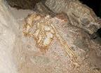 | 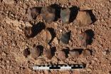 |  | 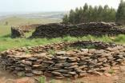 | 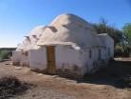 | 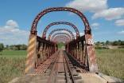

Copy Right:

This report is confidential and intended solely for the use of the individual or entity to whom it is addressed or to whom it was meant to be addressed. It is provided solely for the purposes set out in it and may not, in whole or in part, be used for any other purpose or by a third party, without the author’s prior written consent.

Declaration:

I, J A van Schalkwyk, declare that:
- I am suitably qualified and accredited to act as independent specialist in this application.
- I do not have any financial or personal interest in the proposed development, nor its developers or any of their subsidiaries, apart from the provision of heritage assessment and management services, for which a fair numeration is charged.
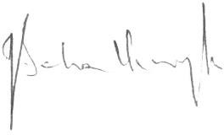
- The work was conducted in an objective manner and any circumstances that might have compromised this have been reported.
J A van Schalkwyk Heritage Consultant January 2018

EXECUTIVE SUMMARY

Phase 1 Cultural Heritage Impact Assessment:
THE PROPOSED UPGRADE OF THE OSHOEK LAND PORT OF ENTRY, SWAZILAND BORDER, ALBERT LUTHULI DISTRICT MUNICIPALITY, MPUMALANGA PROVINCE

The Department of Public Works proposes the upgrade of the Oshoek Land Port of Entry, located along the N17 national route at the border with Swaziland, Albert Luthuli District Municipality, Mpumalanga Province.

In accordance with Section 38 of the NHRA, an independent heritage consultant was appointed by DeltaBEC to conduct a cultural heritage assessment to determine if the proposed upgrade of the port of entry would have an impact on any sites, features or objects of cultural heritage significance.

This report describes the methodology used, the limitations encountered, the heritage features that were identified and the recommendations and mitigation measures proposed relevant to this. It should be noted that the implementation of the mitigation measures is subject to SAHRA/PHRA’s approval.

The cultural landscape qualities of the region essentially consist of various components. The first is a rural area in which the human occupation is made up of a limited Stone Age occupation. This was followed much later by Sotho- and Nguni-speaking agro-pasturalist that settled in the region. They were soon followed by a colonial (farmer) component, which gave rise to the development of small villages and hamlets that dot the larger landscape. The final transformation was brought about by the intensive forestry industry that developed during the past century.

The HIA consisted of a desktop study (archival sources, database survey, maps and aerial imagery) and a physical survey that included the interviewing of relevant people. During the physical survey, a single heritage resource was identified:

IDENTIFIED HERITAGE RESOURCES
Site No. | Site type | NHRA  category | Field rating | Impact rating: Before/After | Proposed mitigation (Refer to definitions in  Addendum Section 4)
Oshoek Land Port of Entry
7.3.1 | Built structure  -26.21565, 30.98427 | Section 34 | Medium significance Grade IV-A | 36 | - Avoid site; or  - Document site
 |  |  |  | 8

Reasoned opinion as to whether the proposed activity should be authorised:

- From a heritage point of view, it is recommended that the proposed development be allowed to continue on acceptance of the proposed mitigation measures.

Conditions for inclusion in the environmental authorisation:

- Should archaeological sites or graves be exposed in other areas during construction work, it must immediately be reported to a heritage practitioner so that an investigation and evaluation of the finds can be made.

J A van Schalkwyk Heritage Consultant January 2018

TECHNICAL SUMMARY

Project description
Description | Upgrade of the existing facilities at the Oshoek border post
Project name | Oshoek Land Port of Entry Upgrade

Applicant
Department of Public Works

Environmental assessors
Delta Built Environmental Consultants
Mr T van Rooy

Property details
Province | Mpumalanga
Magisterial district | Eerstehoek
District municipality | Albert Luthuli
Topo-cadastral map | 2630BB
Farm name | Oshoek
Closest town | Mbabane
Coordinates | Centre point (approximate)
 | No | Latitude | Longitude | No | Latitude | Longitude
 | 1 | -26.21391 | 30.98524

Development criteria in terms of Section 38(1) of the NHR Act | Yes/No
Construction of road, wall, power line, pipeline, canal or other linear form of development or barrier exceeding 300m in length | No
Construction of bridge or similar structure exceeding 50m in length | No
Development exceeding 5000 sq m | Yes
Development involving three or more existing erven or subdivisions | No
Development involving three or more erven or divisions that have been consolidated within past five years | No
Rezoning of site exceeding 10 000 sq m | No
Any other development category, public open space, squares, parks, recreation grounds | No

Land use
Previous land use | Farming/Border post
Current land use | Land Port of Entry / Urban / Vacant

TABLE OF CONTENTS
Page EXECUTIVE SUMMARY II
TECHNICAL SUMMARY IV
GLOSSARY OF TERMS AND ABBREVIATIONS VI
- INTRODUCTION 1
- LEGISLATIVE FRAMEWORK 2
- HERITAGE RESOURCES 3
- STUDY APPROACH AND METHODOLOGY 4
- PROJECT DESCRIPTION 6
- DESCRIPTION OF THE AFFECTED ENVIRONMENT 8
- SURVEY RESULTS 16
- RESULTS: STATEMENT OF SIGNIFICANCE AND IMPACT RATINGS 17
- MANAGEMENT AND MITIGATION MEASURES 18
- CONSLUSIONS AND RECOMMENDATIONS 20
- REFERENCES 22
- ADDENDUM 24
  - Indemnity and terms of use of this report 24
  - Specialist competency 25
  - Assessing the significance of heritage resources and potential impacts 26
  - Mitigation measures 29
  - Relocation of graves 31
  - Inventory of identified cultural heritage sites 32
LIST OF FIGURES
Page Figure 1. Map indicating the track log of the field survey 6
Figure 2. Location of the study area in regional context. 7
Figure 3. Layout of the proposed development. 8
Figure 4. The existence of a border crossing indicated on the Transvaal Map of 1906. 9
Figure 5. The study area on the 1943 version of the topocadastral map 9
Figure 6. Border control facilities 10
Figure 7. Various support facilities 11
Figure 8. Views over the larger study area. 12
Figure 9. Aerial view of the study area. 12
Figure 10. Location of main features in the study area. 13
Figure 11. Location of heritage sites in the study area. 17

GLOSSARY OF TERMS AND ABBREVIATIONS TERMS
Stone Age: The first and longest part of human history is the Stone Age, which began with the appearance of early humans between 3-2 million years ago. Stone Age people were hunters, gatherers and scavengers who did not live in permanently settled communities. Their stone tools preserve well and are found in most places in South Africa and elsewhere.
Early Stone Age 2 000 000 - 150 000 Before Present
Middle Stone Age 150 000 - 30 000 BP
Later Stone Age 30 000 - until c. AD 200

Iron Age: Period covering the last 1800 years, when new people brought a new way of life to southern Africa. They established settled villages, cultivated domestic crops such as sorghum, millet and beans, and they herded cattle as well as sheep and goats. As they produced their own iron tools, archaeologists call this the Iron Age.
Early Iron Age AD 200 - AD 900
Middle Iron Age AD 900 - AD 1300
Later Iron Age AD 1300 - AD 1830

Historic Period: Since the arrival of the white settlers - c. AD 1840 - in this part of the country.

Bioturbation: The burrowing by small mammals, insects and termites that disturb archaeological deposits.

Cumulative impacts: “Cumulative Impact”, in relation to an activity, means the past, current and reasonably foreseeable future impact of an activity, considered together with the impact of activities associated with that activity, that in itself may not be significant, but may become significant when added to existing and reasonably foreseeable impacts eventuating from similar or diverse activities.

Mitigation, means to anticipate and prevent negative impacts and risks, then to minimise them, rehabilitate or repair impacts to the extent feasible.

ABBREVIATIONS

ASAPA Association of Southern African Professional Archaeologists CS-G Chief Surveyor-General
ESA Early Stone Age
MSA Middle Stone Age
LSA Later Stone Age
EIA Early Iron Age
LIA Late Iron Age
HIA Heritage Impact Assessment
I & AP’s Interested and Affected Parties
NASA National Archives of South Africa
NHRA National Heritage Resources Act
PHRA Provincial Heritage Resources Agency SAHRA South African Heritage Resources Agency

Phase 1 Cultural Heritage Impact Assessment:
THE PROPOSED UPGRADE OF THE OSHOEK LAND PORT OF ENTRY, SWAZILAND BORDER, ALBERT LUTHULI DISTRICT MUNICIPALITY, MPUMALANGA PROVINCE

INTRODUCTION

  - Background

The Department of Public Works proposes the upgrade of the Oshoek Land Port of Entry, located along the N17 national route at the border with Swaziland, Albert Luthuli District Municipality, Mpumalanga Province.

South Africa’s heritage resources, also described as the ‘national estate’, comprise a wide range of sites, features, objects and beliefs. However, according to Section 27(18) of the National Heritage Resources Act (NHRA), No. 25 of 1999, no person may destroy, damage, deface, excavate, alter, remove from its original position, subdivide or change the planning status of any heritage site without a permit issued by the heritage resources authority responsible for the protection of such site.

In accordance with Section 38 of the NHRA, an independent heritage consultant was appointed by DeltaBEC to conduct a cultural heritage assessment to determine if the proposed upgrade of the border facility would have an impact on any sites, features or objects of cultural heritage significance.

This report forms part of the Environmental Impact Assessment (EIA) as required by the EIA Regulations in terms of the National Environmental Management Act, 1998 (Act No. 107 of 1998) as amended and is intended for submission to the South African Heritage Resources Agency (SAHRA).

Terms and references

The aim of a full HIA investigation is to provide an informed heritage-related opinion about the proposed development by an appropriate heritage specialist. The objectives are to identify heritage resources (involving site inspections, existing heritage data and additional heritage specialists if necessary); assess their significances; assess alternatives in order to promote heritage conservation issues; and to assess the acceptability of the proposed development from a heritage perspective.
The result of this investigation is a heritage impact assessment report indicating the presence/ absence of heritage resources and how to manage them in the context of the proposed development. Depending on SAHRA’s acceptance of this report, the developer will receive permission to proceed with the proposed development, on condition of successful implementation of proposed mitigation
measures.

    - Scope of work

The aim of this study is to determine if any sites, features or objects of cultural heritage significance occur within the boundaries of the area where the upgrade of the border facility is to take place. This includes:

- Conducting a desk-top investigation of the area;
- A visit to the proposed development site.

The objectives were to:

- Identify possible archaeological, cultural and historic sites within the proposed development areas;

- Evaluate the potential impacts of construction, operation and maintenance of the proposed development on archaeological, cultural and historical resources;
- Recommend mitigation measures to ameliorate any negative impacts on areas of archaeological, cultural or historical importance.

    - Assumptions and Limitations

The investigation has been influenced by the following factors:

- It is assumed that the description of the proposed project, provided by the client, is accurate.
- No subsurface investigation (i.e. excavations or sampling) were undertaken, since a permit from SAHRA is required for such activities.
- It is assumed that the public consultation process undertaken as part of the Environmental Impact Assessment (EIA) is sufficient and that is does not have to be repeated as part of the heritage impact assessment.
- The unpredictability of buried archaeological remains.
- This report does not consider the palaeontological potential of the site.

LEGISLATIVE FRAMEWORK

  - Background

Heritage Impact Assessments are governed by national legislation and standards and International Best Practise. These include:

- South African Legislation
  - National Heritage Resources Act, 1999 (Act No. 25 of 1999) (NHRA);
  - Mineral and Petroleum Resources Development Act, 2002 (Act No. 22 of 2002) (MPRDA);
  - National Environmental Management Act 1998 (Act No. 107 of 1998) (NEMA); and
  - National Water Act, 1998 (Act No. 36 of 1998) (NWA).
- Standards and Regulations
  - South African Heritage Resources Agency (SAHRA) Minimum Standards;
  - Association of Southern African Professional Archaeologists (ASAPA) Constitution and Code of Ethics;
  - Anthropological Association of Southern Africa Constitution and Code of Ethics.
- International Best Practise and Guidelines
  - ICOMOS Standards (Guidance on Heritage Impact Assessments for Cultural World Heritage Properties); and
  - The UNESCO Convention concerning the Protection of the World Cultural and Natural Heritage (1972).

Heritage Impact Assessment Studies

South Africa’s unique and non-renewable archaeological and palaeontological heritage sites are ‘generally’ protected in terms of the National Heritage Resources Act (Act No 25 of 1999, Section 35) and may not be disturbed at all without a permit from the relevant heritage resources authority.

The National Heritage Resources Act (Act No. 25 of 1999, Section 38) provides guidelines for Cultural Resources Management and prospective developments:
“38 (1) Subject to the provisions of subsections (7), (8) and (9), any person who intends to undertake a development categorised as:

- the construction of a road, wall, powerline, pipeline, canal or other similar form of linear development or barrier exceeding 300m in length;
- the construction of a bridge or similar structure exceeding 50m in length;
- any development or other activity which will change the character of a site:
  - exceeding 5 000 m₂ in extent; or
  - involving three or more existing erven or subdivisions thereof; or
  - involving three or more erven or divisions thereof which have been consolidated within he past five years; or
  - the costs of which will exceed a sum set in terms of regulations by SAHRA or a provincial heritage resources authority;
- the re-zoning of a site exceeding 10 000 m₂ in extent; or
- any other category of development provided for in regulations by SAHRA or a provincial heritage resources authority, must at the very earliest stages of initiating such a development, notify the responsible heritage resources authority and furnish it with details regarding the location, nature and extent of the proposed development.”

And:

“38 (3) The responsible heritage resources authority must specify the information to be provided in a report required in terms of subsection (2)(a): Provided that the following must be included:
- The identification and mapping of all heritage resources in the area affected;
- an assessment of the significance of such resources in terms of the heritage assessment criteria set out in section 6(2) or prescribed under section 7;
- an assessment of the impact of the development on such heritage resources;
- an evaluation of the impact of the development on heritage resources relative to the sustainable social and economic benefits to be derived from the development;
- the results of consultation with communities affected by the proposed development and other interested parties regarding the impact of the development on heritage resources;
- if heritage resources will be adversely affected by the proposed development, the consideration of alternatives; and
- plans for mitigation of any adverse effects during and after the completion of the proposed
development.”

HERITAGE RESOURCES

  - The National Estate

The National Heritage Resources Act (No. 25 of 1999) defines the heritage resources of South Africa which are of cultural significance or other special value for the present community and for future generations that must be considered part of the national estate to include:

- places, buildings, structures and equipment of cultural significance;
- places to which oral traditions are attached or which are associated with living heritage;
- historical settlements and townscapes;
- landscapes and natural features of cultural significance;
- geological sites of scientific or cultural importance;
- archaeological and palaeontological sites;
- graves and burial grounds, including-
  - ancestral graves;
  - royal graves and graves of traditional leaders;
  - graves of victims of conflict;
  - graves of individuals designated by the Minister by notice in the Gazette;
  - historical graves and cemeteries; and

  - other human remains which are not covered in terms of the Human Tissue Act, 1983 (Act No. 65 of 1983);
- sites of significance relating to the history of slavery in South Africa;
- movable objects, including-
  - objects recovered from the soil or waters of South Africa, including archaeological and palaeontological objects and material, meteorites and rare geological specimens;
  - objects to which oral traditions are attached or which are associated with living heritage;
  - ethnographic art and objects;
  - military objects;
  - objects of decorative or fine art;
  - objects of scientific or technological interest; and
  - books, records, documents, photographic positives and negatives, graphic, film or video material or sound recordings, excluding those that are public records as defined in section 1(xiv) of the National Archives of South Africa Act, 1996 (Act No. 43 of 1996).

Cultural significance

In the NHRA, Section 2 (vi), it is stated that ‘‘cultural significance’’ means aesthetic, architectural, historical, scientific, social, spiritual, linguistic or technological value or significance. This is determined in relation to a site or feature’s uniqueness, condition of preservation and research potential.

According to Section 3(3) of the NHRA, a place or object is to be considered part of the national estate if it has cultural significance or other special value because of

- its importance in the community, or pattern of South Africa's history;
- its possession of uncommon, rare or endangered aspects of South Africa's natural or cultural heritage;
- its potential to yield information that will contribute to an understanding of South Africa's natural or cultural heritage;
- its importance in demonstrating the principal characteristics of a particular class of South Africa's natural or cultural places or objects;
- its importance in exhibiting particular aesthetic characteristics valued by a community or cultural group;
- its importance in demonstrating a high degree of creative or technical achievement at a particular period;
- its strong or special association with a particular community or cultural group for social, cultural or spiritual reasons;
- its strong or special association with the life or work of a person, group or organisation of importance in the history of South Africa; and
- sites of significance relating to the history of slavery in South Africa.

A matrix was developed whereby the above criteria were applied for the determination of the significance of each identified site. This allowed some form of control over the application of similar values for similar identified sites.

STUDY APPROACH AND METHODOLOGY

  - Extent of the Study

This survey and impact assessment covers all facets of cultural heritage located in the study area as presented in Section 6 below and illustrated in Figures 3 & 4.

Methodology

      - Survey of the literature
A survey of the relevant literature was conducted with the aim of reviewing the previous research done and determining the potential of the area. In this regard, various anthropological, archaeological and historical sources were consulted – see list of references in Section 11.

- Information on events, sites and features in the larger region were obtained from these sources.

      - Data bases
The Heritage Atlas Database, various SAHRA databases, the Environmental Potential Atlas, the Chief Surveyor General and the National Archives of South Africa were consulted.

- Database surveys produced a number of sites located in the larger region of the proposed development.

      - Other sources
Aerial photographs and topocadastral and other maps were also studied - see the list of references below.

- Information of a very general nature were obtained from these sources

The results of the above investigation are summarised in Table 1 below – see list of references in Section 11 – and can be summarised as follows:

- Based on the above assessment, the probability of sites, features and objects of cultural heritage significance occurring in the study area is deemed to be low, but not improbable.

Table 1: Pre-Feasibility Assessment

Category | Period | Presence | Reference
Early hominin | Pliocene – Lower Pleistocene
 | Early hominin | None
Stone Age | Lower Pleistocene – Holocene
 | Early Stone Age | Low | Heritage database
 | Middle Stone Age | Low | Heritage database
 | Later Stone Age | Low | Barham (1989); Heritage Database; Steyn  (1994)
 | Rock Art | Low | Heritage Database; Steyn (1994)
Iron Age | Holocene
 | Early Iron Age | None
 | Middle Iron Age | None
 | Late Iron Age | Medium | Huffman (2007); Ohinata (2000, 2002)
Colonial period | Holocene
 | Contact period | Low | Berg (1998); Bonner (1983); Matsebula  (1972)
 | Recent history | Medium | Berg (1998); Bonner (1983); Matsebula  (1972); Van Schalkwyk (2013)
 | Industrial heritage | Low | Heritage Database

    - Field survey

The field survey was done according to generally accepted archaeological practices, and was aimed at locating all possible sites, objects and structures. The area that had to be investigated was identified by

the DeltaBEC by means of maps and .kml files indicating the development area. This was loaded onto an ASUS digital device and used in Google Earth during the field survey to access the areas.

The site was visited on 14 December 2017 and was investigated by walking the existing roads and tracks
– see Fig. 1 below.

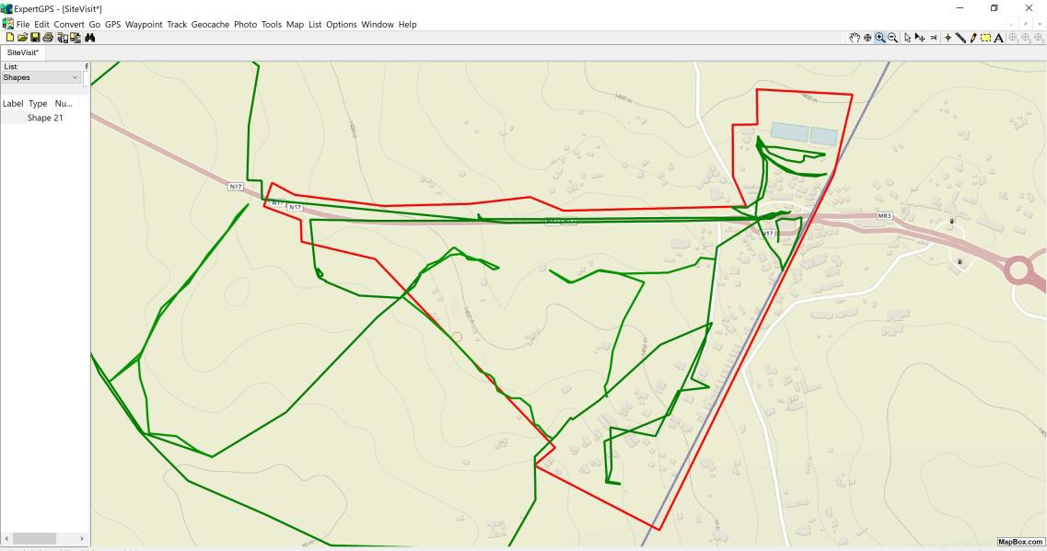

Figure 1. Map indicating the track log of the field survey.

    - Interviews

An interview was conducted with Mr L Mokoena, Deputy Director: IMS, Oshoek Port of Entry, regarding the project and the possibility of heritage sites and features located within the project area.

    - Documentation

All sites, objects and structures that are identified are documented according to the general minimum standards accepted by the archaeological profession. Coordinates of individual localities are determined by means of the Global Positioning System (GPS) and plotted on a map. This information is added to the description in order to facilitate the identification of each locality.

The track log and identified sites were recorded by means of a Garmin Oregon 550 handheld GPS device. Photographic recording was done by means of a Canon EOS 550D digital camera.

Map datum used: Hartebeeshoek 94 (WGS84).

PROJECT DESCRIPTION

  - Site location

The Oshoek Land Port of Entry is located along the N17 national route at the border with Swaziland, Albert

Luthuli District Municipality, Mpumalanga Province (Fig. 2). For more information, see the Technical Summary on p. V above.

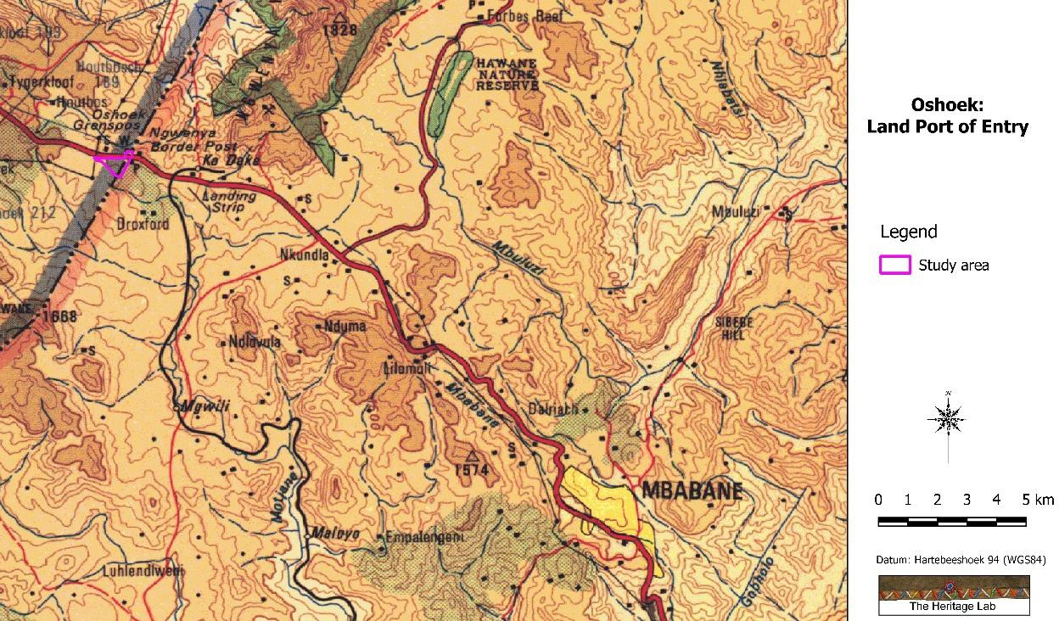

Figure 2. Location of the study area in regional context. (Map 2630: Chief Surveyor-General)

Development proposal

The Department of Public Works proposes the upgrade of the Oshoek Land Port of Entry. According to Mr L Mokoena, Deputy Director: IMS, Oshoek, this upgrade is required due to the increased vehicle traffic daily passing through the border post. This traffic consists increasingly of large vehicles transporting goods to and from the coast, as well as internally through Swaziland.

The upgrade would consist, inter alia, of the following (both departing and incoming sides- see Figure 3 below):

- Administration building
- Staff parking area
- Pedestrian control area
- Inspection bays
- Clearing agents
- SAPS holding
- Holding area
- Incinerator
- Toilets
- Freight handling area
- Car parking bays
- Bus and taxi parking bays
- Freight parking bays
- Kennels
- Weigh bridges
- Gate houses
- Security fences

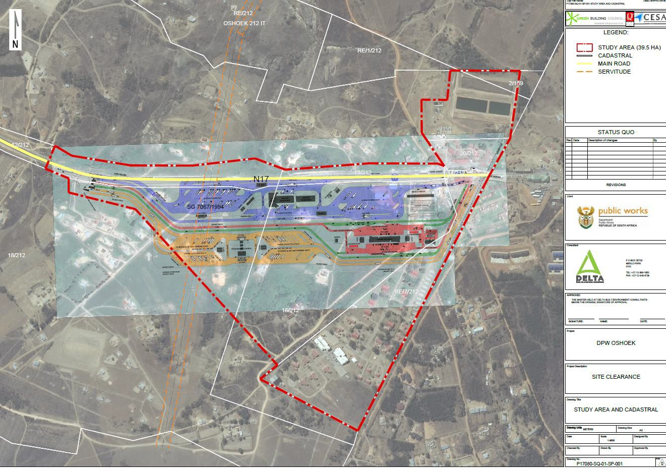

Figure 3. Layout of the proposed development. (Map supplied by DeltaBEC)

The proposed upgrade would impact only on the area south of the N17, including the current immigration, customs and police facilities, as well as some private shops lining the main road and a few existing private houses. The existing staff accommodation and infrastructure on the northern side of the N17 such as the offices and the waste water treatment works would not be impacted on.

DESCRIPTION OF THE AFFECTED ENVIRONMENT

  - Natural Environment

The study area lies in a transformed environment with a well-established forestry/agricultural landscape. The geology of the region is made up of quartz, changing to lava some distance to the north of the study area. The original vegetation is classified as KaNgwane Montane Grassland, falling in the Mesic Highveld Grassland Bioregion, but most of this has been transformed due to farming and forestry activities. The topography of the region is described as high mountains, changing to undulating hills and lowlands south of the study area.

Built Environment

Based on a study of old maps, it is clear that the study area was very much under-developed until quite recently. A road, telegraph wire and possible border crossing is indicated on the 1906 map compiled by the War Office (Fig. 4).

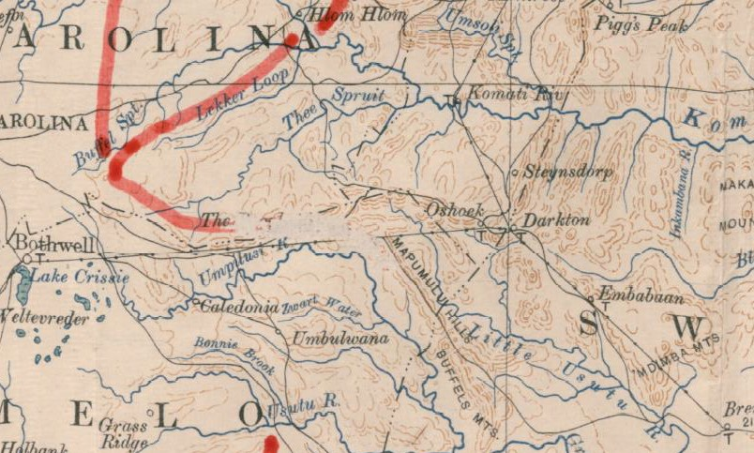

Figure 4. The existence of a border crossing indicated on the Transvaal Map of 1906. (War Office, 1906)

The 1943 version of the 1:50 000 topocadastral map (Fig. 5) indicate very few built structures in the study area. These can be identified as two stores (W = winkels) and a post office (P). The old road still exists today (see map in Fig. 5) and by using this it was possible to determine the location of the old shop/house located west of the border fence.

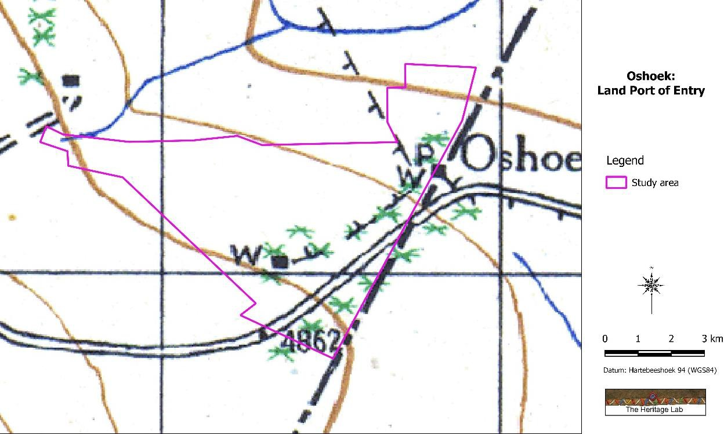

Figure 5. The study area on the 1943 version of the topocadastral map. (Map 2630BB: Chief Surveyor-General)

Currently, the built environment in the study area can be divided into three distinct areas:

- The official border control facilities (Fig. 6 below);
- The support facilities such as staff accommodation and infrastructure (Fig. 7 below);
- Private structures including houses, shops, churches, etc. (Fig. 8).

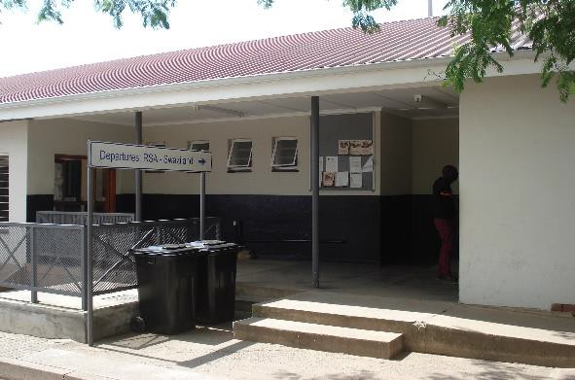  Departure hall | 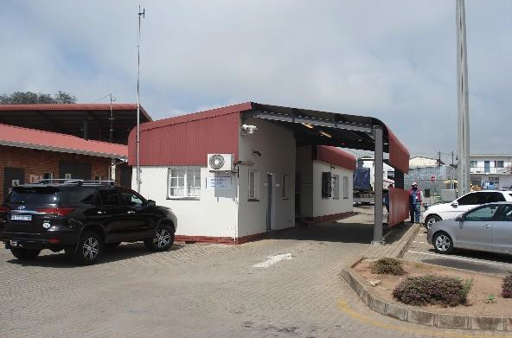  Vehicle inspection area
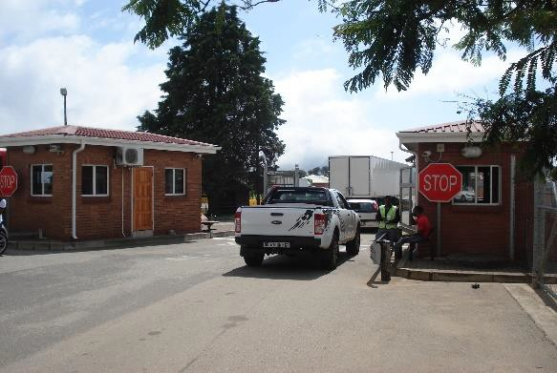  Offices | 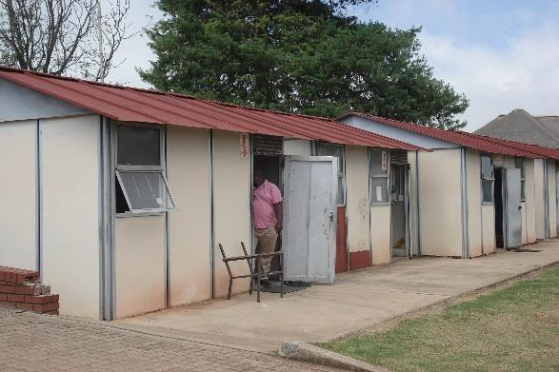  Offices
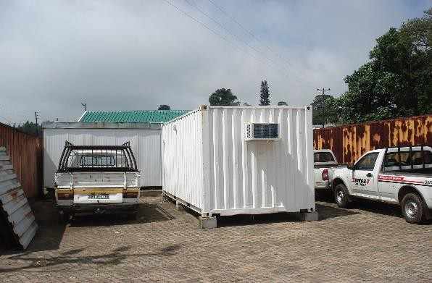  Semi-permanent storage | 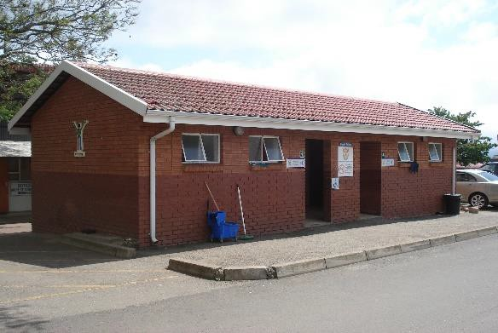  Ablution facilities

Figure 6. Border control facilities.

These buildings comply to a standard pattern found at most border posts around the country. The buildings are purely functional, having been constructed with brick and have tile roofs. As traffic volumes increased over the years, additional facilities were added, most consisting of ‘temporary’ asbestos buildings or shipping containers.

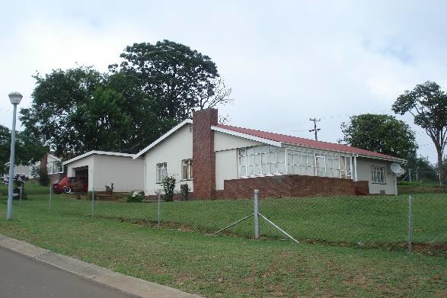  Staff accommodation | 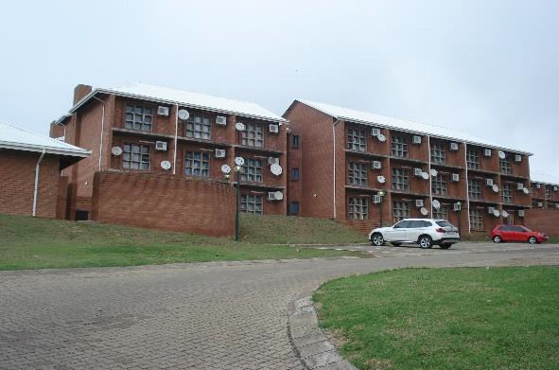  Staff accommodation
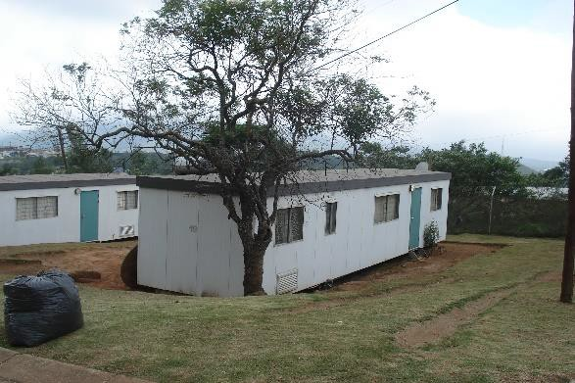  Staff accommodation | 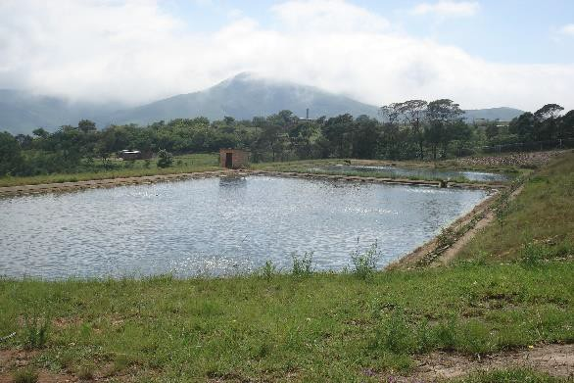  Waste water treatment

Figure 7. Various support facilities.

The support facilities such as the staff accommodation consists of either modern brick and tile houses,
high rise flats and ‘temporary’ trailer-like units.

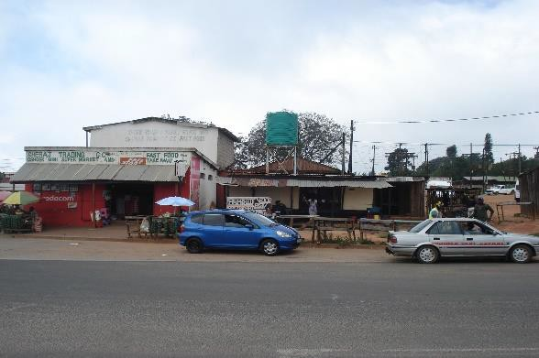  Formal shops | 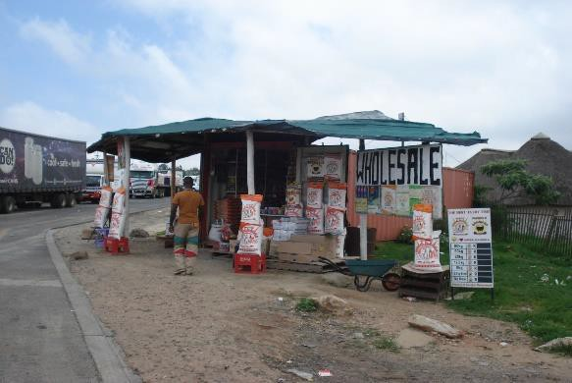  Informal shops
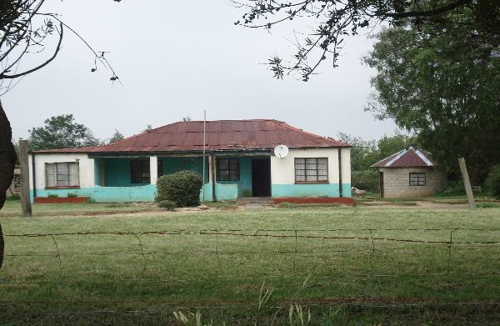  Houses | 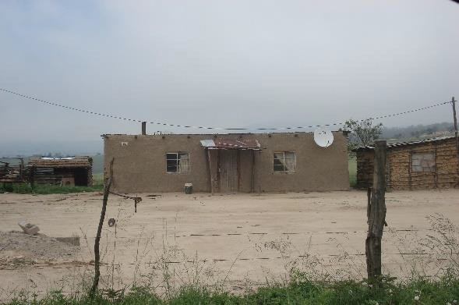  Houses

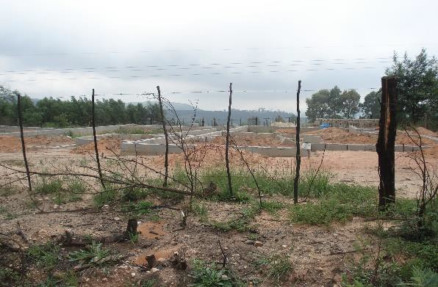  New houses | 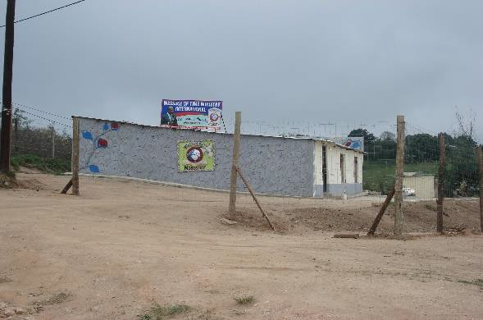  Church
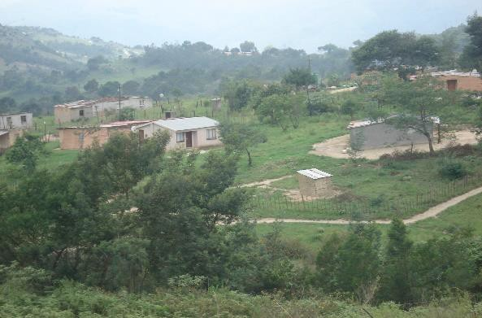  Landscape (looking north) | 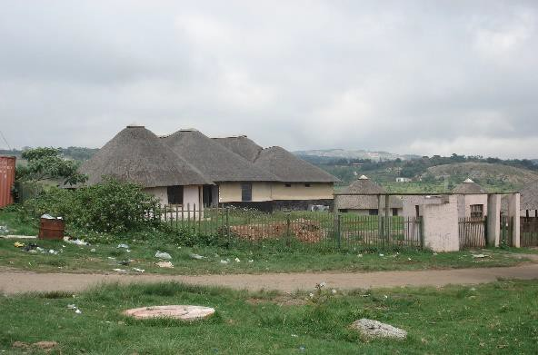  Cultural village (abandoned)

Figure 8. Views over the larger study area.

The area surrounding the border control facility contains an eclectic mix of structures, from formal and informal shops, a disused cultural village, at least two churches and a number of houses, some of bricks with tin roofs, but most are wattle-and-daub flat-roofed structures.

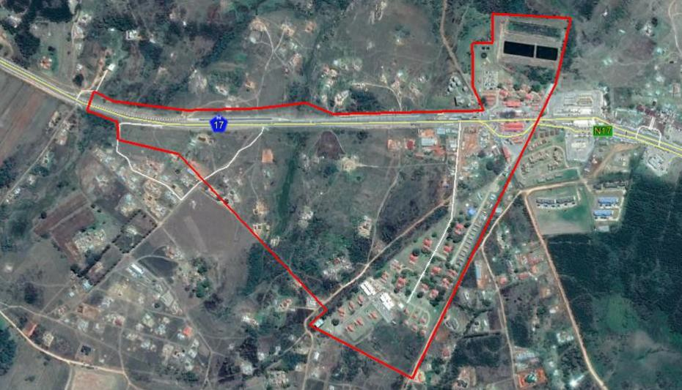

Figure 9. Aerial view of the study area. (Image: Google Earth)

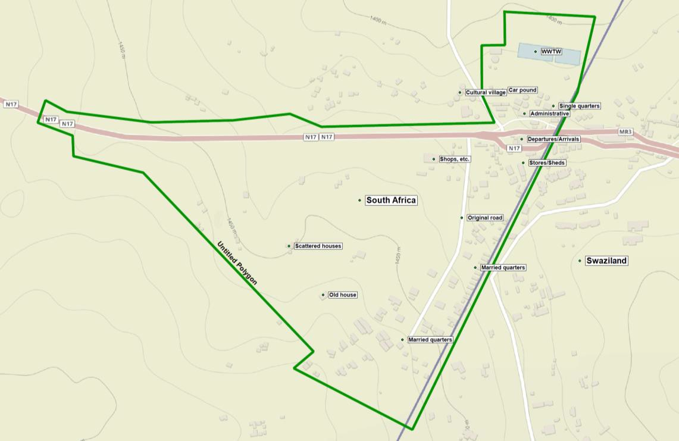

Figure 10. Location of main features in the study area.

Historical Significance

- Are the buildings associated with a historic person or group?
It is unknown whether the border control post or any one of the dwellings can be associated with a particular historic person or group.

- Are the buildings associated with a historic event or activity?
No information could be obtained to confirm whether the buildings are associated with an outstanding historic event of national or regional significance.

- Are the buildings associated with a historic, religious, social, economic or political activity?
The buildings are associated with a particular group of people namely border control workers that filled a particular echelon in the hierarchy of workers within various government departments (customs and immigration, police, etc.).

- Do any of the buildings illustrate a historical period?
The buildings do not illustrate a historical period, apart from the fact that it was designed to fulfil a specific utilitarian function and was probably upgraded during the time when anti-apartheid resistance movements were on the increase.

- Are any of the buildings older than 60 years?
According available information, the architectural ‘style’ and architectural vocabulary, the buildings can
be dated to about 1960-1970.

Architectural significance

- Are any of the buildings an example of a particular building type?
The buildings reflect the type of structures erected by the government at numerous border control
points along South Africa’s borders with its neighbouring countries.

- Are any of the buildings an example of a particular style or period?
The architecture of these buildings does not relate to a particular school-of-design (such as Edwardian, Art Deco or Modern movement) but relate to ‘designed’ functional architecture for utilitarian purposes. At best, it can be referred to as typical ‘border control’. Whether it can be categorized as a ‘style’ in architectural terms still needs to be debated.

- Do the buildings contain fine details and or workmanship?
The buildings can, at best, be described as being bland, with the focus on their functional purposes. No decorations were identified and the construction detailing had low maintenance as aim in mind.

- What is the state of the integrity of the buildings?
As the buildings were erected by the Government, the structures had to be constructed according to strict Government guidelines and details were specified according to the ‘book’ (Government standards, not by Municipal building regulations). This resulted in buildings that were solid in structure and based on a preliminary survey the buildings seem to be structurally sound.

- Are the buildings still utilized?
All the buildings are still utilized according to their original design purpose.

- Were the buildings extended and altered?
None of the buildings have been extended or altered.

Environmental and spatial significance

- Is the site a landmark in the town or city?
The site exists solely for the purpose of controlling the movement of goods and people across an international border.

- Does the site or any of the features contribute to the character of the neighbourhood?
This is a purposely designed site and as such has its own character

- Does the site or any of the features contribute to the character of the street or square?
The site is not located in the vicinity of a square but arranged in a linear pattern along a street (N17) as well as along the border fence.

- Is it an important group of buildings?
It is our judgement that this is not an important group of buildings other than for the purpose they are required to serve – controlling the movement of people and goods across an international border.

Cultural Landscape

The aim of this section is to present an overview of the history of the larger region in order to eventually determine the significance of heritage sites identified in the study area, within the context of their historic, aesthetic, scientific and social value, rarity and representivity.

The cultural landscape qualities of the region essentially consist of various components. The first is a rural area in which the human occupation is made up of a limited Stone Age occupation. This was followed much later by Sotho- and Nguni-speaking agro-pasturalist that settled in the region. They were soon followed by a colonial (farmer) component, which gave rise to the development of small villages and hamlets that dot the larger landscape. The final transformation was brought about by the intensive forestry industry that developed during the past century.

    - Stone Age

The larger region has been inhabited by humans since Early Stone Age (ESA) times. Tools dating to this period are mostly, although not exclusively, found in the vicinity of watercourses. The oldest of these tools are known as choppers, crudely produced from large pebbles found in the river. Later, Homo erectus and early Homo sapiens people made tools shaped on both sides, called bifaces. Biface technology is known as the Acheulean tradition, from St Acheul in France, where bifaces were first identified in the mid-19th century.

Two of the more important sites dating to the Early and Middle Stone Age are Lion and Castle caverns at Ngwenya Mine in western Swaziland and Border Cave in the east, although the latter is located across the border just outside Swaziland.

During Middle Stone Age (MSA) times (c. 150 000 – 30 000 BP), people became more mobile, occupying areas formerly avoided. According to Thakeray (1992) the MSA is a period that still remains somewhat murky, as much of the MSA lies beyond the limits of conventional radiocarbon dating. However, the concept of the MSA remains useful as a means of identifying a technological stage characterized by flakes and flake-blades with faceted platforms, produced from prepared cores, as distinct from the core tool-based ESA technology.

Open sites were still preferred near watercourses. These people were adept at exploiting the huge herds of animals that passed through the area, on their seasonal migration. As a result, tools belonging to this period also mostly occur in the open or in erosion dongas. Similar to the ESA material, artefacts from these surface collections are viewed not to be in a primary context and have little or no significance.

Late Stone Age (LSA) people had even more advanced technology than the MSA people and therefore succeeded in occupying even more diverse habitats. Also, for the first time we now get evidence of people’s activities derived from material other than stone tools. Ostrich eggshell beads, ground bone arrowheads, small bored stones and wood fragments with incised markings are traditionally linked with the LSA.

LSA people preferred, though not exclusively, to occupy rock shelters and caves and it is this type of sealed context that make it possible for us to learn much more about them than is the case with earlier periods. Only a few stratified sites are known to exist in the study area. One of these, called Siphiso Shelter is located in eastern Swaziland and was excavated by Barham (1989). It shows that the later assemblages contain material that can be related to the Oakhurst as well as Wilton Complex.

LSA people also left behand an incredible legacy reflecting on the work view in the form of rock art. A number of sites with rock art are known from the Chrissiesmeer region and near Amsterdam.

    - Iron Age

Iron Age people started to settle in southern Africa c. AD 300, with one of the oldest known site at Silver Leaves south east of Tzaneen dating to AD 270. Having only had cereals (sorghum, millet) that need summer rainfall, Early Iron Age (EIA) people did not move outside this rainfall zone, and neither did they occupy the central interior highveld area. Because of their specific technology and economy, Iron Age people preferred to settle on the alluvial soils near rivers for agricultural purposes, but also for firewood and water.

The occupation of the larger geographical area (including the study area) did not start much before the 1500s. To understand all of this, we have to take a look at the broader picture. Towards the end of the first millennium AD, Early Iron Age communities underwent a drastic change, brought on by increasing trade on the East African coast. This led to the rise of powerful ruling elites, for example at Mapungubwe. The abandonment of Mapungubwe (c. AD 1270) and other contemporaneous settlements

show that widespread drought conditions led to the decline and eventual disintegration of this state Huffman (2005).

By the 16th century things changed again, with the climate becoming warmer and wetter, creating condition that allowed Late Iron Age (LIA) farmers to occupy areas previously unsuitable, for example the Witwatersrand and the treeless, wind swept plains of the Free State and the Mpumalanga highveld.

This period of consistently high rainfall started in about AD 1780. At the same time, maize was introduced from Maputo and grown extensively. Given good rains, maize crops yield far more than sorghum and millets. This increase in food production probably led to increased populations in coastal area as well as the central highveld interior by the beginning of the 19th century.

This wet period came to a sudden end sometime between 1800 and 1820 by a major drought lasting 3 to 5 years. The drought must have caused an agricultural collapse on a large, subcontinent scale.
A number of stone-walled archaeological sites, which are dated to the Late Iron Age (c. AD 1640 - AD 1830s), are said to exist on the highveld areas of Swaziland. Many of these are linked to early Sotho- speaking people that used to live here. Other sites, such as Simunye in the north-east, excavated by Ohinata (2002), are said to be of Tsonga-speaker origin.

The people that eventually became known as the Swazi entered the area c. 1750 under King Ngwane III (Matsebula 1972). The history of modern Swaziland is essentially one of disputes over borders with the ZAR government, entrepreneurs vying for concessions and land, and the British control of the region (Bonner 1983). Industrial and mining activities also took place in the region, on an ever-increasing scale. Gold mining dates to the late 19th, e.g. at Pigg’s Peak and forestry also became a big operation, going back as far as the early 1900s.

    - Historic period

Things were set to change drastically during the early part of the 19th century. Not only was it a time of population movement resulting from events to the south and east, but it was also the arrival of the first white settlers in the area.

Currently, a number of towns exist in the area, with Volksrus and Piet Retief the larger ones. All of these date to the latter half of the 19th century and each has its own history as each developed for a particular reason. As they were small and largely served farming communities, they did not expand rapidly. Consequently, all of them retained many buildings (shops, houses, churches, schools) and other features (cemeteries) of heritage significance.

The various battles and skirmishes resulting from the conflict during the Anglo-Boer War (1899-1902) had a huge impact on heritage resources in the area, as many farms were burned down. Conversely, it also left a legacy of heritage sites scattered across the veld: fortifications and war cemeteries occur all over.

The area remained up till today a largely farming orientated community. Much of the heritage potential of the study area is therefore located within the many farmsteads in the area. Farmhouses and related structures (e.g. barns, sheds, etc.), as well as cemeteries, dot the landscape. Equally important, are the homesteads, related structures and cemeteries of the farm labourers living on these farms.

Industrial and mining activities also took place in the region, on an ever-increasing scale. Coal mining date to the beginning of the 20th century, although there is written evidence that it was exploited by farmers prior to that. Forestry also became a big operation, going back as far as the early 1900s.

SURVEY RESULTS

During the physical survey, the following sites, features and objects of cultural significance were identified in the study area – see Section 6 of the Addendum for a more detailed discussion of each of the identified sites, features or objects:

Stone Age

- No sites, features or objects of cultural significance dating to the Stone Age were identified in the study area.

Iron Age

- No sites, features or objects of cultural significance dating to the Stone Age were identified in the study area.

Historic period

- (7.3.1) An old house that, according to evidence, is probably older than 60 years and as such enjoy general protection under the NHR Act. The house is still in use and seems structurally sound. From an architectural point, it is similar to other structures occurring in the larger region and dates to the period between 1930 to 1950. Due to its good condition, its significance is rated as medium high.

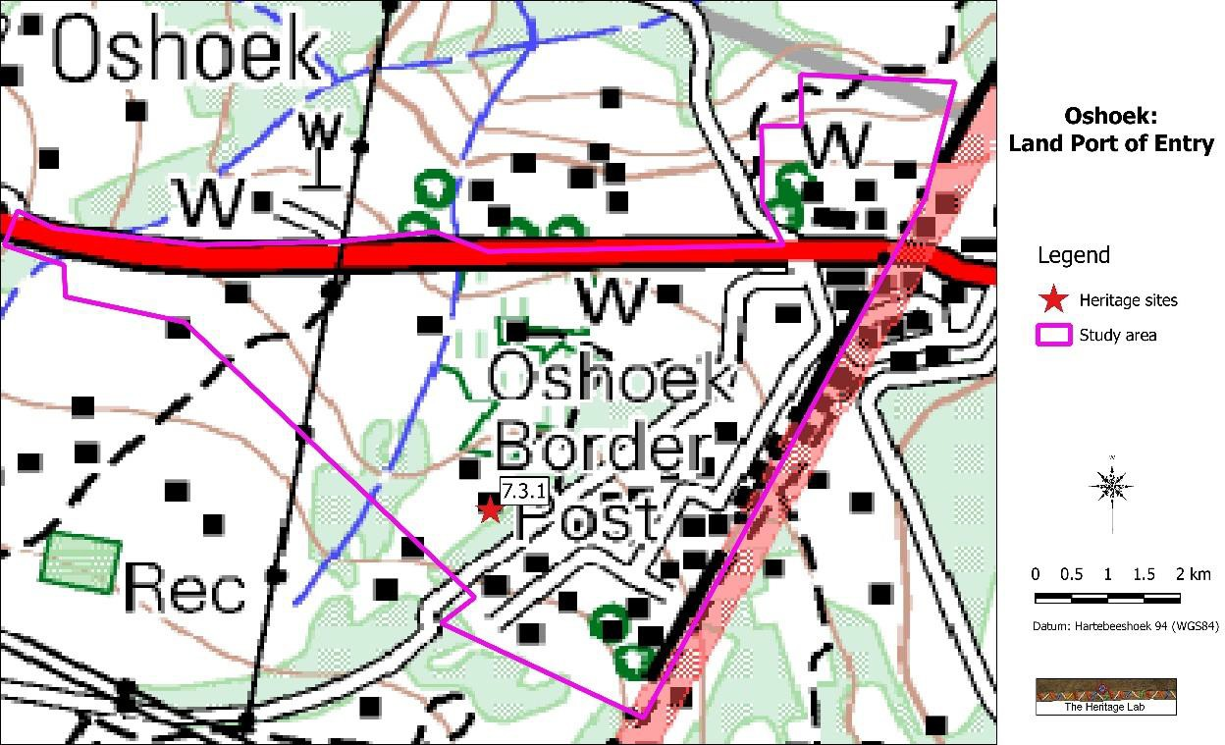

Figure 11. Location of heritage sites in the study area.

RESULTS: STATEMENT OF SIGNIFICANCE AND IMPACT RATINGS

  - Impact assessment

Heritage impacts are categorised as:

- Direct or physical impacts, implying alteration or destruction of heritage features within the project boundaries;
- Indirect impacts, e.g. restriction of access or visual intrusion concerning the broader environment;
- Cumulative impacts that are combinations of the above.

Impact analysis of cultural heritage resources under threat of the proposed development, is based on the present understanding of the development and its significance is calculated and presented below:

- The impact on (Site 7.3.1) is calculated as follows:

Table 2: Impact assessment

Nature: The feature is located inside the proposed development area and an unmitigated impact would be
direct and have permanent consequences.
 | Without mitigation | With mitigation
Extent | Local area | Site
Duration | Permanent | Permanent
Magnitude | Low | Minor
Probability | Probable | Low
Significance | Medium (36) | Low (8)
Status (positive or negative) | Negative | Neutral
Reversibility | Non-reversible | Non-reversible
Irreplaceable loss of resources? | Yes | No
Can impacts be mitigated | Yes
Mitigation: Avoidance of site
Cumulative impact: Loss of one of a limited number of similar features in the larger landscape.

MANAGEMENT AND MITIGATION MEASURES

Heritage sites are fixed features in the environment, occurring within specific spatial confines. Any impact upon them is permanent and non-reversible. Those resources that cannot be avoided and that are directly impacted by the proposed development can be excavated/recorded and a management plan can be developed for future action. Those sites that are not impacted on can be written into the management plan, whence they can be avoided or cared for in the future.

Sources of risk were considered with regards to development activities defined in Section 2(viii) of the NHRA that may be triggered and are summarised in Table 3A and 3B below. These issues formed the basis of the impact assessment described. The potential risks are discussed according to the various phases of the project below.

Objectives

- Protection of archaeological, historical and any other site or land considered being of cultural value within the project boundary against vandalism, destruction and theft.
- The preservation and appropriate management of new discoveries in accordance with the NHRA, should these be discovered during construction activities.

The following shall apply:

- Known sites should be clearly marked in order that they can be avoided during construction activities.

- The contractors and workers should be notified that archaeological sites might be exposed during the construction activities.
- Should any heritage artefacts be exposed during excavation, work on the area where the artefacts were discovered, shall cease immediately and the Environmental Control Officer shall be notified as soon as possible;
- All discoveries shall be reported immediately to a heritage practitioner so that an investigation and evaluation of the finds can be made. Acting upon advice from these specialists, the Environmental Control Officer will advise the necessary actions to be taken;
- Under no circumstances shall any artefacts be removed, destroyed or interfered with by anyone on the site; and
- Contractors and workers shall be advised of the penalties associated with the unlawful removal of cultural, historical, archaeological or palaeontological artefacts, as set out in the National Heritage Resources Act (Act No. 25 of 1999), Section 51. (1).

Control

In order to achieve this, the following should be in place:

- A person or entity, e.g. the Environmental Control Officer, should be tasked to take responsibility for the heritage sites and should be held accountable for any damage.
- Known sites should be located and isolated, e.g. by fencing them off. All construction workers should be informed that these are no-go areas, unless accompanied by the individual or persons representing the Environmental Control Officer as identified above.
- In areas where the vegetation is threatening the heritage sites, e.g. growing trees pushing walls over, it should be removed, but only after permission for the methods proposed has been granted by SAHRA. A heritage official should be part of the team executing these measures.

Table 3A: Construction Phase: Environmental Management Programme for the project

Action required | Protection of heritage sites, features and objects
Potential Impact | The identified risk is damage or changes to resources that are generally protected in terms of Sections 27, 28, 31, 32, 34, 35, 36 and 37 of the NHRA that may occur in the  proposed project area.
Risk if impact is not mitigated | Loss or damage to sites, features or objects of cultural heritage significance
Activity / issue | Mitigation: Action/control | Responsibility | Timeframe
- Removal of Vegetation  - Construction of required infrastructure,  e.g. access roads, water  pipelines | See discussion in Section 9.1 above | Environmental Control Officer | During construction only
Monitoring | See discussion in Section 9.2 above

Table 3B: Operation Phase: Environmental Management Programme for the project

Action required | Protection of heritage sites, features and objects
Potential Impact | It is unlike that the negative impacts identified for pre-mitigation will occur if the recommendations are followed.
Risk if impact is not  mitigated | Loss or damage to sites, features or objects of cultural heritage significance
Activity / issue | Mitigation: Action/control | Responsibility | Timeframe
- Removal of Vegetation  - Construction of  required infrastructure, | See discussion in Section 9.1 above | Environmental Control Officer | During construction only

e.g. access roads, water
pipelines
Monitoring | See discussion in Section 9.2 above

  - Mitigation measures

Mitigation: means to anticipate and prevent negative impacts and risks, then to minimise them, rehabilitate or repair impacts to the extent feasible.

For the current study, two alternative mitigation measures are posed, ranked in order of preference (see Section 4 of the Addendum for a discussion of all possible mitigation measures):

- (1) Avoidance/Preserve: This is viewed to be the primary form of mitigation. The site should be retained in situ and a buffer zone should be created around it, either temporary (by means of danger tape) or permanently (wire fence or built wall). Depending on the type of site, the buffer zone can vary from
  - 10 metres for a single grave or a built structure, to
  - 50 metres where the boundaries are less obvious, e.g. a Late Iron Age site.

- (2) Archaeological investigation: This option can be implemented with additional design and construction inputs. Mitigation is to excavate the site by archaeological techniques, document the site (map and photograph) and analyse the recovered material to acceptable standards. This can only be done by a suitably qualified archaeologist.
  - This option should be implemented when it is impossible to avoid impacting on an identified site or feature.
    - Impacts can be beneficial – e.g. mitigation contribute to knowledge

CONSLUSIONS AND RECOMMENDATIONS

The Department of Public Works proposes the upgrade of the Oshoek Land Port of Entry, located along the N17 national route at the border with Swaziland, Albert Luthuli District Municipality, Mpumalanga Province.

In accordance with Section 38 of the NHRA, an independent heritage consultant was appointed by DeltaBEC to conduct a cultural heritage assessment to determine if the proposed upgrade of the port of entry would have an impact on any sites, features or objects of cultural heritage significance.

This report describes the methodology used, the limitations encountered, the heritage features that were identified and the recommendations and mitigation measures proposed relevant to this. It should be noted that the implementation of the mitigation measures is subject to SAHRA/PHRA’s approval.

The cultural landscape qualities of the region essentially consist of various components. The first is a rural area in which the human occupation is made up of a limited Stone Age occupation. This was followed much later by Sotho- and Nguni-speaking agro-pasturalist that settled in the region. They were soon followed by a colonial (farmer) component, which gave rise to the development of small villages and hamlets that dot the larger landscape. The final transformation was brought about by the intensive forestry industry that developed during the past century.

The HIA consisted of a desktop study (archival sources, database survey, maps and aerial imagery) and a physical survey that included the interviewing of relevant people. During the physical survey, a single heritage resource was identified:

IDENTIFIED HERITAGE RESOURCES
Site No. | Site type | NHRA  category | Field rating | Impact rating: Before/After | Proposed mitigation (Refer to definitions in  Addendum Section 4)
Oshoek Land Port of Entry
7.3.1 | Built structure  -26.21565, 30.98427 | Section 34 | Medium significance Grade IV-A | 36 | - Avoid site; or  - Document site
 |  |  |  | 8

Reasoned opinion as to whether the proposed activity should be authorised:

- From a heritage point of view, it is recommended that the proposed development be allowed to continue on acceptance of the proposed mitigation measures.

Conditions for inclusion in the environmental authorisation:

- Should archaeological sites or graves be exposed in other areas during construction work, it must immediately be reported to a heritage practitioner so that an investigation and evaluation of the finds can be made.

REFERENCES

  - Data bases

Chief Surveyor General
Environmental Potential Atlas, Department of Environmental Affairs and Tourism. Heritage Atlas Database, Pretoria
National Archives of South Africa
SAHRA Archaeology and Palaeontology Report Mapping Project (2009) SAHRIS Database

Literature

Barham, L.S. 1989. A Preliminary Report on the Later Stone Age Artefacts from Siphiso Shelter in Swaziland. South African Archaeological Bulletin 44(149):33-43.

Bergh, J.S. (red.). 1998. Geskiedenisatlas van Suid-Afrika: die vier noordelike provinsies. Pretoria: J.L. Schaik.

Bonner, P. 1983. Kings, Commoners and Concessionairies: the evolution and dissolution of the nineteenth-century Swazi state. Ravan Press: Johannesburg.

Delius, P (ed.) 2007. Mpumalanga: History and Heritage. Scotsville: University of KwaZulu-Natal Press. Delius, P. & Hay, M. 2009. Mpumalanga: an illustrated history. Johannesburg: The Highveld Press.
Huffman, T.N. 2007. Handbook to the Iron Age. Scottsville: University of KwaZulu-Natal Press. Kuper, H. 1952. The Swazi. London: International African Institute.
Kuper, H. 1963. The Swazi: a South African Kingdom. New York: Holt, Rinehart & Winston.

Marwick, B.A. 1940. The Swazi: an Ethnographic Account of the Natives of the Swaziland Protectorate. Cambridge: Cambridge University Press.

Matsebula, J.S.M. 1972. A History of Swaziland. Cape Town: Longmans Southern Africa.

Muncina, L. & Rutherford, M.C. 2006. The Vegetation Map of South Africa, Lesotho and Swaziland. Pretoria: SANBI.

Myburgh, A.C. 1956. Die stamme van die Distrik Carolina. Etnologiese Reeks Nr. 34. Pretoria: Staatsdrukker.

Ohinata, F. 2000. Preliminary results of the 1998 field survey of farming community sites in Swaziland.
Nyame Akuma 53:42-49.

Ohinata, F. 2002. The beginning of ‘Tsonga’ archaeology: excavations at Simunye, north-eastern Swaziland. Southern African Humanities 14:23-50.

Steyn, A.C. 1994. Styl in rotskuns: “Kleinspruit” terrain aan die Oos-Transvaalse Platorand. Research by the National Cultural History Museum 3:1-42.

Van der Merwe, P.D.R. 2001. Historical overview of the Mahlalela People. In Van Schalkwyk, J.A. (ed.) A forgotten corner of the country: heritage documentation and development in the eMbuzini valley, Mpumalanga Province. Research by the National Cultural History Museum 10:19-29.

Van der Merwe, P.D.R. & van Schalkwyk, J.A. 2001. Living heritage. In Van Schalkwyk, J.A. (ed.) A forgotten corner of the country: heritage documentation and development in the eMbuzini valley, Mpumalanga Province. Research by the National Cultural History Museum 10:83-90.

Van Schalkwyk, J.A. 2013. Heritage impact assessment for the proposed Dundonald shopping centre, Dundonald-A, Albert Luthuli Local Municipality, Mpumalanga Province. Pretoria: Unpublished report 2013/JvS/004.

Archival sources

Depot SAB; Source URU; Volume No. 314; Reference 892; Part 1; Starting 1917, Ending 1917. Depot SAB; Source SAS; Volume No. 1632; Reference Rmt142; Part 1; Starting 1926, Ending 1952. Depot SAB; Source URU; Volume No. 1320; Reference 2895; Part 1; Starting 1932, Ending 1932.
Depot SAB; Source URU; Volume No. 4208; Reference 1439; Part 1; Starting 1961, Ending 1961.

Maps and aerial photographs

1: 50 000 Topocadastral maps
War Office 1906, Transvaal Map (Provisional Issue) Google Earth

ADDENDUM

Indemnity and terms of use of this report

The findings, results, conclusions and recommendations given in this report are based on the author’s best scientific and professional knowledge as well as available information. The report is based on survey and assessment techniques which are limited by time and budgetary constraints relevant to the type and level of investigation undertaken and the author reserve the right to modify aspects of the report including the recommendations if and when new information may become available from ongoing research or further work in this field, or pertaining to this investigation.

Although all possible care is taken to identify all sites of cultural importance during the investigation of study areas, it is always possible that hidden or sub-surface sites could be overlooked during the study. The author of this report will not be held liable for such oversights or for costs incurred as a result of such oversights.

Although the author exercises due care and diligence in rendering services and preparing documents, he accepts no liability and the client, by receiving this document, indemnifies the author against all actions, claims, demands, losses, liabilities, costs, damages and expenses arising from or in connection with services rendered, directly or indirectly by the author and by the use of the information contained in this document.

This report must not be altered or added to without the prior written consent of the author. This also refers to electronic copies of this report which are supplied for the purposes of inclusion as part of other reports, including main reports. Similarly, any recommendations, statements or conclusions drawn from or based on this report must make reference to this report. If these form part of a main report relating to this investigation or report, this report must be included in its entirety as an appendix or separate section to the main report.

Specialist competency

Johan (Johnny) van Schalkwyk

J A van Schalkwyk, D Litt et Phil, heritage consultant, has been working in the field of heritage management for more than 40 years. Originally based at the National Museum of Cultural History, Pretoria, he has actively done research in the fields of anthropology, archaeology, museology, tourism and impact assessment. This work was done in Limpopo Province, Gauteng, Mpumalanga, North West Province, Eastern Cape Province, Northern Cape Province, Botswana, Zimbabwe, Malawi, Lesotho and Swaziland. Based on this work, he has curated various exhibitions at different museums and has published more than 70 papers, most in scientifically accredited journals. During this period, he has done more than 2000 impact assessments (archaeological, anthropological, historical and social) for various government departments and developers. Projects include environmental management frameworks, roads, pipeline-, and power line developments, dams, mining, water purification works, historical landscapes, refuse dumps and urban developments.

A complete curriculum vitae can be supplied on request.

Assessing the significance of heritage resources and potential impacts

A system for site grading was established by the NHRA and further developed by the South African Heritage Resources Agency (SAHRA 2007) and has been approved by ASAPA for use in southern Africa and was utilised during this assessment.

  - Significance of the identified heritage resources

According to the NHRA, Section 2(vi) the significance of a heritage sites and artefacts is determined by it aesthetic, architectural, historical, scientific, social, spiritual, linguistic or technical value in relation to the uniqueness, condition of preservation and research potential. It must be kept in mind that the various aspects are not mutually exclusive, and that the evaluation of any site is done with reference to any number of these.

Matrix used for assessing the significance of each identified site/feature

1. SITE EVALUATION
1.1 Historic value
Is it important in the community, or pattern of history
Does it have strong or special association with the life or work of a person, group or organisation
of importance in history
Does it have significance relating to the history of slavery
1.2 Aesthetic value
It is important in exhibiting particular aesthetic characteristics valued by a community or cultural
group
1.3 Scientific value
Does it have potential to yield information that will contribute to an understanding of natural or
cultural heritage
Is it important in demonstrating a high degree of creative or technical achievement at a particular
period
1.4 Social value
Does it have strong or special association with a particular community or cultural group for social,
cultural or spiritual reasons
1.5 Rarity
Does it possess uncommon, rare or endangered aspects of natural or cultural heritage
1.6 Representivity
Is it important in demonstrating the principal characteristics of a particular class of natural or
cultural places or objects
Importance in demonstrating the principal characteristics of a range of landscapes or
environments, the attributes of which identify it as being characteristic of its class
Importance in demonstrating the principal characteristics of human activities (including way of life, philosophy, custom, process, land-use, function, design or technique) in the environment of the
nation, province, region or locality.
2. Sphere of Significance |  | High | Medium | Low
International
National
Provincial
Regional
Local
Specific community
3. Field Register Rating
1. | National/Grade 1: High significance - No alteration whatsoever without permit from SAHRA
2. | Provincial/Grade 2: High significance - No alteration whatsoever without permit from  provincial heritage authority.
3. | Local/Grade 3A: High significance - Mitigation as part of development process not advised.
4. | Local/Grade 3B: High significance - Could be mitigated and (part) retained as heritage register site
5. | Generally protected A: High/medium significance - Should be mitigated before destruction

6. | Generally protected B: Medium significance - Should be recorded before destruction
7. | Generally protected C: Low significance - Requires no further recording before destruction

  - Significance of the anticipated impact on heritage resources

All impacts identified during the HIA stage of the study will be classified in terms of their significance. Issues would be assessed in terms of the following criteria:

Nature of the impact
A description of what causes the effect, what will be affected and how it will be affected.

Extent
The physical extent, wherein it is indicated whether:
- 1 - The impact will be limited to the site;
- 2 - The impact will be limited to the local area;
- 3 - The impact will be limited to the region;
- 4 - The impact will be national; or
- 5 - The impact will be international.

Duration
Here it should be indicated whether the lifespan of the impact will be:
- 1 - Of a very short duration (0–1 years);
- 2 - Of a short duration (2-5 years);
- 3 - Medium-term (5–15 years);
- 4 - Long term (where the impact will persist possibly beyond the operational life of the activity); or
- 5 - Permanent (where the impact will persist indefinitely).

Magnitude (Intensity)
The magnitude of impact, quantified on a scale from 0-10, where a score is assigned:
- 0 - Small and will have no effect;
- 2 - Minor and will not result in an impact;
- 4 - Low and will cause a slight impact;
- 6 - Moderate and will result in processes continuing but in a modified way;
- 8 - High, (processes are altered to the extent that they temporarily cease); or
- 10 - Very high and results in complete destruction of patterns and permanent cessation of processes.

Probability
This describes the likelihood of the impact actually occurring and is estimated on a scale where:
- 1 - Very improbable (probably will not happen);
- 2 - Improbable (some possibility, but low likelihood);
- 3 - Probable (distinct possibility);
- 4 - Highly probable (most likely); or
- 5 - Definite (impact will occur regardless of any prevention measures).

Significance
The significance is determined through a synthesis of the characteristics described above (refer to the formula below) and can be assessed as low, medium or high:

S = (E+D+M) x P; where
S = Significance weighting E = Extent
D = Duration
M = Magnitude P = Probability

Significance of impact
Points | Significant Weighting | Discussion
< 30 points | Low | Where this impact would not have a direct influence on the decision to develop in the area.
31-60 points | Medium | Where the impact could influence the decision to develop in the area  unless it is effectively mitigated.
> 60 points | High | Where the impact must have an influence on the decision process to  develop in the area.

Confidence
This should relate to the level of confidence that the specialist has in establishing the nature and degree of impacts. It relates to the level and reliability of information, the nature and degree of consultation with I&AP’s and the dynamic of the broader socio-political context.
- High, where the information is comprehensive and accurate, where there has been a high degree of consultation and the socio-political context is relatively stable.
- Medium, where the information is sufficient but is based mainly on secondary sources, where there has been a limited targeted consultation and socio-political context is fluid.
- Low, where the information is poor, a high degree of contestation is evident and there is a state of socio-political flux.

Status
- The status, which is described as either positive, negative or neutral.

Reversibility
- The degree to which the impact can be reversed.

Mitigation
- The degree to which the impact can be mitigated.

Nature:
 | Without mitigation | With mitigation
Construction Phase
Probability
Duration
Extent
Magnitude
Significance
Status (positive or negative)
Probability
Duration
Extent
Magnitude
Significance
Status (positive or negative)
Reversibility
Irreplaceable loss of resources?
Can impacts be mitigated

Mitigation measures

- Mitigation: means to anticipate and prevent negative impacts and risks, then to minimise them, rehabilitate or repair impacts to the extent feasible.

Impacts can be managed through one or a combination of the following mitigation measures:

- Avoidance
- Investigation (archaeological)
- Rehabilitation
- Interpretation
- Memorialisation
- Enhancement (positive impacts)

For the current study, the following mitigation measures are proposed, to be implemented only if any of the identified sites or features are to be impacted on by the proposed development activities:

- Avoidance/Preserve: This is viewed to be the primary form of mitigation and applies where any type of development occurs within a formally protected or significant or sensitive heritage context and is likely to have a high negative impact. This measure often includes the change / alteration of development planning and therefore impact zones in order not to impact on resources. The site should be retained in situ and a buffer zone should be created around it, either temporary (by means of danger tape) or permanently (wire fence or built wall). Depending on the type of site, the buffer zone can vary from
  - 10 metres for a single grave, or a built structure, to
  - 50 metres where the boundaries are less obvious, e.g. a Late Iron Age site.

- (2) Archaeological investigation: This option can be implemented with additional design and construction inputs. This is appropriate where development occurs in a context of heritage significance and where the impact is such that it can be mitigated. Mitigation is to excavate the site by archaeological techniques, document the site (map and photograph) and analyse the recovered material to acceptable standards. This can only be done by a suitably qualified archaeologist.
  - This option should be implemented when it is impossible to avoid impacting on an identified site or feature.
  - This also applies for graves older than 60 years that are to be relocated. For graves younger than 60 years a permit from SAHRA is not required. However, all other legal requirements must be adhered to.
    - Impacts can be beneficial – e.g. mitigation contribute to knowledge

- (3) Rehabilitation: When features, e.g. buildings or other structures are to be re-used. Rehabilitation is considered in heritage management terms as an intervention typically involving the adding of a new heritage layer to enable a new sustainable use.
  - The heritage resource is degraded or in the process of degradation and would benefit from rehabilitation.
  - Where rehabilitation implies appropriate conservation interventions, i.e. adaptive reuse, repair and maintenance, consolidation and minimal loss of historical fabric.
    - Conservation measures would be to record the buildings/structures as they are (at a particular point in time). The records and recordings would then become the ‘artefacts’ to be preserved and managed as heritage features or (movable) objects.
    - This approach automatically also leads to the enhancement of the sites or features that are re-used.

- (4) Mitigation is also possible with additional design and construction inputs. Although linked to the previous measure (rehabilitation) a secondary though ‘indirect’ conservation measure would be to use the existing architectural ‘vocabulary' of the structure as guideline for any new designs.

  - The following principle should be considered: heritage informs design.
    - This approach automatically also leads to the enhancement of the sites or features that are re-used.

- (5) No further action required: This is applicable only where sites or features have been rated to be of such low significance that it does not warrant further documentation, as it is viewed to be fully documented after inclusion in this report.
  - Site monitoring during development, by an ECO or the heritage specialist are often added to this recommendation in order to ensure that no undetected heritage/remains are destroyed.

Relocation of graves

If the graves are younger than 60 years, an undertaker can be contracted to deal with the exhumation and reburial. This will include public participation, organising cemeteries, coffins, etc. They need permits and have their own requirements that must be adhered to.

If the graves are older than 60 years old or of undetermined age, an archaeologist must be in attendance to assist with the exhumation and documentation of the graves. This is a requirement by law.

Once it has been decided to relocate particular graves, the following steps should be taken:

- Notices of the intention to relocate the graves need to be put up at the burial site for a period of 60 days. This should contain information where communities and family members can contact the developer/archaeologist/public-relations officer/undertaker. All information pertaining to the identification of the graves needs to be documented for the application of a SAHRA permit. The notices need to be in at least 3 languages, English, and two other languages. This is a requirement by law.
- Notices of the intention needs to be placed in at least two local newspapers and have the same information as the above point. This is a requirement by law.
- Local radio stations can also be used to try contact family members. This is not required by law, but is helpful in trying to contact family members.
- During this time (60 days) a suitable cemetery need to be identified close to the development area or otherwise one specified by the family of the deceased.
- An open day for family members should be arranged after the period of 60 days so that they can gather to discuss the way forward, and to sort out any problems. The developer needs to take the families requirements into account. This is a requirement by law.
- Once the 60 days has passed and all the information from the family members have been received, a permit can be requested from SAHRA. This is a requirement by law.
- Once the permit has been received, the graves may be exhumed and relocated.
- All headstones must be relocated with the graves as well as any items found in the grave.

Information needed for the SAHRA permit application

- The permit application needs to be done by an archaeologist.
- A map of the area where the graves have been located.
- A survey report of the area prepared by an archaeologist.
- All the information on the families that have identified graves.
- If graves have not been identified and there are no headstones to indicate the grave, these are then unknown graves and should be handled as if they are older than 60 years. This information also needs to be given to SAHRA.
- A letter from the landowner giving permission to the developer to exhume and relocate the graves.
- A letter from the new cemetery confirming that the graves will be reburied there.
- Details of the farm name and number, magisterial district and GPS coordinates of the gravesite.

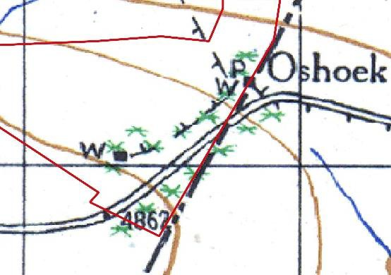

Inventory of identified cultural heritage sites

No.: 7.3.1
Name: Old house/shop  NHRA Category: Structures older than 60 years - Section 34  Farm:  Coordinates: -26,21565; 30,98427 | 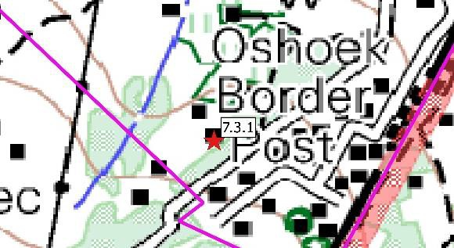

Description
An old house that according to evidence is probably older than 60 years and as such enjoy general protection under the NHR Act. The house is still in use and seems structurally sound. The walls are plastered brick and it has a corrugated tin roof. It is west facing, with a veranda. From an architectural point, it is similar to other structures occurring in the larger region and dates to the
period between 1930 to 1950. Due to its good condition, its significance is rated as medium high.

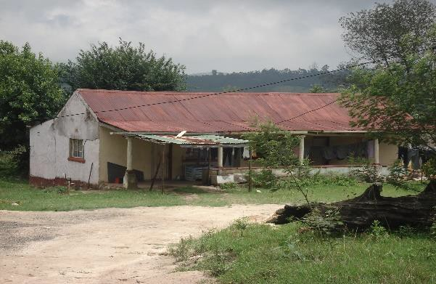 |  | 1943 cadastral map

Significance of site/feature | Generally protected: High significance – Grade IV-A
Reasoned opinion: This feature is probably older than 60 years as it is indicated on the 1943 version
of the 1:50 000 topocadastral map. It is also in a very good condition, reflecting on the excellent quality of the workmanship.

Impact assessment
Although this feature is located inside the study area, it seems as if it might not be impacted on by the proposed development (see Section 5 above). An unmitigated impact would be direct and
permanent.

Mitigation
This feature should be retained and avoided. If that is not possible, it should be documented in full
prior to its destruction. In that case, a permit would be required from PHRA/SAHRA

Significance of impact: before/after mitigation
Extent | Duration | Intensity | Probability | Significance | Weight
2 | 4 | 6 | 3 | 36 | Medium
1 | 1 | 2 | 2 | 8 | Low

Requirements
Conservation by local authority. Site should be mitigated before impact. Permit required from provincial heritage authority.

References
-

