PALAEONTOLOGICAL SPECIALIST STUDY: FIELD ASSESSMENT & RECOMMENDATION FOR EXEMPTION FROM FURTHER STUDIES & MITIGATION

PROPOSED NEW BORROW PIT ALONG THE R327 NEAR VANWYKSDORP, EDEN DISTRICT MUNICIPALITY, WESTERN CAPE

John E. Almond PhD (Cantab.)
Natura Viva cc,
PO Box 12410 Mill Street,

Cape Town 8010, RSA
naturaviva@universe.co.za

May 2014

1. EXECUTIVE SUMMARY

The proposed new MR00356/38.3/0.1L borrow pit along the R327 on Farm 234, situated c. 4.4 km SSE of Vanwyksdorp in Little Karoo region, is to be excavated into marginal marine sediments of the Karies Formation (Upper Bokkeveld Group). Important Middle Devonian fossil assemblages of fish, plants, non-marine bivalves and trace fossils have been recorded elsewhere from this stratigraphic unit. However, the Upper Bokkeveld sediments in the study area are highly weathered and cleaved, so their palaeontological sensitivity is correspondingly very low. The overlying silty alluvial soils and fine downwasted quartz-rich gravels are apparently unfossiliferous.

No further palaeontological heritage studies or mitigation are therefore recommended for this borrow pit project.

2. INTRODUCTION

The Department of Transport, Western Cape, is applying to the Department of Mineral Resources for approval to exploit road material from a proposed new borrow pit MR00356/38.3/0.1L (33°47'5.15" S, 21°28'18.93" E) that will be situated along the unsealed road R327 on Farm 234, c. 4.4 km SSE of the village of Vanwyksdorp in the Little Karoo Region, Western Cape (Fig. 1).

A previous desktop basic assessment of the pit site by the author assessed its palaeontological heritage sensitivity as Medium to High due to the presence of potentially fossiliferous mudrocks of the Karies Formation (Upper Bokkeveld Group). A palaeontological field assessment of the pit as part of an HIA was requested by Heritage Western Cape (HWC Case 131011TS32, Interim comment 23 October 2013) in accordance with the requirements of the National Heritage Resources Act, 1999 (Section 38).

The present palaeontological heritage field assessment and short report were accordingly commissioned by Vidamemoria Heritage Consultants, Cape Town (Address: 3rd Floor, Guarantee House, 37 Burg Street, Greenmarket Square, Cape Town; tel: 021-424 8432; e-mail: Quahnita@vidamemoria.co.za). This is Vidamemoria pit no. 290 and NID ref. no. 205. Fieldwork for this project was carried out on 21 April 2014.

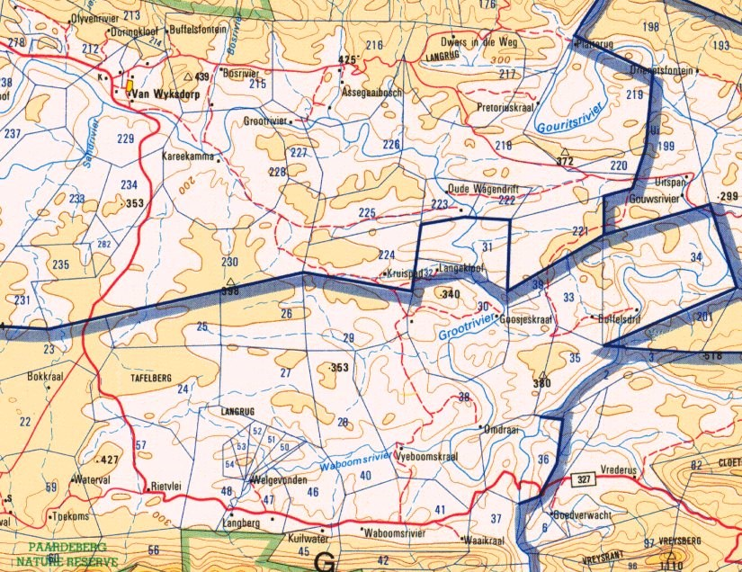
MR00356/38.3/0.1L
5 km
N

Fig. 1. Extract from topographical sheet 3320 Ladismith (Courtesy of the Chief Directorate: National Geo-spatial Information, Mowbray) showing the location of the proposed new borrow pit MR00356/38.3/0.1L on Farm 234, c. 4.4 km SSE of Van Wyksdorp, Eden DM, Western Cape (blue dot).

3. GEOLOGICAL CONTEXT

The geology of the MR00356/38.3/0.1L borrow pit study area is shown on 1: 250 000 sheet 3320 Ladismith (Council for Geoscience, Pretoria; Theron et al. 1991) (Fig. 2). The pit is located at c. 200 m amsl in fairly flat to gently sloping terrain to the south of an east-west trending range of low hills and c. 3 km south of the Grootrivier (Fig. 3). The study area lies within the dissected hilly region to the south of the Rooiberg-Gamkaberg mountain range that is underlain by shallow marine to marginal marine sediments of the Karies Formation (Upper Bokkeveld Group / Traka Subgroup) of Middle Devonian age (Dk, Fig. 2). The Traka bedrocks here are affected by W-E trending fold axes and form part of a large scale synclinal structure within the Bokkeveld Group rocks.

The Karies Formation, forming the lowermost portion of the Traka Subgroup, has an estimated thickness of 300 m, and is dominated by shales, rhythmitites and siltstones. These weather and erode readily and so the Karies outcrop area generally forms lowlands and valleys compared to the more prominent-weathering Adolphspoort Formation that lies directly above. Johnson (1994) records three thin sandstone units within the Karies Formation, but this observation probably applies to the more easterly outcrop area. The Karies Formation mudrocks were probably laid down in quiet, fairly deep waters offshore. A possible depositional setting, which requires confirmation, is the prodeltaic and outer delta slope region, seawards of an advancing delta front. Most of the Karies outcrop is obscured by unconsolidated surface sediment (regolith = weathered material, soils, alluvium etc) and fresh bedrock exposures are rare. The rocks are dark grey when fresh, but often weather greenish-grey. Theron et al. (1991) report large (>1 m diameter), oval concretions (knolle – formed by secondary cementation of sediment after deposition) as well as locally developed small scale cross-lamination.

Where exposed, the Karies Formation bedrocks in the study area appear to consist predominantly of deeply-weathered, friable, well-cleaved, colour-banded siltstones. Apart from isolated float blocks and material excavated from test pits within the study area (Figs. 4 & 5), the Karies Formation bedrocks at the study site are entirely covered in pale brown silty alluvial soils colonised by weedy vegetation. There is a thin surface layer of downwasted fine gravels dominated by angular vein quartz clasts with subordinate amounts of calcrete, ferricrete, sandstone and siltstone (Fig. 6). The absence of Karies bedrock exposure around the small farm dam just to the south of the study site suggests that the superficial deposits here are quite thick.

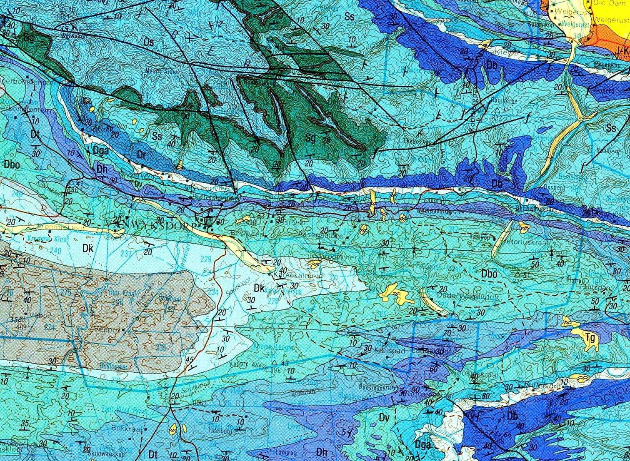
N
MR00356/38.3/0.1L
10 km

Fig. 2. Extract from 1: 250 000 geology sheet 3320 Ladismith (Council for Geoscience, Pretoria) showing location of the proposed new borrow pit MR00356/38.3/0.1L situated c. 4.4 km SSE of Vanwyksdorp, Little Karoo. The pit is excavated into sediments of the Karies Formation (Upper Bokkeveld Group / Traka Subgroup) (Dk, pale blue on map).

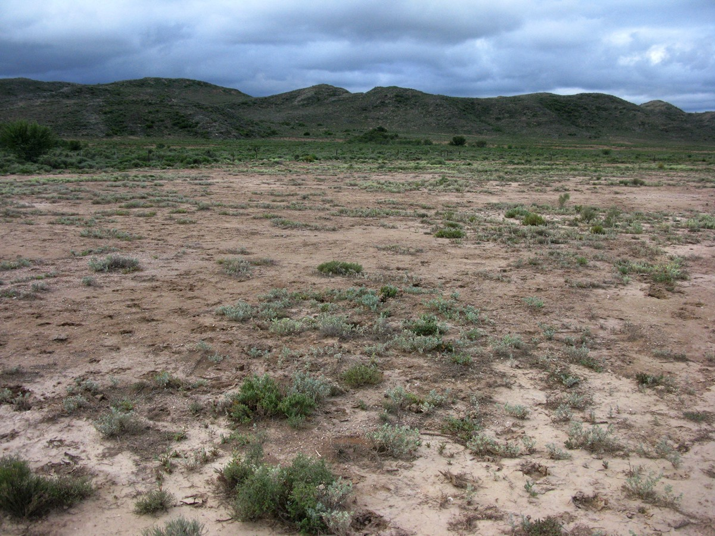

Fig. 3. View across the flat-lying borrow pit study area showing pale grey-brown silty alluvial soils with low hills of Karies Formation rocks in the background.

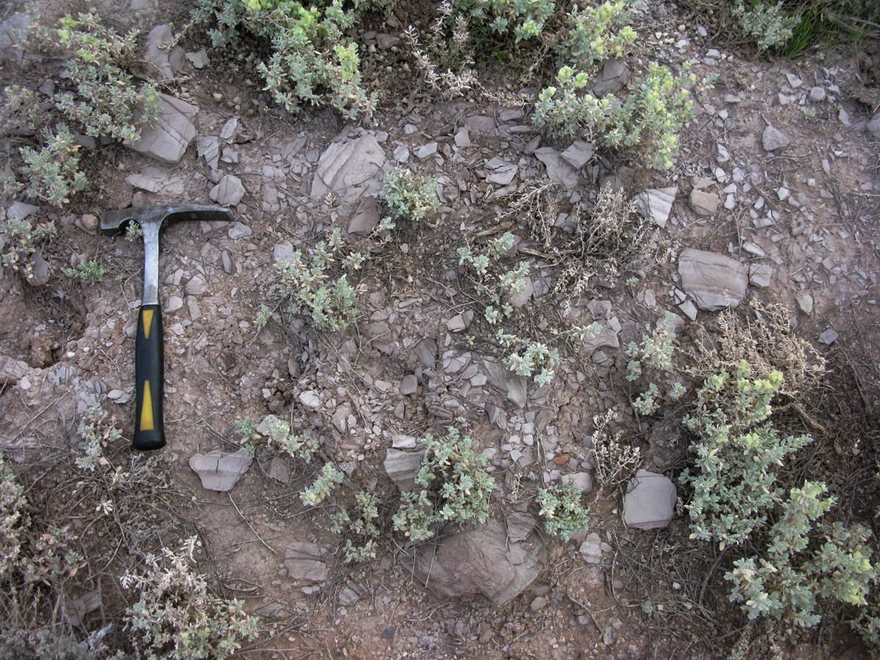

Fig. 4. Scattered float blocks of weathered, friable, lilac-grey, colour-banded Karies Formation bedrocks within the borrow pit study area (Hammer = 30 cm).

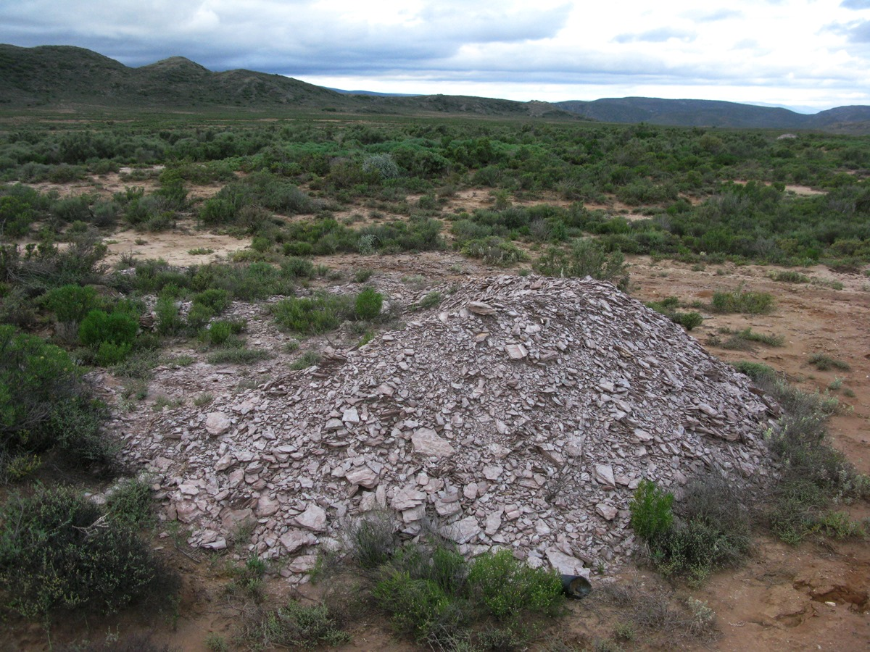

Fig. 5. Pale lilac-grey weathered siltstones of the Karies Formation bedrocks excavated from a test pit in the borrow pit study area.

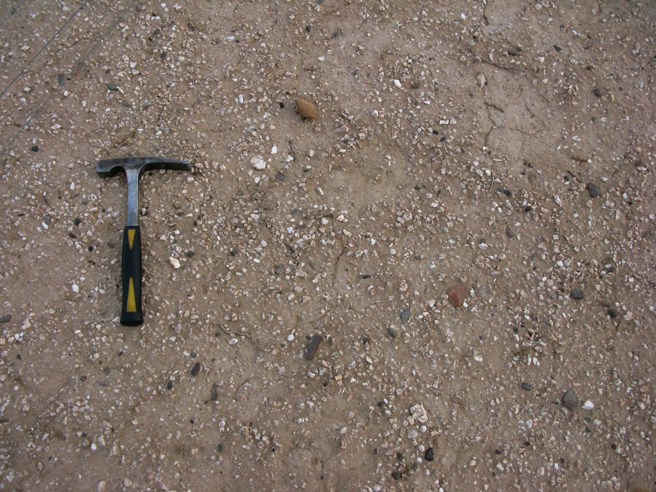

Fig. 6. Thin surface scatter of downwasted fine, angular gravels, predominantly of vein quartz, calcrete, ferricrete, sandstone and siltstone, overlying pale brown silty alluvium (Hammer = 30 cm).
4. PALAEONTOLOGICAL HERITAGE

An important, albeit low-diversity, fossil biota has been recorded from the Middle Devonian Karies and Adolphspoort Formations of the Traka Subgroup (Plumstead 1977, Chaloner et al. 1980, Anderson & Anderson 1985, Theron et al. 1991, Almond 1997, Anderson et al. 1999a, 1999b, Anderson in MacRae 1999, Almond 2005, 2009). The Traka Subgroup fossil assemblages are mainly preserved as moulds and comprise:

• Fragmentary vascular plants, including several species of lycopods (the club mosses Archaeosigillaria, Haplostigma) as well as possible psilopsids;
• Non-marine, thin-shelled bivalves (possibly unionids), often preserved in dense clumps;
• Rare marine invertebrates (e.g. the articulate brachiopod Australospirifer);
• A limited variety of trace fossils including rare trilobite burrows (Cruziana), and unusually small versions of the complex helical burrow Spirophyton;
• A low-diversity assemblage of bony and cartilaginous fish, including acanthodians (“spiny sharks”), several primitive sharks, bony-plated jawed fish known as placoderms , and rare crossopterygians (lobe-finned bony fish). These important Middle Devonian fossil fish have been described and illustrated in detail by Chaloner et al. (1980), Almond (1997), Anderson et al. (1999a, 1999b) and Long et al. (in prep). General accounts of Devonian fish groups from Gondawana are given by Anderson in MacRae (1999) and Long (1995).

Due in part to poor outcrop, understanding of the fossil record of the Karies Formation is very limited. Some of the Mid Devonian fossil plants described by Plumstead (1977) and Chaloner et al. (1980) probably came from the upper part of this unit. Anderson and Anderson (1985) indicate marine invertebrates for the Karies Formation, but the source of this record is unclear and it may be an error (perhaps a misinterpretation of non-marine bivalves), though some marine fossils are certainly to be expected.

No fossils were observed within the Karies Formation bedrocks in the borrow pit study area which are highly weathered and cleaved here. Alluvial and colluvial sediments overlying the Bokkeveld Group bedrocks within the study area are likely to be of low palaeontological sensitivity. Transported remains of vertebrates (bones, teeth, horn cores) and other fossils might occur here, but are probably very sparse.

The palaeontological sensitivity of this site is therefore rated as LOW.

5. CONCLUSIONS & RECOMMENDATIONS

The proposed new MR00356/38.3/0.1L borrow pit along the R327 on Farm 234, situated c. 4.4 km SSE of Vanwyksdorp in Little Karoo region, is to be excavated into marginal marine sediments of the Karies Formation (Upper Bokkeveld Group). Important Middle Devonian fossil assemblages of fish, plants, non-marine bivalves and trace fossils have been recorded elsewhere from this stratigraphic unit. However, the Upper Bokkeveld sediments in the study area are highly weathered and cleaved, so their palaeontological sensitivity is correspondingly very low. The overlying silty alluvial soils and fine downwasted quartz-rich gravels are apparently unfossiliferous.

No further palaeontological heritage studies or mitigation are therefore recommended for this borrow pit project.

6. ACKNOWLEDGEMENTS

Ms Quahnita Samie of Vidamemoria Heritage Consultants, Cape Town, is thanked for commissioning this specialist study and for kindly providing the necessary background information. I am very grateful to Madelon Tusenius as well as Hedi and Erwin Stummer for companionship and logistical support in the field.

7. REFERENCES

ALMOND, J.E. 1997. Fish fossils from the Devonian Bokkeveld Group of South Africa. Stratigraphy. African Anthropology, Archaeology, Geology and Palaeontology 1(2): 15-28.

ALMOND, J.E. 2005. Geology of the Gamkaberg-Rooiberg Conservation Area, Little Karoo, 255pp. Unpublished report for Cape Nature, Natura Viva cc., Cape Town.

ALMOND, J.E. 2009. Geology and fossils of the Sanbona Nature Reserve, Little Karoo, 244 pp. Natura Viva cc.

ALMOND, J.E. & PETHER, J. 2008. Palaeontological heritage of the Western Cape. Interim SAHRA technical report, 20 pp. Natura Viva cc., Cape Town.

ANDERSON, J.M. & ANDERSON, H.M. 1985. Palaeoflora of southern Africa. Prodromus of South African megafloras, Devonian to Lower Cretaceous, 423 pp. Botanical Research Institute, Pretoria & Balkema, Rotterdam.

ANDERSON, M.E., ALMOND, J.E., EVANS, F.J. & LONG, J.A. 1999. Devonian (Emsian-Eifelian) fish from the Lower Bokkeveld group (Ceres Subgroup), South Africa. Journal of African Earth Sciences 29: 179-194.

ANDERSON, M.E., LONG, J.A., EVANS, F.J., ALMOND, J.E., THERON, J.N. & BENDER, P.A. 1999. Biogeographic affinities of Middle and Late Devonian fishes of South Africa. Records of the Western Australian Museum Supplement No. 57: 157-168.

BROQUET, C.A.M. 1992. The sedimentary record of the Cape Supergroup: a review. Pp. 159-183 in De Wit, M.J. & Ransome, I.G.D. (eds.) Inversion tectonics of the Cape Fold Belt, Karoo and Cretaceous Basins of Southern Africa. x + 267 pp. Balkema, Rotterdam.

CHALONER, W.G., FOREY, P.L., GARDINER, B.G., HILL, A.J. & YOUNG, V.T. 1980. Devonian fish and plants from the Bokkeveld Series of South Africa. Annals of the South African Museum 81: 127-157.

HILLER, N. & THERON, J.N. 1988. Benthic communities in the South African Devonian. In: McMillan, N.J., Embry, A.F., & Glass, D.J. (Eds.) Devonian of the World, Volume III: Paleontology, Paleoecology and Biostratigraphy. Canadian Society of Petroleum Geologists, Memoir No. 14, pp 229-242.

JOHNSON, M.R. 1976. Stratigraphy and sedimentology of the Cape and Karoo Sequences in the Eastern Cape Province. 336 pp. Unpublished PhD thesis, Rhodes University, Grahamstown.

JOHNSON, M.R. (ED.) 1994. Lexicon of South African stratigraphy. 56 pp. Council for Geoscience / South African Committee for Stratigraphy, Pretoria.

LONG, J.A. 1995. The rise of fishes. 500 million years of evolution, 223 pp. University of New South Wales Press, Sydney.

LONG, J.A., ALMOND, J.E. & EVANS, F.J. (in prep.). Fish faunas from the Bokkeveld Group (Early – Middle Devonian) of South Africa.

MACRAE, C. 1999. Life etched in stone. Fossils of South Africa. 305 pp. The Geological Society of South Africa, Johannesburg.

PLUMSTEAD, E.P. 1977. A new phytostratigraphical Devonian zone in southern Africa which includes the first record of Zosterophyllum. Transactions of the Geological Society of South Africa 80: 267-277, pls. 1-2.

TANKARD, A.J. & BARWIS, J.H. 1982. Wave-dominated deltaic sedimentation in the Devonian Bokkeveld Basin of South Africa. Journal of Sedimentary Petrology 52: 959-974.

THAMM, A.G. & JOHNSON, M.R. 2006. The Cape Supergroup. In: Johnson, M.R., Anhaeusser, C.R. & Thomas, R.J. (Eds.) The geology of South Africa, pp. 443-459. Geological Society of South Africa, Marshalltown.

THERON, J.N. 1972. The stratigraphy and sedimentation of the Bokkeveld Group. 175 pp, 17 pls. Unpublished DSc Thesis, University of Stellenbosch.

THERON, J.N. & LOOCK, J.C. 1988. Devonian deltas of the Cape Supergroup, South Africa. Pp. 729-740 in McMillan, N.J. , Embry, A.F. & Glass, D.J. (eds.) Devonian of the World, Volume 1: Regional syntheses. Memoir No. 14. Canadian Society of Petroleum Geologists, Calgary.

THERON, J.N. & JOHNSON, M.R. 1991. Bokkeveld Group (including the Ceres, Bidouw and Traka Subgroups). SACS Catalogue of South African Lithostratigraphic Units 1:3-5.

THERON, J.N., WICKENS, H. DE V. & GRESSE, P.G. 1991. Die geologie van de gebied Ladismith. Explanation of Sheet 3320. 99 pp. Geological Survey / Council for Geoscience, Pretoria.

8. QUALIFICATIONS & EXPERIENCE OF THE AUTHOR

Dr John Almond has an Honours Degree in Natural Sciences (Zoology) as well as a PhD in Palaeontology from the University of Cambridge, UK. He has been awarded post-doctoral research fellowships at Cambridge University and in Germany, and has carried out palaeontological research in Europe, North America, the Middle East as well as North and South Africa. For eight years he was a scientific officer (palaeontologist) for the Geological Survey / Council for Geoscience in the RSA. His current palaeontological research focuses on fossil record of the Precambrian - Cambrian boundary and the Cape Supergroup of South Africa. He has recently written palaeontological reviews for several 1: 250 000 geological maps published by the Council for Geoscience and has contributed educational material on fossils and evolution for new school textbooks in the RSA.

Since 2002 Dr Almond has also carried out palaeontological impact assessments for developments and conservation areas in the Western, Eastern and Northern Cape under the aegis of his Cape Town-based company Natura Viva cc. He has been a long-standing member of the Archaeology, Palaeontology and Meteorites Committee for Heritage Western Cape (HWC) and an advisor on palaeontological conservation and management issues for the Palaeontological Society of South Africa (PSSA), HWC and SAHRA. He is currently compiling technical reports on the provincial palaeontological heritage of Western, Northern and Eastern Cape, Gauteng, Limpopo and Free State for SAHRA and HWC. Dr Almond is an accredited member of PSSA and APHP (Association of Professional Heritage Assessment Practitioners – Western Cape).

Declaration of Independence

I, John E. Almond, declare that I am an independent consultant and have no business, financial, personal or other interest in the proposed borrow pit project, application or appeal in respect of which I was appointed other than fair remuneration for work performed in connection with the activity, application or appeal. There are no circumstances that compromise the objectivity of my performing such work.
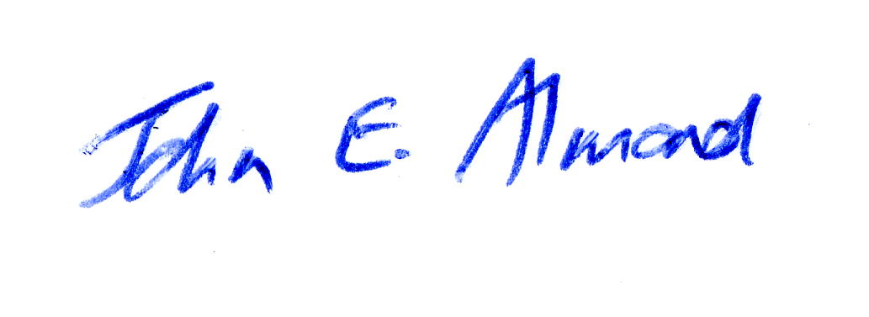
Dr John E. Almond
Palaeontologist
Natura Viva cc

