PALAEONTOLOGICAL SPECIALIST STUDY: FIELD ASSESSMENT & RECOMMENDATION FOR EXEMPTION FROM FURTHER STUDIES & MITIGATION

TWO PROPOSED NEW BORROW PITS ALONG THE DR1655 NEAR OUDTSHOORN, EDEN DISTRICT MUNICIPALITY, WESTERN CAPE

John E. Almond PhD (Cantab.)
Natura Viva cc,
PO Box 12410 Mill Street,

Cape Town 8010, RSA
naturaviva@universe.co.za

March 2013

1. EXECUTIVE SUMMARY

Both the proposed borrow pits along the DR1665 to the south of Oudtshoorn, Eden District Municipality, Western Cape - pit DR01655/5.8/0.2L on the Farm Kleindoornrivier and pit DR01655/17.2/0 R on the Farm Grootdoornrivier – are to be excavated into mudrock-dominated bedrocks of the Gydo Formation that elsewhere is well known for its rich fossil heritage – especially shelly invertebrates – from the Devonian Period.

However, the Lower Bokkeveld sediments in the study area are highly folded and cleaved, so their palaeontological sensitivity is correspondingly very low. Pit site DR01655/17.2/0 R is mantled by semi-consolidated colluvial gravels reworked from an adjacent pediment surface. These gravels are largely unfossiliferous.

No further palaeontological heritage studies or mitigation are therefore recommended for these two borrow pit projects.

2. INTRODUCTION

The Department of Transport, Western Cape, is applying to the Department of Mineral Resources for approval to exploit road material from two proposed new borrow pits along the unsealed road DR01665 to the south of Oudtshoorn, Little Karoo Region. The proposed new pit sites are DR01655/5.8/0.2L on the Farm Kleindoornrivier (33° 44' 44.4"S, 22° 32' 30.4" E) situated c. 17 km south of Oudtshoorn and DR01655/17.2/0 R on the Farm Grootdoornrivier (33° 47' 34.7"S, 22° 15' 11.4" E) located c. 23 km SSE of Oudtshoorn, Eden District Municipality (Fig. 1).

A previous desktop basic assessment of the two pit sites by the author assessed their palaeontological heritage sensitivity as high due to the presence of potentially fossiliferous mudrocks of the Gydo Formation (Lower Bokkeveld Group). Palaeontological field assessments of the pits as part of an HIA were requested by Heritage Western Cape (HWC case 1927 - 2014 120726JL22E, Interim comment 8 August 2012) in accordance with the requirements of the National Heritage Resources Act, 1999 (Section 38).

The present palaeontological heritage field assessments and short report were accordingly commissioned by Vidamemoria Heritage Consultants, Cape Town (Address: 3rd Floor, Guarantee House, 37 Burg Street, Greenmarket Square, Cape Town; tel: 021-424 8432; e-mail: Quahnita@vidamemoria.co.za). These are Vidamemoria pits no. 133 and 134 and NID ref. no. 71. Fieldwork for this project was carried out on 11 December 2012.

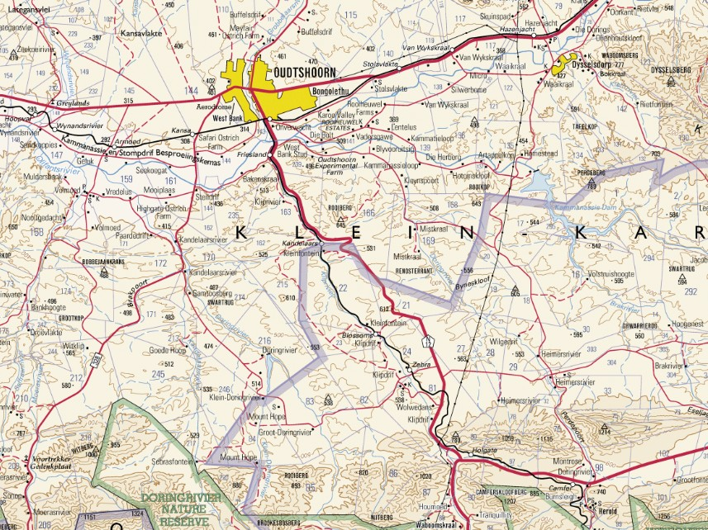
5 km
N
DR01655/5.8/0.2L
DR01655/17.2/0 R

Fig. 1. Extract from topographical sheet 3322 Oudtshoorn (Courtesy of the Chief Directorate: National Geo-spatial Information, Mowbray) showing the location of the two proposed new borrow pits along the DR 1655, DR01655/5.8/0.2L c. 17 km south of Oudtshoorn and DR01655/17.2/0 R c. 23 km SSE of Oudtshoorn, Eden DM, Western Cape (blue dots).

3. GEOLOGICAL CONTEXT

The geology of the borrow pit study areas is shown on 1: 250 000 sheet 3322 Oudtshoorn (Council for Geoscience, Pretoria; Toerien 1979) (Fig. 2). The pits are located in the highly dissected, hilly region to the south of Oudtshoorn between the Doornrivier and Kandelaarsrivier that is underlain by Devonian marine sediments of the Lower Bokkeveld Group (Cape Supergroup). The Bokkeveld rocks in this region are folded along west-east trending fold axes.

Both study areas are underlain by mudrocks of the Gydo Formation (Dg) (Lower Bokkeveld Group, Cape Supergroup) of Emsian or Early Devonian age, some 400 million years old (Theron 1999, Theron & Johnson 1991, Thamm & Johnson 2006). This formation consists of an upward-coarsening, shallowing succession of dark grey to black mudrocks, fine-grained sandstones and medium-grained wackes (dark, impure sandstones). These sedimentary rocks were deposited in a cool shallow seaway, the Agulhas Sea, on the south-western margins of Gondwana some 400 million years ago. Offshore mudrocks were deposited in quiet, deeper waters and may be massive or well-laminated. Pyrite-rich horizons indicate episodes of anoxia at or shortly below the sea floor. Near-shore sandstones were laid down in more turbulent settings and often show the influence of major storms (e.g. well-developed wave ripples, hummocky cross-stratification). The Gydo Formation is consistently the most fossil-rich formation within the Bokkeveld Group (Section 4). Pit DR01655/5.8/0.2L on the Farm Kleindoornrivier is located at c. 430 m amsl on northwest-facing low hillslopes on the east side of the DR1655, some 800 m southwest of the Doringrivier, a tributary of the Olifantsrivier (Fig. 3). Satellite images of the area show well-developed heuweltjies (termite mounds). The Gydo Formation mudrocks exposed here are pervasively cut by a closely-spaced tectonic cleavage (Fig. 4). The mudrocks are micaceous and have a shiny phyllitic-like sheen. Locally they are cut by calcrete veins and covered with a thin- impersistent mantle of downwasted gravels (shaley clasts of mudrock, wacke).

DR01655/17.2/0 R on the Farm Grootdoornrivier is located at c. 480 m amsl on west-facing hillslope c. 500 m east of the Doringrivier, within sight of the historic farm homestead on the far side of the river, and on the east side of the DR1655. The hillslope is capped by a pediment surface that is mantled by ancient (probably Late Tertiary) alluvial gravels. Table Mountain Group sandstones crop out about one kilometre to the south. Gydo Formation mudrocks excavated recently from test pits show high levels of chemical weathering (pale hues, secondary mineralisation, Fig. 5). Both the wackes and siltstones locally exposed at surface in the study area are pervasively cleaved with occasional thin quartz veins (Fig. 6). The Bokkeveld bedrocks are extensively mantled with semi-consolidated pebbly pediment gravels reworked downslope by colluvial processes. Gravel clasts are predominantly of quartzite and wackes with an admixture of milky vein quartz and ferricrete and a sandy soil matrix (Fig. 7).

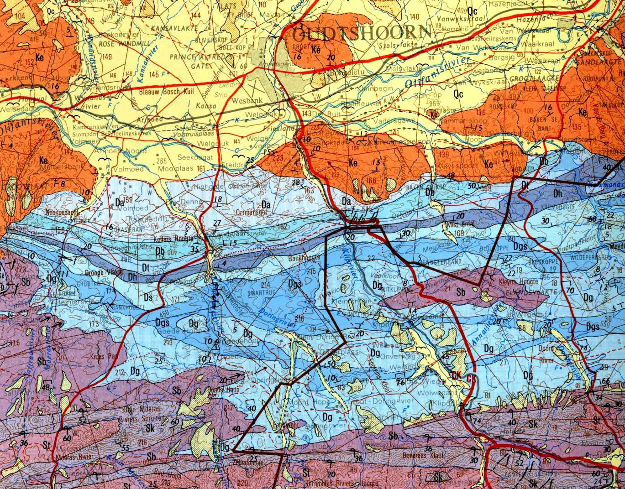
DR01655/5.8/0.2L
N
DR01655/17.2/0 R
5 km

Fig. 2. Extract from 1: 250 000 geology sheet 3322 Oudtshoorn (Council for Geoscience, Pretoria) showing location of the two proposed new borrow pits DR01655/5.8/0.2L and DR01655/17.2/0 R to the south of Oudtshoorn. Both pit study areas are underlain by offshore marine mudrocks of the Early Devonian Gydo Formation (Dg, pale blue) at the base of the Bokkeveld Group. High Level Gravels of Tertiary age (yellow stipple) overlie the pediment surface just east of pit DR01655/17.2/0 R.
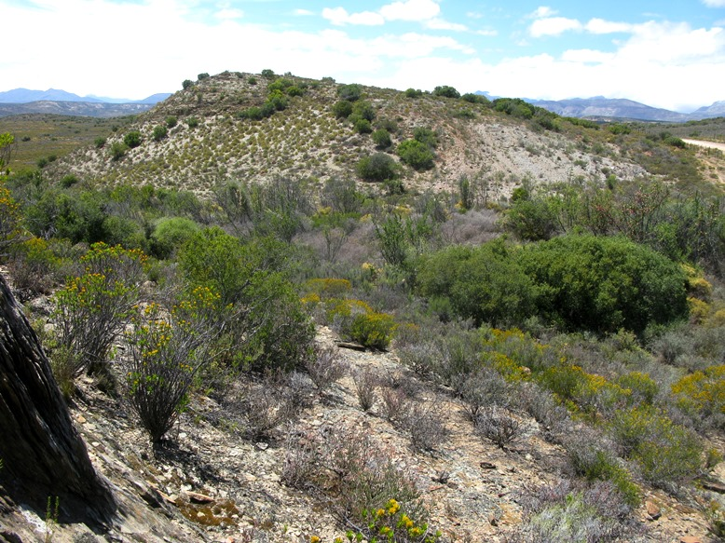

Fig. 3. General view from the NW of the DR01655/5.8/0.2L pit study area on the Farm Kleindoornrivier.

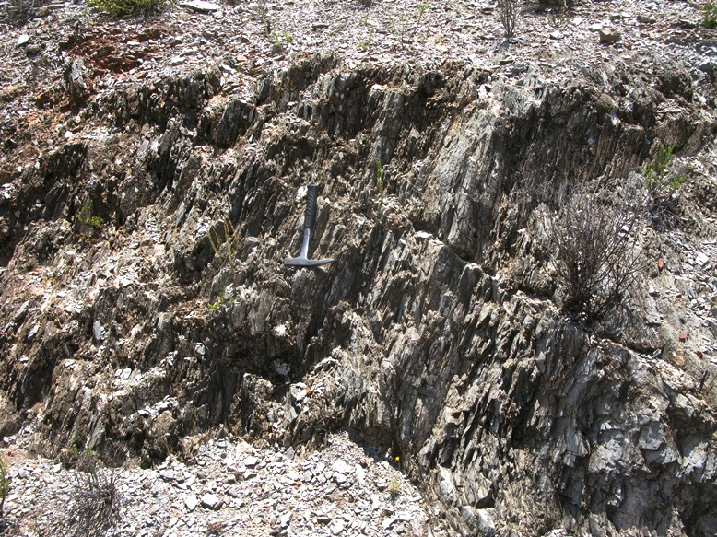

Fig. 4. Highly cleaved, phyllitic micaceous siltstones of the Gydo Formation in DR01655/5.8/0.2L pit study area (Hammer = 27 cm). The cleavage here dips steeply to the north.
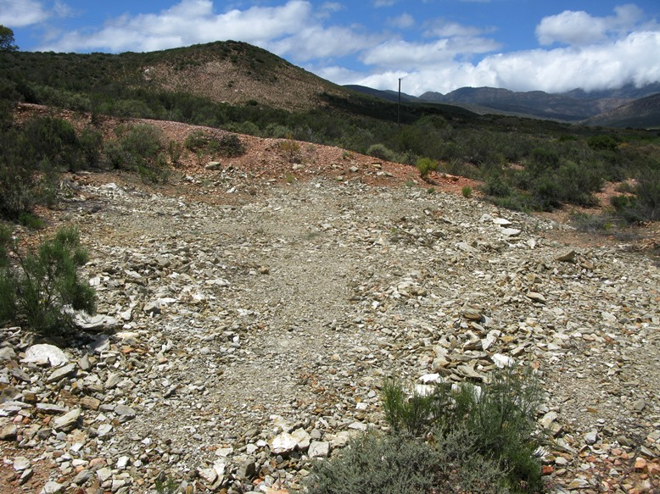

Fig. 5. General view from the north of DR01655/17.2/0 R pit study area on the Farm Grootdoornrivier, showing pale, weathered Gydo Formation mudrocks exposed in the test pit area in the foreground. Note gravelly pediment surface capping the koppie in the background.

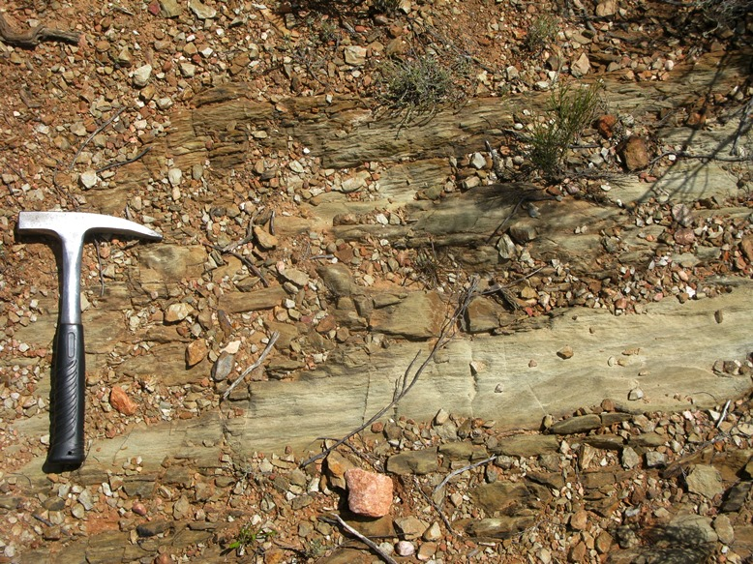

Fig. 6. Pale, highly cleaved Gydo mudrocks exposed at surface in DR01655/17.2/0 R pit study area (Hammer = 27 cm).

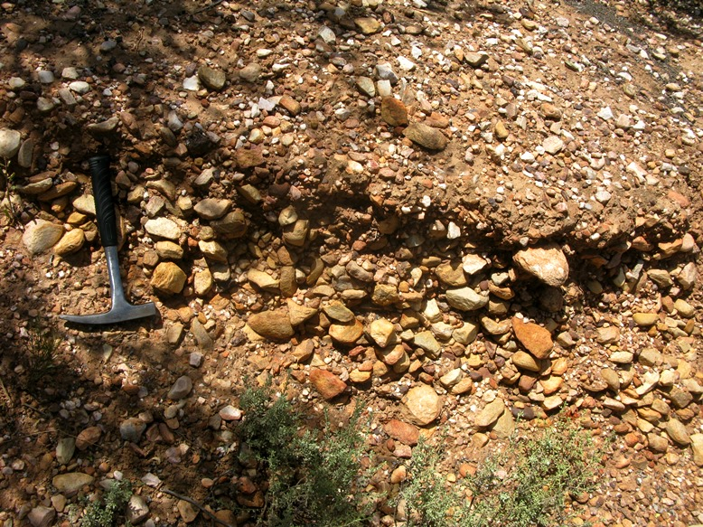

Fig. 7. Thick mantle of semi-consolidated, angular colluvial gravels covering the Bokkeveld Group outcrop in the DR01655/17.2/0 R pit study area (Hammer = 27 cm).

4. PALAEONTOLOGICAL HERITAGE

The lower part of the Bokkeveld Group in the Western Cape (Ceres Subgroup plus lowermost Bidouw Subgroup) – and in particular the Gydo Formation - is known for its rich fossil assemblages of shallow marine invertebrates of the Malvinokaffric Faunal Province of Gondwana (Cooper 1982, Oosthuizen 1984, Hiller & Theron 1988, Theron & Johnson 1991, MacRae 1999, Almond in De Beer et. al. 2002, Thamm & Johnson 2006, Almond 2008). Key fossil groups here include trilobites, brachiopods, various subgroups of molluscs (bivalves, gastropods, nautiloids etc), and echinoderms (starfish, brittle stars, crinoids, carpoids, sea cucumbers etc), with several minor taxa including corals, conulariids, tentaculitids and rare fish remains, among others (Almond 1997, Anderson et al. 1999). These shelly fossil assemblages – generally preserved as impressions or moulds, but occasionally in the Gydo Formation also embedded within phosphatic or siliceous nodules – are especially abundant within the mudrock-dominated units such as the Gydo, Voorstehoek and Waboomberg Formations in their more distal (offshore) outcrop areas. Thin lenticles of shelly debris, known as coquinas, have been concentrated by storm activity and mainly consist of disarticulated specimens.

Fossils from various localities in the Gydo Formation within the broader Swartberg – Little Karoo study region have been treated by Oosthuizen (1984), Theron et al. (1991) and Almond (2005), among others.

No shelly or other fossils were observed within the Gydo Formation bedrocks in either of the two borrow pit study areas. It is likely that most or all the fossils originally present within these rocks have been completely destroyed by tectonic cleavage and weathering. Those that have survived will be highly distorted and poorly preserved, with high levels of disruptive secondary mineralisation (e.g. iron and manganese compounds). The Late Caenozoic gravels and soils mantling the Bokkeveld bedrocks are of low palaeontological sensitivity.

The palaeontological sensitivity of both these sites is therefore rated as VERY LOW.

5. CONCLUSIONS & RECOMMENDATIONS

Both the proposed borrow pits along the DR1665 to the south of Oudtshoorn, Eden District Municipality, Western Cape - pit DR01655/5.8/0.2L on the Farm Kleindoornrivier and pit DR01655/17.2/0 R on the Farm Grootdoornrivier – are to be excavated into mudrock-dominated bedrocks of the Gydo Formation that elsewhere is well known for its rich fossil heritage – especially shelly invertebrates – from the Devonian Period.

However, the Lower Bokkeveld sediments in the study area are highly folded and cleaved, so their palaeontological sensitivity is correspondingly very low. Pit site DR01655/17.2/0 R is mantled by semi-consolidated colluvial gravels reworked from an adjacent pediment surface. These gravels are largely unfossiliferous.

No further palaeontological heritage studies or mitigation are therefore recommended for these two borrow pit projects.

6. ACKNOWLEDGEMENTS

Ms Quahnita Samie of Vidamemoria Heritage Consultants, Cape Town, is thanked for commissioning this specialist study and for kindly providing the necessary background information. I am very grateful to Madelon Tusenius for companionship and logistical support in the field.

7. REFERENCES

ALMOND, J.E. 1997. Fish fossils from the Devonian Bokkeveld Group of South Africa. Stratigraphy. African Anthropology, Archaeology, Geology and Palaeontology 1(2): 15-28.

ALMOND, J.E. 2005. Geology of the Gamkaberg-Rooiberg Conservation Area, Little Karoo, 255pp. Unpublished report for Cape Nature, Natura Viva cc., Cape Town.

ALMOND, J.E. 2008. Palaeozoic fossil record of the Clanwilliam Sheet area (1: 250 000 geological sheet 3218), 42 pp. Report produced for the Council for Geoscience, Pretoria.

ANDERSON, M.E., ALMOND, J.E., EVANS, F.J. & LONG, J.A. 1999. Devonian (Emsian-Eifelian) fish from the Lower Bokkeveld Group (Ceres Subgroup), South Africa. Journal of African Earth Sciences 29: 179-194.

COOPER, M.R. 1982. A revision of the Devonian (Emsian – Eifelian) Trilobita from the Bokkeveld Group of South Africa. Annals of the South African Museum 89: 1-174.

DE BEER, C.H., GRESSE, P.G., THERON, J.N. & ALMOND, J.E. 2002. The geology of the Calvinia area. Explanation to 1: 250 000 geology Sheet 3118 Calvinia. 92 pp. Council for Geoscience, Pretoria.

HILLER, N. & THERON, J.N. 1988. Benthic communities in the South African Devonian. In: McMillan, N.J., Embry, A.F., & Glass, D.J. (Eds.) Devonian of the World, Volume III: Paleontology, Paleoecology and Biostratigraphy. Canadian Society of Petroleum Geologists, Memoir No. 14, pp 229-242.

JELL, P.A. & THERON, J.N. 1999. Early Devonian echinoderms from South Africa. Memoirs of the Queensland Museum 43: 115-199.

MACRAE, C. 1999. Life etched in stone. Fossils of South Africa. 305pp. The Geological Society of South Africa, Johannesburg.

OOSTHUIZEN, R.D.F. 1984. Preliminary catalogue and report on the biostratigraphy and palaeogeographic distribution of the Bokkeveld Fauna. Transactions of the Geological Society of South Africa 87: 125-140.

THAMM, A.G. & JOHNSON, M.R. 2006. The Cape Supergroup. In: Johnson, M.R., Anhaeusser, C.R. & Thomas, R.J. (Eds.) The geology of South Africa, pp. 443-459. Geological Society of South Africa, Marshalltown.

THERON, J.N. 1972. The stratigraphy and sedimentation of the Bokkeveld Group. Unpublished DSc thesis, University of Stellenbosch, 175pp, 17pls.

THERON, J.N. 1999. Lithostratigraphy of the Gydo Formation (Bokkeveld Group). SACS Lithostratigraphic Series No. 33, 1-11. Council for Geoscience, Pretoria.

THERON, J.N. & JOHNSON, M.R. 1991. Bokkeveld Group (including the Ceres, Bidouw and Traka Subgroups). Catalogue of South African Lithostratigraphic Units 3: 3-5.

THERON, J.N., WICKENS, H. DE V. & GRESSE, P.G. 1991. Die geologie van die gebied Ladismith. Explanation to 1: 250 000 geology sheet 3320, 99 pp. Council for Geoscience, Pretoria.

TOERIEN, D.K. 1979. The geology of the Oudtshoorn area. Explanation to Sheet 3322. 13 pp. Geological Survey / Council for Geoscience, Pretoria.

8. QUALIFICATIONS & EXPERIENCE OF THE AUTHOR

Dr John Almond has an Honours Degree in Natural Sciences (Zoology) as well as a PhD in Palaeontology from the University of Cambridge, UK. He has been awarded post-doctoral research fellowships at Cambridge University and in Germany, and has carried out palaeontological research in Europe, North America, the Middle East as well as North and South Africa. For eight years he was a scientific officer (palaeontologist) for the Geological Survey / Council for Geoscience in the RSA. His current palaeontological research focuses on fossil record of the Precambrian - Cambrian boundary and the Cape Supergroup of South Africa. He has recently written palaeontological reviews for several 1: 250 000 geological maps published by the Council for Geoscience and has contributed educational material on fossils and evolution for new school textbooks in the RSA.

Since 2002 Dr Almond has also carried out palaeontological impact assessments for developments and conservation areas in the Western, Eastern and Northern Cape under the aegis of his Cape Town-based company Natura Viva cc. He is a long-standing member of the Archaeology, Palaeontology and Meteorites Committee for Heritage Western Cape (HWC) and an advisor on palaeontological conservation and management issues for the Palaeontological Society of South Africa (PSSA), HWC and SAHRA. He is currently compiling technical reports on the provincial palaeontological heritage of Western, Northern and Eastern Cape, Gauteng, Limpopo and Free State for SAHRA and HWC. Dr Almond is an accredited member of PSSA and APHP (Association of Professional Heritage Assessment Practitioners – Western Cape).

Declaration of Independence

I, John E. Almond, declare that I am an independent consultant and have no business, financial, personal or other interest in the proposed borrow pit project, application or appeal in respect of which I was appointed other than fair remuneration for work performed in connection with the activity, application or appeal. There are no circumstances that compromise the objectivity of my performing such work.
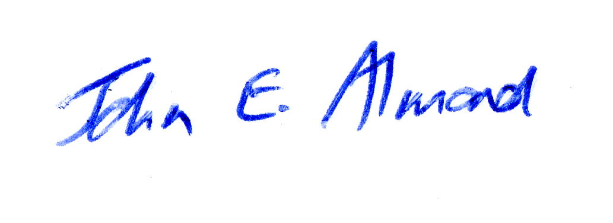
Dr John E. Almond
Palaeontologist
Natura Viva cc

