Appendix B
SITE PHOTOS

The eight major compass point photographs for the preferred alternative are depicted in photos 1 to 8. Additional photos of the site (photo 9 to 14) were taken and are also depicted in the tables below.

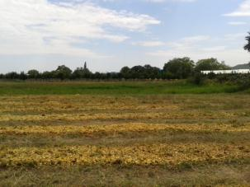  Photo 1: North |  | 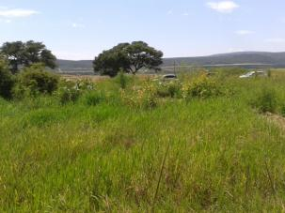  Photo 2: North East
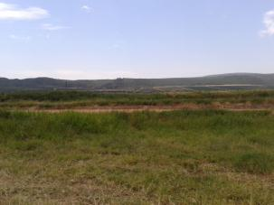  Photo 3: East |  | 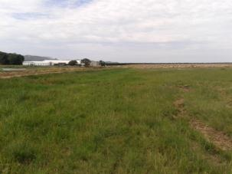  Photo 4: South East
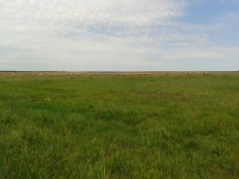  Photo 5: South | 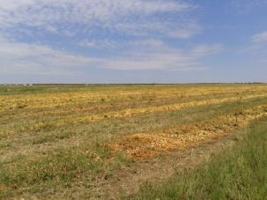  Photo 6: South West
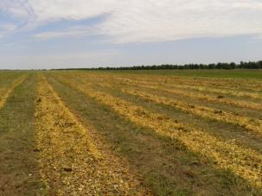  Photo 7: West | 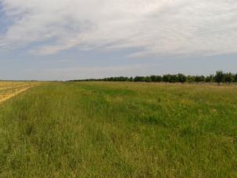  Photo 8: North West

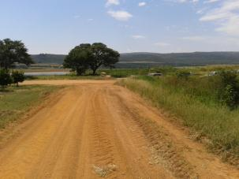  Photo 9: Looking in an easterly direction along the road which is located to the north of the site.  This photo shows where the access road, north of the site joins with the road running along the east side of the site at a T-junction. | 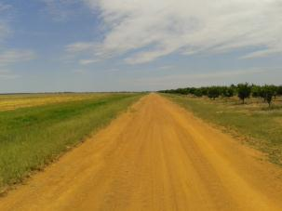  Photo 10: Photo of the road north of the site.  The road depicted in this photo is the same road as the one shown in photo 9, but looking the opposite (westerly) direction.  To the right of the photograph are citrus trees.  To the left of the road, the green vegetation in the man- made storm water canal.
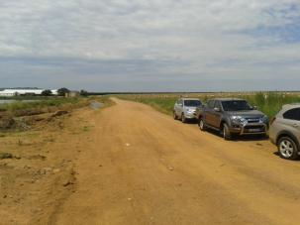  Photo 11: View looking in southerly direction along the road which runs along the east of the site.  This road will be used as an access road to the site. | 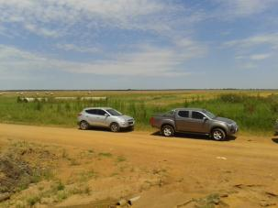  Photo 12: View of the site from an elevated point.  This photo is taken from the north-easterly corner and is looking in a south-westerly direction towards the proposed site.

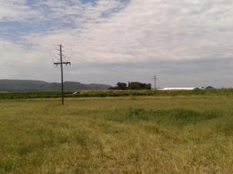  Photo 13: View of existing Eskom power lines on the site.  The existing Eskom power lines are depicted in this photograph. | 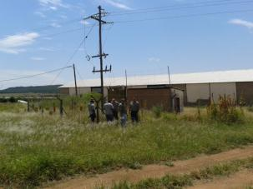  Photo 14: View of the existing substation on the farm.  This photo depicts the point where the Solar PV farm will tie into the Eskom grid.

