**BACKGROUND INFORMATION DOCUMENT**

**FOR THE PROPOSED MINING PERMIT APPLICATION AND ENVIRONMENTAL AUTHORIZATION APPLICATION ON PORTION OF PORTION 11 OF THE FARM LEEUWENFONTEIN 284 IR, SITUATED IN THE MAGISTERIAL DISTRICT OF NIGEL, GAUTENG PROVINCE.**

**PURPOSE OF THIS DOCUMENT**

The purpose of this Background Information Document (BID) is to provide Interested and Affected Parties (I&APs) with background information about the proposed mining permit application and introduce the Environmental Impact Assessment (EIA) process to be followed. It also aims to inform I&APs on how to fully participate in the EIA and encourages response to documents distributed for review and active attendance meetings.

**PROJECT DESCRIPTION**

**Atok Mining House (Pty) Ltd** applied for Mining Permit (DMRE Ref: GP 30/5/1/3/2/10480 MP) and Environmental Authorization in terms of section 27 of the Mineral and Petroleum Resources Development Act (MPRDA), Act No 28 of 2002, for **coal** **and clay (general)** on **portion of portion 11 of the farm Leeuwenfontein 284 IR**.

Atok Mining House (Pty) Ltd appointed Moepathutsi Geo-Environmental Solutions (Pty) Ltd as an independent Environmental Assessment Practitioner (EAP), to conduct Environmental Impact Assessment process for the proposed project.

Notice is hereby given in terms of the Mineral and Petroleum Development Act (MPRDA) (Act 28 of 2002) and EIA regulations 2014, published under Government Notice No.982 in Gazette No. 3822 of 4 December 2014, amended on 7 April 2017, that Atok Mining House (Pty) Ltd has applied for a Mining Permit.

**PROJECT LOCATION**

The Mining Permit area is located on a portion of portion 11 of the farm Leeuwnfontein 284 IR, situated under the Magisterial District of Nigel in the Gauteng province. The proposed mining area is located approximately 15 km northeast of Nigel and 17 km west of Devon, along N17 towards Springs.

Please refer to **Figure 2** for the locality map.

**LEGISLATIVE REQUIREMENTS**

In terms of the National Environmental Management Act (Act 107 of 1998) (NEMA) and its promulgated EIA Regulations of 2017 (GNR 982, 983, 984 and 985) the prospecting activities require an Environmental Authorisation.

An Environmental Authorisation in terms of Section 24 of the National Environmental Management Act, 1998 (Act No. 107 of 1998) read with Regulation 19 of the Environmental Impact Assessment (EIA) Regulations, 2014 (as amended) and Section 27 of the Minerals and Petroleum Resources Development Act, 2002 (Act No. 28 of 2002), as amended by Section 12 of the MPRDA, 2008 (Act No. 49 of 2008) is required for a Mining Permit

**WHAT IS ENVIRONMENTAL IMPACT ASSESSMENT?**

An Environmental Impact Assessment (EIA) is a planning and decision-making tool that is used to identify the environmental consequences of a proposed project, before the development takes place. The purpose of the EIA is to describe the potential consequences of the proposed development in environmental, economic, and social terms. Public issues and concerns must therefore be identified timeously so that these can be recorded and responded to in the EIA. All comments received in writing are included in the submission to the competent authority for their consideration.

**POTENTIAL IMPACTS**

A number of potential impacts have been identified which will be considered further in the process as required. Typical impacts that may be investigated as part of this EIA include:

* Heritage (archaeology and palaeontology).
* Impacts on fauna and flora.
* Agricultural impacts.
* Air quality and noise impacts.
* Terrestrial and aquatic ecology and wetlands.
* Visual impacts

Additional impacts can be added based on the findings of the desktop and site inspection as well as input from the public during Public Participation Process.

**PUBLIC PARTICIPATION PROCESS**

Public participation is the cornerstone of the Environmental Impact Assessment process. The principles of the National Environmental Management Act (NEMA) govern most aspects of Environmental Impact Assessments, including public participation. These include the ongoing provision of sufficient information (in a transparent manner) to Interested and Affected Parties (IAPs).

During the Public Participation Process, input from the applicant, technical experts, government authorities and the general public will be gathered to result in a better understanding of the project for all involved, and more informed decision-making throughout the process. IAPs will be given the opportunity to comment on the findings of both the Scoping and EIA Reports, and findings of the Specialist studies during the specified comment periods.

IAPs are hereby invited to comment on environmental, social, and economic issues relating to the proposed project.

**HOW TO REGISTER AS AN INTERESTED AND AFFECTED PARTY.**

To receive further communications regarding this development, please register by sending the completed and signed registration sheet on the last page of this document by **23 May 2023**, to:

**Miss Avela Mantshontsho**

Tel: 071 628 9187

**Email:** [avela@mges.co.za](mailto:avela@mges.co.za)

The EIA process consists of two stages. The first stage is a Scoping Study, which identifies potential issues requiring more detailed investigation via specialist studies. A complete list of specialist studies and the issues they should address will be detailed in the Draft Scoping Report, which will be made available for public and authority review.

The second stage is the Impact Assessment phase, during which detailed investigations of the issues identified during scoping, will be undertaken.

**ENVIRONMENTAL IMPACT ASSESSMENT PROCESS.**

The flow diagram below provides an overview of the EIA process according to the 2014 EIA Regulations:

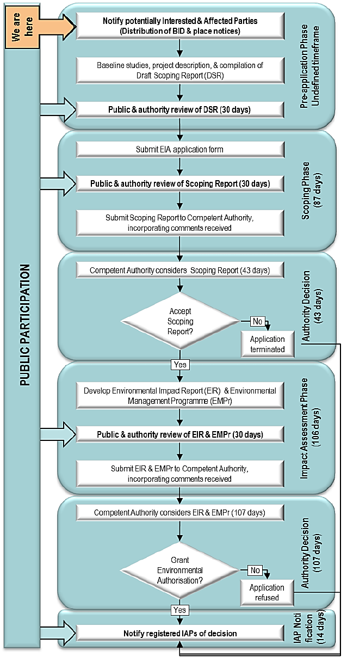

**Figure 1: A typical Environmental Impact Assessment process and stages where public comment will be invited.**

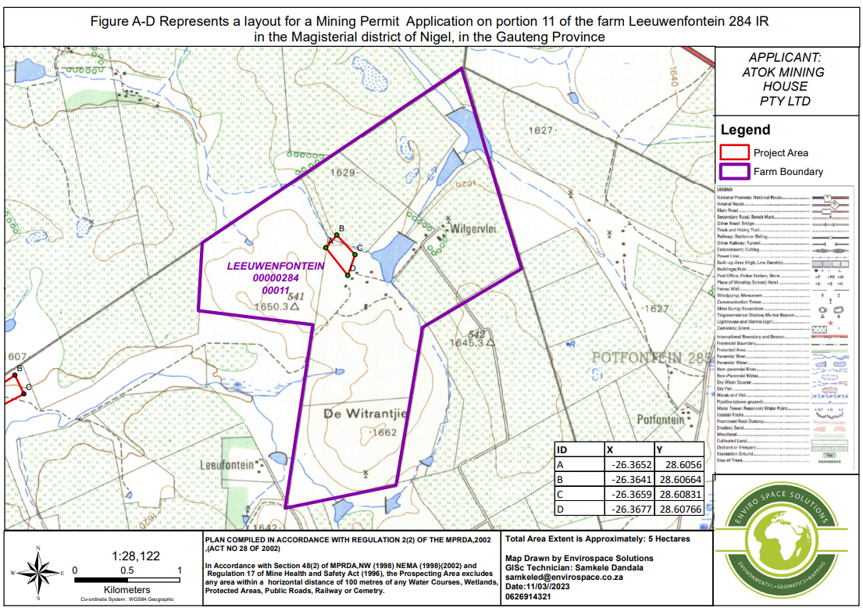

**Figure 2: Locality map of the proposed project area.**

**Address:** 100 Booted Eagle,

Elandspoort,

Pretoria,0184

**Tel:** +27 (0) 71 628 9187

**Email:** avela@mges.co.za

**REGISTRATION AND COMMENT SHEET**

**MINING PERMIT APPLICATION FOR COAL AND GENERAL CLAY ON PORTION OF PORTION 11 OF THE FARM LEEUWENFONTEIN 284 IR (DMRE REF: GP30/5/1/3/2/10480 MP), GAUTENG PROVINCE.**

**Attention**: Miss Avela Mantshontsho

I wish to register an Interested and Affected Party and/or bring to the attention of Moepathutsi Geo-Environmental Solutions the following comments:

|  |  |
| --- | --- |
| **CONTACT INFORMATION** | |
| Title: | Name: |
| Organization: | Nature of interest: |
| Postal Address: | Telephone: |
| Mobile: |
| Email: |
| **\*** The NEMA EIA Regulations, 2014, require that an IAP discloses any direct business, financial, personal or other interest in the approval or refusal of the application.  **\*\***Preferred method of communication. The absence of email / facsimile facilities may result in a delay in receipt of IAP notifications. Please write clearly. | |
| **COMMENTS (Please use additional sheets of paper if required)** | |
|  | |
|  | |
|  | |
|  | |
|  | |
|  | |
|  | |
|  | |