PALAEONTOLOGICAL AND GEOLOGICAL REPORT ON THE PROPOSED BORROW PITS ALONG THE N7 BETWEEN CITRUSDAL AND CLANWILLIAM

Prof. I.C. Rust MSc. DSc. (Stell.), Franschhoek.
SA Council for Natural Scientists 401309/83
Dr J.A. van den Heever MSc. PhD (Stell.)
Department of Botany and Zoology, University of Stellenbosch
The existing borrow pits as well as the new localities that were investigated are all situated in rock formations or erosion products of the Table Mountain Group. These rock layers consist almost exclusively of quartz sandstone and is classified from the upper layers (most recent) to the lowermost layers (oldest) as follows.
Rietvlei Formation Sandstone / Brown weathering shale.
Skurweberg Formation. Coarse, thickly layered, white weathering quartz sandstone.
Goudini Formation. Sandstone / Reddish weathering shale.
Sederberg Formation. Glacial outwash Forms the only shale layer of note in the Table Mountain Group. Contains marine fossils like Brachiopods, Trilobites, Graptolites, Crinoids, Bryozoans and Algae. Approximately 400 million years old.
Pakhuis Tillite Formation. Glacial tillite (Sandstone).
Peninsula Formation. Coarse, white quartz sandstone. Fluvial and marginally marine to shallow marine deposits. Probably subtidal sand banks, beach deposits, Fluvial flood plain deposits and river channel deposits subjected to wave action and sea currents. Poor habitat, paucity of fossils.
Graafwater Formation. Fluvial, intertidal to marginally marine deposits. Forms an extensive tidal flat where sand and mud were deposited. Sediments predominantly red due to the presence iron oxide minerals. Trace fossils of worms, snails and trilobites.
Piekenierskloof Formation. Fluvial sediments deposited in braided river systems. Coarser sediments like conglomerates in the upper reaches of the streams whilst the finer sediments are present downstream.
BORROW PIT 1 (BP1)
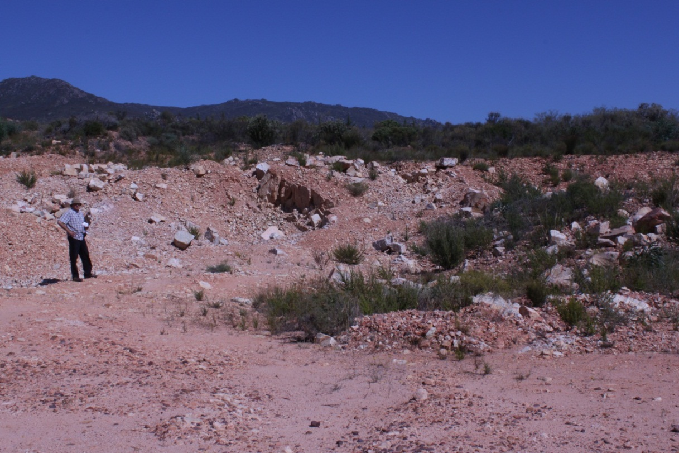
Rietvlei Formation, Modderfontein. Current borrow pit being extended. Palaeontologically sterile. Can be deeply excavated.

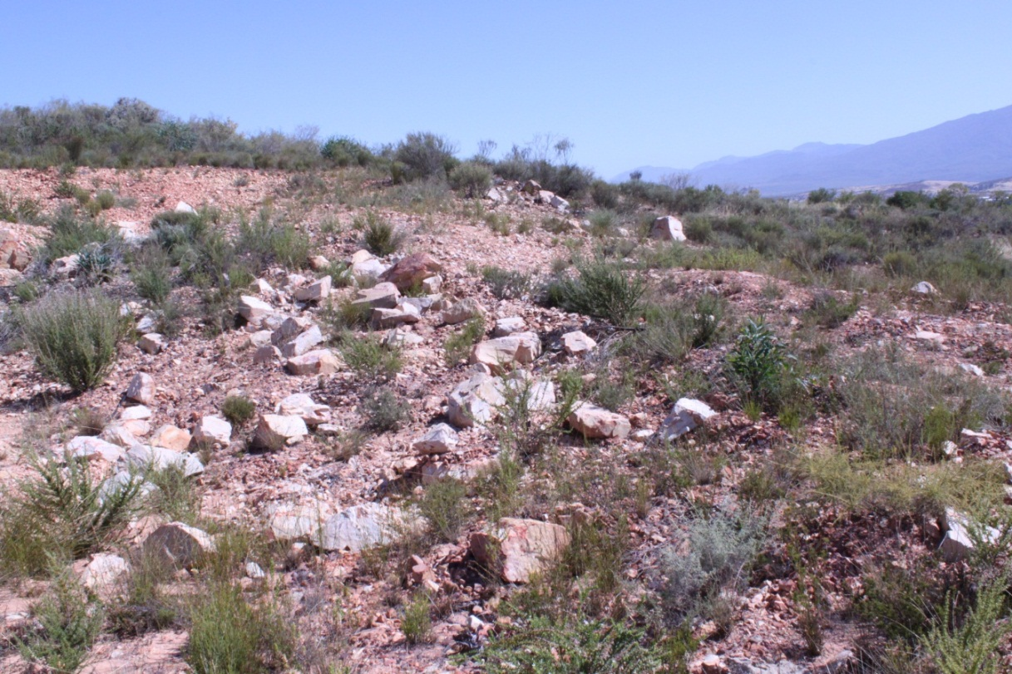

BORROW PIT 5 (BP 5)
Rietvlei Formtion. Modderfontein. New borrow pit on cultivated land. Sandy alluvial soil. Palaeontologically sterile.

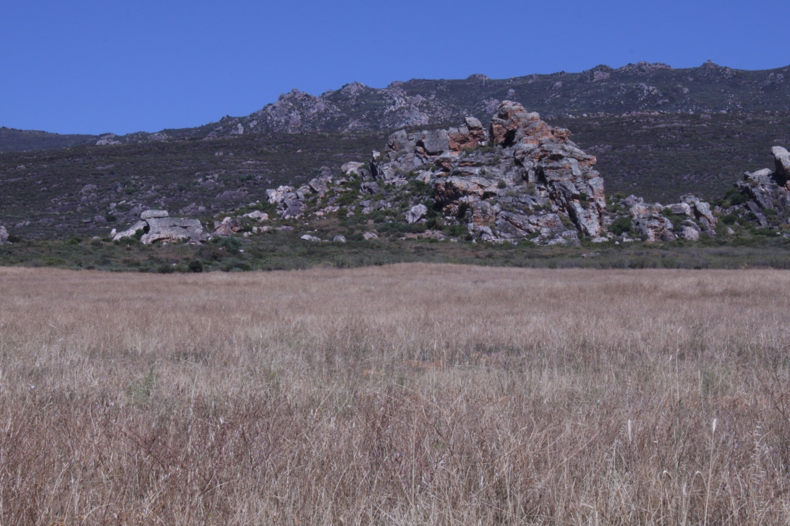

BORROW PIT 19 (BP 19)
La Rhyne. No fossils. Debris on Sederberg shale. Possible exposure of Sederberg shales at depth of five metres. If fossil material is exposed it will be of scientific benefit.

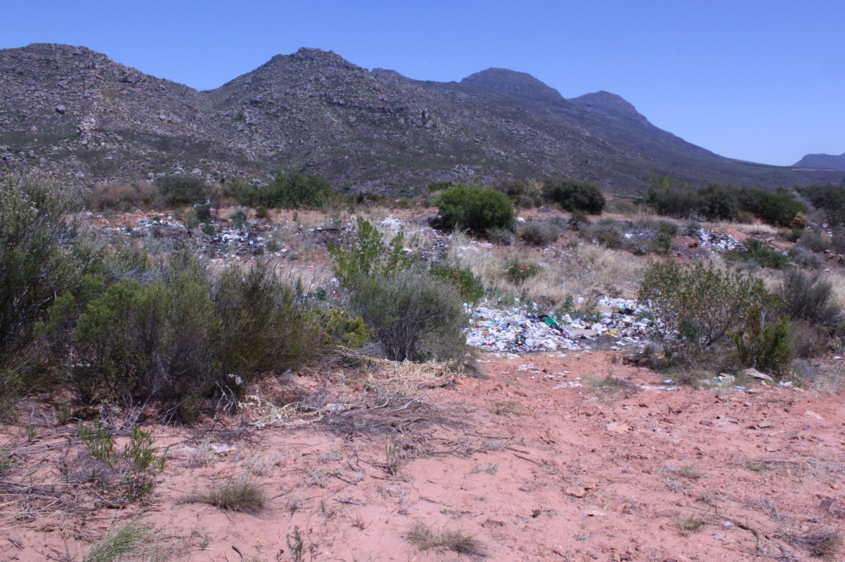

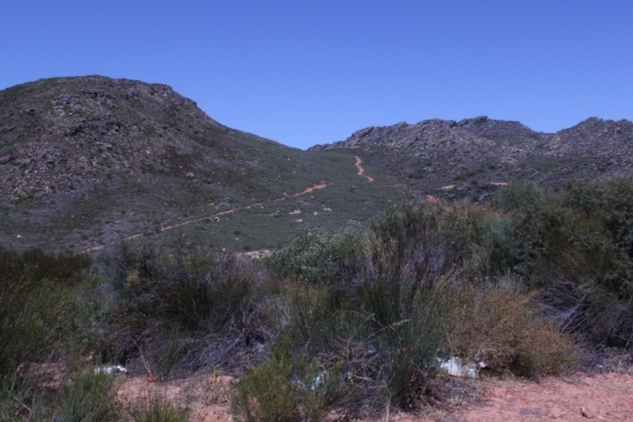

BORROW PIT 20 (BP 20)
Klawervlei. Current borrow pit to be extended. No fossiliferous shale. Uppermost Sederberg.
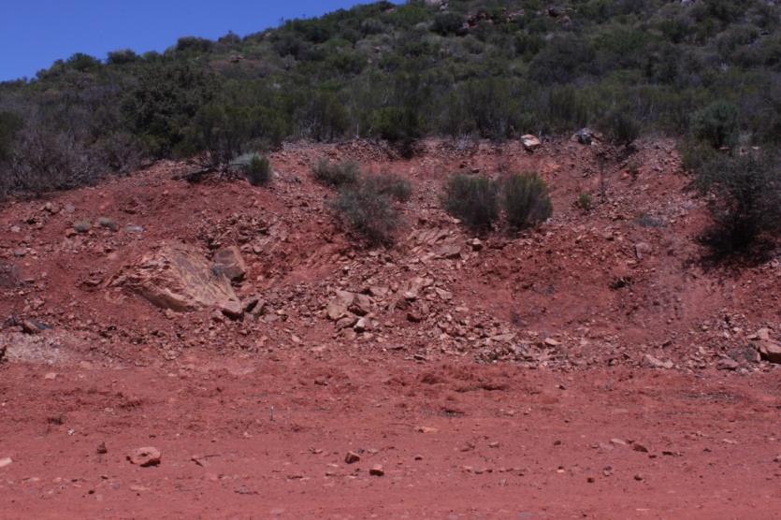

There is no danger of palaeontologically important material being damaged at this site if the proposed depth of two metres is adhered to. Beyond this depth fossil material may be uncovered in the shale layer. Palaeontologists do not possess the means to remove extensive barren rock layers in order to uncover fossiliferous strata. They are therefore dependent on natural erosion (which destroys fossil material) or the quarries of road builders, where fresh material can be collected. Although some fossils may be damaged in the excavation of a quarry it provides, in many cases, a rich source of well-preserved research material and finds of international import have come to light in this way. Working quarries are therefore potentially valuable sources of fossil material in the Sederberg Shale. There is consequently no reason why this borrow pit should not be extended.

BORROW PIT 11 (BP 11)
Langevallei, Korhaanshoogte. Sandy and gravelly alluvial soil underlain by the Rietvlei Formation. Of minor palaeontological import. Possible trace fossils in the Rietvlei Formation. Of minor palaeontological import.
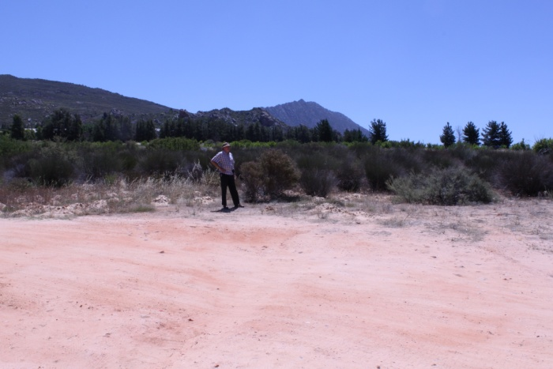

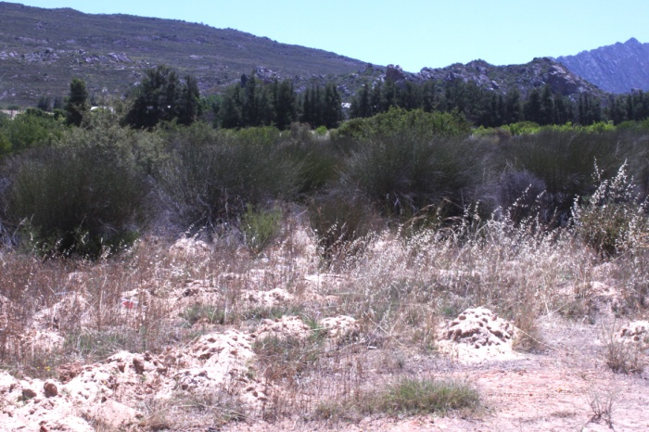

NEW QUARRY
Upper Peninsula Formation. Korhaanshoogte. Quartz sandstone. Possibly widely distributed and sparsely occuring trace fossils. Of minor palaeontological import.

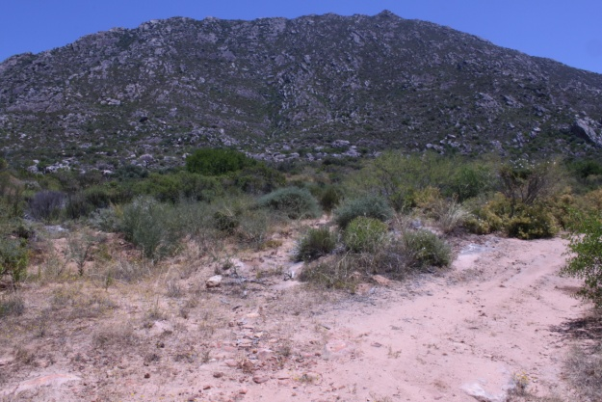

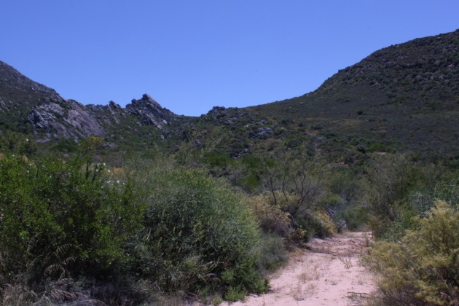

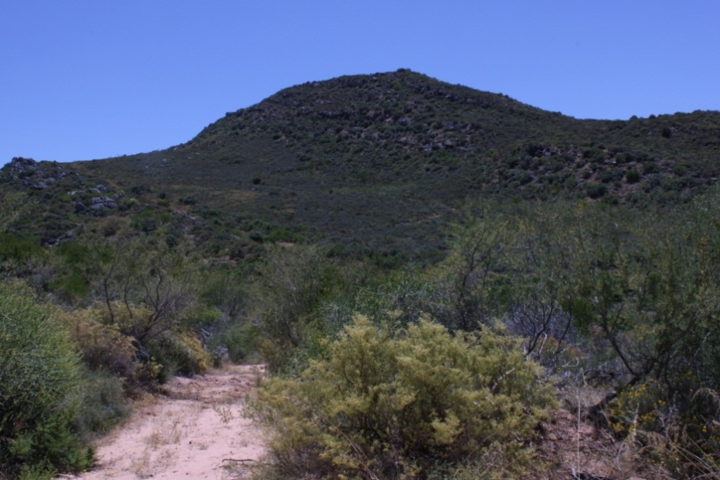
Final comments
Our investigation has clearly shown that the proposed activities of the road builders in the area covered by this report will not endanger palaeontologically sensitive sites. In addition, the photographs attest to the fact that neither buildings of historical importance nor archaeological sites (including examples of rock art) will be negatively affected or destroyed.

