**PALAEONTOLOGICAL DESKTOP ASSESSMENT FOR THE PROPOSED SUSTAINABLE AND INTEGRATED HUMAN SETTLEMENTS AT DIRKIESDORP ON PORTION 3 OF THE FARM SCHOONDERZIGT 68 HT, MKHONDO LOCAL MUNICIPALITY, GERT SIBANDE DISTRICT IN MPUMALANGA PROVINCE.**

**For:**

**HIA CONSULTANTS**



**DATE: 7 August 2016**

**By**

**Gideon Groenewald**

**078 713 6377**

**EXECUTIVE SUMMARY**

Gideon Groenewald was appointed by PGS Heritage and Grave Relocation Consultants to undertake a Desktop Survey, assessing the potential Palaeontological Impact of the proposed Sustainable and Integrated Human Settlements at Dirkiesdorp on Portion 3 of the farm Schoonderzigt 68 HT, Mkhondo Local Municipality, Gert Sibande District Municipality in Mpumalanga Province.

This report forms part of the Environmental Impact Assessment and complies with the requirements of the South African National Heritage Resource Act No 25 of 1999. In accordance with Section 38 (Heritage Resources Management), a Heritage Impact Assessment (HIA) is required to assess any potential impacts to palaeontological heritage within the development footprint of the development. The presence of known as well as potential groundwater resources forms part of the Palaeontological Impact Assessment reports as groundwater is regarded as a historic geological feature, contained in Section 3 of the Heritage resources Act, and is key to the National Heritage Estate of any development site.

The proposed development of Sustainable and Integrated Human Settlements at Dirkiesdorp on Portion 3 of the farm Schoonderzigt 68 HT, Mkhondo Local Municipality, Gert Sibande District Municipality in Mpumalanga Province is underlain by the Permian aged Vryheid Formation with a Very High Palaeontological sensitivity. The study area is also associated with important wetlands of the Mabola River to the East of the study area.

The very high fossiliferous potential of the Vryheid Formation of the Ecca Group, Karoo Supergroup, warrants an allocation of a Very High palaeontological sensitivity to entire development area. If extensive excavation of topsoil and removal of more than 1.5m of soil cover is planned, all the areas of activity will be allocated a Very High Palaeontological Sensitivity as these rocks can contain very significant remains of plants and trace fossils that will contribute significantly to our understanding of the palaeo-environments in this part of the Karoo Basin.

Recommendations:

* + - 1. The EAP as well as the ECO for this project must be made aware of the fact that the Vryheid Formation of the Ecca Group sediments contains very highly significant fossil remains, albeit mostly will only be exposed during infrastructure development. Several types of fossils have been recorded from this Group in the Karoo Basin of South Africa, with special mention of the Vryheid Formation.
      2. A Very High Palaeontological sensitivity is allocated to this area. The EAP must note that, specifically where deep excavation into bedrock is envisaged (following the geotechnical investigation), or where fossils are recorded during the geotechnical investigations, a qualified palaeontologist must be appointed to assess and record fossils at specific footprints of infrastructure developments (Phase 1 PIA) preferably during initial excavations for the development.
      3. The entire study area falls on a highly significant groundwater aquifer terrain and the infiltration of any waste water must be prevented at all cost during this development. Care must most of all be given to the presence of possible seepages of fresh water into the wetland system to the east of the study area.
      4. These recommendations must form part of the EMP of the project.

**TABLE OF CONTENT**

2. INTRODUCTION 1

2.1. Background 1

2.2. Aims and Methodology 1

2.3. Scope and Limitations of the Desktop Study 3

3. DESCRIPTION OF THE PROPOSED DEVELOPMENT 4

4. GEOLOGY 5

4.1. Karoo Supergroup 6

4.1.1. Ecca Group 6

5. PALAEONTOLOGY OF THE AREA 6

5.1. Karoo Supergroup 6

5.1.1. Ecca Group 6

6. HISTORIC AND POTENTIAL GROUNDWATER RESOURCES 6

7. PALAEONTOLOGICAL SENSITIVITY 7

8. CONCLUSION AND RECOMMENDATIONS 8

9. REFERENCES 8

10. QUALIFICATIONS AND EXPERIENCE OF THE AUTHOR 9

1. DECLARATION OF INDEPENDENCE 9

**LIST OF FIGURES**

Figure 2.1 Locality of study area 5

Figure 3.1 Geology of the Dirkiesdorp Housing Development that is underain by the Vryheid Formation (Pv) 5

Figure 5.1 Palaeosensitivity of the Study Area 7

**LIST OF TABLES**

**Table 1.1 Palaeontological Sensitivity Classes and Colour Codes** 2

# INTRODUCTION

## Background

Gideon Groenewald was appointed by PGS Heritage and Grave Relocation Consultants to undertake a Desktop Survey, assessing the potential Palaeontological Impact of the proposed Sustainable and Integrated Human Settlements at Dirkiesdorp on Portion 3 of the farm Schoonderzigt 68 HT, Mkhondo Local Municipality, Gert Sibande District Municipality in Mpumalanga Province.

This report forms part of the Environmental Impact Assessment and complies with the requirements of the South African National Heritage Resource Act No 25 of 1999. In accordance with Section 38 (Heritage Resources Management), a Heritage Impact Assessment (HIA) is required to assess any potential impacts to palaeontological heritage within the development footprint of the development. The presence of known as well as potential groundwater resources forms part of the Palaeontological Impact Assessment reports as groundwater is regarded as a historic geological feature, contained in Section 3 of the Heritage resources Act, and is key to the National Heritage Estate of any development site.

Categories of heritage resources recognised as part of the National Estate in Section 3 of the Heritage Resources Act, and which therefore fall under its protection, include:

* geological sites of scientific or cultural importance (which includes groundwater aquifers);
* objects recovered from the soil or waters of South Africa, including archaeological and palaeontological objects and material, meteorites and rare geological specimens;
* objects with the potential to yield information that will contribute to an understanding of South Africa’s natural or cultural heritage.

## Aims and Methodology

Following the *“SAHRA APM Guidelines: Minimum Standards for the Archaeological & Palaeontological Components of Impact Assessment Reports”* the aims of the palaeontological impact assessment are:

* to identify exposed and subsurface rock formations that are considered to be palaeontologically significant;
* to assess the level of palaeontological significance of these formations;
* to comment on the impact of the development on these exposed and/or potential fossil resources and
* to make recommendations as to how the developer should conserve or mitigate damage to these resources.
* to identify present and future groundwater resources and to prevent future degradation of groundwater resources that might result from the proposed development.

In preparing a palaeontological desktop study the potential fossiliferous rock units (groups, formations etc.) represented within the study area are determined from geological maps. The known fossil heritage within each rock unit is inventoried from the published scientific literature and previous palaeontological impact studies in the same region.

The likely impact of the proposed development on local fossil heritage is determined on the basis of the palaeontological sensitivity of the rock units concerned and the nature and scale of the development itself, most notably the extent of fresh bedrock excavation envisaged. The different sensitivity classes used are explained in Table 1.1 below.

The impact assessment of the development on groundwater resources forms part of the Palaeontological Impact Assessment and the presence of known and potential groundwater resources will, by virtue of the Very High Sensitivity of clean drinking water, always have a Very High Palaeontological Impact Rating for National Heritage.

**Table 1.1 Palaeontological Sensitivity Classes and Colour Codes**

|  |  |
| --- | --- |
| **PALAEONTOLOGICAL SIGNIFICANCE/VULNERABILITY OF ROCK UNITS** | |
| The following colour scheme is proposed for the indication of palaeontological sensitivity classes. This classification of sensitivity is adapted from that of Almond et al (2008, 2009) (Groenewald etal.,2014). | |
|  | |
| **RED** | Very High Palaeontological sensitivity/vulnerability. Development will most likely have a very significant impact on the Palaeontological Heritage of the region. Very high possibility that significant fossil assemblages will be present in all outcrops of the unit. Appointment of professional palaeontologist, desktop survey, phase I Palaeontological Impact Assessment (PIA) (field survey and recording of fossils) and phase II PIA (rescue of fossils during construction ) as well as application for collection and destruction permit compulsory. The Very High Sensitivity of all known and potential future Groundwater Resources must form part of of the Palaeontological Sensitivity Maps of all developmets that might impact on the supply of clean dronking water from groundwater resources. |
| **ORANGE** | High Palaeontological sensitivity/vulnerability. High possibility that significant fossil assemblages will be present in most of the outcrop areas of the unit. Fossils most likely to occur in associated sediments or underlying units, for example in the areas underlain by Transvaal Supergroup dolomite where Cenozoic cave deposits are likely to occur. Appointment of professional palaeontologist, desktop survey and phase I Palaeontological Impact Assessment (field survey and collection of fossils) compulsory. Early application for collection permit recommended. Highly likely that a Phase II PIA will be applicable during the construction phase of projects. |
| **GREEN** | Moderate Palaeontological sensitivity/vulnerability. High possibility that fossils will be present in the outcrop areas of the unit or in associated sediments that underlie the unit. For example areas underlain by the Gordonia Formation or undifferentiated soils and alluvium. Fossils described in the literature are visible with the naked eye and development can have a significant impact on the Palaeontological Heritage of the area. Recording of fossils will contribute significantly to the present knowledge of the development of life in the geological record of the region. Appointment of a professional palaeontologist, desktop survey and phase I PIA (ground proofing of desktop survey) will be required. |
| **BLUE** | Low Palaeontological sensitivity/vulnerability. Low possibility that fossils that are described in the literature will be visible to the naked eye or be recognized as fossils by untrained persons. Fossils of for example small domal Stromatolites as well as micro-bacteria are associated with these rock units. Fossils of micro-bacteria are extremely important for our understanding of the development of Life, but are only visible under large magnification. Recording of the fossils will contribute significantly to the present knowledge and understanding of the development of Life in the region. Where geological units are allocated a blue colour of significance, and the geological unit is surrounded by highly significant geological units (red or orange coloured units), a palaeontologist must be appointed to do a desktop survey and to make professional recommendations on the impact of development on significant palaeontological finds that might occur in the unit that is allocated a blue colour. An example of this scenario will be where the scale of mapping on the 1:250 000 scale maps excludes small outcrops of highly significant sedimentary rock units occurring in larger alluvium deposits. At least a Desktop Survey by a suitably qualified Palaeontologist is required. Collection of a representative sample of potential fossiliferous material is recommended. |
| **GREY** | Very Low Palaeontological sensitivity/vulnerability. Very low possibility that significant fossils will be present in the bedrock of these geological units. The rock units are associated with intrusive igneous activities and no life would have been possible during implacement of the rocks. It is however essential to note that the geological units mapped out on the geological maps are invariably overlain by Cenozoic aged sediments that might contain significant fossil assemblages and archaeological material. Examples of significant finds occur in areas underlain by granite, just to the west of Hoedspruit in the Limpopo Province, where significant assemblages of fossils and clay-pot fragments are associated with large termite mounds. Where geological units are allocated a grey colour of significance, and the geological unit is surrounded by very high and highly significant geological units (red or orange coloured units), a palaeontologist must be appointed to do a desktop survey and to make professional recommendations on the impact of development on significant palaeontological finds that might occur in the unit that is allocated a grey colour. An example of this scenario will be where the scale of mapping on the 1:250 000 scale maps excludes small outcrops of highly significant sedimentary rock units occurring in dolerite sill outcrops. It is important that at least a Desktop PIA report is provided and the report should also refer to archaeological reports with possible reference to palaeontological finds in Cenozoic aged surface deposits. |

## Scope and Limitations of the Desktop Study

The study will include: (i) an analysis of the area’s stratigraphy, age and depositional setting of fossil-bearing units; (ii) a review of all relevant palaeontological and geological literature, including geological maps, and previous palaeontological impact reports; (iii) data on the proposed development provided by the developer (e.g. location of footprint, depth and volume of bedrock excavation envisaged); (iv) where feasible, location and examination of any fossil collections from the study area (e.g. museums) and (v) a review of all existing and potential groundwater resources associated with the study area.

The key assumption for this scoping study is that the existing geological maps and datasets used to assess site sensitivity are correct and reliable. However, the geological maps used were not intended for fine scale planning work and are largely based on aerial photographs alone, without ground-truthing. There is also an inadequate database for fossil heritage for much of the RSA, due to the small number of professional palaeontologists carrying out fieldwork in RSA. Most development study areas have never been surveyed by a palaeontologist.

These factors may have a major influence on the assessment of the fossil heritage significance of a given development and without supporting field assessments may lead to either:

* an underestimation of the palaeontological significance of a given study area due to ignorance of significant recorded or unrecorded fossils preserved there, or
* an overestimation of the palaeontological sensitivity of a study area, for example when originally rich fossil assemblages inferred from geological maps have in fact been destroyed by weathering, or are buried beneath a thick mantle of unfossiliferous “drift” (soil, alluvium etc.).

# DESCRIPTION OF THE PROPOSED DEVELOPMENT

The following description of the proposed development was provided by the HIA consultant.

Mkhondo Local Municipality proposes the development of sustainable and integrated human settlements at Dirkiesdorp, Gert Sibande District in Mpumalanga Province. The proposed development includes the development of 1000 stands with an approximate size of 400-500 m2 and will include the development of water, road, electrical and sewage infrastructure. The Dirkiesdorp node is regarded as a rural development node in terms of the Mkhondo Strategic Development Framework. Development proposals include the consolidating of future business activities and community facilities in the central part around route R543, expanding towards the farm Schoonderzigt.

The proposed development site is located to the West of the town of Dirkiesdorp located 41km to the Southwest of Piet Retief in eastern Mpumalanga as indicated in Figure 2.1. The proposed sustainable and integrated human settlement is planned on Portion 3 of the farm Schoonderzigt 68 HT. The size of the property is 305.0339 Ha. Only approximately 100 ha will be utilised for the proposed development. The site is situated in the quarter degree square 2730AB. Approximate coordinates of the site are 27° 9'58.83"S 30°22'53.93"E. The Mabola River and associated wetlands forms the eastern border of the site

Dirkiesdorp land belongs to public works and was a camp for construction workers in the past. Studies conducted in the area had previously indicated that not enough space was available for the existing housing development. The municipality has therefore proposed to transfer the land from the public works department to the rural development and land reform department in order to ensure land ownership.

Project benefits associated with the development include

Ø  Access to good quality houses,

Ø  Provision of infrastructure that will create an environment that is conducive to economic, growth and development,

Ø  Elimination of informal settlements,

Ø  Development of new housing stock catering for affordable and high income markets,

Ø  Understanding of all housing related matters and available housing options,

Ø  Densification in centrally located areas in order to optimize bulk infrastructure provision,

Ø  Promotion of contractor development and address unemployment, and

Ø  The building of municipal housing development and delivery capacity.

Figure 2.1 Locality of study area

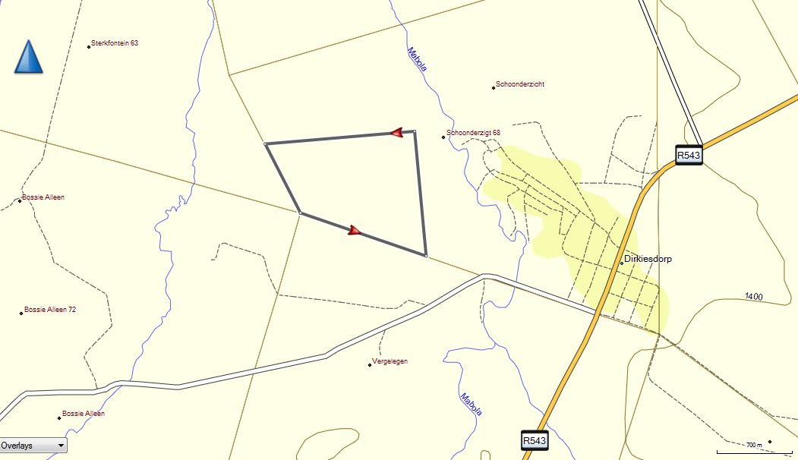

# GEOLOGY

The study area is underlain by Permian aged sandstone and dark coloured shale, with coal beds of the Vryheid Formation (Pv) of the Ecca Group. The development site is bordered by the wetland systems of the Mabola River and the coarse-grained sandstones of the Vryheid Formation is an important secondary aquifer rock in South Africa (Figure 3.1).

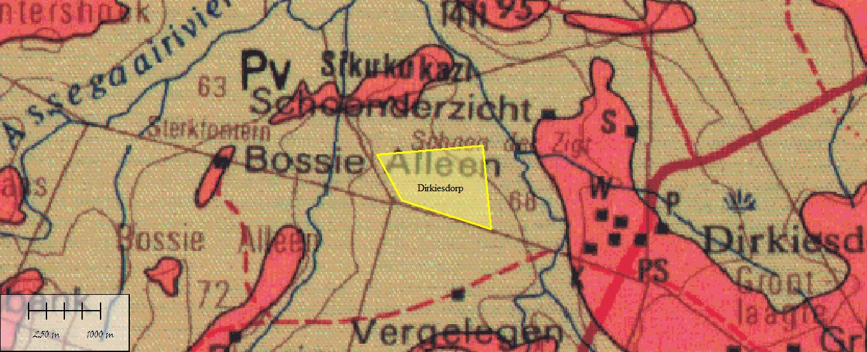

Figure 3.1 Geology of the Dirkiesdorp Housing Development that is underain by the Vryheid Formation (Pv)

## Karoo Supergroup

### Ecca Group

*Vryheid Formation (Pv)*

The Vryheid Formation consists largely of a sequence of coarse-grained sandstone and interbedded dark coloured shale and coal beds, very often occurring in economically viable deposits of coal, mined in this part of the Karoo Basin (Johnson et al, 2009).

# PALAEONTOLOGY OF THE AREA

## Karoo Supergroup

### Ecca Group

*Vryheid Formation (Pv)*

The Permian aged Ecca Group, and more so the Vryheid Formation, is very well known as a treasure house of Palaeontological Heritage in Southern Africa (MacRae, 1999; McCarthy and Rubidge, 2005; Johnson et al, 2009, Bamford, 2011 and Mason and Christie, 1986 ).

The Vryheid Formation is well-known for the occurrence of coal beds that resulted from the accumulation of plant material over long periods of time. Plant fossils described by Bamford (2011) from the Vryheid Formation are; *Azaniodendron fertile, Cyclodendron leslii, Sphenophyllum hammanskraalensis, Annularia sp., Raniganjia sp., Asterotheca spp., Liknopetalon enigmata, Glossopteris > 20 species, Hirsutum 4 spp., Scutum 4 spp., Ottokaria 3 spp., Estcourtia sp., Arberia 4 spp., Lidgetonnia sp., Noeggerathiopsis sp. and Podocarpidites sp.*

According to Bamford (2011), little data has been published on these potentially fossiliferous deposits. Good fossil material is likely around the coal mines and yet in other areas the exposures may be too poor to be of interest. When they do occur fossil plants are usually abundant and it would not be feasible to preserve and maintain all the sites. In the interests of heritage and science, however, such sites should be well recorded, sampled and the fossils kept in a suitable institution.

Although no vertebrate fossils have been recorded from the Vryheid Formation, invertebrate trace fossils have been described in some detail by Mason and Christie (1986). It should be noted, however, that the aquatic reptile, *Mesosaurus*, which is the earliest known reptile from the Karoo Basin, as well as fish (*Palaeoniscus* *capensis*), have been recorded in equivalent-aged strata in the Whitehill Formation in the southern part of the basin (MacRae, 1999). Indications are that the Whitehill Formation in the main basin might be correlated with the mid-Vryheid Formation. If this assumption proves correct, there is a possibility that Mesosaurus could be found in the Vryheid Formation.

The Karoo sediments are almost entirely lacking in body fossils but ichnofossils (trace fossils) are locally abundant. Modern sedimentological and ichnofaunal studies suggest that the north-eastern part of the Karoo basin was marine. In the study area a shallow basin margin probably accommodated a prograding fluviodeltaic complex forming a broad sandy platform on which coal-bearing sediments were deposited. Ichnofossils include U-burrows (formerly *Corophioides*) which are assigned to ichnogenus *Diplocraterion* (Mason and Christie, 1986).

# HISTORIC AND POTENTIAL GROUNDWATER RESOURCES

No historic spring site is known from the study area and the area is underlain by coarse-grained sandstone of the Vryheid Formation (Vegter, 2001) with no obvious linear structures, ie fault zones or dolerite dykes mapped out on the site. No natural springs are indicated on the geological map and pollution of groundwater will be dependent on the secure design of all water pipes and sewerage systems. If French drain systems are planned the developer and the EAP must take note of the fact that the Vryheid Formation is an important aquifer rock (Vegter, 1995, 2001; Jonck and Meyer, undated) and might lead to seepage of sewerage waste water into the rock profile, leading to seepages of sewerage waste water towards the southeast of the study area.

# PALAEONTOLOGICAL SENSITIVITY

The likely impact of the proposed development on local fossil heritage is determined on the basis of the palaeontological sensitivity of the rock units concerned and the nature and scale of the development itself, most notably the extent of fresh bedrock excavation envisaged (Figure 5.1). The different sensitivity classes used are explained in Table 1 above.

The Permian aged Vryheid Formation of the Ecca Group, Karoo Supergroup underlies the entire study site and although large areas are covered in sandy or clayey soils, most of the excavations will be into sandstone or mudstone of the underlying Permian aged sediments that might contain significant plant fossils. Areas underlain by the Permian aged sediments are Very Highly sensitive for Palaeontological Heritage and these areas must be monitored and a suitably qualified Palaeontologist must visit the site as part of a Phase 1 PIA assessment, preferably simultaneous to the timing of initial excavations for construction of roads, infrastructure and then for each individual phase of the project where excavation will be deeper than 1.5m or where geotechnical investigation indicates possible exposure of bedrock during construction.

Figure 5.1 Palaeosensitivity of the Study Area

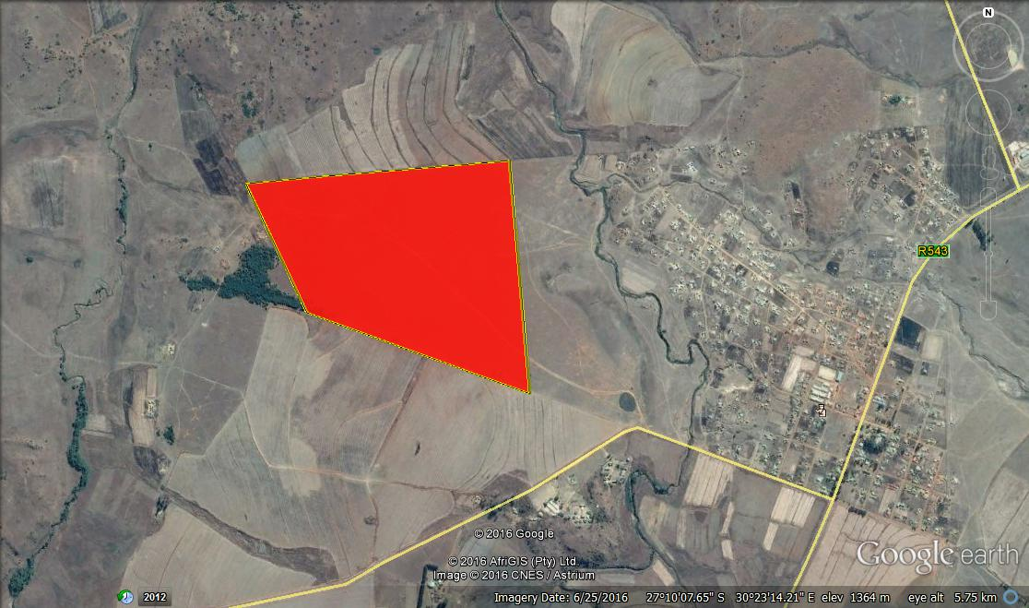

The entire study area is underlain by rocks of the Vryheid Formation of which the coarse-grained sandstone forms a very important secondary aquifer of fresh water for South Africa. The planning of storm water systems and all infrastructures for waste water must include a full geohydrological report. Development of wastewater treatment plants associated with either deep excavation into the Vryheid sandstone and/or close to seepages into the existing Mabola River wetland system to the east of the study area must be planned with caution.

# CONCLUSION AND RECOMMENDATIONS

The proposed development of Sustainable and Integrated Human Settlements at Dirkiesdorp on Portion 3 of the farm Schoonderzigt 68 HT, Mkhondo Local Municipality, Gert Sibande District Municipality in Mpumalanga Province is underlain by the Permian aged Vryheid Formation with a Very High Palaeontological sensitivity. The study area is also associated with important wetlands of the Mabola River to the East of the study area.

The very high fossiliferous potential of the Vryheid Formation of the Ecca Group, Karoo Supergroup, warrants an allocation of a Very High palaeontological sensitivity to entire development area. If extensive excavation of topsoil and removal of more than 1.5m of soil cover is planned, all the areas of activity will be allocated a Very High Palaeontological Sensitivity as these rocks can contain very significant remains of plants and trace fossils that will contribute significantly to our understanding of the palaeo-environments in this part of the Karoo Basin.

Recommendations:

* + - 1. The EAP as well as the ECO for this project must be made aware of the fact that the Vryheid Formation of the Ecca Group sediments contains very highly significant fossil remains, albeit mostly will only be exposed during infrastructure development. Several types of fossils have been recorded from this Group in the Karoo Basin of South Africa, with special mention of the Vryheid Formation.
      2. A Very High Palaeontological sensitivity is allocated to this area. The EAP must note that, specifically where deep excavation into bedrock is envisaged (following the geotechnical investigation), or where fossils are recorded during the geotechnical investigations, a qualified palaeontologist must be appointed to assess and record fossils at specific footprints of infrastructure developments (Phase 1 PIA) preferably during initial excavations for the development.
      3. The entire study area falls on a highly significant groundwater aquifer terrain and the infiltration of any waste water must be prevented at all cost during this development. Care must most of all be given to the presence of possible seepages of fresh water into the wetland system to the east of the study area.
      4. These recommendations must form part of the EMP of the project.

# REFERENCES

**Almond J.E. and Pether J. 2008.** *Palaeontological Heritage of the Western Cape.* Internal Report Heritage Western Cape.

**Almond J.E., De Klerk B. and Gess R., 2009.** *Palaeontological Heritage of the Eastern Cape*. Internal Report, SAHRA.

**Bamford M. 1999.** Permo-Triassic Fossil Woods from the South African Karoo Basin. Palaeontologia Africana, 35-36, p25.

**Groenewald G.H., Groenewald D.P. and Groenewald S.M., 2014.** *Palaeontological Heritage of the Free State, Gauteng, Limpopo, Mpumalanga and North West Provinces*. Internal Palaeotechnical Reports, SAHRA.

**Johnson MR, Anhausser CR and Thomas RJ. 2009**. The Geology of South Africa. Geological Society of South Africa.

**Jonck F and Meyer S. (Internet no date):** *HYDROGEOLOGICAL MAP SERIES OF THE REPUBLIC OF SOUTH AFRICA* • Department of Water Affairs and Forestry, Private Bag X313, PRETORIA, 0001. Jonckf@dwaf.gov.za Schalk Meyer: Department of Water Affairs and Forestry, Private Bag X6553, GEORGE, 6530. [schalkabor@telkomsa.net](mailto:schalkabor@telkomsa.net)

MacRae C. 1999. *Life Etched in Stone*. Geological Society of South Africa, Linden, South Africa.

Mason TR and Christie ADM 1986. Palaeoevironmental significance of ichnogenus *Diplocraterion torell* from the Permian Vryheid Formation of the Karoo Supergroup, South Africa. Palaeogeography, Palaeoclimatology, Palaeoecology 53(3-4):249-265.

McCarthy T and Rubidge BS. 2005. *Earth and Life.* 333pp. Struik Publishers, Cape Town.

**Vegter JR ,1995** *An Explanation of a Set of National Groundwater Maps*. WRC Report No. TT 74/95. Water Research Commission, Pretoria, South Africa.

**Vegter J.R., 2001**. *Groundwater Development in South Africa and an introduction to the Geohydrology of groundwater regions*. Report No TT134.00, Water Research Commission, Pretoria.

# QUALIFICATIONS AND EXPERIENCE OF THE AUTHOR

Dr Gideon Groenewald has a PhD in Geology from the University of Port Elizabeth (Nelson Mandela Metropolitan University) (1996) and the National Diploma in Nature Conservation from Technicon RSA (the University of South Africa) (1989). He specialises in research on South African Permian and Triassic sedimentology and macrofossils with an interest in biostratigraphy, and palaeo-ecological aspects. He has extensive experience in the locating of fossil material in the Karoo Supergroup and has more than 20 years of experience in locating, collecting and curating fossils, including exploration field trips in search of new localities in the southern, western, eastern and north-eastern parts of the country. His publication record includes multiple articles in internationally recognized journals. Dr Groenewald is accredited by the Palaeontological Society of Southern Africa (society member for 35 years). Dr Groenewald has 35 years of experience as a hydrogeologist and is an accredited member of the Borehole Water Association of South Africa.

# DECLARATION OF INDEPENDENCE

I, Gideon Groenewald, declare that I am an independent specialist consultant and have no financial, personal or other interest in the proposed development, nor the developers or any of their subsidiaries, apart from fair remuneration for work performed in the delivery of palaeontological heritage and groundwater assessment services. There are no circumstances that compromise the objectivity of my performing such work.



**Dr Gideon Groenewald**

**Geologist**