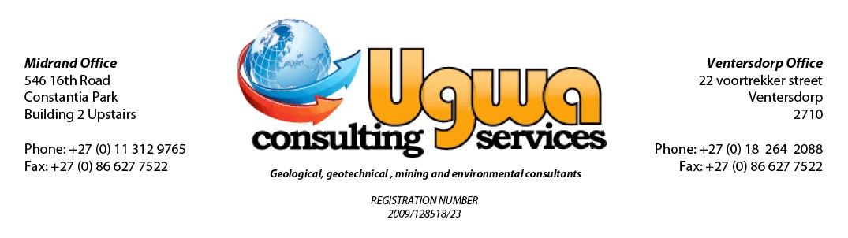
DRAFT BASIC ASSESSMENT REPORT
FOR
THE PROPOSED PROSPECTING RIGHT OF AGGREGATE, MANGANESE AND LIMESTONE

FOR MALEBOGO MINING COMPANY (PTY) LTD
NORTH WEST PROVINCE

FOR COMMENTS
DMR REF: NW30/5/1/3/2/11039 MP
APRIL 2022

Directors: ST Netshiozwi | C Monokofala | MS Masoga |
Email: info@Geoluken Consulting .com | Website: www.Geoluken Consulting .com
DRAFT BASIC ASSESSMENT REPORT
FOR
THE PROPOSED MINING PERMIT OF THE PROPOSED MINING ACTIVITY OF AGGREGATE, MANGANESE AND LIMESTONE
FOR MALEBOGO MINING COMPANY (PTY) LTD
NORTH WEST PROVINCE

Conducted on behalf of:
Malebogo Mining Company (Pty) Ltd
P.O. BOX 4077
Halfway House, Midrand
1685
Compiled by:

Silas Raluthaga (GISSA,)

APRIL 2022

STRICTLY CONFIDENTIAL
Although Ugwa Consulting Services cc exercises due care and diligence in rendering services and preparing documents, Ugwa Consulting Services cc accepts no liability, and the client, by receiving this document, indemnifies Ugwa Consulting Services cc and its directors, managers, agents and employees against all actions, claims, demands, losses, liabilities, costs, damages and expenses arising from or in connection with services rendered, directly or indirectly by Ugwa Consulting Services cc and by the use of the information contained in this document.

This document contains confidential and proprietary information of Ugwa Consulting Services cc and is protected by copyright in favor of Ugwa Consulting Services cc and may not be reproduced or used without the written consent of Ugwa Consulting Services cc, which has been obtained beforehand. This document is prepared exclusively for Malebogo Mining Company (Pty) Ltd and is subject to all confidentiality, copyright and trade secrets, rules, intellectual property law and practices of South Africa.

DEFINITIONS
Activity is a distinct process or task undertaken by an organisation for which a responsibility can be assigned. Activities also include facilities or pieces of infrastructure that are possessed by an organisation.
Environmental Aspect is an ‘element of an organisations activities, products and services which can interact with the environment’. The interaction of an aspect with the environment may result in an impact.
Receptors comprise but are not limited to people or man-made structures.
Resources include components of the biophysical environment.
Environmental Impacts are the consequences of these aspects on environmental resources or receptors of particular value or sensitivity, for example, disturbance due to noise and health effects due to poorer air quality. Receptors can comprise, but are not limited to, people or human-made systems, such as local residents, communities, and social infrastructure, as well as components of the biophysical environment such as aquifers, flora and palaeontology. In the case where the impact is on human health or well-being, this should be stated. Similarly, where the receptor is not anthropogenic, then it should, where possible, be stipulated what the receptor is.
Severity refers to the degree of change to the receptor status in terms of the reversibility of the impact; sensitivity of receptor to stressor; duration of impact (increasing or decreasing with time); controversy potential and precedent setting; threat to environmental and health standards.
Spatial refers to the geographical scale of the impact.
Duration refers to the length of time over which the stressor will cause a change in the resource or receptor.
Frequency of Activity refers to how often the proposed activity will take place.
Frequency of Impact refers to the frequency with which a stressor (aspect) will impact on the receptor.

LIST OF ABBREVIATIONS
BAR Basic Assessment Report
BID Background Information Document
DEA Department of Environmental Affairs
DMR Department of Mineral Resources
DWA Department of Water and Sanitation
EA Environmental Authorisation
EIA Environmental Impact Assessment
EMPR Environmental Management Programme
GN Government Notice
GIS Geographic Information System
HA Hectares
IAPS Interested and Affected Parties
IDP Integrated Development Plan
MPRDA Mineral and Petroleum Resources Development Act, 2002 (Act 28 of 2002)
NEMA National Environmental Management Act, 1998 (Act 107 of 1998)
NEM:WA National Environmental Management Waste Act, 2008 (Act No. 59 of 2008)
NWA National Water Act, 1998 (Act No. 36 of 1998)
PPP Public Participation Process
PPR Public Participation Report
PWP Prospecting Work Programme
SACNASP South African Council of Natural Scientist Profession
SANBI South African National Biodiversity Institute

EXECUTIVE SUMMARY
Malebogo Mining Company (Pty) Ltd has applied for an Environmental Authorisation for proposed Mining activities for Aggregates, Limestone and Manganese ore on a 5ha of a certain portion of portion 3 of the farm farview 410 JQ, in the magisterial district of Ngaka Modiri Molema in the North West, South Africa. The application has been lodged in terms in terms of Section 23 of the Mineral and Petroleum Resources Development Act (MPRDA), 2008 (Act No. 23 of 2008) to the Department of Mineral Resources (DMR), North West Province (North West Regional Department). See APPENDIX A: MAPS for the Regulation 2(2) plan for this proposed mining permit application.
In terms of the NEMA (Act 107 of 1998) and EIA regulations of 2014 as amended, the proposed mining activities triggers a Listed Activity 21 and Activity 27 of Listing Notice 1 (GNR 327) and the applicant cannot proceed without an Environmental Authorisation for the mentioned listed activities. Ugwa Consulting Services cc (Ugwa) has been appointed by Malebogo Mining Company (Pty) Ltd as an independent Environmental Assessment Practitioner to undertake the Environmental Impact Assessment for the proposed mining permit. The purpose of the studies is to identify and assess all the possible impacts that may arise from the implementation of the proposed project and to find the most effective ways of enhancing environmental benefits and mitigating potential impacts to encourage sustainable development within the area. The Public Participation Process will be announced in the local newspaper and the registration process for Interested and Affected Parties (IAPs) will be an ongoing process. The following process will be undertaken as part of the public participation process:
- Publication of a Newspaper advertisement in the Stellalander Newspaper;
- Erecting site notices at visible and accessible entry points in and around the proposed project area will be done;
- Directly notifying affected I& APs and Stakeholders representing various sectors of society by distributing information via e-mail, hand delivery of documents, meetings, postal and telephonically started.

The proposed mining activities will be undertaken over a period of Two (2) years and the activities to be carried out includes invasive and non-invasive methods. Non-invasive method will include desktop studies and data acquisition, whereas Invasive methods will include excavation, stockpiling, loading, hauling, processing and transportation within the mining area. Other stages will involve geological modelling and analyses of metallurgical test work and resource estimation.
Potential risks and key issues identified will be based on consultation with I&APs, through an internal process based on similar projects, current state of the environment of the site, and a site visit. A summarised description of the surrounding land use is provided to ensure that all environmental aspects are highlighted. A description of the biophysical and social environment is also included in the report, to ensure that all potential risks and issues are taken into consideration in all phases of the proposed project.
All environmental data (i.e. surface and ground water qualities and quantities, topographical analyses, soil, vegetation, wetland, and geological conditions including socio-economic aspects) including the historic land uses that has been used in this report has been obtained through desktop studies. Weather data was acquired from the Climate Data Online, 2018. The data accumulated and analysed is therefore deemed insufficient to gain a baseline indication of the present state of the environment. The data will only be deemed sufficient once the public participation, site impact assessment has been completed. The use of this baseline data for determining the potential impacts associated with this project is thus justified, and reliable conclusions couldn’t be made yet.
The findings and conclusions of this document (DBAR and EMPr), which concerns assessment of environmental impacts and a programme for management of the impacts for the proposed mining activities at the Malebogo Mining Company Project site, was compiled in terms of the EIA Regulations of 2014 for review by interested and affected parties including the competent authority. Based on the desktop study in respect of impact assessment, several recommendations are already made to mitigate significant negative impacts as well as to maximize positive impacts that will result from the proposed project.

TABLE OF CONTENTS
STRICTLY CONFIDENTIAL ii
DEFINITIONS iii
LIST OF ABBREVIATIONS iv
EXECUTIVE SUMMARY vii
TABLE OF CONTENTS 1
3 IMPORTANT NOTICE 2
4 OBJECTIVE OF THE BASIC ASSESSMENT PROCESS 3
PART A 4
SCOPE OF ASSSSMENT AND BASIC ASSESSMENT REPORT 4
5 CONTACT PERSON AND CORRESPONDENCE ADDRESS 4
5.1 Details of the 4
5.1.1 Details of the EAP 4
5.1.2 Expertise of the EAP 4
5.1.2.1 The qualifications of the EAP (with evidence) 4
5.1.2.2 Summary of the EAP’s past experience 4
5.2 Location of the overall Activity 5
5.3 Locality map 5
5.4 Description of the scope of the proposed overall activity 7
5.4.1 Listed and specified activities 9
5.4.2 Description of the activities to be undertaken 11
5.5 Policy and Legislative Context 16
5.6 Need and Desirability of the proposed activities 20
5.7 Motivation for the overall preferred site, activities, and technology alternative 21
5.8 Full description of the process followed to reach the proposed preferred alternatives within the site 22
5.8.1 Details of the development footprint alternatives considered. 22
5.8.2 Details of the Public Participation Process Followed 24
5.8.3 Summary of issues raised by I&Aps 29
5.8.4 The Environmental attributes associated with the alternatives 36
5.8.4.1 Baseline Environment 36
5.8.5 Impacts and risks identified including the nature, significance, consequence, extent, duration and probability of the impacts, including the degree to which these impacts 53
5.8.6 Methodology used in determining and ranking the nature, significance, consequences, extent, duration and probability of potential environmental impacts and risks 70
5.8.7 The positive and negative impacts that the proposed activity (in terms of the initial site layout) and alternatives will have on the environment and the community that may be affected 75
5.8.8 The possible mitigation measures that could be applied and the level of risk 76
5.8.9 Motivation where no alternative sites were considered 76
5.8.10 Statement motivating the alternative development location within the overall site 76
5.8.11 Full description of the process undertaken to identify, assess and rank the impacts and risks the activity will impose on the preferred site (in respect of the final site layout plan) through the life of the activity 77
5.8.12 Assessment of each identified potentially significant impact and risk 78
5.8.13 Summary of specialist reports 85
5.8.14 Environmental Impact Statement 86
5.8.15 Proposed impact management objectives and the impact management outcomes for inclusion in the EMPR 89
5.8.16 Aspects for inclusion as conditions of Authorisation 90
5.8.17 Description of any assumptions, uncertainties, and gaps in knowledge 90
5.8.18 Reasoned opinion as to whether the proposed activity should or should not be authorised 90
5.8.19 Period for which the environmental authorisation is required 91
5.8.20 Undertaking 91
5.8.21 Financial Provision 91
Annual Total 93
5.8.22 Specific information required by the Competent Authority 93
5.8.23 Other matters required in terms of sections 24(4)(a) and (b) of the Act 95
PART B 96
ENVIRONMENTAL MANAGEMENT PROGRAMME REPORT 96
1. DRAFT ENVIRONMENTAL MANAGEMENT PROGRAMME 96
1.1 Details of the EAP 96
1.2 Description of the Aspects of the Activity 96
1.3 Composite Map 96
1.4 Description of Impact management objectives including management statements 96
1.4.1 Determination of Closure Objectives 96
1.4.2 Volumes and rate of water use required for the operation 97
1.4.3 Has a water use licence has been applied for? 97
1.4.4 Impacts to be mitigated in their respective phases 98
1.4.5 Impact Management Outcomes 128
1.4.6 Impact Management Actions 159
1.5 Financial Provision 185
1.5.1 Determination of the amount of Financial Provision 185
1.5.1.1 Describe the closure objectives and the extent to which they have been aligned to the baseline environment described under the Regulation. 185
1.5.1.2 Confirm specifically that the environmental objectives in relation to closure have been consulted with landowner and interested and affected parties. 186
1.5.1.3 Provide a rehabilitation plan that describes and shows the scale and aerial extent of the main mining activities, including the anticipated mining area at the time of closure. 186
1.5.1.4 Explain why it can be confirmed that the rehabilitation plan is compatible with the closure objectives. 186
1.5.1.5 Calculate and state the quantum of the financial provision required to manage and rehabilitate the environment in accordance with the applicable guideline. 187
1.5.1.6 Confirm that the financial provision will be provided as determined. 189
1.5.2 Mechanisms for monitoring compliance with and performance assessment against the environmental management programme and reporting thereon, including 189
1.5.3 Indicate the frequency of the submission of the performance assessment/ environmental audit report. 197
1.5.4 Environmental Awareness Plan 197
1.5.4.1 Manner in which the applicant intends to inform his or her employees of any environmental risk which may result from their work. 197
1.5.4.2 Manner in which risks will be dealt with in order to avoid pollution or the degradation of the environment. 199
1.5.4.3 Specific information required by the Competent Authority 201
2. UNDERTAKING 202

LIST OF FIGURES
Figure 1: Locality map of the proposed project area 6
Figure 2: Site Plan of the Area 8
Figure 3: General Layout for prospecting area activities 16
Figure 4: Rainfall and Evaporation 37
Figure 5: The sub-catchment of the project area inclusive 38
Figure 6: Vegetation occurring on the Kruidfontein proposed site 40
Figure 7: Soil Class Map 41
Figure 8: Map illustrating the vegetation in which the study area occurs in. 42
Figure 9: Local geological map 45
Figure 10: Environmental and Current Land Use Map of the area 52
Figure 11: Site Layout Map of the area 87
LIST OF TABLES
Table 1: Location details 5
Table 2: Summary of NEMA Listed activities applied for 10
Table 3: Project Phases 13
Table 4: Applicable Legislation and Guidelines for the proposed Prospecting Project 17
Table 5: Summary of issues raised by I&APs 29
Table 6: Population size of Moses Kotane Local Municipality 49
Table 7: Population Distribution / Composition Structure 49
Table 8: Impact Assessment for Construction Phase 54
Table 9: Impact Assessment for Operational Phase 60
Table 10: Impact Assessment for Decommissioning Phase and Closure 67
Table 11: Criteria for Assessing Significance of Impacts 71
Table 12: Probability Consequence Matrix 73
Table 13: Significance Threshold Limits 74
Table 14: Assessment of each identified potential significant impact and risk 78
Table 15: Summary of Specialist 85
Table 16: Cost Estimate of the expenditure for the Prospecting Operation 92
Table 17: Environmental Management Programme for the proposed prospecting project 98
Table 18: Impact Management Outcomes 128
Table 19: Impact Management Actions 159
Table 20: Closure Cost Estimates 188
Table 21: Mechanism for Monitoring Compliance and Performance Assessment 190
Table 22: Environmental Training and Awareness Schedule 198

BASIC ASSESSMENT REPORT
And
ENVIRONMENTAL MANAGEMENT PROGRAMME REPORT
FOR COMMENTS
DMR REF: NW30/5/1/3/2/11039 MP
SUBMITTED FOR ENVIRONMENTAL AUTHORIZATIONS IN TERMS OF THE NATIONAL ENVIRONMENTAL MANAGEMENT ACT, 1998 AND THE NATIONAL ENVIRONMENTAL MANAGEMENT WASTE ACT, 2008 IN RESPECT OF LISTED ACTIVITIES THAT HAVE BEEN TRIGGERED BY APPLICATIONS IN TERMS OF THE MINERAL AND PETROLEUM RESOURCES DEVELOPMENT ACT, 2002 (MPRDA) (AS AMENDED).

NAME OF APPLICANT: Malebogo Mining Company (Pty) Ltd
TEL NO: 011 312 9765 or 082 095 8830
FAX NO: 086 697 9452
POSTAL ADDRESS: P.O. BOX 4077, Halfway House, Midrand, 1685
PHYSICAL ADDRESS: P.O. BOX 4077, Halfway House, Midrand, 1685
FILE REFERENCE NUMBER SAMRAD: NW30/5/1/3/2/11039 MP

IMPORTANT NOTICE
In terms of the Mineral and Petroleum Resources Development Act (Act 28 of 2002 as amended), the Minister must grant a prospecting or mining right if among others the mining “will not result in unacceptable pollution, ecological degradation or damage to the environment”.

Unless an Environmental Authorisation can be granted following the evaluation of an Environmental Impact Assessment and an Environmental Management Programme report in terms of the National Environmental Management Act (Act 107 of 1998) (NEMA), it cannot be concluded that the said activities will not result in unacceptable pollution, ecological degradation or damage to the environment.

In terms of section 16(3)(b) of the EIA Regulations, 2014, any report submitted as part of an application must be prepared in a format that may be determined by the Competent Authority and in terms of section 17 (1) (c) the competent Authority must check whether the application has taken into account any minimum requirements applicable or instructions or guidance provided by the competent authority to the submission of applications.

It is therefore an instruction that the prescribed reports required in respect of applications for an environmental authorisation for listed activities triggered by an application for a right or a permit are submitted in the exact format of, and provide all the information required in terms of, this template. Furthermore please be advised that failure to submit the information required in the format provided in this template will be regarded as a failure to meet the requirements of the Regulation and will lead to the Environmental Authorisation being refused.

It is furthermore an instruction that the Environmental Assessment Practitioner must process and interpret his/her research and analysis and use the findings thereof to compile the information required herein. (Unprocessed supporting information may be attached as appendices). The EAP must ensure that the information required is placed correctly in the relevant sections of the Report, in the order, and under the provided headings as set out below, and ensure that the report is not cluttered with un-interpreted information and that it unambiguously represents the interpretation of the applicant.

OBJECTIVE OF THE BASIC ASSESSMENT PROCESS
The objective of the basic assessment process is to, through a consultative process─
- determine the policy and legislative context within which the proposed activity is located and how the activity complies with and responds to the policy and legislative context;
- identify the alternatives considered, including the activity, location, and technology alternatives;
- describe the need and desirability of the proposed alternatives,
- through the undertaking of an impact and risk assessment process inclusive of cumulative impacts which focused on determining the geographical, physical, biological, social, economic, heritage , and cultural sensitivity of the sites and locations within sites and the risk of impact of the proposed activity and technology alternatives on the these aspects to determine:
(i) the nature, significance, consequence, extent, duration, and probability of the impacts occurring to; and
(ii) the degree to which these impacts—
(aa) can be reversed;
(bb) may cause irreplaceable loss of resources; and
(cc) can be managed, avoided or mitigated;
(e) through a ranking of the site sensitivities and possible impacts the activity and technology alternatives will impose on the sites and location identified through the life of the activity to—
(i) identify and motivate a preferred site, activity and technology alternative;
(ii) identify suitable measures to manage, avoid or mitigate identified impacts; and
(iii) identify residual risks that need to be managed and monitored.

PART A

SCOPE OF ASSSSMENT AND BASIC ASSESSMENT REPORT

CONTACT PERSON AND CORRESPONDENCE ADDRESS

Details of the

Details of the EAP
Name of the Practitioner: Tshiala Silas Raluthaga
Tel No: 079 665 6827
Fax No: N/A
e-mail address: silas@ugwa.co.za

Expertise of the EAP

The qualifications of the EAP (with evidence)
Tshiala Silas Raluthaga has the following qualifications:
• Post Graduate Certificate - Geographical Information System (NQF 5)
• BSc (Hons) Mining and Environmental Geology.
Tshiala Silas Raluthaga holds a Bachelor of Earth Sciences in Mining & Environmental Geology from the University of Venda and has also completed the following short courses: The Natural Environment as a System, Pollution and Environmental Quality; Environmental Geology and Mine Rehabilitation; Environmental Impact Assessment and Modeling; Resource Evaluation and Information System; GIS and Map Production; and Advanced Mining and Environmental Management.

Summary of the EAP’s past experience
(In carrying out the Environmental Impact Assessment Procedure)
Tshiala Silas has also been involve in successfully compiling, coordinating and managing Basic Asses Reports, Environmental Impact Assessment, NEMA EIA Checklists, Environmental Management Programmes, Waste License Applications, Water Use License Applications, Environmental Rehabilitation Plans, Baseline Biodiversity Surveys for clients. He has proven skills from exploration rigs (Reverse Circulation (RC) drilling). He has proven working experience in field exploration and mapping, borehole logging, borehole sampling, sample preparation for laboratory analysis, handling of GPS, geological report and progress report writing, including Prospecting Work Programmes documents in general.
Please refer to Appendix 1 for a copy of the EAP’s Curriculum Vitae and Professional Registration Certificate.

Location of the overall Activity
Table 1: Location details
Farm Name: | A certain portion of portion 3 of the farm Fairview 410 JQ
Application area (Ha): | 5 Ha
Magisterial district: | Ngaka Modiri Molema
Distance and direction from nearest town: | 10 km north of Mahikeng Town
21 digit Surveyor General Code for each farm portion: | T0JO00000000041000003

Locality map
(show nearest town, scale not smaller than 1:250000)
The Proposed Project will be located on A certain portion of portion 3 of the farm Fairview 410 JQ
Figure 1 below indicates the locality of the proposed prospecting area.

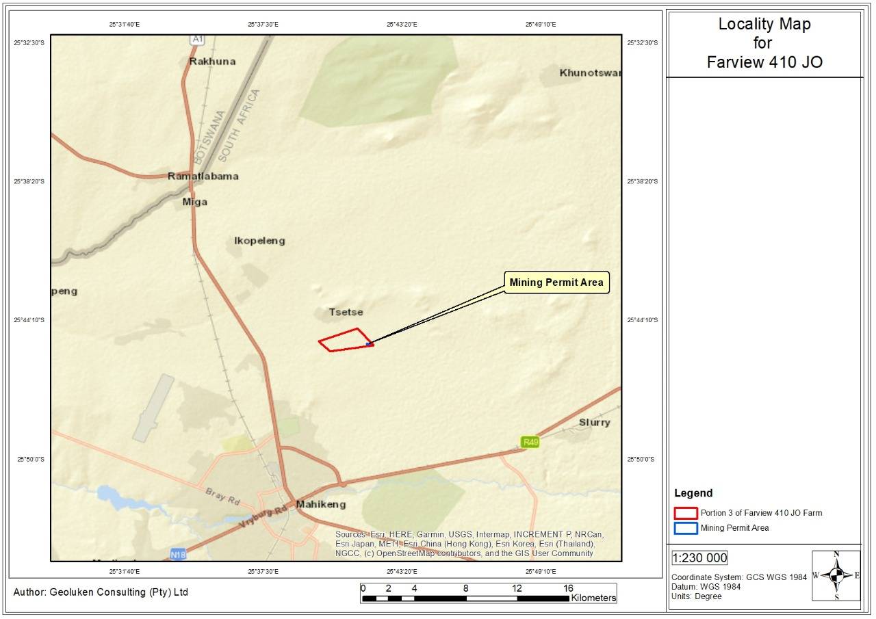
Figure 1: Locality map of the proposed project area

Description of the scope of the proposed overall activity
Provide a plan drawn to a scale acceptable to the competent authority but not less than 1: 10 000 that shows the location, and area (hectares) of all the aforesaid main and listed activities, and infrastructure to be placed on site
Refer to Figure 2 for a Site Plan of the Area.
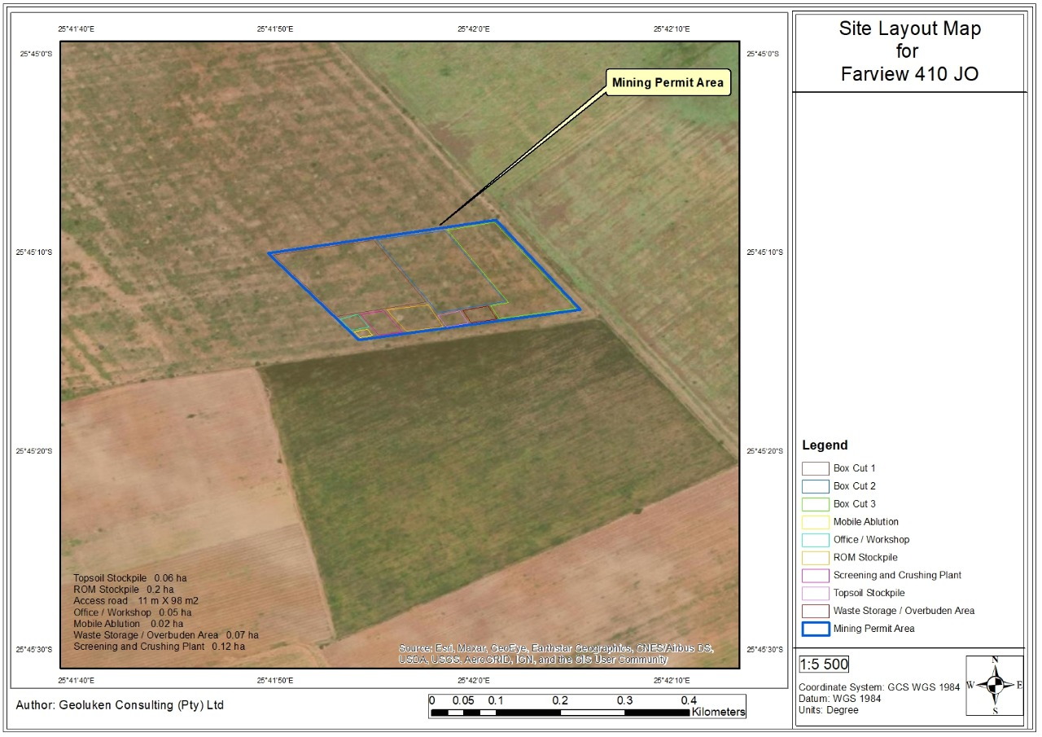
Figure 2: Site Plan of the Area

Listed and specified activities
Malebogo Mining Company (Pty) Ltd has applied for Activity 21 and Activity 27 of the NEMA, EIA Regulations 2014 as amended which falls under Listing Notice 1 (GNR 983) to undertake mining activities in a form of a mining permit for Limestone, Manganese and Aggregates on a 5ha section of Part of Portion 3 of Farview 410 JO Farm in the jurisdiction of Mahikeng Local Municipality of Ngaka Modiri Molema District Municipality in the North West Province of South Africa. The proposed project entails mining for Limestone, Manganese and Aggregates using. The method to be implemented is a very basic form of Open Cast Mining. Extraction of Limestone, Manganese and Aggregates will be facilitated through the use of an excavator and/or front end loader.
Malebogo Mining Company (Pty) Ltd, must obtained environmental authorisation before the commencement of the proposed mining activities. As stated above, Malebogo Mining Company (Pty) Ltd has applied for an environmental authorisation for listed activities within the proposed project area. The above-mentioned environmental authorisation application was lodged on the 29th May 2018 and acknowledgement by the Department of Mineral Resources (North West Offices) on the 18 March 2022. Table 2-1 below has been compiled as prescribed by the Department of Mineral Resources Basic Assessment Report and EMPr template and reflect all applied activities in relation to the proposed project.
Table 2 below indicates the listed activities being applied for

Table 2: Summary of NEMA Listed activities applied for
NAME OF ACTIVITY  (E.g. For prospecting - drill site, site camp, ablution facility, accommodation, equipment storage, sample storage, site office, access route etc…etc…etc  E.g. for mining,- excavations, blasting, stockpiles, discard dumps or dams, Loading, hauling and transport, Water supply dams and boreholes, accommodation, offices, ablution, stores, workshops, processing plant, storm water control, berms, roads, pipelines, power lines, conveyors, etc…etc…etc.) | Aerial extent of the Activity  Ha or m² | LISTED  ACTIVITY | APPLICABLE LISTING NOTICE  (GNR 544, GNR 545 or GNR 546) | WASTE MANAGEMENT AUTHORISATION  (Indicate whether an authorisation is required in terms of the Waste Management Act).  (Mark with an X)
Mining permit activities within the proposed project area for the mining of Limestone, Manganese and Aggregates which will includes excavation,  stockpiling, loading, hauling and transport, discard dumps and supporting infrastructure. | 5 ha (proposed mining permit area) | ACTIVITY 21 OF THE LISTING NOTICE 1:  Any activity including the operation of that activity which requires a mining permit in terms of section 27 of the Mineral and Petroleum Resources Development Act, 2002 (Act No. 28 of 2002), including —  (a) associated infrastructure, structures and earthworks, directly related to the extraction of a mineral resource; or [including activities for which an exemption has been issued in terms of section 106 of the Mineral and Petroleum Resources Development Act, 2002 (Act No. 28 of 2002)]  (b) the primary processing of a mineral resource including winning, extraction, classifying, concentrating, crushing, screening or washing; but excluding the secondary processing of a mineral  resource, including the smelting, beneficiation, reduction, refining, calcining or gasification of the mineral  resource in which case activity 6 in Listing Notice 2 applies.  ACTIVITY 27 OF THE LISTING NOTICE 1:  The clearance of an area of 1 hectare or more, but less than 20 hectares of indigenous vegetation, except where such  clearance of indigenous vegetation is required for-  (i) the undertaking of a linear activity; or  (ii) maintenance purposes undertaken in accordance with a maintenance management plan. | GNR983  (08 Dec  2014 as  amended on  the 07 April  2017) | X

Description of the proposed mining project
(Describe Methodology or technology to be employed, including the type of commodity to be prospected/mined and for a linear activity, a description of the route of the activity)
The proposed mining permit area will be covering 5ha of on Part of Portion 3 of Farview 410 JQ Farm. The mineral to be mined is Limestone, Manganese and Aggregates Ore. The method to be implemented is a very basic form of Open Cast Mining. Extraction of Limestone, Manganese and Aggregates Ore will be facilitated through the use of an excavator and/or front-end loader. An excavator and/or front-end loader will be used to strip a layer of topsoil which will be stockpiled along the northern and southern flanks of the pit for use in later rehabilitation. The topsoil stockpiles will be positioned to create a wind barrier thus preventing wind erosion across the pit and to shield the working equipment and prevent the creation of excessive dust. The excavator and/or front-end loader will excavate Limestone, Manganese and Aggregates from the pit and stockpile the Limestone, Manganese and Aggregates on the west side of the pit. The Limestone, Manganese and Aggregates will be deposited onto the stockpile area within the permit site and loaded onto tip trucks by the front end loader for transport off the site and for sale to the local market.

Duration of Activity
The mine will operate for a period of two (2) years from the time of issuing of a mining permit, and thereafter will become renewable for three (3) further consecutives one-year periods, which totals a maximum five-year operational period. After which a Closure and Rehabilitation Plan will then be implemented (Final Phase of mine life cycle) to ensure the proposed mining site is rehabilitated to an acceptable and mandatory condition.

Site Planning
Before site establishment, mine operation and closure and rehabilitation can occur, careful planning must take place which will lay the foundations and plan of action for the subsequent phases. This will ensure that impacts can be identified at the earliest stage possible and appropriate mitigation measures employed. This in order to prevent/ minimise impacts to acceptable levels. The Basic Assessment Report and associated Appendices, forms part of this process.

Site Preparation/Establishment
While no infrastructure development will occur on site, the site will however be prepared for mining commencement. These activities will include:
- Environmental training and awareness for workers;
- The removal and storage of topsoil that will be kept for the closure and rehabilitation phase;
- The demarcation of the mining site and ‘no-go’ areas;
- The erecting of signage and fences;
- The placement of a portable toilet, bins, spill kits and first aid kits;
- Facilitating the access road to mining site;
- Preparing equipment and vehicles for operation;
- Ensuring that there are no protected trees or fauna on site; and
- Implementing erosion control on site.

Mine Closure and Rehabilitation
During decommissioning, the working areas will be rehabilitated and re-vegetated, as per the approach outlined in the closure/rehabilitated plan. It is important that the applicant and the landowner’s liability for the site persist until such time as a closure certificate has been issued by the DMR, accordingly, once the vegetation has been established, a closure report will be submitted to the DMR.
Post-closure monitoring will assist in determining the success of the rehabilitation and also identify whether any additional measures need to be taken to ensure the area is restored to a reasonable and acceptable condition.

Policy and Legislative Context

Table 3: Applicable Legislation and Guidelines for the proposed Prospecting Project
APPLICABLE LEGISLATION AND GUIDELINES USED TO COMPILE THE REPORT  (a description of the policy and legislative context within which the development is proposed including an identification of all legislation, policies, plans, guidelines, spatial tools, municipal development planning frameworks and instruments that are applicable to this activity and are to be considered in the assessment process | REFERENCE WHERE APPLIED | HOW DOES THIS DEVELOPMENT COMPLIY WITH AND RESPOND TO THE LEGISLATION AND POLICY CONTEXT.  (E.g. In terms of the National Water Act a Water Use License has/ has not been applied for)
Constitution of South Africa, specifically everyone has a right;  - to an environment that is not harmful to their health or well- being; and  - to have the environment protected, for the benefit of present and future generations, through reasonable legislative and other measures that  - prevent pollution and ecological degradation;  - promote conservation; and secure ecologically sustainable development and use of natural resources while promoting justifiable economic and social development. | Public Consultation Report | The Mining activities will only proceed after effective consultation.
Mineral and Petroleum Resources Development Act, 2002 (Act No. 28 of 2002) (MPRDA) and the MPRDA Amendment Act, Act 49 of 2008 | A mining permit was applied for with the Department of Mineral Resources. | The conditions and requirements attached to the granting of the mining permit will apply to the mining activities.
NEMA Environmental Impact Assessment (EIA) Regulations, 2017 | This Basic Assessment Report (BAR) and EMPr | This basic Assessment Report is being undertaken in terms of the National Environmental Management Act as amended in order to determine any possible impacts on the environment and to propose sufficient mitigation in order to prevent harm on the environment.
National Environmental Biodiversity Act  The National Environmental Management Biodiversity Act (NEM:BA), 2004 (Act No.10 of 2004), provides for:  (i) the management and conservation of South Africa`s biodiversity within the framework of the National Environmental Management Act, 1998;  (ii) the protection of species and ecosystems that warrant national protection;  (iii) the sustainable use of indigenous biological resources;  (iv) the fair and equitable sharing of benefits arising from bio-prospecting involving indigenous biological resources;  (v) the establishment and functions of a South African National Biodiversity Institute; | Impact Assessment | Impacts on the biodiversity have been identified and mitigation has been provided.
National Water Act  The NWA (Act No. 36 of 1998) | Department of Water and Sanitation (DWS) | A Water Use License Application, or alternatively a General Authorisation (GA) will need to be applied for from the Department of Water and Sanitation (DWS).
Mine Health and Safety Act, 1996 (Act No. 29 of 1996); | Impact Management | Risk Impact Assessment to be conducted.
Municipal Plans and Policies
Integrated Development Plans (IDPs) |  | The IDP identified job creation as one of their primary objectives. If the prospecting is successful, this mine may contribute to job creation
Strategic Development Framework (SDF) |  | The area is designated for agricultural usage.

Need and Desirability of the proposed activities
(Motivate the need and desirability of the proposed development including the need and desirability of the activity in the context of the preferred location).
In terms of the EIA Regulations the need and desirability of any development must be considered by the relevant competent authority when reviewing an application. The need and desirability must be included in the reports to be submitted during the environmental authorisation application processes. This section of the BAR and EMPr will indicate the need and desirability for the proposed mining project.
In 2019, the sector produced 17 million tonnes of Manganese represanting a 14% increase on the prior year. Manganese prices have been under pressure because of a strong increase in supply coupled with subdued demand out of China which is the core market for South African producers. South Africa hosts 74% of the global manganese resources and 30.2% of the reserves.
Malebogo Mining Company desktop studies have demonstrated that a viable mining operation can be established that would provide significant benefits to the local economy of City of Mahikeng Local Municipality. The broader socio-economic benefits of the project include employment, skills development, local economic development through the availability of the Gold mineral, and increased business development for the area in generally.
The applicant further commits to ensure their contribution to environmental education and to their employees during the project life. The employees will be made aware of work that may be harmful to their health and the environment and of any work posing danger. This is undertaken in terms of the Mine Health and Safety Act, 1999 (Act 29 of 1996) and their regulations, which gives the employees the right to refuse work that is dangerous. The applicant will respect decisions of employees regarding the above and is committed to the protection of employees against any dangerous working environment.

Motivation for the overall preferred site, activities, and technology alternative

Preferred Site
Geophysical surveys, and drilling are the only major methods used in exploring for deposits of this type and also for resource definition and evaluation. The technology to be used cannot be replaced by any other methods thus these are the preferred activities. There is no site or layout alternative as the property provides the ideal geological formation for the presence of the minerals applied for. The positioning of the boreholes is determined by the expected location of the mineral reserve.
Technologies
Due to the nature of the proposed prospecting activities, future land use alternatives will not be compromised. Once the viable reserve has been confirmed, a comprehensive social and environmental impact assessment will be required, during which alternative land use to mining will be investigated.
In terms of the proposed technologies, these have been chosen based on long term proven success in prospecting. The prospecting activities proposed in the Prospecting Works Programme are dependent on the preceding phase (desktop studies), therefore no alternatives have been indicated. The location of the intrusive drilling activities will be determined during Phase 1 of the Prospective Works Programme. All infrastructure will be temporary and/or mobile.
Design/Layout
Since no complicated surface infrastructure will be required for this project no design and layout alternatives for the proposed project were determined.

Full description of the process followed to reach the proposed preferred alternatives within the site
NB!! – This section is about the determination of the specific site layout and the location of infrastructure and activities on site, having taken into consideration the issues raised by interested and affected parties, and the consideration of alternatives to the initially proposed site layout.
The invasive prospecting phase will be dependent of the results of the preceding phase. The location and extent of the drilling sites, soil sampling cannot be determined at this stage, therefore mapping of the specific prospecting activity site could not be undertaken at this stage.
The final location of the drilling activities will be determined during Phase 1 of the Prospective Works Programme and will be aimed at avoiding areas with sensitive environments. The stakeholder consultation process has not been finalised at this stage, and therefore the comments raised by the I&APs have not been incorporated in this section. This will be updated as part of the final report.

Details of the development footprint alternatives considered.
With reference to the site plan provided as Appendix 4 and the location of the individual activities on site, provide details of the alternatives considered with respect to:
- the property on which or location where it is proposed to undertake the activity;
- the type of activity to be undertaken;
- the design or layout of the activity;
- the technology to be used in the activity;
- the operational aspects of the activity; and
- the option of not implementing the activity.

- The property on which or location where it is proposed to undertake the activity
The location alternative considered for the proposed project includes the mining site and access routes. The location alternatives were selected based on a number of criteria, which include the environmental considerations (how sensitive is the area in terms of soils, wetlands, groundwater etc.) and the dependency of the project to the required infrastructure.
- The type of activity to be undertaken
The method to be implemented is a very basic form of Open Cast Mining. The technology to be used cannot be replaced by any other methods thus these are the preferred activities. The technology to be used cannot be replaced by any other methods thus these are the preferred activities
- The design or layout of the activity
The proposal layout for the Limestone, Manganese and Aggregates mining activity will be as per the attached infrastructure sketch plan. There will be one entrance via existing access gravel road from the R40 road and mine/gravel roads. There will also be two (2) sections of dumps and coal stockpiling, immediately from the mine pit. There will be mobile site office and a portable chemical toilets 36 within the mobile offices, which will be utilised by the employees. The site has been minimised to impact the smallest possible area
- The technology to be used in the activity
The method to be implemented is a very basic form of Open Cast Mining. Extraction of Limestone, Manganese and Aggregates will be facilitated through the use of an excavator and/or front end loader. An area less than 5ha will be demarcated for mining and will not compromise any infrastructure, watercourses or wetlands. Drill and blast will be conducted to remove the overlying soil and rock (overburden) to expose a Limestone, Manganese and Aggregates mineralisation area.
An excavator and/or front-end loader will be used to strip a layer of topsoil which will be stockpiled along the northern and southern flanks of the pit for use in later rehabilitation. The topsoil stockpiles will be positioned to create a wind barrier thus preventing wind erosion across the pit and to shield the working equipment and prevent the creation of excessive dust. The excavator and/or front-end loader will excavate Limestone, Manganese and Aggregates from the pit and stockpile the Limestone, Manganese and Aggregates on the west side of the pit. The Limestone, Manganese and Aggregates will be deposited onto the stockpile area within the permit site and loaded onto tip trucks by the front end loader for transport off the site and for sale to the local market.
- The operational aspects of the activity
The mining area must be clearly demarcated (Working Areas and No-go Areas), by means of pegs/markers at all corners of the site and along its boundaries (where practical). Permanent pegs/markers must be firmly erected and maintained in their correct position throughout the life of the operation.
Working areas:
- The Site shall be divided into working areas and ‘no-go’ areas and shall be marked on appropriate plans for reference.
- Working areas are those areas required by the mining permit to erect their site works.
No-go Areas:
- No-go’ areas are generally those large areas outside the designated working areas, and may include, but not be limited to:
- Existing services and infrastructure (e.g. overhead power line towers and bridge pylons)
- Watercourses
- Any heritage sites that receives the protection (Provincial Heritage Resources Authority North West).
- Natural or special features as defined in the Environmental Specification.
- The option of not implementing the activity
The ‘no-go’ alternative is the option of not undertaking mining permit activities on the project site. The no-go option assumes the site remains in its current state. The no go alternative would result in no impacts on the social and biophysical environment.
The Project Manager and Safety Officers shall ensure that all “no go” areas are demarcated and that no unauthorised entry, litter, stockpiling, dumping or storage of equipment or materials shall be allowed within the demarcated “no go” areas. Once mining activities within an area has been completed and the area has been rehabilitated and re-vegetated, it shall be considered a “no go” area.

Details of the Public Participation Process Followed
Describe the process undertaken to consult interested and affected parties including public meetings and one on one consultation. NB the affected parties must be specifically consulted regardless of whether or not they attended public meetings. (Information to be provided to affected parties must include sufficient detail of the intended operation to enable them to assess what impact the activities will have on them or on the use of their land.
In terms of the EIA Regulations, 2014, when applying for environmental authorisation, the EAP managing the application must conduct at least a public participation process where all potential or registered interested and affected parties, including the competent authority, are given a period of at least 30 days to submit comments on each of the basic assessment report, EMPr, scoping and environmental impact assessment report, and where applicable the closure plan. In this case a Basic Assessment Report (BAR) and EMPr is considered. The primarily aim of Public Participation Process (PPP) is to afford I&APs the opportunity to understand the project, prioritises the involvement of parties who potentially have an interest in the proposed project, or may be directly or indirectly affected by the proposed development. Ideally, it is a process leading to a joint effort by stakeholders, technical specialists, the authorities, and the proponent/developer who work together to produce better decisions than if they had acted independently.
In addition, the purpose of consultation with the landowners, affected parties and communities is to provide them with the necessary information about the proposed project so that they can make informed decisions as to whether and to which degree the project will affect them.
Public Participation Process was conducted in terms of Chapter 6 of the National Environmental Management Act, 1998 (Act 107 of 1998). Please refer to Appendix B for a detailed Public Participation Report.
- Identification of Interested and Affected Parties and Interested and Affected Parties (I&Aps) Database
The NEMA Regulations (GNR R982) distinguishes between potential I&APs and registered I&APs. I&APs, as stated in Section 24(4)(d) of the NEMA include:
- any person, group of persons or organisation interested in or affected by an activity; and
- any organ of state that may have jurisdiction over any aspect of the activity.
In terms of the Regulations “registered I&APs” means:
I&APs whose name is recorded in the register opened for that application. For that purpose, an EAP managing an application must open and maintain a register which contains the names, contact details and addresses of:
- All persons who have submitted written comments or attended meetings with the applicant or EAP;
- All persons who have requested the applicant or EAP managing the application, in writing, for their names to be placed on the register; and
- All organs of state which have jurisdiction in respect of the activity to which the application relates.
Landowners (affected and adjacent) were identified through a search conducted via online search engines accessing the Title Deed office database. In addition to landowners, other relevant organisations where identified and notified of the application. This includes:
- National Government;
- Provincial Government;
- Local and District Municipality;
- Interested and affected parties residing within or in close proximity to the proposed project area;
- Non-Governmental Organisations (NGO’s);
- Utilities and services;
- Local Business and commerce/ Parastatals;
- Traditional Authorities; and
- Landowners.
Stakeholder Database will be updated throughout the various phases associated with the proposed project. Please see Stakeholder Database in Appendix 5.
- Project Announcement Phase
  - Distribution of Notification Letters
Notification letters were sent to identified I&APs informing them of the proposed project. I&APs were requested to:
- declare their interests in the project;
- provide contact details; and
- to provide comments and/or objections to the application.
A copy of the notification letter is attached in Appendix 5.
  - Newspaper Advertisement
A newspaper advert (in English) was published in the Platinum Weekly newspaper on 19 March 2021. A copy and proof of the newspaper advertisements can be found in Appendix 5.
  - Site Notices
Site notices notifying stakeholders and I&APs of the proposed project were placed in English at conspicuous places in the project area. Pictures as well as copy of the site notices and proof of their placement will be provided in Appendix 5 of the final BAR.
  - Confirmation of Land Claims
Ugwa Consulting Services approached the Office of the Regional Land Claims Commissioner: North West to verify whether any possible land claims existed on the affected properties. A letter to the Regional Land Claims Commissioners office has been sent on the 04th of April 2022 to inquire if there are no land claims lodged on the affected farm or not. The land claims confirmation letter will be attached in Appendix 5 when available.
  - Phone Calls
Ugwa Consulting Services confirmed contact information telephonically where possible and attempted to find out more information on the property/adjacent properties i.e. verify if the registered property owners were in fact the lawful landowners, whether or not there were land occupiers on the affected and adjacent properties.
- Draft BAR/ EMPr Report Public Review and Comment Period
The Draft BAR and EMPr will be made available to all the stakeholders for a 30- day review and comment period as prescribed by the NEMA.
  - Interested and Affected Parties (I&Aps) Database Update
The stakeholder database will be updated as new I&APs registered and with the identification of additional Interested and Affected Parties.
  - Notification Letters
Stakeholders will be notified of the availability of the Draft BAR/EMPr as follows:
- Distribution of notification letters via emails, posts, and fax.
  - Hard Copies of the Draft BAR/EMPr
Hard copies of the Draft BAR/EMPr and comments forms was made available at various areas near where the proposed site is and also at the municipality and library. The draft BAR/EMPr was also available directly from Ugwa Office during the same commenting period. Stakeholders was provided with the contact details where they could submit written comments and/or queries.
  - Commenting Authorities and Interested and Affected Departments
Copies of the Draft BAR/EMPr was available to the commenting authorities and other interested and affected departments as provided in the distribution record of the Draft BAR/ EMPr.
- Public Meetings
Face to face, meeting public meetings will be held with the stakeholders and due to the Covid 19 pandemic and the restriction imposed by the Government regarding the gatherings of people, a limited number of people will be participating in each meeting.
- Public Participation Report
Comments received during the EA process and public comment period will be collated into a Public Participation Report (PPR). The PPR has been updated with comments received and responses provided during the Draft BAR/EMPr commenting period as part of the Final BAR/EMPr to be submitted to the DMR.
- Notification of DMR Decision
Once the DMR has made a decision on the application, all the registered I&APs will be notified of the decision.

Summary of issues raised by I&Aps
(Complete the table summarising comments and issues raised, and reaction to those responses)
No comments have been received at this stage regarding the proposed project.
Table 4: Summary of issues raised by I&APs
Interested and Affected Parties  List the names of persons consulted in this column, and Mark with an X where those who must be consulted were in fact consulted. |  | Date CommentsReceived | Issues raised | EAPs response to issues as mandated by the applicant | Section and paragraph reference in this report where the issues and or response were incorporated.
AFFECTED PARTIES
Landowner/s | X
Lawful occupier/s of the land
Landowners or lawful occupiers  on adjacent properties | X
Municipal councillor | X
Municipality | X
Organs of state (Responsible for
infrastructure that may be
affected Roads Department,
Eskom, Telkom, DWA e
Communities
Dept. Land Affairs
Traditional Leaders
Dept. Environmental Affairs
Other Competent Authorities affected
OTHER AFFECTED PARTIES
INTERESTED PARTIES

The Environmental attributes associated with the alternatives
(The environmental attributed described must include socio-economic, social, heritage, cultural, geographical, physical and biological aspects)

Baseline Environment
- Type of environment affected by the proposed activity
(Its current geographical, physical, biological, socio- economic and cultural character).
Regional Climate
The global increases in temperatures will in turn impact rainfall and temperatures in the Ngaka Modiri Molema District Municipality. This will have a knock on effect on the economy and resources of the region as it will have a direct impact on how land can be used, dictating such things as crop selection, wildlife habitats and the availability of water for mining.
Climatic changes have already been experienced in the NMMDM and are concerning given the reliance on environmental forces for agriculture and tourism which are pillars of rural development in the area.
The NMMDM can generally be classified as arid with varying rainfall of between 400 to 600mm annually. The average rainfall per annum is calculated at 600mm, see Fig 4 below for the average mean annual rainfall in the district municipality. Thunderstorms and hail does occur in the region, but at a relatively low rate when compared to other areas in the country such as the Highveld areas.
In March and April, the rainfall decreases and slowly gets colder. It further continues in April, which has lovely, clear weather and few clouds. The nights get a bit colder at about 13°C/55°F. Daytime temperatures are pleasant, around 27°C/81°F (Safaribookings, 2021).

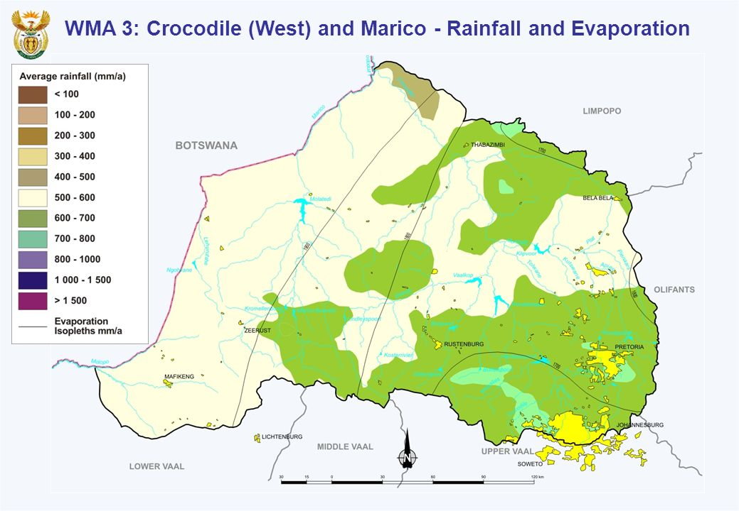
Figure 3: Rainfall and Evaporation
Mean Annual Precipitation (MAP) is generally higher in the southern and eastern parts of the catchment where this value averages out at around 800mm per annum (See Figure 4). The northern and western lower lying areas tend to have a MAP of between 500-600mm. MAPs fluctuate in dry/wet cycles of between 7 and 10 years (variations from 300mm in dry years to 1000mm in good rainfall years). During certain years large-scale flooding occurs in this catchment which wreak tremendous damage on irrigation farming operations (mainly north of Magaliesberg). This irrigation farming tends to be located on the broad floodplains associated with the middle and lower Crocodile River System.
Water Resources
Quaternary Catchment D41A
The Farm Ramatlabana 377 JO and Farview 410 JQ falls within the Upper Molopo catchment, D41A sub-catchment. These catchments are characterised by flat to gently undulating topography (see, figure 5).
According to the Water Management Area report(DWAF:2003), the surface water resource available from the rivers in the Upper Molopo sub-area, before impact of Ecological Reserve on the yield is estimated at approximately at 14 million m3/a. The Setumo Dam and Disaneng Dams are the main dams in the sub-area. The impact of the ecological Reserve is likely to be small but difficult to estimate because the Upper Molopo River is an ephemeral river.
The rural domestic water requirement is quite small but has been increasing because most of the rural communities to the west of the sub-area have had no access to potable water supplies in the past and are now at least beginning to get some basic level of service.
Groundwater
The groundwater resource was re-assessed as part of the ISP and is also estimated to be much higher in the Upper Molopo sub-area than given in the NWRS. However, the groundwater resource availability based on the ability of the aquifers to sustain exploitation has not yet been determined. The NWRS figures have therefore been used although the groundwater resource is expected to be higher as can be seen from the abstraction.
The Upper Molopo catchment (D41A) is classified in the Groundwater abstraction Zone A It would appear that the groundwater abstractions above those set out in Schedule 1 of the National Water Act are being exceeded without authorisation (or license). This might mean that groundwater mining is taking place in some of the compartments of the catchments. Grootfontein compartment seems to be over-abstracted although spring flows in some of the compartments such as Molopo indicate no mining is apparent.
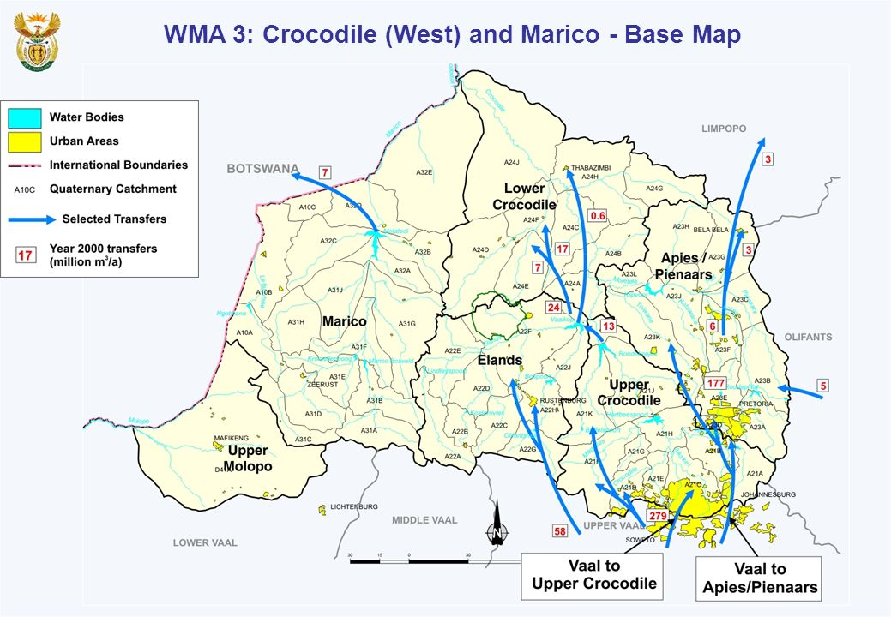
Figure 4: The sub-catchment of the project area inclusive
Topography
Topographically, the North West Province is indicated to have one of the uniform terrains of all the provinces within South Africa. The topography of the eastern region is more variable than that of the southern and western regions.
The proposed project is in an area characterized by gently to moderately undulating landscape. The elevation ranges between 1012m of a minimum level, 1480 at an average level and a maximum of 1084m. The total distance of the proposed area is 48.5km with elevation Gail/loss: 163m. -163m. The maximum slope of the area is: 6.7%, -7,3% with average slope being: 2.7%, -2,6%.

Soil
As it is highlighted below on the map (see Figure 7), the proposed area is consisting of the freely drain and structureless soils that are characterised by high swell-shrink potential; very plastic and sticky and high natural fertility. The soil terrain type associated with these soils is Type S2. It is characterised by plains with open low hills or ridges. They have a water holding capability of about 0 - 20 mm.
Biodiversity
Based on the information obtained from The soil and vegetation of MGREA and PNPEA, undertaken by Stalmans & De Wet (2003), the proposed study area falls within the Pilanesberg National Park Expansion Area (PNPEA). The vegetation type of the proposed mining area is SVk1 (Mafikeng Bushveld). The vegetation and Landscape features are well developed tree shrubs layers, dense stands of Terminalia sericea, Acacia luederitzii and A erioloba in certain areas.
The vegetation of the PNPEA was divided into three groups, namely Acacia-dominated communities on less clayey soil, Acacia-dominated communities on heavy clayey soil (turf soil) and broad-leaved communities found on rocky slopes and outcrops (see Figure 6 and Figure 8 below).
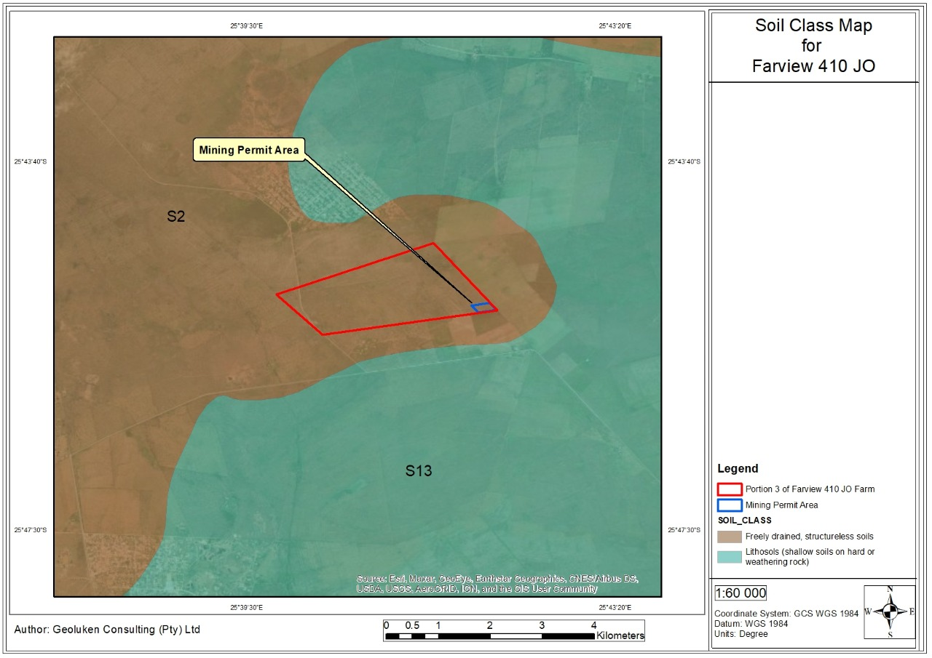
Figure 5: Soil Class Map
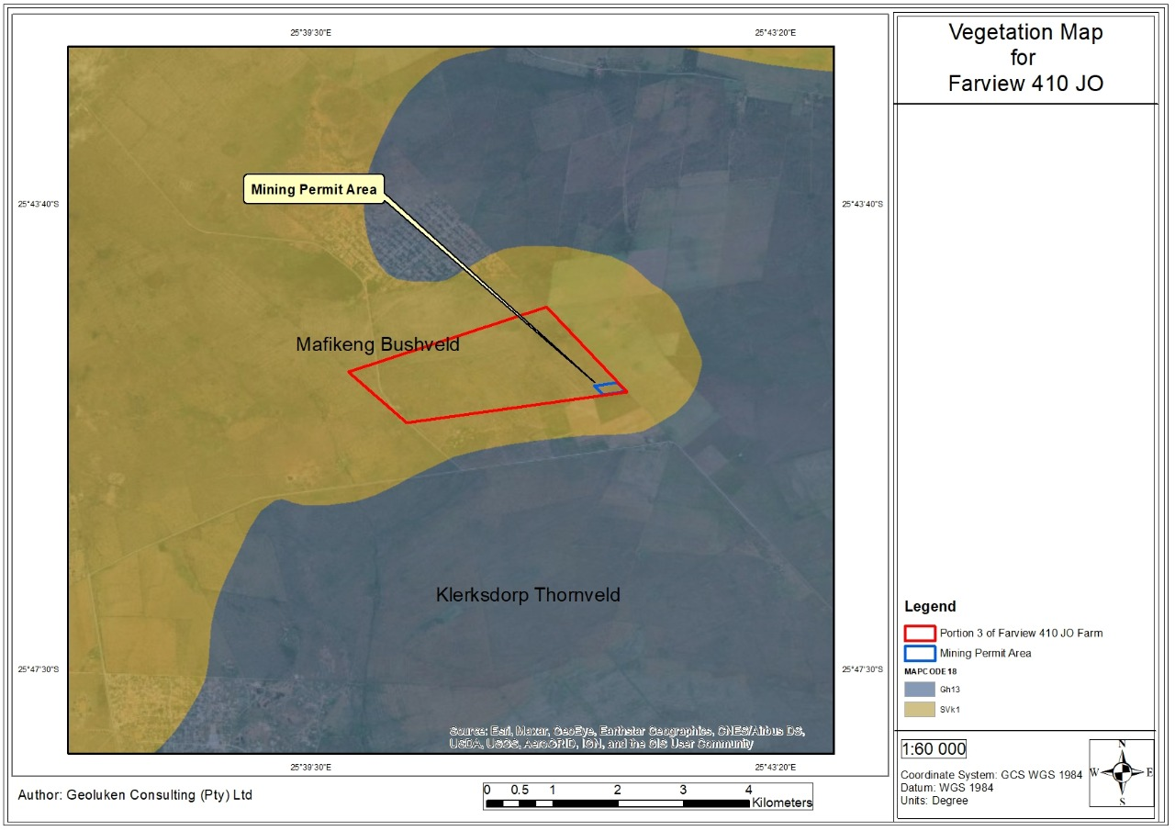
Figure 6: Map illustrating the vegetation in which the study area occurs in.

Geology
- Regional Geology
The North West Province has an interesting and ancient geological heritage, rich in minerals and palaeontological artefacts. The north-eastern and north-central regions of the Province are largely dominated by igneous rock formations, as a result of the intrusion of the Bushveld Complex. Ancient igneous volcanic rocks dating back to the Ventersdorp age (more than 2 000million years) appear to be the dominant formations in the western, eastern and southern regions of the Province. Sedimentary rocks dating back to the Quaternary period (65 million years) occur in the north-western corner of the Province
Archaean Granites
The oldest rock formations in the North West Province are the basement Archaean Granites (3 204 ± 65 Ma, million years); Kent 1980), which mostly form flat to slightly undulating landscapes. Outcrops of these granites occur in the south-eastern portion of the Province (in the Potchefstroom district) and further west as far as the north-central portion of the Vryburg and Ganyesa districts.

Kraaipan Group
The Kraaipan Group consist mainly of schist, amphibolite, jaspilite, lava, banded ironstone and a small proportion of dolomite (Kent 1980). This formation forms a series of narrow, more or less parallel, discontinuous ridges approximately 60km south-west of Mafikeng running north to north-north-west. Another series of parallel, discontinuous outcrops occur approximately 50 km further west (near Stella).

Dominium Group
The Dominium Group, dated at 2 800 Ma, is comprised of arenaceous sediments, conglomerates, grits, basic volcanics, tuffs, coarse pyroclastic rocks and quartzite. It is predominantly volcanic in origin, forming a series of hills to the west of Klerksdorp (in the vicinity of the old gold-mining town of Dominium Reefs). The thickness of the Group is 2 250 m in this area. A second important outcrop occurs at Ottosdal. The third outcrop (maximum thickness of 240m) occurs as a narrow band of rocks on the fringe of the younger Witwatersrand outcrops in the southern portion of the Potchefstroom district (Kent 1980).

Ventersdorp Super Group
The Ventersdorp volcanic rocks also comprise an important geological formation in the Province. This covers an extensive area both within and around the Witwatersrand basin, ranging in thickness from around 5000m to 300m. It is especially prevalent near Ventersdorp, Vryburg, Klerksdorp and Mafikeng where it extends into south eastern Botswana. Other outcrops occur near Vredefort Dome near Parys. The Vredefort Dome near Parys is believed to be the result of a large meteorite impact that occurred some 2000 million years ago. The central core is composed of gneiss granite surrounded by a rim of Witwatersrand, Venterdorp and Transvaal rocks that contain shatter cones indicative of violent mechanical shock. The deformation of the rim layers surrounding the dome provides further evidence that a violent event was responsible for the formation of the Vredefort Dome.
The Ventersdorp formation is composed largely of volcanic andesitic lavas and related pyroclastics (metamorphic rocks formed by the extremely hot temperatures associated with volcanic activity). Various conglomerates, tuffaceous and calcareous shales and porphyries are also constituents of this formation.

- Local Geology

The geology of the study area and surrounds is dominated by the Chuniespoort Group (Situated within the Transvaal Basin of the Transvaal Supergroup), and specifically the Neorachaean dolomites of the Malmani Subgroup. The chert-rich dolomites (i.e. magnesium-rich calcium carbonate rock) of the Monte Christo Formation, which falls within the Malmani Subgroup, underlie the proposed project area and dip shallowly to the north.

The depositional environment of the Malmani Subgroup is interpreted to have been a stable shallow marine platform and basin e.g. something akin to the present vday Great Barrier Reef, and has been subdivided into the following formations (oldest to youngest): Oaktree, Monte Christo, Lyttelton, Eccles and Frisco Formations. The ~10-200 m thick Oaktree Formation forms the base of the Malmani Subgroup and consists of carbonaceous shales, stromatolitic dolomites and locally developed quartzites. The Monte Christo Formation (which underlies the proposed project area) is ~300-500 m thick and consists of chert-rich dolomite and oolitic. The remaining Malmani Subgroup formations that overlie the Monte Christo Formation occur north of the proposed mine. The Lyttelton Formation immediately overlies the Monte Christo Formation ~1.5 km north of the proposed mine, consists of 100-200 m of shales, quartzites and stromatolitic dolomites, and is rich in iron and manganese.

This is overlain by the 600 m thick cherty dolomites of the Eccles Formation. The Frisco Formation forms the top of the Malmani Subgroup and consists of 400 m of stromatolitic dolomites.

Malmani Subgroup and Kalahari Transvaal Supergroup
The project area is within the Neoarchaean intracratonic basin of the Kaapvaal craton, between approximately 2640 Ma and 2516 Ma, two successive stromatolitic carbonate platforms developed. Deposition started with the Schmidtsdrif Subgroup, which is probably oldest in the southwestern part of the basin, and which contains stromatolitic carbonates, siliciclastic sediments and minor lava flows. Subsequently, the Nauga formation carbonates were deposited on peritidal flats located to the southwest and were drowned during a transgression of the Transvaal Supergroup epeiric sea, around 2550 Ma ago. This transgression led to the development of a carbonate platform in the areas of the preserved Transvaal and Griqualand West basins, which persisted for 30–50 Ma. During this time, shales were deposited over the Nauga Formation carbonates in the southwestern portion of the epeiric sea. A subsequent period of basin subsidence led to drowning of the stromatolitic platform and to sedimentation of chemical, iron-rich silica precipitates of the banded iron formations (BIF) over the entire basin. Carbonate precipitation in the Archaean was largely due to chemical and lesser biogenic processes, with stromatolites and ocean water composition playing an important role.

The stromatolitic carbonates in the preserved Griqualand West and Transvaal basins are subdivided into several formations, based on the depositional facies, reflected by stromatolite morphology, and on intraformational unconformities; interbedded tuffs and available radiometric age data do not yet permit detailed correlation of units from the two basins. Thorough dolomitisation of most formations took place at different post-depositional stages, but mainly during early diagenesis. Partial silicification was the result of diagenetic and weathering processes. Karstification of the carbonate rocks was related to periods of exposure to subaerial conditions and to percolation of groundwater. Such periods occurred locally at the time of carbonate and BIF deposition. Main karstification, however, probably took place during an erosional period between approximately 2430 Ma and 2320 Ma.

Allanridge Formation (Ventersdorp Supergroup)
The Allanridge Formation of the Ventersdorp Supergroup in the North West Province consists of andesite to basaltic andesite. The properties of these rocks are described by aid of detail from two localities near Douglas (Kalkdam and Katlani), where seven lava flows can be discerned. Greenschist metamorphism has affected all of the lava flows and sporadic sulphide mineralization has also occurred. The intensity of sulphide mineralization is controlled by porosity so that the amygdaloidal bases and tops of flows are more affected than the massive parts, hence producing a conspicuous bleaching. Thus light amygdaloidal lavas (LA) that are sporadically mineralised by sphalerite, galena and chalcopyrite can be distinguished from less altered dark amygdaloidal (DA) lavas. Sulphides are present in altered amygdales of the LA together with quartz, chlorite and calcite. These minerals were introduced by means of hydraulic fracturing and brecciation features are common. Sphalerite tends to dominate over galena in the amygdaloidal lava flows, while the opposite is true in the breccia zones.

Mass transfer calculations reveal that the net mass loss for LA and DA was 7 to 20 % and 3 to 5% respectively. Enrichment/depletion diagrams illustrate that LA is relatively enriched in SiO2, Al2O3, K2O, P2O5, Rb, Ba, Cr and Zn, while the DA is relatively enriched in MnO, Fe2O3, Nb, Cr, V, Co and Zn with respect to unmineralized lava flows. The alteration of DA may be regarded as propylitic, while changes in LA involved potassium metasomatism also. Two generations of mineralization can be discerned. The source of the saline fluids capable of transporting metals is probably in the banded iron formations of the Griquatown and Kuruman Formations. Channelways for fluid migration were provided during extensive deformation.

Gold Ridge Formation
The area consist of mica, pyrophyllitic and quartz-chlorite schists, magnetite quartzite, dolomite, banded iron-formation and amphibole-rich zones.
- 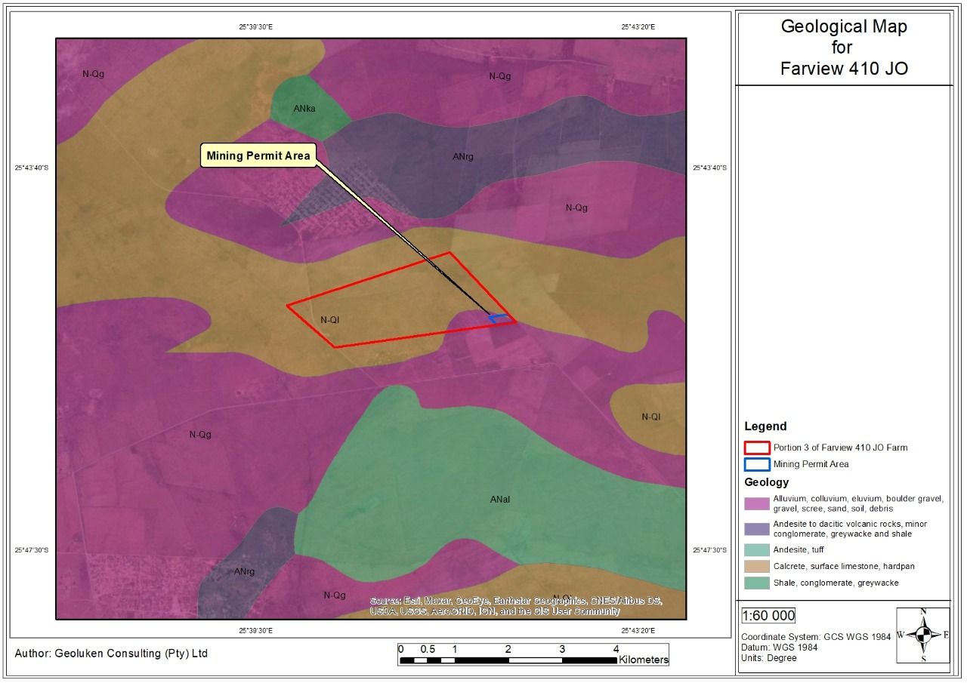
Figure 7: Local geological map
- Socio- Economic Background
  - North West Province
North West Province is one of the smaller provinces of South Africa with a population of 3, 4 million people living in an area of 116 320km². The province has strong economic links with Gauteng and attracts many visitors to view its wildlife and to enjoy a climate conducive to outdoor life. The provincial capital is Mafikeng, and the larger towns are Klerksdorp, Orkney, Potchefstroom, Rustenburg and Brits.
North West Province boasts modern industrial parks and commercial centres supported by sophisticated banking and financial services. The province also has good educational and health facilities in the major commercial centres. Mining plays a dominant role in the economy of North West Province, contributing approximately 66% of the total Gross Domestic Product of the area and employing close to 69,000 of the labour force.
In addition to mining, agriculture is one of the most important sectors in the province with maize, sunflower and groundnuts being the major crops. Currently the North West Province offers numerous investment opportunities in tourism, eco-tourism, mining, manufacturing and agriculture.
  - Ngaka Modiri Molema District Municipality
The Ngaka Modiri Molema District Municipality (NMMDM) is one of the four district municipalities (DMs) in the North West Province (NWP) with a total extend of 28206 km². According to Statistics South Africa Community Survey (STATSSA CS) 2016, NMMDM has a total population of 889 108.
NMMDM is centrally located amongst Bojanala Platinum DM, Dr Ruth Segomotsi Mompati DM and Dr Kenneth Kaunda DM within the NWP and shares a boundary with the Republic of Botswana to the north “a gateway to the broader SADC region”, the Northern Cape Province to the South-west and Limpopo Province to the north-east. Refer to figure below:

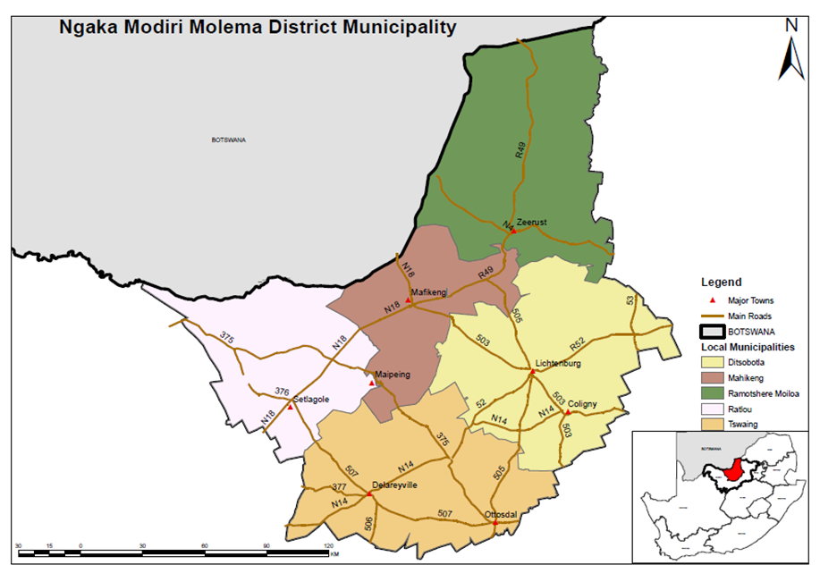
Its strategic location offers great opportunities towards the economic development of the District underpinned by various development corridors namely:
- Platinum Corridor (N4), which stretches from the east to the west of NMMDM connecting Republic of South Africa with Republic of Botswana and Republic of Mozambique.
- The N18 Western Frontier Corridor N18; and
- N14
It is comprised of five Local Municipalities (LMs) namely:
- Ditsobotla LM,
- Mahikeng LM,
- Ramotshere Moiloa LM,
- Ratlou LM and
- Tswaing LM.

  - Mahikeng Local Municipality
Mahikeng Local Municipality (the capital city of the North West Province) like other local municipalities was brought about by the new Local Government transformation in South Africa. Mahikeng Local Municipality is a Category B Municipality established in terms of section 12 of the Municipal Structures Act (MSA). The municipality has adopted the Executive Mayoral system which entails concentration of executive authority in the hands of the Executive Mayor. It is as system wherein the Executive Mayor, assisted by the Mayoral Committee and its Administration, led by the Municipal Manager, executes the mandate of council and the electorate.
The total area of the Mahikeng Local Municipality is approximately 3 703 km2. It is divided into 28 wards consisting of 102 Villages and suburbs. The population of the municipality is estimated at 271 501 people.
The Municipality is a considerably big local municipality as compared to other four local municipalities located within the area of jurisdiction of Ngaka Modiri-Molema District Municipality. Those neighbouring local municipalities which border the Ngaka Modiri-Molema District Municipality are: Ramotsere Moiloa Local Municipality, Tswaing Local Municipality, Ditsobotla Local Municipality and Ratlou Local Municipality.

- Socio- Economic Profile
  - Administration
There is a dual system of governance in the province i.e. the political structures of governance and the traditional authorities, each of the administrative structures is briefly described below.
  - Political Structures of Government
South Africa is a constitutional democracy with a three-tier system of government and an independent judiciary. The national, provincial and local levels of government all have legislative and executive authority in their own spheres.
The provincial government is responsible for providing the strategic vision and framework for the province. They are responsible for ensuring cooperation and collaboration between municipalities and ensuring that each municipality performs their respective functions. District municipalities are responsible for the development of IDP and for the overall provision of services and infrastructure within the districts, including for the local municipalities. The purpose of district and local municipalities sharing the responsibility for local government is to ensure that all communities, particularly disadvantaged communities, are afforded equal access to resources and services.
  - Traditional Authorities
Traditional authorities refer to mainly rural areas whereby chiefs and their councils are responsible for administrative tasks at a community level and in mobilising local communities if there are any investment Projects within their area of jurisdiction. The District is largely a rural district and is made-up of 103 wards, 8 towns, 21 townships, 198 villages. In addition, the District has 22 Traditional Leaders with about 90% of the District’s population living in traditional authority areas. In the District, there are no disputes in terms of ownership of land by Traditional Leaders. Traditional Leaders participate in municipalities and they receive out of pocket expenses and paid allowances.
- Demographic Profile
Population Distribution
Statics South Africa undertook a population community survey which was defined as “the total process of collecting, compiling, evaluating, analyzing and publishing or otherwise disseminating demographic, economic and social data pertaining, at a specific time, to all persons in a country or well-defined part of the county”. This information has since been officially released.
The 2016 official Community Survey indicates that the population of Mahikeng Local municipality has grown to 314 394 since 2016. It also indicated that the municipality has a predominantly African population with fewer Coloureds, Whites and Indian groups.
As per the table below, it is estimated that the population growth has been 1.51%. The demographics indicate also that the municipality has a high population of women than men. Statistics indicate that the municipality has the highest population of youth, therefore all programmes and budgeting must be directed at youth development and empowerment.

Table: Demographic Indicators
Year | Gender | Totals | Total Population
Census 1996 | Male | 114211 | 242 146
Census 1996 | Female | 127935 | 242 146
Census 2001 | Male | 125607 | 259 502
Census 2001 | Female | 133871 | 259 502
Census 2011 | Male | 141642 | 291 527
Census 2011 | Female | 149885 | 291 527
Community Survey 2016 | Male | 153094 | 314 394
Community Survey 2016 | Female | 161300 | 314 394
Population Growth Rate (2011-2016) | 1.51%

The table shows that the area size of Mahikeng municipality is 3,698 KM2. Most of the land in the municipality is farm area (55%) and then traditional area (44%). Less than 2% of the Mafikeng area is urban area. Mafikeng municipality is the most densely populated area in Ngaka Modiri Molema, with 78 people per square Kilometer.
AREA (Km²) | 3,698
POPULATION DENSITY (POP/Km²) | 78.82
URBAN FORMAL AREA | 52 (1.41%)
TRADITIONAL AREA | 1,617 (43.73%)
FARM AREA | 2,030 (54.88%)

Household Size and Composition
Mahikeng Local Municipality is a predominantly black municipality. The highest number of population of the municipality is at ward 13 which is inclusive of unit 8,9,10 and Ext39. Ext 39 is the RDP section of the wards wherein it was established for a new settlement to house residents from various wards; the total number of households at Ext 39 alone is more than 2500.
Employment and Income
The municipality is a predominantly rural municipality and its rural economy is unable to provide individuals with remunerative jobs or self employment opportunities. An estimated amount of about 13755 people in the municipality had no income in 2011. This amounts to 4.72%. Taking the 1.16% annual growth to date this therefore means that to date this figure has risen to 14 405. In general terms, the majority of households in the municipality earns less than the poverty line (about R1, 600 per household per month) and can be considered poor. Those classified as economically active are employed in the services sector. This sector is dominated by the services in terms of the various departments that render services such as health, justice, local government, education, SAPS, etc (MLM IDP 2021-2022).
- Description of the current land uses
The proposed site is an agricultural area and is characterized by farming on the eastern part of the site. The land use is open veld and wilderness.
- Description of specific environmental features and infrastructure on the site
Access Road
A site access road is required to link the site to the national road system. The nearest national road is the N18 and/or R503, which passes through the prospecting area of study. The N18 and/or R503 intersect the Mafikeng North Airport, Makgokgwane via the proposed study site to reach Miga in the north of north werstern direction (NNW).
- Environmental and current land use map
(Show all environmental, and current land use features)
The proposed site is mainly grazing and dryland subsistence agriculture, with Mafikeng the major urban and industrial town. The land use is open veld and wilderness. The properties have also been used for subsistence crop farming. Although there is evidence of past agricultural use, the current land use is largely natural veld interspersed with some exotic plant species. Woodlands is identified on the farm in the higher altitude areas. Refer to 8 below for Land-use map (see Figure 10).

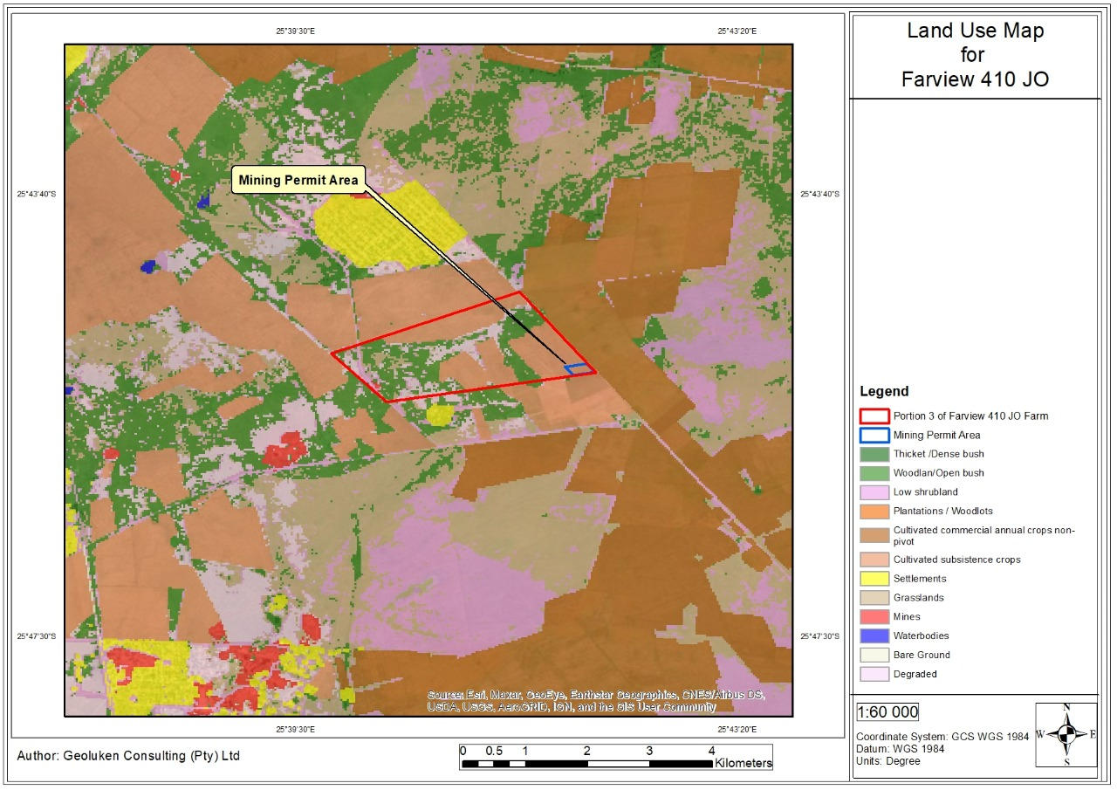
Figure 8: Environmental and Current Land Use Map of the area

Impacts and risks identified including the nature, significance, consequence, extent, duration and probability of the impacts, including the degree to which these impacts
(Provide a list of the potential impacts identified of the activities described in the initial site layout that will be undertaken, as informed by both the typical known impacts of such activities, and as informed by the consultations with affected parties together with the significance, probability, and duration of the impacts. Please indicate the extent to which they can be reversed, the extent to which they may cause irreplaceable loss of resources, and can be avoided, managed, or mitigated).
It is not anticipated that the proposed mining activities will have any lasting material effects on existing land uses on the prospecting areas or any other areas in the vicinity thereof. It is expected that all of the potential impacts will be reversible except in the event that areas of archaeological importance are disturbed which may cause irreplaceable damage.
The summary of the impact assessment during the all phases is provided in Table 5, Table 6, and Table 7 below.

Table 5: Impact Assessment for Construction Phase
Environmental Aspect | Nature of potential impact/risk | Environmental Significance Before Mitigation |  |  |  |  |  | Impact Management Actions (Proposed Mitigation Measures) | Environmental Significance After Mitigation
Environmental Aspect | Nature of potential impact/risk | Severity | Spatial | Duration | Probability | Significance | Significance Rating | Management and Mitigation Measures | Severity | Spatial | Duration | Probability | Significance | Significance Rating
Site Establishment: Establishment of the access roads or tracks to the prospecting site, Establishment of the campsite, site physical surveying and pegging of drilling sites
Socio- economic | The influx of job seekers in the area may result in an increase in petty crimes, and negative social impact on the landowners and land occupiers. | 2 | 2 | 2 | 2 | 12 | ML | Security and safety should be emphasised. Recruitment will not be undertaken on site. Recruitment practises will favour locals. | 1 | 1 | 1 | 2 | 6 | L
Fauna | Movement of construction vehicles and machinery may result in collision with fauna, resulting in loss of fauna. | 2 | 2 | 2 | 2 | 12 | L | No trapping or hunting of fauna shall be permitted. The proposed development footprint areas shall remain as small as possible and where possible be confined to already disturbed areas. No informal fires in the vicinity of construction areas shall be permitted. Edge effects of all construction and operational activities, such as erosion and alien plant species proliferation, which may affect faunal habitat, need to be strictly managed. | 1 | 1 | 1 | 1 | 3 | L
Fauna | Loss of faunal diversity and ecological integrity as a result of construction activities, erosion, poaching and faunal specie trapping. | 2 | 2 | 2 | 2 | 12 | L |  | 1 | 1 | 1 | 1 | 3 | L
Flora | Potential spreading of alien invasive species as indigenous vegetation is removed, and pioneer alien species are provided with a chance to flourish. | 2 | 1 | 2 | 2 | 10 | L | All sites disturbed by construction activities shall be monitored for colonisation by exotic or invasive plants. Exotic or invasive plants shall be controlled as they emerge. Alien Invasive Plant Species Management plan to be implemented. The existing integrity of flora surrounding the study area shall be upheld and no activities shall be carried out outside the footprint of the construction areas. All disturbed areas must be concurrently rehabilitated during construction. Prohibit the collection of any plant material for firewood or medicinal purposes. | 1 | 1 | 1 | 1 | 3 | L
Heritage and Palaeontological Resources | Drilling of exploratory boreholes has potential to impact on palaeontological resources. | 3 | 1 | 4 | 2 | 16 | L | If archaeological sites or graves are exposed during construction work, it should immediately be reported to a heritage practitioner so that an investigation and evaluation of the finds can be made. No construction activities may be undertaken within 50m of the heritage and/or cultural sites. Prior to the site establishment, a heritage impact assessment must be undertaken and mitigation and/or management measure for the protection of such resources must be implemented. | 2 | 1 | 3 | 1 | 6 | L
Heritage and Palaeontological Resources | The proposed project has the potential to impact on sites of archaeological importance. | 3 | 1 | 4 | 2 | 16 | L |  | 2 | 1 | 3 | 1 | 6 | L
Surface water | Potential deterioration in water quality due to the potential accidental spillages of hazardous substances. | 3 | 3 | 3 | 3 | 27 | ML | No construction activities will be undertaken within 100 metres of the nearby steams and 500 meters from wetlands and/or riparian areas without consent from the DWS. Vehicle and personnel movement within watercourses and wetland areas shall be strictly prohibited. Adequate stormwater management must be incorporated into the design of the project in order to prevent contamination of water courses from dirty water. Ensure that topsoil is properly stored, away from the streams and drainage areas. | 2 | 2 | 2 | 2 | 12 | L
Surface water | Contaminated dirty water runoff to surrounding areas resulting in the impact on local surface water quality. | 3 | 3 | 3 | 3 | 27 | ML |  | 2 | 2 | 2 | 2 | 12 | L
Groundwater | Localised spillages of oils, fuels, lubricants, and other chemicals from machinery leaching to groundwater contamination. | 3 | 3 | 3 | 3 | 27 | ML | All construction equipment shall be parked in a demarcated area. Drip trays shall be used when equipment is not used for some time. Refuelling of vehicles will only be allowed in designated areas. No washing of vehicles shall be allowed outside demarcated areas. The bays will be clearly demarcated. Spill kits shall be made available and all personnel shall be trained on how to use the kits and training records shall be made available on request.  Storage of hydrocarbons must be situated in a dedicated area which will include a bund or a drain where necessary to contain any spillages during the use, loading and off-loading of the material. Bund areas shall contain 110% of the stored volume and must be impermeable. Bund areas must have a facility such as a valve/sump to drain or remove clean stormwater.  Regular inspections shall be carried out to ensure the integrity of the bund walls. All preventative servicing of earth moving equipment and construction vehicles shall be undertaken off site. Runoff from this area shall be contained. | 2 | 2 | 2 | 2 | 12 | L
Air Quality | Increase in carbon emissions and ambient air pollutants (NO₂ and SO₂) as a result of movement of vehicles and operation of machinery/equipment. | 2 | 2 | 2 | 2 | 12 | L | Appropriate dust suppression measures may include spraying with water. Dust suppression measures shall be implemented on dry weather days and periods of high wind velocities. Where practical rehabilitation should be undertaken concurrent with the construction activities. A speed limit of 40 km/hr shall apply to limit vehicle entrained dust from the unpaved road. All construction equipment must be scheduled for preventative maintenance to ensure the functioning of the exhaust systems to reduce excessive emissions and limit air pollution. Dust control suppression shall be implemented on dry weather days and periods of high wind velocities. Appropriate dust suppression measures may include limiting the extent of open areas, reducing the frequency of disturbance, and spraying with water. | 1 | 1 | 1 | 1 | 3 | L
Air Quality | Possible increase in dust generation, PM10 and PM2.5 as a result of bulk earthworks, operation of heavy machinery, and material movement. | 2 | 2 | 2 | 2 | 12 | L |  | 1 | 1 | 1 | 1 | 3 | L
Visual | Indirect visual impact due to dust generation as a result of the movement of vehicles and materials, to and from the site area. | 2 | 1 | 2 | 2 | 10 | L | The number of construction vehicles and machinery to be used shall be kept to a minimum. Movement of vehicles shall be kept to outside busy hours to minimise the visual impacts on the residents. Materials transported on public roads must be covered, and where possible, rehabilitation of the work areas shall be undertaken concurrent with construction to ensure that areas stripped of vegetation are kept to a minimum. | 1 | 1 | 1 | 1 | 3 | L
Visual | Visual intrusion as a result of the movement of machinery and the establishment of the required infrastructure. | 2 | 1 | 2 | 2 | 10 | L |  | 1 | 1 | 1 | 1 | 3 | L
Visual | Scaring of the landscape as a result of the clearance of vegetation. | 2 | 1 | 2 | 2 | 10 | L |  | 1 | 1 | 1 | 1 | 3 | L
Noise | The use of vehicles and machinery during the construction phase may generate noise in the immediate vicinity. | 2 | 2 | 2 | 2 | 12 | L | Adjacent landowners must be advised of any work that will take place outside of normal working hours, that may be disruptive in advance. Surrounding communities must be notified in advance of noisy construction activities. All equipment should be provided with standard mufflers. Muffling units on vehicles and equipment must be kept in good working order. Construction staff working in areas where the ambient noise levels exceed 85 Dba should wear ear protection equipment. Where possible, operation of several equipment and machinery simultaneously must be avoided. All equipment must be kept in good working order, with immediate attention being paid to defective silencers, slipping fan-belts, worn bearings and other sources of noise.  Equipment must be operated within specifications and capacity (e.g. no overloading of machines). Regular maintenance of equipment must be undertaken, particularly with regard to lubrication. Equipment shall be switched off when not in operation. Appropriate directional and intensity settings must be maintained on all hooters and sirens. The Contractor must ensure that the employees conduct themselves in an appropriate manner while on site. | 1 | 1 | 1 | 1 | 3 | L
Soil, Land use and Land Capability | Loss of soil and land capability due to reduction in nutrient status - de-nitrification and leaching due to stripping and stockpiling footprint areas. | 2 | 1 | 2 | 2 | 10 | L | Erosion control measures shall be implemented where deemed necessary. In general, all steep slopes steeper than 1:3 or where the soils are more prone to erosion must be stabilised. If stockpiles are not going to be used immediately the stockpiles shall be rehabilitated to prevent erosion. Runoff from stockpiles shall be detained in order to support growth of vegetation. Contaminated soil shall be removed and disposed of to an appropriate licensed landfill site in terms of NEMWA or can be removed by a service provider that is qualified to clean the soil. The time in which soils are exposed during construction activities should remain as short as possible. Vegetation shall be used to promote infiltration of water into the stockpile instead of increasing runoff.  A monitoring programme will be implemented if the stockpiles are not used within the first year whereby the vegetation of the stockpiles is monitored in terms of basal cover and species diversity. Stockpiles shall be maintained until the topsoil is required for rehabilitation purposes. | 1 | 1 | 1 | 1 | 3 | L
Soil, Land use and Land Capability | Clearing of vegetation and compaction of the construction footprint will result in the soils being particularly more vulnerable to soil erosion. | 2 | 1 | 2 | 2 | 10 | L |  | 1 | 1 | 1 | 1 | 3 | L
Soil, Land use and Land Capability | Chemical pollution of soils as a result of vehicle hydrocarbon spillages and compaction. | 2 | 1 | 2 | 2 | 10 | L |  | 1 | 1 | 1 | 1 | 3 | L
Waste Management | Potential water and soil pollution as a result of inappropriate waste management practices. | 2 | 3 | 3 | 2 | 16 | L | All waste shall be separated into general waste and hazardous waste. General waste can be separated into waste that can be recycled and or reused. No littering shall be allowed in and around the site, a sufficient number of bins shall be provided for the disposal of waste. Where necessary dedicate a storage area on site for collection of construction waste. Bins must have lids in order to keep rain water out. Bins shall be emptied regularly to prevent them from overflowing. All work areas shall be kept clean and tidy at all times. All waste management facilities will be maintained in good working order. The maximum retention time for temporary storage of waste generated shall not exceed 30 days, provided the waste does not present a health hazard or risk of odour. Hazardous and general wastes shall be removed and disposed of by a service provider at an appropriate licensed landfill site. A safe disposal certificate must be kept onsite at all times. | 1 | 2 | 2 | 2 | 10 | L
Traffic | Increase in traffic volumes as a result of pre-construction activities which may lead to an increase in traffic congestion along the main roads as well as the farm roads around the prospecting area. | 4 | 3 | 2 | 3 | 27 | ML | Local speed limits and traffic laws shall apply at all times to minimise the occurrences of accidents on public roads. The number of construction vehicles and trips shall be kept to a minimum. Where possible the transportation of construction materials and rubbish shall be undertaken outside traffic peak hours to minimise inconveniencing residents. | 3 | 2 | 2 | 2 | 14 | L

Table 6: Impact Assessment for Operational Phase
Environmental Aspect | Nature of potential impact/risk | Environmental Significance Before Mitigation |  |  |  |  |  | Impact Management Actions (Proposed Mitigation Measures) | Environmental Significance After Mitigation
Environmental Aspect | Nature of potential impact/risk | Severity | Spatial | Duration | Probability | Significance | Significance Rating | Management and Mitigation Measures | Severity | Spatial | Duration | Probability | Significance | Significance Rating
Socio-Economic | Uncontrolled access of private property during operation may result in conflict with affected landowners and occupiers. | 2 | 2 | 2 | 2 | 12 | L | All operations will be carried out under the guidance of a strong, experienced manager with proven skills in public consultation and conflict resolution. All prospecting personnel will be made aware of the local conditions and sensitivities in the prospecting area and the fact that some of the local residents may not welcome the prospecting activities in the area. Drill sites shall be located as far from private property as is possible to minimise damage to infrastructure. Should private property be damaged due to operation activities, property owners shall be appropriately compensated. There will be a strict requirement to treat local residents with respect and courtesy at all times. | 1 | 1 | 1 | 1 | 3 | L
Socio-Economic | Potential damage to adjacent landowner’s/occupiers infrastructure. | 2 | 2 | 2 | 2 | 12 | L |  | 1 | 1 | 1 | 1 | 3 | L
Socio-Economic | Friction between local residents/land owners and construction personnel. | 2 | 2 | 2 | 2 | 12 | L |  | 1 | 1 | 1 | 1 | 3 | L
Fauna and Flora | Loss of animal species as a result of collisions with vehicles or hunting and trapping by personnel. | 2 | 3 | 2 | 2 | 14 | L | Where possible available access tracks will be used. Avoid all plant species of conservation concern (in the unlikely event that they are present) by changing the location of sites accordingly prior to clearing. Areas to be cleared will be limited to the minimum extent possible. Avoid clearing trees where possible. The collection of any plant material for firewood or medicinal purposes shall be strictly prohibited. No uncontrolled fires must be allowed. Intervening by planting indigenous vegetation in disturbed areas should natural revegetation prove unsuccessful. The existing integrity of flora surrounding the study area shall be upheld and no activities shall be carried out outside the footprint of the demarcated drill sites.  Ensure that the drilling of the exploration boreholes is done in such a manner that the environment is protected from probable spillages and contamination by carbonaceous material. | 1 | 2 | 1 | 1 | 4 | L
Fauna and Flora | Loss of vegetation (possible plant species of conservation concern) from clearing or harvesting by personnel or uncontrolled fires set by personnel. | 3 | 2 | 2 | 2 | 14 | L |  | 2 | 1 | 1 | 1 | 4 | L
Fauna and Flora | The use of vehicles during the siting, pegging, and drilling of the exploration boreholes may result in the spillages of hydrocarbon liquids from the vehicles and machinery. This will result in the contamination of the vegetation cover and soils. | 3 | 2 | 2 | 3 | 21 | L | All boreholes and sumps will be rehabilitated to pre-drilling conditions. Tarpaulins will be placed on the ground to prevent oil, grease, hydraulic fluid, and diesel spills during emergency repairs. Oil spills will be remedied using approved methodologies. The contaminated soils will be removed and disposed of at a licensed waste disposal facility. All waste generated from the drilling sites and the campsite will be collected in proper receptacles and removed to a registered disposal facilities. | 2 | 1 | 1 | 2 | 8 | L
Air Quality | Dust generated by moving vehicles and prospecting activities may result in nuisance impacts. | 2 | 2 | 2 | 3 | 18 | L | Areas to be cleared will be limited to the minimum extent possible. Wet suppression must be implemented where dust plumes are noted. A speed limit of 40 km/hr shall apply to limit vehicle entrained dust from the unpaved roads. | 1 | 1 | 1 | 2 | 6 | L
Visual | The drill rigs and towers used during the drilling operations will be visible from the nearby residents and properties. | 2 | 3 | 2 | 3 | 21 | L | Ensure that the time period used for the drill rigs is optimised to ensure that the drill rigs are moved from one site to another over short periods Materials transported on public roads must be covered. | 1 | 2 | 1 | 2 | 8 | L
Noise | Increase in ambient noise levels as a result of the drilling activities. | 3 | 3 | 2 | 2 | 16 | L | All equipment must be kept in good working order, with immediate attention being paid to defective silencers, slipping fan-belts, worn bearings and other sources of noise. Regular maintenance of equipment must be undertaken, particularly with regard to lubrication.  Equipment shall be switched off when not in operation. Adjacent landowners shall be notified in writing if work needs to be carried out after hours or if any blasting will be required. All equipment should be provided with standard mufflers. Muffling units on vehicles and equipment must be kept in good working order.  Staff working in areas where the ambient noise levels exceed 85 Dba should wear ear protection equipment. Adjacent landowners must be advised of any work that will take place outside of normal working hours, that may be disruptive in advance. | 2 | 2 | 1 | 1 | 5 | L
Soil, Land Use and Land Capability | Soil contamination as a result of operational activities can be as a result of a number of activities (i.e. hazardous substance storage, incidental hydrocarbon leakages from construction vehicles). | 3 | 2 | 2 | 3 | 21 | L | Tarpaulins will be placed on the ground to prevent oil, grease, hydraulic fluid and diesel spills during emergency repairs. Soil disturbance within the drill sites shall be kept to a minimum.  Ensure that topsoil is properly stored, away from the streams and drainage areas. The soils must be used for the backfilling and rehabilitation of the sumps. The rehabilitated sump must be seeded with recommended seed mix consisting of indigenous species. | 2 | 1 | 1 | 2 | 8 | L
Traffic | Increase in traffic volumes as a result of vehicles moving to and from prospecting site. | 3 | 3 | 2 | 2 | 16 | L | Local speed limits and traffic laws shall apply at all times to minimise the occurrences of accidents on public roads; and Where possible the transportation of construction materials and rubbish shall be undertaken outside traffic peak hours to minimise inconveniencing residents. | 2 | 2 | 1 | 1 | 5 | L
Heritage and Archaeological Resources/ Palaeontology impacts | The drilling operation may result in the destruction of graves and any other heritage sites during operational phase of the project.  Damage to buried archaeological or paleontological resources of significance. | 4 | 2 | 3 | 3 | 27 | ML | Locate exploration borehole more than 50 m from the identified heritage sites. Personnel will be informed about the consequences of unlawful removal of cultural and historical remains and artefacts associated with heritage sites. | 3 | 1 | 2 | 2 | 12 | L
Surface water | The drilling operations may result in the generation of surface water runoff contaminated with drilling muds and cuttings should spillages occur. The sedimentation and possible contamination with carbonaceous material will have negative impacts on the surrounding clean water environment. These will cause an increase in the turbidity and will decrease acidity of the water in the streams, which will affect the aquatic habitat of the wetland, hence important habitats may be lost. | 2 | 3 | 4 | 3 | 27 | ML | No prospecting operations will be undertaken within 100 metres from the nearby steams and 500 meters from the wetland and/or riparian areas without consent from the DWS. The sumps will be excavated for the collection mud and excess water from the drilling sites.  The sumps will be sized such that they will be able to contain the water and mud that will be generated during the prospecting operation. Storm water generated around the drilling site will be diverted away to the clean water environment. No concrete mixing and vehicle maintenance will be allowed on site. All hydrocarbons will be stored on protected storage areas away from the streams. | 1 | 2 | 3 | 2 | 12 | L
Groundwater | The prospecting operations will require the drilling of boreholes. The boreholes may result in the drawdown, which may affect the yield to the surrounding groundwater users. | 3 | 3 | 3 | 3 | 27 | ML | All boreholes and sumps will be rehabilitated to pre-drilling conditions. Tarpaulins will be placed on the ground to prevent oil, grease, hydraulic fluid, and diesel spills during emergency repairs. Oil spills will be remedied using approved methodologies. The contaminated soils will be removed and disposed of at a licensed waste disposal facility. All waste generated from the drilling sites and the campsite will be collected in proper receptacles and removed to a registered disposal facilities. | 2 | 2 | 2 | 2 | 12 | L
Groundwater | Material used for backfilling may leach pollutants that will result in the pollution of the surrounding groundwater regime. This may even spread beyond the backfilling site via plume migration. | 3 | 3 | 3 | 3 | 27 | ML |  | 2 | 2 | 2 | 2 | 12 | L
Groundwater | Storage of hydrocarbons and chemicals, which may impact on groundwater as a result of spillages and uncontrolled release. | 3 | 3 | 3 | 3 | 27 | ML |  | 2 | 2 | 2 | 2 | 12 | L
Groundwater | The use of vehicles during the drilling of the exploration boreholes may result in the spillages of hydrocarbon liquids from the vehicles and machinery. This will result in the contamination of the vegetation cover and soils. | 3 | 3 | 3 | 3 | 27 | ML |  | 2 | 2 | 2 | 2 | 12 | L

Table 7: Impact Assessment for Decommissioning Phase and Closure
Environmental Aspect | Nature of potential impact/risk | Environmental Significance Before Mitigation |  |  |  |  |  | Impact Management Actions (Proposed Mitigation Measures) | Environmental Significance After Mitigation
Environmental Aspect | Nature of potential impact/risk | Severity | Spatial | Duration | Probability | Significance | Significance Rating | Management and Mitigation Measures | Severity | Spatial | Duration | Probability | Significance | Significance Rating
Soils and Vegetation | Soil and vegetation disturbance from drill pad preparation. | 2 | 1 | 2 | 2 | 10 | L | Disturbed areas will be revegetated with locally indigenous species as soon as possible. No clear scraping (dozing) be carried out unless absolutely necessary to establish a level drill pad. Rather that surface vegetation be cleared to make way for the drilling rig leaving the roots intact so that vegetation can coppice and regrow. The soil disturbance and clearance of vegetation at drill pad areas will be limited to the absolute minimum required.  Ensure that contamination of the rehabilitate area by carbonaceous material and hydrocarbon liquids are prevented. Ensure that the rehabilitation work is done in such a manner that the environment is protected from probable spillages and contamination by carbonaceous material. All boreholes and sumps will be rehabilitated to pre-drilling conditions.  Tarpaulins will be placed on the ground to prevent oil, grease, hydraulic fluid, and diesel spills during emergency repairs. All oil spills will be remedied using approved methodologies. The contaminated soils will be removed and disposed of at a licensed waste disposal facility. All waste generated from the rehabilitation sites will be collected in  proper receptacles and removed to registered disposal facilities. | 1 | 1 | 1 | 1 | 3 | L
Soils and Vegetation | The use of vehicles/machinery during the rehabilitation of the exploration sites may result compaction of soils and in the spillages of hydrocarbon liquids from the vehicles and machinery. This will result in the contamination and destruction of the vegetation cover and soils. | 2 | 1 | 2 | 2 | 10 | L |  | 1 | 1 | 1 | 1 | 3 | L
Soils, Land Capability and Land Use | Positive impacts will result due to the reduction in areas of disturbance and the return of land use of the affected areas and making available an area that was covered by the campsite and drilling sites. | - | - | - | - | - | - |  | - | - | - | - | - | -
Soils, Land Capability and Land Use | The removal of the campsite equipment and the rehabilitation of the drilling sites and associated access infrastructure will result in the affected soil and land use being restored.  This will also result in the resumption of the use of the land since the infrastructure would have been removed. | - | - | - | - | - | - |  | - | - | - | - | - | -
Surface water | During the decommissioning and closure phases equipment will be removed, stockpiled soils will be used for rehabilitation, remaining sumps will be backfilled, levelled, top soiled and the area re-seeded.  During the process of rehabilitation, surface water runoff from the rehabilitation site may have elevated silt load, which may cause pollution of the nearby water environment. | 3 | 3 | 3 | 3 | 27 | ML | Ensure that water leaving the site does not have elevated silt load. Adequate stormwater management shall be conducted on site to ensure that dirty water is kept separate from clean water. Ensure that the rehabilitated areas are free draining and that water from these areas is clean. | 2 | 2 | 2 | 2 | 12 | L
Noise | Noise will be generated during the removal of equipment and rehabilitation of the sites. This noise is not expected to exceed occupational noise limits and will be short lived. | 2 | 1 | 2 | 2 | 10 | L | Where necessary, provide employees with ear plugs and employees must be instructed to use the ear plugs. Ensure that equipment is well maintained and fitted with the correct and appropriate noise abatement measures.  Maintaining equipment and machinery in good working order. Switching off equipment when not in use. | 1 | 1 | 1 | 1 | 3 | L
Air Quality | Rehabilitation and removal of the prospecting sites and equipment will require vehicular movement. This will result in the generation of dust by movement of vehicles and due to blowing winds. Vehicles and machinery will also generate diesel or petrol fumes. Generated dust may settle on surrounding properties including nearby vegetation. | 2 | 3 | 2 | 2 | 14 | L | Dust suppression must be conducted during the decommissioning phase of the project whenever excessive dust is generated. Vehicle maintenance must be conducted regularly to avoid excessive diesel fumes. | 1 | 2 | 1 | 1 | 4 | L

Methodology used in determining and ranking the nature, significance, consequences, extent, duration and probability of potential environmental impacts and risks
(Describe how the significance, probability, and duration of the aforesaid identified impacts that were identified through the consultation process was determined in order to decide the extent to which the initial site layout needs revision).
The EIA utilises a rigorous, numerical environmental significance rating process which is based on the accepted impact assessment methodology that uses the probability of an event occurring and the severity of the impact, should an event occur, as factors to determine the significance of a particular environmental risk.
To determine the severity of any potential environmental impact, the criteria that are taken into consideration are the spatial of the impact, the duration of the impact and the severity of the impact. The probability of an impact occurring is determined by the frequency at which the activity takes place and by how often the type of impact in question has taken place or takes place in similar circumstances. The values assigned to these factors (weighting) are discussed as part of the EIA.
The first stage of any impact assessment is the identification of potential environmental activities, aspects and impacts which may occur during the commencement and implementation of a project. This is supported by the identification of receptors and resources, which allows for an understanding of the impact pathway and an assessment of the sensitivity to change. Environmental impacts (social and biophysical) are then identified based on the potential interaction between the aspects and the receptors/resources.
The significance of the impact is then assessed by rating each variable numerically according to defined criteria as outlined in Table 6 and Table 7. The purpose of the rating is to develop a clear understanding of influences and processes associated with each impact. The severity, spatial and duration of the impact together comprise the consequence of the impact and when summed can obtain a maximum value of 15. The frequency of the activity and the frequency of the impact together comprise the likelihood of the impact occurring and can obtain a maximum value of 10. The values for likelihood and consequence of the impact are then read off a significance rating matrix table as shown in Table 9. This matrix thus provides a rating on a scale of 1 to 150 (low, medium low, medium high or high) based on the consequence and likelihood of an environmental impact occurring.
Details of the impact assessment methodology used to determine the significance of physical, socio-economic and heritage impacts are provided below.
The significance rating process follows the established impact/risk assessment formula:
Significance = Consequence x Probability

Where
Consequence = Severity + Spatial Scale + Duration

And
Probability = Likelihood of an impact occurring

Table 8: Criteria for Assessing Significance of Impacts
Criteria | Description
Severity (S) | The severity of an impact on the receiving environment:  - No Impact- (Weight value- 0)  - Low – Natural and/or cultural processes continue in a modified way and is reversible (weight value – 1)  - Medium – Natural and/or cultural processes stop and is partially reversible (weight value – 2)  - High – Natural and/or cultural processes disturbed to an irreversible state (weight value – 3)  - Low- Low potential that impact might be reversed (weight value- 4)  - Impact cannot be reversed (weight value- 5)
Spatial (S) | Refers to the physical or geographical size that is affected by the impact. It can be categorised into the following ranges:  - Onsite – within specific site boundary (weight value – 1)  - Project area specific – within the prospecting area boundary (weight value – 2)  - Local area - within 5 km of the mine boundary (weight value – 3)  - Regional –Municipal boundary (weight value- 4)
Duration (D) | Time span associated with impact:  - Immediate – 1 Year or less (weight value – 1)  - Short term – 1-5 Years (weight value –2)  - Medium term – Longer than 5 Years (weight value – 3)  - Long term- life of the activity/ operation (weight value-4)  - Permanent (weight value- 5)
Probability (P) | The likelihood of an impact occurring:  - Unlikely – chance of the potential impact occurring (weight value – 1)  - Possible –chance of the potential impact occurring (weight value – 2)  - Likely - chance of the potential impact occurring (weight value – 3)  - High probability - chance of the potential impact occurring (weight value- 4)  - Definite - chance of the potential impact occurring (weight value- 5)
Impact Significance/Consequence | Adding the extent, duration and intensity together provides the significance of the impact (High, Medium, or Low).  Severity + Spatial + Duration + Frequency of Impact = High/Medium/Low Impact
Table 9: Probability Consequence Matrix
Significance
Consequence (Severity + Spatial + Duration)
Likelihood | 1 | 2 | 3 | 4 | 5 | 6 | 7 | 8 | 9 | 10 | 11 | 12 | 13 | 14 | 15
Likelihood | 2 | 4 | 6 | 8 | 10 | 12 | 14 | 16 | 18 | 20 | 22 | 24 | 26 | 28 | 30
Likelihood | 3 | 6 | 9 | 12 | 15 | 18 | 21 | 24 | 27 | 30 | 33 | 36 | 39 | 42 | 45
Likelihood | 4 | 8 | 12 | 16 | 20 | 24 | 28 | 32 | 36 | 40 | 44 | 48 | 52 | 56 | 60
Likelihood | 5 | 10 | 15 | 20 | 25 | 30 | 35 | 40 | 45 | 50 | 55 | 60 | 65 | 70 | 75
Likelihood | 6 | 12 | 18 | 24 | 30 | 36 | 42 | 48 | 54 | 60 | 66 | 72 | 78 | 84 | 90
Likelihood | 7 | 14 | 21 | 28 | 35 | 42 | 49 | 56 | 63 | 70 | 77 | 84 | 91 | 98 | 105
Likelihood | 8 | 16 | 24 | 32 | 40 | 48 | 56 | 64 | 72 | 80 | 88 | 96 | 104 | 112 | 120
Likelihood | 9 | 18 | 27 | 36 | 45 | 54 | 63 | 72 | 81 | 90 | 99 | 108 | 117 | 126 | 135
Likelihood | 10 | 20 | 30 | 40 | 50 | 60 | 70 | 80 | 90 | 100 | 110 | 120 | 130 | 140 | 150

Table 10: Significance Threshold Limits
Significance Points | Environmental Significance | Description
76- 150 | High (H) | A very serious impact which, if negative, may be sufficient by itself to prevent implementation of the project. The impact may result in permanent change. Very often these impacts are immitigable and usually result in very severe effects, or very beneficial effects.
40- 75 | Medium High (MH) | A serious impact, if not mitigated, may prevent the implementation of the project (if it is a negative impact). These impacts would be considered by society as constituting a major and usually a long-term change to the (natural &/or social) environment and result in severe effects or beneficial effects.
26- 39 | Medium Low (ML) | An important impact which requires mitigation. The impact is insufficient by itself to prevent the implementation of the project but which in conjunction with other impacts may prevent its implementation. These impacts will usually result in either a positive or negative medium to long-term effect on the social and/or natural environment.
- 25 | Low (L) | An acceptable impact for which mitigation is desirable but not essential. The impact by itself is insufficient even in combination with other low impacts to prevent the development being approved. These impacts will result in either positive or negative medium to short term effects on the social and/or natural environment.

The positive and negative impacts that the proposed activity (in terms of the initial site layout) and alternatives will have on the environment and the community that may be affected
(Provide a discussion in terms of advantages and disadvantages of the initial site layout compared to alternative layout options to accommodate concerns raised by affected parties)
The invasive activities that entail the drilling of at least 10 to 20 exploration boreholes will have a minimal environmental and social impact as the drill site will be confined to an area of approximately 0.6ha per drill site of the 100.09 ha sized property. This needs to be viewed in the context of the entire prospecting license area under application which covers, and it needs to be kept in mind that of the identified impacts will occur for a limited time and the extent of the impacts will be localized.
The proposed activities have medium to low significance impacts, which will be short term activities in nature. The probability of occurrence of an impact was determined and most of the activities can be controlled and impacts can be reduced or avoided. The probability was also determined based on other prospecting activities of similar nature. It was found that generally prospecting activities have low impact on the environment.
The impacts of the proposed site layout will be the same as those of the alternative sites that may be identified during the prospecting exercise. The alternative sites will be identified based on the location of sensitive environments such as heritage sites (graves etc.), wetlands, riparian zones, and areas with Red Data Species. Changes in the layout plan will be discussed and agreed on with the affected landowners.
The positive impacts of the activities are the creation of employment, which is required in the region. Should viable mineral reserves are found in the project area, Ugwa will be able to mine the available reserves. This will result in job creation and support to local businesses is continued. Ugwa expects that substantial benefits from the project will accrue to the immediate project area, the sub-region and the province of the North West. This prospecting activity has a potential to decrease level of unemployment rate in proposed areas and surroundings. This prospecting activity will bring revenue into the city and the province which will in turn boost the economy of the country.

The possible mitigation measures that could be applied and the level of risk
(With regard to the issues and concerns raised by affected parties provide a list of the issues raised and an assessment/ discussion of the mitigations or site layout alternatives available to accommodate or address their concerns, together with an assessment of the impacts or risks associated with the mitigation or alternatives considered).
Please refer to Section 5.8.5 for the management and mitigation measures.

Motivation where no alternative sites were considered
The site is located in an area where the geology is known for having Aggregates, Manganese and Limestone reserves. Minerals can only be mined where there are identified and verified, therefore it was not practical to select any other sites. If the proposed operation were not to proceed, the land may or may not be utilized for agricultural, or grazing activities in the future. It is worth noting that as much as the no go option may result in the protection of the environment in situ; the consequences of not proceeding with the proposed operation will include the forfeiture of a mining opportunity and therefore the loss of support towards the Rustenburg local municipality. It would further suggest that no new employment opportunities would be created as well as any resultant community upliftment and development programs would likely take place in the surrounding communities.

Statement motivating the alternative development location within the overall site
(Provide a statement motivating the final site layout that is proposed)
The prospecting phases is dependant in the results of the preceding phase. The location and layout of drill sites will be determined based on information derived from the desktop and geophysical surveys (non-invasive activities). Proposed drilling sites and location of infrastructure will be selected to avoid sensitive environments such as heritage features, biodiversity of conservation importance, water courses, wetlands, and infrastructure where practicable.

Full description of the process undertaken to identify, assess and rank the impacts and risks the activity will impose on the preferred site (in respect of the final site layout plan) through the life of the activity
(Including (i) a description of all environmental issues and risks that were identified during the environmental impact assessment process and (ii) an assessment of the significance of each issue and risk and an indication of the extent to which the issue and risk could be avoided or addressed by the adoption of mitigation measures.)
In order to identify the potential impacts associated with the proposed prospecting activities, the following steps were undertaken:
- A detailed desktop investigation was undertaken to determine the environmental setting in which the project is located. Based on the desktop investigations, various resources were used to determine the significance and sensitivity of the various environmental considerations.
- The stakeholder consultation process is currently being conducted in an interactive manner, providing landowners, and interested and/ or affected parties (I&Aps) with the opportunity to provide input into the project. This is considered a key focus, as the local residents can provide site-specific information, which may not be available in desktop research material. I&Aps are requested as part of the Background Information Document (BID), and notification letters, to provide their views on the project and to state any potential concerns they may have. All comments, concerns and responses provided by I&Aps will be captured into the Comments and Responses Report, which will be attached to the final BAR, and will also be incorporated into the final impact assessment; and
- A site visit was undertaken to ensure that the information gathered as part of the Desktop investigation reflects the current status of the land.
The rating of the identified impacts was undertaken in a quantitative manner as provided in Section 5.8.6. The ratings were undertaken in a manner to calculate the significance of each of the impacts. The identification of management and mitigation measures was done based on the significance of the impacts and measures included are considered sufficient, appropriate, and practical to protect the environment.

Assessment of each identified potentially significant impact and risk
(This section of the report must consider all the known typical impacts of each of the activities (including those that could or should have been identified by knowledgeable persons) and not only those that were raised by registered interested and affected parties).
Table 11: Assessment of each identified potential significant impact and risk
NAME OF ACTIVITY | POTENTIAL IMPACT (Including the potential impacts for cumulative impacts) | ASPECTS AFFECTED | PHASE In which impact is anticipated | SIGNIFICANCE if not mitigated | MITIGATION TYPE | SIGNIFICANCE  if mitigated
Desktop Study
Data collection and assessment | None. | N/A | Planning | N/A | No mitigation proposed. | N/A
Geological Mapping
Planning for Drilling Surveys
Geophysical Survey
Site access | Destruction and/or disturbance of onsite fauna and flora, and clearing of Vegetation. | Fauna and Flora | Geophysical Survey | Medium Low | Map indicating the location of each of the drilling sites must be submitted to the relevant landowners, as well as to the DMR and DWS. Upon agreement of the location of the activities can the applicant proceed. Use existing track and roads in all instances as far as is practicable. Already cleared areas should be preferred over heavily dense areas. | Low
Set-up of Geophysical Survey Equipment | Theft. | Socio- Economic | Geophysical Survey | Low | The site camp must be secured and entrance into the site must be controlled. | Low
Site establishment activities
Establishment of access roads, Mobile office, campsite, ablution facility, erection of fence, temporary soil storage area and Core bay, hydrocarbon storage area, waste generation and management, physical surveying of the site and pegging of drilling sites and boreholes. | Increase in ambient noise due to movement of construction vehicles and machinery | Noise. | Construction | Low | Where spillages occur, the soil must be stripped and disposed of as stipulated in the EMPr.  Speed control and limitation of the times when construction vehicles may be on the roads. Rehabilitation of areas cleared of vegetation and dust control. Monitoring through rehabilitation and management of spoil sites.  Control through clear demarcation of prospecting areas to ensure avoidance of graves and other heritage sites Management of drill sites. Should any fossils be discovered, operations must cease and SAHRA must be notified. Control of access to wetland areas and within the regulated 500 m buffer.  Rehabilitation of areas cleared of vegetation. Control of alien invasive plant species. Implement dust control measures.  Management and maintenance of construction vehicles. Management through the use of noise dissipating technologies e.g. noise mufflers.  Control through the limiting of the activities to the day time and the implementation of an open and transparent channel of communication. Control and keep to a minimal the number of vehicles used for construction. Vehicles must be maintained to ensure efficient use of fuel. | Low
 | Visual impacts as a result of vegetation clearance. | Visual. | Construction | Low |  | Low
 | Increased traffic on the roads due to additional construction vehicles. | Traffic, socio- economic. | Construction | Medium Low |  | Low
 | Impact of carbon dioxide (GHG) produced by construction vehicles on the local climate. | Climate Change. | Construction | Low |  | Low
 | Air pollution through nuisance dust, as well as emissions from construction vehicles and machinery. | Air Quality. | Construction | Low |  | Low
 | Loss of natural vegetation in the affected areas. | Flora. | Construction | Low |  | Low
 | Migration of fauna due to disturbance caused by the proposed project. | Fauna. | Construction | Low |  | Low
 | Destruction of graves and cultural heritage sites and fossils. | Heritage and archaeological resources. | Construction | Low |  | Low
 | Contamination of surface water due to erosion of soils which will lead to increased turbidity as well as contamination from hydrocarbon spillages. | Surface water. | Construction | Medium Low |  | Low
 | Contamination of groundwater from hydrocarbon spillages. | Groundwater. | Construction | Medium Low |  | Low
 | Loss of soils, erosion of the soils and impacts on landowners’ livelihood. | Soils, Land capability and Land use. | Construction | Low |  | Low
 | Wetland contamination, destruction, and loss of habitat. | Wetlands and aquatic ecosystems. | Construction | Low |  | Low
Drilling Activities
Drilling Activities | The prospecting operations will require the drilling of boreholes, which my result in the drawdown, which may affect the yield to the surrounding groundwater users. Material used for backfilling boreholes may leach pollutants, which will result in the contamination of surrounding groundwater regime. This may spread beyond the backfilling site via plume migration. | Groundwater. | Operational | Medium Low | The drill bits must be maintained in good condition to prevent leakages of oil when in the underground. | Low
Drilling Activities | The use of vehicles during the drilling of the exploration boreholes may result in the spillages of hydrocarbons from vehicles and machinery. This will result in the contamination of soils and groundwater. | Groundwater. | Operational | Medium Low | Fuel storage tanks will have a secondary containment structure with a capacity of 110% of the total tank capacity. Oils and lubricant will be stored within secondary containment structures. Where practicable, vehicle maintenance will be undertaken offsite. In the event that vehicle maintenance is undertaken on-site (i.e. such as breakdown maintenance), drip trays and/ or UPVC sheets will be used to prevent spills and leaks onto the soil. Unused machinery must be completely drained of oil and other hydrocarbons to ensure that leaks do not develop.  Regular inspections of all vehicles must be carried out to ensure that all leaks are identified early and rectified. A sufficient number of waste receptacles will be provided. | Low
Soil Sampling | Drilling operations my result in the generation of surface water runoff contaminated with drill muds and cuttings, should spillage occur. The sedimentation and possible contamination with carbonaceous material will have negative impacts on the water quality due to increase turbidity and an increase in acidity of the water in the streams. This will have an impact on aquatic habitats. | Surface Water. | Operational | Low | Control through management and monitoring of surface runoff. A sump will be constructed with a sufficient capacity to receive drill fluids and allow for evaporation. The sump will be constructed to divert stormwater away and / or around the sump to avoid clean stormwater inflow. | Low
Soil Sampling | Destruction of Heritage and Palaeontological Resources | Heritage and Palaeontological Resources. | Operational | Low | Should any paleontological or cultural artefacts be discovered work at the point of discovery must stop, the location be clearly demarcated and SAHRA contacted immediately. Work at the discovery site may only be recommenced on instruction from SAHRA. | Low
Soil Sampling | Waste Generation | Waste Management. | Operational | Low | Skips and marked bins must be provided at the site for waste separation. The mechanical wastes must be stored separately from other areas in a waste skip and must be disposed of at an appropriate landfill site. Equipment maintenance must be done off site, and where there is need to conduct it on site, it must be done on a bunded area. Cleaning of equipment must be done on a bunded area. Waste water must not be released into the natural streams prior treatment. The mud generated from the drilling activities must be contained, and contaminated mud must be handled separately, treated or disposed of at an appropriate landfill. | Low
Soil Sampling | Continued soil erosion from topsoil stockpile and soil compaction from drill pad platform. | Loss of soil resources | Operational | Low | The topsoil stockpile will be shaped to divert storm water around the drill pad to minimize soil erosion of the pad. Management efforts through the use of mechanical erosion control methods will be implemented if required. | Low
Soil Sampling | Dust emissions from drilling and general site activities (including vehicle entrained dust). | Air Quality | Operational | Low | Wet dust suppression will be undertaken as and when required to manage dust emissions from vehicle movement. Depending on the need and quantity of water used for wet suppression, chemical suppression alternatives must be considered in order to conserve water resources. | Low
Soil Sampling | Visual Impact affecting visual character and "sense of place". The drill rigs and towers used during the drilling operation phase will be visible from nearby locations and will have visual impact on the local communities in close proximity to the prospecting area. | Visual | Operational | Medium Low | Strategic location of rigs and towers to areas where there may be some tree cover, as far as practicable. | Low
Soil Sampling | The movement of vehicles in the project area will result in an increase in traffic on the roads. | Traffic | Operational | Low | Speed control and limitation of the times when construction vehicles may be on the roads must be enforced all the time. | Low
Soil Sampling | The use of vehicles and machinery may result in an increase in noise in the immediate vicinity of the project. The drilling activities will also result in an increase in noise in the vicinity of the project. | Noise | Operational | Low | Management and maintenance of construction vehicles. Management through the use of noise dissipating technologies e.g. noise mufflers. | Low
Data Analysis and Feasibility Studies Report | None. | N/A | Operational | N/A | N/A | N/A
Closure and Rehabilitation of borehole and infrastructure on site
Borehole capping | Loss of soil resources, and Loss of fauna. | Soils, Land Capability and Land Use | Decommissioning and Closure | Medium Low | Drill holes must be temporarily plugged immediately after drilling is completed and remain plugged until they are permanently plugged below ground to eliminate the risk posed to fauna by open drill holes. Drill holes must be permanently capped as soon as is practicable.  The removal of the campsite equipment and the rehabilitation of the drilling sites and associated access infrastructure will result in the affected soil and land use being restored. This will also result in the resumption of the use of the land since the infrastructure would have been removed. | Low
Removal of equipment and infrastructure | Positive impacts will result due to the reduction in areas of disturbance and the return of land use of the affected areas and making available an area that was covered by the campsite and drilling sites. | Land Use | Decommissioning and Closure | N/A | Positive impacts will result due to the reduction in areas of disturbance and the return of land use of the affected areas and making available an area that was covered by the campsite and drilling sites. | N/A
Removal of equipment and infrastructure | During the process of rehabilitation surface water runoff from the rehabilitation site may have elevated silt load, which may cause pollution of the nearby water environment. | Surface Water | Decommissioning and Closure | Medium Low | Equipment will be removed, stockpiled soils will be used for rehabilitation, remaining sumps will be backfilled, levelled, top soiled and the area re-seeded. | Low
Removal of equipment and infrastructure | The use of vehicles/machinery during the rehabilitation of the exploration sites may result compaction of soils and in the spillages of hydrocarbon liquids from the vehicles and machinery. This will result in the contamination and destruction of the vegetation cover and soils. | Soils and Vegetation | Decommissioning and Closure | Low | All fuel storage tanks will be emptied prior to removal. Drill holes must be permanently capped as soon as is practicable to eliminate the risk of groundwater contamination. Wastes will be removed and disposed of at an appropriately licensed landfill (facility disposal licenses will be verified) and recyclables will be taken to a licensed recycling facility. The compacted soils must be loosened, and topsoil spread on top, and also spreading seeds of indigenous species. All the equipment must be shipped out of the site. | Low
Removal of equipment and infrastructure | Rehabilitation and removal of the prospecting sites and equipment will require vehicular movement. This will result in the generation of dust by movement of vehicles and due to blowing winds. Vehicles and machinery will also be generated diesel or petrol fumes. Generated dust will migrate towards the predominant wind direction and may settle on surrounding properties including nearby vegetation. | Air Quality | Decommissioning and Closure | Low | Dust control measures and rehabilitation of areas stripped of vegetation. | Low
Removal of equipment and infrastructure | Noise will be generated during the removal of equipment and rehabilitation of the sites. This noise is not expected to exceed occupational noise limits and will be short lived. | Noise | Decommissioning and Closure | Low | Management and maintenance of construction vehicles. Management through the use of noise dissipating technologies e.g. noise mufflers. | Low
The supporting impact assessment conducted by the EAP must be attached as an appendix, marked Appendix. Please refer to Appendix 8.

Summary of specialist reports
(This summary must be completed if any specialist reports informed the impact assessment and final site layout process and must be in the following tabular form):-
No specialist studies have been undertaken this will be done during the prospecting phase of the project.
Table 12: Summary of Specialist
LIST OF STUDIES UNDERTAKEN | RECOMMENDATIONS OF SPECIALIST REPORTS | SPECIALIST RECOMMENDATIONS THAT HAVE BEEN INCLUDED IN THE EIA REPORT  (Mark with an X where applicable) | REFERENCE TO APPLICABLE SECTION OF REPORT WHERE SPECIALIST RECOMMENDATIONS HAVE BEEN INCLUDED.
Attach copies of Specialist Reports as appendices

Environmental Impact Statement
- Summary of the key findings of the environmental impact assessment
The employees will undergo training and will be given strict instruction not to undertake activities that will affect the environment and that may have an impact on the landowners. Waste generated from the site will be collected in proper receptacles and disposed of in registered waste disposal sites. Land use will not change. Several landowners and land occupiers within the proposed project area may be affected although on a temporary basis due to the need to access the sites and the establishment and use of the campsite. Measures such as safety along the roads and dust suppression will be undertaken to ensure that the impacts on the land owners and land occupiers are minimised.
Storm water runoff from the dirty water areas of the drilling sites, its associated surface infrastructure (campsite) may have a detrimental impact on the surrounding water environment should this water be released to the environment. In order to prevent the occurrence of the above-mentioned impacts, dirty water collection sump will be used to collect all dirty water from the drilling site.
The water collected from the sump will be re-used, evaporated and the sump will be rehabilitated once the drilling is finished. Sediments will be created from the site during the construction, operational and decommissioning phase, which may impact negatively on the surrounding water environment. The sediments will be treated should they contain hydrocarbon waste.
Key findings of the environmental impact assessment include:
- Vegetation loss is unavoidable during the construction phase of the project. This will however be limited to the footprint of the infrastructure (access road, camp, boreholes). Care must be taken to manage any species of special concern as well as the proliferation of alien invasive plant species;
- All the identified impacts will be localised, short term and will have a medium and low significance. The significance of potential environmental impacts can be reduced to low and very low significance with implementation of mitigation measures and monitoring;
- Cumulative noise, visual and air quality (dust) impacts are deemed to not be significant (low) when proper mitigation measures are implemented.
Monitoring of the required mitigation measures is to take place on site daily by the site geologist. Annual monitoring audits are to take place by an appointed independent environmental assessment practitioner. All of the identified impacts will occur for a limited and the extent of the impacts will be localised. All of the identified impacts can be suitably mitigated with the residual impact ratings being of low significance. After drilling activities have been completed and the drill pads rehabilitated to predrilling status, the impacts will cease to exist.
- Final Site Map
Provide a map at an appropriate scale which superimposes the proposed overall activity and its associated structures and infrastructure on the environmental sensitivities of the preferred site indicating any areas that should be avoided, including buffers .Attach as Appendix
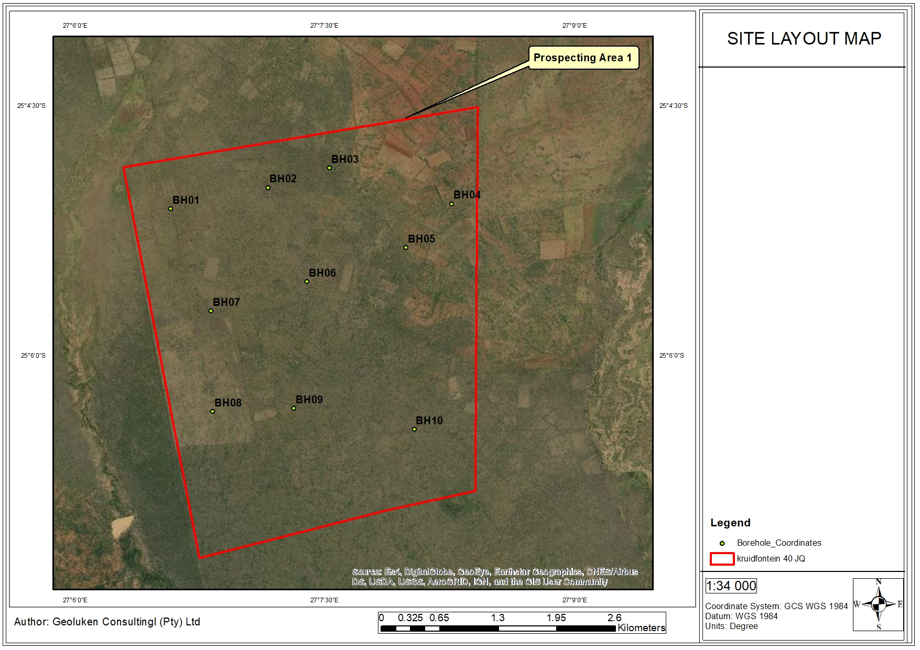
Figure 9: Site Layout Map of the area
The exact location of drilling points cannot be pinpointed as the prospecting activities are conducted in phases, and each phase depends on the success of the previous phase. The drill points must be identified after the geophysical surveys have confirmed the presence of the ore body. The sensitive areas will be identified during the planning phase of the project and no activities will be undertaken at any sensitive area. A detailed map will be produced after the geophysical surveys has been undertaken, although the map will be subjected to changes depending on the results of the preliminary drilling and assaying.

- Summary of the positive and negative impacts and risks of the proposed activity and identified alternatives
The proposed activities have medium and low significance and will be short term activities. The probability of occurrence of an impact was determined and most of these activities can be controlled and impacts can be reduced or avoided. Generally prospecting activities have low impact on the environment. The planned activities negative impacts can be controlled and avoided or minimised. Mitigation measures will be used to manage and control any potential impact. The main impacts will include:
- Influx of job seekers to site may result in increased opportunistic crimes;
- Short term boost for local businesses;
- Potential visual impacts by drilling activities as well as vegetation clearance;
- Increased vehicle activity within the area resulting in potential destruction and disturbance of flora and fauna;
- Potential water and soil pollution resulting from hydrocarbon spills and soil erosion which may impact on ecosystem functioning and on the water resources utilised by the communities and landowners;
- Increased ambient noise levels resulting from drilling activities and increased traffic movement;
- Prospecting will be undertaken by special sub-contractors and it is not anticipated that employment opportunities for local and/or regional communities will result from prospecting activities;
- Soil, surface water and groundwater contamination from hydrocarbons during the construction and operational activities which include drill rig operation and use of vehicles on site;
- Possible destruction or loss of Cultural and Heritage Resources during the construction phase as well as during the operational phase as drilling commenced; and
- Dust fall & nuisance from construction and operational activities.

Proposed impact management objectives and the impact management outcomes for inclusion in the EMPR
Based on the assessment and where applicable the recommendations from specialist reports, the recording of proposed impact management objectives, and the impact management outcomes for the development for inclusion in the EMPr as well as for inclusion as conditions of authorisation.
The objectives of the EMPr will be to:
- Ensure an approach that will provide the necessary confidence in terms of environmental compliance;
- Provide a management plan that is effective and practical for implementation;
- Restrict the area of impact to as small an area as possible;
- Provide sufficient information to strategically plan the prospecting activities as to avoid unnecessary social and environmental impacts and in a manner that will reduce impacts (social, physical and biological) as far as is practically possible; and
- Ensure health and safety of employees.
Through the implementation of the identified proposed mitigation measures, it is anticipated that the identified social & environmental Impacts can be managed and mitigated effectively. Through the implementation of the mitigation and management measures it is expected that:
- Noise impacts can be managed through consultation and through the restriction of operating hours;
- The pollution of soil and water resources can be effectively managed through containment;
- Ecological impact can be managed through the implementation of pollution prevention measures, minimizing land clearing, restricting working hours (faunal disturbance) and rehabilitation;
- Concerns regarding access control to farms can be managed through the development and ensuring compliance to an appropriate access control procedure; and
- Risks associated with crime can be mitigated through avoiding recruitment activities on site, as well as monitoring and reporting.

Aspects for inclusion as conditions of Authorisation
Any aspects which must be made conditions of the Environmental Authorisation
- No activities may be undertaken within 500 m of wetlands and/or within 100 m of watercourses without approval from the DWS;
- No relocation of heritage resources may be undertaken without the approval of SAHRA;
- Landowners as well as land occupiers must be re-consulted at least 30 days prior to any prospecting activities undertaken on their properties; and
- A minimum distance of 500m from any dwellings or infrastructure must be kept.

Description of any assumptions, uncertainties, and gaps in knowledge
(Which relate to the assessment and mitigation measures proposed)
- No detailed site layout is currently available due to the nature of the prospecting activities. The impact assessment was undertaken as a holistic assessment for the overall site;
- No wetland delineation was undertaken;
- No Heritage Impact Assessment was undertaken therefore details on the SAHRA permit requirement are not available;
- Details from the DWS regarding the Water Use Licence requirements are not available;
- Not all landowners were consulted with in person;
- Stakeholder Consultation is not yet complete; and
- The Draft BAR will be updated once the 30- day public review and comment period has lapsed. Comments from the stakeholders will be incorporated into the Final BAR to be submitted to the DMR.

Reasoned opinion as to whether the proposed activity should or should not be authorised
- Reasons why the activity should be authorized or not
It has also been noted that mining sector is the pillar of South African economy and also provides employment opportunities for many. The desktop studies have proven that the site is located on a mineralised zone, prospecting activities must be undertaken to confirm the ore reserves. Without implementation of prospecting activities, the knowledge concerning the potential mineral resource within the prospecting right area will not be confirmed.
The option of not approving the activities will result in a significant loss to valuable information regarding the status of the ore bodies present on these properties. In addition, should economical reserves be present, and the applicant does not have the opportunity to prospect, the opportunity to utilise these reserves for future phases will be lost.
- Conditions that must be included in the authorisation
See Section 5.8.16 above.

Period for which the environmental authorisation is required
The prospecting right has been applied for a period of 3 years. The Environmental Authorisation should therefore allow for 3 years of prospecting, plus a potential to extend the right by an additional 2 years. Therefore, a total period of 5 years may be required.

Undertaking
Confirm that the undertaking required to meet the requirements of this section is provided at the end of the EMPr and is applicable to both the Basic assessment report and the Environmental Management Programme report.
An undertaking by the EAP has been provided for on Section 2 of the EMPr.

Financial Provision
State the amount that is required to both manage and rehabilitate the environment in respect of rehabilitation.
The cost for rehabilitation and closure of the site according to the DMR Guideline format is R74 976.00 (seventy four thousand, nine hundred and seventy six rand and zero cents. A summary of the calculated financial provision costs is presented in Table 17 in Part B.

- Explain how the aforesaid amount was derived
The aforesaid amount was derived using the Department of Mineral Resources guideline document for the evaluation of the quantum of closure-related financial provision provided by a mine. The financial provision for the environmental rehabilitation and closure of any mine/prospecting and its associated operations forms an integral part of the MPRDA. Sections 41 (1) and, 41 (2), 41 (3) and 45 of the MPRDA deal with the financial provision for rehabilitation and closure. The amount for operating cost is provided for in the Prospecting Work Programme. The financial provision has been added on to the initial amount quoted in the Prospecting Work Programme.
- Confirm that this amount can be provided for from operating expenditure
(Confirm that the amount, is anticipated to be an operating cost and is provided for as such in the Mining work programme, Financial and Technical Competence Report or Prospecting Work Programme as the case may be).
The amount required to finance the prospecting activities, including rehabilitation and closure is estimated to be R1 210 000.00. The applicant hereby confirms that the amount is anticipated to be an operating cost and is provided for as such in the Prospecting Work Programme.
Table 13: Cost Estimate of the expenditure for the Prospecting Operation
ACTIVITY | YEAR 1  Expenditure (ZAR) | YEAR 2  Expenditure (ZAR) | YEAR 3  Expenditure (ZAR) | YEAR 4  Expenditure (ZAR) | YEAR 5  Expenditure (ZAR)
PHASE 1
Locate and acquire historical data | R50 000
Data capture, QA/QC and database establishment | R40 000
PHASE 2
Geological Field Mapping |  | R60 000
Geophysical Survey |  | R60 000
PHASE 3
Exploration Drilling of 6 Boreholes (Average Depth of 100m drilling cost R550 per meter) |  |  | R350 000
Drilling Supervision, Geological Logging and Reporting |  |  | R80 000
Laboratory Analysis |  |  | R30 000
PHASE 4
Exploration Drilling of 4 Boreholes (Average Depth of 100m drilling cost R550 per meter) |  |  |  | R270 000
Drilling Supervision, Geological Logging, Pre-Geological Logging and Reporting |  |  |  | R60 000
Laboratory Analysis |  |  |  | R20 000
PHASE 5
Finalisation of geological model |  |  |  |  | R50 000
Resource estimate |  |  |  |  | R50 000
Concept study |  |  |  |  | R80 000
PHASE TOTAL | R90 000 | R120 000 | R460 000 | R350 000 | R190 000
 |  |  |  | TOTAL BUDGET | R1 210 000

Specific information required by the Competent Authority
- Compliance with the provisions of sections 24(4)(a) and (b) read with section 24 (3) (a) and (7) of the National Environmental Management Act (Act 107 of 1998). the EIA report must include the:-
- Impact on the socio-economic conditions of any directly affected person
(Provide the results of Investigation, assessment, and evaluation of the impact of the mining, bulk sampling or alluvial diamond prospecting on any directly affected person including the landowner, lawful occupier, or, where applicable, potential beneficiaries of any land restitution claim, attach the investigation report as an Appendix .
No specific report was generated for the purposes of the socio-economic conditions. Current land uses inside the prospecting area, such as farming and grazing, may be temporarily impacted through the presence of the fenced areas that drill rigs will operate within. These will, however, be small areas. These areas will be rehabilitated post drilling activities and the areas will once again become available for grazing. Other potential socio-economic impacts will include:
- Influx of job-seekers to site, which may result in an increase in opportunistic crime;
- Visual impact as a result of the vegetation clearance;
- Nuisance noise due to on site activities and drilling;
- Uncontrolled access to private property outside of the demarcated boundaries;
- Generation of waste that would be injected into the local waste stream; and
- Potential water and soil pollution resulting from spills and soil erosion.
- Impact on any national estate referred to in section 3(2) of the National Heritage Resources Act
(Provide the results of Investigation, assessment, and evaluation of the impact of the mining, bulk sampling or alluvial diamond prospecting on any national estate referred to in section 3(2) of the National Heritage Resources Act, 1999 (Act No. 25 of 1999) with the exception of the national estate contemplated in section 3(2)(i)(vi) and (vii) of that Act, attach the investigation report as Appendix 2.19.2 and confirm that the applicable mitigation is reflected in 2.5.3; 2.11.6.and 2.12.herein).
Prospecting will be undertaken in phases. The first phase will be a desktop study, which will be followed by ground surveys and soil sampling. Based on the outcome of the activities, soil sampling and drill sites will be determined. Potential heritage impacts will only occur once the drilling sites have been identified. It is therefore recommended that the HIA be undertaken prior to the commencement of the drilling activities, and that the HIA be conducted over the identified localised drill sites and access routes, as opposed to the entire exploration area. This recommendation will be submitted to the SAHRA for approval.

Other matters required in terms of sections 24(4)(a) and (b) of the Act
(the EAP managing the application must provide the competent authority with detailed, written proof of an investigation as required by section 24(4)(b)(i) of the Act and motivation if no reasonable or feasible alternatives, as contemplated in sub-regulation 22(2)(h), exist. The EAP must attach such motivation as Appendix 4).
The proposed prospecting activities requested as part of this authorisation is the only current viable manner in which a mineral resource can be evaluated to determine its economic viability.

PART B

ENVIRONMENTAL MANAGEMENT PROGRAMME REPORT

DRAFT ENVIRONMENTAL MANAGEMENT PROGRAMME

Details of the EAP
(Confirm that the requirement for the provision of the details and expertise of the EAP are already included in PART A, section 1(a) herein as required).
Details of the EAP are included in Part A Section 1 (a).

Description of the Aspects of the Activity
(Confirm that the requirement to describe the aspects of the activity that are covered by the draft environmental management programme is already included in PART A, section (1)(h) herein as required).
The EAP hereby confirms that the requirement to describe the aspects of the activity that are covered by the draft Environmental Management Programme is already included in Part A, Section (1)(h) of this report as required.

Composite Map
(Provide a map (Attached as an Appendix) at an appropriate scale which superimposes the proposed activity, its associated structures, and infrastructure on the environmental sensitivities of the preferred site, indicating any areas that any areas that should be avoided, including buffers)
Please refer to Appendix 3 for the composite map.

1.4 Description of Impact management objectives including management statements

Determination of Closure Objectives
(ensure that the closure objectives are informed by the type of environment described)
As previously mentioned, each phase of the prospecting activities is dependent on the success of the preceding phase. Depending on the findings from Phase 1, Phase 2 will be initiated. The location and extent of the drill sites can therefore not be determined at this stage of the process.
The rehabilitation plan was developed on the basis that the rehabilitated areas will be made safe, stable, non-polluting and will be able to support self-sustaining ecosystems, similar to surrounding natural ecosystems. To ensure that the rehabilitation plan is aligned with the closure objective, high-level risk assessment of the prospecting components was undertaken to establish the potential risks associated therewith.
The closure objectives will be:
- Restore disturbed areas and re-vegetate these areas with plant species naturally occurring in the area to restore the ecological function of the affected areas as far as practicable;
- To establish rehabilitated areas to a state which with no susceptible to soil erosion which may result in loss of soil, and pollution of water resources;
- Remove and/or rehabilitate all pollution and pollution sources such as waste materials and spills;
- Eliminate any safety risks associated with drill holes and sump through adequate drill hole capping and backfilling; and
- Eliminate all alien invasive plant species from the disturbed areas.

Volumes and rate of water use required for the operation
The rates and volumes of water to be used are not available at this stage.

Has a water use licence has been applied for?
Water Use license will not be required for this project.

Impacts to be mitigated in their respective phases
Measures to rehabilitate the environment affected by the undertaking of any listed activity
Table 14: Environmental Management Programme for the proposed prospecting project
ACTIVITIES | PHASE | SIZE AND SCALE of disturbance | MITIGATION MEASURES | COMPLIANCE WITH STANDARDS | TIME PERIOD FOR IMPLEMENTATION
Data collection and assessment | Planning | Entire property | - No mitigation proposed. | Control potential deviations from the approved EMPr through the effective implementation of the data acquisition and desktop study. | Throughout the planning phase.
Geological Mapping
Planning for Drilling Surveys
Geophysical Survey | Planning | Entire property | - Map indicating the location of each of the drilling sites must be submitted to the relevant landowners, as well as to the DMR and DWS. Upon agreement of the location of the activities can the applicant proceed. Use existing track and roads in all instances as far as is practicable. Already cleared areas should be preferred over heavily dense areas. |  | Throughout the planning phase.
Site establishment activities:  Establishment of access roads, vegetation clearance, Mobile office, campsite, ablution facility, erection of fence, temporary soil storage area and Core bay, hydrocarbon storage area, waste generation and management, physical surveying of the site and pegging of drilling boreholes. | Construction | Less than 10000m² | - Contaminated soil shall be removed and disposed of to an appropriate licensed landfill site in terms of NEMWA or can be removed by a service provider that is qualified to clean the soil.  - No soil stripping will be allowed during site establishment.  - Should it be necessary to conduct geophysical surveys and geological mapping, ensure minimal disturbance of soil.  - Any activity that may result into the disturbance of the soils must be rehabilitated immediately.  - Machinery to be used for the operation will be of good working conditions.  - Any hydrocarbon spill from the site establishment will be remediated as soon as possible.  - Erosion control measures shall be implemented where deemed necessary.  - Stockpiles shall be maintained until the topsoil is required for rehabilitation purposes.  - Vegetation shall be used to promote infiltration of water into the stockpile instead of increasing runoff.  - Use existing track and roads in all instances as far as is practicable.  - Floral species of conservation concern, if encountered within the development footprint, are to be handled with care and the relocation of sensitive plant species to suitable similar habitat is to be overseen by a botanist.  - Prohibit the collection of any plant material for firewood or medicinal purposes.  - All disturbed areas must be concurrently rehabilitated during construction.  - All sites disturbed by construction activities shall be monitored for colonisation by exotic or invasive plants.  - Implementation of an Alien Invasive Plant Species Management plan.  - Construction vehicles shall only be allowed on designated roadways to limit the ecological footprint of the project.  - An alien vegetation control program must be developed and implemented within all disturbed areas.  - Site activities will be conducted during daytime hours 07h00– 17h30 to avoid night time noise disturbances and collisions with fauna.  - No trapping or hunting of fauna is shall be permitted.  - Vehicle speed will be reduced, particularly in highly vegetated areas to avoid deaths by vehicle impacts.  - No fires in the vicinity of construction areas shall be permitted.  - Poaching will be prohibited at the prospecting site.  - No site establishment shall be permitted within sensitive landscapes.  - No construction activities shall be permitted within 100 meters of water courses and/or drainage lines and within 500 m of wetlands and/or riparian zones without consent from the DWS.  - Proper waste management facilities will be put in place at the campsite and drilling site.  - Any hydrocarbon spill from the site establishment will be remediated as soon as possible.  - No washing of vehicles shall be allowed outside demarcated areas.  - Washing bays for vehicles and other equipment shall be provided with appropriate soakaways, will be clearly demarcated and will not be allowed to contaminate any surface runoff.  - Refuelling of vehicles will only be allowed in designated areas.  - All construction equipment shall be parked in a demarcated area Drip trays shall be used when equipment is used for some time.  - Surface bulk storage of hydrocarbons must be situated in a dedicated area which will include a bund or a drain where necessary to contain any spillages during the use, loading and offloading of the material.  - Bunded areas shall contain 110% of the stored volume and must be impermeable.  - Bund area must have a facility such as a valve/sump to drain or remove clean stormwater.  - Contaminated water shall be pumped into a container for removal by an approved service provider.  - Regular inspections shall be carried out to ensure the integrity of the bund walls.  - All preventative servicing of earth moving equipment and construction vehicles shall conducted off site.  - Runoff from this area shall be contained.  - Spill kits shall be made available and all personnel shall be trained, and training records shall be made available on request.  - Ensure that topsoil is properly stored, away from the streams and drainage areas.  - Vehicle and personnel movement within watercourses and wetland areas shall be strictly prohibited.  - Adequate stormwater management must be incorporated into the design of the project in order to prevent contamination of water courses and wetlands from dirty water.  - Any abstraction of water for construction purposes must be approved by DWS.  - Dust suppression measures shall be implemented on dry weather days and periods of high wind velocities.  - Wet suppression will be conducted at areas with excessive dust emissions.  - A speed limit of 40 km/hr shall apply to limit vehicle entrained dust from the unpaved roads.  - All construction equipment must be scheduled for preventative maintenance to ensure the functioning of the exhaust systems to reduce excessive emissions and limit air pollution.  - Appropriate dust suppression measures may include limiting the extent of open areas, reducing the frequency of disturbance, and spraying with water.  - Chemical toilets must be emptied / serviced on a regular basis. Proof of this must be provided to the Engineer.  - Ensure that the employees are issued with earplugs and that they are instructed to use them.  - Educate employees on the dangers of hearing loss due to mine machinery noise.  - Adjacent landowners must be advised of any work that will take place outside of normal working hours, that may be disruptive in advance.  - Surrounding communities must be notified in advance of noisy construction activities.  - All equipment should be provided with standard mufflers, and muffling units on vehicles and equipment must be kept in good working order.  - Regular maintenance of equipment must be undertaken, particularly with regard to lubrication.  - Equipment shall be switched off when not in operation.  - Where possible, rehabilitation of the work areas shall be undertaken concurrently with construction to ensure that areas stripped of vegetation are kept to a minimum.  - Prior to the site establishment, a heritage impact assessment must be undertaken and mitigation and /or management measures for the protection of such resources must be implemented.  - If archaeological sites or graves are exposed during construction work, it should immediately be reported to a heritage practitioner so that an investigation and evaluation of the finds can be made.  - The establishment of the sites will be away from any identified grave site or heritage sites.  - Recruitment will not be undertaken on site, and shall favour local people.  - All waste shall be separated into general waste and hazardous waste.  - No littering shall be allowed in and around the site, a sufficient number of bins shall be provided for the disposal of waste.  - No stockpiling of material shall be permitted within 100 m of water courses and/or drainage lines, or within 500 m of wetland and riparian areas.  - General waste will be collected in an adequate number of litter bins and will be located throughout the construction site.  - Bins must have lids in order to keep rain water out.  - Bins shall be emptied regularly to prevent the bins from overflowing.  - All work areas shall be kept clean and tidy at all times.  - All waste management facilities will be maintained in good working order.  - Waste shall be stored in demarcated areas according to type of waste.  - Flammable substances must be kept away from sources of ignition and from oxidizing agents.  - Waste shall not be buried or burned on site.  - The maximum retention time for temporary storage of waste generated shall not exceed 30 days provided the waste does not present a health hazard or risk of odour.  - No dumping shall be allowed in or near the construction site.  - Hazardous containers shall be disposed of at an appropriate licensed site.  - Hazardous waste will be removed and managed by an approved service provider.  - A safe disposal certificate will be provided by the service provider as proof of responsible disposal of hazardous waste.  - The safe disposal certificate shall be stored and provided on site.  - No dumping shall take place in or near the construction site.  - All general waste shall be disposed of to the nearest licensed landfill site.  - Where existing public roads are used to access the construction areas, adequate signage must be put in place to inform the public of increased construction activities in the affected areas.  - Local speed limits and traffic laws shall apply at all times to minimise the occurrences of accidents on public roads. | Implementation of mitigation measures will ensure that the activities in the development of the prospecting sites and associated infrastructure do not have detrimental impacts on the soils, land use and land capability, and on vegetation, in particular indigenous species and species that are of conservation importance.  Measures will be undertaken to ensure that the visual aspects from the site are complying with the relevant visual standards and objectives and ensure that all operations during the construction phase do not result in detrimental visual impacts on surrounding properties, communities, and road users. The mitigation measures will ensure that the construction activities does not have detrimental impacts on the heritage sites. | During the construction phase
Drilling activities | Operational | 0.6ha | - The drilling of the exploration boreholes will be undertaken in such a manner that the environment is protected from probable spillages and contamination by carbonaceous material.  - All boreholes and sumps will be rehabilitated to pre-drilling conditions.  - All oil spills will be remedied using approved methodologies.  - The contaminated soils will be removed and disposed of at a licensed waste disposal facility.  - All waste generated from the drilling sites and the campsite will be collected in proper receptacles and removed top registered disposal facilities.  - The soils must be used for the backfilling and rehabilitation of the sumps.  - No topsoil shall be stored within 100 m of water courses and drainage lines or within 500 m of wetlands and riparian areas.  - The rehabilitated area must be seeded with recommended seed mix.  - Poaching will be prohibited at the prospecting sites.  - Storm water generated around the drilling site will be diverted away to the clean water environment.  - No vehicle maintenance will be allowed on site. All hydrocarbons will be stored on protected storage areas away from the streams.  - The area that was disturbed by the drilling operation at each site shall be rehabilitated, as far as is practicable, to its original state as soon as the drilling is completed.  - Photographs, for monitoring purposes, should be taken before drilling commences and after each drilling site has been rehabilitated.  - These photographs should be included in the required Performance Assessment Reports.  - Every effort must be made to minimise the area needed at each drilling site.  - Vegetation should not be cut or trimmed unless absolutely essential.  - No new roads are to be constructed on this site.  - Tracks across areas covered by natural vegetation will be kept to the absolute minimum required.  - Depending on the need and quantity of water used for wet suppression, chemical suppression alternatives must be considered to conserve water.  - Drill sites shall be located as far from private property as is possible to minimise noise impacts.  - Ensure that the employees are issued with earplugs and that they are instructed to use them.  - Drill rigs shall be located in areas with adequate tree and bush cover to minimise the visual impact on residents.  - Where no adequate vegetation cover is available for the drill rigs, shade cloths can be used to screen off the drill rigs.  - The drilling sites will be situated away from any identified grave site or heritage sites. A 50m buffer will be created between the sites and the proposed camp and drilling sites.  - Communication with land owners and land occupiers shall be kept open during the operational phase of the project. A record of such communication shall be kept on site.  - Ensure that negotiations on compensation are undertaken before the drilling programme can commence. This will include any other conditions that the landowners may deem necessary for the prospecting operation. The outcomes of the negotiations shall be recorded and kept in a file on site.  - Ensure that safety measures are implemented to prevent impacts on land owners and occupiers.  - Access to private property, outside of the demarcated drill sites, without landowner consent shall be strictly prohibited. | The implementation of the mitigation measures will ensure that the land use and capability of the sites where the operations will be undertaken will continue after the proposed project. The applicant must adhere to the NEMA Section 2 Principle and ensure that a cradle to grave approach is followed in terms of waste management and that all activities are undertaken with a precautionary approach. Where impacts may result, a proactive manner should be implemented to ensure that potential negative results are avoided. The applicant must comply with the conditions of the Environmental Authorization at all times. | Throughout the operation phase.
Data Analysis and Feasibility Studies Report | Operational | N/A | N/A | N/A | N/A
Borehole capping | Decommissioning and Closure | All the affected  sites | - Drill holes must be temporarily plugged immediately after drilling is completed and remain plugged until they are permanently plugged below ground to eliminate risk.  - Drill holes must be permanently capped as soon as possible.  - All vehicles and machinery used at the rehabilitation site will be kept in good working order.  - No repairs of vehicles or machinery will be conducted at the rehabilitation site unless it is emergency repairs, which will be conducted on protected ground.  - Movement of vehicles and machinery will be limited to demarcated routes, which will be rehabilitated when no longer in use.  - All infrastructure will be removed from the site in accordance with the rehabilitation plan.  - Contaminated soils shall be cleaned or disposed of at a registered landfill site in terms of the requirements of the NEM: WA.  - The site area will be rehabilitated to be free draining.  - Erosion protection measures such as the use of contour berms and repair of gullies will be undertaken until such time that the rehabilitated surfaces can be shown to be sustainable.  - Existing roads should be used where possible and new disturbed areas should be minimised.  - Where necessary, wet suppression will be conducted at areas with excessive dust emissions.  - Vehicles and machinery will be well maintained.  - The traffic volumes and speed limit within the rehabilitation site will be controlled.  - Re-vegetation will be conducted by hand seeding exposed areas using indigenous grass species as determined by a suitably qualified ecologist.  - Re-vegetation efforts must be monitored monthly for 6 months after initial seeding.  - An effective vegetation cover of 45% must be achieved. Reseeding will be undertaken if this cover has not been achieved after 6 months. | Rehabilitated areas will be maintained to comply with the closure objectives. | Upon cessation of the  Prospecting activities.
Removal of equipment and infrastructure | Decommissioning and Closure | All the affected  sites |  |  | Upon cessation of the  Prospecting activities.

Impact Management Outcomes
(A description of impact management outcomes, identifying the standard of impact management required for the aspects contemplated in paragraph ()
Table 15: Impact Management Outcomes
NAME OF ACTIVITY | POTENTIAL IMPACT (Including the potential impacts for cumulative impacts) | ASPECTS AFFECTED | PHASE  In which impact is anticipated | MITIGATION TYPE | STANDARD TO BE ACHIEVED
Data collection and assessment | None. | N/A | Planning | Control potential deviations from the approved EMPr through the effective implementation of the data acquisition and desktop study. | Remain within the ambits of the PWP and Environmental Authorization.
Geological Mapping
Planning for Drilling Surveys
Site access | Destruction and/or disturbance of onsite fauna and flora and clearing of Vegetation. | Fauna and Flora | Geophysical Survey | Map indicating the location of each of the drilling sites must be submitted to the relevant landowners, as well as to the DMR and DWS. Upon agreement of the location of the activities can the applicant proceed.  Use existing track and roads in all instances as far as is practicable. Already cleared areas should be preferred over heavily dense areas. | Remain within the ambits of the PWP and Environmental Authorization.
Set-up of Geophysical Survey Equipment | Theft. | Socio- Economic | Geophysical Survey | The site camp must be secured and entrance into the site must be controlled | Remain within the ambits of the PWP and Environmental Authorization.
Establishment of access roads, Mobile office, campsite, ablution facility, erection of fence, temporary soil storage area and Core bay, hydrocarbon storage area, waste generation and management, physical surveying of the site and pegging of drilling sites and boreholes. | Increase in ambient noise due to movement of construction vehicles and machinery | Noise. | Construction | Management and maintenance of construction vehicles. Management through the use of noise dissipating technologies e.g. noise mufflers.  Speed control and limitation of the times when construction vehicles may be on the roads.  Rehabilitation of areas cleared of vegetation and dust control. Monitoring through rehabilitation and management of spoil sites.  Implement dust control measures.  Rehabilitation of areas cleared of vegetation. Control of alien invasive plant species. Relocation of affected species of conservation importance. Control through clear demarcation of prospecting areas to ensure avoidance of graves and other heritage sites.  Control of access to wetland areas and within the regulated 500m buffer. Control through management and monitoring of spillages. Where spillages occur, the soil must be stripped and disposed of as stipulated in the EMPr.  Control through the limiting of the activities to the day time and the implementation of an open and transparent channel of communication.  Control and keep to a minimal the number of vehicles used for construction. Vehicles must be maintained to ensure efficient use of fuel. | Remain within the Noise Regulation Standards for Rural Areas.
 | Visual impacts as a result of vegetation clearance. | Visual. | Construction |  | Vegetation clearance must be limited to demarcated areas only.
 | Increased traffic on the roads due to additional construction vehicles. | Traffic, socio- economic. | Construction |  | Minimise the number of vehicles used during construction. Movement of construction vehicles shall be limited to outside of busy hours.
 | Impact of carbon dioxide (GHG) produced by construction vehicles on the local climate. | Climate Change. | Construction |  | Comply with the EMPr. Minimise the number of vehicles used during construction Regular maintenance of vehicles and machinery to improve fuel efficiency.
 | Air pollution through nuisance dust, as well as emissions from construction vehicles and machinery. | Air Quality. | Construction |  | Comply with the requirements of the National Environmental Management: Air Quality Act, 2004: Dust Regulation guidelines for rural communities.
 | Loss of natural vegetation in the affected areas. | Flora. | Construction |  | Comply with existing legislation National Environmental Management: Biodiversity Act 2004 (Act No 10 of 2004) and Alien and Invasive Species Regulations, 2014. No vegetation clearance outside of demarcated areas
 | Migration of fauna due to disturbance caused by the proposed project. | Fauna. | Construction |  | Remain within the designated area demarcated for prospecting activities. Ensure minimal clearance of vegetation
 | Destruction of graves and cultural heritage sites and fossils. | Heritage and archaeological resources. | Construction |  | Comply with the requirements by SAHRA. No damage may result on heritage and cultural significant sites.
 | Contamination of surface water due to erosion of soils which will lead to increased turbidity as well as contamination from hydrocarbon spillages. | Surface water. | Construction |  | Comply with the requirements of the NWA. No construction activities within 100 m of water courses and 500m of wetlands and riparian zones without consent from the DWS.
 | Contamination of groundwater from hydrocarbon spillages. | Groundwater. | Construction |  | Where required, disposal of contaminated soils shall be undertaken in terms of the National Environmental Management: Waste Act, 2008 (Act 59 of 2008) (NEM: WA).
 | Loss of soils, erosion of the soils and impacts on landowners’ livelihood. | Soils, Land capability and Land use. | Construction
Drilling activities | Influx of persons (job seekers) to site as a result of increased activity resulting in increased incidents of theft and opportunistic crime. It is expected that during the drilling phase the project will not result in the creation of employment as prospecting requires highly specialised personnel. The applicant will make use of qualified contractors for the drilling and sampling of the sites. The community will however continue to benefit as a result of the continued boost in small local businesses. | Socio-Economic. | Operational | Control of times during which operation activities will take place.
Drilling activities | The prospecting operations will require the drilling of boreholes, which my result in the drawdown, which may affect the yield to the surrounding groundwater users. Material used for backfilling boreholes may leach pollutants, which will result in the contamination of surrounding groundwater regime. This may spread beyond the backfilling site via plume migration. | Groundwater. | Operational | Rehabilitation of affected areas and control using bunds.
Drilling activities | The use of vehicles during the drilling of the exploration boreholes may result in the spillages of hydrocarbons from vehicles and machinery. This will result in the contamination of soils and groundwater. | Groundwater. | Operational | Fuel storage tanks will have a secondary containment structure with a capacity of 110% of the total tank capacity. Oils and lubricant will be stored within secondary containment structures. Where practicable, vehicle maintenance will be undertaken offsite. In the event that vehicle maintenance is undertaken on-site (i.e. such as breakdown maintenance), drip trays and/ or UPVC sheets will be used to prevent spills and leaks onto the soil. Unused machinery must be completely drained of oil and other hydrocarbons to ensure that leaks do not develop.  Regular inspections of all vehicles must be carried out to ensure that all leaks are identified early and rectified. A sufficient number of waste receptacles will be provided.  Waste separation will be undertaken at source and separate receptacles will be provided (i.e. general waste, recyclables, and hazardous waste). Receptacles will be closed (i.e. fitted with a lockable lid) to eliminate the possibility of access by animals overnight.  Wastes will be removed and disposed of at an appropriately licensed landfill (facility disposal licenses will be verified) and recyclables will be taken to a licensed recycling facility.
Soil Sampling | Drilling operations my result in the generation of surface water runoff contaminated with drill muds and cuttings, should spillage occur. The sedimentation and possible contamination with carbonaceous material will have negative impacts on the water quality due to increase turbidity and an increase in acidity of the water in the streams. This will have an impact on aquatic habitats. | Surface Water. | Operational | Control through management and monitoring of surface runoff. A sump will be constructed with a sufficient capacity to receive drill fluids and allow for evaporation. The sump will be constructed to divert stormwater away and / or around the sump to avoid clean stormwater inflow.
Soil Sampling | The use of vehicles during the drilling of the exploration boreholes may result in the spillages of hydrocarbons from the vehicles and machinery. This will result in the contamination of soils. The materials removed from the drilling sites will contain carbonaceous material, which has potential for contamination should it not be managed properly.  The material from the drilling site may result in the contamination of soils, which may render the land not usable after backfilling operation. | Soil, Land use and Land Capability | Operational
Soil Sampling | Destruction of Heritage and Palaeontological Resources | Heritage and Palaeontological Resources. | Operational | Should any paleontological or cultural artefacts be discovered work at the point of discovery must stop, the location be clearly demarcated and SAHRA contacted immediately. Work at the discovery site may only be recommenced on instruction from SAHRA.
Soil Sampling | Waste Generation | Waste Management. | Operational | Skips and marked bins must be provided at the site for waste separation. The mechanical wastes must be stored separately from other areas in a waste skip and must be disposed of at an appropriate landfill site. Equipment maintenance must be done off site, and where there is need to conduct it on site, it must be done on a bunded area. Cleaning of equipment must be done on a bunded area. Waste water must not be released into the natural streams prior treatment. The mud generated from the drilling activities must be contained, and contaminated mud must be handled separately, treated or disposed of at an appropriate landfill.
Soil Sampling | Continued soil erosion from topsoil stockpile and soil compaction from drill pad platform. | Loss of soil resources | Operational | The topsoil stockpile will be shaped to divert storm water around the drill pad to minimize soil erosion of the pad. Management efforts through the use of mechanical erosion control methods will be implemented if required.
Soil Sampling | Dust emissions from drilling and general site activities (including vehicle entrained dust). | Air Quality | Operational | Wet dust suppression will be undertaken as and when required to manage dust emissions from vehicle movement. Depending on the need and quantity of water used for wet suppression, chemical suppression alternatives must be considered in order to conserve water resources.
Soil Sampling | Visual Impact affecting visual character and "sense of place". The drill rigs and towers used during the drilling operation phase will be visible from nearby locations and will have visual impact on the local communities in close proximity to the prospecting area. | Visual | Operational | Strategic location of rigs and towers to areas where there may be some tree cover, as far as practicable.
Soil Sampling | The movement of vehicles in the project area will result in an increase in traffic on the roads. | Traffic | Operational | Speed control and limitation of the times when construction vehicles may be on the roads must be enforced all the time.
Soil Sampling | The use of vehicles and machinery may result in an increase in noise in the immediate vicinity of the project. The drilling activities will also result in an increase in noise in the vicinity of the project. | Noise | Operational | Management and maintenance of construction vehicles. Management through the use of noise dissipating technologies e.g. noise mufflers.
Data Analysis and Feasibility Studies Report | None. | N/A | Operational | N/A | N/A
Borehole capping | Loss of soil resources, and Loss of fauna. | Soils, Land Capability and Land Use | Decommissioning and Closure | Drill holes must be temporarily plugged immediately after drilling is completed and remain plugged until they are permanently plugged below ground to eliminate the risk posed to fauna by open drill holes. Drill holes must be permanently capped as soon as is practicable.  The removal of the campsite equipment and the rehabilitation of the drilling sites and associated access infrastructure will result in the affected soil and land use being restored. This will also result in the resumption of the use of the land since the infrastructure would have been removed. | No removal of vegetation outside of demarcated areas. Ensure successful rehabilitation of contaminated soils. Rehabilitation of land to a state it was before prospecting activities.
Removal of equipment and infrastructure | Positive impacts will result due to the reduction in areas of disturbance and the return of land use of the affected areas and making available an area that was covered by the campsite and drilling sites. | Land Use | Decommissioning and Closure | Positive impacts will result due to the reduction in areas of disturbance and the return of land use of the affected areas and making available an area that was covered by the campsite and drilling sites. | No removal of vegetation outside of demarcated areas. Ensure successful rehabilitation of contaminated soils. Rehabilitation of land to a state it was before prospecting activities.
Removal of equipment and infrastructure | During the process of rehabilitation surface water runoff from the rehabilitation site may have elevated silt load, which may cause pollution of the nearby water environment. | Surface Water | Decommissioning and Closure | Equipment will be removed, stockpiled soils will be used for rehabilitation, remaining sumps will be backfilled, levelled, top soiled and the area re-seeded. Control through the implementation of the NWA GN 704 water management principles. | Maintain the water quality of water course in the project area. Ensure that dirty stormwater and runoff is diverted from the water courses and wetland areas. Comply with the requirements of GN704
Removal of equipment and infrastructure | The use of vehicles/machinery during the rehabilitation of the exploration sites may result compaction of soils and in the spillages of hydrocarbon liquids from the vehicles and machinery. This will result in the contamination and destruction of the vegetation cover and soils. | Soils and Vegetation | Decommissioning and Closure | All fuel storage tanks will be emptied prior to removal. Drill holes will be permanently capped as soon as is practicable to eliminate the risk of groundwater contamination. Wastes will be removed and disposed of at an appropriately licensed landfill (facility disposal licenses will be verified) and recyclables will be taken to a licensed recycling facility. The compacted soils must be loosened, and topsoil spread on top, and also spreading seeds of indigenous species. All the equipment must be shipped out of the site. | Vehicle movement shall be limited to areas demarcated as access tracks. Comply with the requirements of the EMPr.
Removal of equipment and infrastructure | Rehabilitation and removal of the prospecting sites and equipment will require vehicular movement. This will result in the generation of dust by movement of vehicles and due to blowing winds. Vehicles and machinery will also be generated diesel or petrol fumes. Generated dust will migrate towards the predominant wind direction and may settle on surrounding properties including nearby vegetation. | Air Quality | Decommissioning and Closure | Dust control measures and rehabilitation of areas stripped of vegetation. | Comply with the requirements of the National Environmental Management Air Quality Act, 2004 Dust Regulation guidelines for rural communities.
Removal of equipment and infrastructure | Noise will be generated during the removal of equipment and rehabilitation of the sites. This noise is not expected to exceed occupational noise limits and will be short lived. | Noise | Decommissioning and Closure | Management and maintenance of construction vehicles. Management through the use of noise dissipating technologies e.g. noise mufflers. | Comply with the Noise Regulation Standards for Rural Areas.

Impact Management Actions
(A description of impact management actions, identifying the manner in which the impact management objectives and outcomes contemplated in paragraphs (c) and (d) will be achieved).
Table 16: Impact Management Actions
NAME OF ACTIVITY | POTENTIAL IMPACT (Including the potential impacts for cumulative impacts) | MITIGATION TYPE | TIME PERIOD FOR IMPLEMEMNTATION | COMPLIANCE WITH STANDARDS
Data collection and assessment | None. | Control potential deviations from the approved EMPr through the effective implementation of the data acquisition and desktop study. | Planning | Remain within the ambits of the PWP and Environmental Authorization.
Geological Mapping
Planning for Drilling Surveys
Site access | Destruction and/or disturbance of onsite fauna and flora and clearing of Vegetation. | Map indicating the location of each of the drilling sites must be submitted to the relevant landowners, as well as to the DMR and DWS. Upon agreement of the location of the activities can the applicant proceed.  Use existing track and roads in all instances as far as is practicable. Already cleared areas should be preferred over heavily dense areas. | Planning
Set-up of Geophysical Survey Equipment | Theft. | The site camp must be secured and entrance into the site must be controlled | Planning
Establishment of access roads, Mobile office, campsite, ablution facility, erection of fence, temporary soil storage area and Core bay, hydrocarbon storage area, waste generation and management, physical surveying of the site and pegging of drilling sites and boreholes. | Increase in ambient noise due to movement of construction vehicles and machinery. | Management and maintenance of construction vehicles. Management through the use of noise dissipating technologies e.g. noise mufflers. | Construction | Remain within the Noise Regulation Standards for Rural Areas.
 | Visual impacts as a result of vegetation clearance. | Rehabilitation of areas cleared of vegetation and dust control. | Construction | Vegetation clearance must be limited to demarcated areas only.
 | Increased traffic on the roads due to additional construction vehicles. | Speed control and limitation of the times when construction vehicles may be on the roads. | Construction | Minimise the number of vehicles used during construction. Movement of construction vehicles shall be limited to outside of busy hours.
 | Impact of carbon dioxide (GHG) produced by construction vehicles on the local climate. | Control and keep to a minimal the number of vehicles used for construction. Vehicles must be maintained to ensure efficient use of fuel. | Construction | Comply with the EMPr. Minimise the number of vehicles used during construction Regular maintenance of vehicles and machinery to improve fuel efficiency. Comply with requirements of the National Environmental Management: Air Quality Act, 2004.
 | Air pollution through nuisance dust, as well as emissions from construction vehicles and machinery. | Implement dust control measures. | Construction | Comply with the requirements of the National Environmental Management: Air Quality Act, 2004: Dust Regulation guidelines for rural communities. Comply with the requirements of the Minimum Emission Standards.
 | Migration of fauna due to disturbance caused by the proposed project. | Relocation of affected species of conservation importance. | Construction | Remain within the designated area demarcated for prospecting activities. Ensure minimal clearance of vegetation.
 | Loss of natural vegetation in the affected areas. | Rehabilitation of areas cleared of vegetation. Control of alien invasive plant species. | Construction | Comply with existing legislation National Environmental Management: Biodiversity Act 2004 (Act No 10 of 2004) and Alien and Invasive Species Regulations, 2014. No vegetation clearance outside of demarcated areas.
 | Destruction of graves and cultural heritage sites and fossils. | Control through clear demarcation of prospecting areas to ensure avoidance of graves and other heritage sites. Management of drill sites. Should any fossils be discovered, operations must cease and SAHRA must be notified. | Construction | Comply with the requirements by SAHRA. No damage may result on heritage and cultural significant sites.
 | Contamination of surface water due to erosion of soils which will lead to increased turbidity as well as contamination from hydrocarbon spillages. | Monitoring through rehabilitation and management of spoil sites. | Construction | Comply with the requirements of the NWA. No construction activities within 100m of water courses and 500m of wetlands and riparian zones without consent from the DWS.
 | Contamination of groundwater from hydrocarbon spillages. | Control through management and monitoring of spillages. Where spillages occur, the soil must be stripped and disposed of as stipulated in the EMPr. Control and keep to a minimal the number of vehicles used for construction. Vehicles must be maintained to ensure efficient use of fuel. | Construction | Where required, disposal of contaminated soils shall be undertaken in terms of the National Environmental Management: Waste Act, 2008 (Act 59 of 2008) (NEM: WA).
 | Loss of soils, erosion of the soils and impacts on landowners’ livelihood. | Rehabilitation of areas cleared of vegetation and dust control. | Construction | Retain topsoil integrity for the reuse in rehabilitation. Vegetation clearance shall be kept to a minimum. No clearance of vegetation outside demarcated areas.
 | Wetland contamination, destruction, and loss of habitat. | Control of access to wetland areas and within the regulated 500 m buffer. | Construction | No construction activities may be conducted within 500m of wetlands and riparian zines without approval from the DWS.
Drilling activities | The use of vehicles during the drilling of the exploration boreholes may result in the spillages of hydrocarbons from vehicles and machinery. This will result in the contamination of soils and groundwater. | Rehabilitation of affected areas and control using bunds. | Operational | No soil contamination as a result of hydrocarbon spillages. Rehabilitation and disposal of contaminated soils conducted in terms of the NEM:WA.
Drilling activities | Loss of vegetation (possible plant species of conservation concern) from clearing or harvesting by personnel or uncontrolled fires set by personnel. | No harvesting of plants or hunting and trapping of animals must be allowed. No uncontrolled fires must be allowed. Intervening by planting indigenous vegetation in disturbed areas should natural revegetation prove unsuccessful. Avoid clearing trees. | Operational | Prevent loss of plant species of conservation concern and minimise disturbance to habitat and fauna as per the EMPr.
Drilling activities | Loss of animal species as a result of collisions with vehicles or hunting and trapping by personnel. | Where possible available access tracks will be used.  Avoid all plant species of conservation concern (in the unlikely event that they are present) by changing the location of sites accordingly prior to clearing. Areas to be cleared will be limited to the minimum extent possible. | Operational | Prevent loss of plant species of conservation concern and minimise disturbance to habitat and fauna as per the EMPr.
Drilling activities | Noise from drilling activities may result in nuisance to landowners. | Maintaining equipment and machinery in good working order. Switching off equipment when not in use. | Operational | Avoid disturbance of surrounding residents by implementing measures as EMPr, and noise standards (SANS 10103:2008) must be met. National Environmental Management: Air Quality Act, 2004: Dust Regulation guidelines for rural communities.
Drilling activities | Damage to buried archaeological or paleontological resources of significance. | Damage to buried archaeological or paleontological resources of significance. | Operational | Prevent damage to archaeological resources by implementing measures as per the EMPr, in the unlikely event that artefacts are unearthed they must be dealt with according to the provisions of SAHRA.
 | Dust generated may result in nuisance impacts. | Areas to be cleared will be limited to the minimum extent possible. Wet suppression must be implemented where dust plumes are noted. | Operational | Prevent excessive dust by implementing measures as per the EMPr. Dust generated likely to fall below the threshold as per the National Environmental Management: Air Quality Act, 2004: Dust Regulation guidelines for rural communities.
 | Heavy vehicles and machinery on site may result in potential hydrocarbon leaks which may in turn pollute soil. | Implementing spill prevention measures such as handling and storing hydrocarbons on impermeable surfaces. Adequately maintaining vehicles and machinery to prevent leaks. Cleaning any spills immediately. | Operational | Prevent contamination soil by implementing measures as per the EMPr.
 | Heavy vehicles and machinery on site may result in soil compaction subsequently impacting vegetation reestablishment. | Minimising areas to be disturbed by vehicle and machinery. Ripping and profiling compacted soil. | Operational | Prevent or repair compaction of soil by implementing measures as per the EMPr, to ensure that there are no negative impacts of vegetation reestablishment.
 | Waste spills may result in pollution of soil. | Cleaning any spills immediately. Implementing adequate waste management practices | Operational | Prevent contamination of soil by implementing measures as per the EMPr.
Soil Sampling | Drilling operations my result in the generation of surface water runoff contaminated with drill muds and cuttings, should spillage occur. The sedimentation and possible contamination with carbonaceous material will have negative impacts on the water quality due to increase turbidity and an increase in acidity of the water in the streams. This will have an impact on aquatic habitats. | Control through management and monitoring of surface runoff. A sump will be constructed with a sufficient capacity to receive drill fluids and allow for evaporation. The sump will be constructed to divert stormwater away and / or around the sump to avoid clean stormwater inflow. | Operational | No dirty runoff/stormwater entering water courses. The NWA: No activities within 100m of watercourses and drainage without consent from the DWS.  No soil contamination as a result of hydrocarbon spillages. Rehabilitation and disposal of contaminated soils conducted in terms of the NEM:WA.
Soil Sampling | The use of vehicles during the drilling of the exploration boreholes may result in the spillages of hydrocarbons from the vehicles and machinery. This will result in the contamination of soils. | Rehabilitation of affected areas and control using bunds. | Operational | No soil contamination as a result of hydrocarbon spillages. Rehabilitation and disposal of contaminated soils conducted in terms of the NEM:WA.
Soil Sampling | Destruction of Heritage and Palaeontological Resources | Should any paleontological or cultural artefacts be discovered work at the point of discovery must stop, the location be clearly demarcated and SAHRA contacted immediately. Work at the discovery site may only be recommenced on instruction from SAHRA. | Operational | No destruction/loss of heritage resources. Comply with requirements of the SAHRA.
Soil Sampling | Waste Generation | Skips and marked bins must be provided at the site for waste separation. The mechanical wastes must be stored separately from other areas in a waste skip and must be disposed of at an appropriate landfill site. Equipment maintenance must be done off site, and where there is need to conduct it on site, it must be done on a bunded area. Cleaning of equipment must be done on a bunded area. Waste water must not be released into the natural streams prior treatment. The mud generated from the drilling activities must be contained, and contaminated mud must be handled separately, treated or disposed of at an appropriate landfill. | Operational | No soil contamination as a result of hydrocarbon spillages. Rehabilitation and disposal of contaminated soils conducted in terms of the NEM:WA.
Soil Sampling | Continued soil erosion from topsoil stockpile and soil compaction from drill pad platform. | The topsoil stockpile will be shaped to divert storm water around the drill pad to minimize soil erosion of the pad. Management efforts through the use of mechanical erosion control methods will be implemented if required. | Operational | Retain topsoil integrity for the reuse in rehabilitation.
Soil Sampling | Dust emissions from drilling and general site activities (including vehicle entrained dust). | Wet dust suppression will be undertaken as and when required to manage dust emissions from vehicle movement. Depending on the need and quantity of water used for wet suppression, chemical suppression alternatives must be considered in order to conserve water resources. | Operational | Remain within the National Environmental Management: Air Quality Act, 2004: Dust Regulation guidelines for rural as well as Minimum Air Emissions Standards.
Soil Sampling | Visual Impact affecting visual character and "sense of place". The drill rigs and towers used during the drilling operation phase will be visible from nearby locations and will have visual impact on the local communities in close proximity to the prospecting area. | Speed control and limitation of the times when construction vehicles may be on the roads must be enforced all the time.  Strategic location of rigs and towers to areas where there may be some tree cover, as far as practicable. | Operational | No removal of vegetation outside de of demarcated area to ensure as much vegetation cover for the rigs, as possible. Make use of rigs that have earthy cover to minimise the visual impact.
Soil Sampling | The movement of vehicles in the project area will result in an increase in traffic on the roads. | Speed control and limitation of the times when construction vehicles may be on the roads must be enforced all the time. | Operational | Minimise the number of vehicles on the roads and movement of vehicles shall be kept to outside busy times.
Soil Sampling | The use of vehicles and machinery may result in an increase in noise in the immediate vicinity of the project. The drilling activities will also result in an increase in noise in the vicinity of the project. | Management and maintenance of construction vehicles. Management through the use of noise dissipating technologies e.g. noise mufflers. | Operational | Remain within the Noise Regulation Standards for Rural Areas.  National Noise Control Regulations, SANS10103:2008 guidelines.
Data Analysis and Feasibility Studies Report | None. | N/A | Operational | N/A
Borehole capping | Loss of soil resources, and Loss of fauna. | Drill holes must be temporarily plugged immediately after drilling is completed and remain plugged until they are permanently plugged below ground to eliminate the risk posed to fauna by open drill holes. Drill holes must be permanently capped as soon as is practicable. | Decommissioning and Closure. | No removal of vegetation outside of demarcated areas. Ensure successful rehabilitation of contaminated soils. Rehabilitation of land to a state it was before prospecting activities.
Removal of equipment and infrastructure | Positive impacts will result due to the reduction in areas of disturbance and the return of land use of the affected areas and making available an area that was covered by the campsite and drilling sites. | Positive impacts will result due to the reduction in areas of disturbance and the return of land use of the affected areas and making available an area that was covered by the campsite and drilling sites. | Decommissioning and Closure | No removal of vegetation outside of demarcated areas. Ensure successful rehabilitation of contaminated soils. Rehabilitation of land to a state it was before prospecting activities.
Removal of equipment and infrastructure | The removal of the campsite equipment and the rehabilitation of the drilling sites and associated access infrastructure will result in the affected soil and land use being restored. This will also result in the resumption of the use of the land since the infrastructure would have been removed. | Re-vegetation will be conducted through hand seeding exposed areas using indigenous grass species as determined by a suitably qualified ecologist. | Decommissioning and Closure | No removal of vegetation outside of demarcated areas. Ensure successful rehabilitation of contaminated soils. Rehabilitation of land to a state it was before prospecting activities.
Removal of equipment and infrastructure | During the process of rehabilitation surface water runoff from the rehabilitation site may have elevated silt load, which may cause pollution of the nearby water environment. | Equipment will be removed, stockpiled soils will be used for rehabilitation, remaining sumps will be backfilled, levelled, top soiled and the area re-seeded. Control through the implementation of the NWA GN 704 water management principles. | Decommissioning and Closure | Maintain the water quality of water course in the project area. Ensure that dirty stormwater and runoff is diverted from the water courses and wetland areas. Comply with the requirements of GN704.
Removal of equipment and infrastructure | The use of vehicles/machinery during the rehabilitation of the exploration sites may result compaction of soils and in the spillages of hydrocarbon liquids from the vehicles and machinery. This will result in the contamination and destruction of the vegetation cover and soils. | All fuel storage tanks will be emptied prior to removal. Drill holes will be permanently capped as soon as is practicable to eliminate the risk of groundwater contamination. Wastes will be removed and disposed of at an appropriately licensed landfill (facility disposal licenses will be verified) and recyclables will be taken to a licensed recycling facility. The compacted soils must be loosened, and topsoil spread on top, and also spreading seeds of indigenous species. All the equipment must be shipped out of the site. | Decommissioning and Closure | Vehicle movement shall be limited to areas demarcated as access tracks. Comply with the requirements of the EMPr.
Removal of equipment and infrastructure | Rehabilitation and removal of the prospecting sites and equipment will require vehicular movement. This will result in the generation of dust by movement of vehicles and due to blowing winds. Vehicles and machinery will also be generated diesel or petrol fumes. Generated dust will migrate towards the predominant wind direction and may settle on surrounding properties including nearby vegetation. | Dust control measures and rehabilitation of areas stripped of vegetation. | Decommissioning and Closure | Comply with the requirements of the National Environmental Management Air Quality Act, 2004 Dust Regulation guidelines for rural communities.
Removal of equipment and infrastructure | Noise will be generated during the removal of equipment and rehabilitation of the sites. This noise is not expected to exceed occupational noise limits and will be short lived. | Management and maintenance of construction vehicles. Management through the use of noise dissipating technologies e.g. noise mufflers. | Decommissioning and Closure | Comply with the Noise Regulation Standards for Rural Areas.

Financial Provision

Determination of the amount of Financial Provision

Describe the closure objectives and the extent to which they have been aligned to the baseline environment described under the Regulation.
Each phase of the prospecting activities is dependent on the success of the preceding phase. Depending on the findings from Phase 1, Phase 2 the prospecting drilling will be initiated. The location and extent of the drill sites can therefore not be determined at this stage of the process.
The rehabilitation plan was developed on the basis that the rehabilitated areas will be made safe, stable, non-polluting and will be able to support self-sustaining ecosystems, similar to surrounding natural ecosystems. To ensure that the rehabilitation plan is aligned with the closure objective, high-level risk assessment of the prospecting components was undertaken to establish the potential risks associated therewith.
The closure objectives will be:
- Restore disturbed areas and re-vegetate these areas with plant species naturally occurring in the area to restore the ecological function of the affected areas as far as practicable;
- To establish rehabilitated areas to a state which with no susceptible to soil erosion which may result in loss of soil, and pollution of water resources;
- Remove and/or rehabilitate all pollution and pollution sources such as waste materials and spills;
- Eliminate any safety risks associated with drill holes and sump through adequate drill hole capping and backfilling; and
- Eliminate all alien invasive plant species from the disturbed areas.

Confirm specifically that the environmental objectives in relation to closure have been consulted with landowner and interested and affected parties.
The draft BAR and EMPr will be made available to all registered I&APs for a 30 day review and comment period. All comments received and responses provided to the stakeholders will be incorporated into the final BAR and EMPr and will be collated into a Comments and Responses Register.

Provide a rehabilitation plan that describes and shows the scale and aerial extent of the main mining activities, including the anticipated mining area at the time of closure.
Due to the nature of the activities, the potential impacts will be limited in spatial extent and will be of short duration. The management plan is provided in such a manner as to ensure concurrent rehabilitation. The areas for drilling purposes will be the main area experiencing impacts. The impacts will be temporary in nature, and a detailed management plan has been provided to address the potential impacts associated with these activities.
The only rehabilitation that will specifically be required is borehole capping and revegetation:
- Borehole Capping: Drill holes will be permanently capped as soon as is practicable;
- Re-vegetation: A suitably qualified ecologist will be appointed to determine the appropriate species that may be used for re-vegetating the area; and
- Re-vegetation efforts will be monitored every month for a period of 6 months after the initial seeding. An effective vegetation cover of 45% must be achieved. Re-seeding will be undertaken if the vegetation cover has not been achieved after 6 months.

Explain why it can be confirmed that the rehabilitation plan is compatible with the closure objectives.
The areas for drilling purposes will be the main areas that will require rehabilitation at the end of the prospecting activities. The impacts of the drilling activities will be temporary in nature and a detailed management plan has been provided to address potential impacts.

Calculate and state the quantum of the financial provision required to manage and rehabilitate the environment in accordance with the applicable guideline.
See Table 17 below for the calculation of Quantum of the financial provision required to manage and rehabilitated the environment affected by drilling activities.

Table 17: Closure Cost Estimates

Confirm that the financial provision will be provided as determined.
The amount required to finance the prospecting activities, including rehabilitation and closure is estimated to be R1 210 000.00. The applicant hereby confirms that the amount is anticipated to be an operating cost and is provided for as such in the Prospecting Work Programme.
Malebogo Mining Company (Pty) Ltd will fund the operation and hereby undertakes to fund the operations and to manage the operations. The applicant hereby confirms that the financial provision will be provided as determined in Table 17 above and also in the PWP.

Mechanisms for monitoring compliance with and performance assessment against the environmental management programme and reporting thereon, including
- Monitoring of Impact Management Actions
- Monitoring and reporting frequency
- Responsible persons
- Time period for implementing impact management actions
- Mechanism for monitoring compliance

Table 18: Mechanism for Monitoring Compliance and Performance Assessment
SOURCE ACTIVITY | IMPACTS REQUIRING MONITORING PROGRAMMES | FUNCTIONAL REQUIREMENTS FOR MONITORING | ROLES AND RESPONSIBILITIES  (FOR THE EXECUTION OF THE MONITORING PROGRAMMES) | MONITORING AND REPORTING FREQUENCY and TIME PERIODS FOR IMPLEMENTING IMPACT MANAGEMENT ACTIONS
Site Clearance, removal of vegetation, stockpiling material from site clearance, construction of temporary mobile site infrastructure and access routes, storage of diesel and vehicle/machinery maintenance equipment, waste generation and management, drilling of prospecting boreholes, rehabilitation and restoration of disturbed areas, demolition and/or removal of temporary infrastructure/equipment, discarding material from drill sites. | All site activities to be undertaken must be communicated with directly affected landowners | As soon as the extent of site activities are known. These must be communicated with directly affected landowners. The following procedures must developed in conjunction with these landowners:  Emergency Preparedness and Response Plan; and access control procedures and requirements. | Site Manager | Continuous monitoring of compliance with the access control procedure will be undertaken. Proof of consultation with directly affected landowners and the outcome of such consultation to be submitted to the Department of Mineral Resources.
 | Soil erosion | Soils must be stored properly and revegetated to prevent erosion and to enable re-use during rehabilitation. Stockpiles must be inspected daily to ensure that no erosion is taking place. | ECO, Site Manager | Daily Monitoring and Monthly Reporting.
 | Loss of indigenous plant Species | A suitable ecologist will be required to make recommendations regarding the type of species required and how reseeding should be done. | ECO, Site Manager | Monthly monitoring and monthly reporting.
 | Destruction of graves and cultural resources | No drilling sites shall impact graves and sites of heritage or cultural importance. | ECO, Site Manager | Daily monitoring and monthly reporting.
 | Use of Water | No water may be sources from rivers and streams without approval from the DWS. No clean water shall be used for dust suppression. | ECO, Site Manager | Daily monitoring.
 | Nuisance Noise | Measure noise levels routinely to ensure the noise levels are being kept within the acceptable standards. Adjacent landowners will be informed of the planned dates of the Airborne geophysics survey and a grievance mechanism will be made available. | ECO, Site Manager | Daily monitoring and reporting.
 | Waste Management | Maintain a waste manifest book to record volumes of waste leaving the site, including recyclables. Keep safe disposal certificates on file on site for Hazardous waste. | ECO, Site Manager | Daily, and report on a monthly basis.
 | Stormwater Management | Clean water must be kept separate from contaminated water emanating from the project sites. | ECO, Site Manager | Daily, and report on a monthly basis.
 | Surface water contamination | Monitor surface water quality upstream and downstream of the prospecting area to ensure that the prospecting activities are not contamination water resources. | ECO, Site Manager | Monthly monitoring and reporting.
 | Increased pressure on the road network | Speed limit control and limitation of the times when construction vehicles may be on the roads. | ECO, Site Manager | Daily monitoring and reporting.
 | Soil disturbance resulting in the spread of alien | Alien invasive species monitoring and control through Alien Invasive Management Plan. | ECO, Site Manager | Monthly monitoring and reporting.
 | Visual Intrusion and loss of sense of place | Ensure that infrastructure is kept to its most “natural” state and keep the site clean and tidy at all times. Waste removal and disposal to be monitored throughout construction. Complaints about night lights should be investigated and documented in a register. | ECO, Site Manager | Daily monitoring and reporting
 | Soil and groundwater contamination | Manage through the EMPr and develop a groundwater management programme. Collection of baseline hydrochemistry samples for analysis. | ECO, Site Manager | Monthly monitoring and reporting.
 | Abstraction of groundwater | Ensure that no groundwater abstraction is undertaken without approval from the DWS. Monitoring water levels of the boreholes found in close proximity to the proposed mining site, through a flow meter and water level data logger. | ECO, Site Manager | Daily monitoring and Monthly reporting.
 | Rehabilitation | Monitoring of the following:  - Basal Cover;  - Arial Cover; and  - Species diversity. | ECO, Site Manager | Rehabilitation will be undertaken throughout all the project phases. The final rehabilitation will be undertaken when the prospecting activities have been finalised. The ECO shall inspect the affected areas 6 month after finalisation of rehabilitation to assess the success of the rehabilitation.

Indicate the frequency of the submission of the performance assessment/ environmental audit report.
MPRDA Regulation 55(1) stipulates the requirements for performance assessments of the EMPr. In accordance with Regulation 55 (2) of the MPRDA, the frequency of Performance Assessment shall be:
- In accordance with the period specified in the EMPR;
- Every two years; or
- As agreed to in writing by the Minister.
NEMA also makes provision for environmental audits of the EMP, as per Regulation 34 of the NEMA EIA Regulations (GNR982 of 2014), which must be conducted to determine whether the programme sufficiently provides for the avoidance, management and mitigation of environmental impacts. Regulation 35 of the NEMA EIA Regulations requires an Environmental Audit Report to be submitted to the Competent Authority at the frequency specified within the Environmental Authorisation. The Environmental Authorisation will also specify the frequency of updating the EMPr and Closure Plan.
It is anticipated that the performance assessment report (as required by the MPRDA) and the Environmental Audit Report (as required by NEMA) will be submitted to DMR as a single report, at least annually. This report will meet the requirements of both sets of legislation.

Environmental Awareness Plan

Manner in which the applicant intends to inform his or her employees of any environmental risk which may result from their work.
Before commencement of the prospecting activities all employees and contractors who will be involved with such activities should attend relevant induction and training. It is standard practice for employees and the employees of contractors that will be working on a new project or at a new site to attend an induction where the nature and characteristics of the project and the site are explained. The training course should include key information abstracted from the EMPr pertaining to the potential environmental impacts, the mitigation measures that will be applied, the monitoring activities that will be undertaken and the roles and responsibilities of personnel involved in the project. The full EMPr document must be made available to attendees. The Environmental Awareness Plan also provides for periodic awareness training throughout operations. Adherence to the Environmental Awareness Plan as well as provision of periodic environmental awareness training will be monitored and enforced by the ECO throughout operations. The schedule of the Environmental Training and Awareness is outlined in the table below.
Table 19: Environmental Training and Awareness Schedule
Frequency | Time allocation | Objective
Induction (all staff and workers) | One (1) hour training on environmental awareness training as part of site induction. | Develop an understanding of what is meant by the natural environmental and social environment and establish a common language as it relates to environmental, health, safety and community aspects.  Establish a basic knowledge of the environmental legal framework and consequences of non-compliance. Clarify the content and required actions for the implementation of the Environmental Management Plan.  Confirm the spatial extent of areas regarded as sensitive and clarify restrictions. Provide a detailed understanding of the definition, the method for identification and required response to emergency incidents
Monthly Awareness Talks (all staff and workers) | 30 minute awareness talks | Based on actual identified risks and incidents (if occurred) reinforce legal requirements, appropriate responses, and measures for the adaptation of mitigation and/or management practices.
Risk Assessments (supervisor and workers involved in task) | Daily task based risk assessment | Establish an understanding of the risks associated with a specific task and the required mitigation and management measures on a daily basis as part of daily tool box talks.

Manner in which risks will be dealt with in order to avoid pollution or the degradation of the environment.
As prescribed in Table 19, Task/Issue based Risk Assessments must be undertaken with all workers involved in the specific tasks in order to establish an understanding of the risks associated with a specific task and the required mitigation and management measures contained in this report. Environmental Awareness Training Content- Induction Training: The following environmental awareness training will be provided to all staff and workers who will be involved in prospecting activities:
- Description of the approved prospecting activities and content of the prospecting right;
- An overview of the applicable legislation and regulations as they relate to environmental, health, safety and community;
Content and implementation of the approved EMPr specifically:
- Allocated roles and responsibilities;
- Management and mitigation measures; and
- Identification of risks and requirements adaptation.
Sensitive environments and features:
- Description of environmentally sensitive areas and features; and
- Prohibitions as it relates to activities in or in proximity to such areas.
Emergency Situations and Remediation:
- Methodology for the identification of areas where accidents and emergencies may occur, communities and individuals that may be affected;
- An overview of the response procedure;
- Equipment and resources;
- Designate of responsibilities;
- Communication, including communication with the potentially affected communities and responsible authorities; and
- Training schedule to ensure effective response.
Development of procedures and checklists: The following procedures will be developed, and all staff and workers will be adequately trained on the content and implementation thereof:
Emergency Preparedness and Response: The procedure will be developed to specifically include risk identification, preparedness, response measures and reporting. The procedure will specifically include spill and fire risk, preparedness, and response measures. The appropriate emergency control center’s (fire department, hospitals etc.) will be identified and the contact numbers obtained and made available on site. The procedure must be developed in consultation will potentially affected landowners.
In the even that risks are identified, which may affect adjacent landowners (or other persons), the procedure will include appropriate communication strategy to inform such persons and provide response measures to minimize the impact.
Incident Reporting Procedure: Incident reporting will be undertaken in accordance with an established incident reporting procedure to:
Provide details of the responsible person, including any person who
- Is responsible for the incident;
- Owns any hazardous substance involved in the incident;
- Was in control when the incident occurred;
- Provide details of the incident (time, date, location);
- The details of the cause of incident;
- Identify aspects of the environment affected;
- The details of corrective action taken; and
- The identification of any potential residual or secondary risks that must be monitored and corrected or managed.
Environmental and Social Audit Checklist: An environmental audit checklist will be established to include the environmental and social mitigation and management measures as developed and approved as part of the EMPr. Non-conformances will be identified, and corrective action taken where required.

Specific information required by the Competent Authority
(Among others, confirm that the financial provision will be reviewed annually).
The Applicant commits to reviewing the Financial Provision on an annual basis as per the requirements of Section 24(P)(3) of NEMA, which states that every holder must annually assess his or her environmental liability and, if circumstances so require, must adjust his or her financial provision to the satisfaction of the Minister responsible for mineral resources. In addition the Applicant commits to conduct EMP performance assessments as required in terms of Regulation 55 of the MPRDA on an annual basis. The Competent Authority has not requested any specific information to date.

UNDERTAKING
The EAP herewith confirms
  - the correctness of the information provided in the reports
  - the inclusion of comments and inputs from stakeholders and I&APs ;
  - the inclusion of inputs and recommendations from the specialist reports where relevant; and
  - that the information provided by the EAP to interested and affected parties and any responses by the EAP to comments or inputs made by interested and affected. parties are correctly reflected herein.

Signature of the environmental assessment practitioner:

Ugwa Consulting Services cc
Name of company:

21 November 2021
Date:

