



Comprehensive and Professional Solutions for all Heritage Related Matters

**CK 2006/014630/23 VAT NO.: 4360226270**

**REPORT ON A HERITAGE SURVEY ON THE**

**FARM KONINGSKROON 447, EMAKHOSINI OPATHE HERITAGE PARK AREA, NEAR ULUNDI, KZN**

For:

***Amafa AkwaZulu-Natali***

***P.O.Box 2685***

***Pietermaritzburg***

***3200***

REPORT: **APAC013/27**

***A.J. Pelser***

***Professional Member of ASAPA***

***Professional Member of SASCH***

Field Work conducted: ***March 2013*** Report: ***April 2013***

|  |
| --- |
| **P.O.BOX 73703** |
| **LYNNWOOD RIDGE** |
| **0040** |
| **Tel: 083 459 3091** |
| **Fax: 086 695 7247** |
| **Email: pelseranton@gmail.com** |

**Member: AJ Pelser BA (UNISA), BA (Hons) (Archaeology), MA (Archaeology) [WITS]**

**©Copyright**

**APELSER ARCHAEOLOGICAL CONSULTING**

**The information contained in this report is the property of APelser Archaeological Consulting. It may only be used for the purposes it was commissioned for by the client.**

**I HEREBY DECLARE THAT I AM AN INDEPENDENT**

**SPECIALIST APPOINTED BY THE CLIENT ON A CONSULTANCY BASIS**



**SUMMARY**

APELSER ARCHAEOLOGICAL CONSULTING cc was contracted by Amafa Akwazulu Natali to undertake a detailed heritage survey of the farm Koningskroon 447, situated adjacent to the Emakhosini Opathe Heritage Park, in KZN. This provincial park is set in the so-called Valley of Kings and lies approximately 10km south of the town of Ulundi on the banks of the White Mfolozi and incorporates the Ophathe Game Reserve and the eMakhosini Valley. The Park aims to recapture the cultural heritage of the Zulu people, and natural landscape of the valley.

Amafa is embarking on a multi-year, systematic heritage survey of the whole Park, and as part of this project Amafa required a survey of the farm Koningskroon 447 to:

1. Identify all objects, sites, occurrences and structures of an archaeological or historical nature located on the property

2. Assess each heritage resource’s significance

This report is a discussion of the results of the investigations and also provides recommendations regarding the way forward. A total of 14 sites, containing a range of features, structures and artifacts, were identified and recorded during the field survey.

**CONTENTS**

SUMMARY 3

CONTENTS 4

INTRODUCTION 5

AIMS 5

METHODOLOGY 6

BACKGROUND 7

SURVEY RESULTS 7

CONCLUSIONS AND RECOMMENDATIONS 30

REFERENCES 31

ACKNOWLEDGEMENTS 32

**REPORT ON A HERITAGE SURVEY ON THE**

**FARM KONINGSKROON 447, EMAKHOSINI OPATHE HERITAGE PARK AREA, NEAR ULUNDI, KZN**

**INTRODUCTION**

APELSER ARCHAEOLOGICAL CONSULTING cc was contracted by Amafa Akwazulu Natali to undertake a detailed heritage survey of the farm Koningskroon 447, situated adjacent to the Emakhosini Opathe Heritage Park, in KZN. This provincial park is set in the so-called Valley of Kings and lies approximately 10km south of the town of Ulundi on the banks of the White Mfolozi and incorporates the Ophathe Game Reserve and the eMakhosini Valley. The Park aims to recapture the cultural heritage of the Zulu people, and natural landscape of the valley.

Amafa is embarking on a multi-year, systematic heritage survey of the whole Park, and as part of this project Amafa required a survey of the farm Koningskroon 447 to:

1. Identify all objects, sites, occurrences and structures of an archaeological or historical nature located on the property

2. Assess each heritage resource’s significance

The owner of the farm, Mr.Paul Smith, accompanied the team during the fieldwork, and indicated many of the sites to them. He has been conducting searches and background research on the area and the sites located on Koningskroon and other farms for many years, and a great deal of the background research was provided by him and will be utilized in this document. A total of 14 sites, containing a range of features, structures and artifacts, were identified and recorded during the field survey. Most of these sites carry a High Heritage significance.

**AIMS**

The aims of the Heritage Survey on Koningskroon 447 were as follows:

1. To provide a listing of all identified heritage resources within the footprint.
2. To provide coordinate information of all heritage resources identified and produce maps showing the location of each resource.
3. To provide clear and detailed photographs of all heritage resources identified.
4. To provide a reference list of all research and publications related to the area and used for the survey.
5. To provide a set of management recommendations related to the study area and sites recorded.

**METHODOLOGY**

The methodology comprised the following:

***Background Research*** – This included background research on the area where the survey was focused on. During the field survey local Museums and heritage sites were also visited to provide further background information relevant to the sites identified and recorded on Koningskroon.

***Photographic*** - Photographs of all sites and features identified and recorded in the area were taken, while individual objects were also photographed for recording purposes.

***Mapping***

GPS coordinates of each site and feature was taken in order to put it on a Site Distribution Map of the area, using a handheld Garmin 550 GPS device.

***Field Survey***

The area was surveyed on foot and by vehicle. Known sites were indicated to the team by the owner of the farm Koningskroon 477 (Mr. Paul Smith), who also accompanied the team to other relevant sites in the Emakhosini Valley area.

**BACKGROUND**

Amafa AKwaZulu Natali is the provincial heritage agency appointed in terms of the KZN Heritage Act. It is responsible for, inter alia, adding to the provincial Emakhosini Ophathe Heritage Park that is set in the eMakhosini Valley. This area is also known as the Valley of Kings and lies approximately 10km south of the town of Ulundi on the banks of the White Mfolozi and incorporates the Ophathe Game Reserve and the eMakhosini Valley. The Park aims to recapture the cultural heritage of the Zulu people and natural landscape of the valley. The 24 000 hectare Park encompasses valley bushveld, mist belt grasslands, wetland, woodland, ngongoni grassland and riparian that collectively gives rise to a rich biodiversity, complimenting the diverse geology. Game has already been reintroduced. The Valley of the Kings or the eMakhosini Valley is the birthplace of the Zulus, and this is where Shaka spent much of his youth and where Dingane fought the Voortrekkers. Many of Shaka’s forebears are buried here, including Kings Zulu (Nkosinkulu), Phunga, Mageba, Ndaba, Jama and Senzagakhona.

Amafa is embarking on a multi-year, systematic heritage survey of the whole Park. As part of this project Amafa required a survey of the farm Koningskroon 447 to:

1. Identify all objects, sites, occurrences and structures of an archaeological or historical nature located on the property

2. Assess each heritage resource’s significance

Many significant heritage sites are located on the farm Koningskroon 447 and surrounds, identified and researched to some extent by the owner of the farm (Mr. Paul Smith) over many years. Part of the survey aims was to visit the sites recorded by him and to confirm their locations and their significance. In total 14 sites were recorded during the fieldwork. The details on the sites will be discussed in the next section of this document.

Other significant heritage sites in the EOHP and larger geographical area include the following:

1. King Dingane’s Royal Residence (uMgungundlovu). Occupied between 1829 & 1838.

2. Piet Retief Monument. Voortrekker leader Piet Retief and a group of his followers were put to death on Dingane’s orders at uMgungundlovu, and were buried hered at kwaMatiwane, the Hill of Execution.

3. Biyaela Ancestral Sites

4. Spirit of eMakhosini Monument

5. Mtonjaneni Heights: Several earthen mound British fortifications and King Dingane’s Spring

6. Opathe Game Reserve and battle sites

7. KwaGqokli Hill – the site of Shaka’s most significant military victory

8. Fort Nolela – The British camped here prior to the Battle of Ulundi in 1879

9. Ondini Historical Reserve. Residence of King Cetshwayo. KwaZulu Cultural Museum also located here

10. Nodwengu – Residence of King Mpande

11. Ulundi Battlefield & Monument

A number of large erosion dongas in the Park also contain Stone Age remains (stone tools), while individual (scattered MSA/LSA) tools were also noted on Koningskroon during the survey. Due to time constraints and weather induced delays similar dongas on Koningskroon could not be visited, but it is envisaged that they will also contain stone tools and other cultural material.

**SURVEY RESULTS**

The fieldwork was conducted over a four day period in March. As mentioned earlier 14 sites were identified and recorded and their significance assessed. Each site will be discussed separately.

**Site 1 – eMakheni**

Site Coordinates – **S28 25 02.6 E31 18 52.5**  Second kraal: **S28 26 25.3 E31 17 50.6**

The site is located on a portion of Dorstfontein 526, opposite Koningskroon farm. This site, also known as “**The Perfumery**” because this was the sacred homestead where the Zulu king and members of his household were periodically anointed with sweet smelling herbs (Lugg 1949: 118). According to records the site was originally built by Ndaba, the great great grandfather of Shaka ka Senzangakhona. Ndaba reigned from around 1740-1781. According to Lugg (p.118) “**eMakheni stood on a ridge on the right of the road to Denny Dalton and about 4 miles east of Dingane’s Mgungundhlovu**”.

According to oral records, eMakheni holds great historical significance for the Zulu nation. The site is seen as sacred and men are not allowed to strike or even touch the ground with their sticks in fear of disturbing the spirits of their ancestors (Bourquin 1986: 29). eMakheni also featured significantly during the later historical period in KZN and history of the Zulu. When King Mpande died in 1872 the British saw the opportunity to impose their will on the King and the Zulu Nation. Shepstone, the Natal Secretary for Native Affairs, decided to crown the Zulu king himself, forcing him to rule under his guidance. The king’s council, under the leadership of Masipula Ntshanghase pre-empted this move and decided to inaugurate Cetshwayo at eMakheni before Shepstone arrived (Laband 1995: 168; Binns 1963: 61). During the Anglo-Zulu War (1879) eMakheni was burnt down by British forces on their way to Ulundi around the 28th of June 1879 (Lugg 1949: 18).

The site is identified today by a distinct clearing (kraal area) overlooking the road towards Vryheid and the farm Koningskroon. Dense vegetation during the survey made visibility difficult, but some broken grinding stone and a few pieces of pottery were identified as well. A second, smaller, kraal was also located not far from the main site. No stone walled features could be identified.

***Site Significance***

Based on oral and other records, as well as the positioning of the site in terms of other known sites (uMgungundlovu) in these records, it is clear that Site 1 is likely the historical and sacred eMakheni. The following can be stated regarding its significance:

**High Heritage Significance** in terms of (a) **Historic value**: Important in the community or pattern of history or has an association with the life or work of a person, group or organization of importance in history (b) **Scientific value**: Potential to yield information that will contribute to an understanding of natural or cultural history or is important in demonstrating a high degree of creative or technical achievement of a particular period

(c) **Social value**: Have a strong or special association with a particular community or cultural group for social, cultural or spiritual reasons.

**Heritage significance**: **Grade II** - Heritage resources with qualities giving it provincial or regional importance although it may form part of the national estate.

**Field rating**: ii. **Provincial Grade II significance** - should be managed as part of the provincial estate

It can also be stated that the site should be mapped in more detail, and that further archaeological & historical research on it be carried out. This will provide the necessary information that could potentially be utilized in the EOHP Multimedia Centre, such as displays, while the memorialization of the site should also be considered.

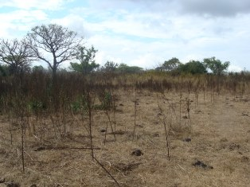

**Figure 1: View of a section of eMakheni.**

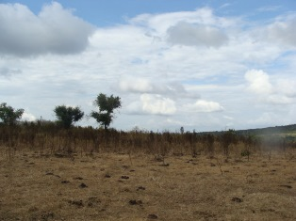

**Figure 2: Another section of the site.**

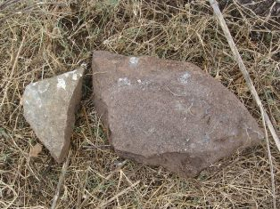

**Figure 3: Broken lower grinding stones on the site.**

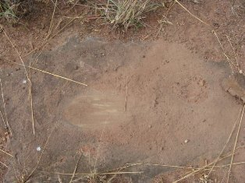

**Figure 4: Communal grinding hollows close to eMakheni.**

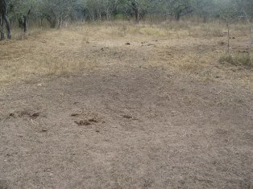

**Figure 5: A possible ash midden situated close to the site.**

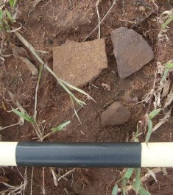

**Figure 6: Pieces of pottery identified.**

**Sites 2, 3 & 4 – Kwa Bulawayo 1 (circa 1818)**

All three these sites (or features) are apparently associated with Shaka’s first homestead (Bulawayo I) built by him around 1818.

Site 2 (ash midden): **S28 25 34.0 E31 18 12.0**

Site 3 (Main site): **S28 25 25.7 E31 18 07.3**

Site 4 (Isivivani): **S28 25 22.4 E32 18 05.4**

Site 2 is likely associated with the main kraal site, but rain and grass cover made identification and recording of cultural material difficult. Site 3 is the site associated with Shaka’s first homestead. According to Paul Smith the homestead was established by Shaka and was also known as kwa Gibixhegu (which means “drive out the old man”) in celebration of his defeat of Zwide of the Ndwandwe. According to oral tradition the uFasmimba regiment (Shaka’s first and favourite) was tasked with building his first capital. It was situated on the right bank of the Mhodi River, a tributary of the Mkumbane River at the eastern end of the eMakhosini Valley. Shaka called his first capital “kwaBulawayo” in bitter remembrance of the wrongs he suffered during his childhood (Mountain 1999: 20; Bryant 1965: 643). The Mhodi flows through the farm Koningskroon, and according to Paul Smith this is the most likely position of this site. The uFasimba regiment was also known as the abaFana basem Mhodi.

Site 3 is an ***Isivivane*** located close to Site 2, on an old footpath leading to the site. These heaps of stone are common and are usually situated alongside roads or pathways leading to places of importance. Anyone passing picked up a stone, spat on it and threw it on the heap as a sign of good luck (Smail 1979: 28).

According to Paul Smith, based on oral records, Mzilikazi (after coming into conflict with Shaka) fled from here, effectively starting the ***mfecane.*** From this point of view, as well, the site (if indeed proven to be the location of Shaka’s first capital), the site is therefore of High significance.

***Site Significance***

Based on oral and other records, as well as the positioning of the site in terms of other known sites (uMgungundlovu) in these records, it is clear that Site 1 is likely the historical and sacred eMakheni. The following can be stated regarding its significance:

High Heritage Significance in terms of (a) **Historic value**: Important in the community or pattern of history or has an association with the life or work of a person, group or organization of importance in history (b) **Scientific value**: Potential to yield information that will contribute to an understanding of natural or cultural history or is important in demonstrating a high degree of creative or technical achievement of a particular period

(c) **Social value**: Have a strong or special association with a particular community or cultural group for social, cultural or spiritual reasons.

Heritage significance: **Grade II** - Heritage resources with qualities giving it provincial or regional importance although it may form part of the national estate.

Field rating: ii. **Provincial Grade II significance** - should be managed as part of the provincial estate

The site should be mapped in more detail, and further archaeological & historical research on it be carried out. This will provide the necessary information that could potentially be utilized in the EOHP Multimedia Centre, such as displays, while the memorialization of the site should also be considered***.***

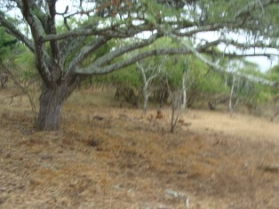

**Figure 7: View of a part of the location of kwaBulawayo.**

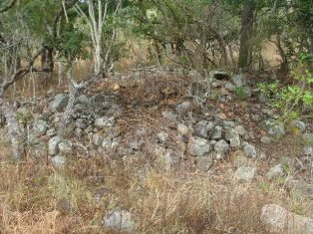

**Figure 8: Site 4 – Isivivane.**

**Site 5 – Blacksmith Site**

According to Mr.Smith this could be the site of Shaka’s regimental blacksmith, although this has not been proven. A number of well-preserved fireplaces (hearths) associated with huts, as well as an iron smelting furnace occurs on the site. Broken lower grinding stone and upper grinders also occur. Once again dense vegetation (grass cover) made visibility difficult and impeded identifying and recording cultural material and other features.

If this does indeed prove to be the location of Shaka’s blacksmith then the heritage significance would be high. It is recommended that the site be properly mapped and archaeologically investigated. The preservation of the furnace and hearths are quite good, and it is envisaged that well preserved cultural material and features would be recovered.

Site Location: **S28 26 25.5 E31 17 51.0** (furnace)

**S28 26 25.2 E31 17 51.6** (Hut)

**S28 26 22.9 E31 17 49.7** (Hut)

***Site Significance***

The following can be stated regarding its significance:

High Heritage Significance in terms of (a) **Historic value**: Important in the community or pattern of history or has an association with the life or work of a person, group or organization of importance in history (b) **Scientific value**: Potential to yield information that will contribute to an understanding of natural or cultural history or is important in demonstrating a high degree of creative or technical achievement of a particular period

(c) **Social value**: Have a strong or special association with a particular community or cultural group for social, cultural or spiritual reasons.

Heritage significance: **Grade II** - Heritage resources with qualities giving it provincial or regional importance although it may form part of the national estate.

Field rating: ii. **Provincial Grade II significance** - should be managed as part of the provincial estate

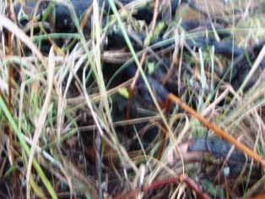

**Figure 9: View of furnace remains covered by branches for**

**protection.**

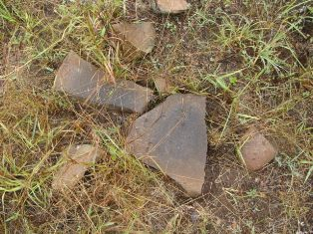

**Figure 10: Grinding stones on Site 5.**

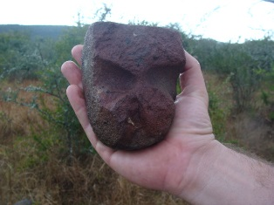

**Figure 11: Broken bored stone from the same site.**

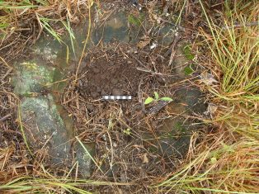

**Figure 12: One of the very well preserved hearths (*iziko*)**

**that forms part of a hut at Site 5.**

**Site 6 – Furnace remains**

This site is located in the middle of one of the dirt roads on the farm, and contains remnants of a furnace (baked clay walling), charcoal and pieces of slag. The age of the site/feature is not known, and no other features or sites were identified in the vicinity, although is it highly likely that more exist. Unfortunately the sites’ location leads to its further degradation, and excavating the feature archaeologically should be considered.

Site location: **S28 26 13 E31 18 09.0.**

Because of its state of preservation and isolated location the site is seen as of low-medium significance from a Heritage perspective.

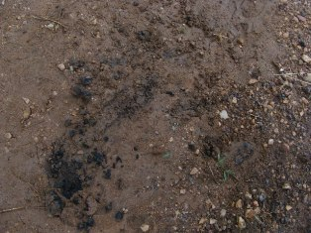

**Figure 13: Site 6 furnace remains.**

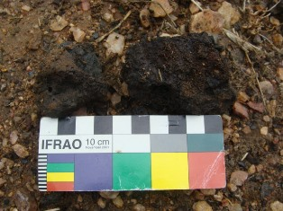

**Figure 14: Metal slag from the furnace.**

**Sites 7 – 10: Small kraals/homesteads and Khangela**

All four sites are likely associated with the site (Site 8) of Khangela (one of Dingane’s regiments’ kraals), with sites 7, 9 & 10 probably related kraals/homesteads.

According to information obtained by Paul Smith from Samuelson (n.d.) the Khangela was a regiment formed by King Jama who reigned from 1753-1781. Shaka moved this regiment to Port Natal to keep an eye on white settlers. The suburb of Congella in Durban is a misspelling of this name. In 1829 Dingane moved this regiment back to the eMakhosini Valley when he built Mgungungdlovu. According to oral legend the regiment had to keep watch on the young Zulu woman from Dinganes’ homestead that had to fetch water for him from a fountain at Mtonjaneni. From Site 8 (assumed to be the location of Khangela) both Mtonjaneni and Mgungundlovu can be seen in the distance. Khangela was also burnt down by the advancing British forces on their way to Ulundi in 1879.

Site 7 (smaller kraal): **S28 26 52.4 E31 18 51.6**

Site 8 (Khangela main site): **S28 26 42.2 E31 18 54.0**

Site 9 (smaller kraal): **S28 26 35.2 E31 18 46.1**

Site 10 (smaller kraal): **S28 26 31.4 E31 18 43.8**

All four sites are characterized by open patches of kraal deposit, with low grass growth. Some grinding stones were also identified, as well as some pieces of undecorated pottery. Another characteristic of these sites are sunken grain pits, varying in number and size on each site. The heritage significance varies between medium and high, and should this indeed be the location of Khangela the rating for it would be higher. It is recommended that the sites be mapped in detail and that some archaeological investigations be carried out on Khangela as well.

***Site Significance***

The following can be stated regarding the significance of the sites:

Medium to High Heritage Significance in terms of (a) **Historic value**: Important in the community or pattern of history or has an association with the life or work of a person, group or organization of importance in history (b) **Scientific value**: Potential to yield information that will contribute to an understanding of natural or cultural history or is important in demonstrating a high degree of creative or technical achievement of a particular period

(c) **Social value**: Have a strong or special association with a particular community or cultural group for social, cultural or spiritual reasons.

Heritage significance: **Grade III** - Other heritage resources of local importance and therefore worthy of conservation.

Field rating: **Local Grade IIIB** - should be included in the heritage register and may be mitigated (high/ medium significance).

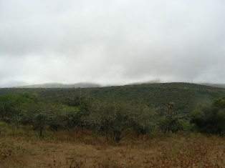

**Figure 15: Site 7.**

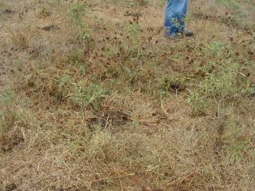

**Figure 16: One of the sunken grain pits.**

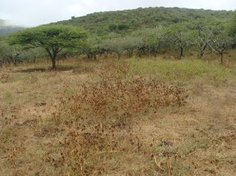

**Figure 17: View of a portion of the site of Khangela.**

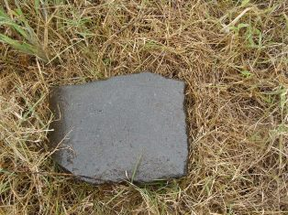

**Figure 18: A whetstone found on one of the other sites near Khangela.**

**Site 11 – Brass ring site**

This is the approximate location where Mr.Paul Smith’s father recovered two brass rings (***umDaka***) when digging trenches for water pipes many years ago. The Zulu’s did not know how to manufacture brass, but did do considerable brass work. The brass was imported/traded through Delagoabay and possibly Portuguese traders. The brass was rough and re-worked. The ***umDaka*** was a valuable commodity and could be used to buy wives (one umDaka for one wife). One umDaka was the equivalent of one head of cattle, and from these ***umNakas*** (hollow rings worn around the necks of woman of high status) were made, as well as the ***inGxotha*** arm-ring shaped like a gauntlet (Krige 1950: 218).

The location of the site close to Khangela is significant, but the area has been disturbed through farming activities over the years.

Site location: **S28 26 23.1 E31 18 41.5.**

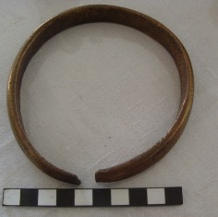

**Figure 19: One of the copper rings found at Site 11.**

**Site 12 – Chelmsford’s Camp Site**

This site is apparently the area where Chelmsford and the British forces camped on the 30th of June 1879 during their march towards Ulundi. The site is marked by a redoubt (stone wall and soil/sand embankment, and gave the camp and fortification an uninterrupted field of vision and fire. According to Paul Smith he had picked up some nails and remains of food tins here in the past, but during the field visit no cultural remains could be identified as a result of dense grass cover.

The reason why this spot was chosen for the camp is the fact that it was close to a stream that was the only watering place in the sandy bush-covered flat extending from the base of the Entonjaneni Heights to the banks of the Umfolozi (Narrative of the Field Operations Connected with the Zulu War of 1879 – 1989: 112). It was also at this camp site that a Zulu envoy from Cetshwayo approached Chelmsford with the sword of the late Prince Imperial, two elephant tusks, 100 oxen and a letter written by the Dutchman Vijn on Cetshwayo’s behalf. He sued for peace and also promised that the guns captured at Isandlawana would follow (Narrative 1989: 112). Chelmsford of course did not accept the peace offering.

Site Location: **S28 26 06.8 E31 19 03.6.**

It is recommended that the site be mapped in detail and that historical-archaeological excavations be carried out in order to retrieve as much cultural material as possible and also to determine the exact location of the camp site. It is believed that the actual campsite was located behind, some distance away, from the redoubt. Mapping will also aim at locating the refuse midden of the camp, as although they only camped here one night a force of more than 5000 men was camped here.

***Site Significance***

The following can be stated regarding the significance of the site:

Medium to High Heritage Significance in terms of (a) **Historic value**: Important in the community or pattern of history or has an association with the life or work of a person, group or organization of importance in history (b) **Scientific value**: Potential to yield information that will contribute to an understanding of natural or cultural history or is important in demonstrating a high degree of creative or technical achievement of a particular period

(c) Social value: Have a strong or special association with a particular community or cultural group for social, cultural or spiritual reasons.

Heritage significance: **Grade III -** Other heritage resources of local importance and therefore worthy of conservation.

Field rating: **Local Grade IIIB** - should be included in the heritage register and may be mitigated (high/ medium significance).

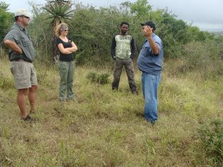

**Figure 20: Survey team at Site 12 standing on the redoubt.**

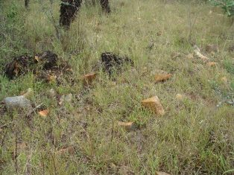

**Figure 21: Part of the redoubt wall.**

**Site 13 – Fort Victoria**

Fort Victoria was built on the 9th of August 1879 by the 58th Regiment (Lt Col Clark’s Column), whose headquarters and companies remained here until the 26th of August 1879 when the garrison was reduced to one company (Narrative 1989: 127; Laband & Thompson 1983: 93). A map drawing of the Fort also exists (Laband & Thompson 1983: 98).

The Fort is fairly well preserved, with its stone waling and earthen embankment clearly visible. A possible gun emplacement was also identified. There is also a single grave (unmarked headstone) located close by. According to Paul Smith this grave might belong to an unknown soldier who died here as a result of wounds or disease.

Site location: S28 25 55.7 E31 19 03.6 (Fort)

S28 25 53.8 E31 19 02.9 (Grave)

The site should be re-mapped and historical-archaeological excavations be undertaken.

**Site Significance**

The following can be stated regarding the significance of the site:

Medium to High Heritage Significance in terms of (a) **Historic value**: Important in the community or pattern of history or has an association with the life or work of a person, group or organization of importance in history (b) **Scientific value**: Potential to yield information that will contribute to an understanding of natural or cultural history or is important in demonstrating a high degree of creative or technical achievement of a particular period

(c) **Social value**: Have a strong or special association with a particular community or cultural group for social, cultural or spiritual reasons.

Heritage significance: **Grade III** - Other heritage resources of local importance and therefore worthy of conservation.

Field rating: **Local Grade IIIB** - should be included in the heritage register and may be mitigated (high/ medium significance).

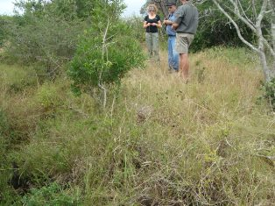

**Figure 22: Survey team on top of Fort Victoria’s earthen and stone**

**Embankment.**

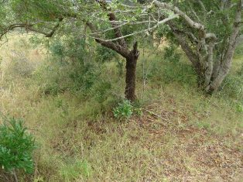

**Figure 23: Another view of one of the Forts’ walls.**

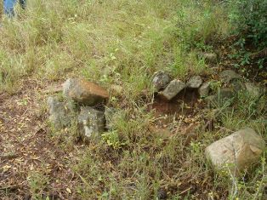

**Figure 24: One side of the entrance to the Fort.**

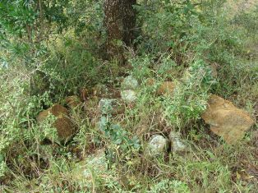

**Figure 25: Possible gun platform.**

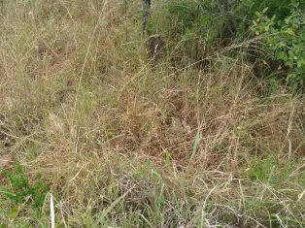

**Figure 26: Stone packed grave. The headstone is visible.**

**Dense grass cover the graves.**

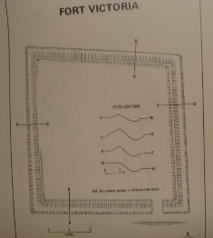

**Figure 27: Map of Fort Victoria**

**(Laband & Thompson 1983:98)**

**Site 14 - Dukuza**

This site is located on the farm Moordplaats 193, and fairly close to Mgungundlovu. A number of hut floors and fireplaces, as well as kraal deposit are visible at the site. After the death of Shaka on the 24th of September 1828, Dingane became king of the Zulu nation. According to Paul Smith he moved back to the eMakhosini Valley in 1829 and temporarily located his capital to kwaNobamba (ancestral home of King Jama kaNdaba) while building Mgungundlovu. To the west of Mgungundlovu, on the banks of the Nzololo stream, he constructed a spiritual home for Shaka known as **Dukuza or uMuzi weDlozi**.

It is assumed that this is the site of Shaka’s spiritual home, and if indeed it proves to be would be from a Cultural Heritage point of view a very significant site. During the survey 3 hut floors and hearths were recorded, although it was indicated that there are at least 6 (James van Vuuren: Pers.Comm: March 2013). The site should be mapped in detail, archaeological excavations conducted here to obtain as much information as possible on its age and function and it should also be memorialized.

Site location: S28 26 39.7 E31 15 45.9

S28 26 39.9 E31 15 45.2 (Hut)

S28 26 39.5 E31 15 46.2 (Hut)

S28 26 33.2 E31 15 43.4 (Hut)

***Site Significance***

The following can be stated regarding its significance:

High Heritage Significance in terms of (a) **Historic value**: Important in the community or pattern of history or has an association with the life or work of a person, group or organization of importance in history (b) **Scientific value**: Potential to yield information that will contribute to an understanding of natural or cultural history or is important in demonstrating a high degree of creative or technical achievement of a particular period

(c) **Social value**: Have a strong or special association with a particular community or cultural group for social, cultural or spiritual reasons.

Heritage significance: **Grade II** - Heritage resources with qualities giving it provincial or regional importance although it may form part of the national estate.

Field rating: ii. **Provincial Grade II significance** - should be managed as part of the provincial estate.

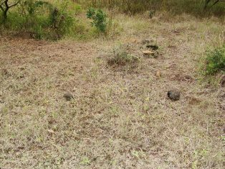

**Figure 28: View of a section of Dukuza (Site 14).**

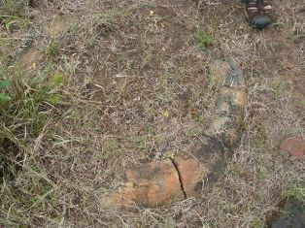

**Figure 29: One of the hearths/hut floors on Site 14.**

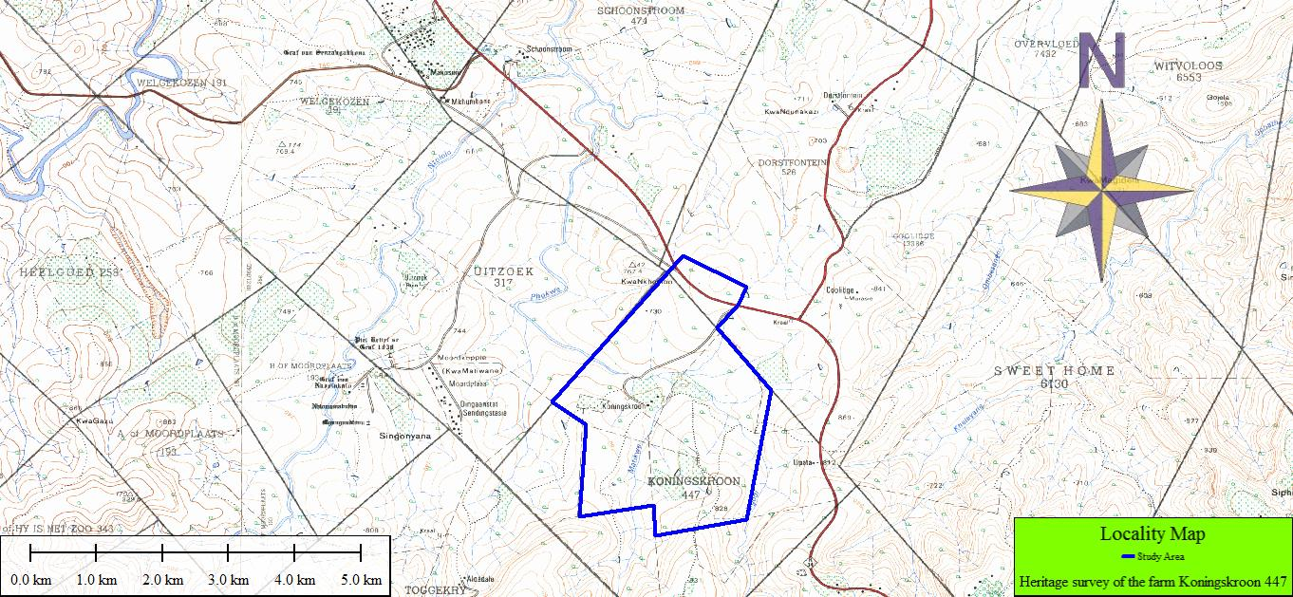

**Figure 30: Location map.**

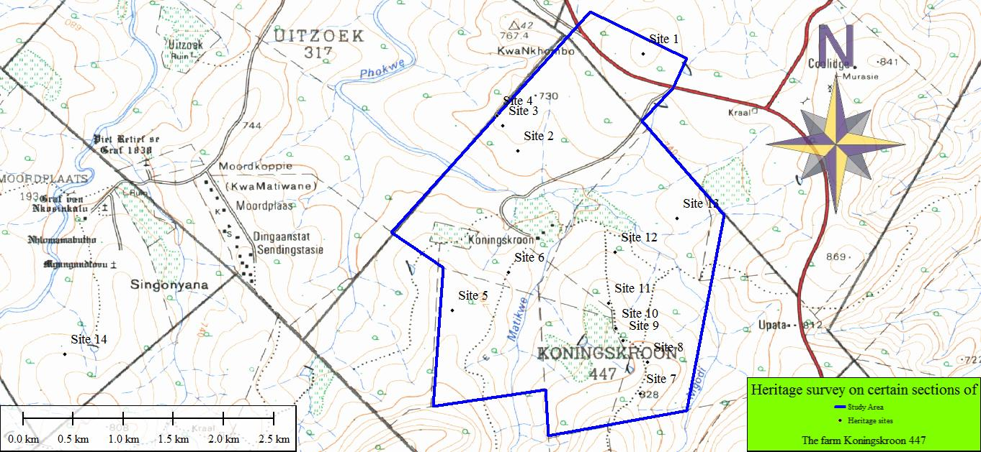

**Figure 31: Site distribution map.**

**CONCLUSIONS AND RECOMMENDATIONS**

In conclusion it can be said that the field assessment on sections of the farm Koningskroon 447 for the EOHP Phase 1 Heritage Survey was completed successfully. Some sites on Dorstfontein 526 and Moordplaats 193 were also assessed. Many of the sites were known to and researched by the owner, Mr.Paul Smith, who indicated them to the survey team and provided relevant information. During the survey rain weather hampered the work, while dense vegetation and grass cover made recording and identifying sites, features and cultural material difficult. The aims of the survey were to record all possible sites on the farm, assess their significance and to produce a site distribution map. Finally, recommendations on the way forward in terms of these sites’ conservation, utilization and possible archaeological excavations were also to be made.

Fourteen sites in total were identified and recorded, dating from early Shakan times up to the late 19th century. Some sites could possibly date to the early Iron Age. The sites include ritual/sacred sites, capital settlements, regimental kraals, military sites and graves. Many of the sites carry a High Cultural Heritage Significance, and should be declared Provincial Heritage Sites at least, although some might even be regarded as part of the National Estate.

The following is recommended:

1. that all the Highly significant sites identified during the survey be mapped in detail, archaeologically and historically investigated and be preserved for future generations

2. that sites such as eMakheni, Bulawayo 1, Khangela, Fort Victoria and Dukuza be Memorialised

3. that a detailed Heritage Survey of other farms in the area, as well as in EOHP, be undertaken

4. that a Cultural Heritage Management Plan for Koningskroon and other farms be drafted and implemented as a matter of urgency

**REFERENCES**

Study area location and Site Distribution map (Produced by Jaco van der Walt: Heritage & Archaeological Contracts)

Binns, C.T. 1963. **The Last Zulu King: The Life and Death of Cetshwayo**. Longman’s Southern Africa (Pty) Ltd. Cape Town.

Bourquin, S. (ed.). 1986. **Paulina Dlamini: Servant of two Kings**. Killy Campbell Africana Library: Durban & University of Natal Press. Pietermaritzburg.

Bryant, A.T. 1965. **Olden Times in Zululand and Natal: Containing Earlier Political History of the Eastern Nguni Clans**. C. Struik. Cape Town.

Krige, Eileen Jensen. 1950. **The Social System of the Zulus**. Shuter & Shooter. Pietermaritzburg.

Laband, John. 1995. **Rope of Sand: The Rise and Fall of the Zulu Kingdom in the Nineteenth Century**. Jonathan Ball Publishers. Johannesburg.

Laband, J.P.C & P.S. Thompson. 1983. **Field Guide to the War in Zululand and the defence of Natal in 1879**. University of Natal Press. Pietermaritzburg.

Lugg, H.C. 1949. **Historic Natal & Zululand**. Shuter & Shooter. Pietermaritzburg.

Mountain, Allan. 1999. **The Rise and Fall of the Zulu Empire**. kwaNtaba Publications. Constantia.

**Narrative of the Field Operations Connected with the Zulu War of 1879: Prepared in the Intelligence Branch of the War Office**. Edited by Lionel Leventhal in 1989. Published Greenhill Books Lionel Leventhal Limited.

Smail, J.L. 1979. **From the land of the Zulu Kings**. A.J. Pope. Durban.

**ACKNOWLEDGEMENTS**

I would like to acknowledge to following institutions and individuals for their assistance and support:

1. Amafa aKwaZulu-Natali, for providing us with this opportunity to be of service to the Provincial Heritage Authority

2. Mr.Paul Smith, owner of Koningskroon, for assisting us in recording and assessing the sites on his property. Also for all the information provided and his interest in and passion for preserving these sites for posterity

3. Me. Annie Radford of Amafa for all her help and assistance, as well as Mr. Siya Mbatha of Amafa for his help during the survey,

5. And finally, Jaco van der Walt, for his assistance during the fieldwork and for producing the Location & Site Distribution Maps