RECOMMENDED EXEMPTION FROM FURTHER PALAEONTOLOGICAL STUDIES:

Proposed iNca Gouda wind energy facility, Gouda, Malmesbury Magisterial District, Western Cape

John E. Almond PhD (Cantab.)
Natura Viva cc,
PO Box 12410 Mill Street,

Cape Town 8010, RSA
naturaviva@universe.co.za

November 2011

1. OUTLINE OF DEVELOPMENT

The company iNca Gouda Wind (Pty) Ltd is proposing to construct a wind energy facility to generate approximately 30 Megawatts (MW) on Portion 1 of Farm No. 397 and Portion 2 of Farm No. 397, Gouda. The study area is about 860 ha in area and is situated approximately one kilometre north-west of Gouda in the Western Cape (Figs. 1 & 2). Associated infrastructure would include access roads between the turbines and two new 66kV overhead powerlines to connect the wind farm to the Eskom grid at the Gouda Substation.

Specialist comment on the potential impact of the proposed development on palaeontological heritage has been commissioned on behalf of the client by Aurecon, Aurecon Centre, 1 Century City Drive, Waterford Precinct, Century City I South Africa (Contact: Ms Nicole Petersen).

2. GEOLOGICAL BACKGROUND

The development site comprises fairly flat-lying agricultural land at c. 70-80m amsl on the western side of the R44 tar road, between the Berg River and the Klein Berg River. Satellite images show that the level of bedrock outcrop here is very low (Fig. 2).

The geology of the study area is shown on 1: 250 000 sheet 3319 Worcester (Fig. 3). It is entirely underlain by subunits of the Late Precambrian Malmesbury Group, namely the Noree Formation (Nn) and the Porterville Formation (Npo). Brief descriptions of these Malmesbury Group rocks are given by Gresse and Theron (1992), Gresse et al. (2006) and Almond (2010). It should be noted that the lithostratigraphic subdivision of the Malmesbury Group sensu lato has recently been revised, with the recognition of a separate highly deformed Swartland Group (Early Ediacaran) that is unconformably overlain by a younger, less deformed Malmesbury Group sensu stricto (Late Ediacaran; Belcher & Kisters 2003, Buggisch et al. 2010, Rowe et al. 2010).

The Malmesbury Group sensu lato comprises a wide range of near-coastal marine, shallow shelf and submarine fan sediments of Late Precambrian age that crop out on the coastal plain and in the Tulbagh Valley. Due to the recessive weathering of most Malmesbury Group rocks, the topographically subdued, gently hilly coastal plain features very few natural exposures of fresh bedrock. These rocks display evidence of extensive deformation, including intense folding, faulting, quartz veining and cleavage development, as well as regional metamorphism during the Late Proterozoic to Cambrian Saldanian Orogeny (mountain-building event). The more pelitic (clay-rich) Malmesbury rocks have in addition suffered extensive chemical weathering under humid tropical conditions during Cretaceous and Tertiary times so that fresh bedrock is almost universally covered with a deep mantle of multi-hued, kaolinitic and ochreous saprolite (in situ weathered rock) and surface gravels (sometimes silcretized) (Almond 2010). In the present study area between the Berg and Klein Berg Rivers, it is likely that Quaternary to Recent alluvial deposits are also present locally above Malmesbury Group bedrocks.

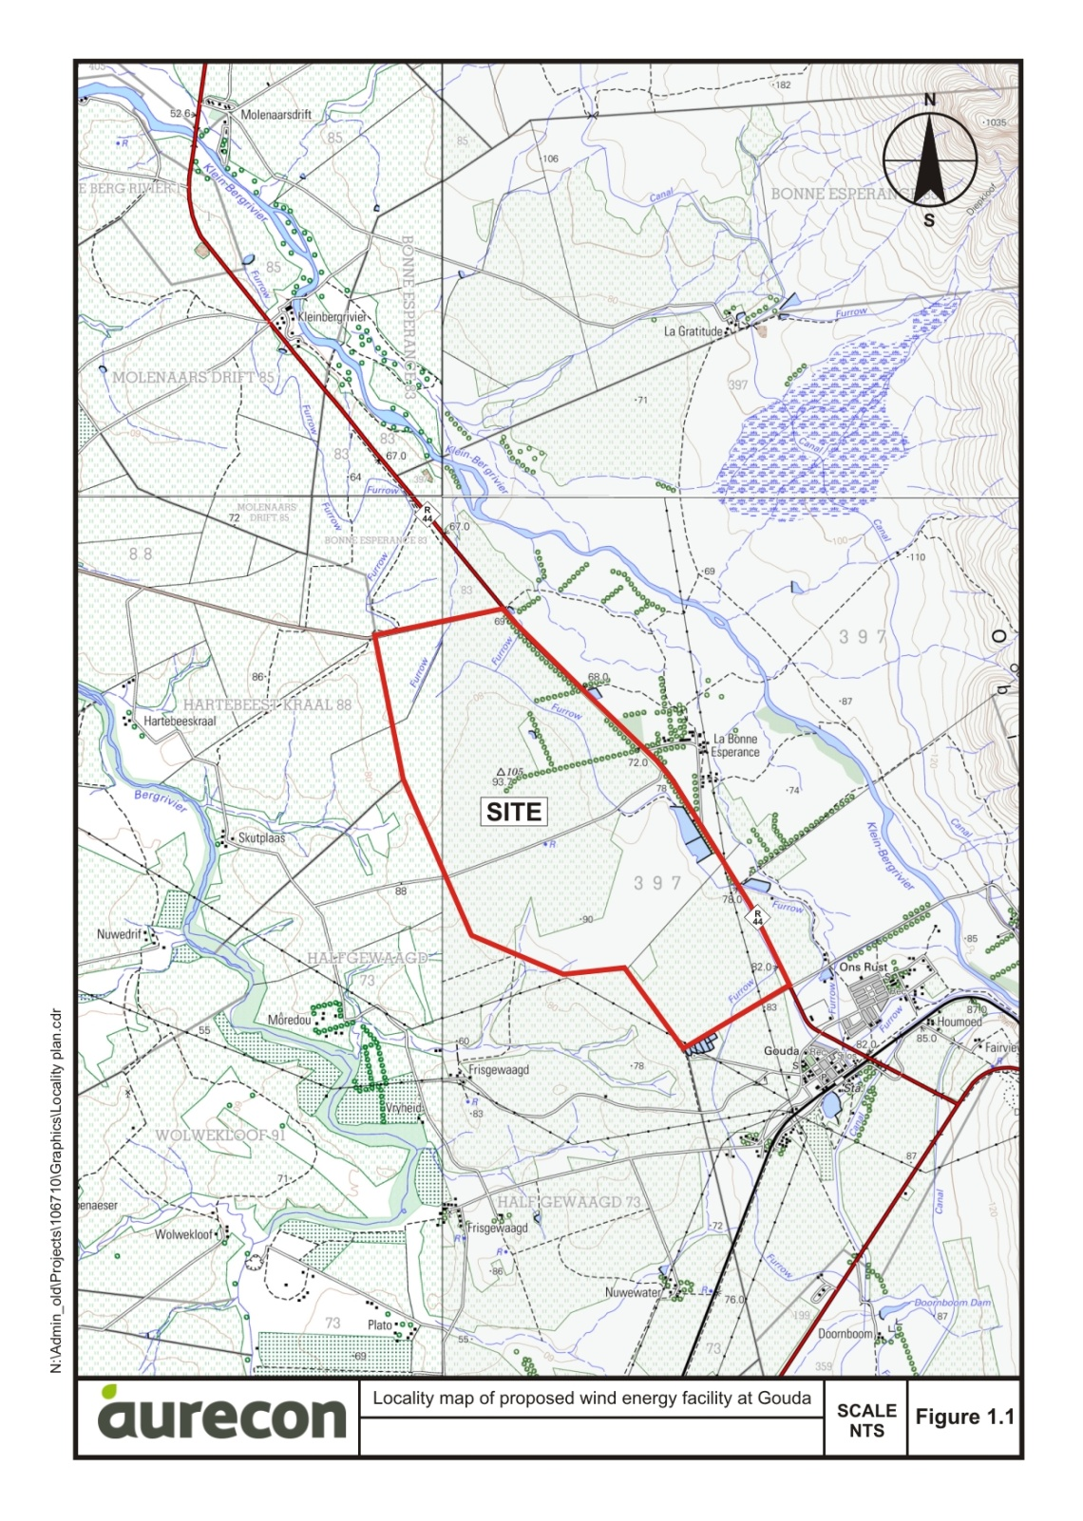
Fig. 1. Location (red polygon) of the proposed iNca Gouda wind energy facility about one kilometer north-west of the town of Gouda, Western Cape (Image kindly supplied by Aurecon).

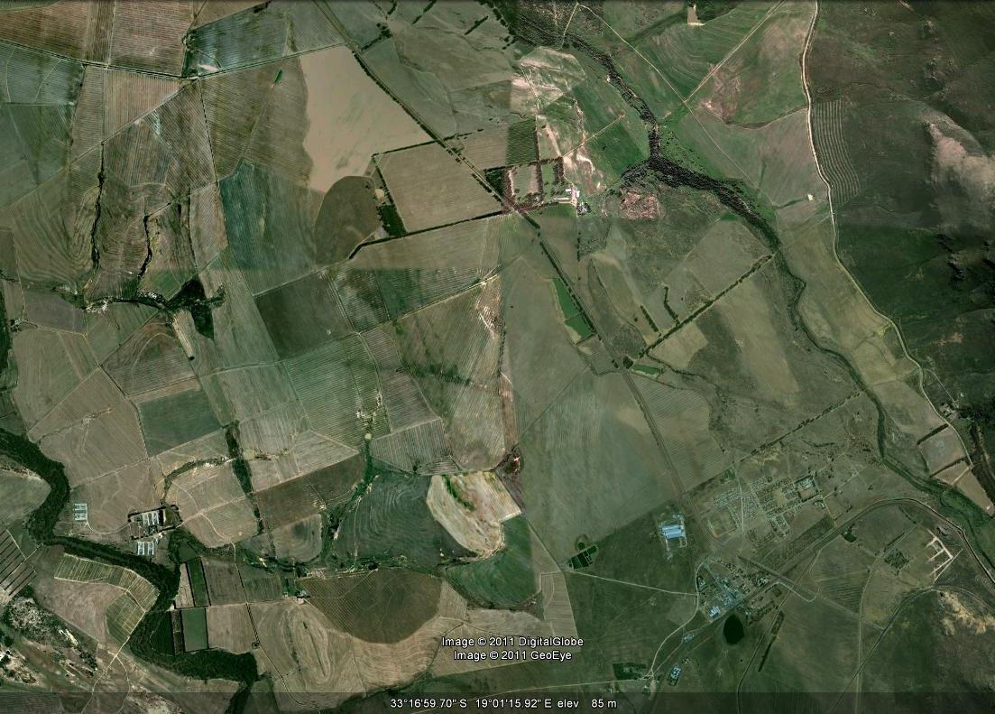
Gouda

Fig. 2. Google Earth© satellite image of the study area on the north-western outskirts of Gouda, Western Cape. The Berg River runs to the west and the Klein Berg River to the east.

3. PALAEONTOLOGICAL HERITAGE

Recent research shows that these rocks are actually of Late Proterozoic (Ediacaran) age and are therefore potentially fossiliferous (Belcher & Kisters 2003, Gresse et al. 2006, Almond 2008). Groups of fossils that may have originally been preserved within siliciclastic or minor carbonate sediments here include trace fossils, stromatolites, organic-walled microfossils (e.g. acritarchs) as well as the enigmatic vendobiontans. Intense tectonic deformation, regional metamorphism and subsequent, post-Gondwana deep chemical weathering have probably obliterated most or all organic remains here, however, with the possible exception of microfossils. Micropalaeontological analysis of these difficult rocks is now in progress (G. Germs, pers. comm. 2008).

The overall palaeontological sensitivity of the Malmesbury Group rocks and overlying superficial sediments (alluvium etc) is very low.

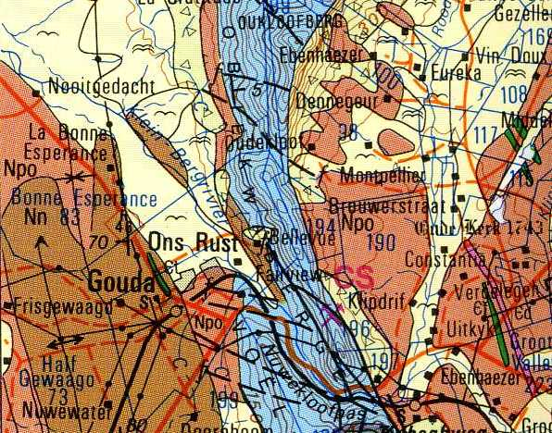

Fig. 3. Extract from 1: 250 000 geological map 3319 Worcester (Council for Geoscience, Pretoria) showing approximate location of the wind farm study area north-west of Gouda (yellow rectangle). Geological units represented in this area are the Noree Formation (Nn, brown) and the Porterville Formation (Npo, tan) of the Malmesbury Group as well as river alluvium (pale yellow with “flying bird” symbol).

4. CONCLUSIONS & RECOMMENDATIONS

The construction of the proposed iNca Gouda wind farm is not considered to pose a serious threat to local fossil heritage because the Malmesbury Group bedrocks and overlying mantle of Late Caenozoic superficial sediments (alluvium, soils etc) are of very low palaeontological sensitivity.

It is therefore recommended that exemption from further specialist palaeontological studies and mitigation be granted for this alternative energy development.

Should any substantial fossil remains (e.g. stromatolites, trace fossils, shells) be encountered during excavation, however, these should be reported to Heritage Western Cape for possible mitigation by a professional palaeontologist.

5. REFERENCES

ALMOND, J.E. 2010. Eskom Gamma-Omega 765kV transmission line: Phase 2 palaeontological impact assessment. Sector 2, Omega Substation to Kappa Substation (Western Cape Province). 100pp. Natura Viva cc, Cape Town.

ALMOND, J.E. & PETHER, J. 2008. Palaeontological heritage of the Western Cape. Interim SAHRA technical report, 124 pp. Natura Viva cc., Cape Town.

BELCHER, R.W. & KISTERS, A.F.M. 2003. Lithostratigraphic correlations in the western branch of the Pan-African Saldania Belt, South Africa: the Malmesbury Group revisited. South African Journal of Geology 106: 327-342.

BUGGISCH, W., KLEINSCHMIDT, G. & KRUMM, S. 2010. Sedimentology, geochemistry and tectonic setting of the Neoproterozoic Malmesbury Group (Tygerberg Terrane) and its relation to neighbouring terranes, Saldania Fold Belt, South Africa. Neues Jahrbuch für Geologie und Paläontologie – Abhandlungen 257, 85-114.

GRESSE, P.G. & THERON, J.N. 1992. The geology of the Worcester area. Explanation of geological Sheet 3319. 79 pp, tables. Council for Geoscience, Pretoria.

GRESSE, P.G., VON VEH, M.W. & FRIMMEL, H.E. 2006. Namibian (Neoproterozoic) to Early Cambrian successions. In: Johnson, M.R., Anhaeusser, C.R. & Thomas, R.J. (Eds.) The geology of South Africa, pp. 395-420. Geological Society of South Africa, Marshalltown.

ROWE, C.D., BACKEBERG, N.R., VAN RENSBURG, T., MACLENNAN, S.A., FABER, C., CURTIS, C. & VIGLIETTI, P.A. 2010. Structural geology of Robben Island: implications for the tectonic environment of Saldanian deformation. South African Journal of Geology 113, 57-72.

6. QUALIFICATIONS & EXPERIENCE OF THE AUTHOR

Dr John Almond has an Honours Degree in Natural Sciences (Zoology) as well as a PhD in Palaeontology from the University of Cambridge, UK. He has been awarded post-doctoral research fellowships at Cambridge University and in Germany, and has carried out palaeontological research in Europe, North America, the Middle East as well as North and South Africa. For eight years he was a scientific officer (palaeontologist) for the Geological Survey / Council for Geoscience in the RSA. His current palaeontological research focuses on fossil record of the Precambrian - Cambrian boundary and the Cape Supergroup of South Africa. He has recently written palaeontological reviews for several 1: 250 000 geological maps published by the Council for Geoscience and has contributed educational material on fossils and evolution for new school textbooks in the RSA.

Since 2002 Dr Almond has also carried out palaeontological impact assessments for developments and conservation areas in the Western, Eastern and Northern Cape under the aegis of his Cape Town-based company Natura Viva cc. He is a long-standing member of the Archaeology, Palaeontology and Meteorites Committee for Heritage Western Cape (HWC) and an advisor on palaeontological conservation and management issues for the Palaeontological Society of South Africa (PSSA), HWC and SAHRA. He is currently compiling technical reports on the provincial palaeontological heritage of Western, Northern and Eastern Cape as well as Limpopo, Free State and Gauteng for SAHRA and HWC. Dr Almond is an accredited member of PSSA and APHAP (Association of Professional Heritage Assessment Practitioners – Western Cape).

Declaration of Independence

I, John E. Almond, declare that I am an independent consultant and have no business, financial, personal or other interest in the proposed project, application or appeal in respect of which I was appointed other than fair remuneration for work performed in connection with the activity, application or appeal. There are no circumstances that compromise the objectivity of my performing such work.


Dr John E. Almond
Palaeontologist
Natura Viva cc

