SITE VISIT REPORT: MAPUNGUBWE HERITAGE COLLECTION
Prepared By: Nkosazana Queenie Machete {nmachete@sahra.org.za}
HERITAGE PROTECTION UNIT
APP Indicator Number: 2.1
DATE: 15 APRIL 2019

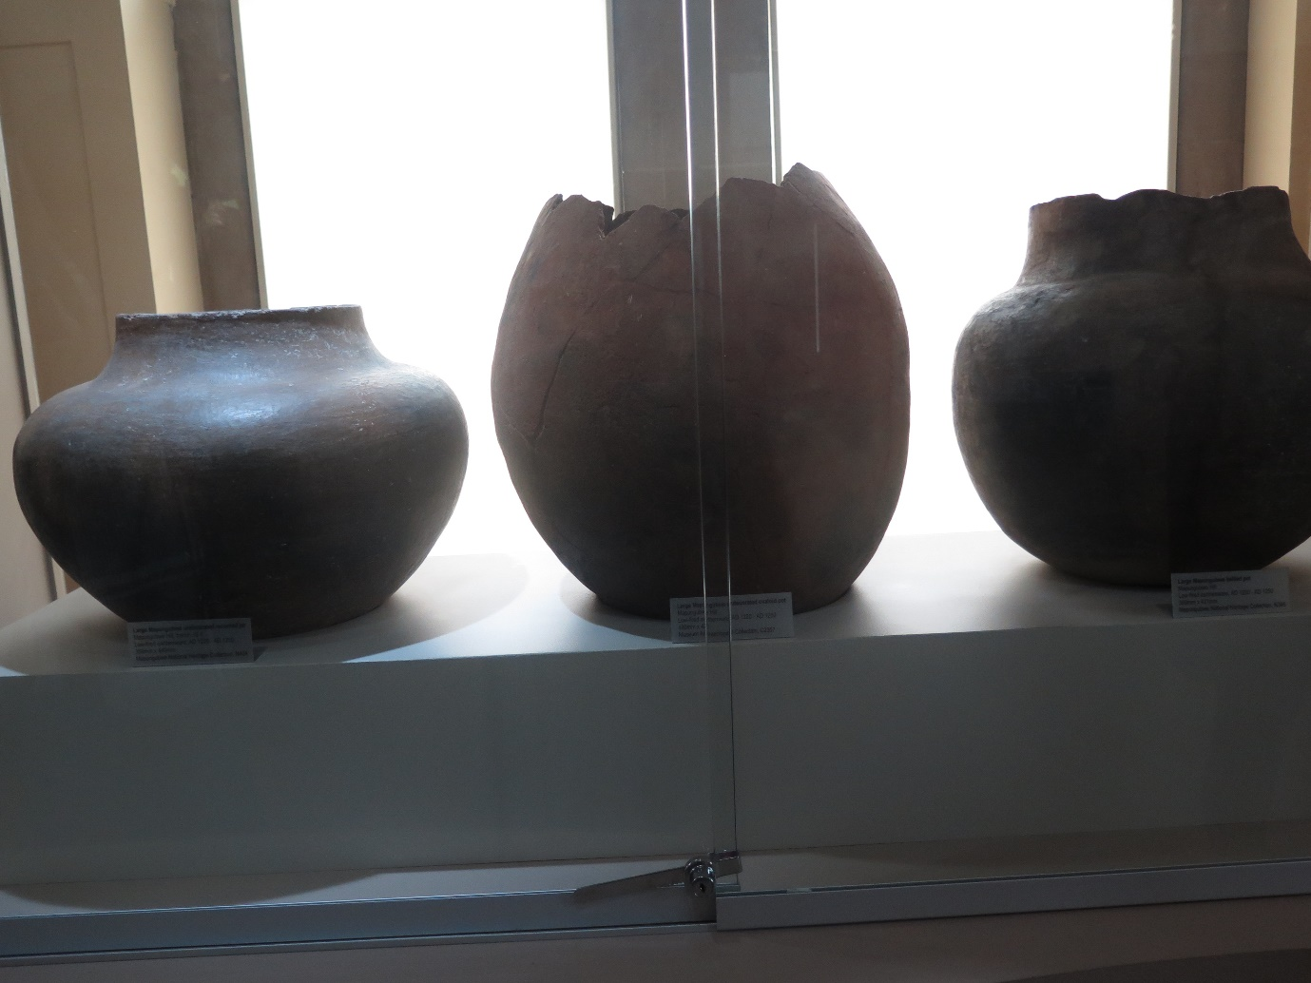

Introduction
Section 5 (1)(a) of the National Heritage Resources Act 25 of 1999 (NHRA) states that “Heritage resources have lasting value in their own right and provide evidence of the origins of the South African society and as they are valuable, finite, non-renewable and irreplaceable they must be carefully managed to ensure their survival”.
On the 11th of April 2019, South African Heritage Resources Agency (SAHRA) Heritage Protection Unit conducted an inspection at the University of Pretoria Mapungubwe Museum.

Locality and Description of the Building
The Mapungubwe museum is located at the University of Pretoria- the Old Arts Building. However, upon inspection, the gold collection was stored at the storage place and not at the museum. The Mapungubwe collection is to be exhibited at the new Javelin Arts Museum.
- Significance of the objects
The ancient city of Mapungubwe (meaning 'hill of the jackal') is an Iron Age archaeological site in the Limpopo Province on the border between South Africa, Zimbabwe and Botswana, 75 km from Messina. The civilization thrived as a sophisticated trading center from around 1200 to 1300 AD, trading gold and ivory with China, India and Egypt. On the hill they noticed stone walls and on closer inspection, they recovered gold and iron artefacts, pottery and glass beads.
The gold findings are also evidence of early gold smelting. A large amount of artefacts from the royal family were discovered at Mapungubwe. The best known of these objects is the golden rhinoceros. All in all, the amount of gold from this burial amounted to 7 503 ounces.
Management of the farm was taken over by the provincial Department of Nature Conservation in 1992 and control was transferred to SANParks in 1999. Mapungubwe was declared a World Heritage Site by the United Nations Educational, Scientific and Cultural Organisation (UNESCO) in July 2003.

Object and Building Assessment
The museum collection is protected as an official repository of heritage objects complying with national and international museum policy and professional standards of the South African Museums Association and the International Council of Museums. The Mapungubwe collection, both on exhibition and in storage, comprises mainly original archaeological objects or artefacts made available for exhibition, conservation and research purposes.
The collection consists of: metal objects and fragments of gold, copper and iron, ivory, bone tools, animal bones, trade glass beads, marine and terrestrial shells, organic materials such as fragile fibres, seeds, charred sorghum and millet, clay figurines, a few dinosaur fossil remains, Chinese celadon fragments, low-fired ceramics and thousands upon thousands of potsherds and animal bone fragments.
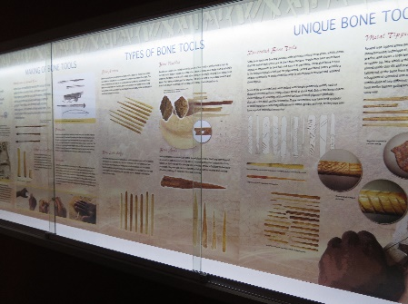
Figure 1: Bone/ Lerapo Exhibition
The objects were not displayed, however put in storage for safe keeping until they are to be moved to the new Javett Art Museum.
The collection is however stored in a cool temperature; set to ensure that the objects are properly conserved and not damaged.
The building is secured with one security guard, CCTV’S and the keys are only accessed by the museum manager and museum assistant.
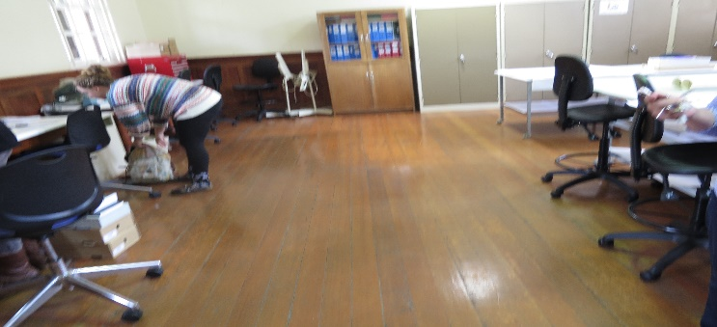
Figure 2: Research Facility

Status of the objects
The objects are in a good condition. However, some clay pots have been cracked.
Conclusion
It is imperative that the heritage collection be monitored regularly to ensure that they are well conserved and that none of the objects are missing.
Manager: Nkosazana Machete Executive Officer: Mamakomoreng Nkhasi

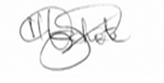
------------------------ -----------------------------
Date: 19 April 2019 Date:

