**PHASE ONE HERITAGE IMPACT ASSESSMENT OF THE PROPOSED ESTABLISHMENT OF EIGHT (8) POULTRY HOUSES ON ‘WATERVAL 1’ LOCATED ON PORTION 7 OF WATERVAL NO. 987, THREE (3) POULTRY HOUSES ON ‘WATERVAL 2’ LOCATED ON PORTION 3 OF WATERVAL NO. 987 AND SIX (6) POULTRY HOUSES ON ‘WARTBURG’ LOCATED ON PORTION 164 OF HINDERBURG NO. 1963, WARTBURG, KWAZULU-NATAL.**



ACTIVE HERITAGE cc.

For: Green Door Environmental

Frans Prins

MA (Archaeology)

**P.O. Box 947**

**Howick**

**3290**

[**feprins@gmail.com**](mailto:feprins@gmail.com)

[**activeheritage@gmail.com**](mailto:activeheritage@gmail.com)

[**www.activeheritage.webs.com**](http://www.activeheritage.webs.com) **20 May 2018**

**Fax: 086 7636380**

**Details and experience of independent Heritage Impact Assessment Consultant**

Consultant: Frans Prins (Active Heritage cc)

Contact person: Frans Prins

Physical address: 33 Buchanan Street, Howick, 3290

Postal address: P O Box 947, Howick, 3290

Telephone: +27 033 3307729

Mobile: +27 0834739657

Fax: 0867636380

Email: Activeheritage@gmail.com

PhD candidate (Anthropology) University of KwaZulu-Natal

MA (Archaeology) University of Stellenbosch 1991

Hons (Archaeology) University of Stellenbosch 1989

University of KwaZulu-Natal, Honorary Lecturer (School of Anthropology, Gender and Historical Studies).

Association of Southern African Professional Archaeologists member

Frans received his MA (Archaeology) from the University of Stellenbosch and is presently a PhD candidate on social anthropology at Rhodes University. His PhD research topic deals with indigenous San perceptions and interactions with the rock art heritage of the Drakensberg.

Frans was employed as a junior research associate at the then University of Transkei, Botany Department in 1988-1990. Although attached to a Botany Department he conducted a palaeoecological study on the Iron Age of northern Transkei - this study formed the basis for his MA thesis in Archaeology. Frans left the University of Transkei to accept a junior lecturing position at the University of Stellenbosch in 1990. He taught mostly undergraduate courses on World Archaeology and research methodology during this period.

From 1991 – 2001 Frans was appointed as the head of the department of Historical Anthropology at the Natal Museum, Pietermaritzburg. His tasks included academic research and publication, display conceptualization, and curating the African ethnology collections of the Museum. He developed various displays at the Natal Museum on topics ranging from Zulu material culture, traditional healing, and indigenous classificatory systems. During this period Frans also developed a close association with the Departments of Fine Art, Psychology, and Cultural and Media Studies at the then University of Natal. He assisted many post-graduate students with projects relating to the cultural heritage of South Africa. He also taught post-graduate courses on qualitative research methodology to honours students at the Psychology Department, University of Natal. During this period he served on the editorial boards of the *South African Journal of Field Archaeology* and *Natalia*.

Frans left the Natal Museum in 2001 when approached by a Swiss funding agency to assist an international NGO (Working Group for Indigenous Minorities) with the conceptualization of a San or Bushman museum near Cape Town. During this period he consulted extensively with various San groupings in South Africa, Namibia and Botswana. During this period he also made major research and conceptual contributions to the Kamberg and Didima Rock Art Centres in the Ukhahlamba Drakensberg World Heritage Site.

Between 2003 and 2007 Frans was employed as the Cultural Resource Specialist for the Maloti Drakensberg Transfrontier Project – a bilateral conservation project funded through the World Bank. This project involved the facilitation with various stakeholders in order to produce a cultural heritage conservation and development strategy for the adjacent parts of Lesotho and South Africa. Frans was the facilitator for numerous heritage surveys and assessments during this project. This vast area included more than 2000 heritage sites. Many of these sites had to be assessed and heritage management plans designed for them. He had a major input in the drafting of the new Cultural Resource Management Plan for the Ukahlamba Drakensberg World Heritage site in 2007/2008. A highpoint of his career was the inclusion of Drakensberg San indigenous knowledge systems, with San collaboration, into the management plans of various rock art sites in this world heritage site. He also liaised with the tourism specialist with the drafting of a tourism business plan for the area.

During April 2008 Frans accepted employment at the environmental agency called Strategic Environmental Focus (SEF). His main task was to set-up and run the cultural heritage unit of this national company. During this period he also became an accredited heritage impact assessor and he is rated by both Amafa and the South African Heritage Resources Agency (SAHRA). He completed almost 50 heritage impact assessment reports nation-wide during an 18th month period.

Frans left SEF and started his own heritage consultancy called “Active Heritage cc” in July 2009. Although mostly active along the eastern seaboard his clients also include international companies such as Royal Dutch Shell through Golder Associates, and UNESCO. He has now completed almost 1000 heritage conservation and management reports for various clients since the inception of “Active Heritage cc”. Amongst these was a heritage study of the controversial fracking gas exploration of the Karoo Basin and various proposed mining developments in South Africa and proposed developments adjacent to various World Heritage sites. Apart from heritage impact assessments (HIA’s) Frans also assist the National Heritage Council (NHC) through Haley Sharpe Southern Africa’, with heritage site data capturing and analysis for the proposed National Liberation Route World Heritage Site and the national intangible heritage audit. In addition, he is has done background research and conceptualization of the proposed Dinosaur Interpretative Centre at Golden Gate National Park and the proposed Khoi and San Interpretive Centre at Camdeboo, Eastern Cape Province. During 2009 he also produced the first draft dossier for the nomination of the Sehlabathebe National Park, Lesotho as a UNESCO inscribed World Heritage Site.

Frans was appointed as temporary lecturer in the department of Heritage and Tourism, UKZN in 2011. He is also a research affiliate at the School of Cultural and Media Studies in the same institution.

Frans’s research interests include African Iron Age, paleoecology, rock art research, San ethnography, traditional healers in South Africa, and heritage conservation. Frans has produced more than fourty publications on these topics in both popular and academic publications. He is frequently approached by local and international video and film productions in order to assist with research and conceptualization for programmes on African heritage and culture. He has also acted as presenter and specialist for local and international film productions on the rock art of southern Africa. Frans has a wide experience in the fields of museum and interpretive centre display and made a significant contribution to the conceptual planning of displays at the Natal Museum, Golden Horse Casino, Didima Rock Art Centre and !Khwa tu San Heritage Centre. Frans is also the co-founder and active member of “African Antiqua” a small tour company who conducts archaeological and cultural tours world-wide. He is a Thetha accredited cultural tour guide and he has conducted more than 50 tours to heritage sites since 1992.

**Declaration of Consultants independence**

Frans Prins is an independent consultant to Green Door Environmental and has no business, financial, personal or other interest in the activity, application or appeal in respect of which he was appointed other than fair renumeration for work performed in connection with the activity, application or appeal. There are no circumstances whatsoever that compromise the objectivity of this specialist performing such work.



**Frans Prins**

**TABLE OF CONTENTS**

1 BACKGROUND INFORMATION ON THE PROJECT 2

2 BACKGROUND TO ARCHAEOLOGICAL HISTORY OF AREA 3

2.1 Archaeology 3

3 BACKGROUND INFORMATION OF THE SURVEY 5

3.1 Methodology 5

3.1.1 Guidance from Desktop Study 6

3.2 Restrictions encountered during the survey 7

3.2.1 Visibility 7

3.2.2 Disturbance 7

3.3 Details of equipment used in the survey 7

4 Description of sites and material observed 8

4.1 Locational data 8

4.2 Description of the general area surveyed 8

4.2.1 Backgound 8

4.2.2 Desktop Paleontology Assessment 8

5 STATEMENT OF SIGNIFICANCE (HERITAGE VALUE) 8

5.1 Field Rating 8

6 RECOMMENDATIONS 11

7 MAPs and FIGURES 12

8 REFERENCES 17

**LIST OF TABLES**

Table 1. Background information………………………………………………………….2

Table 2. Field rating and recommended grading of sites (SAHRA 2005) ………….….9

Table 3. Evaluation and statement of significance……………………………………..10

**LIST OF ABBREVIATIONS AND ACRONYMS**

|  |  |
| --- | --- |
| EIA | Early Iron Age |
| ESA | Early Stone Age |
| HISTORIC PERIOD | Since the arrival of the white settlers - c. AD 1820 in this part of the country |
| IRON AGE | Early Iron Age AD 200 - AD 1000  Late Iron Age AD 1000 - AD 1830 |
| LIA | Late Iron Age |
| LSA | Late Stone Age |
| MSA | Middle Stone Age |
| NEMA | National Environmental Management Act, 1998 (Act No. 107 of 1998 and associated regulations (2006)). |
| NHRA | National Heritage Resources Act, 1999 (Act No. 25 of 1999) and associated regulations (2000)) |
| SAHRA | South African Heritage Resources Agency |
| STONE AGE | Early Stone Age 2 000 000 - 250 000 BP  Middle Stone Age 250 000 - 25 000 BP  Late Stone Age 30 000 - until c. AD 200 |

**EXECUTIVE SUMMARY**

A heritage survey of the proposed Mkabela Poultry Expansion near Wartburg, KwaZulu-Natal identified no heritage sites on the proposed development plots. In addition, no heritage sites occur within 50m from any of the proposed alternative sites. The greater area is also not part of any known cultural landscape. The desktop paleontology assessment indicate that no Paleontological Assessment will be required. However, a protocol of finds will be required. Attention is drawn to the South African Heritage Resources Act, 1999 (Act No. 25 of 1999) and the KwaZulu-Natal Heritage Act (Act No. 4 of 2008), which requires that operations that expose archaeological or historical remains as well as graves and fossil material should cease immediately, pending evaluation by the provincial heritage agency. It is important to note that all graves in KwaZulu-Natal, including those younger than 60 years, are protected by provincial heritage legislation.

# BACKGROUND INFORMATION ON THE PROJECT

Table . Background information

|  |  |
| --- | --- |
| Consultant: | Frans Prins (Active Heritage cc) for Green Door Environmental |
| Type of development: | Mkabela Poultry (Pty) Ltd, wishes to establish eight (8) poultry houses on ‘Waterval 1’ located on Portion 7 of Waterval No. 987, three (3) poultry houses on ‘Waterval 2’ located on Portion7 of  Waterval No. 987, and six (6) poultry houses on ‘Wartburg’ located on Portion 164 of Hinderburg No.1963, Wartburg, KwaZulu-Natal. This totals an additional seventeen (17) poultry houses.In 2012, Green Door Environmental made application for the establishment of four new broilerbreeder houses on ‘Frostpocket’, located on Portion 31 of Waterval No. 987 and one new rearing on ‘Waterval 1’, located on Portion 10 of the Farm Waterval No. 987, which form part of the Mkabela Poultry Facility. Environmental Authorisation was granted 28 February 2014 (Reference Number: DC22/0035/2012) and a Waste Management License was granted 18 March 2014 (Reference Number: DC22/WML/0042/2013). In terms of current regulations a Waste Management License is no longer applicable to poultry facilities. The Applicant no longer wishes to continue with the five approved houses, but wishes to relocate these five houses within the facility. The relocation of these houses is being applied for in a separate Environmental Amendment Process. The five houses mentioned above, and all of the seventeen proposed poultry houses will form part of the Mkabela Poultry Facility |
| Rezoning or subdivision: | Rezoning |
| Terms of reference | To carry out a Heritage Impact Assessment |
| Legislative requirements: | The Heritage Impact Assessment was carried out in terms of the National Environmental Management Act, 1998 (Act No. 107 of 1998) (NEMA) and following the requirements of the National Heritage Resources Act, 1999 (Act No. 25 of 1999) (NHRA) and the KwaZulu-Natal Heritage Act, 1997 (Act No. 4 of 2008) |

.

**1.1.** Details of the area surveyed:

The project area is situated adjacent to the R614 approximately 3km to the east of Wartburg, KwaZulu Natal(Fig 1). It consists of three proposed development plots. These include the proposed development of eight poultry houses on ‘Waterval 1’ located on Portion 7 of Waterval No. 987, three poultry houses on ‘Waterval 2’ located on Portion7 of Waterval No. 987 (Fig 4), and six poultry houses on ‘Wartburg’ located on Portion 164 of Hinderburg No. 1963, Wartburg, KwaZulu-Natal (Fig 2). This totals an additional seventeen poultry houses. All three proposed development plots are presently situated in sugar cane plantations (Figs 5 - 9).

The GPS coordinates for each of the proposed development plots are:

Waterval 1: S 29°27’ 32.41” E 30°38’ 53.45”

Waterval 2: S 29° 25’ 38.99 E 30° 36’ 53.04”

Wartburg: S 29° 26’ 23.20” E 30° 35’ 27.44”

# BACKGROUND TO ARCHAEOLOGICAL HISTORY OF AREA

## Archaeology

Portions of the greater Wartburg area has been relatively well surveyed forarchaeological heritage sites by the KwaZulu-Natal Museum, post-graduate students

from the Universities of Cape Town and the Witwatersrand, and subsequently by private heritage consultants in the last few years. However, the project area has not been covered in these surveys.

The available evidence, as captured in the Amafa and the KwaZulu-Natal Museum heritage site inventories, indicates that this area contains a wide spectrum of archaeological sites covering different time-periods and cultural traditions. These range

from Early Stone Age, Middle Stone Age, and Later Stone Age to Early Iron Age, Middle and Later Iron Age sites as well as historical sites relating to the rise of the Zulu Kingdom and the subsequent colonial period. There are four Middle Stone Age sites, four later Stone Age sites, two San rock art sites, seven Later Iron Age sites and two recorded historical period sites in the greater Wartburg/Dalton area.

The San were the owners of the land for almost 30 000 years but the local demography started to change soon after 2000 years ago when the first Bantuspeaking farmers crossed the Limpopo River and arrived in South Africa. Around 800 years ago, if not earlier, Bantu-speaking farmers also settled in the greater Wartburg and Dalton areas. Although some of the sites constructed by these African farmersconsisted of stone walling not all of them were made from stone. Sites located elsewhere in the KwaZulu-Natal Midlands show that many settlements just consisted of wattle and daub structures. These Later Iron Age sites were most probablyinhabited by Nguni-speaking groups such as the Wushe, Zondo and related groups (Bryant 1965). These groups were known to be excellent metal workers and it is not surprising that some archaeological evidence for early metal working has been found near Wartburg. However, by 1820 the original African farmers were dispersed from this area due to the expansionistic policies of the Zulu Kingdom of King Shaka. African refugee groups and individuals were given permission to settle in the area by the British colonial authorities after 1845 where most of them became farm labourers.

These Zulu clans have deep roots in pre-colonial and colonial history, being Nuyswa,Qadi, Ngcolosi, Chili, Shangase, Maphephetheni. The Nyuswa and Qadi are descended from the Ngcobo (described in proverb as: uNgcobo lomhle, lotima, lokhanya ngamatinyo - "The Ngcobos, their beautiful black skin, with the shining white teeth"). Also referred to as Debe ("those who cut their faces"), their custom of ascribing tribal membership was by imprinting distinctive markings around the eyes, cheeks and mouth. This is still practised today in some areas. Dispersed in disputes over succession, AmaQadi fled across the Tugela where some settled on the Bluff and others still today occupy part of the Inanda location.AmaNyuswa, during the time of Shaka's father, lived on the northern bank of the Tugela opposite Kranskop. As the royal house, Ama-Nyuswa

traditionally produced the tribal chieftain. Shaka settled a dispute between two sons of the royal kraal over successionby ordering his army to sweep the Nyuswa into the Tugela. The surviving Nyuswa took refuge with Zihlandlo, chief of the Mbo, until he was overthrown by Dingane Natal. Then theyfled with the Mbo to Natal. Later, under Sir Theophilus Shepstone, they were offered a more spacious settlement on the upper UMona stream and the Noodsberg hills where they still live. AbakwaNgcolosi, early subjects of the Zulu, were once on the Tugela (Thukela). Fleeing from an onslaught

by Dingane, they took refuge in the Umgeni Valley (Fourie 2007).

After the Anglo-Zulu war of 1879 and the Bambatha Rebellion of 1911 many of theAfrican people in the study area adopted a Zulu ethnic identity. European settlement of the area started soon after 1838 when the first Voortrekker settlers marked out large farms in the area. However, most of these farms were abandoned in the 1840’s when Natal became a British colony only to be reoccupied again by British immigrants.

The greater Wartburg area, however, was settled in the1850s by German families (Derwent 2006). Many of the people living here today are fourth generation Germans, with their language, customs, schooling and worship a legacy from the immigrant farmers and missionaries who arrived in the colony in the mid 19th century. It was in 1850 that cotton planter families founded New Hanover, followed in 1854 by members of the Hermannsburg Mission who settled in what became known as Hermannsburg. More German immigrants, mostly from the Hanover district, followed. As new settlements arose, steeped in the Lutheran faith, churches and schools were built. The Wartburg crest depicts the arrival of the immigrants by sailing vessels; the heraldry of Wartburg castle in Eisenach where Dr Martin Luther translated the bible into German; the ‘Luther Rose’: and the watchword ‘Pray and Work’. These words are also inscribed on the church bell of Kirschdorf, near Wartburg,and reflect the industry of the local community to this day. The Wartburg church and school came in to being in 1892,

however some sources indicate that the Wartburg Mission may have been established as early as 1855 (Fourie 2007).

# BACKGROUND INFORMATION OF THE SURVEY

## Methodology

A desktop study was conducted of the archaeological databases housed in the KwaZulu-Natal Museum. The SAHRIS website was consulted for previous heritage surveys and heritage site data covering the project area. Two previous reports cover a section of the project area (Fourie 2007; Prins 2012). However, none of them reported any heritage sites on or near the footprint. In addition, the available archaeological and heritage literature covering the greater Wartburg area was consulted. Aerial photographs covering the area were scrutinised for potential Iron Age and historical period structures and grave sites. A ground survey, following standard and accepted archaeological procedures, was conducted on the 19 May 2018. Particular attention was focused on the occurrence of potential grave sites and other heritage resources on the footprint.

### Guidance from Desktop Study

* The desktop study indicates that Stone Age Sites of all periods and traditons may occur in the Midlands of KwaZulu-Natal including the greater project area. However, Early Stone Age sites typically occurs close to permanent and prominent sources of water, none of which occur in the immediate environs of the footprint.
* Middle Stone Age tools have been found in dongas and erosion gullies at various locales in the KwaZulu-Natal Midlands including the greater Wartburg area. These sites are usually out of context and of little research value. Middle Stone Age deposts often occur in deep cave deposits throughout KwaZulu-Natal (including the greater Wartburg area). Again no erosion gullies or suitable rocky outcrops that may harbour shelters with deep cave deposits occur on the footprint.
* Later Stone Age sites are more prolific in the coastal areas of KwaZulu-Natal and also in the foothiils of the Drakensberg to the west. Although Later Stone Age sites have are known from the KZN Midlands they are rather scarce. Although rock art occur near Wartburg to the east and west of the project area there are no shelters or suitable rocky surfaces on the footprint that may harbour such.
* Early Iron Age Sites typically occur along major river valleys below the 700 m contour in KwaZulu-Natal. It is very unusual to find sites above the 1000m contour. The project area is situated above the 900m contour far removed from a major river valley setting. It is therefore most unlikely to expect Early Iron Age sites on the footprint.
* Later Iron Age sites may occur in the project area. These sites were occupied by the ancestors of the first Nguni-speaking agriculturistsas well as their descendants who settled in KwaZulu-Natal. In some areas in KwaZulu-Natal, such as at Estcourt, Ladysmith and Nqutu, these early agriculturists built with stone and as a result such sites have a high archaeological visibility. However, in other areas such as those regions around the Karkloof Mountains and the KZN South Coast these agriculturists built with wattle and daub and the archaeological site visibility is far more compromised. Often sites are only located with referece to historical or oral data. We know, for instance that the Wushe settled in the nearby Karkloof Mountains in the early decades of the 19th century and it can be expected that some associated Later Iron Age sites that extended into the historical era may be found in the area.
* Historical buildings, structures and farmsteads do occur scattered throughout the Midlands of KwaZulu-Natal. The desktop study indicated that historical buildings associated with early German settlement of the area occur in the town of Wartburg approximately 2 – 3km frm the footprint. Historical era buildings and structures could occur at or near the project area.

## Restrictions encountered during the survey

### Visibility

Visibility was good but compromised by dense sugar cane plantations on all three development plots.

### Disturbance

No disturbance of any potential heritage features was noted.

## Details of equipment used in the survey

GPS: Garmin Etrek

Digital cameras: Canon Powershot A460

All readings were taken using the GPS. Accuracy was to a level of 5 m.

# Description of sites and material observed

## Locational data

Province: KwaZulu-Natal

Closest Towns: Wartburg

Municipality: Umshwathi Municipality

## Description of the general area surveyed

### Backgound

All three proposed development plots are situated on a commercial farm amidst sugar cane fields and related commercial activies. The heritage site visibility is very low in these circumstances. However, no archaeological or heritage sites occur on any of the proposed development plots. This is indicated by both the desktop study and the ground survey of the footprint. In addition, the consultant also spoke to farm labourers who were busy harvesting the sugar cane during the site visit. None of them were aware of any graves or other heritage features on the areas surveyed. The area is also not part of any known cultural landscape (Table 3).

### Desktop Paleontology Assessment

The updated fossil sensitivity map, as provided by the SAHRIS website, shows that the project area (including all three proposed development plots) is of low paleontological sensitivity (Fig 3). According to Amafa policy the implication is that no paleontological desktop study will be required before the proposed development may proceed. However, a protocol of finds will be required.

# STATEMENT OF SIGNIFICANCE (HERITAGE VALUE)

## Field Rating

Not applicable as no heritage sites are known to occur on the footprint of any of the three proposed development plots identified. However, should graves occur on the property then they would be rated as locally significant (Table 2).

Table 2. Field rating and recommended grading of sites (SAHRA 2005)

|  |  |  |
| --- | --- | --- |
| **Level** | **Details** | **Action** |
| National (Grade I) | The site is considered to be of National Significance | Nominated to be declared by SAHRA |
| Provincial (Grade II) | This site is considered to be of Provincial significance | Nominated to be declared by Provincial Heritage Authority |
| Local Grade IIIA | This site is considered to be of HIGH significance locally | The site should be retained as a heritage site |
| Local Grade IIIB | This site is considered to be of HIGH significance locally | The site should be mitigated, and part retained as a heritage site |
| Generally Protected A | High to medium significance | Mitigation necessary before destruction |
| Generally Protected B | Medium significance | The site needs to be recorded before destruction |
| Generally Protected C | Low significance | No further recording is required before destruction |

No heritage sites occur on any of the three plots identified for the proposed Mkabela Poultry expansion. The footprint has no heritage value (Table 3). From a heritage perspective the three plots are equally suitable for the proposed development and there is no merit in rating these three sites in terms of suitability.

**Table 3. Evaluation and statement of significance***.*

|  |  |  |
| --- | --- | --- |
| Significance criteria in terms of Section 3(3) of the NHRA | | |
|  | **Significance** | **Rating** |
| 1. | **Historic and political significance -** The importance of the cultural heritage in the community or pattern of South Africa’s history. | None. |
| 2. | **Scientific significance** – Possession of uncommon, rare or endangered aspects of South Africa’s cultural heritage. | None. |
| 3. | **Research/scientific significance** – Potential to yield information that will contribute to an understanding of South Africa’s natural or cultural heritage. | None. |
| 4. | **Scientific significance** – Importance in demonstrating the principal characteristics of a particular class of South Africa’s cultural places/objects. | None. |
| 5. | **Aesthetic significance** – Importance in exhibiting particular aesthetic characteristics valued by a community or cultural group. | None. |
| 6. | **Scientific significance** – Importance in demonstrating a high degree of creative or technical achievement at a particular period. | None. |
| 7. | **Social significance** – Strong or special association with a particular community or cultural group for social, cultu-ral or spiritual reasons. | None. |
| 8. | **Historic significance** – Strong or special association with the life and work of a person, group or organization of importance in the history of South Africa. | None. |
| 9. | The significance of the site relating to the history of slavery in South Africa. | None. |

# RECOMMENDATIONS

As no heritage sites, features or graves occur in the near environs of any of the proposed development plots there is no reason why the proposed development may not proceed form a heritage perspective. The three plots are equally suitable for development from a heritage perspective. There is no need to conduct a second phase paleontological impact assessment. However, a protocol of finds is required. In the unlikely even that the developers may happen across any fossil material then these finds must be reported to the provincial heritage agency pending further investigation. It is also important to take note of the KwaZulu-Natal Heritage Act that requires that any exposing of graves and archaeological and historical residues should cease immediately pending an evaluation by the heritage authorities.

# MAPs and FIGURES

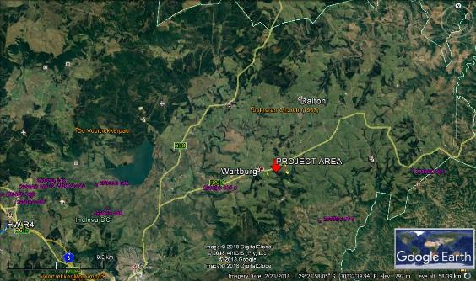

***Figure 1. Google Earth Imagery showing the location of the project area in the greater Wartburg. The purple polygons indicate known archaeological sites and the orange markers historical sites.***



***Figure 2. Google Earth Imagery showing the location of the three proposed development plots for the Mkabela Poultry Project (Source: Green Door).***

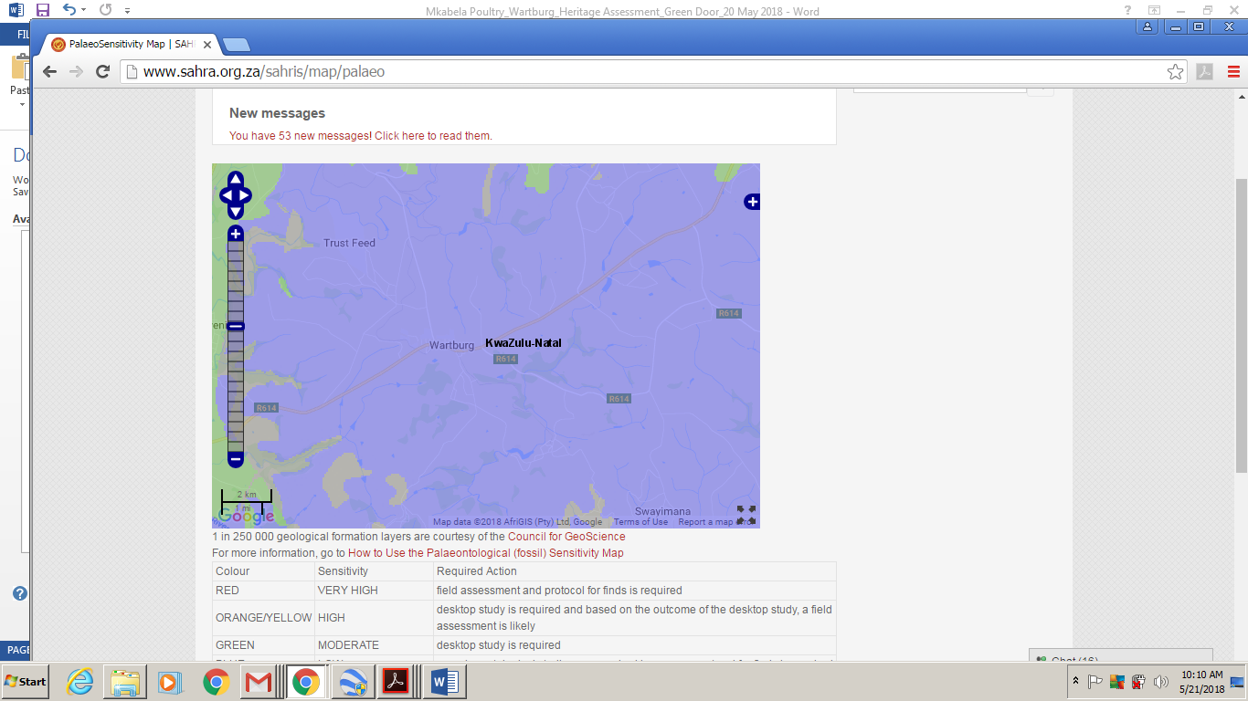

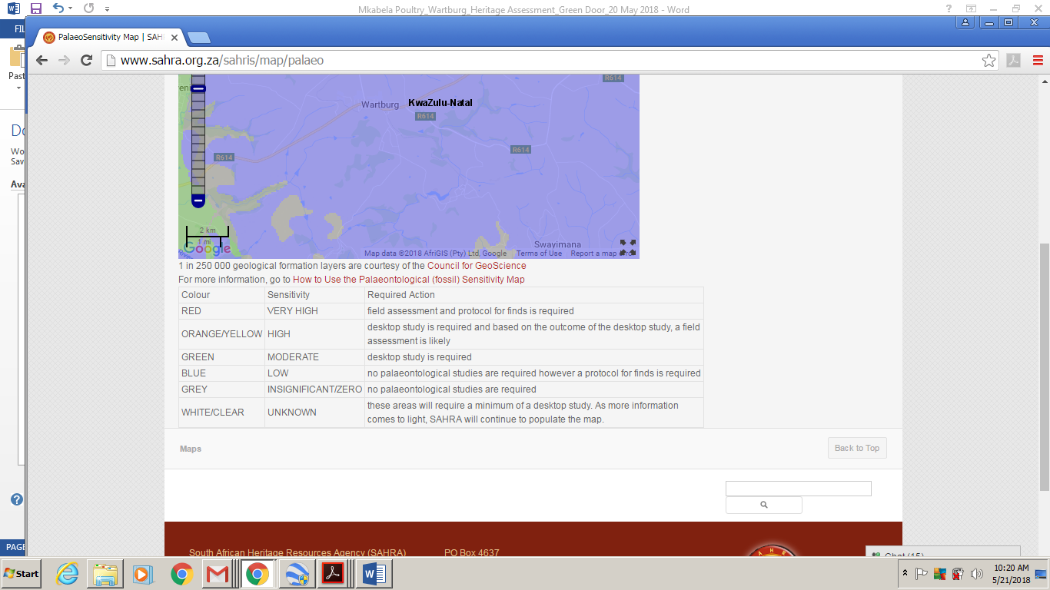

***Figure 3. Fossil Sensitivity Map of the project area: The proposed development sites are indicated by the black polygon. The blue backgound colour indicates that the area has a low fossil sensitivity. No palaeontological studies are required, but, a protocol of finds is required (Source: SAHRIS website).***

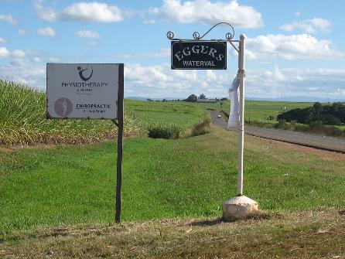

***Figure 4. Entrance to the Waterval Farm adjacent to the R614.***

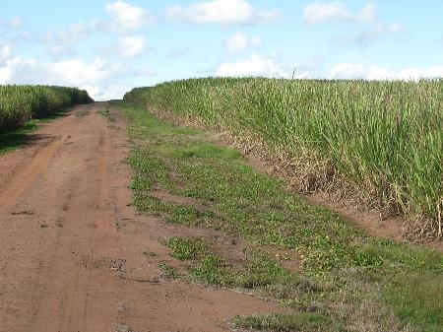

***Figure 5. Waterval 2: covered by sugar cane with a low archaeological site viasibility.***

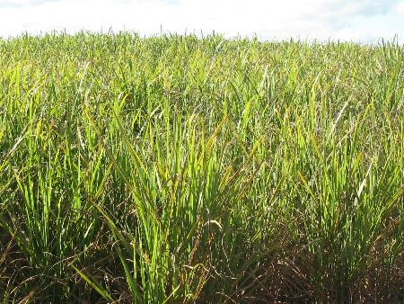

***Figure 6. Dense Sugar cane plantation at Waterval 2.***

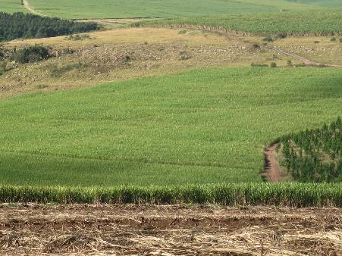

***Figure 7. Waterval 1 is also covered by Sugar cane.***

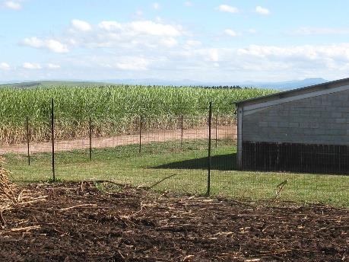

***Figure 8. Sugar cane plantations at Wartburg behind the existing poutry facility.***

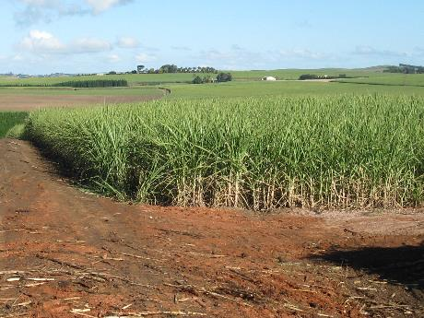

***Figure 9. Sugar cane plantations at Wartburg.***

# REFERENCES

Bryant, A. T. 1965. *Olden times in Zululand and Natal*. Cape Town: C. Struik.

Bulpin, T.V. 1966. *Natal and the Zulu Countr*y. Cape Town: Books of Africa.

Derwent, S. 2006. *KwaZulu-Natal Heritage Sites: A Guide to Some Great Places*. David Phillips: Cape Town

Fourie, W. 2007*. Heritage Impact Assessment of the Augmentation and Extension of the Wartburg Bulk Water System, KwaZulu-Natal.* Report handed to Amafa and published on the SAHRIS website.

Guy, J. 2013. *Theophilus Shepstone and the Forging of Natal*. University of KwaZulu-Natal Press. Pietermaritzburg.

Huffman, T. N. 2007. *Handbook to the Iron Age: The Archaeology of Pre-colonial* *Farming Societies in Southern Africa*. University of KwaZulu-Natal Press. Pietermaritzburg.

Lugg, H.C. 1949. *Historic Natal and Zululand*. Pietermaritzburg: Shuter and Shooter.

Maggs, T. The Iron Age farming communities. In Duminy, A. and Guest, B. 1989. *Natal and Zululand: from Earliest Times to 1910. A New History*. Pg. 28-46. University of Natal Press. Pietermaritzburg.

Mazel, A. The Stone Ages. In Duminy, A and Guest, B. 1989*. Natal and Zululand: from Earliest Times to 1910.* A New History. Pg. 1-27. University of Natal Press. Pietermaritzburg.

Mitchell, P. 2002. *The Archaeology of Southern Africa*. Cambridge University Press: Cambridge

Prins, F E. 2012. *Cultural Heritage Impact Assessment Of The Proposed Establishment Of Four New Broilerbreeder Houses On Waterval East Farm, Located On Portion 31 Of The Waterval No. 987, And One New Rearing House On Waterval Farm, Located On Portion 10 Of The Waterval No. 987, Wartburg, KwaZulu-Natal*. Green Door Environmental Consultants. Report handed to Amafa and published on the SAHRIS website.

SAHRA, 2005. *Minimum Standards for the Archaeological and the Palaeontological Components of Impact Assessment Reports, Draft version 1.4.*

**APPENDIX 1 RELOCATION OF GRAVES**

Burial grounds and graves older than 60 years are dealt with in Article 36 of the NHR Act, No. 25 of 1999. The Human Tissues Act (Act No. 65 of 1983)protects graves younger than 60 years. These fall under the jurisdiction of the National Department of Health and the Provincial Health Departments. Approval for the exhumation and reburial must be obtained from the relevant Provincial MEC as well as the relevant Local Authorities.

Below follows a broad summary of how to deal with graves in the event that they are indentified within the footprint , or within 25m, of the proposed development.

▪ If the graves are younger than 60 years, an undertaker can be contracted to deal with the exhumation and reburial. This will include public participation, organising cemeteries, coffins, etc. They need permits, such as those relating to health and safety, and have their own requirements that must be adhered to.

▪ If the graves are older than 60 years old or of undetermined age, an archaeologist must be in attendance to assist with the exhumation and documentation of the graves. This is a requirement by provincial heritage legislation.

Once it has been decided to relocate particular graves, the following steps should be taken:

▪ Notices of the intention to relocate the graves need to be put up at the burial site for a period of 60 days. This should contain information where communities and family members can contact the developer/archaeologist/public-relations officer/undertaker. All information pertaining to the identification of the graves needs to be documented for the application of a SAHRA permit. The notices need to be in at least 3 languages, English, and two other languages. This is a requirement by law.

▪ Notices of the intention needs to be placed in at least two local newspapers and have the same information as the above point. This is required by provincial heritage legislation.

▪ Local radio stations can also be used to try contact family members. This is not required by law, but is helpful in trying to contact family members.

▪ During this time (60 days) a suitable cemetery need to be identified close to the development area or otherwise one specified by the family of the deceased.

▪ An open day for family members should be arranged after the period of 60 days so that they can gather to discuss the way forward, and to sort out any problems. The developer needs to take the families requirements into account. This is a required by provincial heritage legislation.

▪ Once the 60 days has passed and all the information from the family members have been received, a permit can be requested from SAHRA. This is a required by provincial heritage legislation.

▪ Once the permit has been received, the graves may be exhumed and relocated.

▪ All headstones must be relocated with the graves as well as any items found in the grave