SITE VISIT REPORT FOR MQHEKEZWENI NELSON MANDELA CHILDHOOD SITE

Introduction

Sections 50 of National Heritage Resources Act 25 of 1999 give provision for the designation of the heritage inspectors. Section 50(7) state that the heritage inspectors, may at all reasonable time enter upon any land or premises for the purpose of inspecting any heritage resources protected in terms of the provision of the NHRA, or any other property in respect of which the heritage resources authority is exercising its functions in terms of the Act.

Purpose of the site visit
The site visit was conducted as part of the monitoring and evaluation of the National Heritage Sites in South Africa. This is to ensure that proper protection is given to the National Heritage Site. Main objectives are to identify challenges, risk and possible maintenance of the heritage resources in the country. Section 5 (1)(a) of the NHRA clearly state that, heritage resources have lasting value in their own right and provide evidence of the origins of South Africa society and as they are valuable, finite, non-renewable and irreplaceable they must be carefully managed to ensure their survival.This prompts the visit to the Mqhekezweni to ensure that the site is maintained.

Significance and status

Dr Nelson Rolihlahla Mandela was born on 18 July 1918 at Mvezo on the banks of the Mbhashe River and his middle name Rolihlahla literally mean pulling the branch of a tree or trouble maker and Nelson name was given to him by his white missionary school teacher. His parents were Nongaphi Nosekeni Mandela and Nkosi Mphakanyiswa Gadla Mandela, a chief and chief councilor to the paramount chief of

abaThembu and a member of the Madiba clan. After the death of his father in 1927, Rolihlahla Mandela was placed under the care of his father’s cousin, Regent of the abaThembu people, King Jongintaba Dalindyebo. He was registered at Clarkebury the then oldest Wesleyan mission and education centre in area of the abaThembu people. After completing his studies at Clarkebury, he attended a high school at Healdtown Methodist Boarding School. Mandela was the first member of his family to attend high school and when he matriculated at Healdtown in 1938 he formed part of a very small number of Black pupils who had attained a high school education in the country.

The patronage of the paramount chief resulted in Mandela joining the chief‘s son, Justice, when they were sent to the only university for Blacks (African, Coloured and Indian) at Fort Hare near Alice in the Eastern Cape. During this period, Mandela befriended Africa, Indian and Coloured students, many of whom went on to play leading roles in the South African liberation struggle and in the anti-colonial struggle in other African countries. Mandela did not complete his studies at Fort Hare after a dispute related to the elections process of the Student Representative Council. Mandela refused to take his seat on the council because he disagreed with the way the elections were run. He was given ultimatum to either take the seat or face expulsion. He chose expulsion as he could not comprise his principles. He informed his guardian that he would not be returning to Fort Hare and stubbornly stood his ground when the Regent pleaded with him. The Regent Jongintaba Dalindyebo had coincidently made arrangements for his son Justice and Mandela to marry two young women he had chosen for them. Both young men decided to defy the Regent, stole two of his cattle and sold them to raise funds to secretly leave for Johannesburg.

Mqhekezweni is where Justice and Rolihlahla grow up. The house which Justice and Rolihlahla used after initiation school named Intanga where they used for their personal use and engage with ladies in private. SAHRA has graded the whole homestead but it needs to be revamped as it is depleting.
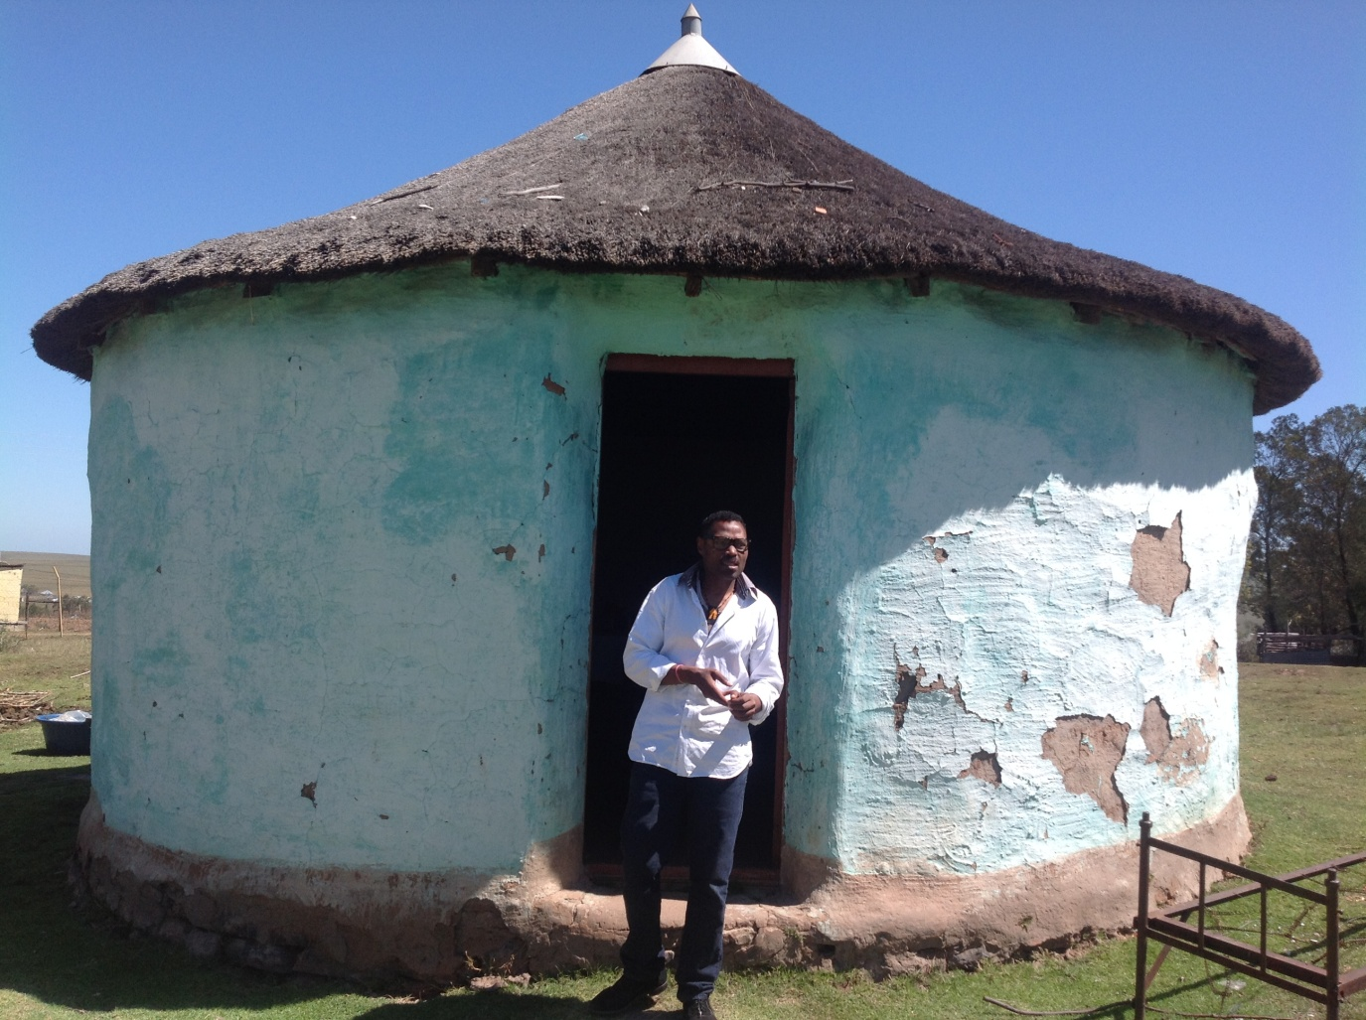
Picture 1, taken by N.Q. Machete, Chief Zanomthetho Mtirara in front of the graded hut of Mandela and Justice where they resided after initiation school its over 60 years .

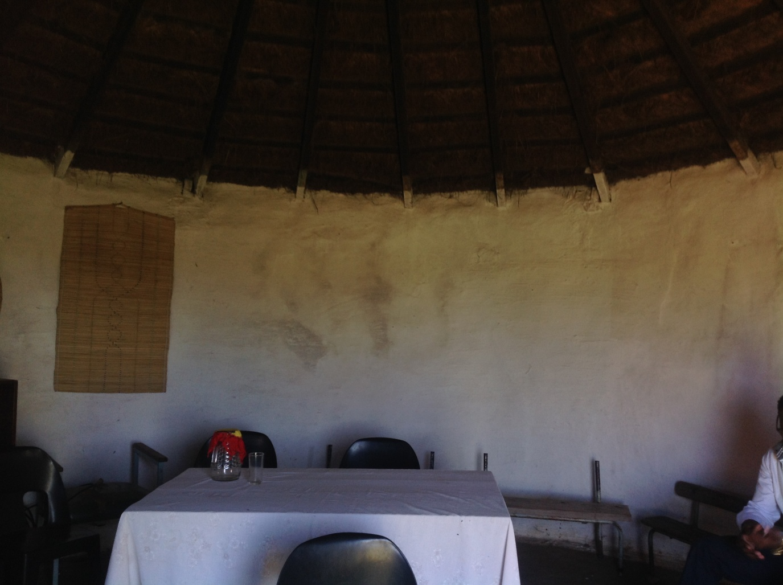
Picture 2, taken by N.Q. Machete, of the interior part of the hut where Mandela and Mtirara resided.

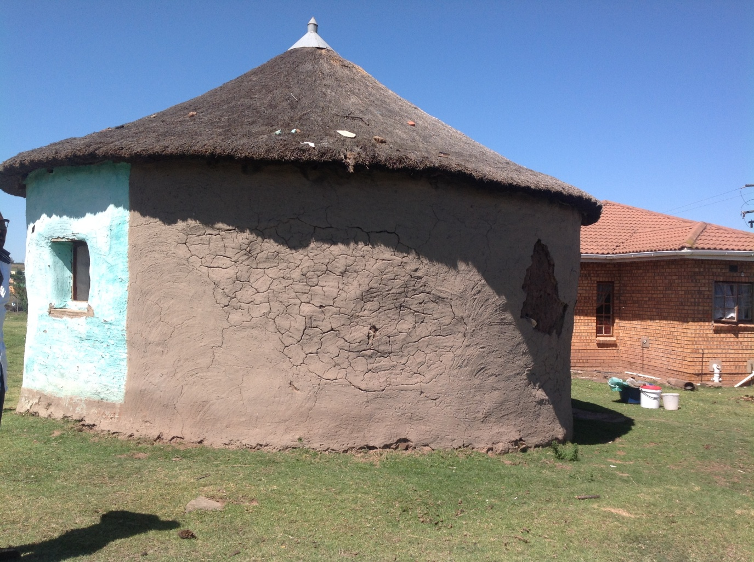
Picture 3, taken by N.Q. Machete, the exterior part of the hut.
The Regent chose Nompumelelo Mtirara who was later named Nozolile as his makoti for Justice. The current chief Zanomthetho Thembinkosi Mtirara haul praises for mama Nozolile as the pillar of strength of the abaThembu clan.
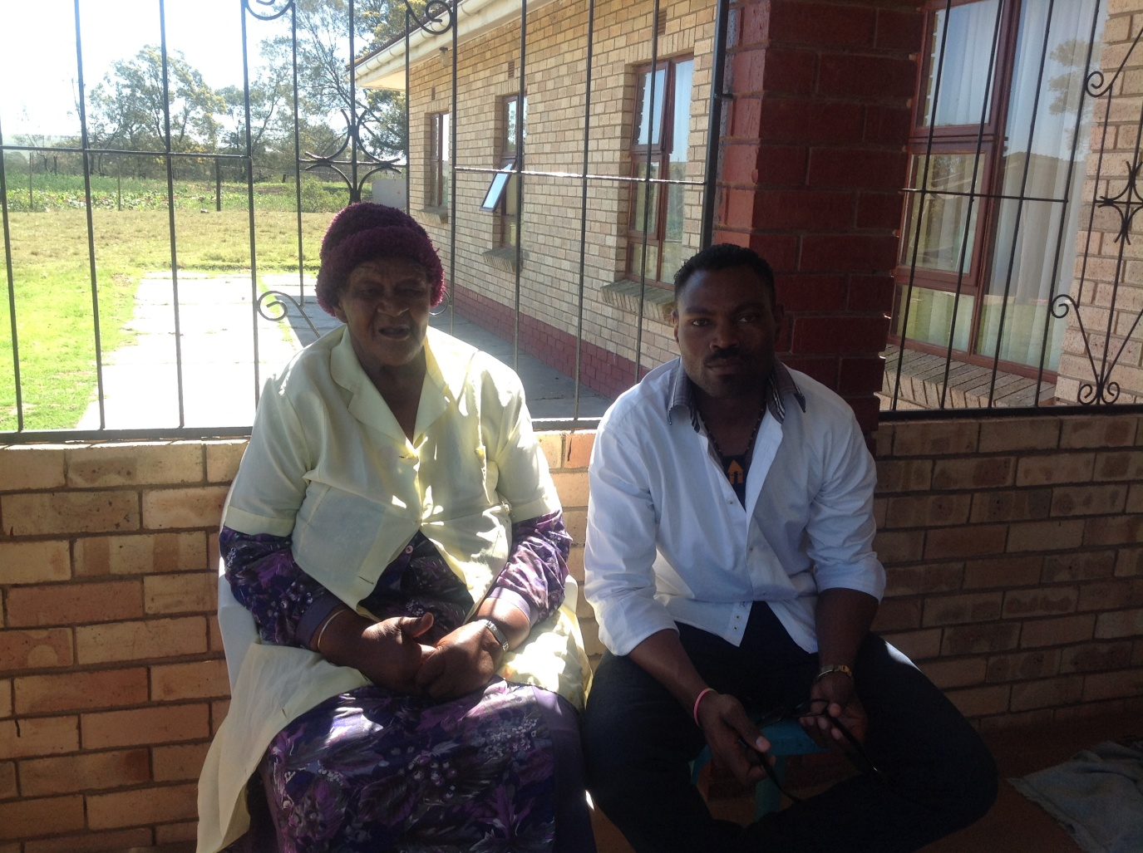
Picture 4, taken by N.Q. Machete mama Nozolile Mtirara and his grandson Chief Zanomthetho Mtirara.

Methodology of the site visit

The site visit was conducted on the 30 October 2015 at Mqhekezweni with the assistance of Chief Zanomthetho Mtirara who took us through the whole history of Mqhekezweni. See attached pictures.

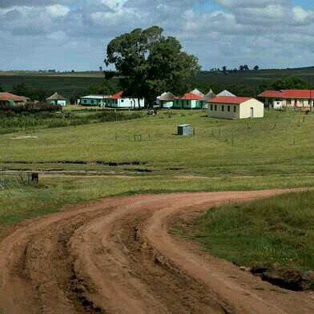
Picture 5, taken by N.Q. Machete the Mtirara homestead and tree where Dr Nelson Mandela learned how to preside over court cases/enkundleni.

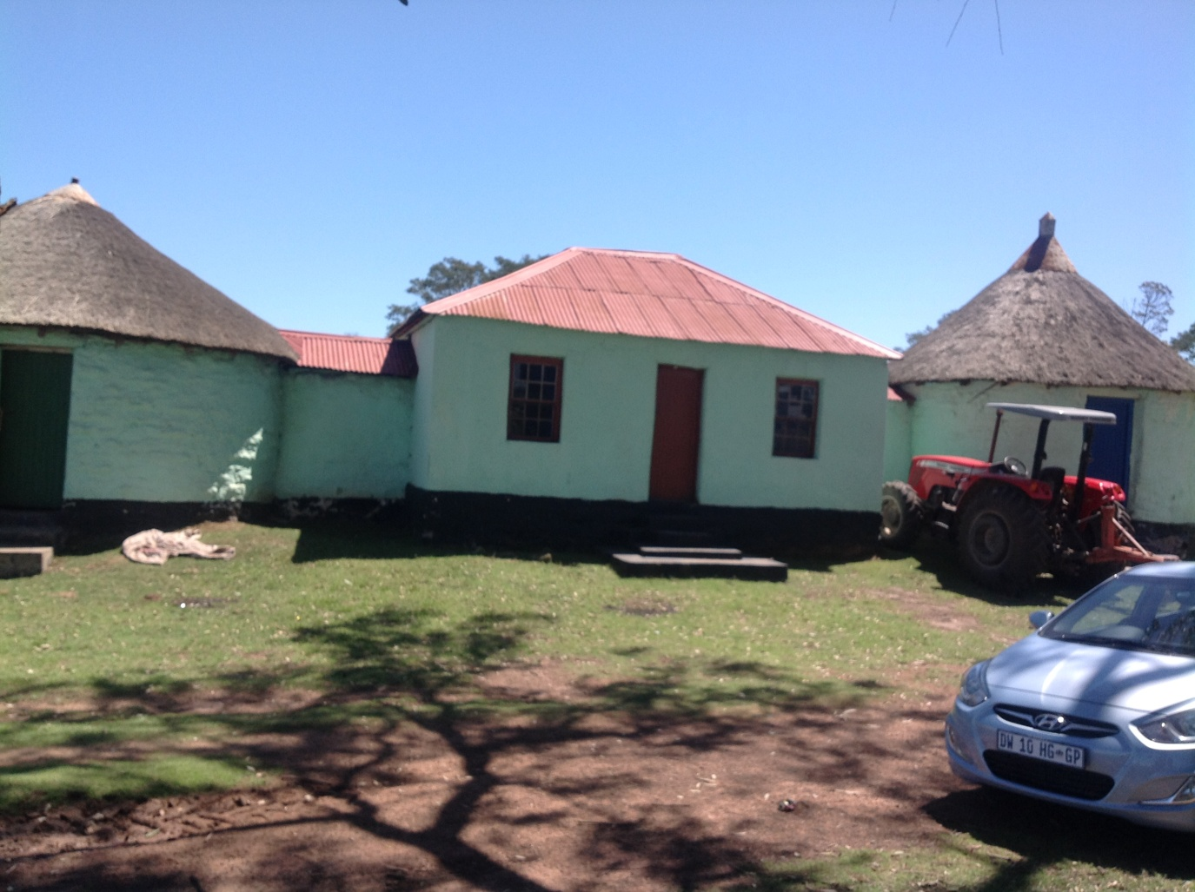
Picture 6, taken by N.Q. Machete the receiving and dinning house of King Jongintaba Mtirara

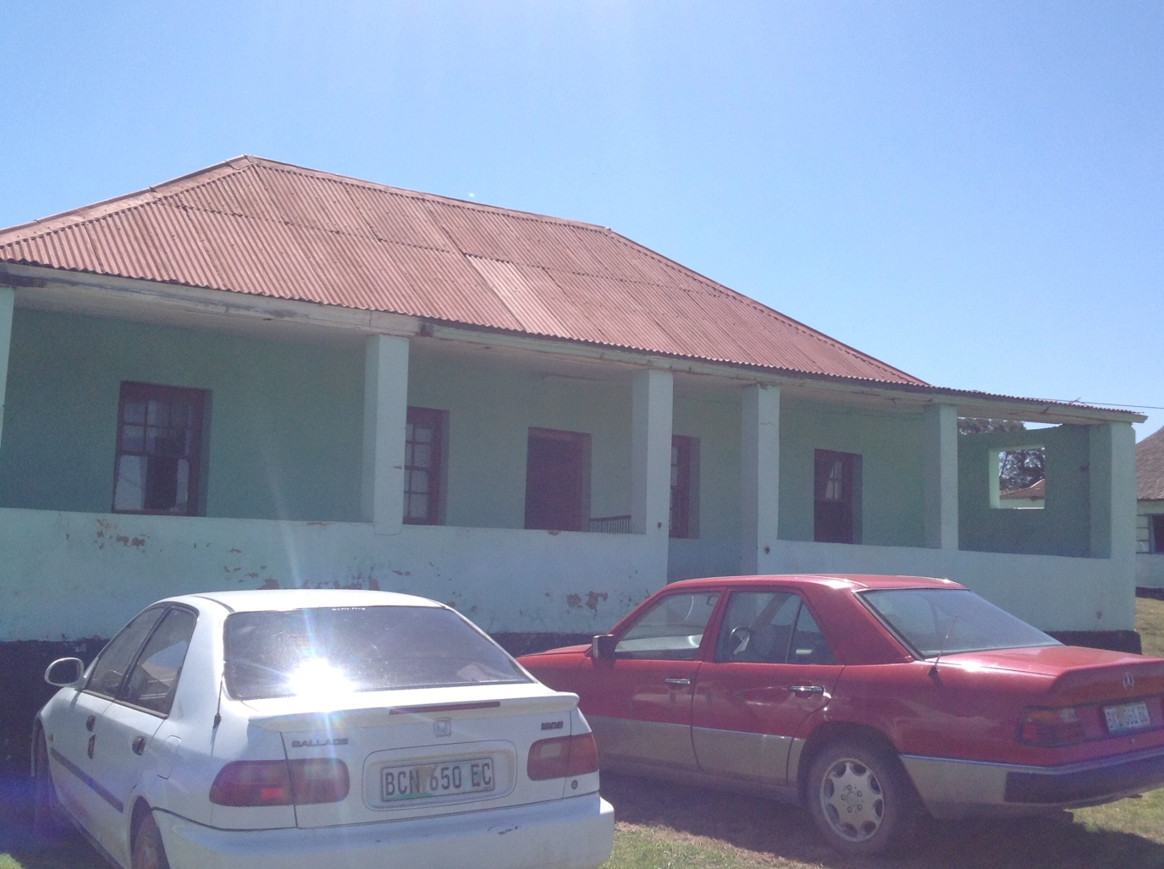
Picture 7, taken by N.Q. Machete maize storage house which was converted to be a residential house.

Discussion
The whole Mtirara homestead has been graded as grade 1 site and there is a need to repair the whole homestead as it was neglected after Mama Nozolile left the homestead due to family related matters. After Dr Mandela was released from prison he intervened and she came back hence chief Zanomthetho praise her pillar of strength for the family.

Conclusions and Recommendations
This is a very crucial site for Dr Mandela as the homestead becomes the indigenous college and the informal training ground for him. Through the councils held by King Jongintaba Mtirara, Dr Rolihlahla Mandela was molded to be the lawyer the first and black president of the country. Without the inventions of the King Jongintaba of allowing Dr Mandela to be an observer in the council meetings and encouraging him to study as the Dr Mandela late father instructed the King. There is a great need to restore the homestead and give it the status it deserves, which is to be formally declared as National heritage site in terms of section 27 of the National Heritage Resources Act 25 of 1999.

