



PALAEONTOLOGICAL WALKDOWN

**BRAKLAAGTE PV PROJECT**

FREE STATE

2022

COMPILED ON BEHALF OF:

NALA ENVIRONMENTAL

**Declaration of Independence**

I, Elize Butler, declare that –

General declaration:

* I act as the independent palaeontological specialist in this application
* I will perform the work relating to the application in an objective manner, even if this results in views and findings that are not favorable to the applicant
* I declare that there are no circumstances that may compromise my objectivity in performing such work.
* I have expertise in conducting palaeontological impact assessments, including knowledge of the Act, Regulations and any guidelines that have relevance to the proposed activity.
* I will comply with the Act, Regulations, and all other applicable legislation.
* I will consider, to the extent possible, the matters listed in section 38 of the NHRA when preparing the application and any report relating to the application.
* I have no, and will not engage in, conflicting interests in the undertaking of the activity.
* I undertake to disclose to the applicant and the competent authority all material information in my possession that reasonably has or may have the potential of influencing - any decision to be taken with respect to the application by the competent authority; and - the objectivity of any report, plan or document to be prepared by myself for submission to the competent authority.
* I will ensure that information containing all relevant facts in respect of the application is distributed or made available to interested and affected parties and the public and that participation by interested and affected parties is facilitated in such a manner that all interested and affected parties will be provided with a reasonable opportunity to participate and to provide comments on documents that are produced to support the application.
* I will provide the competent authority with access to all information at my disposal regarding the application, whether such information is favorable to the applicant or not
* All the particulars furnished by me in this form are true and correct.
* I will perform all other obligations as expected a palaeontological specialist in terms of the Act and the constitutions of my affiliated professional bodies; and
* I realize that a false declaration is an offense in terms of regulation 71 of the Regulations and is punishable in terms of section 24F of the NEMA.

**Disclosure of Vested Interest**

I do not have and will not have any vested interest (either business, financial, personal or other) in the proposed activity proceeding other than remuneration for work performed in terms of the Regulations.

**PALAEONTOLOGICAL CONSULTANT:** Banzai Environmental (Pty) Ltd

**CONTACT PERSON:** Elize Butler

Tel: +27 844478759

Email: elizebutler002@gmail.com



**SIGNATURE:** ______________________________

**EXECUTIVE SUMMARY**

South Africa Mainstream Renewable Power Developments (Pty) Ltd. obtained approval to develop 11 solar Energy Facilities and associated electrical infrastructure near Dealesville in the Free State. These Energy Facilities are known as the Kentani Solar Cluster. This walkdown report is for one of the 11 Energy Facilities namely the Braklaagte PV project (14/12/16/3/3/2/727).

Banzai Environmental was appointed by Nala Environmental to conduct the Palaeontological Walkdown to assess the authorised **Braklaagte PV Facility and supporting electrical infrastructure**. No fossil Heritage were identified during the walkdown but this does not necessarily imply that fossil heritage is not present in the development footprint. This may be attributed to vegetation cover and unexposed fossils in the Braklaagte PV study area. If undocumented fossils are uncovered during the construction phase of the development the Chance find Protocol included in this report should be implemented without delay.

Based on the walkdown, it is not expected that the proposed Braklaagte PV and supporting electrical infrastructure will negatively impact on the palaeontological heritage of the development footprint. As such there is no objection to the proposed layout and final alignment of the Braklaagte PV and associated infrastructure from a palaeontological perspective.

CONTENTS

1 INTRODUCTION 1

1.1 Background 2

1.2 Technical Information 4

1.3 Locality 5

1.4 General Site description 9

2 Assessment methodology 11

2.1 Physical Survey and Assessment: 11

2.2 Assumptions and Limitations 11

3 GEOLOGICAL AND PALAEONTOLOGICAL HERITAGE 12

4 Site visit 21

5 Assessments of Impacts 22

5.1 Assessment of impact to Palaeontological Resources 22

6 QUALIFICATIONS AND EXPERIENCE OF THE AUTHOR 23

7 LEGISLATION 23

7.1 National Heritage Resources Act (25 of 1999) 23

8 Conclusions AND RECOMMENDATIONS 25

9 REFERENCES 25

FIGURES

Figure 1:Kentani Projects 2

Figure 2 – Google Earth (2021) Image of the proposed Braklaagte Solar PV Facility and Supporting Electrical Infrastructure near Dealesville in the Free State. 7

Figure 3 – Locality Map of the proposed Braklaagte Solar PV Facility and Supporting Electrical Infrastructure near Dealesville in the Free State. 8

Figure 4 – Typical low vegetation with termite mounds scattered throughout the area. No bedrock is exposed 10

Figure 5 – Scattered round dolerite corestones 10

Figure 6 – Extract of the 1:250 000 Kimberley 2824 (1989) Geological map (Council of Geoscience, Pretoria) indicating the surface geology of the proposed development. The study area is underlain by Quaternary sediments (Qs; yellow). 15

Figure 7 – Geology indicated by Shape Files (compiled by the Council of Geosciences, Pretoria). The proposed development is underlain the Karoo Dolerite as well as the calcrete, surface limestone and Hardpan sediments. 18

Figure 8 – Extract of the 1 in 250 000 SAHRIS PalaeoMap map (Council of Geosciences) indicating the proposed development in yellow. 19

Figure 9 - Quarry excavation into weathered dolerite 21

**TABLES**

Table 1:Proposed projects, generation capacity and land required 3

Table 2: Components forming part if the solar project 5

Table 3: Land portions affected by the Braklaagte PV Project 6

Table 4 – Legend of the 1:250 000 284 Kimberley Geological map (1989) (Council of Geoscience, Pretoria) 16

Table 5: Legend to Map and short explanation of the development and surrounding sediments (Modified from the 1:250 000 2824 Kimberley Geological Map (1993) (Council of Geoscience, Pretoria). Formations present in the development is indicated in bold 17

Table 6 – Palaeontological Sensitivity on SAHRIS 20

**Appendix 1:** **Chance Find Protocol**

**Appendix 2: CV**

1. INTRODUCTION

Nala Environmental (Nala) was commissioned by South Africa Mainstream Renewable Power Developments (Pty) Ltd to conduct the final layout walkdowns for the Kentani Solar Cluster near Dealsville in the Free State. The Kentani Energy Cluster is situated within 12km from Dealsville in the Tokologo Local Municipality (Lejweleputswa District Municipality) and about 70km north-east of Bloemfontein and 50km southeast of Boshof. This walkdown report is for the **Braklaagte PV facility** 14/12/16/3/3/2/727 that forms part of the Kentani PV Cluster.

The Heritage Impact Assessments for the project were conducted by Dr J. Orton (Archaeology) and Dr L. Rossouw (Palaeontology).

Orton, J. July 2015. Heritage Impact Assessment: 11 Solar PV Facilities and Supporting Electrical Infrastructure near Dealesville in the Free State Province Proposed by Mainstream Renewable Power Developments (Pty) Ltd.

Rossouw, L. Palaeontological Desktop Assessment for 12 new Solar Photovoltaic facilities near Dealesville, Free State Province.

In his desktop report Dr Rossouw found that the proposed development was underlain by the Middle Permian Tierberg Formation (Ecca Group) and Quaternary alluvial deposits. He described the Tierberg Formation as poorly fossiliferous and that the Palaeontological Sensitivity of the development is Moderate. Fossil assemblages from the Tierberg Formation include fragmentary fish remains, trace fossils while plant remains comprise of petrified wood and leaves. Dolerite dykes and sills are common in the study area and as it is igneous in origin it is not palaeontologically significant. In spring and pan deposits as well as along major water courses Quaternary alluvial deposits are Highly Sensitive, while the palaeontological significance of sediments along ephemeral water courses or residual drift and sheet wash deposits is low. He recommended that the localized spring and pan dune deposits are strictly avoided and that a site visit is necessary prior to the construction phase of the projects to identify localized spring and pan dune deposits within the development footprints.

SAHRA issued their Final Comment on 27 October 2015, and requested that Ecca sediments should be avoided during construction where possible. A site visit is recommended prior to the construction phase to identify localized spring and pan dune deposits within the development footprint. Palaeontological monitoring was advised as an alternative at the start of, or during >60cm deep trench excavations into Ecca bedrock.

* 1. Background

Information extracted from the CSIR, 2016 EIA Report.

CSIR, 2016. Environmental Impact Assessment Report for the proposed Braklaagte PV solar energy project and supporting electrical infrastructure near Dealesville in the Free State CSIR Report number: CSIR/CAS/EMS/ER/2014/0011/B

South Africa Mainstream Renewable Power Developments (Pty) Ltd. (Reg. No. 2009/007850/07) (“Mainstream”) intends to develop 11 solar PV or CPV projects and associated electrical infrastructure near Dealesville in the Free State province, South Africa. The projects are collectively referred to as the suite of Kentani Solar Developments and are located within 12 km from Dealesville in the Tokologo Local Municipality which is located in the Lejweleputswa District Municipality, 50 km south-east of Boshof and 70 km north-east of Bloemfontein (**Figure 1-3**).

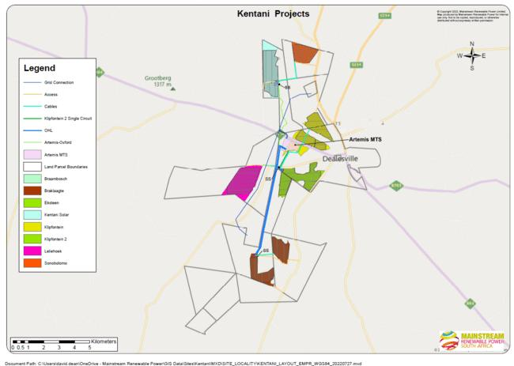

Figure 1:Kentani Projects

Twelve separate Environmental Authorisation (EA) application forms were submitted on 17 June 2014 to the Competent Authority (CA), the National Department of Environmental Affairs (DEA), for twelve proposed projects. Following the submission of the twelve EA applications forms and Scoping Process, one of the projects, Klipfontein PV 1, was withdrawn. Therefore, only eleven projects form part of the suite of Kentani Solar Developments. The eleven projects, associated DEA reference numbers and generation capacities are shown in Table 1 below. Mainstream proposes to develop the facilities with a possible maximum installed capacity of 75 MW or 100 MW of electricity per project. Once a Power Purchase Agreement (PPA) is awarded, this facility will generate electricity for a minimum period of 20 years.

The proposed Braklaagte PV Project and supporting electrical infrastructure is located 6 km north west of Dealesville and is accessed by an untarred road. The centre point coordinates for this project site are 28°44'20.46"S; 25°42'39.25"E.

Table 1:Proposed projects, generation capacity and land required

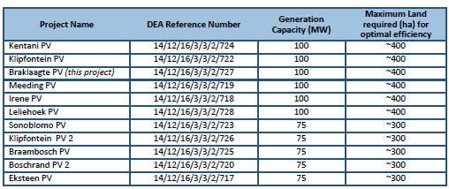.

.

* 1. Technical Information

**Solar field**

• Solar Arrays

o Solar technology: PV or CPV; and

o Mounting system technology: Single Axis Tracking PV, Dual Axis Tracking PV or Fixed

Axis Tracking PV.

• Building infrastructure

o Offices;

o Operational control centre;

o Warehouse/workshop;

o Ablution facilities;

o Converter station;

o Battery Facility; and

o On-site substation and substation building.

• Electrical infrastructure

o 33 kV distribution lines.

**Associated infrastructure**

• Transmission lines;

• Underground cabling;

• Access roads;

• Internal gravel roads;

• Fencing;

• Operation and Maintenance Area;

• Laydown Area;

• Stormwater channels; and

• Water pipelines.

The solar facility will either:

1) connect via an on-site substation to a northern or southern collector substation (to be constructed) to the existing Eskom Perseus substation (located on Farm Kentani 953) or Eskom Beta substation (located on Farm Braklaagte 149), or 2) connect directly via a northern or southern collector substation (to be constructed) to the existing Eskom Perseus substation or Eskom Beta substation.

Mainstream will implement the Self-Build Option for the additional electrical infrastructure to be constructed. Following the construction phase, the electrical infrastructure will either be transferred into the ownership of Eskom or otherwise remain in the ownership of Mainstream.

Table 2: Components forming part if the solar project

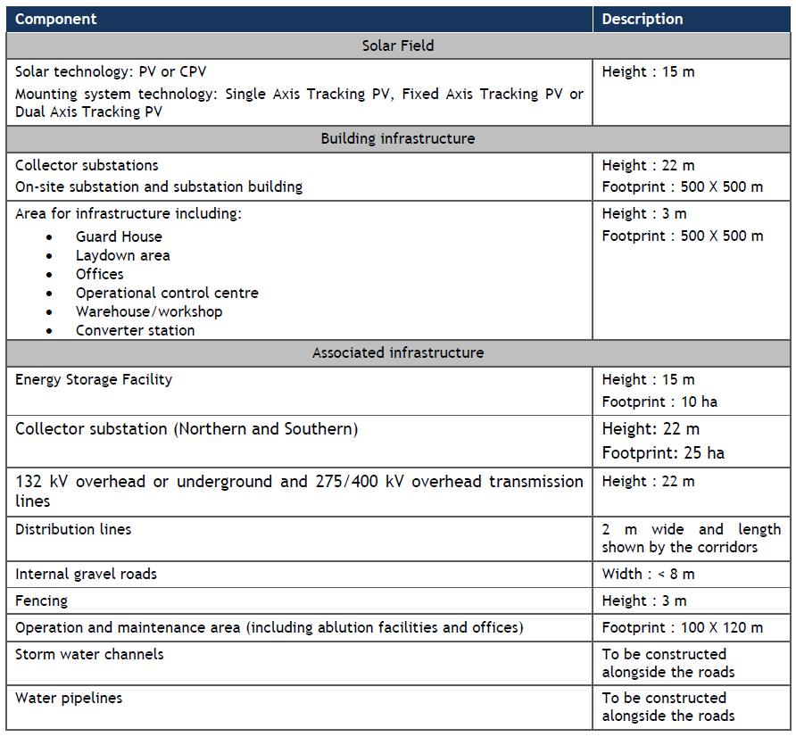

* 1. Locality

The Kentani Energy Cluster is situated within 12km from Dealsville in the Tokologo Local Municipality (Lejweleputswa District Municipality) and about 70km north-east of Bloemfontein and 50km southeast of Boshof. This walkdown report is for the Braklaagte PV facility that forms part of the Kentani PV Cluster.

Table 3: Land portions affected by the Braklaagte PV Project

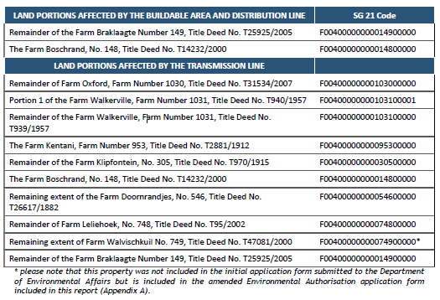

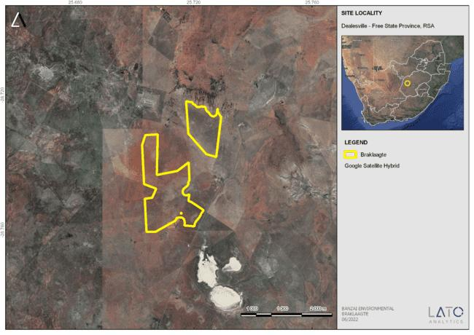

Figure 2 – Google Earth (2021) Image of the proposed Braklaagte Solar PV Facility and Supporting Electrical Infrastructure near Dealesville in the Free State.

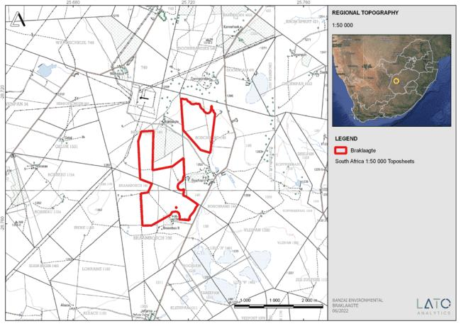

Figure 3 – Locality Map of the proposed Braklaagte Solar PV Facility and Supporting Electrical Infrastructure near Dealesville in the Free State.

* 1. General Site description

Dealsville is the third largest settlement in the municipality and serves as an agricultural service center for the surrounding agricultural communities. Dealesville comprises of Dealesville town and the informal settlement Tswaraganang. Currently the area between the two areas is developed as a new residential area. Kimberley and Bloemfontein are connected through the R64 that passes through Dealesville. Only the R64 is tarred while the other roads in the town is untarred. Farm roads connects the surrounding agricultural communities to the town. Railway lines is absent in this district.

Dealesville is known for the extensive electrical infrastructure outside Dealesville. The Beta Substation is located south-west of the town while the Perseus Substation lies north-west of Dealesville. Numerous transmission lines unite at these substations and the landscape is dominated by power lines and large pylons. The Kentani Cluster are located in less than 10 km to one of the two substations (Holland, 2015).

The topography of the area is flat with elevations between 1200 m and 1320 m above mean sea level (AMSL). From the Modder River the land rises gently from the south (1200 m AMSL) to a moderately rolling plateau in the north (varying between 1290 and 1320 m AMSL) (**Figure 4-5**). Most of the Kentani Solar Cluster are situated on this plateau. Occasionally Karoo koppies are present in the area. The topography of the area is influenced by the Modder River south of the proposed development as well as al large number of endorheic pans in the surrounding landscape (Holland, 2015).

Three vegetation types occur in the study area namely the Western Free State Clay Grassland, Vaal-Vet Sandy Grassland and Highveld Salt Pans, while the fourth vegetation type Vaalbos Rocky Shrubland are not mapped within the boundaries of the current study area. Only two vegetation types, Western Free State Clay Grassland and Vaal-Vet Sandy Grassland are present in the proposed solar and supporting electricity development.

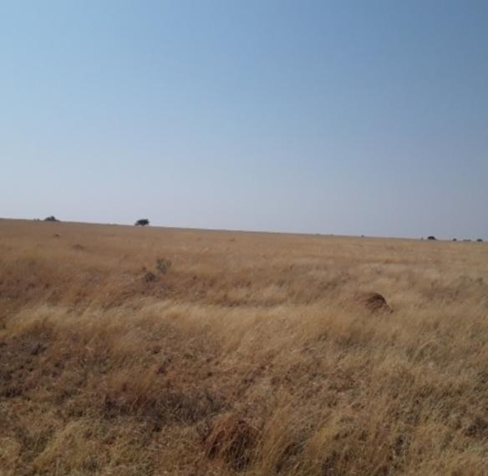

Figure 4 – Typical low vegetation with termite mounds scattered throughout the area. No bedrock is exposed

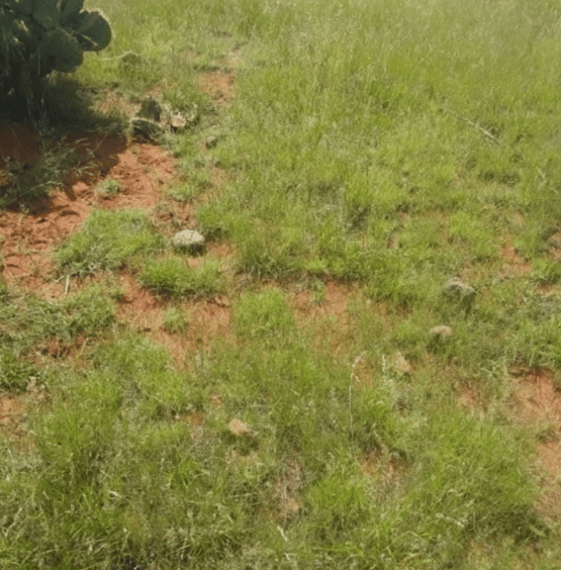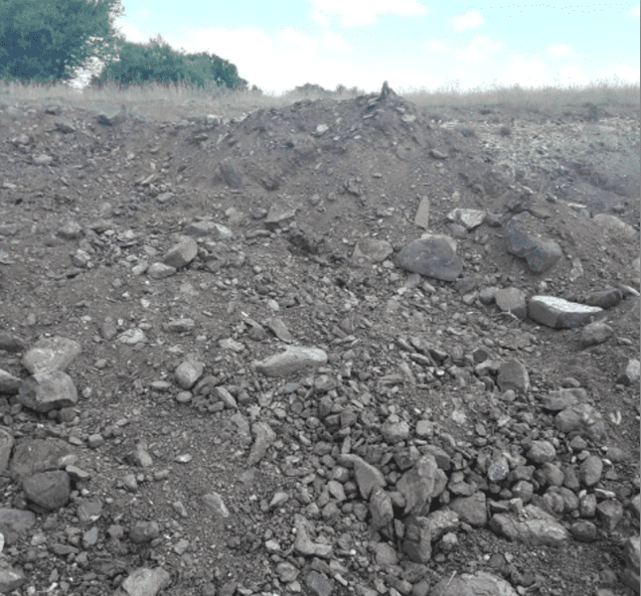

Figure 5 – Scattered round dolerite corestones

1. Assessment methodology

SAHRA issued their Final Comment on 27 October 2015, and requested that Ecca sediments should be avoided during construction where possible. A site visit is recommended prior to the construction phase to identify localized spring and pan dune deposits within the development footprint

* 1. Physical Survey and Assessment:

An overall 3-day site-specific field survey of the development footprint was conducted on foot and by motor vehicle during October 2021 and February 2022.

* 1. Assumptions and Limitations

The proposed Braklaagte study area is underlain by Quaternary sediments mantling the Jurassic dolerite and the Tierberg Formation of the Ecca Group (Karoo Supergroup). According to the PalaeoMap on the South African Heritage Resources Information System (SAHRIS) database, the Palaeontological Sensitivity of the Quaternary superficial sediments is low but locally high, that of the Jurassic dolerite is Zero as it is igneous in origin, while the Tierberg Formation has a High Palaeontological Sensitivity (Almond and Pether, 2009; Almond *et al*., 2013).

No fossils have been located during the walk down. However, there is a distinct possibility that fossil heritage is present in the area. This may be attributed to vegetation cover and unexposed fossils. If undocumented fossils are uncovered during the construction phase of the development the Chance find Protocol included in this report should be implemented immediately.

1. GEOLOGICAL AND PALAEONTOLOGICAL HERITAGE

The authorised 75MW Braklaagte PV facility near Dealsville in the Free State is depicted on the 1:250 000 2824 (1993) Kimberley Geological Map (Council of Geoscience, Pretoria). The study area is underlain by Quaternary sediments (Qs; yellow) mantling Jurassic dolerite (Jd, red), and the Tierberg Formation (Pt; orange) of the Ecca Group (Karoo Supergroup) (**Figure 6**). Recent Shape files produced by the Council of Geosciences, Pretoria) is indicated in **Figure 7**. According to the PalaeoMap on the South African Heritage Resources Information System (SAHRIS) database, the Palaeontological Sensitivity of the Quaternary superficial sediments is low but locally high, that of the Jurassic dolerite is Zero as it is igneous in origin, while the Tierberg Formation has a High Palaeontological Sensitivity (Almond and Pether, 2009; Almond *et al*., 2013, **Figure 8**). Topographical as well as Google Earth images indicate that the relief of the proposed project is low, and outcrops in the area are rare.

**Quaternary superficial deposits** (Qs, yellow **Figure 6**; and calcrete, surface limestones and Hardpan) are the youngest geological deposits formed during the most recent period of geological time namely the Quaternary (approximately 2.6 million years ago to present). Most of the superficial deposits are unconsolidated sediments and consist of calcretes, sand, silt, and clay, and they form relatively thin, often discontinuous patches of sediments or larger spreads onshore.

The Quaternary deposits reveal palaeoclimatic changes in the different geological formations (Hunter et al., 2006). The climatic fluctuations in the Cenozoic Era were responsible for the formation of most geomorphologic features in southern Africa (Maud, 2012). Various warming and cooling events occurred in the Cenozoic but climatic changes during the Quaternary, specifically the last 1.8 Ma, were the most drastic climate changes relative to all climate variations in the past Barnosky (2005). Climate in the Quaternary Period were both drier and wetter than the present and resulted in changes in river flow patterns, sedimentation processes and vegetation variation (Tooth et al., 2004).

The fossil assemblages of this Group are generally very low in diversity, but locally high and occur over a wide range. Quaternary deposits are especially important when in fluvial environments along water courses. Fossil assemblages include diatoms, gastropod shells, bivalves, ostracods, and trace fossils. These fossils represent terrestrial plants and animals with a close resemblance to living forms. Fossil remains include mammalian bones and teeth as well as coprolites, freshwater molluscs, and plant microfossils). Various authors have described fossilized hyena burrows in Late Pleistocene alluvial sediments of the Modder River (Broom 1909 a, b; Cooke 1955; Churchill et al. 2000; Rossouw 2006). Fossilized hyena lairs are occasionally located outside the present river valleys along localized spring deposits and calcified pan dunes (Scott & Brink 1991). Fossiliferous sediments (local peat deposits) occur within calcified pan dunes in this region (Horowitz et al. 1978; Scott and Klein 1981; Butzer 1984). These types of pans formed when the prevailing winds blew aeolian sands (unconsolidated material) into newly formed lunettes on the lee side of the deflation hollows and sometimes provided a site for hyena burrows and prehistoric human habitation.

Pleistocene vertebrate fossils and plant microfossils are associated with spring and pan deposits [e.g., Florisbad, (northwest of Bloemfontein, Baden Baden (north of Dealesville,) Liebenbergspan (Voigts Post), Deelpan between Bloemfontein and Petrusburg) (Brink 1987, 1988; Scott & Rossouw 2005)]. Florisbad has been declared a Provincial Heritage Site while Erfkroon is another valuable fossil site along the Modder River (15 km southwest of the southern end of the Braklaagte Project site). Fossils in these areas occur over large areas in erosion gullies. Stone artefacts from the earlier part of the Middle Stone Age and the Later Stone Age have also been uncovered and are sometimes associate with bones (Churchill et al. 2000). The palaeontology of the Quaternary superficial deposits has been relatively neglected in the past. Late Cenozoic calcrete may comprise of bones, horn corns as well as mammalian teeth. Tortoise remains have also been uncovered as well as trace fossils which includes termite and insect’s burrows and mammalian trackways. Amphibian and crocodile remains have been uncovered where the depositional settings in the past were wetter.

The **Karoo igneous province** (Jd-red**, Figure 6-7**) is one of the worlds classic continental basalt (CFB) provinces. This province consists of intrusive and extrusive rocks that occur over a large area (Duncan et al, 2006). Generally, the flood basalts do not contribute to prominent volcanic structures, but instead are formed by successive eruptions from a set of fissures that form sub-horizontal lava flows (sills and dykes) varying in thickness. This lava caps the landscape on which they erupted. As the Karoo is an old flood basalt province it is today preserved as erosional fragments of a more extensive lava cap that covered much of southern Africa in the geological past. It is estimated that the Karoo lava outcrop currently covered at least 140 000 km2 while it was largerin the past [~2 000 000 km2 (Cox 1970, 1972)]

The Karoo Igneous Province contains a large volume of flood basalts as well as silicic volcanic rocks. These units are comprised of rhyodacite and rhyolitic magma and crops out along the Lebombo monocline. Individual units span up to 60 km and sometimes show massive pyroclastic structures and are thus classified as rheoignimbrites. The basal lavas lie conformable on the Clarens Formation but in specific localities sandstone erosion occurred before the volcanic eruptions took place. Lock *et al* (1974) found evidence in the Eastern Cape that in the early stages of volcanism magma interacted with ground water to produce volcaniclastic deposits as well as phreatic and phreatomagmatic diatremes. Eales *et al* (1984) also found evidence of aqueous environments during early volcanism by the existence of pillow lavas and associated hyaloclastite breccias and thin lenses of fluviatile sandstones interbedded with the lowermost magmas.

.

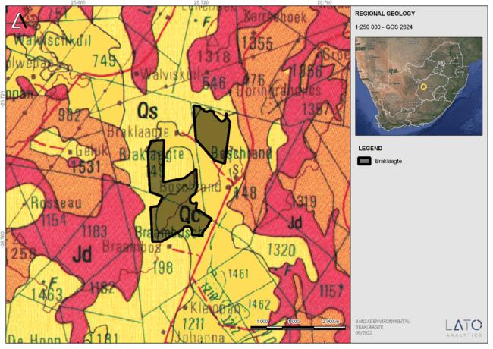

Figure 6 – Extract of the 1:250 000 Kimberley 2824 (1989) Geological map (Council of Geoscience, Pretoria) indicating the surface geology of the proposed development. The study area is underlain by Quaternary sediments (Qs; yellow).

Table 4 – Legend of the 1:250 000 284 Kimberley Geological map (1989) (Council of Geoscience, Pretoria)

Table 5: Legend to Map and short explanation of the development and surrounding sediments (Modified from the 1:250 000 2824 Kimberley Geological Map (1993) (Council of Geoscience, Pretoria). Formations present in the development is indicated in bold

|  |  |  |
| --- | --- | --- |
| **Symbol** | **Stratigraphy** | **Lithology** |
| **Qs** | **Quaternary** | **Sand: Red and grey Gravel, Diamondiferous in places** |
| Qa | Quaternary | Alluvial diamondiferous gravel |
| Qc | Quaternary | Calcrete, calcified pan dune and surface limestone. |
| Qc | Quaternary | Calcrete |
| **Jd** | **Jurassic** | **Dolerite** |
| **Pt** | **Tierberg Formation, Ecca Group, Karoo Supergroup** | **Sandstone, siltstone, mudstone** |
| C-Pd | Dwyka Group, Karoo Supergroup | Tillite, sandstone, shale |

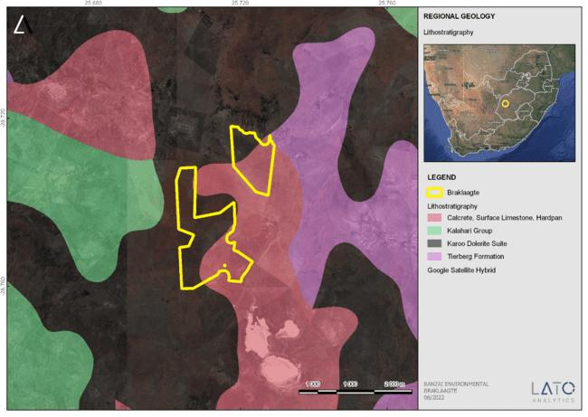

Figure 7 – Geology indicated by Shape Files (compiled by the Council of Geosciences, Pretoria). The proposed development is underlain the Karoo Dolerite as well as the calcrete, surface limestone and Hardpan sediments.

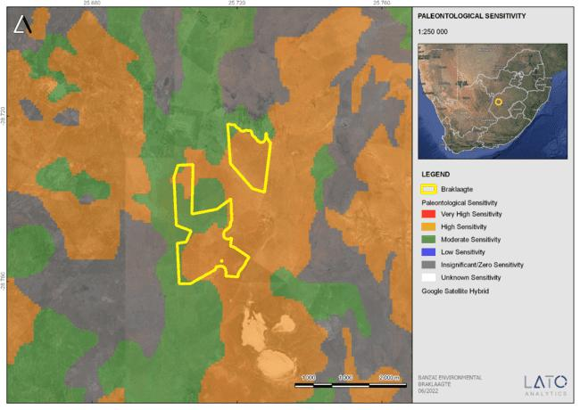

Figure 8 – Extract of the 1 in 250 000 SAHRIS PalaeoMap map (Council of Geosciences) indicating the proposed development in yellow.

According to the SAHRIS Palaeosensitivity map (**Figure 8)** the proposed development is underlain by sediments with a High (orange), Moderate (green) and Zero (grey) Palaeontological Sensitivity.

Table 6 – Palaeontological Sensitivity on SAHRIS

|  |  |  |
| --- | --- | --- |
| Colour | Sensitivity | Required Action |
| RED | VERY HIGH | field assessment and protocol for finds is required |
| **ORANGE/YELLOW** | **HIGH** | **desktop study is required and based on the outcome of the desktop study; a field assessment is likely** |
| **GREEN** | **MODERATE** | **desktop study is required** |
| BLUE | LOW | no palaeontological studies are required however a protocol for finds is required |
| **GREY** | **INSIGNIFICANT/ZERO** | **no palaeontological studies are required** |
| WHITE/CLEAR | UNKNOWN | these areas will require a minimum of a desktop study. As more information comes to light, SAHRA will continue to populate the map. |

The colours on the PalaeoMap indicate the following degrees of sensitivity: red = very highly sensitive; orange/yellow = high; green = moderate; blue = low; grey = insignificant/zero.

.

1. Site visit

The proposed Braklaagte PV and supporting electrical infrastructure development is located just north of Dealesville. No fossil heritage was identified during the site visit.

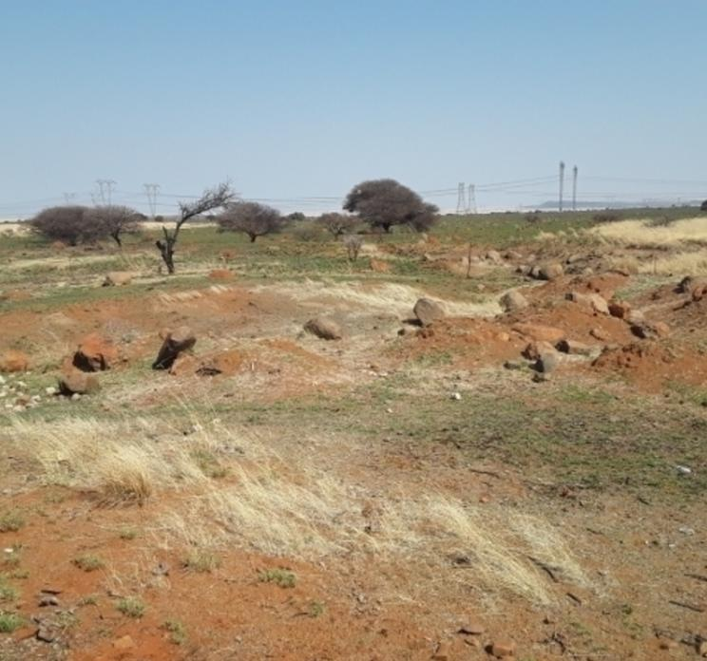

Figure 9 - Quarry excavation into weathered dolerite

1. Assessments of Impacts
   1. Assessment of impact to Palaeontological Resources

Based on the Palaeontological walkdown assessment for this project, the area planned for the Braklaagte PV Project has an overall low palaeontological sensitivity. It is not likely that the proposed development will have a negative impact on significant palaeontological heritage. Furthermore, all recommended mitigation measures from the approved Braklaagte PV Project and associated electricity infrastructure (Rossouw, 2015) will be applied.

1. QUALIFICATIONS AND EXPERIENCE OF THE AUTHOR

This present study has been conducted by Mrs Elize Butler. She has conducted approximately 300 palaeontological impact assessments for developments in the Free State, KwaZulu-Natal, Eastern, Central, and Northern Cape, Northwest, Gauteng, Limpopo, and Mpumalanga. She has an MSc (*cum laude*) in Zoology (specializing in Palaeontology) from the University of the Free State, South Africa and has been working in Palaeontology for more than twenty-five years. She has experience in locating, collecting, and curating fossils. She has been a member of the Palaeontological Society of South Africa (PSSA) since 2006 and has been conducting PIAs since 2014.

1. LEGISLATION
   1. National Heritage Resources Act (25 of 1999)

Cultural Heritage in South Africa, includes all heritage resources, is protected by the National Heritage Resources Act (Act 25 of 1999) (NHRA). Heritage resources as defined in Section 3 of the Act include **“all objects recovered from the soil or waters of South Africa, including archaeological and palaeontological objects and material, meteorites and rare geological specimens**”.

The identification, evaluation and assessment of any cultural heritage site, artefact or finds in the South African context is required and governed by the following legislation:

* National Environmental Management Act (NEMA) Act 107 of 1998
* National Heritage Resources Act (NHRA) Act 25 of 1999
* Notice 648 of the Government Gazette 45421- general requirements for undertaking an initial site sensitivity verification where no specific assessment protocol has been identified.

The next section in each Act is directly applicable to the identification, assessment, and evaluation of cultural heritage resources.

GNR 982 (Government Gazette 38282, 14 December 2014) promulgated under the National Environmental Management Act (NEMA) Act 107 of 1998

* Basic Assessment Report (BAR) – Regulations 19 and 23
* Environmental Impacts Assessment (EIA) – Regulation 23
* Environmental Scoping Report (ESR) – Regulation 21
* Environmental Management Programme (EMPr) – Regulations 19 and 23

National Heritage Resources Act (NHRA) Act 25 of 1999

* Protection of Heritage Resources – Sections 34 35, 36
* Heritage Resources Management – Section 38

The NEMA (No 107 of 1998) states that an integrated EMP should (23:2 (b)) “…*identify, predict and evaluate the actual and potential impact on the environment, socio-economic conditions and cultural heritage*”.

In agreement with legislative requirements, EIA rating standards as well as SAHRA policies the following comprehensive and legally compatible PIA report have been compiled.

Palaeontological heritage is exceptional and non-renewable and is protected by the NHRA. Palaeontological resources and may not be unearthed, broken moved, or destroyed by any development without prior assessment and without a permit from the relevant heritage resources authority as per section 35 of the NHRA.

**This Palaeontological Impact assessment forms part of the Heritage Impact Assessment (HIA) and adhere to the conditions of the Act**. According to **Section 38 (1)**, an HIA is required to assess any potential impacts to palaeontological heritage within the development footprint where:

* the construction of a road, wall, power line, pipeline, canal or other similar form of linear development or barrier exceeding 300 m in length.
* the construction of a bridge or similar structure exceeding 50 m in length.
* any development or other activity which will change the character of a site—
* (Exceeding 5 000 m2 in extent; or
* involving three or more existing erven or subdivisions thereof; or
* involving three or more erven or divisions thereof which have been consolidated within the past five years; or
* the costs of which will exceed a sum set in terms of regulations by SAHRA or a provincial heritage resources authority
* the re-zoning of a site exceeding 10 000 m² in extent.
* or any other category of development provided for in regulations by SAHRA or a Provincial heritage resources authority.

1. Conclusions AND RECOMMENDATIONS

Based on the Palaeontological walkdown assessment for this project, the area planned for the Braklaagte PV and supporting electrical Infrastructure has an overall low palaeontological sensitivity. It is not likely that the proposed development will have a negative impact on significant palaeontological heritage. All recommended mitigation measures from the approved Braklaagte PV Project (Rossouw, 2015) will be applied. This includes that Ecca sediments should be avoided during construction where possible. A site visit is recommended prior to the construction phase to identify localized spring and pan dune deposits within the development footprint. Subsequent Palaeontological monitoring was advised as an alternative at the start of, or during >60cm deep trench excavations into Ecca bedrock.

1. REFERENCES

Almond, J.E. & Pether, J. 2009. Palaeontological heritage of the Northern Cape. Interim SAHRA technical report, 124 pp. Natura Viva cc., Cape Town.

Almond, J., Pether, J, And Groenewald, G. 2013. South African National Fossil Sensitivity Map. SAHRA and Council for Geosciences.

Anderson, A.M. 1976. Fish trails from the Early Permian of South Africa. *Palaeontology* 19: 397-409, pl. 54.

Barnosky, A.D. 2005. Effects of Quaternary Climatic Change on Speciation in Mammals. *Journal of Mammalian Evolution.* 2005(12):247-264, June

Bosch, P.J.A. 1993. Die geologie van die gebied Kimberley. Toeligting van Blad 2824. *Geologiese Opname*, Pretoria 60 pp.

Brink, J.S. 1987. The archaeozoology of Florisbad, Orange Free State. *Memoirs of the National Museum* 24: 1 – 151.

Broom, R. 1909 a. On a large extinct species of Bubbalus. *Annals of the South African Museum* 7:219 - 280

Broom, R. 1909 b. On the evidence of a large horse recently extinct in South Africa. *Annals of the South African* 7.28l -282.

Butzer, K. W. 1984. *Archaeology and Quaternary environment in the interior of southern Africa* In: R.G. Klein (ed.) *Southern African prehistory and palaeoenvironments.* Rotterdam. Balkema pp 1-64.

Churchill, S.E., Brink, J.S., Berger, L.R. Hutchison, R.A., Rossouw L., *et. al*. 2000. Erfkroon: a new Florisian fossil locality from fluvial contexts in the western Free State, South Africa. *South African Journal of Science* 96: 161 – 163.

CSIR, 2016. Environmental Impact Assessment Report for the proposed Braklaagte PV solar energy project and supporting electrical infrastructure near Dealesville in the Free State CSIR Report number: CSIR/CAS/EMS/ER/2014/0011/B

Cole, D.I. 2005. Catalogue of South African Lithostratigraphic Units 8: 33-36.

De Wit, M.C.J., Marshall, T.R. & Partridge, T.C. 2000. Fluvial deposits and drainage evolution. In: Partridge, T.C. & Maud, R.R. (Eds.) The Cenozoic of southern Africa, pp.55-72. Oxford University Press, Oxford.

Dingle, R.V., Siesser, W.G. & Newton, A.R. 1983. Mesozoic and Tertiary geology of southern Africa. viii + 375 pp. Balkema, Rotterdam.

Eales, H.V., Marsh, J.S. and Cox, K.G. (1984). The Karoo Igneous Province: an introduction. *In*: Erlank, A.J. (Ed.), *Petrogenesis of the Volcanic Rocks of the Karoo Province*. Spec. Publ. Geol. Soc. S. Afr., **13**, 1–26.

Haddon, I.G. 2000. Kalahari Group sediments. In: Partridge, T.C. & Maud, R.R. (Eds.) The Cenozoic of southern Africa, pp. 173-181. Oxford University Press, Oxford.

Horowitz *et al*. 1978. Analysis of the Voigtspost site, OFS. *South African Archaeological Bulletin* 33: 152 – 159.

Holland, H., (2014). Eleven Solar PV Facilities and Supporting Electrical Infrastructure near Dealesville in the Free State Province Proposed by Mainstream Renewable Power Developments (Pty) Ltd. Visual Impact Assessment

Hunter, D.R., Johnson, M.R., Anhaeusser, C. R. And Thomas, R.J. 2006. Introduction. (*In*: Johnson, M.R., Anhaeusser, C.R. and Thomas, R.J. (Eds), *The Geology of South Africa*. Geological Society of South Africa, Johannesburg/Council for Geoscience, Pretoria, 585-604.)

Johnson, M.R. *et. al*. 2006. Sedimentary Rocks of the Karoo Supergroup. In: M.R. Johnson, *et. al*. (eds). *The Geology of South Africa*. Geological Society of South Africa.

Kent, L. E., 1980. Part 1: Lithostratigraphy of the Republic of South Africa, South West Africa/Namibia and the Republics of Bophuthatswana, Transkei, and Venda. SACS, Council for Geosciences, Pp 535-574.

Kitching, J.W. 1977. The distribution of Karoo Vertebrate Fauna. *Bernard Price Institute for Palaeontological Research, Memoir* 1, 1 – 131.

Kitching, J.W. 1995. Biostratigraphy of the Dicynodon AZ. **In**: B.S. Rubidge, *Biostratigraphy of the Beaufort Group*. Biostrat. Ser. S.Afr. Comm. Strat. 29 – 34.

Klein, R.G. 1984. The large mammals of southern Africa: Late Pliocene to Recent. In: Klein, R.G. (Ed.) Southern African prehistory and paleoenvironments, pp 107-146. Balkema, Rotterdam.

Maud, R. 2012. Macroscale Geomorphic Evolution. (*In* Holmes, P. and Meadows, M. Southern Africa Geomorphology, New trends and new directions. Bloemfontein: Sun Press. p. 7- 21)

Partridge, T.C., Botha, G.A. & Haddon, I.G. 2006. Cenozoic deposits of the interior. In: Johnson, M.R., Anhaeusser, C.R. & Thomas, R.J. (Eds.) The geology of South Africa, pp. 585-604. Geological Society of South Africa, Marshalltown.

Rossouw, L. 2006. Florisian mammal fossils from erosional gullies along the Modder River at Mitasrust farm, central Free State, South Africa. *Navorsinge van die Nasionale Museum* 22(6): 145-162.

Rubidge, B. S. 1995. (ed.) *Biostratigraphy of the Beaufort Group*. Biostrat. Ser. S.Afr. Comm. Strat. 1, 1 – 45.

Scott, L. and Klein, R.G. 1981. A hyena-accumulated bone assemblage from Late Holocene deposits at Deelpan, Orange Free State. Annals of the South African Museum 86(6): 217 – 227.

SG 2.2 SAHRA APMHOB Guidelines, 2012. Minimum standards for palaeontological components of Heritage Impact Assessment Reports, Pp 1-15.

Tooth, S. Brandt, D., Hancox P.J. And McCarthy, T. S. 2004. Geological controls on alluvial river behaviour: a comparative study of three rivers in the South African Highveld. *Journal of African Earth Sciences,* 38(2004): 79-97, 15 Aug.

Viljoen, J.H.A. 2005. Tierberg Formation. SA Committee for Stratigraphy, Catalogue of South African Lithostratigraphic Units 8: 37-40.

Viljoen, J.H.A. 2005. Tierberg Formation. SA Committee for Stratigraphy, Catalogue of South African Lithostratigraphic Units 8: 37-40.

VISSER, J.N.J. 1982. Upper Carboniferous glacial sedimentation in the Karoo Basin near Prieska, South Africa. Palaeogeography, Palaeoclimatology, Palaeoecology 38, 63-92.

Zawada, P.K. 1992. The geology of the Koffiefontein area. Explanation of 1: 250 000 geology sheet 2924, 30 pp. Council for Geoscience, Pretoria.

**APPENDIX 1**

CHANCE FINDS PROTOCOL

The following procedure will only be followed if fossils are uncovered during excavation.

Adopted form Heritage Western Cape June 2016

Introduction

This document is aimed to inform workmen and foremen working on a construction and/or mining site. It describes the procedure to follow in instances of accidental discovery of palaeontological material (please see attached poster with descriptions of palaeontological material) during construction/mining activities. This protocol does not apply to resources already identified under an assessment undertaken under s. 38 of the National Heritage Resources Act (no 25 of 1999). Fossils are rare and irreplaceable. Fossils tell us about the environmental conditions that existed in a specific geographical area millions of years ago. As heritage resources that inform us of the history of a place, fossils are public property that the State is required to manage and conserve on behalf of all the citizens of South Africa. Fossils are therefore protected by the National Heritage Resources Act and are the property of the State. Ideally, a qualified person should be responsible for the recovery of fossils noticed during construction/mining to ensure that all relevant contextual information is recorded. Heritage Authorities often rely on workmen and foremen to report finds, and thereby contribute to our knowledge of South Africa’s past and contribute to its conservation for future generations.

Training

Workmen and foremen need to be trained in the procedure to follow in instances of accidental discovery of fossil material, in a similar way to the Health and Safety protocol. A brief introduction to the process to follow in the event of possible accidental discovery of fossils should be conducted by the designated Environmental Control Officer (ECO) for the project, or the foreman or site agent in the absence of the ECO It is recommended that copies of the attached poster and procedure are printed out and displayed at the site office so that workmen may familiarise themselves with them and are thereby prepared in the event that accidental discovery of fossil material takes place.

Actions to be taken

One person in the staff must be identified and appointed as responsible for the implementation of the attached protocol in instances of accidental fossil discovery and must report to the ECO or site agent. If the ECO or site agent is not present on site, then the responsible person on site should follow the protocol correctly in order to not jeopardize the conservation and well-being of the fossil material. Once a workman notices possible fossil material, he/she should report this to the ECO or site agent.

Procedure to follow if it is likely that the material identified is a fossil:

* The ECO or site agent must ensure that all work ceases immediately in the vicinity of the area where the fossil or fossils have been found;
* The ECO or site agent must inform HWC of the find immediately. This information must include photographs of the findings and GPS co-ordinates;
* The ECO or site agent must compile a Preliminary Report and fill in the Fossil Discoveries: HWC Preliminary Record Form within 24 hours without removing the fossil from its original position.

The Preliminary Report records basic information about the find including:

● The date

● A description of the discovery

● A description of the fossil and its context (e.g. position and depth of find)

● Where and how the find has been stored

● Photographs to accompany the preliminary report (the more the better):

* ➔ A scale must be used
* ➔ Photos of location from several angles
* ➔ Photos of vertical section should be provided
* ➔ Digital images of hole showing vertical section (side);
* ➔ Digital images of fossil or fossils.

Upon receipt of this Preliminary Report, HWC will inform the ECO or site agent whether or not a rescue excavation or rescue collection by a palaeontologist is necessary.

* Exposed finds must be stabilised where they are unstable and the site capped, e.g. with a plastic sheet or sand bags. This protection should allow for the later excavation of the finds with due scientific care and diligence. HWC can advise on the most appropriate method for stabilisation.
* If the find cannot be stabilised, the fossil may be collected with extreme care by the ECO or the site agent and put aside and protected until HWC advises on further action. Finds collected in this way must be safely and securely stored in tissue paper and an appropriate box. Care must be taken to remove the all-fossil material and any breakage of fossil material must be avoided at all costs.
* No work may continue in the vicinity of the find until HWC has indicated, in writing, that it is appropriate to proceed.

**APPENDIX 2**

**ELIZE BUTLER**

**PROFESSION:**  Palaeontologist

**YEARS’ EXPERIENCE**: 29 years in Palaeontology

**EDUCATION:** B.Sc Botany and Zoology, 1988

University of the Orange Free State

B.Sc (Hons) Zoology, 1991

University of the Orange Free State

Management Course, 1991

University of the Orange Free State

M. Sc. *Cum laude* (Zoology), 2009

University of the Free State

**Dissertation title:** The postcranial skeleton of the Early Triassic non-mammalian Cynodont *Galesaurus planiceps*: implications for biology and lifestyle

**MEMBERSHIP**

Palaeontological Society of South Africa (PSSA) 2006-currently

**EMPLOYMENT HISTORY**

Part time Laboratory assistant Department of Zoology & Entomology University of the Free State Zoology 1989-1992

Part time laboratory assistant Department of Virology

University of the Free State Zoology 1992

Research Assistant National Museum, Bloemfontein 1993 – 1997

Principal Research Assistant National Museum, Bloemfontein

and Collection Manager 1998–currently

**TECHNICAL REPORTS**

**Butler, E. 2014.** Palaeontological Impact Assessment of the proposed development of private dwellings on portion 5 of farm 304 Matjesfontein Keurboomstrand, Knysna District, Western Cape Province. Bloemfontein.

**Butler, E. 2014.** Palaeontological Impact Assessment for the proposed upgrade of existing water supply infrastructure at Noupoort, Northern Cape Province. 2014. Bloemfontein.

**Butler, E. 2015.** Palaeontological impact assessment of the proposed consolidation, re-division, and development of 250 serviced erven in Nieu-Bethesda, Camdeboo local municipality, Eastern Cape. Bloemfontein.

**Butler, E. 2015.** Palaeontological impact assessment of the proposed mixed land developments at Rooikraal 454, Vrede, Free State. Bloemfontein.

**Butler, E. 2015.** Palaeontological exemption report of the proposed truck stop development at Palmiet 585, Vrede, Free State. Bloemfontein.

**Butler, E. 2015.** Palaeontological impact assessment of the proposed Orange Grove 3500 residential development, Buffalo City Metropolitan Municipality East London, Eastern Cape. Bloemfontein.

**Butler, E. 2015.** Palaeontological Impact Assessment of the proposed Gonubie residential development, Buffalo City Metropolitan Municipality East London, Eastern Cape Province. Bloemfontein.

**Butler, E. 2015.** Palaeontological Impact Assessment of the proposed Ficksburg raw water pipeline. Bloemfontein.

**Butler, E. 2015.** Palaeontological Heritage Impact Assessment report on the establishment of the 65 mw Majuba Solar Photovoltaic facility and associated infrastructure on portion 1, 2 and 6 of the farm Witkoppies 81 HS, Mpumalanga Province. Bloemfontein.

**Butler, E. 2015.** Palaeontological Impact Assessment of the proposed township establishment on the remainder of portion 6 and 7 of the farm Sunnyside 2620, Bloemfontein, Mangaung metropolitan municipality, Free State, Bloemfontein.

**Butler, E. 2015.** Palaeontological Impact Assessment of the proposed Woodhouse 1 photovoltaic solar energy facilities and associated infrastructure on the farm Woodhouse729, near Vryburg, North West Province. Bloemfontein.

**Butler, E. 2015.** Palaeontological Impact Assessment of the proposed Woodhouse 2 photovoltaic solar energy facilities and associated infrastructure on the farm Woodhouse 729, near Vryburg, North West Province. Bloemfontein.

**Butler, E. 2015.**Palaeontological Impact Assessment of the proposed Orkney solar energy farm and associated infrastructure on the remaining extent of Portions 7 and 21 of the farm Wolvehuis 114, near Orkney, North West Province. Bloemfontein.

**Butler, E. 2015.** Palaeontological Impact Assessment of the proposed Spectra foods broiler houses and abattoir on the farm Maiden Manor 170 and Ashby Manor 171, Lukhanji Municipality, Queenstown, Eastern Cape Province. Bloemfontein.

**Butler, E. 2016.** Palaeontological Impact Assessment of the proposed construction of the 150 MW Noupoort concentrated solar power facility and associated infrastructure on portion 1 and 4 of the farm Carolus Poort 167 and the remainder of Farm 207, near Noupoort, Northern Cape. Prepared for Savannah Environmental. Bloemfontein.

**Butler, E. 2016.** Palaeontological Impact Assessment of the proposed Woodhouse 1 Photovoltaic Solar Energy facility and associated infrastructure on the farm Woodhouse 729, near Vryburg, North West Province. Bloemfontein.

**Butler, E. 2016.**  Palaeontological Impact Assessment of the proposed Woodhouse 2 Photovoltaic Solar Energy facility and associated infrastructure on the farm Woodhouse 729, near Vryburg, North West Province. Bloemfontein.

**Butler, E. 2016.** Proposed 132kV overhead power line and switchyard station for the authorised Solis Power 1 CSP project near Upington, Northern Cape. Bloemfontein.

**Butler, E. 2016.**  Palaeontological Impact Assessment of the proposed Senqu Pedestrian Bridges in Ward 5 of Senqu Local Municipality, Eastern Cape Province. Bloemfontein.

**Butler, E. 2016.** Recommendation from further Palaeontological Studies: Proposed Construction of the Modderfontein Filling Station on Erf 28 Portion 30, Founders Hill, City of Johannesburg, Gauteng Province. Bloemfontein.

**Butler, E. 2016.**  Recommendation from further Palaeontological Studies: Proposed Construction of the Modikwa Filling Station on a Portion of Portion 2 of Mooihoek 255 Kt, Greater Tubatse Local Municipality, Limpopo Province. Bloemfontein.

**Butler, E. 2016.** Recommendation from further Palaeontological Studies: Proposed Construction of the Heidedal filling station on Erf 16603, Heidedal Extension 24, Mangaung Local Municipality, Bloemfontein, Free State Province. Bloemfontein.

**Butler, E. 2016.**  Recommended Exemption from further Palaeontological studies: Proposed Construction of the Gunstfontein Switching Station, 132kv Overhead Power Line (Single or Double Circuit) and ancillary infrastructure for the Gunstfontein Wind Farm Near Sutherland, Northern Cape Province. Savannah South Africa. Bloemfontein.

**Butler, E. 2016.** Palaeontological Impact Assessment of the proposed Galla Hills Quarry on the remainder of the farm Roode Krantz 203, in the Lukhanji Municipality, division of Queenstown, Eastern Cape Province. Bloemfontein.

**Butler, E. 2016.** Chris Hani District Municipality Cluster 9 water backlog project phases 3a and 3b: Palaeontology inspection at Tsomo WTW. Bloemfontein.

**Butler, E. 2016.** Palaeontological Impact Assessment of the proposed construction of the 150 MW Noupoort concentrated solar power facility and associated infrastructure on portion 1 and 4 of the farm Carolus Poort 167 and the remainder of Farm 207, near Noupoort, Northern Cape. Savannah South Africa. Bloemfontein.

**Butler, E. 2016.** Palaeontological Impact Assessment of the proposed upgrading of the main road MR450 (R335) from Motherwell to Addo within the Nelson Mandela Bay Municipality and Sunday’s River valley Local Municipality, Eastern Cape Province. Bloemfontein.

**Butler, E. 2016.** Palaeontological Impact Assessment construction of the proposed Metals Industrial Cluster and associated infrastructure near Kuruman, Northern Cape Province. Savannah South Africa. Bloemfontein.

**Butler, E. 2016.** Palaeontological Impact Assessment for the proposed construction of up to a 132kv power line and associated infrastructure for the proposed Kalkaar Solar Thermal Power Plant near Kimberley, Free State and Northern Cape Provinces. PGS Heritage. Bloemfontein.

**Butler, E. 2016.** Palaeontological Impact Assessment of the proposed development of two burrow pits (DR02625 and DR02614) in the Enoch Mgijima Municipality, Chris Hani District, Eastern Cape.

**Butler, E. 2016.** Ezibeleni waste Buy-Back Centre (near Queenstown), Enoch Mgijima Local Municipality, Eastern Cape. Bloemfontein.

**Butler, E. 2016.** Palaeontological Impact Assessment for the proposed construction of two 5 Mw Solar Photovoltaic Power Plants on Farm Wildebeestkuil 59 and Farm Leeuwbosch 44, Leeudoringstad, North West Province. Bloemfontein.

**Butler, E. 2016.** Palaeontological Impact Assessment for the proposed development of four Leeuwberg Wind farms and basic assessments for the associated grid connection near Loeriesfontein, Northern Cape Province. Bloemfontein.

**Butler, E. 2016.** Palaeontological impact assessment for the proposed Aggeneys south prospecting right project, Northern Cape Province. Bloemfontein.

**Butler, E. 2016.** Palaeontological impact assessment of the proposed Motuoane Ladysmith Exploration right application, KwaZuluNatal. Bloemfontein.

**Butler, E. 2016.** Palaeontological impact assessment for the proposed construction of two 5 MW solar photovoltaic power plants on farm Wildebeestkuil 59 and farm Leeuwbosch 44, Leeudoringstad, North West Province. Bloemfontein.

**Butler, E. 2016**: Palaeontological desktop assessment of the establishment of the proposed residential and mixed-use development on the remainder of portion 7 and portion 898 of the farm Knopjeslaagte 385 Ir, located near Centurion within the Tshwane Metropolitan Municipality of Gauteng Province. Bloemfontein.

**Butler, E. 2017.** Palaeontological impact assessment for the proposed development of a new cemetery, near Kathu, Gamagara local municipality and John Taolo Gaetsewe district municipality, Northern Cape. Bloemfontein.

**Butler, E. 2017.** Palaeontological Impact Assessment of The Proposed Development of The New Open Cast Mining Operations on The Remaining Portions Of 6, 7, 8 And 10 Of the Farm Kwaggafontein 8 In the Carolina Magisterial District, Mpumalanga Province. Bloemfontein.

**Butler, E. 2017.**  Palaeontological Desktop Assessment for the Proposed Development of a Wastewater Treatment Works at Lanseria, Gauteng Province. Bloemfontein.

**Butler, E. 2017.** Palaeontological Scoping Report for the Proposed Construction of a Warehouse and Associated Infrastructure at Perseverance in Port Elizabeth, Eastern Cape Province.

**Butler, E. 2017.**  Palaeontological Desktop Assessment for the Proposed Establishment of a Diesel Farm and a Haul Road for the Tshipi Borwa mine Near Hotazel, In the John Taolo Gaetsewe District Municipality in the Northern Cape Province. Bloemfontein.

**Butler, E. 2017.**  Palaeontological Desktop Assessment for the Proposed Changes to Operations at the UMK Mine near Hotazel, In the John Taolo Gaetsewe District Municipality in the Northern Cape Province. Bloemfontein.

**Butler, E. 2017.**  Palaeontological Impact Assessment for the Development of the Proposed Ventersburg Project-An Underground Mining Operation near Ventersburg and Henneman, Free State Province. Bloemfontein.

**Butler, E. 2017.**  Palaeontological desktop assessment of the proposed development of a 3000 MW combined cycle gas turbine (CCGT) in Richards Bay, Kwazulu-Natal.Bloemfontein.

**Butler, E. 2017.**  Palaeontological Impact Assessment for the Development of the Proposed Revalidation of the lapsed General Plans for Elliotdale, Mbhashe Local Municipality. Bloemfontein.

**Butler, E. 2017.** Palaeontological assessment of the proposed development of a 3000 MW Combined Cycle Gas Turbine (CCGT) in Richards Bay, Kwazulu-Natal.Bloemfontein.

**Butler, E. 2017.** Palaeontological Impact Assessment of the proposed development of the new open cast mining operations on the remaining portions of 6, 7, 8 and 10 of the farm Kwaggafontein 8 10 in the Albert Luthuli Local Municipality, Gert Sibande District Municipality, Mpumalanga Province. Bloemfontein.

**Butler, E. 2017.** Palaeontological Impact Assessment of the proposed mining of the farm Zandvoort 10 in the Albert Luthuli Local Municipality, Gert Sibande District Municipality, Mpumalanga Province. Bloemfontein.

**Butler, E. 2017.** Palaeontological Desktop Assessment for the proposed Lanseria outfall sewer pipeline in Johannesburg, Gauteng Province. Bloemfontein.

**Butler, E. 2017.** Palaeontological Desktop Assessment of the proposed development of open pit mining at Pit 36W (New Pit) and 62E (Dishaba) Amandelbult Mine Complex, Thabazimbi, Limpopo Province. Bloemfontein.

**Butler, E. 2017.** Palaeontological impact assessment of the proposed development of the sport precinct and associated infrastructure at Merrifield Preparatory school and college, Amathole Municipality, East London. PGS Heritage. Bloemfontein.

**Butler, E. 2017.** Palaeontological impact assessment of the proposed construction of the Lehae training and fire station, Lenasia, Gauteng Province. Bloemfontein.

**Butler, E. 2017.** Palaeontological Desktop Assessment of the proposed development of the new open cast mining operations of the Impunzi mine in the Mpumalanga Province. Bloemfontein.

**Butler, E. 2017.** Palaeontological Desktop Assessment of the construction of the proposed Viljoenskroon Munic 132 KV line, Vierfontein substation and related projects. Bloemfontein.

**Butler, E. 2017.** Palaeontological Desktop Assessment of the proposed rehabilitation of 5 ownerless asbestos mines. Bloemfontein.

**Butler, E. 2017.** Palaeontological Desktop Assessment of the proposed development of the Lephalale coal and power project, Lephalale, Limpopo Province, Republic of South Africa. Bloemfontein.

**Butler, E. 2017.** Palaeontological Impact Assessment of the proposed construction of a 132KV powerline from the Tweespruit distribution substation (in the Mantsopa local municipality) to the Driedorp rural substation (within the Naledi local municipality), Free State province. Bloemfontein.

**Butler, E. 2017.** Palaeontological Desktop Assessment of the proposed development of the new coal-fired power plant and associated infrastructure near Makhado, Limpopo Province. Bloemfontein.

**Butler, E. 2017.**  Palaeontological Impact Assessment of the proposed construction of a Photovoltaic Solar Power station near Collett substation, Middelburg, Eastern Cape. Bloemfontein.

**Butler, E. 2017.**  Palaeontological Impact Assessment for the proposed township establishment of 2000 residential sites with supporting amenities on a portion of farm 826 in Botshabelo West, Mangaung Metro, Free State Province. Bloemfontein.

**Butler, E. 2017.** Palaeontological Desktop Assessment for the proposed prospecting right project without bulk sampling, in the Koa Valley, Northern Cape Province. Bloemfontein.

**Butler, E. 2017.** Palaeontological Desktop Assessment for the proposed Aroams prospecting right project, without bulk sampling, near Aggeneys, Northern Cape Province. Bloemfontein.

**Butler, E. 2017.** Palaeontological Impact Assessment of the proposed Belvior aggregate quarry II on portion 7 of the farm Maidenhead 169, Enoch Mgijima Municipality, division of Queenstown, Eastern Cape. Bloemfontein.

**Butler, E. 2017.**  PIA site visit and reportof the proposed Galla Hills Quarry on the remainder of the farm Roode Krantz 203, in the Lukhanji Municipality, division of Queenstown, Eastern Cape Province. Bloemfontein.

**Butler, E. 2017.** Palaeontological Impact Assessment of the proposed construction of Tina Falls Hydropower and associated power lines near Cumbu, Mthlontlo Local Municipality, Eastern Cape. Bloemfontein.

**Butler, E. 2017.** Palaeontological Desktop Assessment of the proposed construction of the Mangaung Gariep Water Augmentation Project. Bloemfontein.

**Butler, E. 2017.** Palaeontological Impact Assessment of the proposed Belvoir aggregate quarry II on portion 7 of the farm Maidenhead 169, Enoch Mgijima Municipality, division of Queenstown, Eastern Cape. Bloemfontein.

**Butler, E. 2017.** Palaeontological Impact Assessment of the proposed construction of the Melkspruit-Rouxville 132KV Power line. Bloemfontein.

**Butler, E. 2017.** Palaeontological Desktop Assessment of the proposed development of a railway siding on a Portion of portion 41 of the farm Rustfontein 109 is, Govan Mbeki local municipality, Gert Sibande district municipality, Mpumalanga Province. Bloemfontein.

**Butler, E. 2017.** Palaeontological Impact Assessment of the proposed consolidation of the proposed Ilima Colliery in the Albert Luthuli local municipality, Gert Sibande District Municipality, Mpumalanga Province. Bloemfontein.

**Butler, E. 2017.** Palaeontological Desktop Assessment of the proposed extension of the Kareerand Tailings Storage Facility, associated borrow pits as well as a storm water drainage channel in the Vaal River near Stilfontein, North West Province. Bloemfontein.

**Butler, E. 2017.** Palaeontological Desktop Assessment of the proposed construction of a filling station and associated facilities on the Erf 6279, district municipality of John Taolo Gaetsewe District, Ga-Segonyana Local Municipality Northern Cape. Bloemfontein.

**Butler, E. 2017.** Palaeontological Desktop Assessment of the proposed of the Lephalale Coal and Power Project, Lephalale, Limpopo Province, Republic of South Africa. Bloemfontein.

**Butler, E. 2017.** Palaeontological Desktop Assessment of the proposed Overvaal Trust PV Facility, Buffelspoort, North West Province. Bloemfontein.

**Butler, E. 2017.** Palaeontological Impact Assessment of the proposed development of the H2 Energy Power Station and associated infrastructure on Portions 21; 22 And 23 of the farm Hartebeestspruit in the Thembisile Hani Local Municipality, Nkangala District near Kwamhlanga, Mpumalanga Province. Bloemfontein.

**Butler, E. 2017.** Palaeontological Impact Assessment of the proposed upgrade of the Sandriver Canal and Klippan Pump station in Welkom, Free State Province. Bloemfontein.

**Butler, E. 2017.** Palaeontological Impact Assessment of the proposed upgrade of the 132kv and 11kv power line into a dual circuit above ground power line feeding into the Urania substation in Welkom, Free State Province. Bloemfontein.

**Butler, E. 2017.** Palaeontological Desktop Assessment of the proposed Swaziland-Mozambique border patrol road and Mozambique barrier structure. Bloemfontein.

**Butler, E. 2017.** Palaeontological Impact Assessment of the proposed diamonds alluvial & diamonds general prospecting right application near Christiana on the remaining extent of portion 1 of the farm Kaffraria 314, registration division HO, North West Province. Bloemfontein.

**Butler, E. 2017.** Palaeontological Desktop Assessment for the proposed development of Wastewater Treatment Works on Hartebeesfontein, near Panbult, Mpumalanga. Bloemfontein.

**Butler, E. 2017.** Palaeontological Desktop Assessment for the proposed development of Wastewater Treatment Works on Rustplaas near Piet Retief, Mpumalanga. Bloemfontein.

**Butler, E. 2018.** Palaeontological Impact Assessment for the Proposed Landfill Site in Luckhoff, Letsemeng Local Municipality, Xhariep District, Free State. Bloemfontein.

**Butler, E. 2018.** Palaeontological Impact Assessment of the proposed development of the new Mutsho coal-fired power plant and associated infrastructure near Makhado, Limpopo Province. Bloemfontein.

**Butler, E. 2018.** Palaeontological Impact Assessment of the authorisation and amendment processes for Manangu mine near Delmas, Victor Khanye local municipality, Mpumalanga. Bloemfontein.

**Butler, E. 2018.** Palaeontological Desktop Assessment for the proposed Mashishing township establishment in Mashishing (Lydenburg), Mpumalanga Province. Bloemfontein.

**Butler, E. 2018.** Palaeontological Desktop Assessment for the Proposed Mlonzi Estate Development near Lusikisiki, Ngquza Hill Local Municipality, Eastern Cape. Bloemfontein.

**Butler, E. 2018.** Palaeontological Phase 1 Assessment of the proposed Swaziland-Mozambique border patrol road and Mozambique barrier structure. Bloemfontein.

**Butler, E. 2018.** Palaeontological Desktop Assessment for the proposed electricity expansion project and Sekgame Switching Station at the Sishen Mine, Northern Cape Province. Bloemfontein.

**Butler, E. 2018.** Palaeontological field assessment of the proposed construction of the Zonnebloem Switching Station (132/22kV) and two loop-in loop-out power lines (132kV) in the Mpumalanga Province. Bloemfontein.

**Butler, E. 2018.** Palaeontological Field Assessment for the proposed re-alignment and de-commissioning of the Firham-Platrand 88kv Powerline, near Standerton, Lekwa Local Municipality, Mpumalanga province. Bloemfontein.

**Butler, E. 2018.** Palaeontological Desktop Assessment of the proposed Villa Rosa development In the Buffalo City Metropolitan Municipality, East London. Bloemfontein.

**Butler, E. 2018.** Palaeontological field Assessment of the proposed Villa Rosa development In the Buffalo City Metropolitan Municipality, East London. Bloemfontein.

**Butler, E. 2018.** Palaeontological desktop assessment of the proposed Mookodi – Mahikeng 400kV line, North West Province. Bloemfontein.

**Butler, E. 2018.** Palaeontological Desktop Assessment for the proposed Thornhill Housing Project, Ndlambe Municipality, Port Alfred, Eastern Cape Province. Bloemfontein.

**Butler, E. 2018.** Palaeontological desktop assessment of the proposed housing development on portion 237 of farm Hartebeestpoort 328. Bloemfontein.

**Butler, E. 2018.** Palaeontological desktop assessment of the proposed New Age Chicken layer facility located on holding 75 Endicott near Springs in Gauteng. Bloemfontein.

**Butler, E. 2018** Palaeontological Desktop Assessment for the development of the proposed Leslie 1 Mining Project near Leandra, Mpumalanga Province. Bloemfontein.

**Butler, E. 2018.** Palaeontological field assessment of the proposed development of the Wildealskloof mixed use development near Bloemfontein, Free State Province. Bloemfontein.

**Butler, E. 2018.** Palaeontological Field Assessment of the proposed Megamor Extension, East London. Bloemfontein

**Butler, E. 2018.** Palaeontological Impact Assessment of the proposed diamonds Alluvial & Diamonds General Prospecting Right Application near Christiana on the Remaining Extent of Portion 1 of the Farm Kaffraria 314, Registration Division HO, North West Province. Bloemfontein.

**Butler, E.** **2018**. Palaeontological Impact Assessment of the proposed construction of a new 11kV (1.3km) Power Line to supply electricity to a cell tower on farm 215 near Delportshoop in the Northern Cape. Bloemfontein.

**Butler, E. 2018.** Palaeontological Field Assessment of the proposed construction of a new 22 kV single wood pole structure power line to the proposed MTN tower, near Britstown, Northern Cape Province. Bloemfontein.

**Butler, E. 2018.** Palaeontological Exemption Letter for the proposed reclamation and reprocessing of the City Deep Dumps in Johannesburg, Gauteng Province. Bloemfontein.

**Butler, E.** 2018. Palaeontological Exemption letter for the proposed reclamation and reprocessing of the City Deep Dumps and Rooikraal Tailings Facility in Johannesburg, Gauteng Province. Bloemfontein.

**Butler, E.** 2018. Proposed Kalabasfontein Mine Extension project, near Bethal, Govan Mbeki District Municipality, Mpumalanga. Bloemfontein.

**Butler, E.** 2018. Palaeontological Desktop Assessment for the development of the proposed Leslie 1 Mining Project near Leandra, Mpumalanga Province. Bloemfontein.

**Butler, E.** 2018. Palaeontological Desktop Assessment of the proposed Mookodi – Mahikeng 400kV Line, North West Province. Bloemfontein.

**Butler, E.** 2018. Environmental Impact Assessment (EIA) for the Proposed 325mw Rondekop Wind Energy Facility between Matjiesfontein and Sutherland in the Northern Cape Province.

**Butler, E.** 2018. Palaeontological Impact Assessment of the proposed construction of the Tooverberg Wind Energy Facility, and associated grid connection near Touws River in the Western Cape Province. Bloemfontein.

**Butler, E.** 2018. Palaeontological impact assessment of the proposedKalabasfontein Mining Right Application, near Bethal, Mpumalanga.

**Butler, E.,** 2019. Palaeontological Desktop Assessment of the proposed Westrand Strengthening Project Phase II.

**Butler, E.,** 2019. Palaeontological Field Assessment for the proposed Sirius 3 Photovoltaic Solar Energy Facility near Upington, Northern Cape Province

**Butler, E.,** 2019. Palaeontological Field Assessment for the proposed Sirius 4 Photovoltaic Solar Energy Facility near Upington, Northern Cape Province

**Butler, E.,** 2019. Palaeontological Field Assessment for Heuningspruit PV 1 Solar Energy Facility near Koppies, Ngwathe Local Municipality, Free State Province.

**Butler, E.,** 2019. Palaeontological Field Assessment for the Moeding Solar Grid Connection, North West Province.

**Butler, E.,** 2019. Recommended Exemption from further Palaeontological studies for the Proposed Agricultural Development on Farms 1763, 2372 And 2363, Kakamas South Settlement, Kai! Garib Municipality, Mgcawu District Municipality, Northern Cape Province.

**Butler, E., 2019.** Recommended Exemption from further Palaeontological studies: of Proposed Agricultural Development, Plot 1178, Kakamas South Settlement, Kai! Garib Municipality

**Butler, E., 2019.** Palaeontological Desktop Assessment for the Proposed Waste Rock Dump Project at Tshipi Borwa Mine, near Hotazel, Northern Cape Province:

**Butler, E., 2019**. Palaeontological Exemption Letter for the proposed DMS Upgrade Project at the Sishen Mine, Gamagara Local Municipality, Northern Cape Province

**Butler, E., 2019.** Palaeontological Desktop Assessment of the proposed Integrated Environmental Authorisation process for the proposed Der Brochen Amendment project, near Groblershoop, Limpopo

Butler, E., **2019.** Palaeontological Desktop Assessment of the proposed updated Environmental Management Programme (EMPr) for the Assmang (Pty) Ltd Black Rock Mining Operations, Hotazel, Northern Cape

**Butler, E., 2019**. Palaeontological Desktop Assessment of the proposed Kriel Power Station Lime Plant Upgrade, Mpumalanga Province

**Butler, E.,** **2019**. Palaeontological Impact Assessment for the proposed Kangala Extension Project Near Delmas, Mpumalanga Province.

**Butler, E., 2019**. Palaeontological Desktop Assessment for the proposed construction of an iron/steel smelter at the Botshabelo Industrial area within the Mangaung Metropolitan Municipality, Free State Province.

**Butler, E., 2019**. Recommended Exemption from further Palaeontological studies for the proposed agricultural development on farms 1763, 2372 and 2363, Kakamas South settlement, Kai! Garib Municipality, Mgcawu District Municipality, Northern Cape Province.

**Butler, E., 2019.** Recommended Exemption from further Palaeontological Studies for Proposed formalisation of Gamakor and Noodkamp low-cost Housing Development, Keimoes, Gordonia Rd, Kai !Garib Local Municipality, ZF Mgcawu District Municipality, Northern Cape Province.

**Butler, E., 2019**. Recommended Exemption from further Palaeontological Studies for proposed formalisation of Blaauwskop Low-Cost Housing Development, Kenhardt Road, Kai !Garib Local Municipality, ZF Mgcawu District Municipality, Northern Cape Province.

**Butler, E., 2019**. Palaeontological Desktop Assessment of the proposed mining permit application for the removal of diamonds alluvial and diamonds kimberlite near Windsorton on a certain portion of Farm Zoelen’s Laagte 158, Registration Division: Barkly Wes, Northern Cape Province.

**Butler, E., 2019**. Palaeontological Desktop Assessment of the proposed VedantaHousing Development, Pella Mission 39, Khâi-Ma Local Municipality, Namakwa District Municipality, Northern Cape.

**Butler, E., 2019**. Palaeontological Desktop Assessment for The Proposed 920 KWP Groenheuwel Solar Plant Near Augrabies, Northern Cape Province

**Butler, E., 2019.** Palaeontological Desktop Assessment for the establishment of a Super Fines Storage Facility at Amandelbult Mine, Near Thabazimbi, Limpopo Province

**Butler, E., 2019.** Palaeontological Impact Assessment for the proposed Sace Lifex Project, Near Emalahleni, Mpumalanga Province

**Butler, E., 2019.** Palaeontological Desktop Assessment for the proposed Rehau Fort Jackson Warehouse Exten*s*ion, East London

**Butler, E., 2019.** Palaeontological Desktop Assessment for the proposed Environmental Authorisation Amendment for moving 3 Km of the Merensky-Kameni 132KV Powerline

**Butler, E., 2019.** Palaeontological Impact Assessment for the proposed Umsobomvu Solar PV Energy Facilities, Northern and Eastern Cape

**Butler, E., 2019.** Palaeontological Desktop Assessment for six proposed Black Mountain Mining Prospecting Right Applications, without Bulk Sampling, in the Northern Cape.

**Butler, E., 2019.** Palaeontological field Assessment of the Filling Station (Rietvlei Extension 6) on the Remaining Portion of Portion 1 of the Farm Witkoppies 393JR east of the Rietvleidam Nature Reserve, City of Tshwane, Gauteng

**Butler, E., 2019.** Palaeontological Desktop Assessment of The Proposed Upgrade of The Vaal Gamagara Regional Water Supply Scheme: Phase 2 And Groundwater Abstraction

**Butler, E., 2019.** Palaeontological Desktop Assessment of The Expansion of The Jan Kempdorp Cemetery on Portion 43 Of Farm Guldenskat 36-Hn, Northern Cape Province

**Butler, E., 2019.** Palaeontological Desktop Assessment of the Proposed Residential Development on Portion 42 Of Farm Geldunskat No 36 In Jan Kempdorp, Phokwane Local Municipality, Northern Cape Province

**Butler, E.,** 2019. Palaeontological Impact Assessment of the proposed new Township Development, Lethabo Park, on Remainder of Farm Roodepan No 70, Erf 17725 And Erf 15089, Roodepan Kimberley, Sol Plaatjies Local Municipality, Frances Baard District Municipality, Northern Cape

**Butler, E.,** 2019. Palaeontological Protocol for Finds for the proposed 16m WH Battery Storage System in Steinkopf, Northern Cape Province

**Butler, E.,** 2019. Palaeontological Exemption Letter of the proposed 4.5WH Battery Storage System near Midway-Pofadder, Northern Cape Province

**Butler, E.,** 2019. Palaeontological Exemption Letter of the proposed 2.5ml Process Water Reservoir at Gloria Mine, Black Rock, Hotazel, Northern Cape

**Butler, E.,** 2019. Palaeontological Desktop Assessment for the Establishment of a Super Fines Storage Facility at Gloria Mine, Black Rock Mine Operations, Hotazel, Northern Cape:

**Butler, E.,** 2019. Palaeontological Desktop Assessment for the Proposed New Railway Bridge, and Rail Line Between Hotazel and the Gloria Mine, Northern Cape Province

**Butler, E.,** 2019. Palaeontological Exemption Letter of The Proposed Mixed Use Commercial Development on Portion 17 of Farm Boegoeberg Settlement Number 48, !Kheis Local Municipality in The Northern Cape Province. Banzai Environmental (Pty) Ltd, Bloemfontein.

**Butler, E.,** 2019. Palaeontological Desktop Assessment of the Proposed Diamond Mining Permit Application Near Kimberley, Sol Plaatjies Municipality, Northern Cape Province. Banzai Environmental (Pty) Ltd, Bloemfontein.

**Butler, E.,** 2019. Palaeontological Desktop Assessment of the Proposed Diamonds (Alluvial, General & In Kimberlite) Prospecting Right Application near Postmasburg, Registration Division; Hay, Northern Cape Province. Banzai Environmental (Pty) Ltd, Bloemfontein.

**Butler, E.,** 2019.Palaeontological Desktop Assessment of the proposed diamonds (alluvial, general & in kimberlite) prospecting right application near Kimberley, Northern Cape Province. Banzai Environmental (Pty) Ltd, Bloemfontein.

**Butler, E.,** 2019. Palaeontological Phase 1 Impact Assessment of the proposed upgrade of the Vaal Gamagara regional water supply scheme: Phase 2 and groundwater abstraction. Banzai Environmental (Pty) Ltd, Bloemfontein.

**Butler, E.,** 2019. Palaeontological Desktop Assessment of the proposed seepage interception drains at Duvha Power Station, Emalahleni Municipality, Mpumalanga Province. Banzai Environmental (Pty) Ltd, Bloemfontein.

**Butler, E.,** 2019. Palaeontological Desktop Assessment letter for the Proposed PV Solar Facility at the Heineken Sedibeng Brewery, near Vereeniging, Gauteng. Banzai Environmental (Pty) Ltd, Bloemfontein.

**Butler, E.,** 2019. Palaeontological Phase 1 Assessment letter for the Proposed PV Solar Facility at the Heineken Sedibeng Brewery, near Vereeniging, Gauteng. Banzai Environmental (Pty) Ltd, Bloemfontein.

**Butler, E.,** 2019. Palaeontological field Assessment for the Proposed Upgrade of the Kolomela Mining Operations, Tsantsabane Local Municipality, Siyanda District Municipalitty, Northern Cape Province, Northern Cape. Banzai Environmental (Pty) Ltd, Bloemfontein.

**Butler, E.,** 2019. Palaeontological Desktop Assessment of the proposed feldspar prospecting rights and mining application on portion 4 and 5 of the farm Rozynen 104, Kakamas South, Kai! Garib Municipality, Zf Mgcawu District Municipality, Northern Cape. Banzai Environmental (Pty) Ltd, Bloemfontein.

**Butler, E.,** 2019. Palaeontological Phase 1 Field Assessment of the proposed Summerpride Residential Development and Associated Infrastructure on Erf 107, Buffalo City Municipality, East London. Banzai Environmental (Pty) Ltd, Bloemfontein.

**Butler, E.,** 2019. Palaeontological Desktop Impact Assessment for the proposed re-commission of the Old Balgay Colliery near Dundee, KwaZulu Natal.

**Butler, E.,** 2019. Palaeontological Phase 1 Impact Assessment for the Proposed Re-Commission of the Old Balgay Colliery near Dundee, KwaZulu Natal. Banzai Environmental (Pty) Ltd, Bloemfontein.

**Butler, E.,** 2019. Palaeontological Desktop Assessment for the Proposed Environmental Authorisation and Amendment Processes for Elandsfontein Colliery. Banzai Environmental (Pty) Ltd, Bloemfontein.

**Butler, E.,** 2019. Palaeontological Impact Assessment and Protocol for Finds of a Proposed New Quarry on Portion 9 (of 6) of the farm Mimosa Glen 885, Bloemfontein, Free State Province. Banzai Environmental (Pty) Ltd, Bloemfontein.

**Butler, E.,** 2019. Palaeontological Impact Assessment and Protocol for Finds of a proposed development on Portion 9 and 10 of the Farm Mimosa Glen 885, Bloemfontein, Free State Province. Banzai Environmental (Pty) Ltd, Bloemfontein.

**Butler, E.,** 2019. Palaeontological Exemption Letter for the proposed residential development on the Remainder of Portion 1 of the Farm Strathearn 2154 in the Magisterial District of Bloemfontein, Free State. Banzai Environmental (Pty) Ltd, Bloemfontein.

**Butler, E.,** 2019. Palaeontological Field Assessment for the Proposed Nigel Gas Transmission Pipeline Project in the Nigel Area of the Ekurhuleni Metropolitan Municipality, Gauteng Province. Banzai Environmental (Pty) Ltd, Bloemfontein.

**Butler, E.,** 2019. Palaeontological Desktop Assessment for five Proposed Black Mountain Mining Prospecting Right Applications, Without Bulk Sampling, in the Northern Cape. Banzai Environmental (Pty) Ltd, Bloemfontein.

**Butler, E.** 2019. Palaeontological Desktop Assessment for the Proposed Environmental Authorisation and an Integrated Water Use Licence Application for the Reclamation of the Marievale Tailings Storage Facilities, Ekurhuleni Metropolitan Municipality - Gauteng Province. Banzai Environmental (Pty) Ltd, Bloemfontein.

**Butler, E.,** 2019. Palaeontological Impact Assessment for the Proposed Sace Lifex Project, near Emalahleni, Mpumalanga Province. Banzai Environmental (Pty) Ltd, Bloemfontein.

**Butler, E.,** 2019. Palaeontological Desktop Assessment for the proposed Golfview Colliery near Ermelo, Msukaligwa Local Municipality, Mpumalanga Province

**Butler, E.,** 2019. Palaeontological Desktop Assessment for the Proposed Kangra Maquasa Block C Mining development near Piet Retief, in the Mkhondo Local Municipality within the Gert Sibande District Municipality. Banzai Environmental (Pty) Ltd, Bloemfontein.

**Butler, E.,** 2019. Palaeontological Desktop Assessment for the Proposed Amendment of the Kusipongo Underground and Opencast Coal Mine in Support of an Environmental Authorization and Waste Management License Application. Banzai Environmental (Pty) Ltd, Bloemfontein.

**Butler, E.,** 2019. Palaeontological Exemption Letter of the Proposed Mamatwan Mine Section 24g Rectification Application, near Hotazel, Northern Cape Province. Banzai Environmental (Pty) Ltd, Bloemfontein.

**Butler, E.,** 2020. Palaeontological Field Assessment for the Proposed Environmental Authorisation and Amendment Processes for Elandsfontein Colliery. Banzai Environmental (Pty) Ltd, Bloemfontein.

**Butler, E.,** 2020. Palaeontological Desktop Assessment for the Proposed Extension of the South African Nuclear Energy Corporation (Necsa) Pipe Storage Facility, Madibeng Local Municipality, North West Province. Banzai Environmental (Pty) Ltd, Bloemfontein.

**Butler, E.,** 2020. Palaeontological Field Assessment for the Proposed Piggery on Portion 46 of the Farm Brakkefontien 416, Within the Nelson Mandela Bay Municipality, Eastern Cape. Banzai Environmental (Pty) Ltd, Bloemfontein.

**Butler, E.,** 2020. Palaeontological field Assessment for the proposed Rietfontein Housing Project as part of the Rapid Land Release Programme, Gauteng Province Department of Human Settlements, City of Johannesburg Metropolitan Municipality. Banzai Environmental (Pty) Ltd, Bloemfontein.

**Butler, E.,** 2020. Palaeontological Desktop Assessment for the Proposed Choje Wind Farm between Grahamstown and Somerset East, Eastern Cape. Banzai Environmental (Pty) Ltd, Bloemfontein.

**Butler, E.,** 2020. Palaeontological Desktop Assessment of the Proposed Prospecting Right Application for the Prospecting of Diamonds (Alluvial, General & In Kimberlite), Combined with A Waste License Application, Registration Division: Gordonia and Kenhardt, Northern Cape Province. Banzai Environmental (Pty) Ltd, Bloemfontein.

**Butler, E.,** 2020. Palaeontological Impact Assessment for the Proposed Clayville Truck Yard, Ablution Blocks and Wash Bay to be Situated on Portion 55 And 56 Of Erf 1015, Clayville X11, Ekurhuleni Metropolitan Municipality, Gauteng Province. Banzai Environmental (Pty) Ltd, Bloemfontein.

**Butler, E.,** 2020. Palaeontological Desktop Assessment for the Proposed Hartebeesthoek Residential Development. Banzai Environmental (Pty) Ltd, Bloemfontein.

**Butler, E.,** 2020. Palaeontological Desktop Assessment for the Proposed Mooiplaats Educational Facility, Gauteng Province. Banzai Environmental (Pty) Ltd, Bloemfontein.

**Butler, E.,** 2020. Palaeontological Impact Assessment for the Proposed Monument Park Student Housing Establishment. Banzai Environmental (Pty) Ltd, Bloemfontein.

**Butler, E.,** 2020. Palaeontological Field Assessment for the Proposed Standerton X10 Residential and Mixed-Use Developments, Lekwa Local Municipality Standerton, Mpumalanga Province. Banzai Environmental (Pty) Ltd, Bloemfontein.

**Butler, E.,** 2020. Palaeontological Field Assessment for the Rezoning and Subdivision of Portion 6 Of Farm 743, East London. Banzai Environmental (Pty) Ltd, Bloemfontein. Banzai Environmental (Pty) Ltd, Bloemfontein.

**Butler, E.,** 2020. Palaeontological Field Assessment for the Proposed Matla Power Station Reverse Osmosis Plant, Mpumalanga Province. Banzai Environmental (Pty) Ltd, Bloemfontein.

**Butler, E.,** 2020. Palaeontological Desktop Assessment of the Proposed Prospecting Right Application Without Bulk Sampling for the Prospecting of Diamonds Alluvial near Bloemhof on Portion 3 (Portion 1) of the Farm Boschpan 339, the Remaining Extent of Portion 8 (Portion 1), Portion 9 (Portion 1) and Portion 10 (Portion 1) and Portion 17 (Portion 1) of the Farm Panfontein 270, Registration Division: Ho, North West Province. Banzai Environmental (Pty) Ltd, Bloemfontein.

**Butler, E.,** 2020. Palaeontological Desktop Assessment of the Proposed Prospecting Right Application Combined with a Waste Licence Application for the Prospecting of Diamonds Alluvial, Diamonds General and Diamonds near Wolmaransstad on the Remaining Extent, Portion 7 and Portion 8 Of Farm Rooibult 152, Registration Division: HO, North West Province. Banzai Environmental (Pty) Ltd, Bloemfontein.

**Butler, E.,** 2020. Palaeontological Desktop Assessment of the Proposed Prospecting Right Application With Bulk Sampling combined with a Waste Licence Application for the Prospecting of Diamonds Alluvial (Da), Diamonds General (D), Diamonds (Dia) and Diamonds In Kimberlite (Dk) near Prieska On Portion 7, a certain Portion of the Remaining Extent of Portion 9 (Wouter), Portion 11 (De Hoek), Portion 14 (Stofdraai) (Portion of Portion 4), the Remaining Extent of Portion 16 (Portion Of Portion 9) (Wouter) and the Remaining Extent of Portion 18 (Portion of Portion 10) of the Farm Lanyon Vale 376, Registration Division: Hay, Northern Cape. Banzai Environmental (Pty) Ltd, Bloemfontein.

**Butler, E.,** 2020. Palaeontological Desktop Assessment of the Proposed Prospecting Right Area and Mining Permit Area near Ritchie on the Remaining Extent of Portion 3 (Anna’s Hoop) of the Farm Zandheuvel 144, Registration Division: Kimberley, Northern Cape Province. Banzai Environmental (Pty) Ltd, Bloemfontein.

**Butler, E.,** 2020. Palaeontological Desktop Assessment of the Proposed Okapi Diamonds (Pty) Ltd Mining Right of Diamonds Alluvial (Da) & Diamonds General (D) Combined with a Waste Licence Application on the Remaining Extent of Portion 9 (Wouter) of the Farm Lanyon Vale 376; Registration Division: Hay; Northern Cape Province. Banzai Environmental (Pty) Ltd, Bloemfontein.

**Butler, E.,** 2020. Palaeontological Field Assessment of the Proposed Prospecting Right Application for the Prospecting of Diamonds (Alluvial & General) between Douglas and Prieska on Portion 12, Remaining Extent of Portion 29 (Portion of Portion 13) and Portion 31 (Portion of Portion 29) on the Farm Reads Drift 74, Registration Division; Herbert, Northern Cape Province. Banzai Environmental (Pty) Ltd, Bloemfontein.

**Butler, E.,** 2020. Palaeontological Desktop Assessment for the Proposed Mining Permit Application Combined with a Waste License Application for the Mining of Diamonds (Alluvial) Near Schweitzer-Reneke on a certain Portion of Portion 12 (Ptn of Ptn 7) of the Farm Doornhoek 165, Registration Division: HO, North West Province. Banzai Environmental (Pty) Ltd, Bloemfontein.

**Butler, E.,** 2020. Palaeontological Desktop Assessment for Black Mountain Koa South Prospecting Right Application, Without Bulk Sampling, in the Northern Cape. Banzai Environmental (Pty) Ltd, Bloemfontein.

**Butler, E.,** 2020. Palaeontological Impact Assessment of the Proposed AA Bakery Expansion, Sedibeng District Municipality, Gauteng. Banzai Environmental (Pty) Ltd, Bloemfontein.

**Butler, E.,** 2020. Palaeontological Desktop Assessment for the Proposed Boegoeberg Township Expansion,! Kheis Local Municipality, ZF Mgcawu District Municipality, Northern Cape Province. Banzai Environmental (Pty) Ltd, Bloemfontein.

**Butler, E.,** 2020. Palaeontological Desktop Assessment for the Proposed Gariep Township Expansion, !Kheis Local Municipality, ZF Mgcawu District Municipality, Northern Cape Province. Banzai Environmental (Pty) Ltd, Bloemfontein.

**Butler, E.,** 2020. Palaeontological Desktop Assessment for the Proposed Groblershoop Township Expansion, !Kheis Local Municipality, Zf Mgcawu District Municipality, Northern Cape Province. Banzai Environmental (Pty) Ltd, Bloemfontein.

**Butler, E.,** 2020. Palaeontological Desktop Assessment for the Proposed Grootdrink Township Expansion, !Kheis Local Municipality, ZF Mgcawu District Municipality, Northern Cape Province. Banzai Environmental (Pty) Ltd, Bloemfontein.

**Butler, E.,** 2020. Palaeontological Exemption Letter for the Proposed Opwag Township Expansion,! Kheis Local Municipality, ZF Mgcawu District Municipality, Northern Cape Province. Banzai Environmental (Pty) Ltd, Bloemfontein.

**Butler, E.,** 2020. Palaeontological Exemption Letter for the Proposed Topline Township Expansion, !Kheis Local Municipality, ZF Mgcawu District Municipality, Northern Cape Province. Banzai Environmental (Pty) Ltd, Bloemfontein.

**Butler, E.,** 2020. Palaeontological Desktop Assessment for the Proposed Wegdraai Township Expansion, !Kheis Local Municipality, Zf Mgcawu District Municipality, Northern Cape Province. Banzai Environmental (Pty) Ltd, Bloemfontein.

Butler, E., 2020. Palaeontological field Assessment for the Proposed Establishment of an Emulsion Plant on Erf 1559, Hardustria, Harrismith, Free State. Banzai Environmental (Pty) Ltd, Bloemfontein.

**Butler.** 2020. Part 2 Environmental Authorisation (EA) Amendment Process for the Kudusberg Wind Energy Facility (WEF) near Sutherland, Western and Northern Cape Provinces- Palaeontological Impact Assessment. Banzai Environmental (Pty) Ltd, Bloemfontein.

**Butler, E.,** 2020. Palaeontological Desktop Assessment Proposed for the Construction and Operation of the Battery Energy Storage System (BESS) and Associated Infrastructure and inclusion of Additional Listed Activities for the Authorised Droogfontein 3 Solar Photovoltaic (PV) Energy Facility Located near Kimberley in the Sol Plaatje Local Municipality, Francis Baard District Municipality, in the Northern Cape Province of South Africa. Banzai Environmental (Pty) Ltd, Bloemfontein.

**Butler, E.,** 2020. Palaeontological Impact Assessment for the Proposed Development of a Cluster of Renewable Energy Facilities between Somerset East and Grahamstown in the Eastern Cape. Banzai Environmental (Pty) Ltd, Bloemfontein.

**Butler, E.,** 2021. Palaeontological Desktop Assessment for the Proposed Amaoti Secondary School, Pinetown, eThekwini Metropolitan Municipality KwaZulu Natal. Banzai Environmental (Pty) Ltd, Bloemfontein.

**Butler, E.,** 2021. Palaeontological Impact Assessment for the Proposed an Inland Diesel Depot, Transportation Pipeline and Associated Infrastructure on Portion 5 of the Farm Franshoek No. 1861, Swinburne, Free State Province. Banzai Environmental (Pty) Ltd, Bloemfontein.

**Butler, E.,** 2021. Palaeontological Impact Assessment for the proposed erosion control gabion installation at Alpine Heath Resort on the farm Akkerman No 5679 in the Bergville district Kwazulu-Natal. Banzai Environmental (Pty) Ltd, Bloemfontein.

**Butler, E.,** 2021. Palaeontological Impact Assessment for the proposed Doornkloof Residential development on portion 712 of the farm Doornkloof 391 Jr, City of Tshwane Metropolitan Municipality in Gauteng, South Africa. Banzai Environmental (Pty) Ltd, Bloemfontein.

**Butler, E.,** 2021. Palaeontological Desktop Assessment for the Proposed Expansion of the Square Kilometre Array (SKA) Meerkat Project, on the Farms Mey’s Dam RE/68, Brak Puts RE /66, Swartfontein RE /496 & Swartfontein 2/496, in the Kareeberg Local Municipality, Pixley Ka Seme District Municipality, and the Farms Los Berg 1/73 & Groot Paardekloof RE /74, in the Karoo Hoogland Local Municipality, Namakwa District Municipality, Northern Cape Province. Banzai Environmental (Pty) Ltd, Bloemfontein.

**Butler, E.,** 2021. Palaeontological Desktop Assessment for De Beers Consolidated Mines: Proposed Drilling on Portion 6 of Scholtzfontein 165 and Farm Arnotsdale 175, Herbert District in the Northern Cape. Banzai Environmental (Pty) Ltd, Bloemfontein.

**Butler, E.,** 2021.Palaeontological Desktop Assessment for De Beers Consolidated Mines: Proposed Drilling on the Remaining Extent of Biessie Laagte 96, and Portion 2 and 6 of Aasvogel Pan 141, Near Hopetown in the Northern Cape. Banzai Environmental (Pty) Ltd, Bloemfontein.

**Butler, E.,** 2021.Palaeontological Desktop Assessment for De Beers Consolidated Mines: Proposed Drilling in the North West Province: on Portions 7 (RE) (of Portion 3), 11, 12 (of Portion 3), 34 (of Portion 30), 35 (of Portion 7) of the Farm Holfontein 147 IO and Portions 1, 2 and the RE) of the Farm Kareeboschbult 76 Ip and Portions 1, 2, 4, 5, 6, (of Portion 3), 7 (of Portion 3), 13, 14, and the Re of the farm Oppaslaagte 100IP and portions 25 (of Portion 24) and 30 of the farm Slypsteen 102 IP. Banzai Environmental (Pty) Ltd, Bloemfontein.

**Butler, E.,** 2021. Palaeontological Desktop Assessment for the Proposed Expansion of the Cavalier Abattoir on farm Oog Van Boekenhoutskloof of Tweefontein 288 JR, near Cullinan, City of Tshwane Metropolitan Municipality, Gauteng. Banzai Environmental (Pty) Ltd, Bloemfontein.

**Butler, E., 2021.** Palaeontological Impact Assessment for the Proposed Doornkloof Residential Development on Portion 712 of the Farm Doornkloof 391 JR, City of Tshwane Metropolitan Municipality in Gauteng, South Africa. Banzai Environmental (Pty) Ltd, Bloemfontein.

**Butler, E., 2021.** Palaeontological Desktop Assessment for the proposed High Density Social Housing Development on part of the Remainder of Portion 171 and part of Portion 306 of the farm Derdepoort 326 JR, City of Tshwane. Banzai Environmental (Pty) Ltd, Bloemfontein.

**Butler, E., 2021.** Palaeontological Desktop Assessment for the proposed Red Rock Mountain Farm activities on Portions 2, 3 and 11 of the Farm Buffelskloof 22, near Calitzdorp in the Western Cape. Banzai Environmental (Pty) Ltd, Bloemfontein.

**Butler, E., 2021.** Palaeontological Desktop Assessment for the proposed Mixed-use Development on a Part of Remainder of Portion 171 and Portion 306 of the farm Derdepoort 326 JR, City of Tshwane. Banzai Environmental (Pty) Ltd, Bloemfontein.

**Butler, E., 2021.** Palaeontological Impact Assessment for the Proposed Realignment of the D 2809 Provincial Road as well as the Mining Right Application for the Glisa and Paardeplaats Sections of the NBC Colliery (NBC) near Belfast (eMakhazeni), eMakhazeni Local Municipality, Nkangala District Municipality, Mpumalanga Province. Banzai Environmental (Pty) Ltd, Bloemfontein.

**Butler, E., 2021.** Palaeontological Desktop Assessment for the proposed construction of Whittlesea Cemetery within Enoch Mgijima Local Municipality area, Eastern Cape. Banzai Environmental (Pty) Ltd, Bloemfontein.

**Butler, E., 2021.** Palaeontological Impact Assessment for the establishment of a mixed-use development on Portion 0 the of Erf 700, Despatch, Nelson Mandela Bay Municipality, Eastern Cape. Banzai Environmental (Pty) Ltd, Bloemfontein.

**Butler, E., 2021.** Palaeontological Desktop Assessment for the proposed EastOrchards Poultry Farm, Delmas/Botleng Transitional Local Council, Mpumalanga. Banzai Environmental (Pty) Ltd, Bloemfontein.

**Butler, E., 2021.** Palaeontological Impact Assessment for the proposed EastOrchards Poultry Farm, Delmas/Botleng Transitional Local Council, Mpumalanga. Banzai Environmental (Pty) Ltd, Bloemfontein.

**Butler, E., 2021.** Palaeontological Desktop Assessment to assess the proposed Gariep Road upgrade near Groblershoop, Northern Cape Province. Banzai Environmental (Pty) Ltd, Bloemfontein.

**Butler, E., 2021. Palaeontological Impact Assessment** for the Ngwedi Solar Plant which forms part of the authorised Paleso Solar Powerplant near Viljoenskroon in the Free State. Banzai Environmental (Pty) Ltd, Bloemfontein.

**Butler, E., 2021.** Palaeontological Impact Assessment for the Noko Solar Power Plant and power line which forms part of the authorised Paleso Solar Powerplant near Orkney in the North West. Banzai Environmental (Pty) Ltd, Bloemfontein.

**Butler, E., 2021.** Palaeontological Impact Assessment for the Proposed Power Line as part of the Paleso Solar Power Plant near Viljoenskroon in the Free State. Banzai Environmental (Pty) Ltd, Bloemfontein.

**Butler, E., 2021.** Palaeontological Impact Assessment for the Thakadu Solar Plant which forms part of the authorised Paleso Solar Powerplant near Viljoenskroon in the Free State. Banzai Environmental (Pty) Ltd, Bloemfontein.

**Butler, E., 2020.** Palaeontological Desktop Assessment for the proposed Farming Expansions on Portions 50 of the Farm Rooipoort 555 JR, Portion 34 of the Farm Rooipoort 555 JR, Portions 20 and 49 of the Farm Rooipoort 555 JR and Portion 0(RE) of the Farm Oudou Boerdery 626 JR, Tshwane Metropolitan Municipality, Gauteng Province. Banzai Environmental (Pty) Ltd, Bloemfontein.

**Butler, E., 2020.** Palaeontological Desktop Assessment for the proposed Saselamani CBD on the Remainder of Tshikundu’s Location 262 MT, and the Remainder of Portion 1 of Tshikundu’s Location 262 MT, Collins Chabane Local Municipality, Limpopo Province. Banzai Environmental (Pty) Ltd, Bloemfontein.

**Butler, E., 2021.** Palaeontological Impact Assessment for the proposed expansions of the existing Molare Piggery infrastructure and related activities on Portion 0(Re) of the farm Arendsfontein 464 JS, Portion 0(Re) of the farm Wanhoop 443 JS, Portion 0(Re) of the farm Eikeboom 476 JS and Portions 2 & 7 of the farm Klipbank 467 JS within the jurisdiction of the Steve Tshwete Local Municipality, Mpumalanga Province. Banzai Environmental (Pty) Ltd, Bloemfontein.

**Butler, E., 2021.** Palaeontological Desktop Assessment for the proposed Nchwaning Rail Balloon Turn Outs at Black Rock Mine Operations (BRMO) near Hotazel in the John Taolo Gaetsewe District Municipality in the Northern Cape. Banzai Environmental (Pty) Ltd, Bloemfontein.

**Butler, E., 2021.** Palaeontological Desktop Assessment for the proposed Black Rock Mining Operations (BRMO) new rail loop and stacker reclaimer Project at Gloria Mine near Hotazel in the Northern Cape. Banzai Environmental (Pty) Ltd, Bloemfontein.

**Butler, E., 2020.** Palaeontological Desktop Assessment for the proposed Nchwaning Rail Balloon Turn Outs at Black Rock Mine Operations (BRMO) near Hotazel in the John Taolo Gaetsewe District Municipality in the Northern Cape.

**Butler, E., 2021.** Palaeontological Impact Assessment for the proposed utilization of one Borrow Pit for the planned Clarkebury DR08034 Road Upgrade, Engcobo Local Municipality, Eastern Cape. Banzai Environmental (Pty) Ltd, Bloemfontein.

**Butler, E., 2021.** Palaeontological Desktop Assessment for the proposed Kappies Kareeboom Prospecting Project on Portion 1 and the Remainder of the farm Kappies Kareeboom 540, the Remainder of Farm 544, Portion 5 of farm 534 and Portion 1 of the farm Putsfontein 616, ZF Mgcawu District Municipality**,** Northern Cape Province. Banzai Environmental (Pty) Ltd, Bloemfontein.

**Butler, E., 2021.** Palaeontological Desktop Assessment for the proposed Kameel Fontein Prospecting Project on the Remainder of the farm Kameel Fontein 490, a portion of the farm Strydfontein 614 and the farm Soetfontein 606, ZF Mgcawu District Municipality**,** Northern Cape Province. Banzai Environmental (Pty) Ltd, Bloemfontein.

**Butler, E., 2021.** Palaeontological Desktop Assessment for the proposed Lewis Prospecting Project on Portions of the Farms Lewis 535, Spence 537, Wright 538, Symthe 566, Bredenkamp 567, Brooks 568, Beaumont 569 and Murray 570, John Taolo Gaetsewe District Municipality in the Northern Cape Province. Banzai Environmental (Pty) Ltd, Bloemfontein.

**Butler, E., 2021.** Palaeontological Desktop Assessment for the Construction of the Ganspan Pering 132kV Powerline, [Phokwane Local Municipality, Frances Baard District Municipality in the Northern Cape](https://www.mindat.org/loc-335641.html). Banzai Environmental (Pty) Ltd, Bloemfontein.

**Butler, E., 2021.** Palaeontological Desktop Assessment for the Longlands Prospecting Project on a Portion of the farm Longlands 350, Frances Baard District Municipality, Northern Cape Province. Banzai Environmental (Pty) Ltd, Bloemfontein.

**Butler, E., 2021.** Palaeontological Impact Assessment for the proposed development of 177 new units in the northern section of Mpongo Park in the Eastern Cape. Banzai Environmental (Pty) Ltd, Bloemfontein.

**Butler, E., 2021.** Palaeontological Desktop Assessment for the proposed Qhumanco Irrigation Project, Chris Hani District Municipality Eastern Cape. Banzai Environmental (Pty) Ltd, Bloemfontein.

**Butler, E., 2021.** Palaeontological Desktop Assessment for the proposed Raphuti Settlement Project on Portions of the Farm Weikrans 539KQ in the Waterberg District Municipality of the Limpopo Province. Banzai Environmental (Pty) Ltd, Bloemfontein.

**Butler, E., 2021.** Palaeontological Impact Assessment for the Senqu Rural Project, Joe Gqabi District Municipality, Senqu Local Municipality, in the Eastern Cape Province. Banzai Environmental (Pty) Ltd, Bloemfontein.

**Butler, E., 2021.** Palaeontological Impact Assessment for the proposed new Township development on portion of the farm Klipfontein 716 and farm Ceres 626in Bloemfontein, Mangaung Metropolitan Municipality, Free State. Banzai Environmental (Pty) Ltd, Bloemfontein.

**Butler, E., 2021.** Palaeontological Desktop Assessment for the ECDOT Borrow Pits and WULA near Sterkspruit, Joe Gqabi District Municipality in the Eastern Cape Province. Banzai Environmental (Pty) Ltd, Bloemfontein.

**Butler, E., 2021.** Palaeontological Desktop Assessment for the proposed SANRAL Stone Crescent Embankment Stabilisation Works along the N2 on the farm Zyfer Fonteyn 253 (Portion 0, 11 and 12RE) and Palmiet Rivier 305 (Portion 34, 36) near Grahamstown in the Eastern Cape. Banzai Environmental (Pty) Ltd, Bloemfontein.

**Butler, E., 2021.** Palaeontological Impact Assessment for the Klein Rooipoort Trust Citrus Development, in the Eastern Cape. Banzai Environmental (Pty) Ltd, Bloemfontein.

**Butler, E., 2021.** Palaeontological Impact Assessment for the proposed Victoria West water augmentation project in the Northern Cape. Banzai Environmental (Pty) Ltd, Bloemfontein.

**Butler, E., 2021.** Palaeontological Desktop Assessment for the proposed Campbell Sewer, Internal Reticulation, Outfall Sewer Line and Oxidation Ponds, located on ERF 1, Siyancuma Local Municipality in the Northern Cape. Banzai Environmental (Pty) Ltd, Bloemfontein.

**Butler, E., 2021.** Palaeontological Desktop Assessment for the proposed Development and Upgrades within the Great Fish River Nature Reserve, Eastern Cape Province. Banzai Environmental (Pty) Ltd, Bloemfontein.

**Butler, E., 2021.** Palaeontological Desktop Assessment for proposed Parsons Power Park a portion of Erf 1. within the Nelson Mandela Bay Municipality in the Eastern Cape. Banzai Environmental (Pty) Ltd, Bloemfontein.

**Butler, E., 2021.** Palaeontological Desktop Assessment for the proposed expansion of the farming operations on part of portions 7 and 8 of farm Boerboonkraal 353 in the Greater Tubatse Local Municipality of Sekhukhune District, Limpopo Province. Banzai Environmental (Pty) Ltd, Bloemfontein.

**Butler, E., 2021.** Palaeontological Desktop Assessment to assess the proposed low-level pedestrian bridge, in Heilbron, Free State. Banzai Environmental (Pty) Ltd, Bloemfontein.

**Butler, E., 2021.** Palaeontological Desktop Assessment to assess the proposed township developments in Hertzogville, Malebogo, in Heilbron, Free State. Banzai Environmental (Pty) Ltd, Bloemfontein.

**Butler, E., 2021.** Palaeontological Impact Assessment for the proposed construction of Malangazana Bridge on Farm No.64 Nkwenkwana, Engcobo Local Municipality, Eastern Cape. Banzai Environmental (Pty) Ltd, Bloemfontein.

**Butler, E., 2021.** Palaeontological Impact Assessment to assess the proposed Construction of Middelburg Integrated Transport Control Centre on Portion 14 of Farm 81 Division of Middelburg, Chris Hani District Municipality in the Eastern Cape. Banzai Environmental (Pty) Ltd, Bloemfontein.

**Butler, E., 2021.** Palaeontological Desktop Assessment for the Witteberge Sand Mine on the remainder of farm Elandskrag Plaas 269 located in the Magisterial District of Laingsburg and Central Karoo District Municipality in the Western Cape. Banzai Environmental (Pty) Ltd, Bloemfontein.

**Butler, E., 2021.** Palaeontological Impact Assessment (PIA) to assess the proposed Agrizone 2, Dube Trade Port in KwaZulu Natal Province. Banzai Environmental (Pty) Ltd, Bloemfontein.

**Butler, E., 2021.** Palaeontological Desktop Assessment assessing the proposed Prospecting Right application without bulk sampling for the prospecting of Chrome ore and platinum group metals on the Remaining Extent of the farm Doornspruit 106, Registration Division: HO; North West Province. Banzai Environmental (Pty) Ltd, Bloemfontein.

**Butler, E., 2022.** Palaeontological Desktop Assessment for the proposed Ennerdale Extension 2 Township Establishment on the Undeveloped Part of Portion 134 of the Farm Roodepoort 302IQ, City of Johannesburg Metropolitan Municipality, Gauteng Province**.** Banzai Environmental (Pty) Ltd, Bloemfontein.

**Butler, E., 2022.** Palaeontological Desktop Assessment for the Construction of the ESKOM Mesong 400kV Loop-In Loop-Out Project, Ekurhuleni Municipality, Gauteng Province. Banzai Environmental (Pty) Ltd, Bloemfontein.