**Palaeontological Impact Assessment for the proposed NTT Witwater Airfield,**

**northwest of Mokopane,**

**Limpopo Province**

**Desktop Study (Phase 1)**

**For**

**Elemental Sustainability**

**25 August 2023**

**Prof Marion Bamford**

Palaeobotanist

P Bag 652, WITS 2050

Johannesburg, South Africa

[Marion.bamford@wits.ac.za](mailto:Marion.bamford@wits.ac.za)

### Expertise of Specialist

The Palaeontologist Consultant: Prof Marion Bamford

Qualifications: PhD (Wits Univ, 1990); FRSSAf, mASSAf, PSSA

Experience: 3s4 years research and lecturing in Palaeontology

26 years PIA studies and over 300 projects completed

### Declaration of Independence

This report has been compiled by Professor Marion Bamford, of the University of the Witwatersrand, sub-contracted by Elemental Sustainability, South Africa. The views expressed in this report are entirely those of the author and no other interest was displayed during the decision making process for the Project.

Specialist: Prof Marion Bamford

Signature:

**Executive Summary**

A Palaeontological Impact Assessment was requested for the proposed construction of an airfield (runway) on portions of Farms Witwater 44, Leanetta Haar Loop 43 and Duikerfontein 206. The site is about 50km northwest of Mokopane, Limpopo Province.

To comply with the regulations of the South African Heritage Resources Agency (SAHRA) in terms of Section 38(8) of the National Heritage Resources Act, 1999 (Act No. 25 of 1999) (NHRA), a desktop Palaeontological Impact Assessment (PIA) was completed for the proposed development.

The proposed site lies on the Mogalakwena Formation (Waterberg Group) that might preserve trace fossils of microbial activity. Therefore, a Fossil Chance Find Protocol should be added to the EMPr. Based on this information it is recommended that no further palaeontological impact assessment is required unless fossils are found by the contractor, environmental officer or other designated responsible person once excavations, drilling or mining activities have commenced. Since the impact will be low, as far as the palaeontology is concerned, the project should be authorised.

| ASPECT | SCREENING TOOL SENSITIVITY | VERIFIED SENSITIVITY | OUTCOME STATEMENT/ PLAN OF STUDY | RELEVANT SECTION MOTIVATING VERIFICATION |
| --- | --- | --- | --- | --- |
| Palaeontology | Moderate | Low | Paleontological Impact Assessment | Section 7.2. SAHRA Requirements |

Table of Contents

Expertise of Specialist 1

Declaration of Independence 1

1. Background 4

2. Methods and Terms of Reference 7

3. Geology and Palaeontology 7

i. Project location and geological context 7

ii. Palaeontological context 9

4. Impact assessment 10

5. Assumptions and uncertainties 11

6. Recommendation 11

7. References 12

8. Chance Find Protocol 13

9. Appendix A – Examples of fossils ………………. 13

10. Appendix B – Details of specialist 15

Figure 1: Google Earth map of the general area to show the relative land marks. ………….. 6

Figure 2: Google Earth Map of the proposed development …………….. 6

Figure 3: Geological map of the area around the project site…………. ……. 7

Figure 4: SAHRIS palaeosensitivity map for the site …………… 9

# Background

A Palaeontological Impact Assessment was requested for the proposed construction of an airfield (runway) on portions of Farms Witwater 44, Leanetta Haar Loop 43 and Duikerfontein 206. The site is about 50km northwest of Mokopane, Limpopo Province (Figure 1). The project comprises a runway and minimal infrastructure (Figure 2).

A Palaeontological Impact Assessment was requested for the NTT Witwater Airfield project. To comply with the regulations of the South African Heritage Resources Agency (SAHRA) in terms of Section 38(8) of the National Heritage Resources Act, 1999 (Act No. 25 of 1999) (NHRA), a desktop Palaeontological Impact Assessment (PIA) was completed for the proposed development and is reported herein.

Table 1: National Environmental Management Act, 1998 (Act No. 107 of 1998) (NEMA) and Environmental Impact Assessment (EIA) Regulations, 2014 (as amended) - Requirements for Specialist Reports (Appendix 6).

|  | **A specialist report prepared in terms of the Environmental Impact Regulations of 2017 must contain:** | **Relevant section in report** |
| --- | --- | --- |
| ai | Details of the specialist who prepared the report, | Appendix B |
| aii | The expertise of that person to compile a specialist report including a curriculum vitae | Appendix B |
| b | A declaration that the person is independent in a form as may be specified by the competent authority | Page 1 |
| c | An indication of the scope of, and the purpose for which, the report was prepared | Section 1 |
| ci | An indication of the quality and age of the base data used for the specialist report: SAHRIS palaeosensitivity map accessed – date of this report | Yes |
| cii | A description of existing impacts on the site, cumulative impacts of the proposed development and levels of acceptable change | Section 5 |
| d | The date and season of the site investigation and the relevance of the season to the outcome of the assessment | N/A |
| e | A description of the methodology adopted in preparing the report or carrying out the specialised process | Section 2 |
| f | The specific identified sensitivity of the site related to the activity and its associated structures and infrastructure | Section 4 |
| g | An identification of any areas to be avoided, including buffers | N/A |
| h | A map superimposing the activity including the associated structures and infrastructure on the environmental sensitivities of the site including areas to be avoided, including buffers; | N/A |
| i | A description of any assumptions made and any uncertainties or gaps in knowledge; | Section 5 |
| j | A description of the findings and potential implications of such findings on the impact of the proposed activity, including identified alternatives, on the environment | Section 4 |
| k | Any mitigation measures for inclusion in the EMPr | Section 8, Appendix A |
| l | Any conditions for inclusion in the environmental authorisation | N/A |
| m | Any monitoring requirements for inclusion in the EMPr or environmental authorisation | Section 8, Appendix A |
| ni | A reasoned opinion as to whether the proposed activity or portions thereof should be authorised | Section 6 |
| nii | If the opinion is that the proposed activity or portions thereof should be authorised, any avoidance, management and mitigation measures that should be included in the EMPr, and where applicable, the closure plan | Sections 6, 8 |
| o | A description of any consultation process that was undertaken during the course of carrying out the study | N/A |
| p | A summary and copies of any comments that were received during any consultation process | N/A |
| q | Any other information requested by the competent authority. | N/A |
| 2 | Where a government notice gazetted by the Minister provides for any protocol or minimum information requirement to be applied to a specialist report, the requirements as indicated in such notice will apply. | N/A |

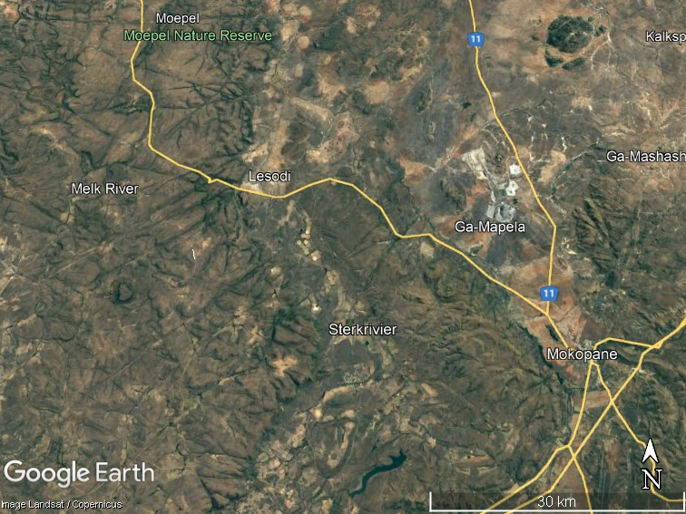**Figure 1: Google Earth map of the general area to show the relative landmarks. The proposed NTT Witwater airfield indicated by the arrow.**

Figure 2: Google Earth Map of the proposed NTT Witwater Airfield. Runway shown by the thin white line.

# Methods and Terms of Reference

The Terms of Reference (ToR) for this study were to undertake a PIA and provide feasible management measures to comply with the requirements of SAHRA.

The methods employed to address the ToR included:

1. Consultation of geological maps, literature, palaeontological databases, published and unpublished records to determine the likelihood of fossils occurring in the affected areas. Sources included records housed at the Evolutionary Studies Institute at the University of the Witwatersrand and SAHRA databases;
2. Where necessary, site visits by a qualified palaeontologist to locate any fossils and assess their importance (*not applicable to this assessment*);
3. Where appropriate, collection of unique or rare fossils with the necessary permits for storage and curation at an appropriate facility (*not applicable to this assessment*); and
4. Determination of fossils’ representivity or scientific importance to decide if the fossils can be destroyed or a representative sample collected (*not applicable to this assessment*).

# Geology and Palaeontology

## Project location and geological context

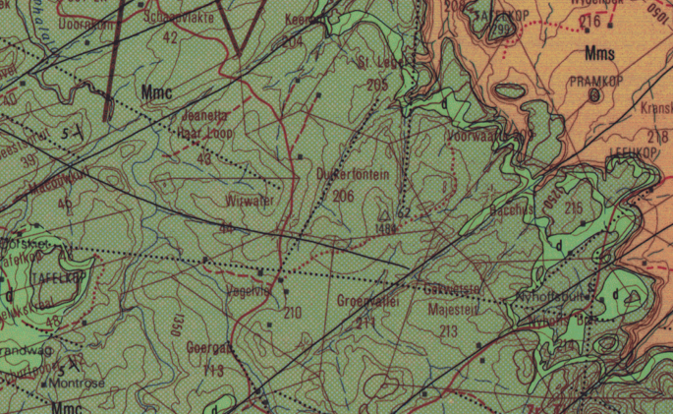

Figure 3: Geological map of the area around the Farm Witwater 44. The location of the proposed project is indicated within the yellow rectangle. Abbreviations of the rock types are explained in Table 2. Map enlarged from the Geological Survey 1: 250 000 map 2428 Nylstroom.

Table 2: Explanation of symbols for the geological map and approximate ages (Barker et al., 2006; Johnson et al., 2006). SG = Supergroup; Fm = Formation; Ma = million years; grey shading = formations impacted by the project.

| **Symbol** | **Group/Formation** | **Lithology** | **Approximate Age** |
| --- | --- | --- | --- |
| Q | Quaternary | Alluvium, sand, calcrete | Neogene, ca 2.5 Ma to present |
| di | diabase | Dolerite dykes, intrusive | Jurassic, approx. 180 Ma |
| Mmc | Mogalakwena Fm, Kransberg Subgroup, Waterberg Group | Coarse-grained purplish-brown sandstone | Palaeoproterozoic  2080 – 1880 Ma |
| Mms | Makgabeng Fm, Matlabas Subgroup, Waterberg Group | Fine to medium, sometimes feldspathic, sandstone | Palaeoproterozoic  2080 – 1880 Ma |

The project lies in the north central part of main Waterberg Basin in western and central Limpopo. To the north is the Ellisras basin with Karoo Supergroup sediments and both sequences are unconformably overlain by much younger sands of Quaternary age (Figure 3).

The Waterberg Group occurs in the Waterberg and Nylstroom Basins (Barker et al., 2006) and rests unconformably on rocks of the Transvaal Supergroup and the Bushveld Complex. It is overlain by Karoo Supergroup rocks. Three subgroups are recognised throughout the main Waterberg Basin but only the oldest subgroup occurs in the Nylstroom Basin. Different formations are noted in the south, southwest and central areas compared to the North, northeast and central areas according to SACS (1980). The three subgroups are the Nylstroom Subgroup that has been divided in to the lower Swaershoek Formation and upper Alma Formation. The Matlabas Subgroup is the middle stratum and has been divided into two formations in each of the southern parts and the northern parts, namely the Skilpadop and Aasvoelskop Formations in the former area and the Setloale and Makgabeng Formations in the northern part. The upper Kransberg Subgroup has three formations in the southern part (Sandriviersberg, Cleremont and Vaalwater Formations) and three formations in the northern part (**Mogalakwena**, Cleremont and Vaalwater Formations).

The Waterberg Group was deposited between 2080 and 1880 million years ago, well after the Great Oxidation Event (GOE, ca 2.5Ga) so oxygen was available and these shallow water deposits are known as red beds. The Nylstroom and Matlabas Subgroups form a crude upward-fining sequence with rudites and arenites at the base and grading to lutites and well-sorted arenites at the top. The overlying Kransberg Subgroup forms a second, similar, upward-fining sequence in the Waterberg Basin (Barker et al., 2006; Simpson et al., 2013).

Some parts of the area are covered by much younger sands, aeolian sands and surface calcrete of the Gordonia Formation (Kalahari Group). These originate from the north east and cover lower lying areas (Partridge et al., 2006).

## Palaeontological context

The palaeontological sensitivity of the area under consideration is presented in Figure 4. The site for development is in the moderately sensitive (green) Mogalakwena Formation.

The Waterberg Group sandstones represent four phases of sedimentary infilling of the three ancient basins. There is some evidence for periodic arid conditions indicated in the Makgabeng Formation from the dunes and cross-bedding, and the braided streams channel sandstones in the Mogalakwena Formation (Corcoran et al., 2013). In contrast, Simpson et al. (2013) advocate the presence of microbial mats using the terminology of Noffke et al. (2001). Microbial activity is recognised by the very subtle sedimentary structures such as roll-up structures, sand cracks, wrinkle structures, tufted microbial mats, biological soils crusts and gas-escape features. These structures have only been found in the Makgabeng Formation but the SAHRIS palaeosensitivity map, based on the Palaeotechnical Report for Limpopo (Groenewald et al., 2014), suggests that they may be more widespread.

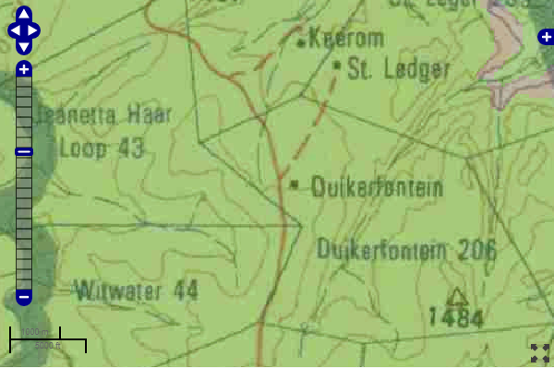

Figure 4: SAHRIS palaeosensitivity map for the site for the proposed NTT Witwater Airfield shown within the yellow rectangle. Background colours indicate the following degrees of sensitivity: red = very highly sensitive; orange/yellow = high; green = moderate; blue = low; grey = insignificant/zero.

# Impact assessment

An assessment of the potential impacts to possible palaeontological resources considers the criteria encapsulated in Table 3:

Table 3a: Criteria for assessing impacts

|  |  |  |
| --- | --- | --- |
| PART A: DEFINITION AND CRITERIA | | |
| **Criteria for ranking of the SEVERITY/NATURE of environmental impacts** | **H** | Substantial deterioration (death, illness or injury). Recommended level will often be violated. Vigorous community action. |
| **M** | Moderate/ measurable deterioration (discomfort). Recommended level will occasionally be violated. Widespread complaints. |
| **L** | Minor deterioration (nuisance or minor deterioration). Change not measurable/ will remain in the current range. Recommended level will never be violated. Sporadic complaints. |
| **L+** | Minor improvement. Change not measurable/ will remain in the current range. Recommended level will never be violated. Sporadic complaints. |
| **M+** | Moderate improvement. Will be within or better than the recommended level. No observed reaction. |
| **H+** | Substantial improvement. Will be within or better than the recommended level. Favourable publicity. |
| **Criteria for ranking the DURATION of impacts** | **L** | Quickly reversible. Less than the project life. Short term |
| **M** | Reversible over time. Life of the project. Medium term |
| **H** | Permanent. Beyond closure. Long term. |
| **Criteria for ranking the SPATIAL SCALE of impacts** | **L** | Localised - Within the site boundary. |
| **M** | Fairly widespread – Beyond the site boundary. Local |
| **H** | Widespread – Far beyond site boundary. Regional/ national |
| **PROBABILITY**  **(of exposure to impacts)** | **H** | Definite/ Continuous |
| **M** | Possible/ frequent |
| **L** | Unlikely/ seldom |

Table 3b: Impact Assessment

| PART B: Assessment | | |
| --- | --- | --- |
| **SEVERITY/NATURE** | **H** | - |
| **M** | - |
| **L** | Soils do not preserve fossils; so far there are no records from the Mogalakwena Fm sandstones of microbial feaures in this region so it is very unlikely that fossils occur on the site. The impact would be negligible |
| **L+** | - |
| **M+** | - |
| **H+** | - |
| **DURATION** | **L** | - |
| **M** | - |
| **H** | Where manifest, the impact will be permanent. |
| **SPATIAL SCALE** | **L** | Since the only possible fossils within the area would be trace fossils in the sandstones, the spatial scale will be localised within the site boundary. |
| **M** | - |
| **H** | - |
| **PROBABILITY** | **H** | **-** |
| **M** | **-** |
| **L** | It is extremely unlikely that any fossils would be found in the loose soils and sands that cover the area or in the sandstones of the underlying Mogalakwena Fm that might be excavated. Nonetheless, a Fossil Chance Find Protocol should be added to the eventual EMPr. |

Based on the nature of the project, surface activities may impact upon the fossil heritage if preserved in the development footprint. The geological structures suggest that the rocks are mostly much too old to contain body fossils but might have microbial traces. Furthermore, the material to be excavated is soil and this does not preserve fossils. Since there is an extremely small chance that fossils from sandstones below the ground may be disturbed a Fossil Chance Find Protocol has been added to this report. Taking account of the defined criteria, the potential impact to fossil heritage resources is extremely low.

# Assumptions and uncertainties

Based on the geology of the area and the palaeontological record as we know it, it can be assumed that the formation and layout of the dolomites, sandstones, shales and sands are typical for the country and only some contain trace fossils, fossil plant, insect, invertebrate and vertebrate material. The sands of the Quaternary period would not preserve fossils. It is not known if the Mogalakwena Formation even has microbial traces, or if there are any sandstones below the ground surface.

# Recommendation

Based on experience and the lack of any previously recorded fossils from the area, it is extremely unlikely that any fossils would be preserved in the overlying soils and sands of the Quaternary. There is a very small chance that fossils may occur below ground in the sandstones of the Mogalakwena Formation so a Fossil Chance Find Protocol should be added to the EMPr. If fossils are found by the environmental officer, or other responsible person once excavations for foundations have commenced then they should be rescued and a palaeontologist called to assess and collect a representative sample. The impact on the palaeontological heritage would be very low, so as far as the palaeontology is concerned, the project should be authorised.

# References

Barker, O B., Brandl, G., Callaghan, C.C., Erikssen, P.G., van der Neut, M., 2006. The Soutpansberg and Waterberg Groups and the Blouberg Formation. In: Johnson, M.R., Anhaeusser, C.R. and Thomas, R.J., (Eds). The Geology of South Africa. Geological Society of South Africa, Johannesburg / Council for Geoscience, Pretoria. Pp 301-318.

Corcoran, P.L., Bumby, A.J. and Davis, D.W., 2013. The Paleoproterozoic Waterberg Group, South Africa: provenance and its relation to the timing of the Limpopo orogeny. Precambrian Research, 230, 45-60.

Groenewald, G., Groenewald, D., Groenewald, S., 2014. SAHRA Palaeotechnical Report. Palaeontological Heritage of Limpopo. 22 pages.

Johnson, M.R., van Vuuren, C.J., Visser, J.N.J., Cole, D.I., Wickens, H.deV., Christie, A.D.M., Roberts, D.L., Brandl, G., 2006. Sedimentary rocks of the Karoo Supergroup. In: Johnson, M.R., Anhaeusser, C.R. and Thomas, R.J., (Eds). The Geology of South Africa. Geological Society of South Africa, Johannesburg / Council for Geoscience, Pretoria. Pp 461 – 499.

Noffke, N., Gerdes, G., Klenke, Th., Krumbein, W.E., 2001. Microbially induced sedimentary structures indicating climatological, hydrologically, and depositional conditions within recent and Pleistocene coastal facies zones (southern Tunisia).Facies 44, 23–30.

Partridge, T.C., Botha, G.A., Haddon, I.G., 2006. Cenozoic deposits of the interior. In: Johnson, M.R., Anhaeusser, C.R. and Thomas, R.J., (Eds). The Geology of South Africa. Geological Society of South Africa, Johannesburg / Council for Geoscience, Pretoria. Pp 585-604.

Simpson, E.L., Heness, E., Bumby, A., Eriksson, P.G., Eriksson, K.A, Hilbert-Wolf, H.L., Linnevelt, S., Malenda, H.F., Modungwa, T., Okaforba, O.J., 2013. Evidence for 2.0 Ga continental microbial mats in a paleodesert setting. Precambrian Research 327, 36-50.

South African Committee for Stratigraphy (SACS), 1980. Stratigraphy of South Africa. Part 1 (Comp. L.E. Kent). Lithostratigraphy of the Republic of South Africa, South West Africa/Namibia, and the republics of Bophuthatswana, Transkei and Venda. Handbook Geological Survey of South Africa, 8, 689pp.

# Chance Find Protocol

**Monitoring Programme for Palaeontology – to commence once the excavations activities begin.**

1. The following procedure is only required if fossils are seen on the surface and when excavations commence.
2. When excavations begin the rocks and must be given a cursory inspection by the environmental officer or designated person. Any fossiliferous material (plants, insects, bone or coal) should be put aside in a suitably protected place. This way the project activities will not be interrupted.
3. Photographs of similar fossils must be provided to the developer to assist in recognizing the fossil plants, vertebrates, invertebrates or trace fossils in the shales and mudstones (for example see Figure 5). This information will be built into the EMP’s training and awareness plan and procedures.
4. Photographs of the putative fossils can be sent to the palaeontologist for a preliminary assessment.
5. If there is any possible fossil material found by the developer/environmental officer then the qualified palaeontologist sub-contracted for this project, should visit the site to inspect the selected material and check the dumps where feasible.
6. Fossil plants or vertebrates that are considered to be of good quality or scientific interest by the palaeontologist must be removed, catalogued and housed in a suitable institution where they can be made available for further study. Before the fossils are removed from the site a SAHRA permit must be obtained. Annual reports must be submitted to SAHRA as required by the relevant permits.
7. If no good fossil material is recovered then no site inspections by the palaeontologist will be necessary. A final report by the palaeontologist must be sent to SAHRA once the project has been completed and only if there are fossils.
8. If no fossils are found and the excavations have finished then no further monitoring is required.

# Appendix A – Examples of microbial traces fossils from the Waterberg Group.

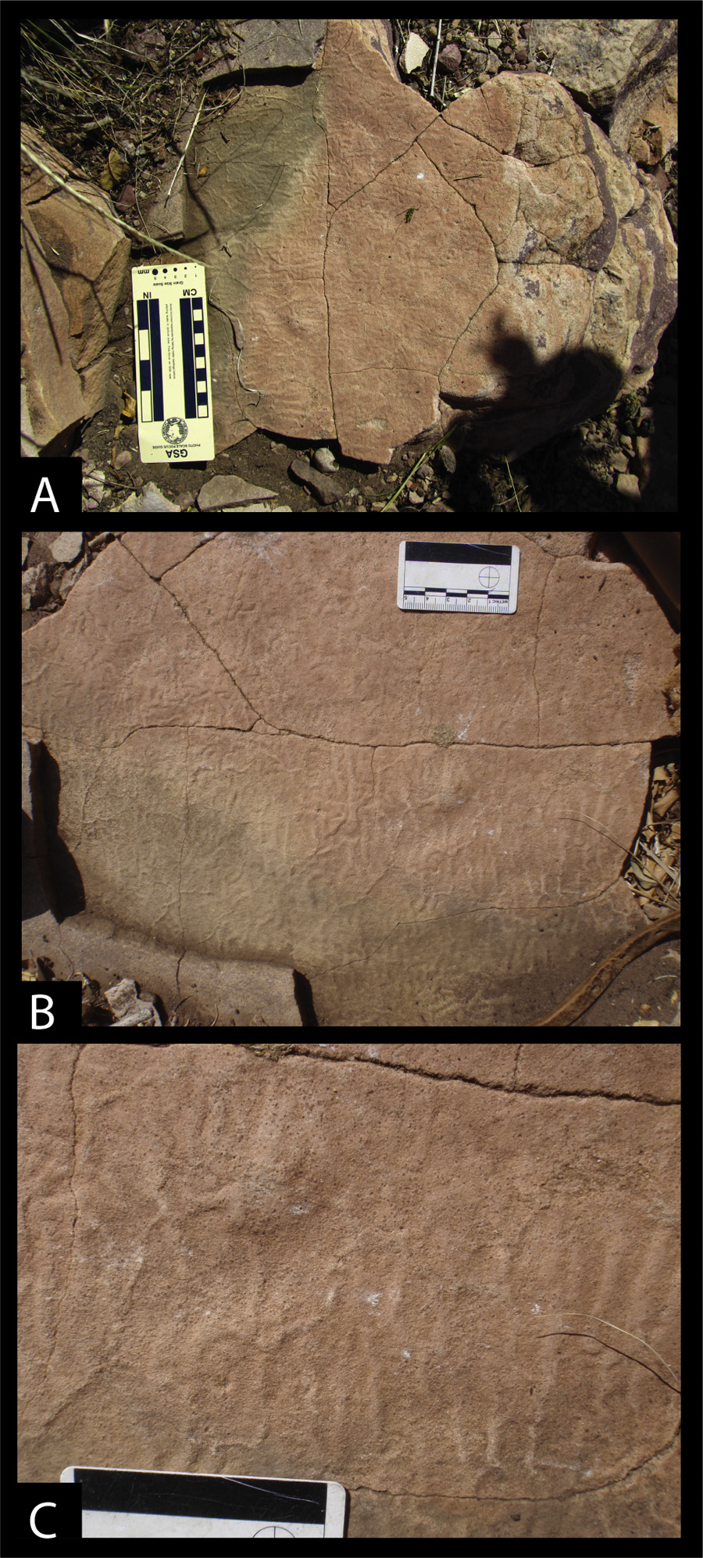

**Figure 5: Makgabeng Formation trace fossils. *From Simpson et al., 2013: Fig. 10. Field photographs of the wrinkled mats on bedding planes. (A) Outcropping of wrinkled mats in interdune deposit. Scale is in cm. (B) Enlargement showing complex, wrinkle morphology. Scale is in cm. (C) Wrinkle mat close up. In top portion is an elevated mound with radiating wrinkles. Scale is 5 cm.***

# Appendix B – Details of specialist

**Curriculum vitae (short) - Marion Bamford PhD**

**July 2023**

1. **Personal details**

Surname : **Bamford**

First names : **Marion Kathleen**

Present employment : Professor; Director of the Evolutionary Studies Institute.

Member Management Committee of the NRF/DST Centre of

Excellence Palaeosciences, University of the Witwatersrand,

Johannesburg, South Africa

Telephone : +27 11 717 6690

Fax : +27 11 717 6694

Cell : 082 555 6937

E-mail : [marion.bamford@wits.ac.za](mailto:marion.bamford@wits.ac.za) ;

marionbamford12@gmail.com

**ii) Academic qualifications**

Tertiary Education: All at the University of the Witwatersrand:

1980-1982: BSc, majors in Botany and Microbiology. Graduated April 1983.

1983: BSc Honours, Botany and Palaeobotany. Graduated April 1984.

1984-1986: MSc in Palaeobotany. Graduated with Distinction, November 1986.

1986-1989: PhD in Palaeobotany. Graduated in June 1990.

NRF Rating: C-2 (1999-2004); B-3 (2005-2015); B-2 (2016-2020); B-1 (2021-2026)

**iii) Professional qualifications**

*Wood Anatomy Training (overseas as nothing was available in South Africa)*:

1994 - Service d’Anatomie des Bois, Musée Royal de l’Afrique Centrale, Tervuren, Belgium, by Roger Dechamps

1997 - Université Pierre et Marie Curie, Paris, France, by Dr Jean-Claude Koeniguer

1997 - Université Claude Bernard, Lyon, France by Prof Georges Barale, Dr Jean-Pierre Gros, and Dr Marc Philippe

**iv) Membership of professional bodies/associations**

Palaeontological Society of Southern Africa

Royal Society of Southern Africa - Fellow: 2006 onwards

Academy of Sciences of South Africa - Member: Oct 2014 onwards

International Association of Wood Anatomists - First enrolled: January 1991

International Organization of Palaeobotany – 1993+

Botanical Society of South Africa

South African Committee on Stratigraphy – Biostratigraphy - 1997 - 2016

SASQUA (South African Society for Quaternary Research) – 1997+

PAGES - 2008 –onwards: South African representative

ROCEEH / WAVE – 2008+

INQUA – PALCOMM – 2011+onwards

**vii) Supervision of Higher Degrees**

All at Wits University

|  |  |  |
| --- | --- | --- |
| Degree | Graduated/completed | Current |
| Honours | 13 | 0 |
| Masters | 11 | 3 |
| PhD | 11 | 6 |
| Postdoctoral fellows | 15 | 4 |

**viii) Undergraduate teaching**

Geology II – Palaeobotany GEOL2008 – average 65 students per year

Biology III – Palaeobotany APES3029 – average 45 students per year

Honours – Evolution of Terrestrial Ecosystems; African Plio-Pleistocene Palaeoecology; Micropalaeontology – average 12-20 students per year.

**ix) Editing and reviewing**

Editor: Palaeontologia africana: 2003 to 2013; 2014 – Assistant editor

Guest Editor: Quaternary International: 2005 volume

Member of Board of Review: Review of Palaeobotany and Palynology: 2010 –

Associate Editor Open Science UK: 2021 -

Review of manuscripts for ISI-listed journals: 30 local and international journals

Reviewing of funding applications for NRF, PAST, NWO, SIDA, National Geographic, Leakey Foundation

**x) Palaeontological Impact Assessments**

Selected from the past five years only – list not complete:

* Overlooked Quarry 2019 for Cabanga
* Richards Bay Powerline 2019 for NGT
* Eilandia dam 2019 for ACO
* Eastlands Residential 2019 for HCAC
* Fairview MR 2019 for Cabanga
* Graspan project 2019 for HCAC
* Lieliefontein N&D 2019 for EnviroPro
* Skeerpoort Farm Mast 2020 for HCAC
* Vulindlela Eco village 2020 for 1World
* KwaZamakhule Township 2020 for Kudzala
* Sunset Copper 2020 for Digby Wells
* McCarthy-Salene 2020 for Prescali
* VLNR Lodge 2020 for HCAC
* Madadeni mixed use 2020 for EnviroPro
* Frankfort-Windfield Eskom Powerline 2020 for 1World
* Beaufort West PV Facility 2021 for ACO Associates
* Copper Sunset MR 2021 for Digby Wells
* Sannaspos PV facility 2021 for CTS Heritage
* Smithfield-Rouxville-Zastron PL 2021 for TheroServe
* Glosam Mine 2022 for AHSA
* Wolf-Skilpad-Grassridge OHPL 2022 for Zutari
* Iziduli and Msenge WEFs 2022 for CTS Heritage
* Hendrina North and South WEFs & SEFs 2022 for Cabanga
* Dealesville-Springhaas SEFs 2022 for GIBB Environmental
* Vhuvhili and Mukondeleli SEFs 2022 for CSIR
* Chemwes & Stilfontein SEFs 2022 for CTS Heritage
* Equestria Exts housing 2022 for Beyond Heritage
* Zeerust Salene boreholes 2022 for Prescali
* Tsakane Sewer upgrade 2022 for Tsimba
* Transnet MPP inland and coastal 2022 for ENVASS
* Ruighoek PRA 2022 for SLR Consulting (Africa)
* Namli MRA Steinkopf 2022 for Beyond Heritage

**xi) Research Output**

Publications by M K Bamford up to July 2023 peer-reviewed journals or scholarly books: over 170 articles published; 5 submitted/in press; 10 book chapters.

Scopus h-index = 31; Google scholar h-index = 39; -i10-index = 116.

Conferences: numerous presentations at local and international conferences.