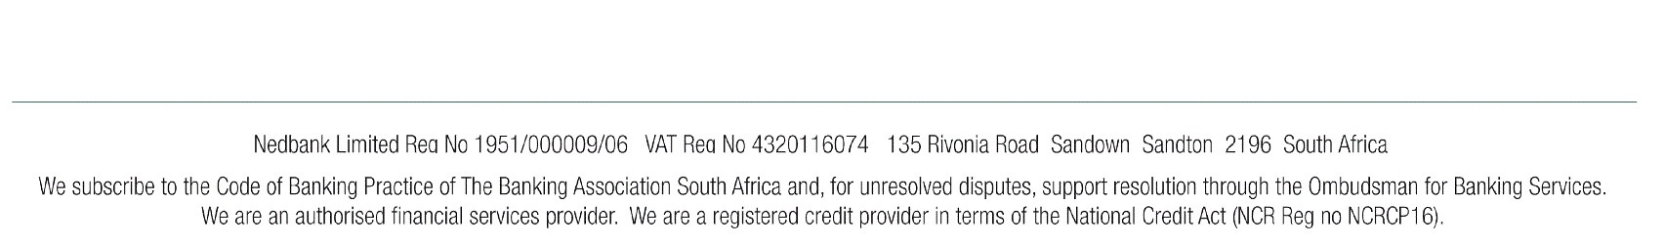Notification of Payment

Nedbank Limited confirms that the following payment has been made:

Date of Payment :
Reference Number :
Beneficiary details
Recipient :
Amount :
14/09/2022
2022-09-14/Nedbank/003657705412

AMAFA
R4000.00

Recipient Reference : 1513 Sarnia Rd Hillary. Third

Bank :
Account Number :
Channel :
Payer details
Paid from Account Holder :
ABSA BANK
...356024
Internet payment

THIRD DAY MINISTRIES

Nedbank will never send you an e-mail link to access Verify payments, always go to Online Banking on
www.nedbank.co.za and click on Verify payments.
This notification of payment is sent to you by Nedbank Limited Reg No 1951/000009/06. Enquiries regarding this payment notification should be directed to the Nedbank Contact Centre on 0860 555 111. Please contact the payer for enquiries regarding the contents of this notification.
Nedbank Ltd will not be held responsible for the accuracy of the information on this notification and we accept no liability whatsoever arising from the transmission and use of the information.
Payments may take up to three business days. Please check your account to verify the existence of the funds.
Note: We as a bank will never send you an e-mail requesting you to enter your personal details or private identification
and authentication details.
Nedbank Limited email disclaimer
This email and any accompanying attachments may contain confidential and proprietary information. This information is private and protected by law and, accordingly, if you are not the intended recipient, you are requested to delete this entire communication immediately and are notified that any disclosure, copying or distribution of or taking any action based on this information is prohibited. Emails cannot be guaranteed to be secure or free of errors or viruses. The sender does not accept any liability or responsibility for any interception, corruption, destruction, loss, late arrival or incompleteness of or tampering or interference with any of the information contained in this email or for its incorrect delivery or non-delivery for whatsoever reason or for its effect on any electronic device of the recipient. If verification of this email or any attachment is required, please request a hard copy version.

Security Code : E2E024540FE295795C50BD4B80809EC08388C63D

