

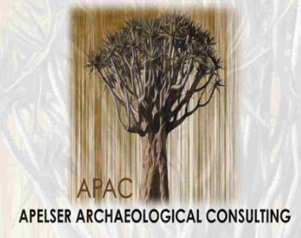

Comprehensive and Professional Solutions for all Heritage Related Matters

**CK 2006/014630/23 VAT NO.: 4360226270**

**A REPORT ON THE ARCHAEOLOGICAL INVESTIGATION**

**OF LATE IRON AGE STONE WALLED SITES**

**IMPACTED ON BY THE ESKOM STEELPOORT-TUBATSE SWITHCHING STATION LOCATED ON PORTION 5 OF THE FARM LUIPERSHOEK 149JS, NEAR STEELPOORT, LIMPOPO**

For:

***Savannah Environmental (Pty) Ltd***

***P.O.Box 148***

***SUNNINGHILL***

***2157***

REPORT: **APAC013/78**

***A.J. Pelser***

***Professional Member of ASAPA***

Field Work conducted: ***October 2013*** Report: ***January 2014***

|  |
| --- |
| **P.O.BOX 73703** |
| **LYNNWOOD RIDGE** |
| **0040** |
| **Tel: 083 459 3091** |
| **Fax: 086 695 7247** |
| **Email: pelseranton@gmail.com** |

**Member: AJ Pelser BA (UNISA), BA (Hons) (Archaeology), MA (Archaeology) [WITS]**

**©Copyright**

**APELSER ARCHAEOLOGICAL CONSULTING**

**The information contained in this report is the sole intellectual property of APelser Archaeological Consulting. It may only be used for the purposes it was commissioned for by the client.**

**I HEREBY DECLARE THAT I AM AN INDEPENDENT**

**SPECIALIST APPOINTED BY THE CLIENT ON A CONSULTANCY BASIS**



**SUMMARY**

APelser Archaeological Consulting was appointed by Savannah Environmental (Pty) Ltd, on behalf of ESKOM, to undertake the Phase 2 Archaeological Mitigation (Excavations & Mapping) of a Late Iron Age (LIA) stone walled settlement site that will be impacted by the development of the Tubatse Switching Station, forming part of ESKOM’s Steelpoort-Marble Hall Integration Project. The settlement site was identified by Van Schalkwyk in 2012, and reported on in an amended report in January 2013.

As part of the mitigation work a preliminary mapping exercise was also undertaken in order to identify all possible settlement features that could be negatively impacted by ESKOM’s Geotechnical test pits, done prior to the construction of the Substation and related infrastructure. The identification of features that formed the focus of the Phase 2 archaeological excavations also formed part of this mapping exercise.

After the obtaining of an excavation permit from SAHRA (Permit No.: 606) archaeological work on the site was conducted during October 2013, and included a number of shovel test pits (STP’s) and a formal excavation on a cattle kraal (the only area with clear material deposit), as well as some more mapping of stone walled features. This report discusses the results of the fieldwork, and provides recommendations on the way forward in terms of the destruction of the site for development purposes. It is believed that the work was done successfully and that the development of the Switching Station can now proceed once the Destruction Permit has been issued by SAHRA.

**CONTENTS**

SUMMARY 3

CONTENTS 4

INTRODUCTION 5

AIMS 5

METHODOLOGY 6

ARCHAEOLOGICAL BACKGROUND 6

ARCHAEOLOGICAL INVESTIGATIONS 14

1. *MAPPING* 14
2. *EXCAVATIONS* 20
3. *RESULTS* 22
4. *DISCUSSION OF CULTURAL MATERIAL* 27

CONCLUSIONS AND RECOMMENDATIONS 34

REFERENCES 36

ACKNOWLEDGEMENTS 36

**A REPORT ON THE ARCHAEOLOGICAL INVESTIGATION**

**OF LATE IRON AGE STONE WALLED SITES**

**IMPACTED ON BY THE ESKOM STEELPOORT-TUBATSE SWITHCHING STATION LOCATED ON PORTION 5 OF THE FARM LUIPERSHOEK 149JS, NEAR STEELPOORT, LIMPOPO**

**INTRODUCTION**

APelser Archaeological Consulting was appointed by Savannah Environmental (Pty) Ltd, on behalf of ESKOM, to undertake the Phase 2 Archaeological Mitigation (Excavations & Mapping) of a Late Iron Age (LIA) stone walled settlement site that will be impacted by the development of the Tubatse Switching Station, forming part of ESKOM’s Steelpoort-Marble Hall Integration Project.

As part of the mitigation work a preliminary mapping exercise was also undertaken in order to identify all possible settlement features that could be negatively impacted by ESKOM’s Geotechnical test pits, done prior to the construction of the Substation and related infrastructure. The identification of features that formed the focus of the Phase 2 archaeological excavations also formed part of this mapping exercise.

After the obtaining of an excavation permit from SAHRA (Permit No.: 606) archaeological work on the site was conducted during October 2013, and included a number of shovel test pits (STP’s) and a formal excavation on a cattle kraal (the only area with clear material deposit), as well as some more mapping of stone walled features.

The site that will be affected by the development consists of stone built agricultural terraces, livestock enclosures (kraals), granary platforms and possible hut bays. The site forms part of the stone walled settlement identified during previous Heritage studies by Van Schalkwyk and numbered T/12-14 (with the T12 site the one directly impacted by the substation development). The study area is located on Portion 5 of the farm Luipershoek 149JS.

**AIMS**

The aims of the Archaeological Investigation (including mapping of the stone walled sites and excavations were as follows:

1. to conduct excavations on various locations on the sites in order to determine the type of settlement, time-frame of occupation and material culture
2. to map the sites and features on it in detail to help with determining settlement layout and extent
3. the analysis of the cultural material recovered during the excavations
4. the drafting of a detailed report on all the findings and recommendations on the way forward and finally,
5. the proper curation of the material at a recognized institution. In this case (as per permit regulations) the material will be lodged at the repository of the Lydenburg Museum

**METHODOLOGY**

The methodology comprised the following:

***Background Research*** – This included background research on the area and its archaeology.

***Photographic*** - Photographs of the sites and area were taken, while all identifiable features, excavations and individual objects were also photographed for recording purposes.

***Mapping***

All identifiable features, excavations and the site’s extent were recorded and a map produced.

***Archaeological Excavations***

One formal excavation (on a cattle kraal area) and a number of STP’s (Shovel Test Pits) were done on the site.

***Analysis & Documentation/Curation of cultural material***

All the cultural material recovered was documented photographically and analyzed accordingly. The material was also cleaned superficially and packed in bags and boxes for delivery to Lydenburg Museum for proper curation.

**ARCHAEOLOGICAL BACKGROUND**

The larger study area (for the Steelpoort-Marble Hall 400kV Power line and Steelpoort Integration projects) involves two sections of power line corridors, most of which follows existing corridors. The longest power line runs eastwards from south of Marblehall, across the Nebo plateau, across the Lulu Mountains and down into the Steelpoort River valley, where the development of a substation is proposed. The second line runs from this substation in a north-westerly direction to the farm Syferfontein 136JS, where a new substation will be constructed. To be expected with such a large study area, the environment changes drastically from west to east. The west forms part of a Highveld area typified by an undulating landscape. Going down the escarpment to the middle veld, the area is typified by mountains. In contrast, the eastern section is marked by mountains and hills, creating a broken type of environment (Van Schalkwyk, 2013:2).

The Tubatse Switching Station is located on Portion 5 of the farm Luipershoek 149 JS, and is situated in the Steelpoort Valley around 40km west of Steelpoort. The topography of the site is relatively flat, although very rocky, and is surrounded by mountain ranges (Lulu Mountain). Dense tree cover and grass makes identifying sites and features difficult, although the site had been cleared of grass prior to the site visits. This assisted the archaeologists in identifying settlement features and conducting mapping and archaeological excavations.

The site is located at approximately S25.11248 E29.82557.

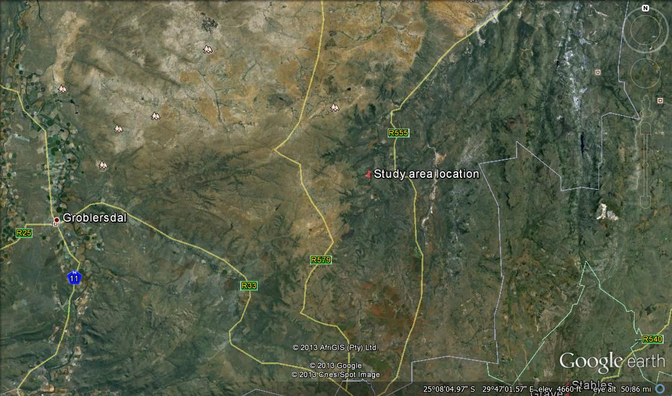

**Figure 1: Google image of study area location (Google Earth 2013).**

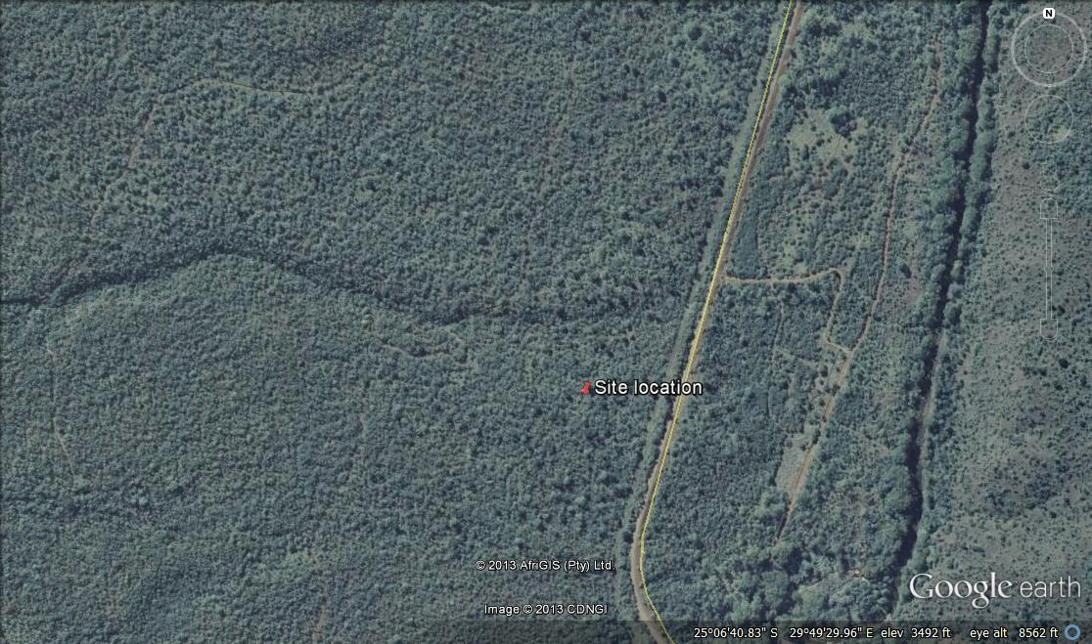

**Figure 2: Closer aerial view of site location. Note the dense tree cover.**

**Google Earth 2013.**



**Figure 3: Topographic location of sites T12-14. Note the power line corridors.**

**T12 is where the switching station is to be developed (From Van Schalkwyk 2013:p.7).**

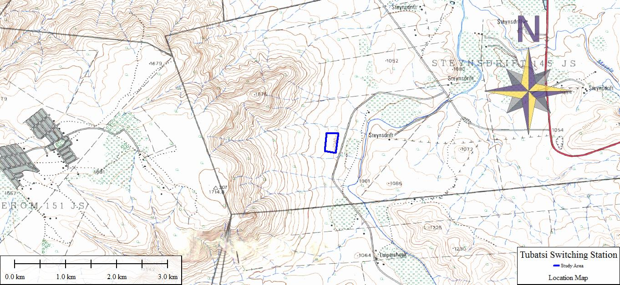

**Figure 4: Another topographic map indicating the positioning of the switching station area.**

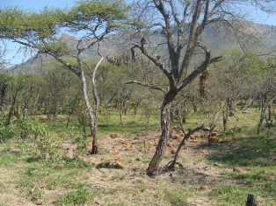

**Figure 5: A section of the site. Note the mountain ranges in the background.**

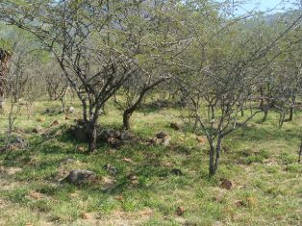

**Figure 6: Another view of a section of the area.**

**Note the tree cover. The grass had been cut making**

**visibility easier and exposing the stone walled features.**

The site that will be impacted on by the development of the Tubatse Switching Station was identified in late 2012 by Van Schalkwyk during a Heritage Walkdown. It forms part of a larger Late Iron Age (LIA) stone walled settlement complex, numbered T12-14.

Sites 13 & 14 represent a large settlement site. It dates to the Late Iron Age and consists of homestead areas, public areas such as a male gathering place and livestock enclosures (cattle and other smaller livestock). It measures approximately 500 X 400 meters (north/south by east/west), with a small section on the western side of the road.

Site 12 (the site impacted by the development) represents the agricultural terracing and fields of the former, although some homestead areas were also identified.

Van Schalkwyk indicated that the significance of the settlement site as High on a Regional level (Grade III) and recommended that if the substation location cannot be moved away from the archaeological site, that archaeological excavations should be conducted to negate the impacts of the development.

The preliminary mapping of the site (T12) focused on determining the nature of the settlement, types of features present, as well as to mark significant features and areas that had to be avoided by the geotechnical test trenches planned for the development. It also aimed at locating features that will be focused on during the archaeological excavations to be completed as part of the Phase 2 Mitigation. It has to be mentioned that although the actual Switching Station footprint only measures 120m x 60m x 30m, related infrastructure including the access road and other structural developments forms part of the development and the area impacted on is therefore much larger. The total area cleared by the ESKOM team prior to the mapping was therefore focused on during this session.

Nearly the whole area is covered by features related to the settlement, with stone walled agricultural terracing, stone cairns (granary platforms), small and large enclosures (for livestock) and possible hut (residential) bays. With agricultural terracing forming a large part of the site, and with the potential of disturbing significant archaeological deposits on the terraces being fairly low, it was decided to focus the mapping exercise on determining those features and areas on the site that could potentially contain highly significant deposits such as livestock and residential (hut) enclosures and granaries and that need to be avoided during the geotechnical testing. These features were plotted on a map and will help in planning the positioning of the geotechnical pits.

The features that were identified (and need to be avoided) were also the ones that will be focused on by the excavations during the Phase 2 Mitigation. The archaeological investigations (excavations & further mapping) planned on the site aimed at recovering as much cultural material and data as possible in order to facilitate the interpretation and reconstruction of the cultural history of the site. Once this has been completed a Destruction Permit will be applied for in order for the development to continue.

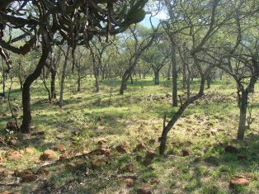

**Figure 8: A view of the agricultural terracing found on the site.**

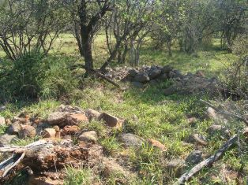

**Figure 9: Stone walling on the site. This is a circular enclosure that could be a livestock (cattle) kraal.**

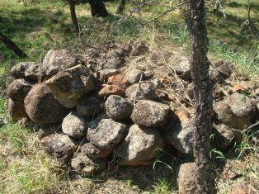

**Figure 10: A granary stand/platform on the site.**

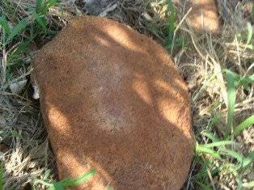

**Figure 11: A lower grinding stone on the site.**

The origins of the first Bantu-Negroid farming communities who practised agriculture, live-stock herding and metal working can be traced to the SteelpoortValley. These Early Iron Age farming communities, whose settlements have been recorded on amongst others Hendriksplaats 281 and Derde Gelid 278, were related to Early Iron Age communities who, contemporaneously, from AD500 to AD900, settled further towards the east in the Lydenburg Valley. One of the settlements belonging to the Early Iron Age Lydenburg culture won international acclaim as the so-called Lydenburg Heads (clay masks) were discovered at this site near the Sterkspruit, south of Lydenburg (Pistorius 2013: 18).

The historical period in the SteelpoortValley is associated with the second millennium AD when a predominantly Northern Sotho-speaking population occupied the Steelpoort. These people are part of a larger Northern Sotho-speaking community who occupy a vast area between the Limpopo River in the north, the Drakensberg in the east and the Sekhukhune Mountains in the west. Numerous divisions and groups or clans occupied this vast region. The history of the people of this area can be divided into several periods:

The earliest period of settlement is characterized by small groups of Bantu speaking people who started to drive the San and Khoi Khoi from the area and who are difficult to identify. From approximately AD1700 ancestral groupings of the present inhabitants of the land began to arrive in the area. Groups that can be distinguished include:

1. A large group of Sotho who came from the north-eastern parts of the Lowveld and who settled on the plateau to the north and to the south of the Strydpoortberge.

2. Small groups of Kgatla and Huruthshe-Kwena origin moved from the Tswana area (Brits and Rustenburg) into the territory. Amongst them were the present Pedi (or Rota) who moved into what is now Sekhukhuneland, where they subjected the Sotho already living there.

3. During these times Sekhukhuneland was also penetrated by Sotho arriving from the south-east.

4. After AD1600 the Northern Ndebele arrived from the south-east and settled in what is now the Mokerong district (Pistorius 2013: 19).

It is assumed that during the period from AD1700 to AD1826 the Pedi took political control over the territory previously known as Lebowa, but to the south of the Strydpoortberge. The Pedi chiefdom reached its zenith during the reign of Thulare who died in 1824. During the disruption of the difaqane (AD1822 to AD1828) Mzilikazi attacked the Pedi from the south-east in 1826 and in 1827/1828. This caused large-scale depopulation of the southern part of the Northern-Sotho territory. The Pedi sought refuge in the Soutpansberg in 1822 and only returned in 1828. After the wars with Mzilikazi there were wars with the Swazi. The Voortrekkers arrived in the Steelpoort area in the late 1840’s. Several armed struggles between the Voortrekkers and the Pedi ensued (Pistorius 2013: 19-20).

After the British annexed the Transvaal (AD1877 to AD1881) the Pedi was subjugated by the British who were supported by the Swazi during the war of Sekhukhune in 1879. In 1842 Andries Hendrik Potgieter wished to move from the British sphere of influence and to establish trade relations with Delagoa Bay. He moved with his followers from Potchefstroom to the Eastern Transvaal and founded Andries Ohrigstad (named after himself and Gergios Gerhardus Ohrig, a merchant from Amsterdam who was well disposed towards the Voortrekkers). The name was later abbreviated to Ohrigstad. The town also served as the seat of the Volksraad. During 1848 to 1849 Ohrigstad was abandoned when many people died of malaria. The town of Lydenburg was founded further to the south near the confluence of the Sterkspruit and the Spekboom River. This area was located on higher ground and was therefore healthier than Ohrigstad. The railway line between Steelpoort and Lydenburg was constructed in 1924 due to an increase in the mining of chrome and magnetite. The name Steelpoort is derived from a hunting expedition that took place either in the late 19th century or the early 20th century. When a group of Voortrekkers from Natal under Frans Joubert had settled there, a man called Scholtz shot an elephant at dusk and on returning next morning found that the tusks had been removed. When the wagons were searched, the tusks were found in the possession of a man called Botha, after which the farm Bothashoek was named. Because an elephant had been killed there, the poort was named Olifantspoort. The river flowing through the Poort was called Steelpoort River [‘steel’ meaning steal] (Pistorius 2013: 20).

The Pedi were governed by Thulware until his death in 1824. His main village was Monganeng on the banks of the Tubatse River. His son, Sekwati, fled to the Soutpansberg in the north during the raids of Mzilikazi in 1822. He returned in 1828 and occupied the mountain fortress Phiring, his capital from where he united the Pedi. The Pedi initially maintained good relations with the Voortrekkers who arrived in Ohrigstad from 1845. However, after a clash with Andries Hendrik Potgieter in 1852 Sekwati moved his capital to Thaba Mosego. Border disputes with the Zuid-Afrikaansche Republiek (ZAR) were settled in 1857 with an accord that stated that the Steelpoort River served as the border between Pedi land and the Lydenburg Republic. Sekwati gave the Berlin Missionary Society permission to establish the Maandagshoek missionary station in Pedi territory. After Sekwati’s death in 1861, his son Sekhukhune succeeded his father and also established his village at Thaba Mosego. He ordered the Berlin Missionary Society to discontinue their work and the mission station was burn down. Alexander Merensky, one of the missionaries, thereafter established the well-known Botšabelo missionary station at Middelburg (Pistorius 2013: 21).

The good relationship between the ZAR and the Pedi was gradually weakened. The period from 1876 to 1879 was one of conflict and war, first with the ZAR and then with the British who annexed the Transvaal in 1877. During the First Sekhukhune War in August 1876, the Voortrekkers attacked Thaba Mosego and partly destroyed the settlement. The Second Sekhukhune War followed in November 1879 during which Sekhukhune was captured in the Mamatamageng cave and sent to prison in Pretoria. Two divisions attacked the Pedi. The main division, comprised of 3 000 whites and 2 500 black allies, attacked from the north-east. The Lydenburg division consist of 5 000 to 8 000 Swazi Impi, 400 other black allies and 400 white soldiers who attacked from Burgersfort in the south. The Second Sekhukhune War is associated with the settlements of Thaba Mosego and Tšate, a new village established by Sekhukhune close to Thaba Mosego (Pistorius 2013: 21-22).

The stone walled sites located at the Tubatse Switching Station area are most likely associated with the Pedi and later Iron Age and historical period of settlement in the Steelpoort Valley.

**ARCHAEOLOGICAL INVESTIGATIONS**

The archaeological investigations at the Tubatse Switching Station site aimed at obtaining as much information as possible on the settlement layout, function, time-frame of settlement and material culture deposit present here. The methodology employed comprised mapping of the site and settlement features and archaeological excavations on certain features.

**Mapping**

The mapping was done on two occasions - once before the excavation session in order to determine the extent and nature of the site that will be impacted on by the development of the switching station and then again during the excavations. The mapping aimed at determining the type of settlement, its function and the different features located on it. Finally all excavations and shovel test pits were also recorded.

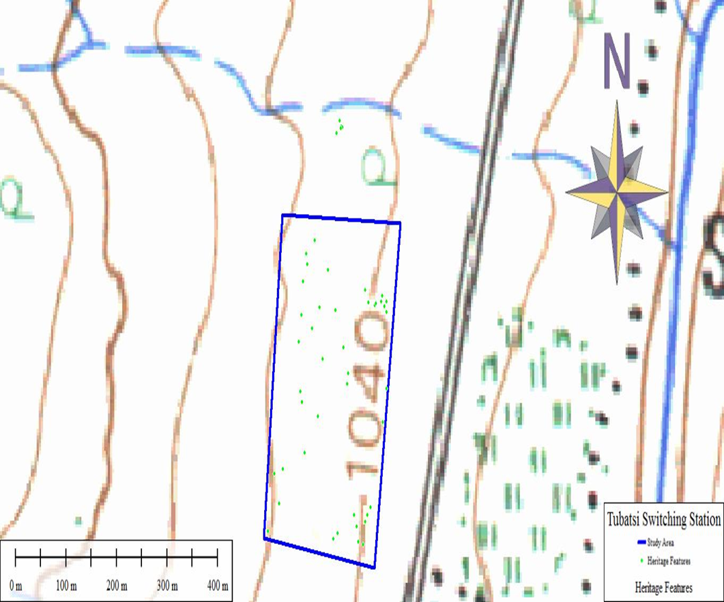

**Figure 12: Map showing positioning of features on the site. Each dot represents a feature such as stone cairn, small enclosure or upper/lower grinder. The empty spaces in between are covered by terrace walling which are not shown on this map.**

The mapping of the site clearly shows that it was mainly used for agricultural purposes, with terrace walling the dominant feature found. A number of stone cairns (platforms for grain bins/granary stands) are also found scattered across the site, while both upper grinders and lower grinding stones identified throughout are further evidence of the sites’ function mainly for agriculture.

Only a small percentage of the site contains some features associated with settlement, and includes small circular enclosures for livestock (cattle, sheep/goat) and possible hut bays. It is most likely that these features are associated with the individuals who had to tend to the fields and look after the livestock (cattle herders). Settlement sites are found higher up towards the mountains surrounding the area and on the slopes of these ranges. Furthermore very little cultural material deposit was found in the excavations and test pits, as well as on the surface of the site, pointing towards the fact again that this site mainly functioned as an agricultural area.

The mapping conducted during the October 2013 archaeological excavations focused on the section of the site (T12-14) that will be directly impacted on by the switching station development. This is T12 & 13 mainly and to a large degree T12 where mainly agricultural terracing is located. T14 falls outside the direct area of impact and was not mapped and investigated. Although there are some stone walled enclosures on these sites they were most likely not used for long-term and major human habitation, but more possibly only for limited settlement during agricultural activities and for livestock herding.

Elements recorded during the mapping were dominated by rows of terracing, some granary stands/platforms, a number of stone cairns (possibly the result of clearing of fields for ploughing) as well as both upper grinders and lower grinding stones. Other cultural material (such as pottery and faunal remains) were lacking on the surface of the sites. Some disturbance to the walling in the recent past as a result of cattle grazing has occurred (walls broken/collapsed), while the activities of baboons overturning some of the rocks for spiders & scorpions also have an impact.

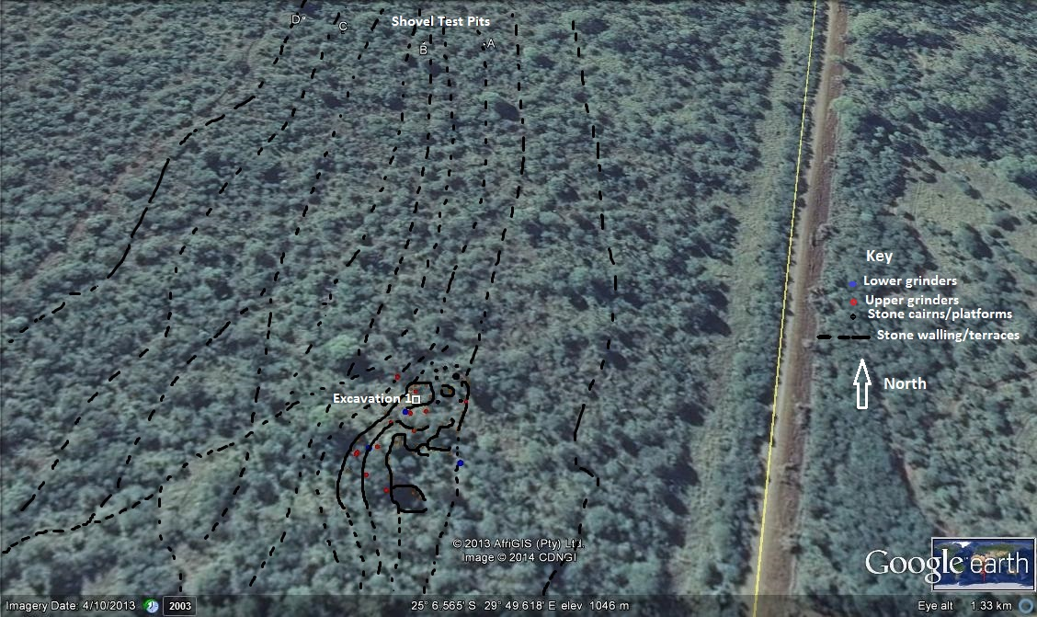

**Figure 13: Map of site. Site 13 (location of Excavation 1) contains some circular enclosures, large numbers of upper and lower grinders as well as stone cairns/platforms. The area where the shovel test pits are located is part of T12 which contains mainly agricultural terracing although there are a few small enclosures and granary stands as well (Google Earth 2014).**

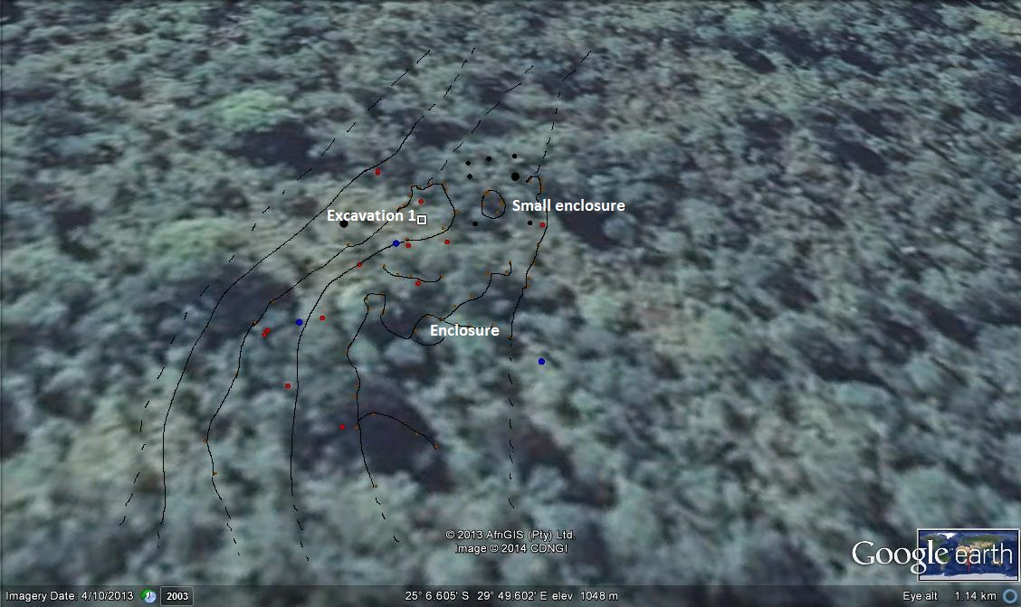

**Figure 14: A closer view of T13 showing the terracing and other features. The red dots are upper grinders, the blue lower grinding stones and the black stone cairns/platforms (Google Earth 2014).**

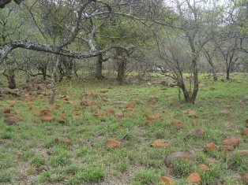

**Figure 15: A view of a section of T12/13, with terracing visible.**

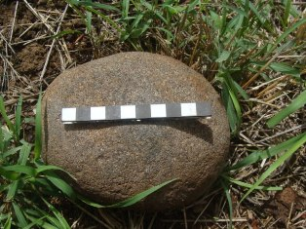

**Figure 16: A typical upper grinder found all over the site.**

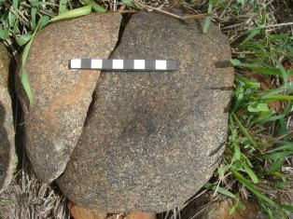

**Figure 17: A large broken lower grinding stone on the site.**

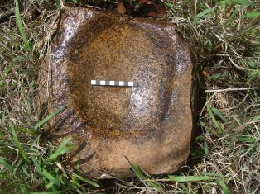

**Figure 18: Another lower grinding stone. These types of grinding**

**stones were used for the grinding of maize.**

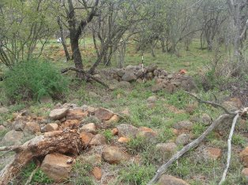

**Figure 19: One of the small circular enclosures on Site T13.**

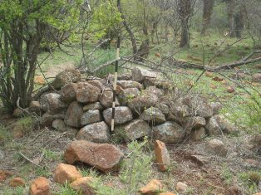

**Figure 20: One of a number of stone packed platforms found.**

**These were most likely used as grain bin stands.**

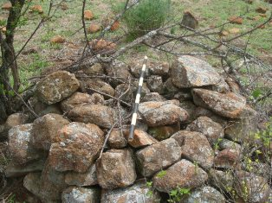

**Figure 21: Close-up of same platform showing that it is**

**nearly circular in shape.**

**Excavations**

With little or no cultural material deposit visible on the sites it was decided to conduct one formal excavation (Excavation 1) on the only area where material was visible. This was on an area with visible cattle dung that was both part of a terrace and a possible cattle kraal (Site T13). It was also decided that the terraces on Site T12 (where the switching station will be largely located) will be tested through a number of Shovel Test Pits (STP’S A-D) to see what the depth of possible deposit would be and if there would be any useable cultural material.

Excavation 1 was a 2m x 2m square excavated up to natural rock bed.

GPS Location: **S25 06.596 E29 49.593**

STP’s A – D was all approximately the size of a shovel head and was dug on alternating terraces, from the bottom of the site moving up to its end. The terraces follow the natural contours of the area.

GPS Locations: S25 06.442 E29 49.605 (A); S25 06.445 E29 49.583 (B); S25 06.443 E29 49.553 (C); S25 06.437 E29 49.538 (D).

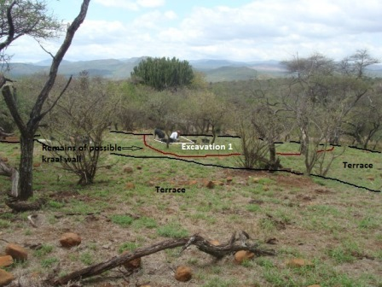

**Figure 22: The location of Excavation 1 was on top of one of the terraces on site T13.**

**The black lines indicate the terraces, while the red line shows the position of the foundations of a possible older kraal wall.**

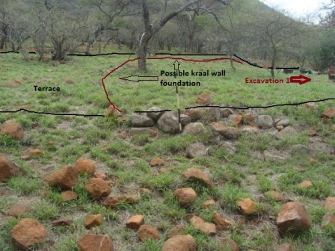

**Figure 23: Another view of the same area showing the terraces as well as the position**

**of a possible earlier kraal wall foundation.**

**Results**

***Excavation 1***

This excavation was measured out on one of the terraces that dominate the area of T13 and also T12. The motivation for placing the excavation here was the fact that it showed the most potential for cultural deposit, it was slightly elevated and contained what could be the foundations of a possible earlier kraal or enclosure. The excavation measured 2m x 2m.

The stratigraphy of the excavation consisted of a single homogenous layer of around 25cm of dark brown soil under which a layer of natural rock was located. The dark brown soil layer contained very little cultural material, although some pottery fragments and a few small bone (faunal) pieces were recovered in this layer. Material (including metal fragments, bone and pottery, was also found on top of and between the rock base but for the most part was sterile. The excavation was stopped at a depth of around 45cm below the present surface level.

Evidence that there was a possible livestock/cattle enclosure where the terrace was developed later came in the form of a thin layer of cattle dung, just below the level of the rocks (at around 26 cm depth). This layer or section of dung is located around 90cm from the northwest corner of the excavation and measures approximately 90cm (E/W direction) and for 35cm (N-S direction). It is however possible that it extends further (outside of the excavation) towards the west.

Based on the evidence found it is possible that the area where this terrace is located was initially used as a livestock enclosure before it was terraced. The area was leveled and rich top soil brought in to cover the natural rocky base of the site to enable agriculture activities. No charcoal to assist with the radiocarbon dating of the feature and site was recovered during the excavation.

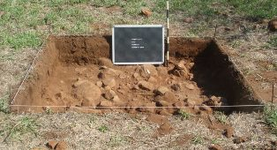

**Figure 24: Excavation 1.**

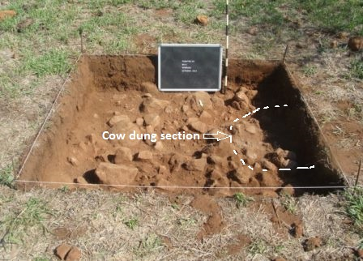

**Figure 25: Excavation 1. Note the small section of cow dung.**

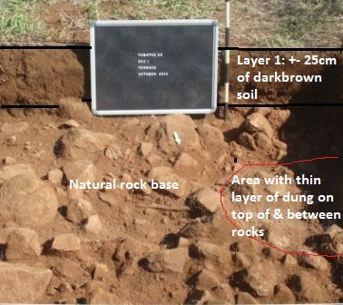

**Figure 26: Excavation 1 stratigraphy.**

***Shovel Test Pits (STP A-D)***

As mentioned earlier these test pits were located on the terraces of site T12 and aimed at determining the depth of and possible cultural deposit and to recover cultural material from the site. No cultural material (such as bone, pottery and other) was recovered from any of the STP’s. The stratigraphy in them were also fairly homogenous, consisting of a layer of dark brown soil between 25cm and 34cm thick, overlaying a natural level of weathered rock similar to the situation in Excavation 1. It is once again clear that soil was used (brought in) to cover the natural rock layer and to level the terraces for agricultural purposes.

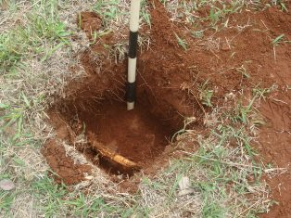

**Figure 27: STP A.**

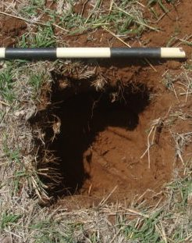

**Figure 28: STP B.**

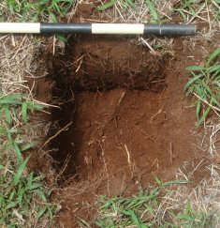

**Figure 29: STP C.**

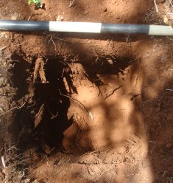

**Figure 30: STP D.**

***Discussion of Cultural Material***

With hardly any cultural material present (or visible) on the surface of the impacted sites, a general surface collection in the wider area around the switching station sites (T12 & 13) were undertaken to increase the sample size. Mostly pottery and some stone tools were collected mainly from open areas and a dirt track that borders the sites on their western side. This is also closer to main settlement features.

**Pottery**

The pottery sampled from the general surface of the area included 33 undecorated body sherds, with no rim fragments recovered. Some of these pieces contain traces of either red (ochre) or black (graphite) burnish on their outer surfaces. A number of the pieces have also been burnt black, evidence of being used as cooking vessels. Both thick and thin walled pottery is represented and various types of containers including storage (maize, water), cooking and drinking are probably represented in the sample.

Four decorated pieces were recovered from the surface. None of these have rim sections and are very small so determining the positioning of the decoration on the vessels, as well as full decoration motif, was not possible. The decorations included a piece with black graphite burnish with line incisions; 1 piece with a band of incised lines; 1 with comb stamping and 1 with partial herring bone incisions bordered by a single line incision. It seems as if the vessel broke at the rim and therefore that the decoration was just below this and on the neck of the pot.

With the pieces very small, and with only partial decorations visible, it is difficult to determine to which cultural grouping or Iron Age pottery tradition it belongs. Providing a relative age for the site is also difficult. However, research in the broader Steelpoort Valley area provides some evidence.

Iron Age occupation of the region seems to have taken place on a significant scale and at least three different phases of occupation have been identified. Sites dating to the Early Iron Age are found in the Steelpoort River valley. Preliminary identification of the pottery indicates that it belong to the Doornkop phase of the Early Iron Age, and should have a date of between AD 600 – 900. These are the same group of people that produced the remarkable clay masks found near Lydenburg in the 1960s. These settlements seem to have been followed at a slightly later date by settlements linked to the Eiland Phase of the EIA (c. AD 1000). The last period of pre-colonial occupation consisted of Pedi-related and Swazi-speaking and Ndebele-speaking people that settled on stone-walled terraced sites at the foot on the mountains. At present it is not clear, but, judged on the pottery found here these sites might even date to early historic times (Van Schalkwyk 2007: 10).

Based on the decorated pieces found on the site, it is possible that earlier Iron Age occupation of the site also occurred. The types of decoration has similarities with Huffman’s Icon facies (of the Urewe Tradition, Molok Branch) pottery that has key decoration features that include multiple bands of incisions separated by color (either red ochre or black graphite), while also including comb stamping and punctates (Huffman 2007: 185). His research also indicates the presence of Icon in the Steelpoort area, with a most likely date range between AD1300 & 1500 (Huffman 2007: 183).

***Stone tools***

Only 3 weathered MSA type tools were recovered from the surface of the area. They included 1 flake-blade with evidence of retouch on its edge; 1 core and 1 broken flake tool.

Stone Age (open-air) sites are scattered in the extensive network of dongas which occur across the wide valley floors between the Leolo and other mountain ranges in the northern part of the Steelpoort Valley. The stone tools found here date from the Early Stone Age right through to the Late Stone Age (Pistorius 2013: 18). According to Pistorius, no archaeological survey for Stone Age sites as part of any extensive or in-depth Stone Age research project has been conducted in the Steelpoort River Valley as yet (p.18).

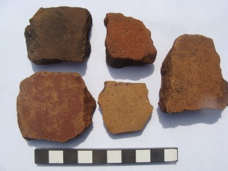

**Figure 31: Pieces of undecorated pottery from the surface of the area.**

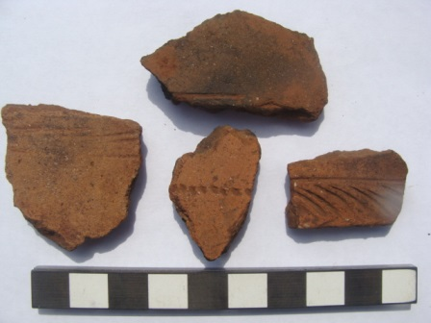

**Figure 32: The decorated pottery fragments found the surface.**

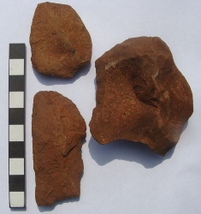

**Figure 33: The MSA artefacts found.**

***Excavation 1***

The excavation produced relatively little cultural material, although pottery, bones, metal fragments and stone tools were recovered.

**Bone**

Faunal remains and shell were virtually absent from the excavation, and only 6 small fragments of unidentifiable bone were recovered. All six have been burnt white.

**Metal**

The only metal objects from Excavation 1 were 7 small fragments of a heavily rusted, unidentifiable object.

**Stone tools**

Four (4) Middle Stone Age tools were recovered from the excavation, with all coming from the level of the natural rock base. Two possible broken point and flake-scrapers were recovered. The presence of these tools in the Iron Age deposit could just be accidental, although it is also known from some sites that these tools were sometimes re-used by Iron Age occupants of an area.

**Pottery**

Pottery made up the largest percentage of the cultural material sample from Excavation, and included both undecorated and decorated pieces.

Sixty-one (61) undecorated body pieces were recovered, representing various vessels. Both thick and thin-walled vessels are present and probably included cooking pots, storage containers and others. A number of pieces either have red (ochre) or black (graphite) burnish, while some have been burnt black from use on cooking fires.

Only 3 undecorated pieces with rims were found. All three are however too small to help with determining vessel shape and profile.

The decorated pottery was once again very fragmented, small pieces (7 in total) and no rim pieces included. Determining decoration motif and the position of the decoration on any possible vessel was impossible. However, it is possible to say that decoration types included incisions that were either single lines alone; bands of thin lines that seemed to have formed a triangular motif or incised lines either in combination with black graphite or with red ochre and black graphite. The types of decoration are fairly similar to that found on the decorated pottery from the surface. Once again, with such a small, fragmented sample available, it is very difficult to come to any definitive conclusions.

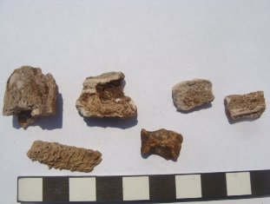

**Figure 34: Unidentifiable burnt bone pieces from Excavation 1.**

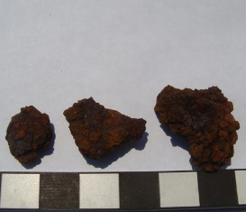

**Figure 35: Fragments of metal recovered.**

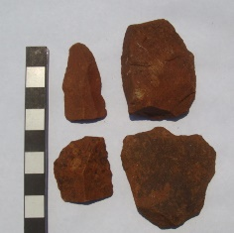

**Figure 36: The MSA tools from Excavation 1.**

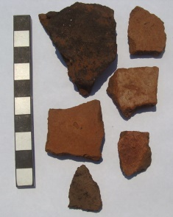

**Figure 37: Some of the undecorated pottery.**

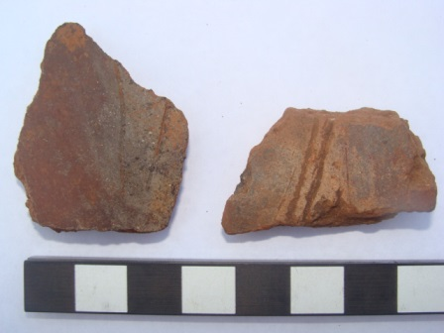

**Figure 38: Two decorated pieces with incisions in combination with graphite**

**and red ochre & graphite.**

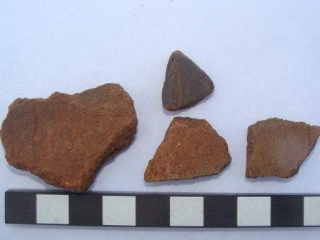

**Figure 39: More decorated pieces with incised lines.**

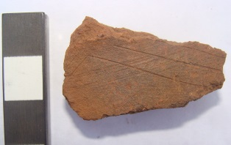

**Figure 40: A piece with fine line incisions seemingly forming a**

**triangular-like motif.**

**CONCLUSIONS AND RECOMMENDATIONS**

In conclusion it is possible to say that the archaeological investigation (mitigation) of the sites that will be impacted on by the development of the ESKOM Tubatse Switching Station was concluded successfully. Although only Site T12 (a mainly terraced site) will be directly impacted, Site T13 were also investigated. Site T14 falls outside of the area that will be

impacted. The archaeological investigations comprised mapping of the sites and features contained on them, as well as limited archaeological excavations comprising a formal excavation (Excavation 1 at T13) and a number of Shovel Test Pits (STP A – D on T12).

Very little cultural material was recovered from the excavations, while the surface sample similarly shows a lack of cultural material deposit being present. Mainly pottery was found, although a limited amount of bone (faunal remains) and metal were recovered from Excavation 1. No cultural material or evidence for the presence of cultural material deposit was found in any of the STP’s. Using the cultural material to provide a relative date for utilization or linking a cultural group to it is therefore at most speculative. However, both historical information and archaeological evidence gathered from other sites in the Steelpoort Valley area seems to indicate settlement of these terraced sites by Pedi, Swazi-speaking and Ndebele-speaking people at the foot of the mountains during more recent historical times.

Based on physical observations in the field, as well as the mapping conducted and excavations it is clear that the Sites T12 & 13 were mainly utilized for agricultural purposes. The main feature on both sites is stone walled terraces that were “constructed” using the natural contours and rocky slopes that run up to the foot of the mountain ranges surrounding the area. The rocky slopes were “leveled” with a layer of rich soil for the purposes of planting and growing crops. Packed stone platforms used as grain bin stands or for grain baskets are found throughout the area (on both sites), while large numbers of both upper and lower grinding stones are further evidence for the mainly agricultural function of these sites. Only a small number of circular enclosures (for livestock) and possible hut bays are present on T12 & T13, but these could have been for short-term habitation during crop season or even remains of earlier settlement here. Excavation 1 seems to indicate this as well, with the foundations of a possible cattle kraal found on the terrace where the excavation was located, as well as feint traces of an earlier kraal in the form of cattle dung. Main settlement sites, such as T14 (outside of the impact area) and others in the area are situated further up the slopes and at the foot of the mountain ranges in the area. T12 and 13 more than likely functioned as the agricultural section of these homesteads and larger settlement complex here.

Finally it is concluded that the development will have a limited impact on the stone walled sites in the area and that only a relatively small section of the terraced sites will be destroyed as a result. From an archaeological perspective the development should therefore be allowed to continue after the issuing of a destruction permit by SAHRA, taking cognizance of the following recommendations:

a. should any significant archaeological features, such as possible granary pits, unmarked human burials and cultural material deposits be exposed during any development actions work should be halted in the areas where they are discovered and an archaeologist must then be called in to investigate and recommend on the best way forward.

b. development work should only be limited to the area indicated originally. Should there be any amendments to the development footprint and location this should be reported and the changes investigated to determine if any new sites and features could possibly be impacted.

**REFERENCES**

Aerial views of area, site location and maps of sites and site features: Google Earth 2013 & 2014.

HUFFMAN, T. 2007. *Handbook to the Iron Age. The archaeology of pre-colonial farming societies in Southern Africa.* University of KwaZulu-Natal Press: Scottsville.

Pelser, A.J. 2013. *A Short Report on the preliminary mapping of a Stone Walled Late Iron Age Site impacted on by the development of the ESKOM Tubatse Switching Station, near Steelpoort in the Limpopo Province.*Unpublished Report APAC013/48 APELSER ARCHAEOLOGICAL CONSULTING cc. For: Savannah Environmental (Pty) Ltd. July 2013.

Pistorius, Dr. Julius C.C. 2013. *A Phase I Heritage Impact Assessment (HIA) study for ESKOM’S proposed new 132kV loop-in and loop-out Power Line from the 132KV Jane Furse/Merensky Power Line to the proposed new Grootboom Substation in the Steelpoort Valley in the Limpopo Province of South Africa.* Unpublished Report for the Polokwane Environmental Management Limpopo Operating Unit. Mbofho Consulting and Project Management. January 2013.

Van Schalkwyk, Dr. J.A. 2007. *Heritage Impact Assessment for the planned Steelpoort Pumped Storage Station, Lydenburg Municipal District, Mpumalanga Province.* Unpublished Report National Cultural History Museum 2007H002. For: Bohlweki Environmental Consultants. January 2007.

Van Schalkwyk, Dr. J.A. 2013. *Compilation of Construction Environmental Management Programmes for the Steelpoort to Marble Hall 400Kv Powerline and the Steelpoort Integration Project: Heritage Resources Assessment.* Unpublished Report 2012/JvS/060. For: Iliso Consulting - Amended January 2013.

**ACKNOWLEDGEMENTS**

We would like to acknowledge to following institutions and individuals for their assistance and support:

1. Savannah Environmental, and ESKOM, for appointing us to conduct the required work

2. SAHRA, for providing us with the required excavation permit in order to conduct the archaeological investigations on the site

3. Mr. Jaco van der Walt, who assisted greatly with the mapping of the site and features found on it

4. Me. Me. Jenny Halvitzis, Mr. Frank Teichert and Mr. Jacques Hattingh without whom the excavations would not have been possible. Thank you for all your hard work and input – even when the rain came.