SITE VISIT REPORT FOR MAKGABENG IN LIMPOPO PROVINCE

Introduction

Sections 50 of National Heritage Resources Act 25 of 1999 give provision for the designation of the heritage inspectors. Section 50(7) state that the heritage inspectors, may at all reasonable time enter upon any land or premises for the purpose of inspecting any heritage resources protected in terms of the provision of the NHRA, or any other property in respect of which the heritage resources authority is exercising its functions in terms of the Act.

Purpose of the site visit
The site visit was conducted after receiving a complaint from Dr Tlou Setumu about the heritage which is destroyed and damaged by the Platinum Group Metals. This is part of the monitoring and evaluation of the National Heritage Sites in South Africa an inspection was conducted to establish if the mine has followed what was stipulated in the permit for prosecuting rights. This was to ensure that proper protection is given to the National Heritage Site and the sites which have heritage but not nominated. Makgabeng is not graded or declared site but has Iron Age Rock Art Site. Main objectives are to identify challenges, and risk on the resources in the Country. Section 5 (1)(a) of the NHRA clearly state that, heritage resources have lasting value in their own right and provide evidence of the origins of South Africa society and as they are valuable, finite, non-renewable and irreplaceable they must be carefully managed to ensure their survival.

Significance and status
It has the highest concentration of farming community rock art in South Africa, located alongside and superimposed on the rock art paintings of hunter-gatherers and pastoralists. Culturally this mountain range is significant because of its long pre-historic occupation of Hunter-Gatherer groups; Pastoralist groups and the Sotho speaking farming community. Archaeological evidence in the form of cave occupation remains by these people was found and a lot of research has been dedicated to understanding the history of the plateau (Eastwood et al 2002).

This mountain range is a UNESCO protected biosphere reserve, it is found that much of the natural landscape and plants and reptiles are endemic to this area. This mountain range is also known as the last stand that the chief Malebogo made towards the trek-Boers, before he was captured and taken to Pretoria in a train as is painted in one of the large shelters. Subsequently the today the Makgabeng Plateau is still used for male initiation (ibid)

Archaeological research since the 1950s has discovered and argued the importance of the Makgabeng Plateau as a cultural landscape.

Methodology of the site visit
The site visit was conducted on the 21 October 2015 started at 10 o’clock in the morning, with Mr Thys Botha from Platinum Group Metals and was to establish if they have followed what was stipulated in the permit given to them by SAHRA for prosecuting rights. See attached photos included in the report.
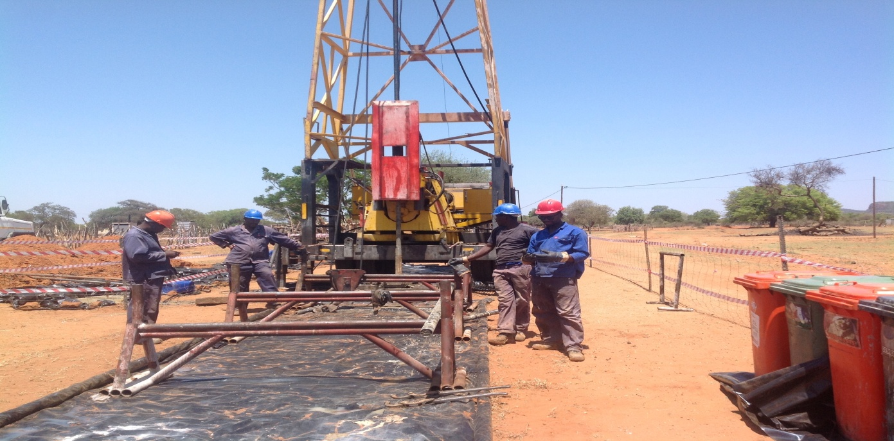
Picture 1: Drilling machine taken by N.Q. Machete

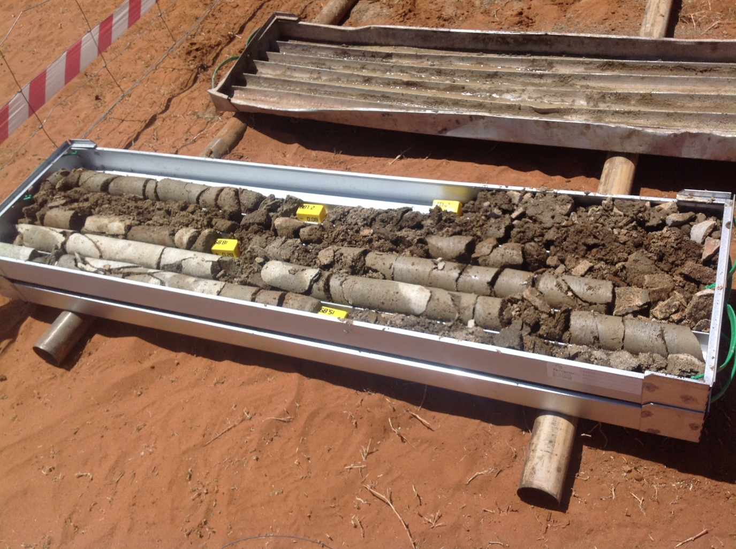
Picture 2: Deposit from the ground taken by N.Q. Machete
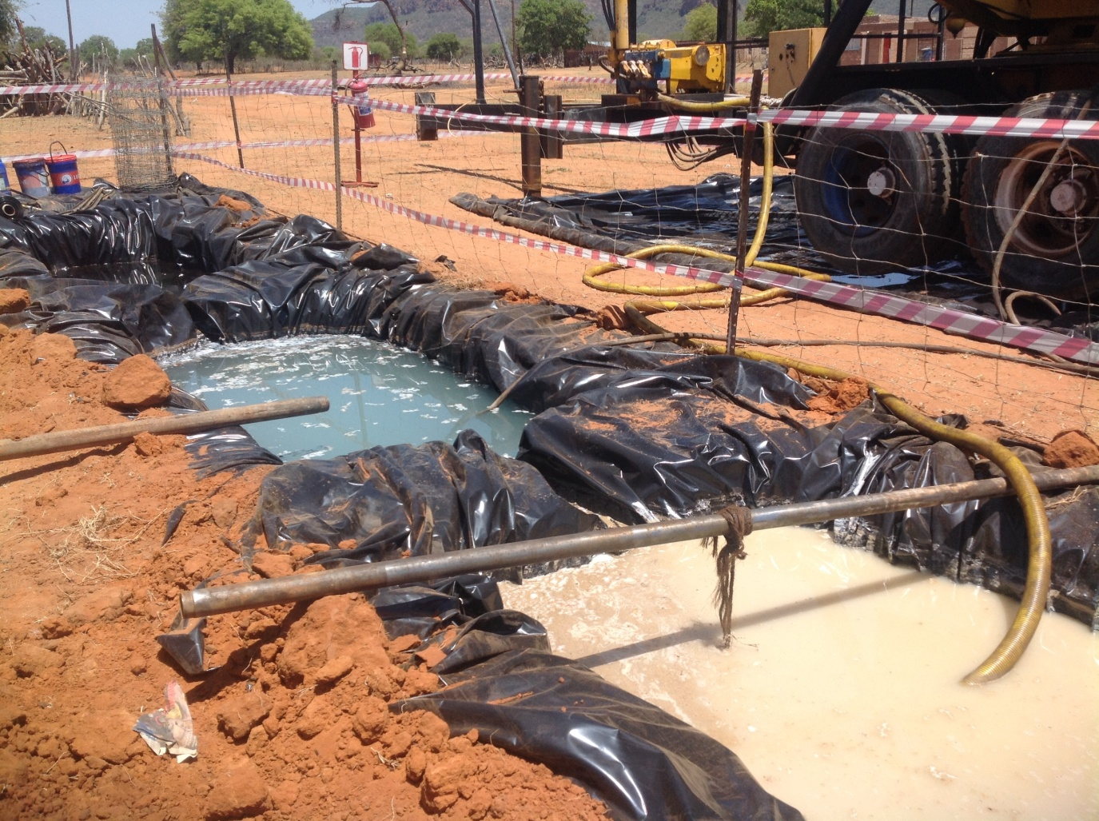
Picture 3: Deposit divided into clean water, chemical water and waste collected and taken to the dumping site with black plastic bag visible in the picture. Then the pit will be closed after drilling is over and done with. Picture taken by N.Q. Machete

Discussion
The majority of the sites visited were essentially a biodiversity issue, and not a heritage resources management issue. SAHRA can only intervene where actual heritage resources are under threat from the prospecting activities.

When Mr Hine and the team visited the site on the 8-9 October 2014 they found out it should have been clearly stated in the prospecting EMP that a 22km road was going to be constructed. Widening the road servitude, moving large pieces of surface rock material and constructing workers camps for prospecting was not mentioned in the EMP to be of this large scale.

Such significant transformation of the landscape would have been subject of an HIA. It was conveyed to the RARI representatives that a prospecting application is usually not subject to a HIA. Also such applications are not subject to the full EIA processes. The heritage statement that was submitted along with the EMP was considered sufficient at the time when the SAHRA comment was issued.

The complaint from the community about Platinum Group Metals not consulting the community was unfounded. The mine has a register of people consulted and the complaint was not consulted Mrs. Manoko Chief Woman who is not formally elected as the matter is in court. This is not SAHRA’s mandate and they could not show where the destroyed heritage was. See attached photo of the group that SAHRA spoke too.

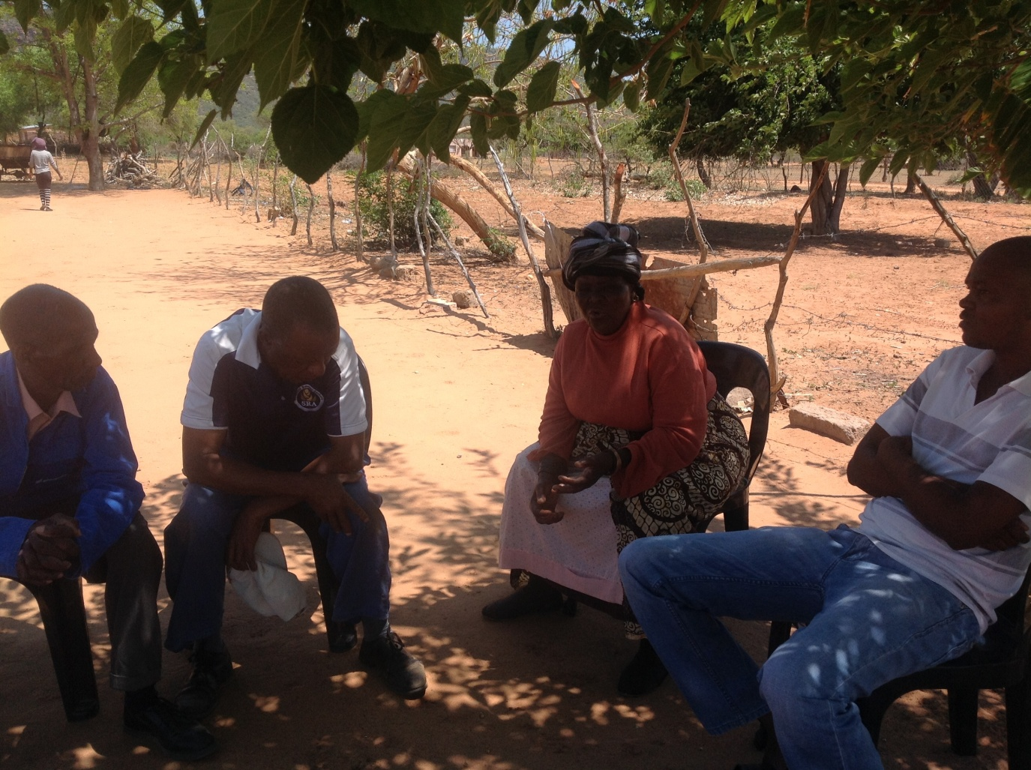
Picture 4: From the left Mr Godlief. Ngoepe, Mr Gabriel Ngoepe, Mrs. Manoko Ngoepe and Mr Salome Setumu (Head Woman) are the complaints representing other community members.

Conclusions and Recommendations
Due to the concerns raised regarding the extent of the prospecting activities and how this might impact significant heritage resources, SAHRA staff informed the stakeholder that there was very little that the SAHRA could do in terms to stop further prospecting, since most of the issues require action from the competent environmental authorities. The chieftain/indunaship matter is in court and SAHRA can be involved in this matter as it is out of our scope of work. Stakeholders holder were informed about what avenues could be explored to protect significant resources, these would include nominating the site as a National Heritage Site or applying for Provisional Protection.

References
1). Eastwood E.D, Van Schalkwyk, J and Smith, B. 2002. Archaeological and Rock Art Survey of the Makgabeng Plateau, Central Limpopo Basin. The Digging Stick, Vol. 19, No. 1, pp. 1-3

