SITE VISIT REPORT FOR NGQUZA HILL

Introduction

Sections 50 of National Heritage Resources Act 25 of 1999 give provision for the designation of the heritage inspectors. Section 50(7) state that the heritage inspectors, may at all reasonable time enter upon any land or premises for the purpose of inspecting any heritage resources protected in terms of the provision of the NHRA, or any other property in respect of which the heritage resources authority is exercising its functions in terms of the Act.

Purpose of the site visit
The site visit was conducted as part of the monitoring and evaluation of the National Heritage Sites in South Africa. This is to ensure that proper protection is given to the National Heritage Site. Main objectives are to identify challenges, risk and possible maintenance of the heritage resources in the country. Section 5 (1)(a) of the NHRA clearly state that, heritage resources have lasting value in their own right and provide evidence of the origins of South Africa society and as they are valuable, finite, non-renewable and irreplaceable they must be carefully managed to ensure their survival. This is the reason why had to visit the site.

Significance and status

Nqguza Hill is located in the Northern part of Pondoland in Eastern Cape Province. The site significance is rooted from the popular uprising of the Pondoland Revolt. In the late 1950’s and 1960’s thousands amaMPondo rose up against apartheid government’s racist policies of separate development. AmaMPondo protests were against the traditional leaders who collaborated with the state in the implementation of the oppressive policies. The movement called Intaba/Kongo had overtly political and judicial dimension and for a short while in the 1960 its structure took over the functions of the chiefs and headmen.

On the 6th June 1960 thousands of unarmed iKongo members gathered at the valley at the foot of the Nqguza Hill to discuss their grievances. They were ambushed and attacked by the military and police who surrounded the precinct. At least fifty eight people were injured and 11 people died in the valley. In the wake of the massacre, thousands of amaMPondo were arrest and havoc wrought by the apartheid state upon their lives. Thirty of those arrested during the period were executed.

On the day of the massacre in June 1960, police gathered on the site of the proposed museum, to launch their attack on the people at the valley. The monument
bears testimony of those killed and buried where they fell and thirteen local men who were executed in the wake of the uprising. On the 6 June 2003 their remains were reburied alongside the monument. A ceremony is held annually on the 6 June to commemorate the uprising and the massacre. This cultural landscape of Nqguza Hill is a national symbol of resistance against oppression and dispossession.

Methodology of the site visit
The site visit was conducted on the 30 October 2015 at 4:30 the site was locked and we took pictures from outside the gate.

Picture 1, taken by N.Q. Machete entrance Nqguza Hill museum which is not opened yet
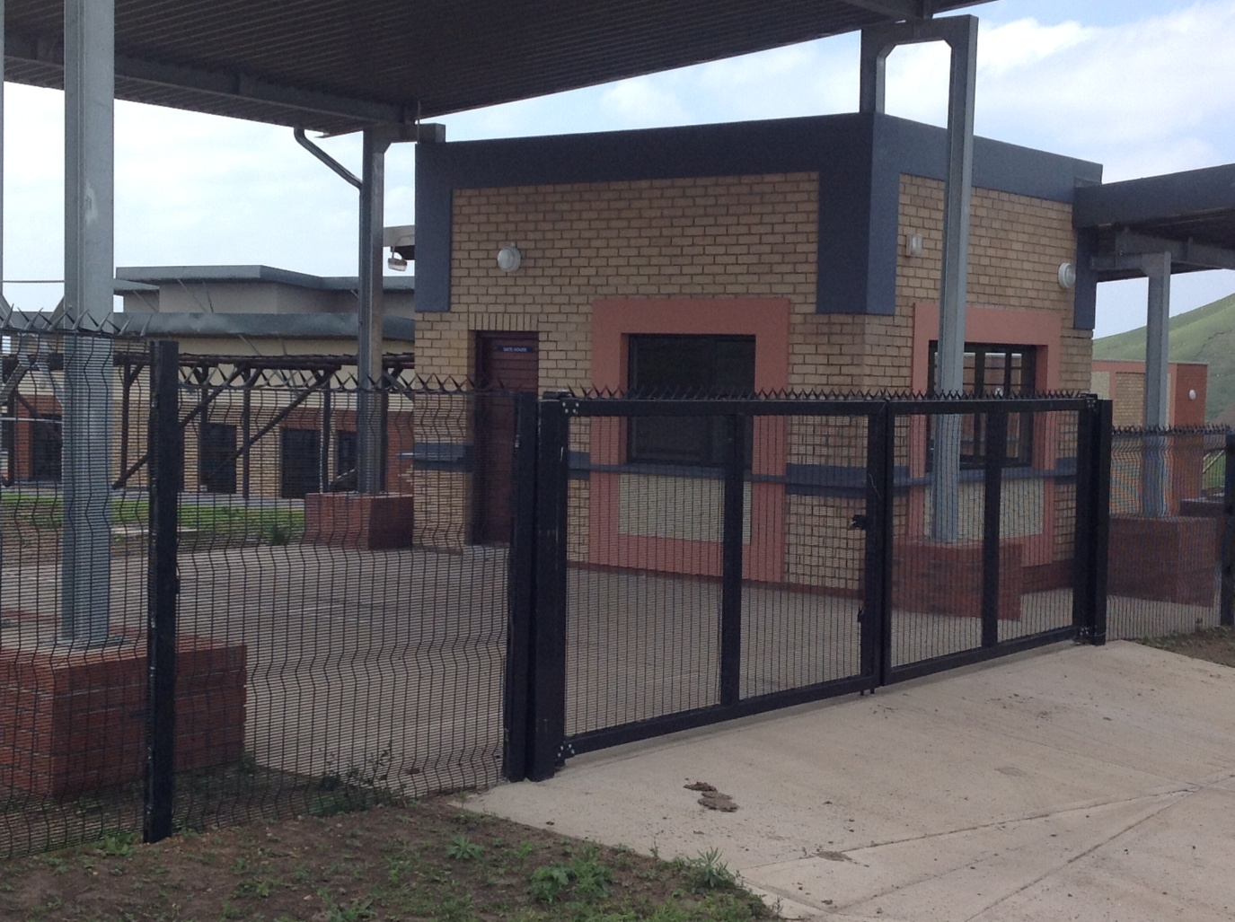

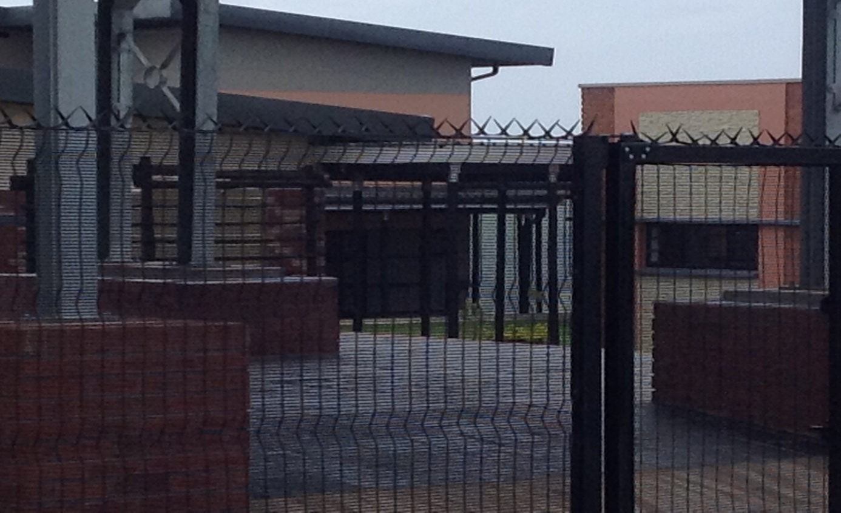
Picture 2, taken by N.Q. Machete, the exterior part of the Ngquza

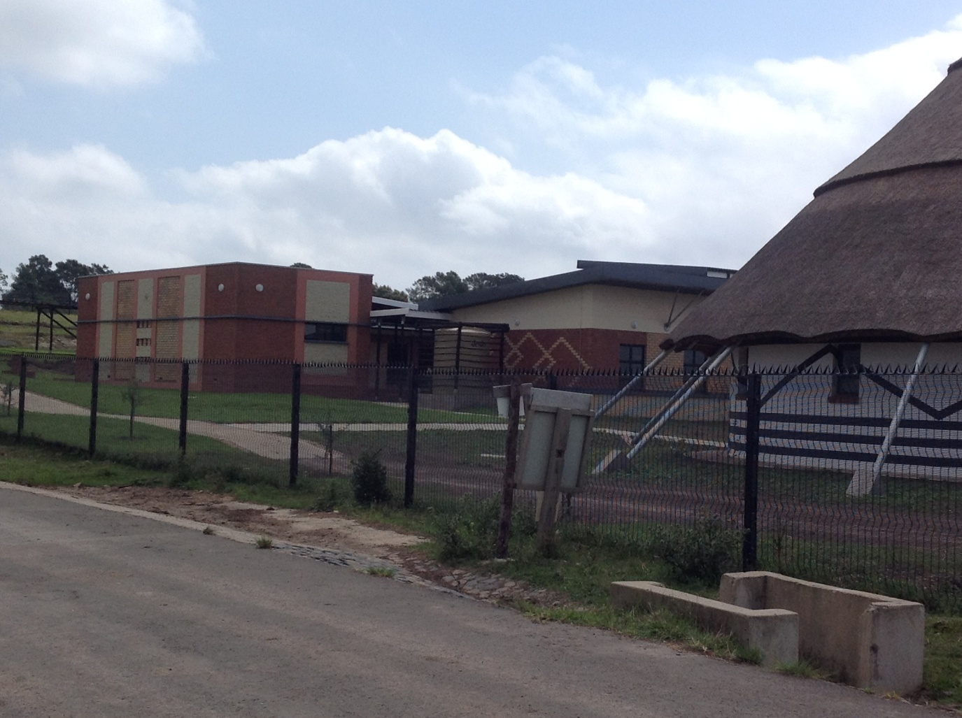
Picture 3, taken by N.Q. Machete, Ngquza Hill reception and museum.
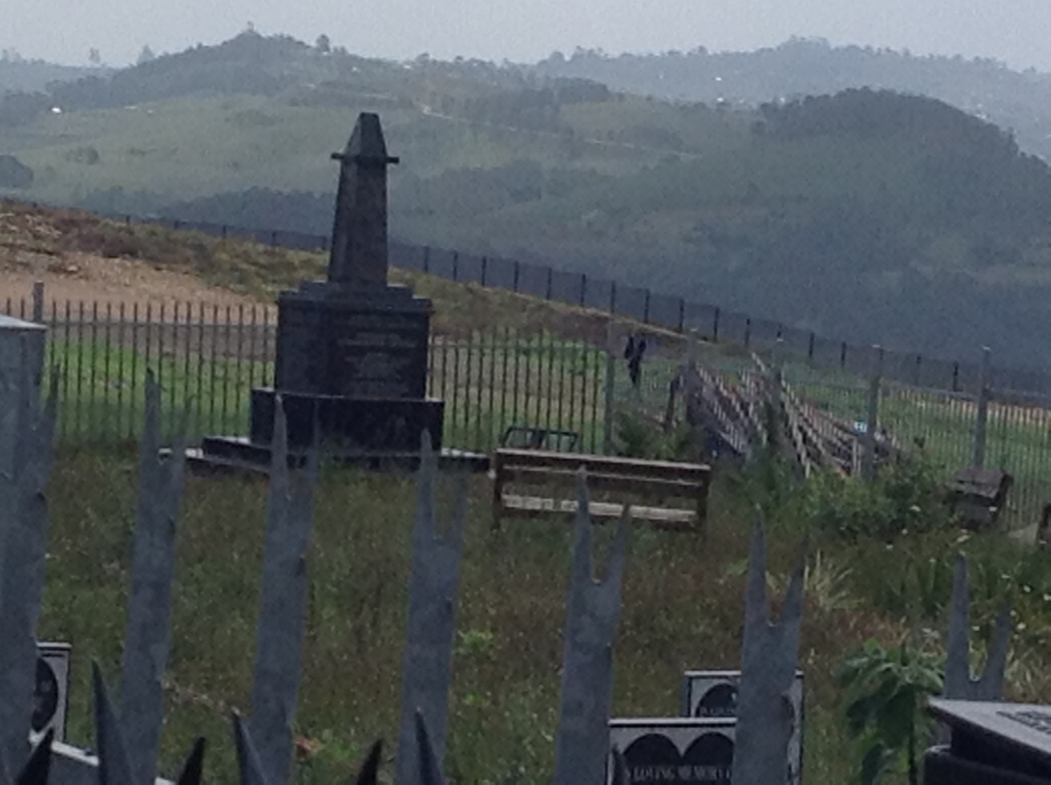
Picture 4, taken by N.Q. Machete Ngquza Hill Memorial.

Discussion
This site is taken care of by the Department of Arts and Culture, the construction is almost done. The official opening will be 6 June 2016. The graves of the victims of conflict are not taken care of as the grass is very long.

Conclusions and Recommendations

No action is needed from SAHRA side expect to attend the meetings to keep abreast of what is happening concerning the official opening and maintenance of the site.

