SITE VISIT REPORT FOR VLAKFONTEIN HERITAGE SITE

Introduction

Sections 50 of National Heritage Resources Act 25 of 1999 give provision for the designation of the heritage inspectors. Section 50(7) state that the heritage inspectors, may at all reasonable time enter upon any land or premises for the purpose of inspecting any heritage resources protected in terms of the provision of the NHRA, or any other property in respect of which the heritage resources authority is exercising its functions in terms of the Act.

Purpose of the site visit
The site visit was conducted as part of the monitoring and evaluation of the National and Grade 1 Heritage Sites in South Africa. This is to ensure that proper protection, further assessment is given to the National Heritage Site. Main objectives are to identify challenges, risk, status and possible maintenance of the heritage resources in the Country. Section 5 (1)(a) of the NHRA clearly state that, heritage resources have lasting value in their own right and provide evidence of the origins of South Africa society and as they are valuable, finite, non-renewable and irreplaceable they must be carefully managed to ensure their survival. Vlakfontein was graded as a grade 1 site before 2003. In 2003 further submission for final declaration was submitted to SAHRA (see file 9/2/263/0020 in sahris) as part of the serial nomination that included Kaditshwene and Molokwane, North West. No record of any development since the submission in 2003. It is unclear at this stage how far the declaration processes is. In order to establish the status in terms of the declaration process, the inspectorate official of SAHRA accepted the invitation by the Royal Bafokeng community to visit the site and addresses other issues regarding different sites under the Bafokeng royalty.

Significance and status
Vlakfontein was one of the largest urban clusters in South Africa in the late 18th and early 19th centuries. The site represents the rise of Tswana people as part of the historical process in South Africa, especially around North West. The site reflects, the importance in the pattern of South Africa’s history, possession of uncommon, rare or endangered Aspects of South Africa’s natural or cultural heritage for the Tswana people, provide a particular example of the late 18th and early 19th century Western Tswana town and has the potential to yield information regarding the rise and cultural sophistications of the Tswana people.

Methodology of the site visit

On the 29th October 2015 the inspectorate officials had a meeting with the Royal Bafokeng royalty whom own part of the Vlakfontein farm where the ruins are located. They pre-briefed the officials about the status, challenges and assessment done on various sites including Vlakfontein. This was to proud a clear picture of the site. On the 30th October 2015, actual site visit took place. The officials were accompanied by the Ms Rebecca who leased the farm from Royal Bafokeng. The site inspection commenced at around 11h00 and various pictures were taken.

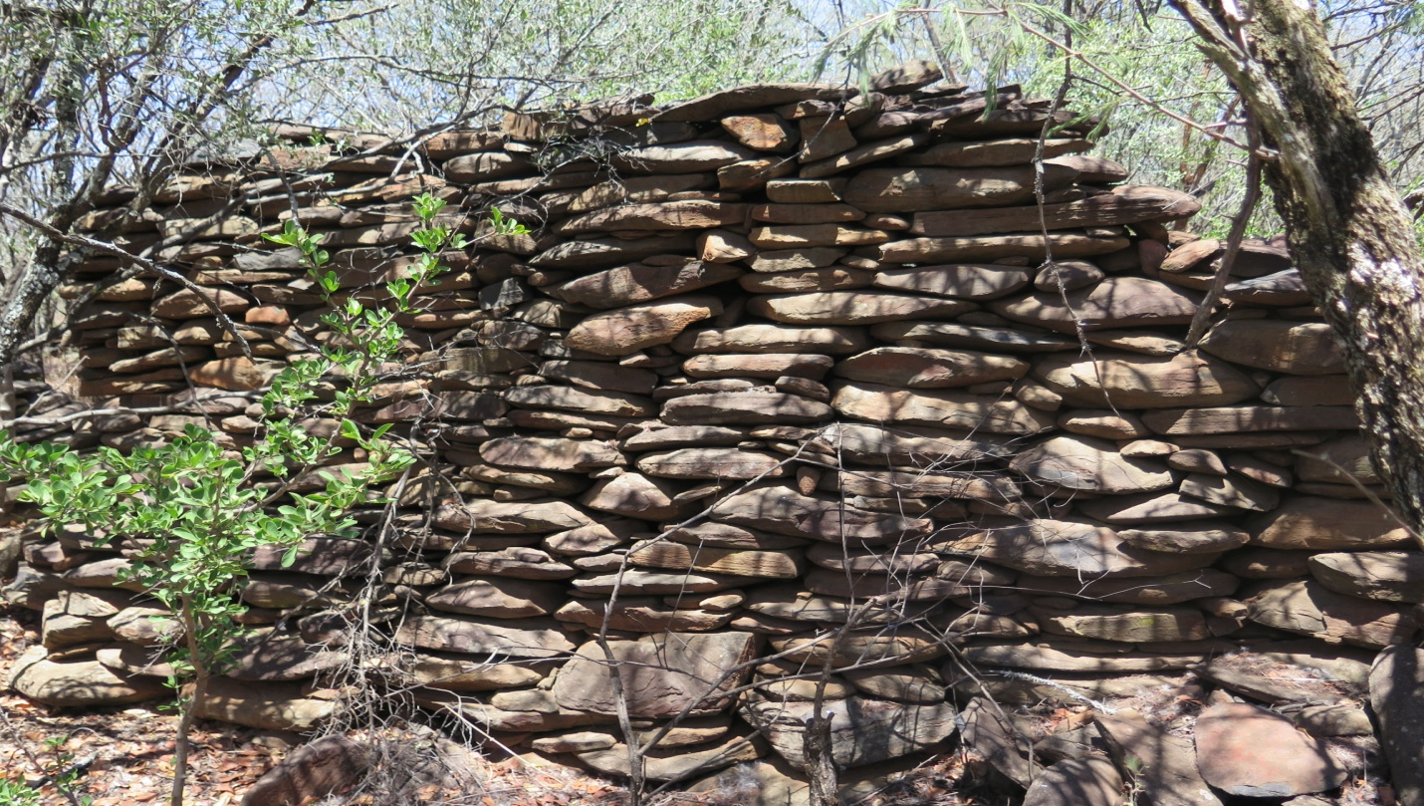
Picture 1: some of the remaining ruins in Vlakfontein
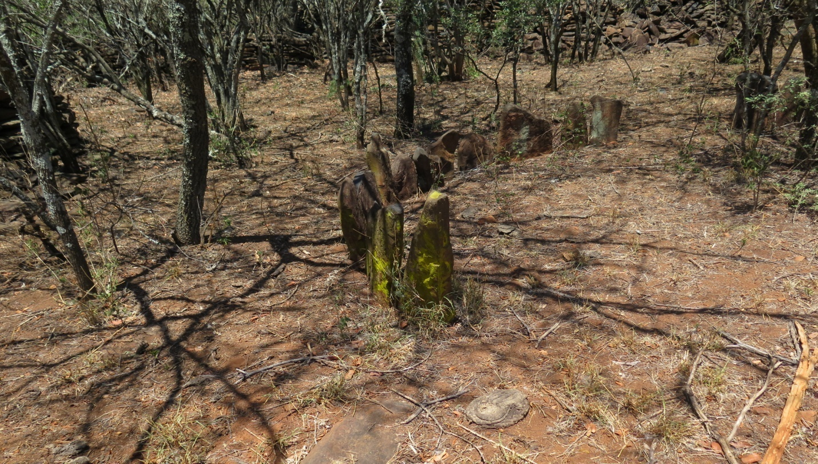
Picture 2: ruins in Vlakfontein (Tswana Town)

Discussion
The submission was made on 2003 for the site to be formally declared in terms of section 29 of the National Heritage Resources Act 25 of 1999. The submission detailed the significance of the site in relation to Batswana tribe in North West. The ruins within the site were allegedly dated back to late 18th and early 19th century. The site is one of few sites scattered around North West that portrays the previous social and cultural structure of the Tswana people in North West. Currently, this cultural heritage is in danger of destruction. Community around are not aware of the significance of the ruins. Dr Mohapi who worked at the municipality also emphasizes this notion that the community members give little care of the ruins. This is due to lack of education regarding heritage resources issues. The recent construction of the roads in the farm is a typical example of little regard to the ruins.
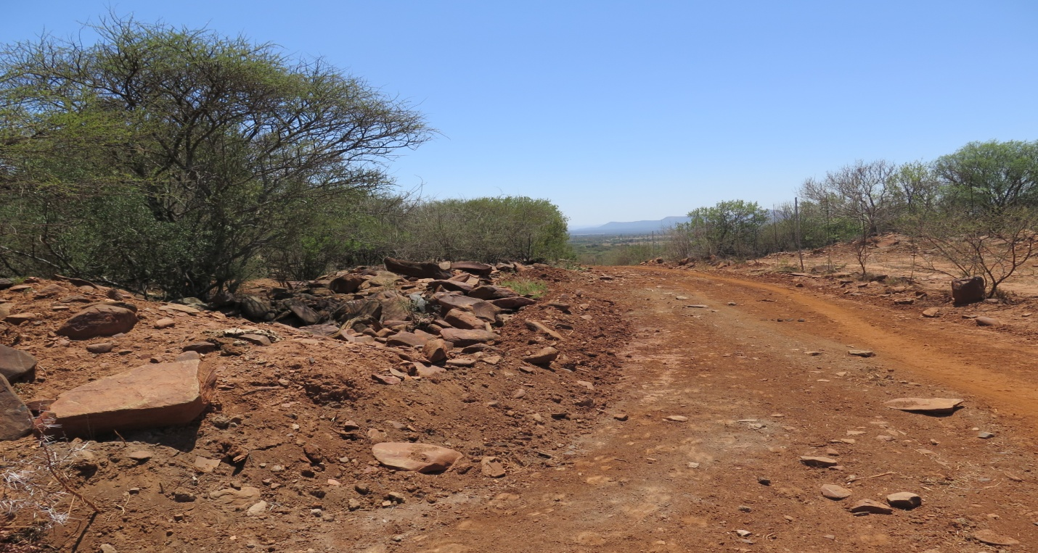
Picture 3: recently constructed road.

The area is used as a cattle grazing area and lot of trees has grown in and around the ruins. Until such time that the site is provisionally protected in terms of section 29, or declared in terms of section 27 to give SAHRA a comprehensive legal standing on the site.
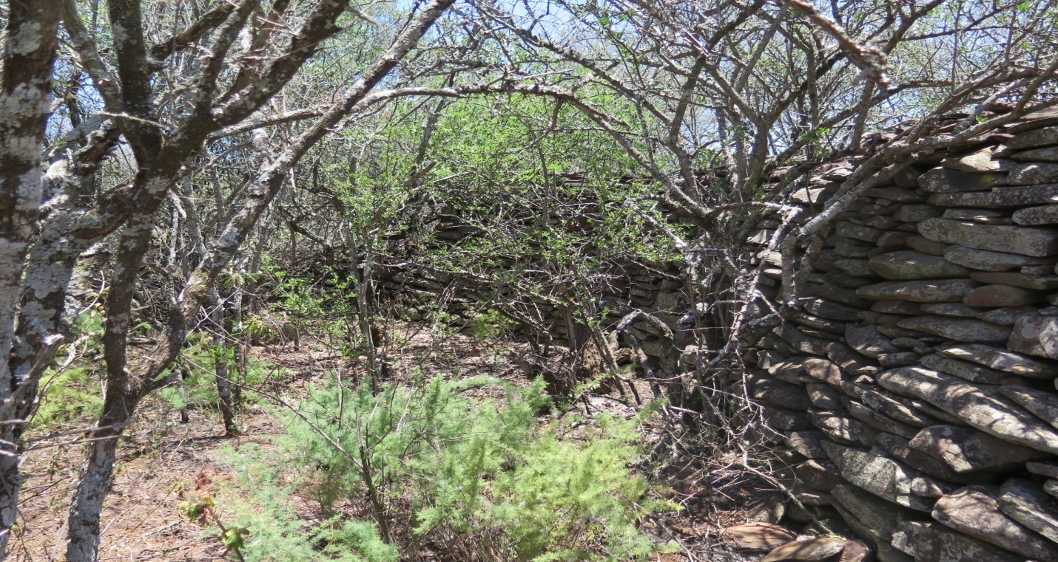Picture 4: trees that has grown between the ruins and threatening the stability of the ruins

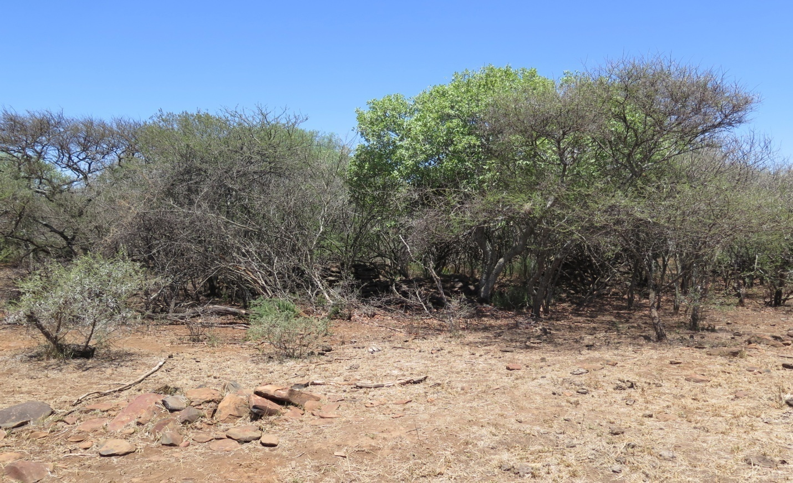
Picture 5: jungle developing around the ruins

Conclusions and Recommendations

It is clear that the site meet the criteria in terms of section 3 of the NHRA. The biggest threat to the site is the lack of knowledge by the community members who uses the site and its surrounding regularly. As the custodian of the site, conservation and management of the Vlakfontein will rest on their hands. SAHRA need to conduct further assessment of the site and submit the assessment report to the Declaration Review Committee to make a final decision on whether to formally declare Vlakfontein as a National Heritage site. The committee may also in collaboration with the provincial authority refer the site to provincial as grade II site.

References

Mary Leslie’s submission, 2003 (file 9/2/263/0020 in sahris)

See Mary Leslie’s submission, 2003 (file 9/2/263/0020 in sahris)

