
AFRICA GEO-ENVIRONMENTAL SERVICES
PO BOX
POLOKWANE
0700

ATT: Johan Botha

22 February 2013

Phase 1 Heritage Resource Impact Assessment (Scoping & Evaluation)
DEVELOPMENT OF NEW ALOE FIELDS
VIVO, LIMPOPO

STATEMENT WITH REGARD TO HERITAGE RESOURCES MANAGEMENT

Map reference: South Africa 1:50000 2229 DB
Project location: Vivo
Farm: Wintersveld 427 MS
General GPS: Field 1 S22º 53’ 18.6” E29º 13’ 53.7”
Field 2 S22º 53’ 33.0” E29º 13’ 52.5”
Field 3 S22º 54’ 11.4” E29º 13’ 11.6”

INTRODUCTION

The statement with regard to heritage resources management, addresses the proposed extension and development of new Aloe fields to add to existing fields.

The Project proposal constitutes an activity, which may potentially be harmful to heritage resources that may occur in the demarcated area. The National Heritage Resources Act (NHRA - Act No. 25 of 1999) protects all structures and features older than 60 years (section 34), archaeological sites and material (section 35) and graves and burial sites (section 36). In order to comply with the legislation, the Applicant requires information on the heritage resources, and their significance that occur in the demarcated area. This will enable the Applicant to take pro-active measures to limit the adverse effects that the development could have on such heritage resources. (For pertinent legislation see Appendix A and terminology see Appendix B).

TERMS OF REFERENCE

The author was contracted to undertake a Phase 1 Heritage Resources Impact Assessment for the proposed development of new Aloe fields on the farm Wintersveld 427 MS, near Vivo, Limpopo Province.

The aim of the assessment was to determine the probability of the presence of heritage resources such as archaeological or historical sites and features, graves and places of religious and cultural significance; to assess the impact of the proposed project on such heritage resources; and to submit appropriate recommendations with regard to the cultural resources management measures that may be required at affected sites / features. This survey forms part of the EIA-scoping process and data regarding the environmental and socio-demographic conditions and issues should be read in the main report.

Consequently, a letter containing a qualified statement of the status quo with regard to heritage resources, instead of a full report, is deemed sufficient.

DESCRIPTION OF THE TERRAIN

The development site lies within the Savanna biome which is the largest biome in Southern Africa. It is characterized by a grassy ground layer and a distinct upper layer of woody plants (trees and shrubs). The environmental factors delimiting the biome are complex and include altitude, rainfall, geology and soil types, with rainfall being the major delimiting factor. Fire and grazing also keep the grassy layer dominant. The most recent classification of the area by Mucina & Rutherford shows that the vegetation is classified as Limpopo Sweet Bushveld.

This vegetation type occurs at altitudes of 600 to 1000 meters above mean sea level. The landscape features of the study area can be described as plains.

The conservation status of the Limpopo Sweet Bushveld is least threatened, with 5% transformed by mainly cultivation. (Taken from AGES Environmental report.)

METHODOLOGY

The farm manager accompanied the archaeologist to the demarcated areas where a pedestrian survey of the demarcated area was undertaken, by traversing the proposed area. Standard methods of archaeological observation were applied. As most archaeological material occur in single or multiple stratified layers beneath the soil surface, special attention was given to disturbances, both man-made such as roads and clearings, as well as those made by natural agents such as burrowing animals and erosion.

DISCUSSION

According to the most recent archaeological cultural distribution sequences by Huffman (2007), this area falls within the distribution area of various cultural groupings originating out of both the Urewe Tradition (eastern stream of migration) and the Kalundu Tradition (western stream of migration). The facies that may be present are:

Urewe Tradition: Moloko Branch - Icon facies AD 1300 - 1500 (Late Iron Age) Kwale branch - Mzonjani facies AD 450 - 750 (Early Iron Age)

Kalundu Tradition: Benfica Sub-branch - Bambata facies AD 150 - 650 (Early Iron Age)
Happy Rest sub-branch – Happy Rest facies AD 500 - 750
(Early Iron Age)
Eiland facies AD 1000 -1300 (Middle Iron Age)
Khami Facies AD 1400 –1820 (Later Iron Age) Tavhatshena Facies AD 1450- 1600 (Late Iron Age)
Letaba facies AD 1600 - 1840 (Late Iron Age)
Mutamba Facies AD 1250- 1450 (Middle Iron Age)
None of the above-mentioned archaeological remains or other heritage remains of importance were recorded on the terrain. However, the archaeological cultures referred to above may be present as obscured subterranean deposits.

The Soutpansberg Saltpans are about 10km away from the proposed development. Rock art has been documented at the Saltpan Shelter (Hall and Smith 2000 from the Journal of Social Archaeology).

The Tshivula, a western group of Venda, had their main village close to the Saltpans during the 18th and 19th centuries. (The Historical Archaeology of Mapungubwe: The Birwa, Venda and Machete. Huffmann T.N)

No remains relating to socio-religious activities or graves were recorded.

MANAGEMENT AND MITIGATION MEASURES

No management or mitigation measures are required. This letter serves to confirm that no significant heritage resources such as archaeological or historical material or places of social or religious significance were found on the site of the proposed development. From a heritage resources management point of view, we have no objection with regard to the development.

The discovery of previously undetected subterranean heritage remains on the terrain must be reported to the Limpopo Heritage Authority or the archaeologist, and may require further mitigation measures.

REFERENCE

Huffman, T.N. 2007. Handbook to the Iron Age. The archaeology of Pre-colonial Farming Societies in Southern Africa. University of KwaZulu-Natal Press.

Huffman, T.N The Historical Archaeology Of Mapungubwe: The Birwa, Venda and Machete. University of the Witwatersrand, Johannesburg.

King, R 2011 11: 311. Archaeological naissance at Mapungubwe. Journal Of Social Archaeology.

Yours faithfully



FRANS E ROODT
(BA Hons Archaeology)


FRANS ROODT (BA Hons, MA Archaeology, Post Grad. Dip. Museology; UP)
Principal Investigator for SHASA Heritage Consultants

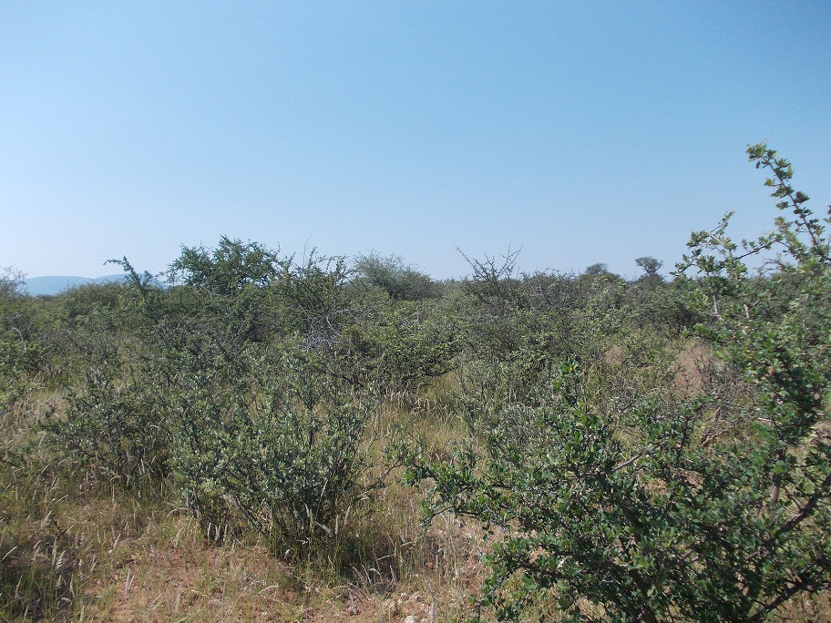
Fig 1. Field 1
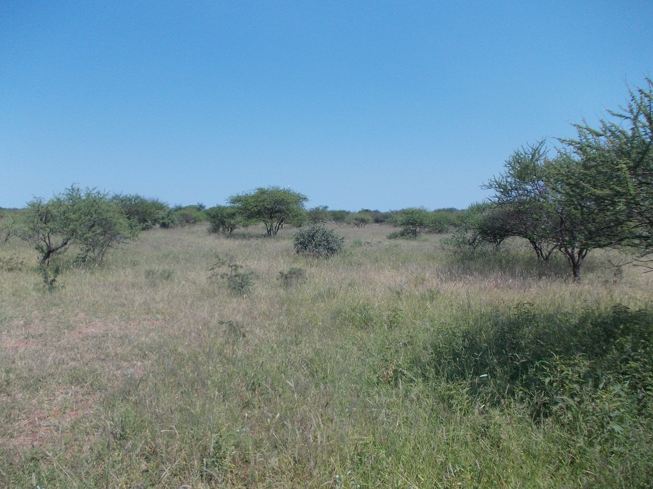
Fig 2. Field 2
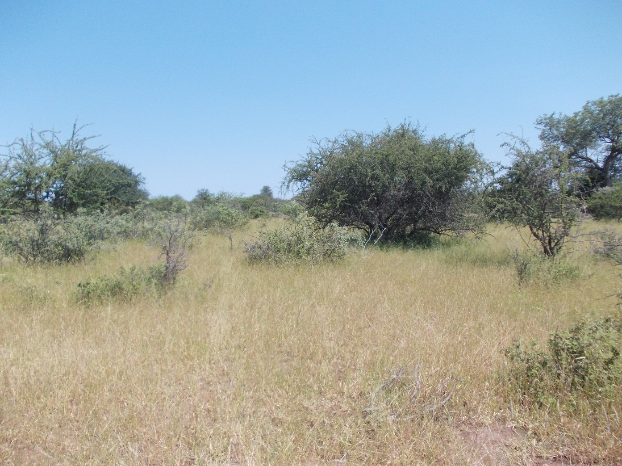
Fig 3. Field 3

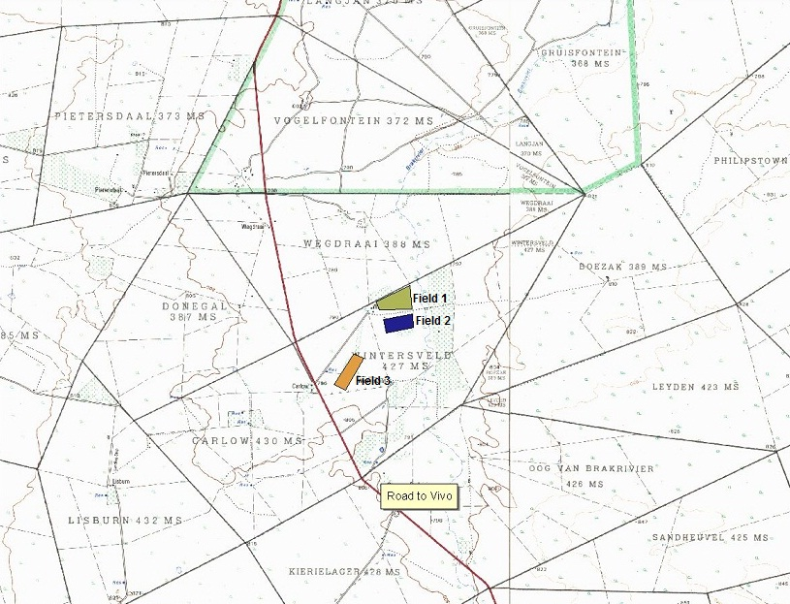
1 to 50 000 Map of Development area
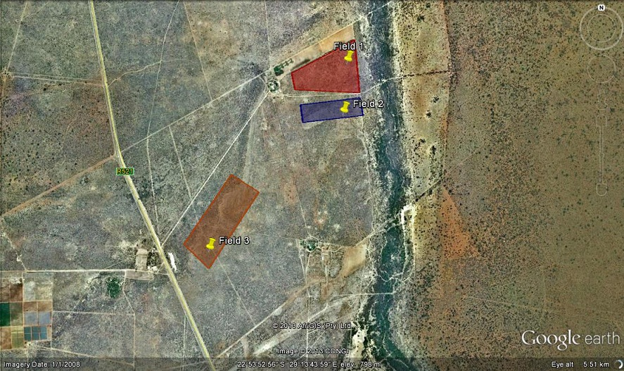
Google Image of Development Area


