SITE VISIT REPORT FOR VOORTREKKER MONUMENT

Introduction

Sections 50 of National Heritage Resources Act 25 of 1999 give provision for the designation of the heritage inspectors. Section 50(7) state that the heritage inspectors, may at all reasonable time enter upon any land or premises for the purpose of inspecting any heritage resources protected in terms of the provision of the NHRA, or any other property in respect of which the heritage resources authority is exercising its functions in terms of the Act.

Purpose of the site visit
The site visit was conducted as part of the monitoring and evaluation of the National Heritage Sites in South Africa. This is to ensure that proper protection is given to the National Heritage Site. Main objectives are to identify challenges, risk and possible maintenance of the heritage resources in the Country. Section 5 (1)(a) of the NHRA clearly state that, heritage resources have lasting value in their own right and provide evidence of the origins of South Africa society and as they are valuable, finite, non-renewable and irreplaceable they must be carefully managed to ensure their survival. On the 9th September 2015, the Inspectorate officials visited the Voortrekker Monument as an ongoing monitoring of all National Heritage sites in South Africa. This will enable SAHRA to be more proactive on challenges facing the national Heritage Sites in country.
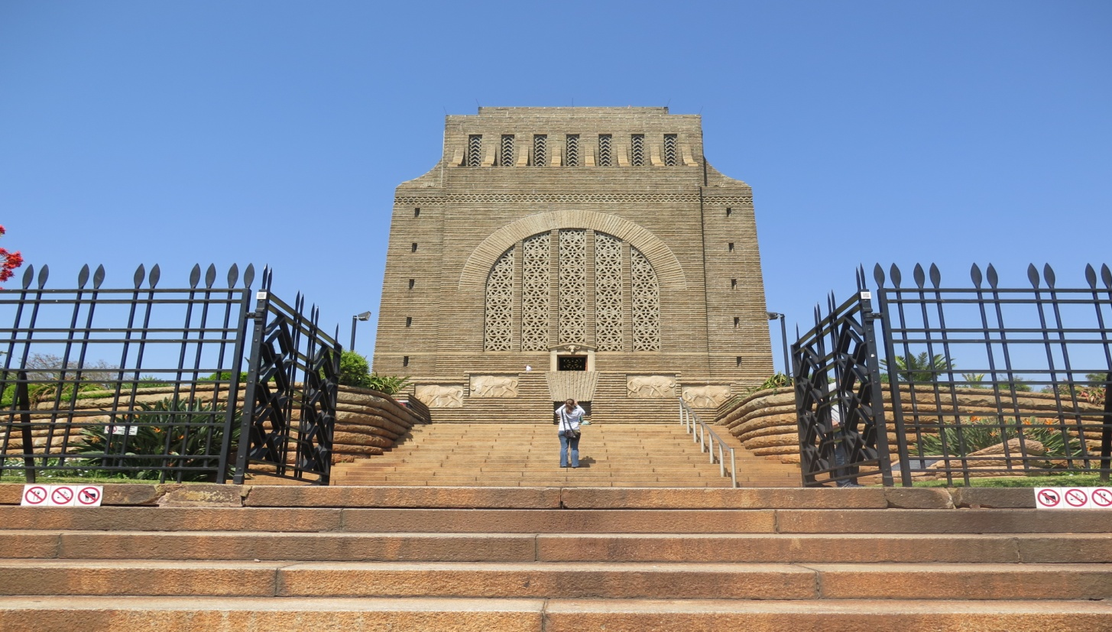
Figure 1: the entrance of the Voortrekker Monument. Photo taken by Themba Monnye

Significance and status
Voortrekker monument possesses the combination of architectural significance and the commemorations of the Great Trek. The monument was designed by well known South African architect, Gerhard Moerdyk and constructed between 1937 and 1949. The monument was constructed to commemorate the Great Trek, focusing on the 16th December 1838 when the Zulu Army of Dingaan was defeated. This formed the landscape of South African political history which had an effect in a way in which the new democratic South Africa has developed. The monument was declared as a National Heritage site in July 2011.
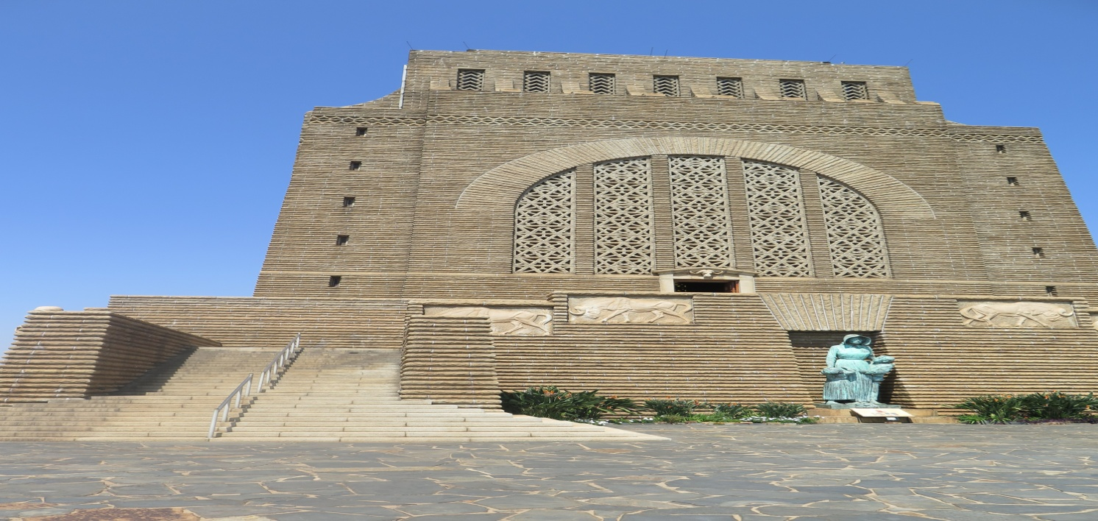
Figure 2: photo depicting sculpture of a woman as a mother-figure. Photo taken by Themba Monnye

Methodology of the site visit
Site visit took place on the 09th September 2015 and included the inspection of the surrounding area, exterior of the monument and the interior of the monument guided by the officials of the monument. Various photos were taken to illustrate the condition and surrounding of the monument.

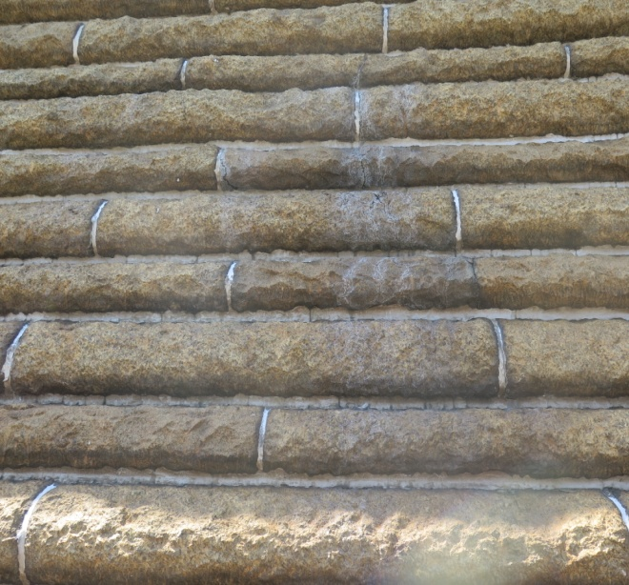 | 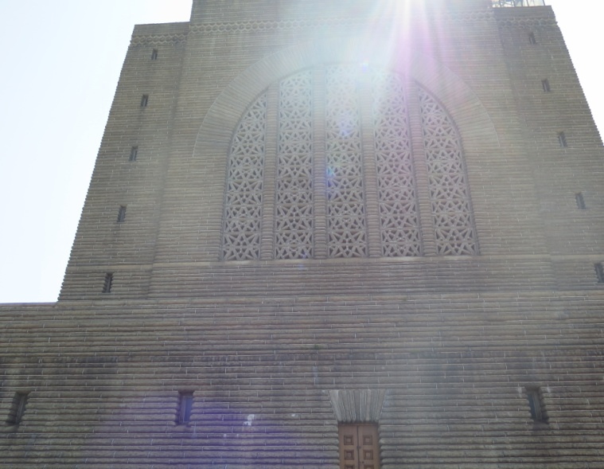
Figure 3 & 4: showing the exterior walls and leaking water. Photos by Themba Monnye

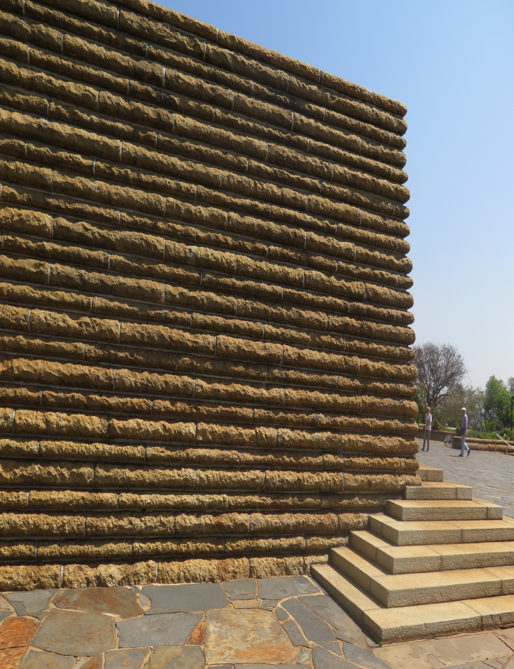
Overall the monument still in good conditions and illustrate that constant maintenance is performed by the managing companies.
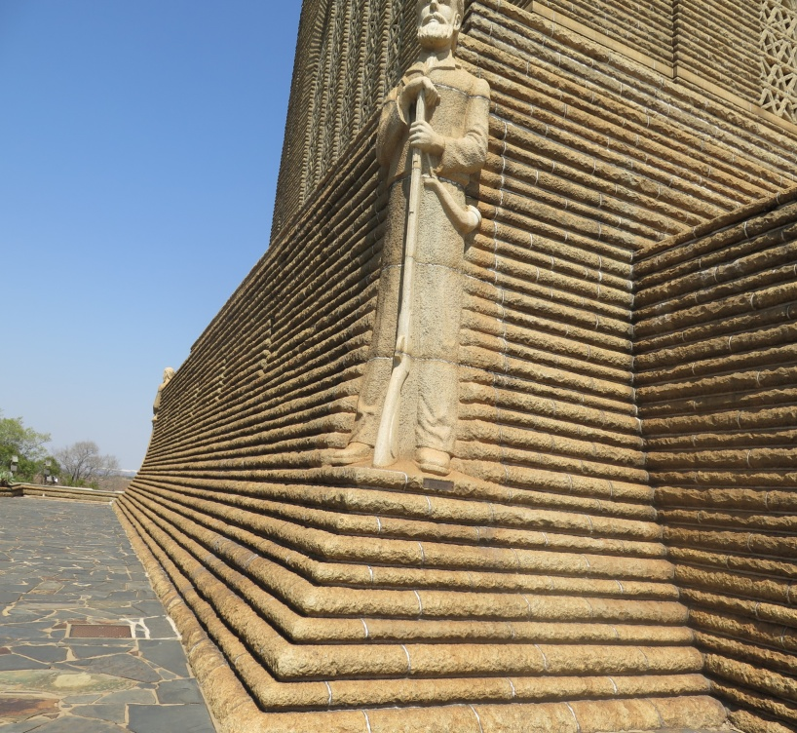
Figure 5 & 6: showing the base of the Voortrekker monument.

Discussion
The monument is managed by the two parties, one managing the actual museum within the monument and while the Heritage Foundation manage the heritage aspects of the monument. The monument is still in good conditions. The exterior and interior well looked after. Etta Judson, the manager of the museum highlighted the challenges that face the maintenance of the monument. She stated that SAHRA used to provide funds for the maintenance within and surrounding the museum, but now they have stopped. This creates a financial constraint to the management of the monument, especially when number of visitors decline due to economic related issues. The new Conservation Management Plan has been recently being approved by the Voortrekker monument board and it will be made available to SAHRA as soon as possible.

Conclusions
The site still condition and well looked after. SAHRA will await a new a copy of Conservation Management plan allegedly recently approved. Once the proposal for the submission of world heritage site is finalized, SAHRA will give their inputs.

