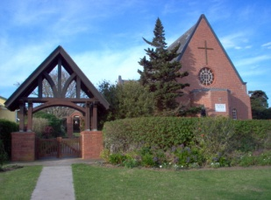
ARCHDEACON R P MURRAY
PO Box 69 Port Alfred 6170
Tel/ Fax (046) 624 1236
Cell 083 303 1605
email: r.murray@telkomsa.net

3 July 2013

Dear Basille

I refer to our discussion on the proposed lime mining project at Southwell.

Part of the Diocese plans for the Eastern Cape is to start up a tourism route of the frontier churches stretching from Cuylerville to Southwell . This route will include St Mary’s Cuylervillle, St Stephens Ostrich Springs, St Johns Bathurst and St James at Bathurst. As you are aware these are all frontier churches.

The scheme is to cater for mainly overseas tourists where there is keen interest shown in this type of tour. We have already completed a project at St Mathews mission where a large conference centre together with accommodation for tourists at a cost of R25m.

The project for the frontier churches will include a bed and breakfast self catering cottages at Bathurst.

The churches at Southwell are of special significance in that the complex includes St Thomas mission church, St James Chuch as well the school.

The diocese will soon start discussions with the Southwell Trust, which is the present owner of the old Southwell school with the objective to renovate the school building to be used to accommodate the tourists or to upgrade the buildings and reinstate the school. This project will obviously require staff and it is envisaged that probably employment will be created for at least five semi-permanent jobs for local unemployed people.

This work would include the upkeep of the grounds of both churches as well as the school grounds and the two cemeteries

Further employment will be created when tourists start using the accommodation.

I will be pleased if you can forward this letter to the board hearing on the Mining Right Application

Yours sincerely

RP Murray
Archdeacon of Albany

